

*Mobility as a Service* White Paper

**Bringing Mobility as a Service to the United States: Accessibility Opportunities and Challenges**

The development and deployment of Mobility as a Service (MaaS) systems in Europe has been increasing at a rapid rate over the past few years. However, in the U.S. during the same time frame, MaaS implementation has been limited. While there are no MaaS systems in the U.S., several systems are under development. A few of these are described later in the paper. The definition of, and unique opportunities and challenges associated with MaaS in the U.S. will be explored.

The accessibility aspect of MaaS has been discussed in a limited way. While this paper directly addresses the current thinking regarding MaaS accessibility in a later section, accessibility is also mentioned briefly in the background, opportunities and challenges sections.

***What is Mobility as a Service?***

According to the MaaS Alliance, “Mobility as a Service (MaaS) puts users, both travelers and goods, at the core of transport services, offering them tailor-made mobility solutions based on their individual needs. This means that, for the first time, easy access to the most appropriate transport mode or service will be included in a bundle of flexible travel service options for end users.”[1] Figure 1 illustrates the MaaS ecosystem.

There are four objectives of MaaS, as follows[2]:

1. Seamless and efficient flow of information, goods, and people both locally and through long distances;
2. Globally scalable door-to-door mobility services without owning a car;
3. A better level of service than the private car; and
4. An open ecosystem for information and services in intelligent transportation.

There are several similarities between MaaS, and one call-one click services and mobility management in general. There are differences as well. In terms of the similarities, one overall vision of all three concepts is to improve livability in a community or region. More specifically, one call-one click can be a component of mobility management, given that mobility management is “a process of managing a coordinated community-wide transportation service network comprised of the operations and infrastructures of multiple trip providers in partnership with each other.”[3] MaaS satisfies several of the elements of mobility management as follows:[4]

* Emphasizes the discrete travel needs of individual consumers
* Emphasizes the entire trip, not just that portion of the trip on one mode or another
* Offers a full range of travel options to the single occupant of an automobile
* Cultivates partnerships and multi-agency activities
* Offers a single point of access for customers to multiple travel modes
* Applies advanced technologies
* Improves the information that is available about those services

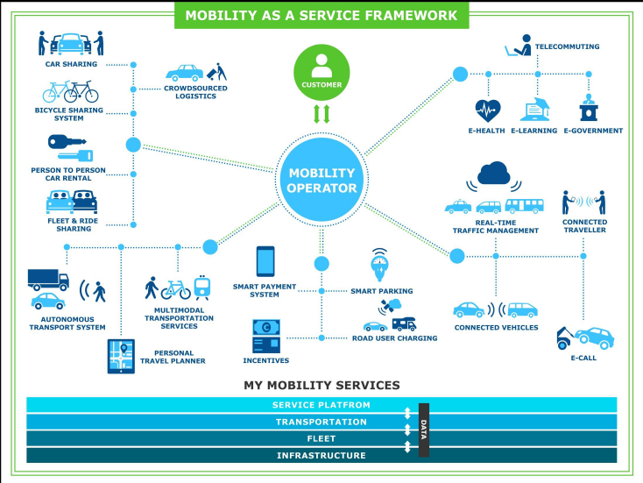In terms of the differences, the one major difference is that in MaaS, the consumer purchases a “package” of transportation services, typically on a monthly basis. Further, MaaS is operated by one entity, which can be a public or private organization. While mobility management can be performed by one organization, it is not necessarily responsible for negotiating financial relationships with transportation service providers. Finally, mobility management’s objectives are typically more focused on the traveler with special needs, while MaaS’s objectives focus is on providing individual mobility with a better level of service than that of a single-occupant vehicle.

Figure 1. MaaS Ecosystem

**An example of MaaS is Whim**, the MaaS system currently operating in Helsinki, Finland. Whim offers four possible mobility “packages” as shown in Figure 2. An example of MaaS in the US could be a personal mobility package for $200/month that includes the following:

* Transportation from A to B according to service level agreement (SLA)
* Access to all transportation services
* Access to transport related services (city logistics, home deliveries etc.)
* Roaming in other cities and countries

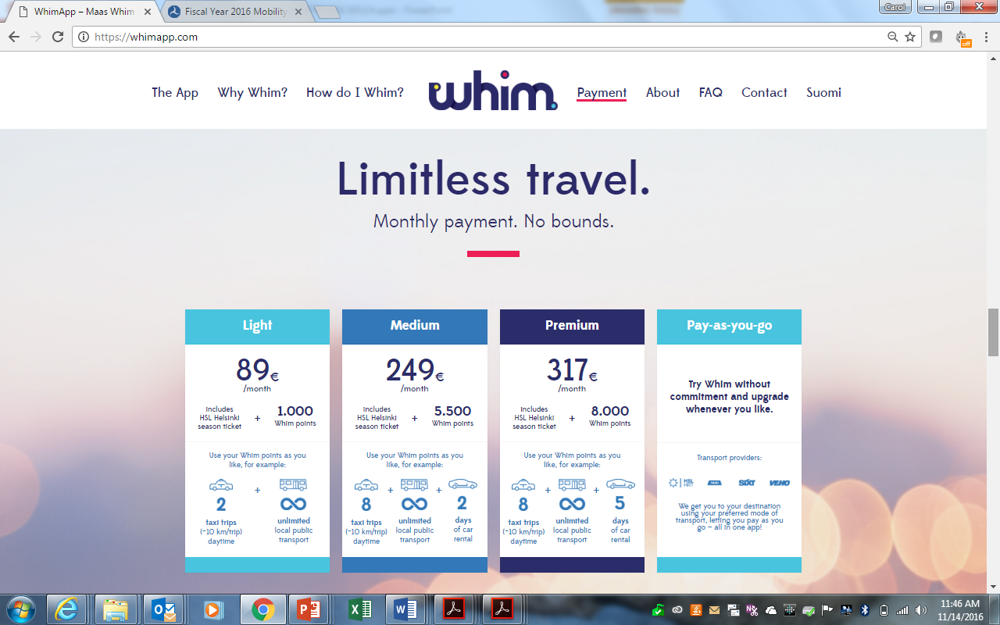

Figure 2. Whim MaaS Mobility Packages

***Setting the U.S. Stage***

To begin to understand the unique challenges associated with deploying MaaS systems in the U.S., it is important to review the current environment within which trip-making is done as well as the characteristics of travelers. **First,** personal mobility in the U.S. is dominated by personally owned vehicles, which accounts for more than 80% of trips. These personally owned vehicles produce 15% of U.S. emissions, are unused over 95% of the time and consume 27% of income in U.S. median income households[5]. The reliance on costly personal vehicles leaves lower-income persons without access to affordable mobility.

**Second**, there are seven major trends over the past five to ten years that have had a significant impact on transportation[6], as follows:

1. Demographic changes, **most notably large numbers of Baby Boomers** and Millennials
2. Preferences for urban living and more flexible lifestyles
3. Availability of WiFi, the global positioning system (GPS), sensors and smartphones
4. Expectation of connectivity anywhere and everywhere
5. **Changes in car driving** and ownership preference
6. **Viewing travel as part of life experiences**
7. Redefining transport through new service providers and systems

**Finally**, there are seven expected trends over the next five to ten years that will affect transportation2:

1. Synchronizing and connecting every network
2. Performance-based public–private partnerships becoming the norm
3. Diversification and consolidation of transport manufacturers and service providers
4. Modular, combined shared “e-mobility” systems in urban areas
5. Commercial deliveries and phased introduction of drones
6. Driverless vehicles and their potential
7. **MaaS with routing, booking, payment, unlocking, gamification and trading**

***Opportunities***

Given the background provided earlier, there are several opportunities that will drive MaaS development and implementation in the U.S.

**First,** and most important, is redefining transportation in terms of mobility, rather than modes. Historically, we have focused on individual modes (e.g., bus, subway, walking, cycling) and whether they are public or private. **Recognizing that mobility represents an individual’s travel better than specific modes will allow the U.S. to make a positive impact on traveler’s ability to make a trip in the manner that works best for them**. One person’s trip decisions will not be the same as another’s.

In order to fully embrace this redefinition, we need to change the existing travel models to account for (1) new mode choice behavior (e.g., lower car ownership); (2) incorporating incentives or rewards; (3) integrating technology-enabled transportation tools; and (4) incorporating effects of new transportation tools – both individually and in combination.

**Second**, the implementation of integrated payment systems is a necessity for MaaS and has a direct impact on mobility. In the US, integrated payment system development is being driven by a variety of factors including the penetration of smartphones in the US mobile device market and competition of various players in the payment market.

**Third**, we need to **develop and promote mobility “equity” tools to meet the needs of those who are poorly served by transportation in their region**. This will be discussed in the section about MaaS accessibility opportunities and challenges.

**Fourth**, the use of data is a key element of MaaS, and provides not only an understanding of travel patterns (that can be used as input to travel models), but can be turned into traveler information.

**Finally**, there are several additional opportunities for making MaaS possible:

* **Incorporating new service providers, such as Transportation Network Companies (TNCs) and micro-transit providers, and understanding their ability to complement existing services**
* Encouraging the use of public transportation and new mobility tools
* Making better use of existing technology and infrastructure
* Expanding access to cellular networks, Wi-Fi and electric outlets in transit stations and aboard transit vehicles
* **Focusing on personalized mobility** (one person’s way of traveling will not be the same as the next person’s)

***Challenges***

There are institutional, operational and technical challenges that must be overcome in order to deploy MaaS in the U.S., and of course, challenges for the traveler.

**Overall Challenge**

Before describing these challenges, it is important to understand one **overall challenge**. Typically, MaaS is being deployed in major urban areas that already have significant transit systems. In the U.S., the majority of the country is in rural and small urban areas. Having less transportation alternatives, less funding and less technology infrastructure, implementing MaaS in these areas is challenging. However, one MaaS that is being developed for these types of areas in the U.S., focusing on mobility for transportation disadvantaged individuals, is described later in this paper.

**Challenges for the Traveler**

From a **traveler’s perspective,** the challenges associated with participating in a MaaS scheme include the following:

* Access to more information with which they can make more informed choices
* Helping travelers make trips that they may not have made in the past
* Ensuring the accessibility of transportation services offered by the MaaS system, including those made by older adults and people with disabilities
* The potential decline or demise of taxi companies (and increase in TNCs) in places where low-income, people with disabilities, and older adults rely on taxis

**Institutional Challenges**

From the **institutional perspective**, often, transportation organizations have not worked together or coordinated services before. This could present a challenge in that a MaaS scheme assumes some cooperation among service providers and the MaaS operator. Also, institutions participating in a MaaS scheme may need to conduct business in different ways, perhaps requiring reorganization of services, operations, staff or customer service. This reorganization may include the development of new tools for operations and customer service staff. Further, application vendors will need to provide open solutions and share information with their competitors. **One last, and perhaps the most significant institutional challenge**, is which organization will actually operate a MaaS scheme. This challenge is being faced in Europe as well - current MaaS schemes are being operated by private companies, transportation service providers or public agencies.

Other institutional challenges include obtaining the financing necessary for MaaS technology procurement, implementation, and on-going operations and maintenance, and the lack of technology experience in organizations participating in MaaS.

**Operational Challenges**

In terms of **operational challenges**, many transit agencies operate independently and may not coordinate their services with other providers. Thus, participation in MaaS may require changes not only in the way agencies schedule and operate their services, but also in the role of each agency in the overall transportation network and MaaS scheme. Further, different governmental and regulatory agencies currently provide transportation services under an array of policies and objectives while trying to satisfy travelers’ needs simultaneously. Other operational challenges include addressing the changes that will be caused by the deployment of MaaS.

**Technical Challenges**

While **technical challenges** are often considered easier to overcome than institutional challenges, those associated with MaaS implementation could be more difficult to overcome since there are a wide variety of technology-related aspects of MaaS. The five major technical challenges that are being considered in U.S. MaaS development:

* Old, unintelligent, or lacking infrastructure in the MaaS service area and how to incorporate this into MaaS architectures. Another related challenge is the ability to use or integrate old technologies with new technologies.
* If MaaS technology fails, can MaaS functions be performed manually?
* “Unbanked” travelers, such as those without credit accounts, may not be able to access new MaaS services
* Travelers who do not have mobile devices capable of functions needed to interact with MaaS applications
* Automation of functions that could alienate agency staff and customers. Similarly, the lack of technical guidance for agencies’ staff presents a challenge.

***Accessibility Challenges and Opportunities***

In examining the potential for MaaS in the U.S. and accessibility factors of MaaS, several transportation professionals have discussed how MaaS must incorporate features to ensure it can be used by everyone, including older adults, persons with disabilities or low-income individuals.

Seleta Reynolds, General Manager for Los Angeles Department of Transportation (LADOT), describes the challenges associated with the future of mobility for older adults, people with disabilities, and low income individuals as follows.

*“In fact, planning for aging is one area with great potential for improvement in LA County. Folks are increasingly aging in place, and we have not done a great job preparing for that outcome through land-use planning. We need to make sure that people can get to their medical appointments or to the grocery store and retain their independence. The systems that we have in place to do that now are not where any of us would like for them to be.*

*Perhaps we need translators who can work with older adults to help them access new transportation choices. Perhaps we need to create new access points. For example, a lot of older adults may not be comfortable with smart phones, but they are comfortable with a desktop computer; we have to make sure you can call for transportation services from your desktop and not just from your smartphone.*

*These are the kinds of things that we have to start thinking about now to ensure that we don’t turn around one day and find ourselves totally unprepared. We have to know that we’ve been slowly but surely building toward this future all along.” [7]*

Greg Lindsay, a Senior Fellow with the New Cities Foundation, describes how public transit authorities “can transform themselves to tackle the changing mobility needs of city-dwellers and in the face of technology-driven disruption” such as MaaS. One longer-term strategy is “Embrace connected mobility while bridging the digital divide. Smartphones are not, in fact, ubiquitous. Neither are credit cards or bank accounts. Transit agencies must continue to guarantee access for the most vulnerable, whether that means trip-planning kiosks at stations, basic fare cards or tickets with QR codes, and consolidated call centers for users without phones.”[8] “Even Uber has begun taking requests by SMS message and by phone.”[9]

**Two communities** – one in the United States, the other in the United Kingdom – are currently grappling with the accessibility challenges, opportunities and potential solutions related to MaaS.

**Tompkins County, NY**

Perhaps the most forward thinking about accessible MaaS is described by several members of **Tompkins County, NY** transportation and social service organizations. In the May 2016 report entitled [“Age-Friendly Transportation Domain: Report and Recommendations,”](http://www.tccoordinatedplan.org/uploads/3/1/4/7/3147084/age-friendlytransportation_report_6-2-16.docx) specific transportation challenges and opportunities led to identifying accessible MaaS as one of several solutions to meet the need for Integrated Mobility Solutions.

After identifying the challenges associated with transportation in the Tompkins County area, they recognized the following opportunities[10]:

* There is room for coordination between different needs and sectors.
* Greater service and efficiency could be provided if there were a single phone number and website that could book transportation services, answer consumer transportation questions and provide support for complicated transportation requests (cross county trips for example.) (Note: the 2015 updated Tompkins County Coordinated Transportation Plan called for such a service.)
* A comprehensive system for which consumers pay must be available to those who cannot pay.
* Begin with identification of low hanging fruit.
* There is room to reinvent volunteer driver services - expansion to regional scope
* Individual service providers do not have the resources or, in some cases, the motivation, to initiate an integrated mobility system, however, they could be brought together to increase and streamline their provision of services.
* The need to develop new business models to serve transportation demand. These models exist in Europe.
* The Village model exists for one-call access to transportation services.
* Tompkins County challenge: to foster the political will to make significant change in existing transportation systems.
* A ‘third party’ alliance of government, business, and citizens could lead an integration effort.

Their vision for Tompkins County Transportation by 2020 is as follows: “Integration of existing systems: coordination among existing resources that creates a seamless and comprehensive system offering access to people wherever they are in the county and whatever their transportation needs are. It follows that this will lead to more efficient and effective use of existing resources.”[11]

Their recommendations related to MaaS include the following:

* In the short term (2-3 years), “utilize [New York State Energy Research and Development Authority] NYSERDA grant to explore feasibility of MaaS in Tompkins County.”[12]
* In the long term (5 years), “introduce MaaS, Mobility as a Service, concept and application to Tompkins County.”10

Dwight Mengel, Chief Transportation Planner with Tompkins County Department of Social Services, envisions MaaS in a small urban and rural area, which is somewhat different from the more urban-focused systems that are being deployed in Europe. His concept, which will be accessible to older adults, persons with disabilities or low-income individuals, is described in the U.S. MaaS examples section below.

**United Kingdom**

In the **United Kingdom (UK),** the development of transportation services within a MaaS framework that specifically addresses the needs of vulnerable populations is being conducted by Viaqqio in a project called “Upstream.” In this project, the needs of individuals with dementia are being identified in terms of shared travel. The approach to defining these user needs as the basis of the service design is described by Beth Garner of Viaqqio[13] as follows:

* Use a Service Design approach - co-design
* Listen to peoples’ stories
* Understand real user challenges, requirements and expectations
* Create a strong value proposition
  + Create gains
  + Relieve pains
* Design the service touchpoints
* Design the full user experience

***U.S. MaaS Examples***

**Smart Mobility – Silicon Valley, California[14]**

*“There is a ‘perfect storm’ of state, regional, and local public policy moving towards commute mode shift [in Silicon Valley, CA] for: a) traffic congestion relief and b) per-capita Vehicle Miles Traveled (VMT) reduction to protect the climate. Next-generation Enterprise Commute Trip Reduction (ECTR) software combined with Smartphone Mobility Aggregation can be used to implement a $3/day ‘revenue-neutral workplace parking feebate’ to reduce suburban Bay Area commuting from 75% single occupancy vehicle (SOV) to 50%. ECTR connotes a solution that: a) meets the needs of employers in assisting employees, b) expands upon current payroll commute benefits programs, and c) provides real-time commute metric dashboards. Mobility Aggregation (MobAg) provides a smartphone app with a seamless combination of public/private transit, bikeshare, rideshare, carshare, vanpool, and electric scooter/bike ‘loan-to-own,’ with smartphone payment and commute mode detection.”[15]*

The components of Smart Mobility are shown in Figure 3.

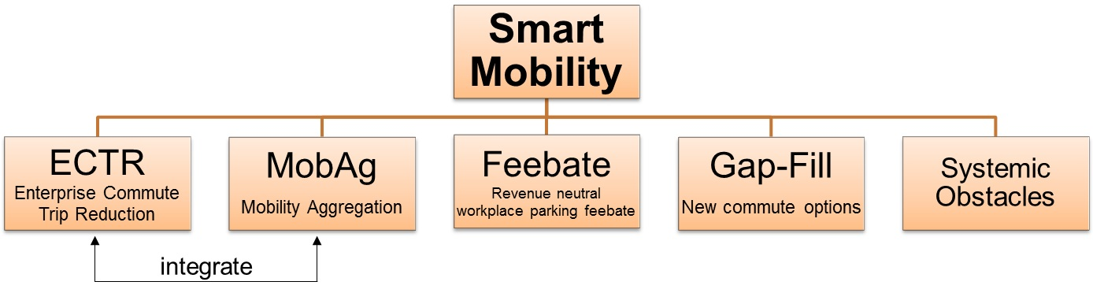Figure 3. Smart Mobility Components**[16]**

This MaaS deployment directly addresses one of the biggest challenges, which is developing MaaS for suburban and rural areas. Silicon Valley is primarily a suburban area and is auto-centric.

One of the most innovative aspects of Smart Mobility is providing monetary incentives to employees who use non-SOV modes to work. As shown in Figure 4, (an example from Seattle Children’s Hospital) an employee will receive a “feebate” when they use alternate modes to get to work.

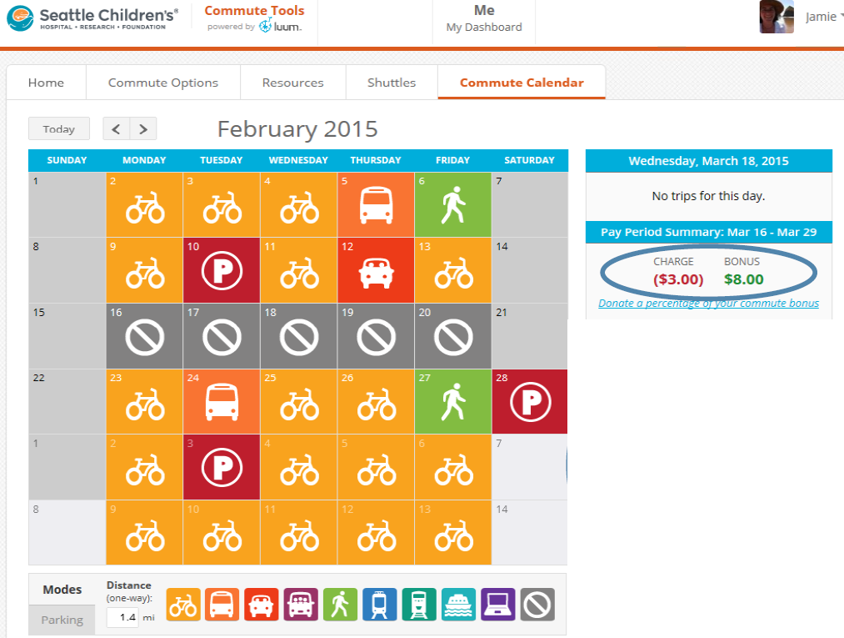

Figure 4. Example of Commuter “Feebate” in MaaS Scheme

**MaaS as Customer Service Integrator - Ithaca, NY**

Dwight Mengel, Chief Transportation Planner at the Tompkins County Department of Social Services in Ithaca, NY, has developed a MaaS concept that specifically addresses rural and small urban areas as well as transportation-disadvantaged individuals. This concept’s business model has the following value propositions and characteristics[17]:

* Consumer education about mobility
* Individual mobility solutions and accounts
* Discounts and public support
* Clearinghouse for financial transactions
* Concierge service (24/7) to resolve complaints
* Guaranteed Ride to work and home
* Local businesses co-marketing and discounts
* Member-based organization
* Tools for inbound marketing and applications.

A sample “menu” of MaaS services and example pricing in this MaaS scheme is shown in Table 1. Tables 2 and 3 show examples of MaaS costs for a small urban and rural area, respectively.

**Table 1. Sample Mobility Menu**

| **Mobility Menu** | **Unit Cost** | **Unit** |
| --- | --- | --- |
| Annual Adult Bus Pass | $450 | Annual |
| Annual Youth Bus Pass | $110 | Annual |
| Ithaca Carshare "It’s my car" Plan | $8 | Hour |
| Ithaca Carshare "Just in Case" Plan | $11 | Hour |
| Car Rental | $55 | Day |
| Taxi trip - City | $8 | Urban Trip |
| Taxi trip - Rural | $20 | Rural Trip |
| Bicycle Maintenance | $50 | Voucher |
| Electric Bike Purchase | $2,000 | HE Bike |
| Bike Purchase | $700 | Bike |
| Rideshare Driver – Miles | $0.54 | Mile |
| Rideshare Rider – Miles | $0.15 | Mile |
| GADABOUT Paratransit | $4 | Trip |
| Vanpool Membership | $125 | Month/Seat |
| Guaranteed Ride | $30 | Annual |

**Table 2. Small City Household: 1 car, 2 adults, 1 youth, Walkscore = 96**

|  |  |
| --- | --- |
| **Small City Mobility Budget** | |
| Carshare | $900 |
| Annual Bus Passes (2) | $560 |
| Taxi | $192 |
| Bicycle Maintenance | $100 |
| Guaranteed Ride | $30 |
| Member Support | $178 |
| Annual Total | $1,960 |
|  |  |
| **Monthly Payment** | **$163** |

**Table 3. Rural Household: 1 car, 2 adults, 1 child, Walkscore = 0**

| **Rural Mobility Budget** | |
| --- | --- |
| Vanpool | $1,500 |
| Carshare | $480 |
| Taxi | $480 |
| Guaranteed Ride | $30 |
| Member Support | $146 |
| Volunteer Driver Revenue | $(400) |
| Vanpool Program Subsidy | $(600) |
| Total | $1,636 |
|  |  |
| **Monthly Payment** | **$136** |

**San Francisco Municipal Transportation Agency’s (SFMTA’s) Vision for MaaS: Access Over Ownership**

Timothy Papandreou, former Chief Innovation Officer with the Office of Innovation at SFMTA[18], has described a vision for MaaS in the near future that provides travelers with access to a menu of mobility options that meet their needs individually whether they live in an urban, suburban or rural area.[19] Currently, the Bay area has multiple modes, with little or no integration, multiple payments and multiple bookings. The modes are privately-owned vehicles, public transit, regional and intercity services, air, shared fleet vehicles, employer shuttles, jitneys, commercial deliveries, taxis, limousine and transportation network companies (TNCs).

The SFMTA vision for MaaS includes a focus on the customer experience by providing one application that includes integrated routing, booking, payments, credits/offsets and games/value add. Using this application, a traveler provides a destination, and the application returns all available options along with the amount of time it will take to get to the destination and each option’s cost. Once you make a selection, the application provides the opportunity to reserve and pay for the trip, and provides the routing. The MaaS vision is to purchase a package of “Mobility Minutes” for local, regional, national and international travel. For example, $150 “My City” Plan (for example, on a monthly basis) includes 1,000 city minutes divided into 100 Rideshare minutes, 100 Carshare minutes, 400 Transit minutes and 400 Bikeshare minutes. The plan would also include walking credits and the ability to share minutes. Another example is $500 “My Travel” Plan, which includes 300 Flying minutes and 700 City minutes.

1. http://maas-alliance.eu/
2. http://eutravel.eu/Conference/wp-content/uploads/2016/10/INLECOM_EUTRAVEL.pdf
3. Elizabeth Ellis, Mobility Management, prepared for AARP Public Policy Institute, October 2009, © 2009, p. 1, http://assets.aarp.org/rgcenter/ppi/liv-com/roundtable_091013_mobility.pdf
4. Ibid, pp. 1-2
5. Carlin, Kelly, Bodhi Rader, and Greg Rucks. Interoperable Transit Data: Enabling a Shift to Mobility as a Service. Rocky Mountain Institute, October 2015, <http://www.rmi.org/mobility_ITD>
6. Timothy Papandreou, former Director, Office of Innovation at San Francisco Municipal Transportation Agency, “The (Likely) future of Urban Mobility: Key trends, issues and opportunities for cities,” LinkedIn post, August 25, 2015, <http://www.racfoundation.org/research/mobility/380610>
7. The Planning Report: Insider’s Guide to Planning & Infrastructure, October 31, 2016 “’Mobility as a Service’ Central to LADOT’s New Urban Mobility Vision, October 2016 Issue, http://www.planningreport.com/2016/10/31/mobility-service-central-ladot-s-new-urban-mobility-vision
8. Greg Lindsay, Senior Fellow, New Cities Foundation, “Now Arriving: A Connected Mobility Roadmap for Public Transport,” October 2016, <http://bit.ly/NCFConnectedMobility>, page 6
9. Ibid, page 59.
10. “Age-Friendly Transportation Domain: Report and Recommendations,” May 2016, <http://www.tccoordinatedplan.org/uploads/3/1/4/7/3147084/age-friendlytransportation_report_6-2-16.docx>, page 3
11. Ibid, pages 3-4
12. Ibid, page 6
13. Beth Garner, “Preparing for the Future of Transport – Mobility as a Service,” presentation at Smart Ticketing & Payments 2016 conference, London, UK, November 23, 2016, page 6
14. Steve Raney, Executive Director, Smart Mobility, Joint Venture Silicon Valley, “Silicon Valley Mobility as a Service (MaaS): Software EcoSystem Acceleration,” May 12, 2015
15. Steve Raney, “THE CONCEPT: Reduce Bay Area commuting VMT/GHG by 25% via Fair Value Commuting,” February 22, 2016, <http://bit.ly/1T1QcDm>
16. <http://www.jointventure.org/mobility-as-a-service>
17. Dwight Mengel, “Mobility as a Service (MaaS): Ithaca, NY vs. Vienna,” presentation to Community Transportation Association of America (CTAA) EXPO 2016, Portland, OR, May 22-27, 2016
18. Currently at Waymo
19. <http://innovativemobility.org/wp-content/uploads/2015/02/Timothy-Papandreou-Access-Trumps-Ownership.pdf>

    **About the Author**

    **Carol Schweiger**, President of Schweiger Consulting, has over 36 years of experience and is

    nationally and internationally recognized in transportation technology consulting. Her wide

    ranging and in-depth expertise is in several specialty areas including systems engineering,

    technology strategies for public agencies, public transit technology, and traveler information

    strategies and systems. Ms. Schweiger has provided nearly 50 transportation agencies with

    technology technical assistance, including developing and applying structured processes to

    procure and implement technology systems; providing detailed procurement and

    implementation assistance; evaluating technology deployments; conducting research and

    delivering training.