EVERY RIDE COUNTS is a comprehensive publicity campaign of the National Aging and Disability Transportation Center (NADTC). The goal of the campaign is to promote the availability and accessibility of transportation options for older adults, people with disabilities and caregivers in communities around the country. The campaign is comprised of carefully crafted messages and materials that promote the use of varied transportation options by older adults and people with disabilities in your community.

EVERY RIDE COUNTS is a campaign for your community. NADTC is making these materials available to transportation agencies around the country with the hope that they will be used to make older adults, people with disabilities and their caregivers aware of how, with just a bit of planning, local transportation options can help them get where they want and need to go.

The campaign consists of postcards, flyers and social media images that can be customized with local contact information.

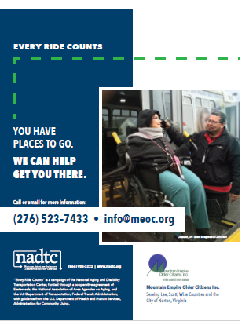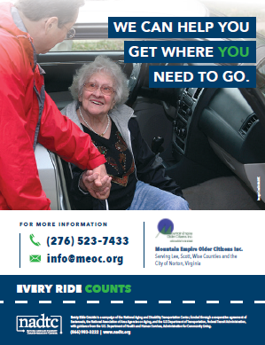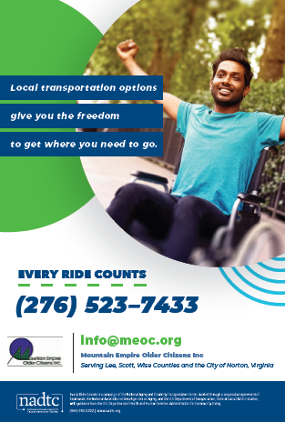

Learn more at www.nadtc.org/EveryRideCounts

