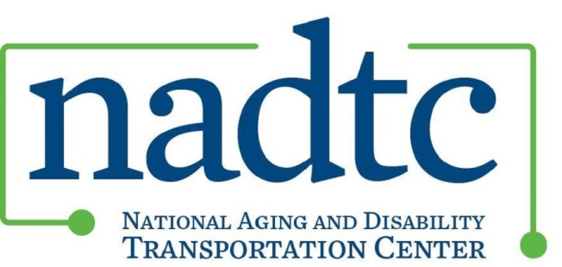

National Aging and Disability Transportation Center:
Innovations in Accessible Mobility Grant Program
Awarded: January 1, 2017

NADTC’s premier group of six Innovations in Accessible Mobility Grants launched in January 2017. Over the course of twelve months, each project will develop and implement a program innovation to increase accessible transportation options for older adults and people with disabilities living in the community. The projects will also seek to maximize the utilization of Section 5310 and other federal funding investments. Grants of up to $50,000 were awarded.
NADTC defines innovation as the development and implementation of: new services; new approaches to service delivery or program oversight; new solutions to longstanding problems; new technological applications to enhance accessibility; new solutions to address old challenges. Innovations may be intended to provide better solutions to meet new requirements or respond more effectively to previously unarticulated needs.
Together, the six NADTC grantees are implementing a variety of innovative approaches, including:
- Using technology, one call centers, and mobility navigators to improve scheduling, communication with drivers and riders, improve service delivery and increase regional coordination;
- Using volunteer Transportation Aides to accompany older adults and people with disabilities who need addition assistance during their ride;
- Combining transportation and nutrition services to promote health and socialization;
- Creating individual, group and peer-to-peer travel training curriculum to educate and empower individuals to travel independently;
- Increasing coordination by incorporating partnerships among aging, disability, transportation, and the entity responsible for the Section 5310 coordinated transit-human services plan;
- Increased understanding of, and support for, accessible transportation in the grantee community by including older adults and people with disabilities in the decision making process.

Any questions on NADTC’s Innovations in Accessible Mobility Grant can be directed to Eileen Miller, emiller@n4a.org and Julie Dupree, jdupree@easterseals.com.
2017 NADTC Grant Innovations

Area Agency on Aging 1-B
Location: Southfield, MI Project Service Area: Oakland, Macomb and western Wayne Counties
Population Served: Older adults and people with disabilities
Contact: Roberta Habowski, Mobility Project Manager, rhabowski@aaa1b.com
- Develop and implement travel training as an adjunct to myride2 (which currently offers a one-call service and mobility management) for older adults and people with disabilities.
- Utilize group, individual and peer-to-peer travel training approaches.
- Evaluate the impact of the different training approaches on travel behavior.

This project will:

Berkshire Regional Planning Commission
Location: Pittsfield, MA Project Service Area: Berkshire County
Population Served: Older adults and people with disabilities seeking medical visits and residing in a Berkshire County municipality currently without transportation services.
Contact: Laura Kittross, Manager, Public Health Program, lkittross@berkshireplanning.org
- Provide reimbursable medical trips across jurisdictional lines for pre-arranged medical appointments.
- Coordinate rides and reimbursement with transportation providers from Councils on Aging and other social service agencies to serve more remote areas.
- Develop and implement a centralized scheduling hub and electronic “real time” reporting of trips to ensure efficiency.
This project will:

City of Hernando
Location: Hernando, MS Project Service Area: DeSoto County
Population Served: Older adults and people with disabilities
Contact: Gia Matheny, Community Development Director, gmatheny@cityofhernando.org
- Create and implement a unique new travel model for older adults that promotes regional coordination and partnerships to enhance travel options throughout the City of Hernando.
- Add weekend bus service to connect older adults to the local farmer’s market and increase their social engagement.
- Develop new partnerships to yield lasting mobility improvements.
This project will:

Mountain Empire Older Citizens
Location: Big Stone Gap, VA Project Service Area: Lee, Wise, Scott Counties, and the City of Norton
Population Served: Older adults and people with disabilities, specifically individuals with chronic care conditions and dialysis needs.
Contact: Mitch Elliott, Transit Director, melliot@meoc.org
- Provide same-day, on-time specialized transportation services to individuals with chronic care needs and dialysis patients.
- Offer specialized assistance by a Care Coordinator to ensure transportation needs are met as an adjunct to an existing one call center.
- Recruit and train Volunteer Transportation Aids to educate riders on how to use the transit system and provide additional passenger assistance when needed.
This project will:

Peace Village Cancer Project/Cancer Justice Network
Location: Cincinnati, OH Project Service Area: Cincinnati Region
Population Served: Older adults, people with disabilities, and low-income residents of the greater Cincinnati region seeking transportation to cancer screening and treatment services.
Contact: Steve Sunderland, PhD, Director, steve.c.sunderland@icloud.com
- Create a Transportation Navigator program as an adjunct to its current Cancer Navigation Program.
- Develop and implement a central scheduling and coordination hub to increase awareness and access to transportation services.
- Utilize Medicaid-funded bus passes to enable low income individuals to get to cancer prevention, screening and treatment services.
This project will:

Senior Transportation Connection
Location: Cleveland/North Olmsted, OH Project Service Area: North Olmstead
Population Served: Older adults and people with disabilities
Contact: Janice Dzigiel, Executive Director, jdzigiel@ridestc.org
- Create evening and weekend transportation services and options to adults age 60+ and adults with disabilities.
- Create service options and opportunities to access social, worship, and recreation activities through the development of a premium service options program, STC Plus.
- Engage the community and stakeholders in sustaining STC Plus innovations.

This project will:
For more information on the NADTC Grants, visit www.nadtc.org.

For more information on the NADTC Grants, visit http://www.nadtc.org/grants-funding/.

