Half Fare or Reduced Fare Requirements

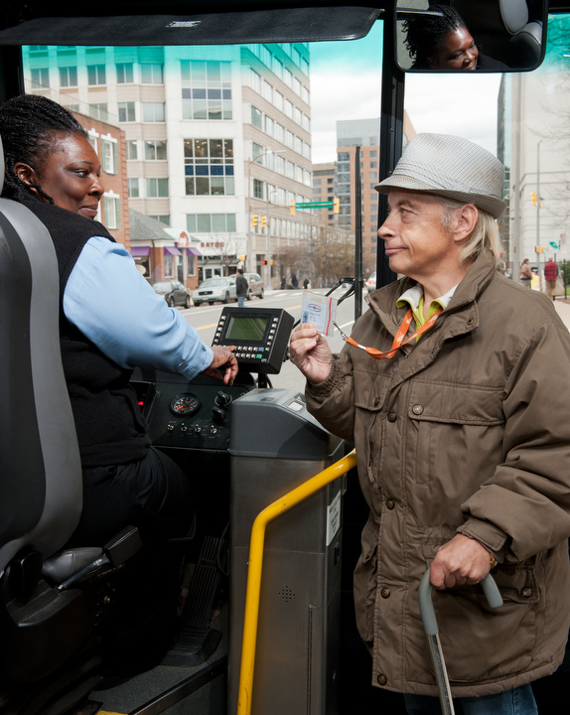
Public transportation law requires public transportation agencies that receive Federal Transit Administration (FTA) funding under the Section 5307 Urbanized Area Formula Program to offer half fare or reduced fare to people with disabilities and seniors during off-peak hours for fixed-route services. This requirement is not associated with the Americans with Disabilities Act (ADA) and only applies to specific transit operators and routes. Many transit agencies identify their “half fare policy” as a “reduced fare policy.” The important consideration is that the half fare basic requirement is effectively being met when the policy is implemented.

Half Fare Basic Requirement: During nonpeak hours, transit agencies may not charge seniors, persons with disabilities, or an individual presenting a Medicare card, more than half of the peak hour fare.

Half fare requirements apply to:
- Fixed-route (e.g., bus, rail and passenger ferry) services that operate during peak and non-peak hours using facilities or equipment financed with Section 5307 funds.
- Commuter and express services that operate beyond peak hours.
- Any grantee, sub-recipients, contractors and any other entity that leases or uses the facilities or equipment of the grantee.
- Fixed-route services that operate with reduced fares in both peak and nonpeak hours. For example, if transit offers reduced promotional fares to attract ridership on specific routes, the half fare requirement must be met if the fare reduction is less than half fare.

Half fare requirements do not apply to:
- Demand responsive services, including ADA paratransit.
- Service that does not receive Section 5307 funds for equipment or facilities.
- Service operating only during non-peak hours such as shopping shuttles, midday shuttles, or circulators.

Important Considerations
From the Urbanized Area Formula Program (5307) Circular FTA C 9030.1E, p. VI-4

Fares Charged to Seniors and Persons with Disabilities During Nonpeak Hours:
According to 49 U.S.C. 5307(c)(1)(D), a recipient must certify that the fares charged to seniors, individuals with disabilities, or individuals presenting a Medicare card during nonpeak hours, for transportation using or involving a facility or equipment of a project financed under this section, are not more than 50 percent of the peak hour fare, regardless of whether the service is provided by the recipient or by another entity under contract, lease, or other arrangement.

How are “peak hours” determined?
To determine peak hours, transit agencies may analyze passenger counts to determine peak periods. In general, peak periods coincide with morning and evening commute times. If a transit agency does not define peak and off peak service, all service will be deemed as “off peak” and half fares are offered to people with disabilities and seniors at all times. “Off peak hour service” is defined locally. Generally, it is the service hours during periods of the day when traffic congestion and ridership is lower, and less transit service is scheduled. It is sometimes called “non-rush hour service.”

How is proof of eligibility determined when boarding a vehicle?
Most transit agencies issue a special identification card for passengers who are eligible for half or reduced fare. Individuals usually need to apply for these ID cards before receiving eligibility for half fare programs. Whether or not a transit agency issues its own ID cards, a Medicare card must be accepted as an ID at time of boarding.
Transit agencies may request Medicare card holders provide a photo ID to ensure the person is entitled to the half fare.

Who are seniors?
FTA regulations require that the definition of senior "at a minimum, include all persons 65 years of age or over." As a local policy, grantees are permitted to use a definition that applies this half fare to younger customers such as people 60 years of age and older.

Who are persons with disabilities?
The FTA definition of a person with a disability applies to this requirement: "any individual who, by reason of illness, injury, age, congenital malfunction or other permanent or temporary incapacity of disability, is unable without special facilities or special planning or design to utilize mass transportation facilities and services as effectively as persons who are not so affected." However, transit agencies may choose to offer half fare rates to all passengers with disabilities as this Section 5307 definition is narrower than the ADA. The Appendix to 49 CFR part 609 provides additional guidance on eligibility for half fare.

A reduced fare policy for additional groups of riders such as children, students, active duty military members, or military veterans is a local policy decision.

Does the requirement apply to visitors?
Customers can contact the transit agency in the city to be visited ahead of time to inquire about half-fare ID requirements. Some agencies will honor an out of town fare discount identification card while other agencies will provide a temporary fare discount card for the customer to use while visiting.

Who is a Medicare Card holder?
Medicare card holders are eligible by showing their Medicare card. Medicare is available for people age 65 or older or people with disabilities. Transit agencies cannot require additional eligibility requirements for Medicare cardholders to receive the half fare; however, it is reasonable for a transit agency to request an applicant to validate Medicare status for half fare application to show a picture ID card. This is a local policy decision.

Please note: A Medicare Beneficiary Identifier (MBI) will replace the SSN-based Health Insurance Claim Number (HICN) on the new Medicare cards. New card phase-in starts in April 2018. Information on these changes can be found through the Centers for Medicare & Medicaid Services at https://www.cms.gov/Medicare/New-Medicare-Card/index.html. Transit policy and descriptions of Medicare cards may need revision to reflect these changes.
What about Medicaid cards?
There is often confusion between “Medicare” and “Medicaid.” Medicaid is a program that assists with medical costs for eligible people with limited income or disabilities and is operated by a state. Medicare is the federal health insurance program for people age 65 or older, certain younger people with disabilities, and people with End-Stage Renal Disease (permanent kidney failure requiring dialysis or a transplant). Medicaid card holders must apply for eligibility for reduced fare through the regular process. Some people are eligible for both Medicare and Medicaid and can be eligible for reduced fare as Medicare card holders.

Are ID cards required to contain a photograph of an eligible applicant?
Photographs are not required, but many transit agencies find that they help drivers to identify riders eligible for the half fare. This is a common practice to ensure discounts are applied to the correct person and to reduce fraud.

Can transit agencies charge fees for the ID cards?
Producing laminated ID cards and cards with a photograph is an added expense. A fee for creating a reduced fare ID card and replacement are allowed but not required. Typical fees are between $2 and $5. Reasonable fees may also be charged for lost or replacement cards.

Card Application Process
A simple application form with verification for age or disability is recommended.
Submission and communication of applications can be in writing on paper, electronic (online), in-person, or by telephone. Transit agencies must advertise and promote the availability of the reduced fare program and explain the application process on websites and in print material. Outreach to people with disabilities and seniors is encouraged. Card applications and information on reduced fare must be available in alternative formats such as large print, braille, audio recordings, or electronically in a format preferred by an applicant. The application process must also allow for qualified interpreters, video relay such as 711, or another auxiliary aid or service to assist an applicant, when needed.

Application Submission Location(s)
Transit agencies must ensure that the physical location for obtaining reduced fare ID cards is physically accessible and accessible by public transit. The ID cards must be easy for the eligible rider to obtain, and materials and staff must be available to assist customers. Hours when the facility is open or available to serve applicants must be advertised.

Training
The transit agency is responsible to train staff on the half fare program requirements, the eligibility criteria, and the application process. Transit personnel and operators must be knowledgeable about the half fare program and requirements and assist riders who request information.

REFERENCES
- 49 USC Chapter 53, Federal Transit Laws
- 49 CFR Part 609, “Transportation for Elderly and Handicapped Persons.” https://www.gpo.gov/fdsys/pkg/CFR-2005-title49-vol7/pdf/CFR-2005-title49-vol7-part609.pdf
- Appendix A to Part 609—ELDERLY AND HANDICAPPED. https://www.gpo.gov/fdsys/pkg/CFR-2005-title49-vol7/pdf/CFR-2005-title49-vol7-part609-appA.pdf
- FTA Circular 9030.1E, “Urbanized Area Formula Program: Program Guidance and Application Instructions.” https://www.transit.dot.gov/regulations-and-guidance/fta-circulars/urbanized-area-formula-program-program-guidance-and.

This Half Fare Information Brief was co-authored by Tara N. Clark, Program Manager, Federal Transit Administration Office of Program Management.

Publication Date: February 2018

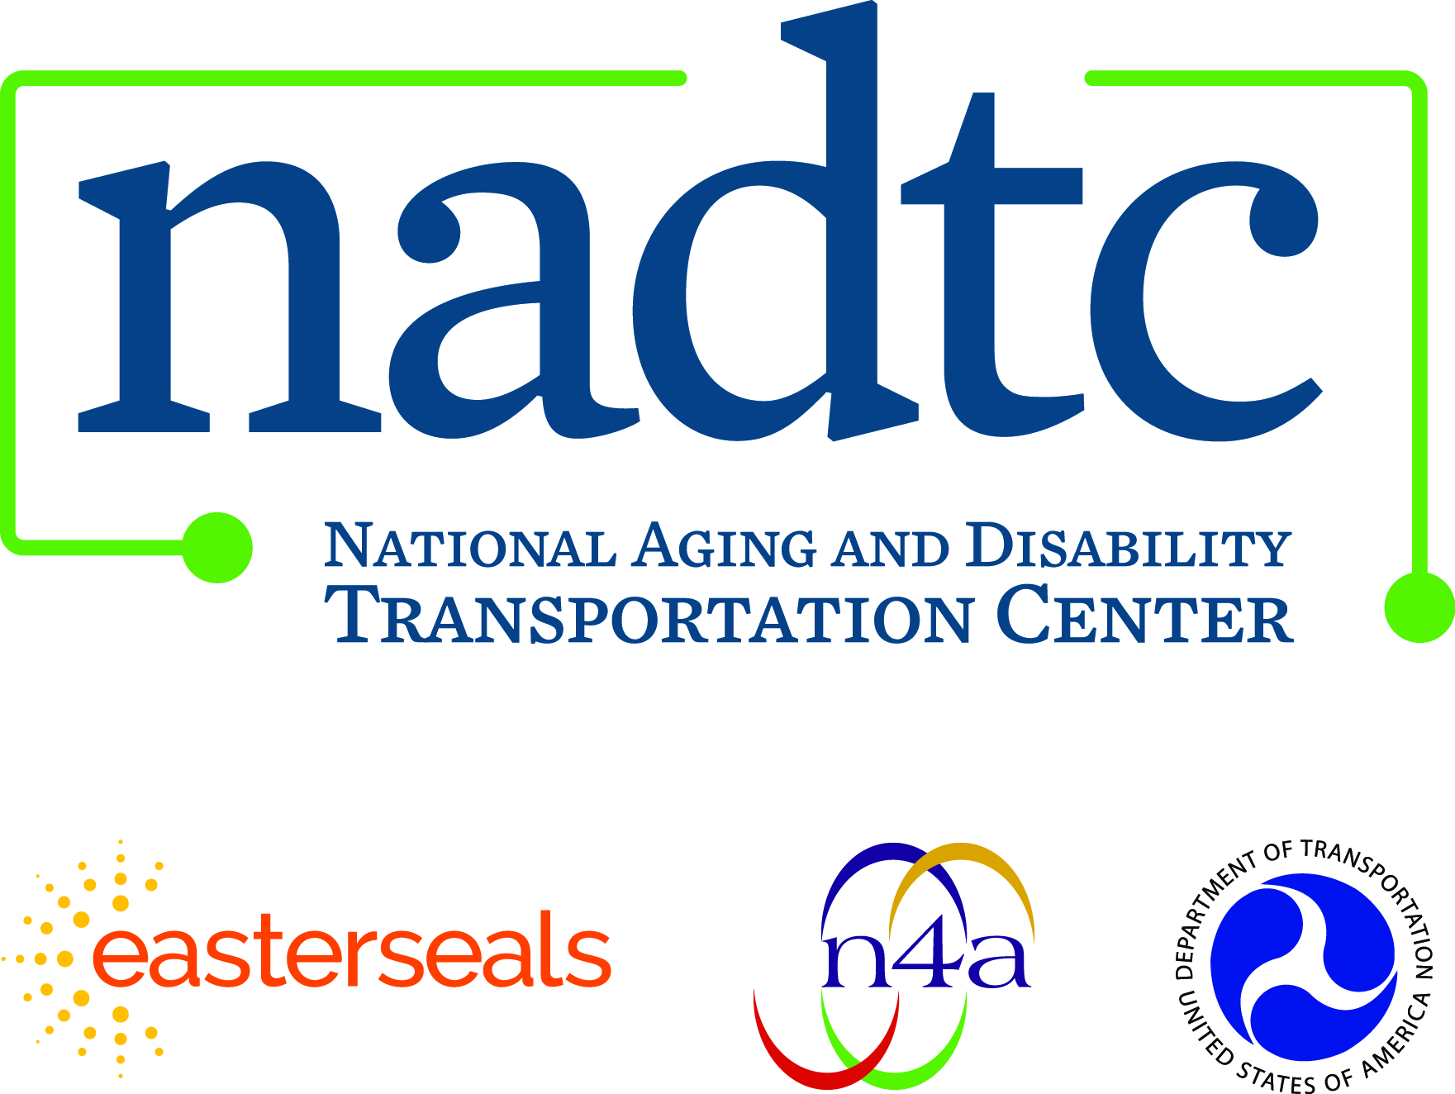

Call toll-free: 866.983.3222
Email: contact@nadtc.org
Web: www.nadtc.org

Find us on Facebook, Twitter, YouTube & LinkedIn!

Who We Are

Established in 2015, the NADTC is a federally funded technical assistance center administered by Easterseals and the National Association of Area Agencies on Aging based in Washington, D.C.

The National Aging and Disability Transportation Center is a program funded by the Federal Transit and administered by Easterseals and the National Association of Area Agencies on Aging (n4a) with guidance from the U.S Department of Health and Human Services, Administration for Community Living.

The National Association of Area Agencies on Aging (n4a) is a 501c(3) membership association representing America’s national network of 622 Area Agencies on Aging (AAAs) and providing a voice in the nation’s capital for the 256 Title VI Native American aging programs. The mission of n4a is to build the capacity of its members so they can better help older adults and people with disabilities live with dignity and choices in their homes and communities for as long as possible. www.n4a.org

Easterseals is the leading non-profit provider of services for individuals with autism, developmental disabilities, physical disabilities and other special needs. For nearly 100 years, we have been offering help, hope, and answers to children and adults living with disabilities, and to the families who love them. Through therapy, training, education and support services, Easterseals creates life-changing solutions so that people with disabilities can live, learn, work and play. www.easterseals.com

