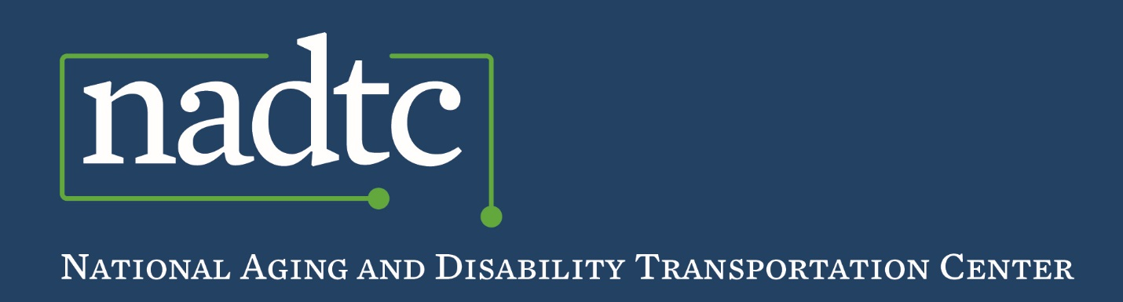

*Best Practice*

**Rural Transportation Best Practice:**

***Transportation for Individuals with Chronic Care Conditions***

**Mountain Empire Older Citizens (MEOC)** in Big Stone Gap, VA is adesignated Area Agency on Aging and serves as the public transit provider for the area.

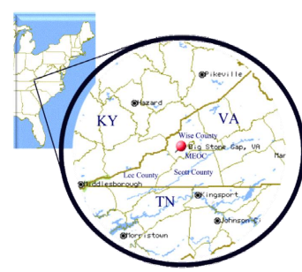**Service Area:** MEOC serves the Virginia counties of Lee, Scott, Wise and the city of Norton. It is comprised of 1,389 square miles and is uniformly rural, with small towns and unincorporated places separated by mountain ranges.

**Population:** Approximately 92,925 people live in MEOC’s service area. 30% of this population is over the age of 55 and 16% are over the age of 65. 10% of the population has a disability and 13% live below the poverty rate.

*When compared with the overall population of Virginia, people living in MEOC’s service area are more likely to be isolated, poor, living on social security, and medically underserved. They are much more likely to suffer from significant health ailments such as heart disease, chronic lung disease, diabetes or kidney disease*.

**How the Program Works**

MEOC is a provider of **demand-response public transportation**. The service does not follow a fixed route and ride requests must be made in advance of the trip. MEOC uses an innovative approach to providing **transportation assistance**, specifically aimed at the needs of older adults, people with disabilities, and veterans for chronic disease health appointments (dialysis, chemotherapy, etc.).

* **Transportation Assistance** isdesigned to provide more assistance than is typically available through traditional curb-to-curb service and includes:

MEOC uses both paid and volunteer **transportation aides** to provide transportation assistance. Aides educate riders on how to use the transit system and provide additional passenger assistance when needed. Volunteer transportation aides have recently been recruited and trained to expand the service. MEOC recruits volunteers from the community, but has had particular success in recruiting student volunteers from local college nursing and medical training programs, who find these real life volunteer experiences valuable as a supplement to their classroom instruction. Many of the riders are patients at local dialysis and chemotherapy centers. These on-board aides can offer assistance when requested and also provide assistance for the rider to exit the bus and enter their home.

* + **Door-to-door assistance**: passengers are helped to enter and exit the vehicle and the driver or transportation aid may walk with passengers to the front door of their residence or destination.
  + **Door-through-door assistance:** passengers are helped from the vehicle through the door of their residence or destination. The drivers or transportation aid may assist with opening doors, provide verbal guidance, stay with the passenger once on-board the vehicle and assist passengers at the destination.
  + **On-board assistance** is provided by paid or volunteer transportation aides who may assist the passenger to get settled on the ride, carry packages and stay by the passenger’s side in case any unplanned needs arise.
* MEOC also expanded its existing **one-call center**[1] to provide targeted assistance to individuals with chronic care needs. A one-call center helps customers obtain rides they need for daily activity or for occasional appointments by simplifying access for customers and matching their varied needs with appropriate options through the use of a single telephone number. The new service is staffed by a community care coordinator who can arrange rides to medical appointments and also make referrals to other social services offered by MEOC that might be needed by the rider (e.g., home delivered meals, additional in-home assistance, etc). Riders can request door-to-door, door-through-door, and on-board transportation assistance through this system.

These activities are part of a larger ongoing effort employed by MEOC to continually improve services based on community needs. The agency frequently holds community forums to gather input and feedback on local transit services from riders. Community members are asked to serve on MEOC Transportation Advisory Committee to provide insight from the perspective of older adults and people with disabilities. Mountain Empire Older Citizens is committed to offering responsive, reliable and accessible transportation to meet the needs of all residents of the area.

**For additional information, contact:** Mitchell Elliott, Transit Director, Mountain Empire Older Citizens. Email: [melliot@meoc.org](mailto:melliot@meoc.org). **Agency Website:** [www.meoc.org](http://www.meoc.org)

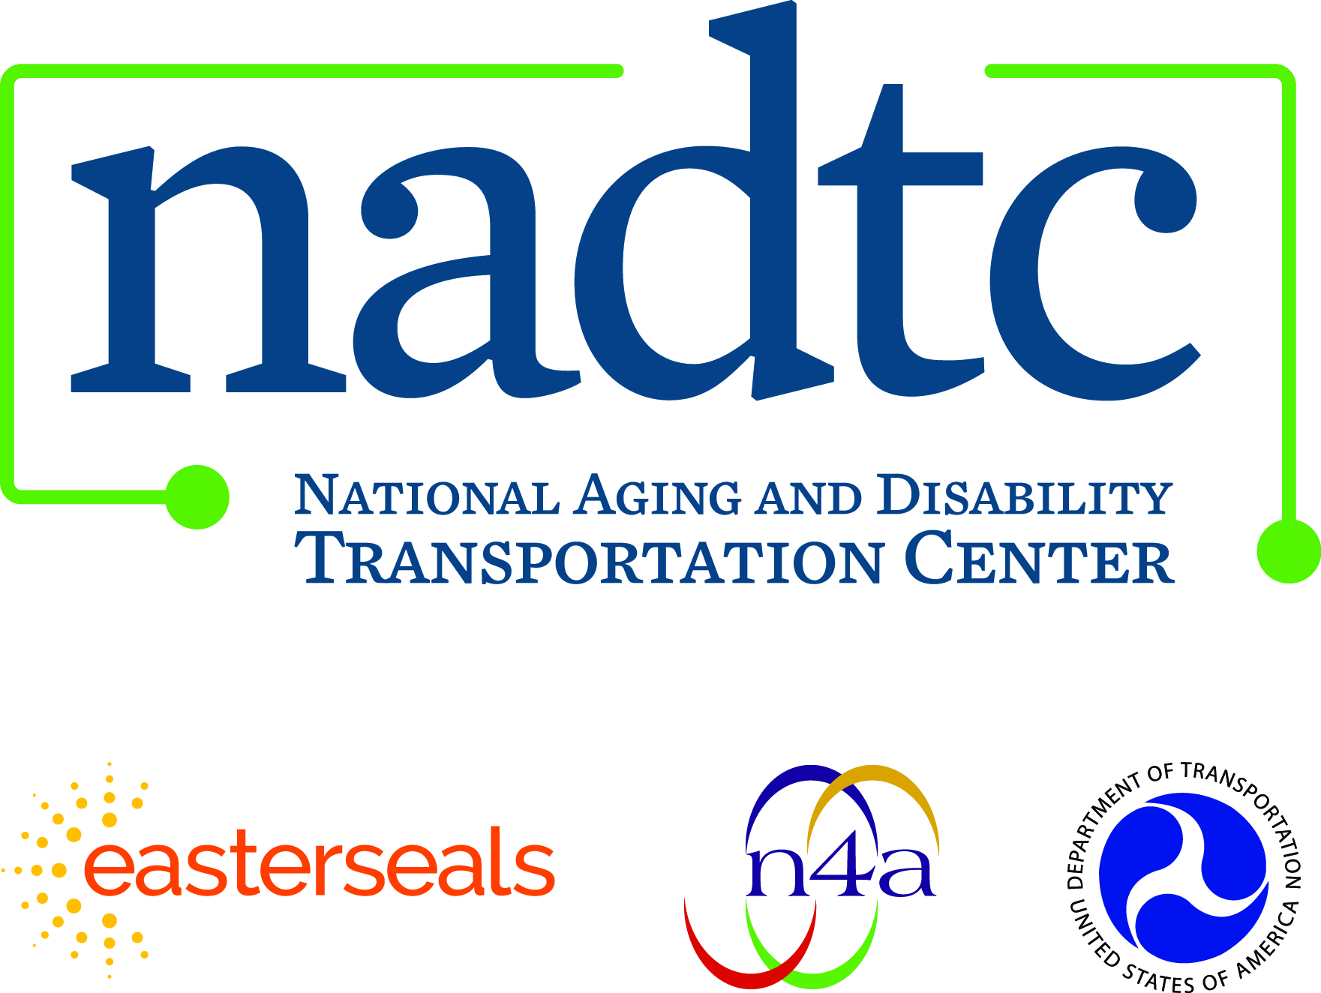

**Call toll-free:** 866.983.3222

**Email:** contact@nadtc.org

**Web:** [www.nadtc.org](http://www.nadtc.org)

**Find us** on Facebook, Twitter, YouTube & LinkedIn!





**Who We Are**

The **National Aging and Disability Transportation Center** is funded through a cooperative agreement of Easterseals, the National Association of Area Agencies on Aging, and the U.S Department of Transportation, Federal Transit Administration, with guidance from the U.S. Department of Health and Human Services, Administration for Community Living.

The **National Association of Area Agencies on Aging (n4a)** is a 501c(3) membership association representing America’s national network of 622 Area Agencies on Aging (AAAs) and providing a voice in the nation’s capital for the 256 Title VI Native American aging programs. The mission of n4a is to build the capacity of its members so they can better help older adults and people with disabilities live with dignity and choices in their homes and communities for as long as possible. [**www.n4a.org**](http://www.n4a.org)

**Easterseals** is the leading non-profit provider of services for individuals with autism, developmental disabilities, physical disabilities and other special needs. For nearly 100 years, we have been offering help, hope, and answers to children and adults living with disabilities, and to the families who love them. Through therapy, training, education and support services, Easterseals creates life-changing solutions so that people with disabilities can live, learn, work and play. **[www.easterseals.com](http://www.easterseals.com/)**

1. This program was developed in 2017 with grant funding from NADTC.