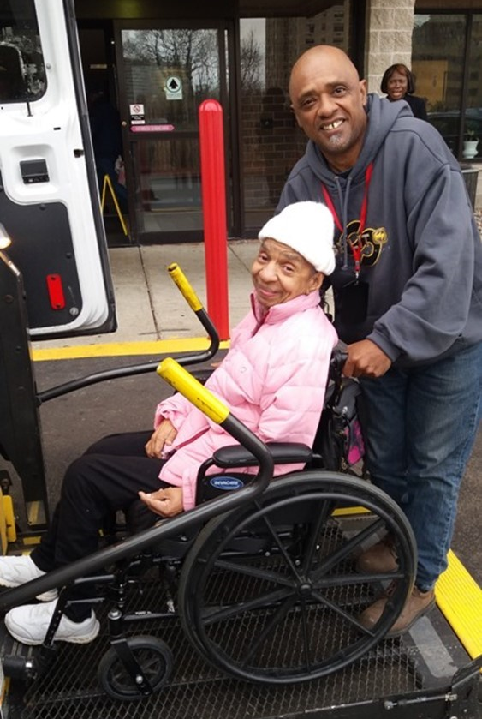
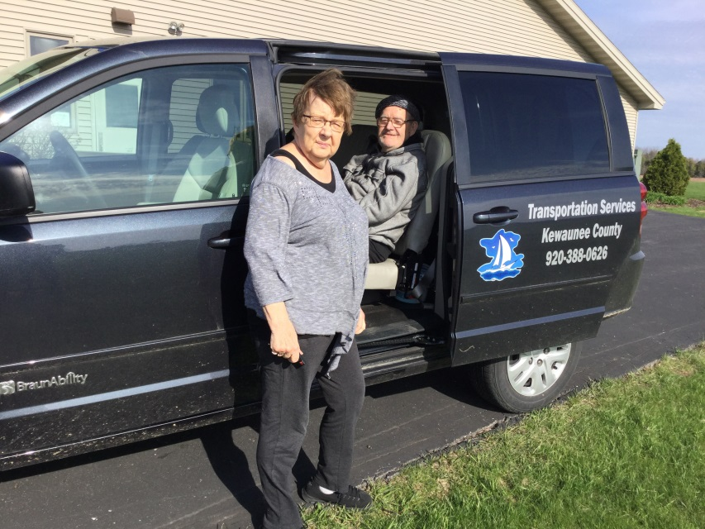
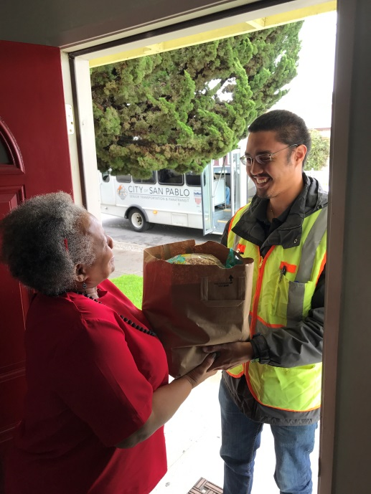
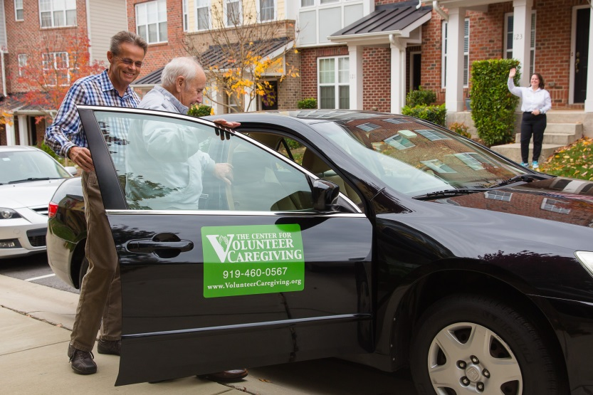

Cover Photo Credits
Top left: 8330 On the River/Poah Communities, Detroit, Michigan
Top right: Kewaunee County Services, Kewaunee, Wisconsin
Bottom left: The Center for Volunteer Caregiving, Cary, North Carolina
Bottom right: Wallingford Committee on Aging, Inc., Wallingford, Connecticut
Bottom right:

Introduction

The National Aging and Disability Transportation Center (NADTC) is pleased to present this Trends Report Topic Spotlight on Connected Vehicle Technology. Self-driving vehicles can be of great value and open up a new world for people with disabilities and older adults. Mitigating transportation obstacles for individuals with disabilities would enable new employment opportunities and save money in healthcare expenditures from missed medical appointments.
The Trends Report is divided into stand-alone information briefs that explore significant issues that affect the availability of accessible transportation in communities. Each brief includes case studies on how changes in transportation are being implemented in communities in the U.S., from large cities like Denver, to small towns on the Eastern Shore of Maryland.
2017’s information briefs address:
- Americans with Disabilities Act No-Shows and Cancellations
- Americans with Disabilities Act Complaint Process
- Connected Vehicle Technology
- Real-Time Transit Technology
- Rural Travel Training
- Seamless Mobility
While the ADA can hardly be considered a “trending topic”, NADTC regularly receives questions about how to implement ADA requirements. No-shows, cancellations, and the complaint process are topics frequently addressed by our technical assistance specialists. The technology and mobility briefs take a look at how the rapidly evolving world of technology is affecting safety, service efficiency, and customer information. Finally, the rural travel training brief gets back to basics with information on how small transportation systems with limited resources can make a difference through passenger instruction and peer-mentoring.
If you have questions about any Topic Spotlight or have a story to share from your community, reach out to us at (866) 983-3222 or email contact@nadtc.org.

Connected Vehicle Technology

Introduction

Self-driving vehicles can be of great value and open up a new world for people with disabilities and older adults. Autonomous vehicles began with Google’s Self-Driving Car project, now called Waymo, which is an initiative to enhance mobility for all while providing safe, efficient, and affordable transportation. Although, vehicles are becoming more and more “smart” today with enhanced safety features, imagine the freedom to be able to simply get into a vehicle that’s friendly for passengers with disabilities, program your route in a car that has been retrofitted to meet your personal challenges, and sit back and relax while the vehicle does the driving for you. Mitigating transportation obstacles for individuals with disabilities would enable new employment opportunities and save money in healthcare expenditures from missed medical appointments. This is in the context of the anticipated broader impacts of autonomous vehicles according to the Ruderman White Paper Self-Driving Cars and the Impact on People with Disabilities.
Challenges and Opportunities
What is a self-driving or autonomous vehicle?
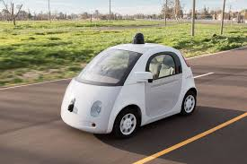
A fully autonomous vehicle is capable of sensing its environment and navigating without human input. This technology will allow cars to talk to one another (e.g., communicate whether they are accelerating, turning or braking and even tell other cars their final destination). The more cars know what other cars are doing on the road, the more they can coordinate. Ultimately, we will have safer cars that can sense traffic and highway conditions far better than any single driver. So the question is, do we focus on individual self-driving vehicles or should we put more of a focus on autonomous shuttles that can move more people? Transportation access is especially important for people with disabilities and older adults, and investment in public transportation is the alternative to the expense of retrofitting vehicles to accommodate individual needs.
What is Connected Vehicle (CV) Technology?
Many auto manufacturers are currently working on some form of shared driverless bus that has Connected Vehicle Technology. It can be argued that the Connected Vehicle technology is safer than humans driving vehicles on the road because of the sophisticated network of wireless communication among the vehicles. With connected vehicle technology, vehicles will have the capability to communicate with infrastructure, road signs and the passengers’ electronics. Many of the connected vehicles use sensors that bounce laser beams off of objects in the vicinity, such as traffic lights and pedestrians, to create a 3-D vision of the surrounding area for safety.

How will driverless vehicles communicate with roads and infrastructure such as traffic lights and pedestrians?

Autonomous vehicles will communicate with infrastructure and the road with new sophisticated technology, such as: Transit Bus Stop Pedestrian Warning which alerts transit bus drivers and pedestrians at the bus stop when the passenger is in harm’s way as the bus pulls in and out of the bus stop; Transit Signal Priority that provides traffic light signal priority to transit at the intersection; Pedestrian in Signalized Crosswalk Warning, which warns transit bus operators when pedestrians are in the intended path of an oncoming bus; and Positive Train Controls system that monitors the location and movement of the train and slows or stop the train to avoid a collision.

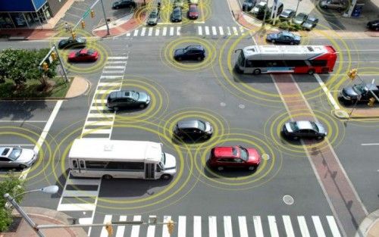
https://www.its.dot.gov/cv_basics/cv_basics_what.htm

How will driverless vehicles communicate with roads/infrastructure (e.g., traffic lights, pedestrians)?
Case examples:

Greater Cleveland Regional Transit Authority
Greater Cleveland Regional Transit Authority has six test pilot buses with connected vehicle technology. On February 10, 2015, RTA received a 2.7 million dollar grant from FTA to test two (2) programs: the Enhanced Transit Safety Retrofit Package (E-TRP) and the Transit Bus Stop Pedestrian Warning (TSPW). The E-TRP program involves using vehicle-to-infrastructure (V2I) technology to avoid collisions with pedestrians in or near intersections and crosswalks, as well as vehicle-to-vehicle (V2V) technology to warn drivers when buses are about to be cut off. The V2V technology targets vehicles that drive up along the left side of a bus, and then make a right-hand turn in front of it. As of October 4, 2016, updated information on the status of the study is not currently available.

University of Michigan in Ann Arbor tested a driverless 15-passenger shuttle service on campus in June 2017. The GPS vehicle in a geofenced setting provided transportation to students and staff from one building to another within a two mile radius while driving with regular vehicles on the road.

Navya, a French start-up that makes driverless shuttles, has demonstrated its shuttle in downtown Las Vegas during the Consumer Electronics Show in January of 2017. Their ARMA driverless and electric public transport shuttles can carry up to 15 people at a top speed of 28 miles per hour. The plan is for the shuttles to have a regular route along Fremont Street between Las Vegas Boulevard and Eighth Street.

The New York City (NYC) Connected Vehicle Pilot Deployment (CVPD) project plans to incorporate Connected Vehicle technology in taxis, buses, commercial fleet delivery trucks, city vehicles and 310 signalized intersections along major city streets. Sponsored by the U.S. Department of Transportation, this pilot project started September 1, 2016. The goal is to improve safety of travelers and pedestrians in the city.

Summary

Can driverless vehicles solve the problem of giving up the keys?

It is yet to be determined. With new independence using driverless vehicles, people with mobility-related disabilities will be able to get to work, meet up with friends, attend worship service, and keep their medical appointments and not have to depend on friends and family to get around. They can summon a driverless shuttle to take them to their destination. This is a very exciting time in transportation and the future is bright with possibilities.

Resources

U.S. Department of Transportation (DOT) Connected Vehicle Program: https://www.transportation.gov/briefing-room/us-dot-advances-deployment-connected-vehicle-technology-prevent-hundreds-thousands
National Highway and Traffic Safety Administration (NHSTA): https://www.nhtsa.gov/press-releases/us-dot-advances-deployment-connected-vehicle-technology-prevent-hundreds-thousands. https://www.nytimes.com/2014/11/09/automobiles/in-self-driving-cars-a-potential-lifeline-for-the-disabled.html?mcubz=0
Ruderman White Paper on Self-Driving Cars: http://secureenergy.org/wp-content/uploads/2017/01/Self-Driving-Cars-The-Impact-on-People-with-Disabilities_FINAL.pdf

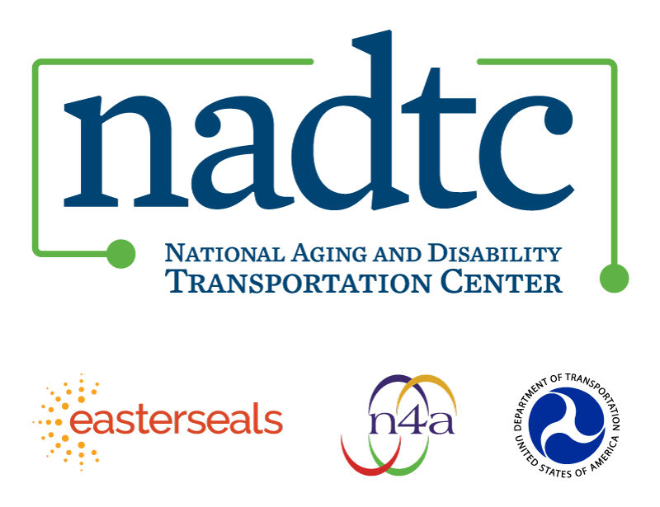

The National Aging and Disability Transportation Center is funded through a cooperative agreement of Easter Seals, the National Association of Area Agencies on Aging, and the U.S, Department of Transportation, Federal Transit Administration, with guidance from the U.S. Department of Health and Human Services, Administration for Community Living. NADTC’s mission is to increase accessible transportation options for older adults, people with disabilities and caregivers nationwide.

National Aging and Disability Transportation Center
Washington, D.C. 20005
Telephone and toll-free hotline: (866) 983-3222
TTY: (202) 347-7385
Email: contact@nadtc.org
Website: www.nadtc.org

Follow us:
Facebook
Twitter
YouTube
LinkedIn

