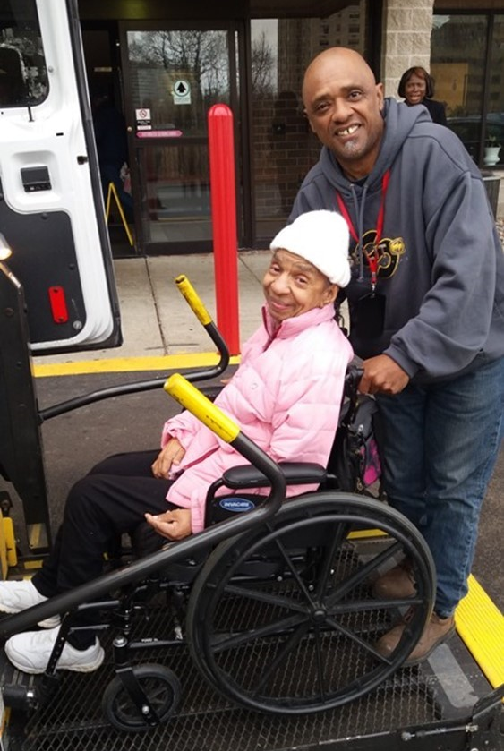
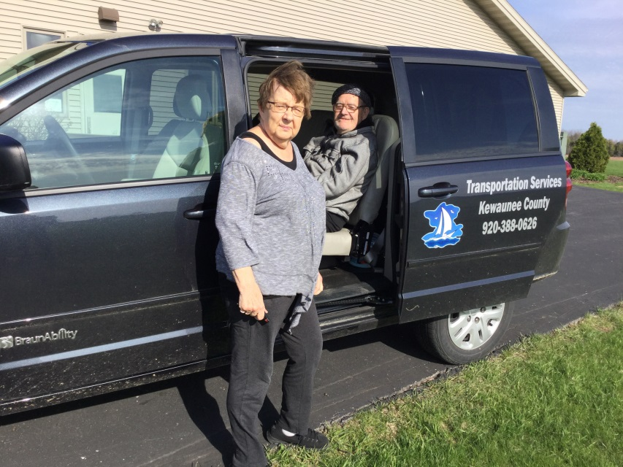
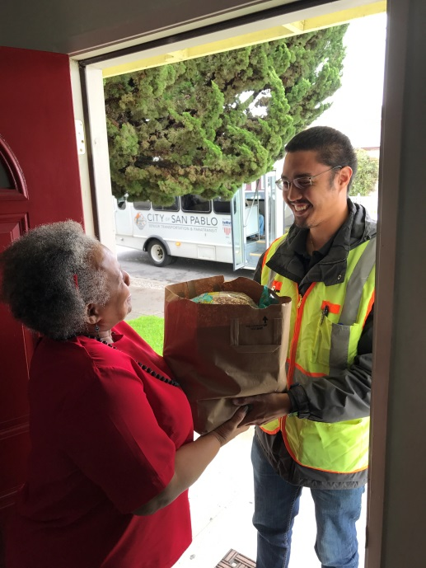
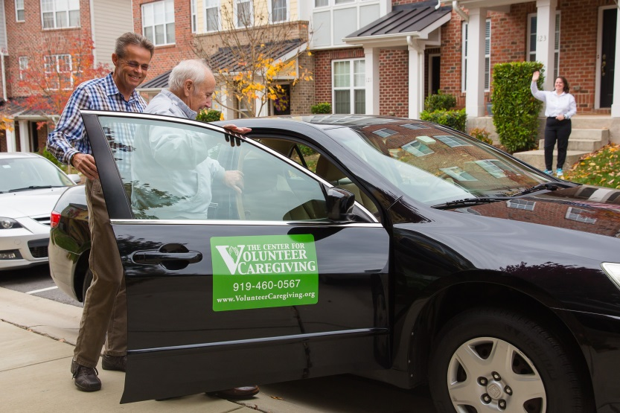

Introduction
The National Aging and Disability Transportation Center (NADTC) is pleased to present this Trends Report Topic Spotlight on Rural Travel Training.
The Trends Report is divided into stand-alone information briefs that explore significant issues that affect the availability of accessible transportation in communities. Each brief includes case studies on how changes in transportation are being implemented in communities in the U.S., from large cities like Denver, to small towns on the Eastern Shore of Maryland.
2017’s information briefs address:
- Americans with Disabilities Act No-Shows and Cancellations
- Americans with Disabilities Act Complaint Process
- Connected Vehicle Technology
- Real-Time Transit Technology
- Rural Travel Training
- Seamless Mobility
While the ADA can hardly be considered a “trending topic”, NADTC regularly receives questions about how to implement ADA requirements. No-shows, cancellations, and the complaint process are topics frequently addressed by our technical assistance specialists. The technology and mobility briefs take a look at how the rapidly evolving world of technology is affecting safety, service efficiency, and customer information. Finally, the rural travel training brief gets back to basics with information on how small transportation systems with limited resources can make a difference through passenger instruction and peer-mentoring.
If you have questions about any Topic Spotlight or have a story to share from your community, reach out to us at (866) 983-3222 or email contact@nadtc.org.

Cover Photo Credits
Top left: 8330 On the River/Poah Communities, Detroit, Michigan
Top right: Kewaunee County Services, Kewaunee, Wisconsin
Bottom left: The Center for Volunteer Caregiving, Cary, North Carolina
Bottom right: Wallingford Committee on Aging, Inc., Wallingford, Connecticut
Bottom right:

Rural Travel Training

Introduction
Travel training programs across the country help teach people the critical independent travel skills they need to travel around their communities. Each day, travel trainers in cities, suburban areas, and rural towns are teaching their trainees how to safely and independently access and ride public transportation.
Travel training in rural areas brings both unique challenges and opportunities to the professionals who currently deliver those services, or to those who are seeking to begin a new type of program. Multiple levels of travel training include orientation and scheduling, familiarization on how to ride public transit, and hands-on training in a group or one-to-one setting. Rural travel training programs are growing in popularity and successful programs have been launched across the country.
Rural Travel Training Challenges
Travel training is the act of teaching independent travel, and the goal is for participants to demonstrate travel skills on their own after the conclusion of their travel instruction. Due the nature of rural transportation services, not every rural travel training program may employ a full-time travel trainer who teaches people to use transit in real-time settings. Many rural travel training programs deliver travel training under a broader definition of transportation education, and their efforts focus on teaching people how to move about their communities regardless of their travel mode.
Rural travel training often encounters unique challenges. Travel training programs report that they experience many of the following issues as they begin or enhance travel training efforts:
- Lack of money, staff time, and other critical start-up components
- Rider recruitment and addressing the stigma around reliance on public transportation
- Limited transportation options and service availability
- Sustainability challenges for ongoing funding
- Larger service areas mean longer trips and schedule flexibility
- Physical infrastructure challenges: mountains, snow and ice, watershed, isolated areas, etc.

Opportunities
With unique challenges come unique opportunities. Travel trainers in rural areas may find themselves needing to do more with less, and, while that can be a big task, rural areas have certain benefits. In smaller towns that have an “everyone knows everyone” mentality, it can be easier to make needed connections, build partnerships, and take on new tasks, such as building transportation education efforts. In areas where gaining riders through travel training can be challenging, some of the best marketing can be done by word of mouth and utilizing current riders to spread the word about your local transit services and travel training options. Doing so can increase independence for those who need it, while simultaneously increasing ridership rates for local transportation services.
Other community programs may also see a boost from the existence of a travel training program, and the resulting transportation independence that may result as people travel to health, education, workforce, and recreational places.
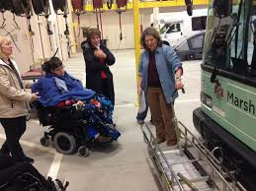
Volunteer peer-to-peer travel training remains a very popular model in many communities, as people enjoy learning from their peers in relaxed settings. Transit and human service agencies leverage their existing riders and give them training on how to be travel ambassadors.
Train-the-trainer programs also remain a popular approach to rural travel training. Existing staff may train local human and senior services agencies, who, in turn, train their own clients how to safely and independently ride local transit services.
Some communities also host annual “Transportation Days,” where the local transit service will have people come learn more about bus options available to them, practice boarding a bus and paying their fare, and more. Often times, practicing riding the bus while it is out of service can calm fears and anxieties by giving potential riders a little more time to get to know the bus and ask transit staff questions.
Levels of Rural Travel Training
There are three main levels of rural travel training:
- Transit orientation outlines the local options and services available in a given area. It may also detail topics including how to schedule a trip, preparing for a trip, and more.
- Transit familiarization demonstrates how to use a system. It typically involves a bus ride, where an overview is given on how to ride, pay your fare, and more.
- Hands-on training is training provided in a one-to-one setting repeatedly over a short time period. Training topics could include how to safely cross streets, how to board a bus using a mobility device, how to be a safe pedestrian, how to overcome anxiety and fears, and more.

Best Practices in Rural Travel Training
1. STAR Transit’s Client Advocate Program – Terrell, Texas
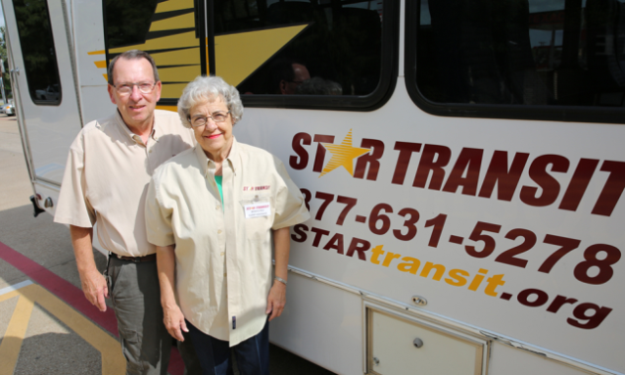
- STAR Transit is a demand response provider in rural Terrell, Texas. Their successful volunteer Client Advocate program is a peer-to-peer training model. A volunteer Client Advocate is matched with a rider in need of travel services. That volunteer is picked up first and dropped off last. He or she stays with the client who has requested a Client Advocate and helps the rider reach their destination and return home safely. In many cases, a Client Advocate will also stay with a rider during medical appointments, outpatient procedures, and other areas where care may be needed. Client Advocates support riders from the beginning to the end of their trips, teaching independent travel and safety skills along the way. This service is offered to STAR Transit riders at no additional cost, and a rider simply requests a Client Advocate when scheduling a ride.
http://www.startransit.org/star-transit/client-advocates/

2. Delmarva Community Services One Stop Travel Program – Rural Eastern Shore of Maryland
- Delmarva Community Service’s unique One-Stop Travel Program serves a large service area on Maryland’s rural Eastern Shore. Their program gives people a menu of transportation services available to them and the ability to request a Travel Trainer to assist them in learning how to utilize available services. This program looked at who was already providing educational services to people with disabilities and older adults, and those leaders came together to develop customized travel plans as needed for individuals they serve. Mobility Managers, human services staff, senior center staff, and Hispanic outreach staff all lend their expertise to the individual travel training needs.
http://www.dcsdct.org/transportation--mobility.html

3. Rogue Valley Transit District – Medford, Oregon
- RVTD’s travel training program helps people with disabilities and older adults in rural Oregon learn how to plan routes, communicate with a bus operator, navigate options, and more. RVTD also operates a transportation education program in collaboration with local school programs, including the Gus Rides the Bus interactive bus program that promotes bus and community safety.
www.rvtd.org

5. Valley Regional Transit – Meridian, Idaho
- Valley Regional Transit operates a ValleyRide travel training program. Travel Trainers teach people how to read bus schedules and maps, identify bus stops, plan trips, and more. In addition to the availability of travel trainers working one-on-one with trainees in need of travel supports, Valley Regional Transit also operates a robust Travel Information Volunteer Program. This program recruits current riders and equips them with training so that they can teach others how to ride the bus system. Volunteers may count these hours as community service as well.
www.valleyride.org

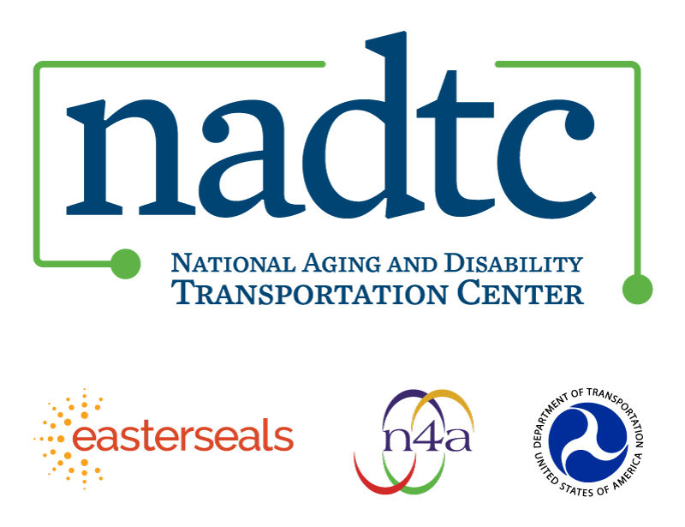

The National Aging and Disability Transportation Center is funded through a cooperative agreement of Easter Seals, the National Association of Area Agencies on Aging, and the U.S, Department of Transportation, Federal Transit Administration, with guidance from the U.S. Department of Health and Human Services, Administration for Community Living. NADTC’s mission is to increase accessible transportation options for older adults, people with disabilities and caregivers nationwide.

National Aging and Disability Transportation Center
Washington, D.C. 20005
Telephone and toll-free hotline: (866) 983-3222
TTY: (202) 347-7385
Email: contact@nadtc.org
Website: www.nadtc.org

Follow us:
Facebook
Twitter
YouTube
LinkedIn

