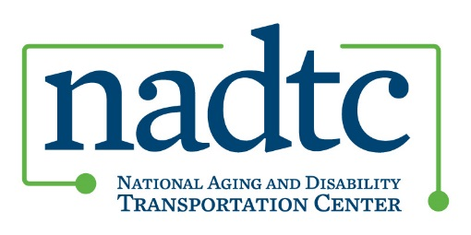
NADTC Accessible Pedestrian Pathways Mini-Couse Overview
Transcript
RACHEL BEYERLE: Welcome to the National Aging and Disability Transportation Center Accessible Pedestrian Pathways Mini-Course Overview. My name is Rachel Beyerle and I’m communications director at NADTC. The course opens with registration on August 1st and ends on September 14, 2018 when final assignments are due.
The accessible pedestrian mini-course is designed to increase your knowledge and awareness of Americans with Disabilities Act requirements and features, rise of the walkability movement in the United States, technology and its role in pedestrian facilities, federal programs and initiatives, as well as local projects and promising practices.
As part of the course, you’ll listen to three short webinars on accessibility features, national initiatives, and local projects. There will be a quiz after each webinar. All participants will be asked to complete and submit a walking assessment. This is an activity you can do on your own or with others and you get to define the geographic area that you’re assessing whether that be a block, your whole neighborhood or your community at large. We’ll provide a checklist that you can use. And finally you will complete an assignment related to one of the following. It will be your choice of one of these four: development of a policy statement, identification of a pedestrian improvement project, establishment or at least a plan to establish a pedestrian advisory committee or group or planning a full-scale community walking assessment.
The course will be six weeks long and will begin with our Americans with Disabilities Act overview, then we’ll move on to the rise of the walkability movement in the United States, we’ll take a look at technology, national initiatives, local projects and promising practices, and then you’ll have the last week to work on your final project assignment.
As I mentioned, each participant be asked to conduct and submit an assessment of their local area of choice. You can use the Neighborhood Wayfinding assessment checklist that we have available at www.nadtc.org, you can record signs or signage, whether there are lights, whether there are comfort features such as benches available, the general conditions, physical conditions of the walkway, intersection features such as whether there are audible pedestrian signals or painted crosswalks, and general accessibility features such as curb ramps or tactile warnings. In addition to assessing what you’re seeing, we hope you’ll also take the opportunity to think about what changes you’d recommend in your local area.
You’ll have your choice of final assignment. We’re asking that you submit a two to five-page document for one of the following. You can develop a pedestrian-related policy recommendation, identify and describe a pedestrian improvement project, develop an implementation plan for establishing a pedestrian advisory group, or you can write a plan and an event schedule for a community group walking assessment.
We’ll offer resources along the way. Some of the websites for national organizations and federal agencies that we recommend include America Walks, the National Complete Streets Coalition, the Federal Highway Administration, ITE Institute of Transportation Engineers, and our own website, nadtc.org.
If you’re ready to register for the course, all you have to do is go to nadtc.org, complete the registration form, and you’ll receive an email confirmation from NADTC staff. That will include instructions and a link to the course website where you can download materials, take the quizzes, listen to the webinars, submit your walking assessment results, and final assignment.
If you have questions along the way, feel free to contact me, Rachel Beyerle. I’m at rbeyerle@easterseals.com or you can reach me by phone at (202) 347-3066 extension 8304.
We look forward to your participation in the Accessible Pedestrian Pathways online mini-course. In the meantime, please be sure to follow us on social media. We’re on Twitter, Facebook, LinkedIn, and YouTube. Or you can also subscribe to our monthly e-newsletter by going to www.nadtc.org, scrolling down to where it says subscribe to newsletter (Connect with Us page) and entering your email address.
We look forward to hearing from you, and we look forward to your participation in our upcoming mini-course. Thanks and have a good day!

