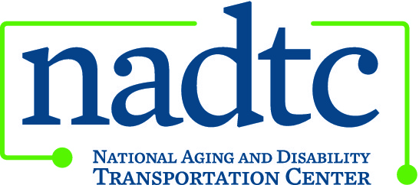

This publication was downloaded from the National Aging and Disability Transportation Center’s website (www.nadtc.org). It was developed by Easter Seals Project ACTION, a technical assistance center operated by Easter Seals, Inc. through a cooperative agreement with the U.S. Department of Transportation, Federal Transit Administration.

NADTC
ADA Paratransit Customer Rights & Responsibilities Bookmark

Tips for Using ADA Paratransit Service:

• You may apply for paratransit service
if you are unable to use fixed-route service.
• Paratransit eligibility is based on:
• Whether you can board, ride or
disembark from an accessible vehicle.
• Availability of an accessible vehicle
on your desired route and/or hour of
service.
• Existence of a specific impairment,
condition or physical barrier that
prevents you from getting to or from
the bus stop.
• Expect to pay up to double the fixed-route
fare for an ADA complementary
trip. Expect to pay premium charges for
service offered beyond the transit
authority’s ADA obligations.
• You may negotiate times with the transit
provider. You are not required to
schedule a trip more than one hour earlier
or later than you would like to travel.
• Your personal care attendants rides free of
charge when accompanying you on a trip.
• You have the right to file a complaint with
the transportation provider.

www.nadtc.org

Easterseals logo
National Association of Area Agencies on Aging logo
U.S. Department of Transportation logo

A program of the U.S. Department of Transportation, Federal Transit Administration, administered by Easterseals and the National Association of Area Agencies on Aging (n4a) with guidance from the U.S. Department of Health and Human Services, Administration for Community Living.

Customer Responsibilities

If you qualify for ADA complementary
paratransit, be aware that it is
a shared-ride service, and you have
responsibilities as a passenger.
• Make sure you understand the
pickup window and vehicle wait
time so that you are prepared to
board when the vehicle arrives.
• Be prepared for the driver to make
stops ahead of yours. You may not
be the first one dropped off even if
you were first to be picked up.
• Prior to making a trip reservation,
review the information needed
to book the trip. Be prepared to
provide the necessary information
when you call.
• Know your provider’s no-show and
late-cancellation policies. Cancel
reservations as soon as you determine
you don’t need the trip. Be
aware that you may be penalized
for an excessive number of late
cancellations or no-shows.
• Treat the driver and other passengers
with courtesy and respect.
• If an appeal becomes necessary
because of denied eligibility, be
familiar with the appeals process.

To learn more about accessible
public transportation, contact:

National Aging and Disability Transportation Center
Washington, DC
Toll-free: 866.983.3222
contact@nadtc.org

December 2017

