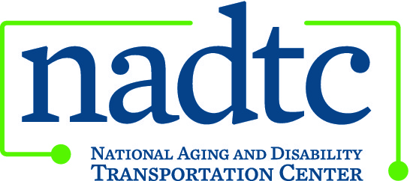

This publication was downloaded from the National Aging and Disability Transportation Center’s website (www.nadtc.org). It was developed by Easter Seals Project ACTION, a technical assistance center operated by Easter Seals, Inc. through a cooperative agreement with the U.S. Department of Transportation, Federal Transit Administration.

Easter Seals Project ACTION
ADA Paratransit Customer Rights & Responsibilities Bookmark

Accessible Community Transportation in Our Nation

Let the ADA give you a lift!
Do you have a disability?
Do you have places to go?

Tips for Using ADA Paratransit Service:
• You may apply for paratransit service
if you are unable to use fixed-route service.
• Paratransit eligibility is based on:
• Whether you can board, ride or
disembark from an accessible vehicle.
• Availability of an accessible vehicle
on your desired route and/or hour of
service.
• Existence of a specific impairment,
condition or physical barrier that
prevents you from getting to or from
the bus stop.
• Expect to pay up to double the fixedroute
fare for an ADA complementary
trip. Expect to pay premium charges for
service offered beyond the transit
authority’s ADA obligations.
• You may negotiate times with the transit
provider. You are not required to
schedule a trip more than one hour earlier
or later than you would like to travel.
• Personal care attendants ride free of
charge on paratransit.
• You have the right to file a complaint with
the transportation provider if necessary.

Customer Responsibilities
• If you qualify for ADA complementary
paratransit, be aware that it is
a shared-ride service, and you have
responsibilities as a passenger.
• Make sure you understand the
pickup window and vehicle wait
time so that you are prepared to
board when the vehicle arrives.
• Be prepared for the driver to make
stops ahead of yours. You may not
be the first one dropped off even if
you were first to be picked up.
• Prior to making a trip reservation,
review the information needed
to book the trip. Be prepared to
provide the necessary information
when you call.
• Know your provider’s no-show and
late-cancellation policies. Cancel
reservations as soon as you determine
you don’t need the trip. Be
aware that you may be penalized
for an excessive number of late
cancellations or no-shows.
• Treat the driver and other passengers
with courtesy and respect.
• If an appeal becomes necessary
because of denied eligibility, be
familiar with the appeals process.

To learn more about accessible
public transportation, contact:
Easter Seals Project ACTION
1425 K Street, NW, Suite 200
Washington, DC 20005
800-659-6428 or 202-347-3066
202-347-7385 (TTY)
202-737-7914 (Fax)
projectaction@easterseals.com

Easter Seals Project ACTION is funded through a
cooperative agreement with the U.S. Department of
Transportation, Federal Transit Administration.
www.projectaction.org

July 2010

