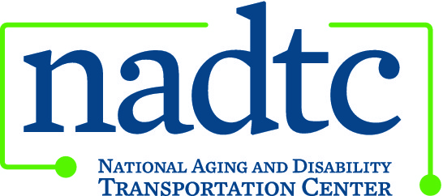

This publication was downloaded from the National Aging and Disability Transportation Center’s website (www.nadtc.org). It was developed by Easter Seals Project ACTION, a technical assistance center operated by Easter Seals, Inc. through a cooperative agreement with the U.S. Department of Transportation, Federal Transit Administration.

Fixed-Route Transit Rights & Responsibilities Bookmark

Note: This version is provided for those using screen readers.

FRONT

NADTC Logo

The ADA gives you the right to:

- Use any public bus or rail system.
- Receive transportation route and service information in an accessible and useable form.
- Use a wheelchair or other mobility device to board a bus or train.
- Find all lifts and securement devices in good working order.
- Ride the bus or train seated in your wheelchair or mobility device.
- Have stops, major streets and intersections announced along the route.
- Travel with a personal care attendant if needed.
- Travel with a service animal.
- Travel with any necessary equipment and devices.
- Receive courteous, respectful service and ample time to get on and off the vehicle.
- File a complaint with the transportation provider.

www.nadtc.org

Easterseals n4a and USDOT logos

A program of the U.S. Department of Transportation, Federal Transit Administration administered by Easterseals and the National Association of Area Agencies on Aging (n4a) with guidance from the U.S. Department of Health and Human Services, Administration for Community Living.

BACK

Customer Responsibilities

- Know whether or not your mobility aid is within ADA requirements.
- Know the size and weight of your mobility device with yourself in it
because the maximum size and weight capacities of lifts vary.
- Know how to contact the transportation provider and receive route schedules and information.
- Arrive at the bus, train or paratransit stop at the correct time.
- Pay the proper fare.
- Keep service animals under control.
- Comply with the transit provider’s policies on securing wheelchairs and mobility devices.
- Request lap/shoulder belts and securement for your wheelchair if desired.
- Signal or ask the driver to stop the bus at the desired designated stop before you get there.
- Treat the driver and other passengers with courtesy and respect.

To learn more about accessible public transportation, contact:

National Aging and Disability Transportation Center
Washington, D.C.
Toll-free 866.983.3222
contact@nadtc.org

Revised 12/2017

