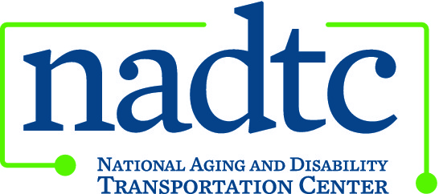

This publication was downloaded from the National Aging and Disability Transportation Center’s website (www.nadtc.org). It was developed by Easter Seals Project ACTION, a technical assistance center operated by Easter Seals, Inc. through a cooperative agreement with the U.S. Department of Transportation, Federal Transit Administration.

Easter Seals Project ACTION
ADA Rights & Responsibilities Bookmark

Note: This version is provided for those using screen readers.

FRONT

Let the ADA give you a lift!

Do you have a disability?
Do you have places to go?
The ADA gives you the right to:

- Use any public bus or rail system.
- Receive transportation route and service information in an accessible and useable form.
- Use a wheelchair or other mobility device to board a bus or train.
- Find all lifts and securement devices in good working order.
- Ride the bus or train seated in your wheelchair or mobility device.
- Have stops, major streets and intersections announced along the route.
- Travel with a personal care attendant if needed.
- Travel with a service animal.
- Travel with any necessary equipment and devices.
- Receive courteous, respectful service and ample time to get on and off the vehicle.
- File a complaint with the transportation provider if necessary.

www.projectaction.org

Easter Seals Project ACTION is funded through a cooperative agreement with the U.S. Department of Transportation, Federal Transit Administration.

BACK

Customer Responsibilities

- Use fixed-route transportation when possible.
- Know whether or not your mobility aid is within ADA requirements.
- Know the size and weight of your mobility device with yourself in it
because the maximum size and weight capacities of lifts vary.
- Know how to contact the transportation provider and receive route schedules and information.
- Arrive at the bus, train or paratransit stop at the correct time.
- Pay the proper fare.
- Keep service animals under control.
- Comply with the transit provider’s policies on securing wheelchairs and mobility devices.
- Request lap/shoulder belts and securement for your wheelchair if desired.
- Signal or ask the driver to stop the bus at the desired designated stop before you get there.
- Treat the driver and other passengers with courtesy and respect.

To learn more about accessible public transportation, contact:

www.projectaction.org

Easter Seals Project ACTION
1425 K Street, NW, Suite 200
Washington, DC 20005
800-659-6428 or 202-347-3066
202-347-7385 (TTY)
202-737-7914 (Fax)
projectaction@easterseals.com

Revised 2/2014

