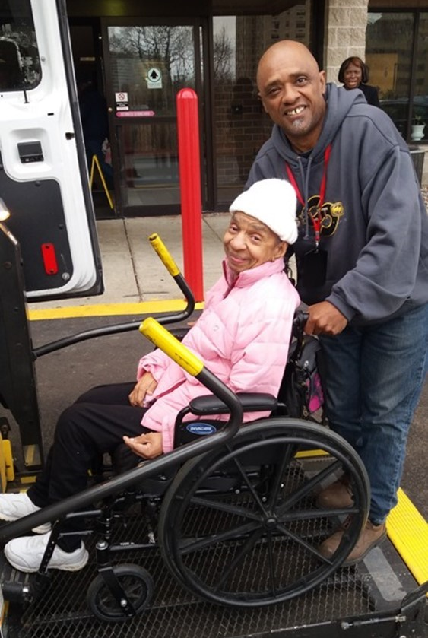
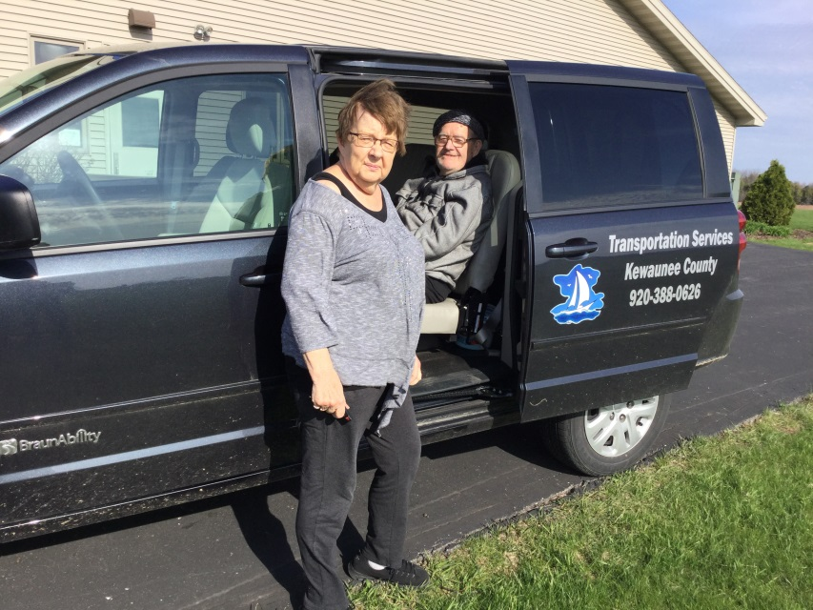
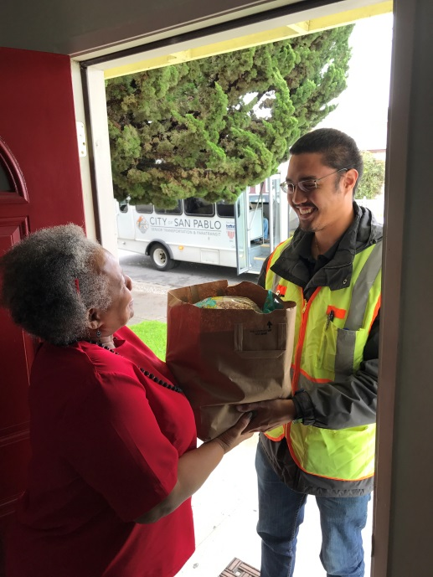
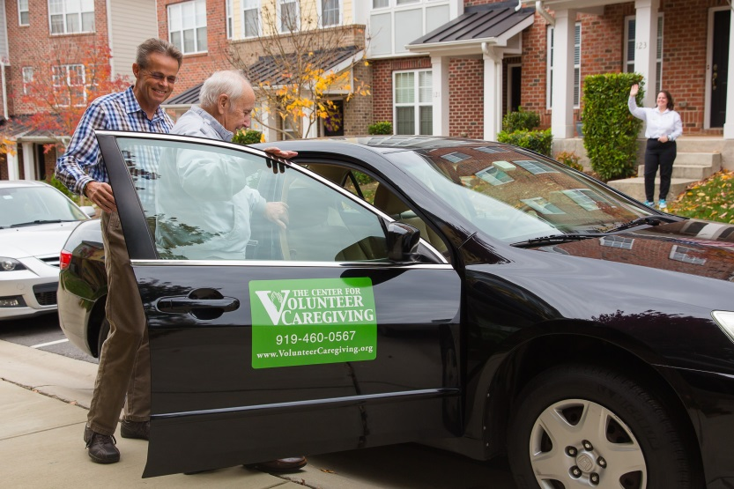
Table of Contents

1 Introduction 1-3
2 ADA Trending Questions Requiring Clarification: No-Shows and Penalties for Paratransit 2-4
3 ADA Trending Questions Requiring Clarification: Complaint Process 3-8
4 Connected Vehicle Technology 4-12
5 Real-Time Transit Technology 5-16
6 Rural Travel Training 6-23
7 Seamless Mobility through Technology, Route Design, and Coordinated Systems 7-27

Cover Photo Credits
Top left: 8330 On the River/Poah Communities, Detroit, Michigan
Top right: Kewaunee County Services, Kewaunee, Wisconsin
Bottom left: The Center for Volunteer Caregiving, Cary, North Carolina
Bottom right: Wallingford Committee on Aging, Inc., Wallingford, Connecticut
Bottom right:

Introduction

The National Aging and Disability Transportation Center (NADTC) is pleased to present this second annual report of trending topics in transportation. As in 2016, the Trends Report is divided into stand-alone information briefs that explore significant issues that affect the availability of accessible transportation in communities. Each brief includes case studies on how changes in transportation are being implemented in communities in the U.S., from large cities like Denver, to small towns on the Eastern Shore of Maryland.
With its mission to increase the availability and accessibility of transportation for older adults and people with disabilities, the NADTC recognizes that our work must be grounded in, and respond to, the needs and preferences of the communities and organizations that the center was created to serve. Critical to the center’s success is access to information about local communities’ efforts to develop accessible transportation, how those developments are received by people with disabilities and older adults, and the reactions of leaders in accessible transportation to developments in the transportation field.
2017’s information briefs address:
- Americans with Disabilities Act No-Shows and Cancellations
- Americans with Disabilities Act Complaint Process
- Connected Vehicle Technology
- Real-Time Transit Technology
- Rural Travel Training
- Seamless Mobility
While the ADA can hardly be considered a “trending topic”, NADTC regularly receives questions about how to implement ADA requirements. No-shows, cancellations, and the complaint process are topics frequently addressed by our technical assistance specialists. The technology and mobility briefs take a look at how the rapidly evolving world of technology is affecting safety, service efficiency, and customer information. Finally, the rural travel training brief gets back to basics with information on how small transportation systems with limited resources can make a difference through passenger instruction and peer-mentoring.
Explore transportation’s trending news with us through this report! If you have questions about any topic here or have a story to share from your community, reach out to us at (866) 983-3222 or email contact@nadtc.org.

ADA Trending Questions Requiring Clarification: No-Shows and Penalties for Paratransit

Introduction
The Americans with Disabilities Act (ADA) is a civil rights law prohibiting discrimination against persons with disabilities. Under Title II of the ADA, public transportation must be usable by people with disabilities. The U.S. Department of Transportation regulations pertaining to transportation (49 CFR Part 37 and 38) are written to create an equal travel environment so that people with disabilities will not be excluded or denied from participation in using transportation systems or facilities.

While the ADA addresses a number of issues that promote transportation accessibility, issues around no-shows and penalties for ADA paratransit frequently evoke questions or requests for technical assistance. This brief intends to clarify many of these recurring issues and provide information that is helpful to transit providers.

Key Points
- Define when a “no-show” occurs and include the “pick-up window” in the definition.
- Penalties can be established that are reasonable.
- Any penalty can be appealed.
- Protect return trips on the schedule if rider is a “no-show” on the outbound trip.

For transit agencies, a comprehensible ADA paratransit no-show policy and penalty process will provide assurance that customer complaints and concerns are resolved in a timely manner and with fairness. ADA regulations at Part 37.125(h) and Part 37, App. D, Part 37.125 require agencies to have specific procedures in place to address no-shows and equitable penalties.

It is important to define when a “no-show” occurs. Typically, a no-show is when a transit vehicle or contracted provider arrives at a location at a negotiated scheduled time or within a “pick-up window” but the customer and the driver do not connect for the ride. Keep in mind that regulations in Part 37.121 require complementary paratransit service to be comparable to the fixed-route service. Transit agencies can establish a reasonable pick-up window—typically within 20 to 30 minutes of the negotiated pick-up time. The pick-up window allows for an arrival time dependent on traffic or other delays. This pick-up window would make the scheduled pick-up time comparable to the fixed-route. Additionally, a common practice is for paratransit drivers to wait at least five minutes for a rider to board the van. If the van arrives early, it is recommended that the countdown for the five minute period does not start until the beginning of the pick-up window. (See FTA ADA Circular Section 8.5.3.)

Penalties

An ADA eligible rider may be suspended for a reasonable period of time if they have established a pattern or practice of no-showing for scheduled trips.

The ADA regulations at Part 37.125 state:
(h) The entity may establish an administrative process to suspend, for a reasonable period of time, the provision of complementary paratransit service to ADA eligible individuals who establish a pattern or practice of missing scheduled trips.
(1) Trips missed by the individual for reasons beyond his or her control (including, but not limited to, trips which are missed due to operator error) shall not be a basis for determining that such a pattern or practice exists.
(2) Before suspending service, the entity shall take the following steps:
(i) Notify the individual in writing that the entity proposes to suspend service, citing with specificity the basis of the proposed suspension and setting forth the proposed sanction.
(ii) Provide the individual an opportunity to be heard and to present information and arguments;
(iii) Provide the individual with written notification of the decision and the reasons for it.
(3) The appeals process of paragraph (g) of this section is available to an individual on whom sanctions have been imposed under this paragraph. The sanction is stayed pending the outcome of the appeal.

Remember, “establishing a pattern” is not the rider with one or two no-shows in a six-month period, but several no-shows over a reasonable period of time. When considering penalties for no-shows, a transit agency should look at the proportion of no-shows in relationship to the number of trips scheduled. A rider who requests sixty trips in one month and who has five no-shows has a proportional no-show rate of 8%. This should be compared to the amount with the agency’s system wide average of no-shows. Amounts higher than the system wide average could be considered for penalty.

The transit agency must not count no-shows outside of a rider’s control and only count legitimate occurrences. Missed trips, where a driver does not arrive within a pick-up window or does not wait for at least five minutes, must not be counted as a no-show. Agencies often include late cancellations in this calculation. Such occurrences should only be included if they are so close in time as to have the operational equivalent of a no-show. An example would be a trip cancellation with a one hour or less notification to the transit agency.

Determine a reasonable time period for suspension by working with your local disability and aging community. Suspensions of months may cause an economic or medical hardship for people while a one or two week penalty may be difficult though reasonable enough to remind customers that no-shows must be taken seriously. Every no-show, because it may involve a penalty that could deny service, must have a clear process for remediation. The appeals process must be based on factual information and be fair to both parties. No-show penalties should not be given casually.

DOT ADA regulation Part 37, Appendix D provides some guidance:

It is very important to note that sanctions could be imposed only for a ``pattern or practice'' of missed trips. A pattern or practice involves intentional, repeated or regular actions, not isolated, accidental, or singular incidents. Moreover, only actions within the control of the individual count as part of a pattern or practice. Missed trips due to operator error are not attributable to the individual passenger for this purpose.

If the vehicle arrives substantially after the scheduled pickup time, and the passenger has given up on the vehicle and taken a taxi or gone down the street to talk to a neighbor, that is not a missed trip attributable to the passenger. If the vehicle does not arrive at all, or is sent to the wrong address, or to the wrong entrance to a building, that is not a missed trip attributable to the passenger. There may be other circumstances beyond the individual's control (e.g., a sudden turn for the worse in someone with a variable condition, a sudden family emergency) that make it impracticable for the individual to travel at the scheduled time and also for the individual to notify the entity in time to cancel the trip before the vehicle comes. Such circumstances also would not form part of a sanctionable pattern or practice.

FTA Compliance Review Findings
- To count all cancellations after 5:00 p.m. in the evening is not the operational equivalent of a no-show (transit operates until 10:00 p.m.).
- Three no-shows in a 90-day period would not be a pattern or practice for a daily rider (2% of trips).
- A suspension for one year of a rider who no-shows 12 times in a year would not be a reasonable sanction.

Keep Return Trips on the Schedule
When a rider misses a scheduled outbound trip, transit agencies should not automatically cancel his or her return trip. For instance, a rider might get to an appointment by riding with a family member but will use paratransit for the trip back home. Without an indication from the rider that the return trip is not needed, it should remain on the schedule and be protected from cancellation. If a return trip is not protected and cancelled by the transit agency, it must be counted as a missed trip.

Section 7 of Topic Guides on ADA Transportation is a useful resource on no-shows. These guides provide ADA related technical assistance on transportation for transit agencies, riders, and advocates and bring together the requirements of the ADA and the DOT ADA regulations, FTA compliance determinations, and operational practices for ADA compliance. The guides can be found at https://dredf.org/ADAtg/index.shtml.

Summary

A public or private transportation provider that operates fixed-route or demand response service, or any combination, is required to provide accessible services for everyone meeting the ADA requirements and without discrimination. A comprehensible ADA paratransit no-show policy and penalty process will provide assurance that customer complaints and concerns are resolved in a timely manner and with fairness. It is important that public transit agencies develop a policy that defines when a “no-show” occurs and put in place an unbiased administrative process for penalty. The counted no-shows must establish a “pattern or practice” to be considered for penalty. Every no-show must have a clear process for remediation any penalties or to challenge no-shows. There must be a fair appeal process that gives the rider an opportunity to present factual information and any circumstances beyond the rider’s control should not count towards a no-show penalty. For the transit agency, it is important that accurate trip information is available for the appeal from trip logs and other communications.

Resources
Americans with Disabilities Act: Guidance, FTA Circular 4710.1
https://www.transit.dot.gov/sites/fta.dot.gov/files/docs/Final_FTA_ADA_Circular_C_4710.1.pdf
TCRP Synthesis 60: Practices in No-Show and Late Cancellation Policies for ADA Paratransit
http://www.trb.org/Publications/Blurbs/156210.aspx

Topic Guides on ADA Transportation (No-Shows as section 7)
https://dredf.org/ADAtg/index.shtml

Transit Manager’s Toolkit: ADA
http://nationalrtap.org/transitmanager/Administration-Compliance/ADA

ADA Trending Questions Requiring Clarification: Complaint Process
Introduction

For transit agencies, a solid Americans with Disabilities Act (ADA) complaint process and policy will ensure that customer complaints and concerns are resolved quickly and fairly. ADA regulations at 49 CFR Part 37.17 and 27.13 require agencies to have specific procedures in place to address complaints alleging ADA violations. The regulations also require a designated responsible employee to manage the overall process.

Key Points
- Adopt complaint procedures that provide for prompt and equitable resolution
- Maintain a copy of all complaints of ADA noncompliance for 1 year
- Maintain a record (summary) of all complaints for 5 years

Keep in mind that the complaint process is the responsibility of the transit agency. Complaint procedures must apply to all transit service provided by the agency including contracted service.

FTA Compliance Review Findings
- A record of complaints on a spreadsheet without details of follow-up communication and resolution is not adequate.
- Agency did not advertise to the public what process to follow for filing an ADA complaint.
- Accessible formats of the complaint process were not available on request.

Complaint Procedures Requirement

Transit agencies must have a process in place for the prompt and equitable resolution of complaints.

49 CFR Part 37.17 - Designation of responsible employee and adoption of complaint procedures.
(a) Designation of responsible employee. Each public or private entity subject to this part shall designate at least one person to coordinate its efforts to comply with this part. (b) Adoption of complaint procedures. An entity shall adopt procedures that incorporate appropriate due process standards and provide for the prompt and equitable resolution of complaints alleging any action prohibited by this part and 49 CFR parts 27, 38 and 39. The procedures shall meet the following requirements:

(1) The process for filing a complaint, including the name, address, telephone number, and email address of the employee designated under paragraph (a) of this section, must be sufficiently advertised to the public, such as on the entity's Web site;

(2) The procedures must be accessible to and usable by individuals with disabilities;

(3) The entity must promptly communicate its response to the complaint allegations, including its reasons for the response, to the complainant and must ensure that it has documented its response. Transit agencies must advertise the process for filing a complaint through means such as agency websites and include the contact information (name, address, telephone number, and email address) for the employee designated to coordinate compliance. A defined advertising process will be informative to riders on how to file a complaint.

FTA has found it acceptable to designate a staff person with a title of “ADA Coordinator” or “Customer Complaint Representative” so that communications are directed to the designated employee with that job title can then promptly respond to the complainant. Complaints should be filed through a defined collection process or person rather than in an informal manner with various transit personnel; this enables a complaint and resolution to be easily tracked. At the same time, the procedures help ensure that the agency provides appropriate due process for any actual ADA complaints received. This can be accomplished by forwarding telephone calls, retrieving recorded messages, forwarding emails, or other communications to appropriate staff.

It is crucial that the complaint process and procedures be accessible and usable by individuals with disabilities. Alternative formats can include large print, braille, audio recordings, and documents stored electronically on CDs in a format preferred by the requestor. The complaint process must allow for qualified interpreters, video relay such as 711, or another auxiliary aid or service so that a complainant can communicate effectively with the transit agency.

Submission and communication of complaints can be in writing on paper, electronic (online), in-person, or by telephone. Transit agencies must promptly communicate its response to the complainant, including the reasons for the response, and document this response for purposes of recordkeeping, see part 37.17(b)(3). The transit agency must also track communications on an internal records system.
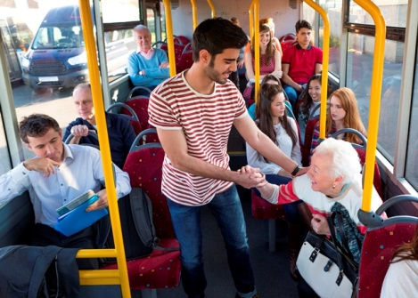

Collecting Information

Transit agencies typically request the following information to assist with investigating a complaint:
- Contact information (name, rider ID (if applicable), address, telephone, email, etc.)
- Mobility aid used or other equipment including (type or model)
- Date, time, and location of the incident
- Transit mode and rail line or route number including vehicle ID number
- Name(s) or ID numbers of agency employee(s) or others
- Clear description of the incident
- Other documentation including photographs or video

Because of the unique service requirements of complementary paratransit, many agencies also establish specific information requirements related to such topics as:
- Telephone reservations or cancellations
- Lateness and missed trips
- On-board ride times

Part 37.17(b) requires agencies to resolve complaints in a manner that is both “prompt” and “equitable” so as not to discriminate against individuals with disabilities. Transit agencies are free to establish their own timelines for resolving complaints. Include a process that captures:
- Date of receipt of complaint
- Date of assignment for investigation
- Date of resolution
- Date of communication to complainant

Retain this information as part of the complaint file. FTA recommends that complaint investigations include communications with complainant and applicable staff. Other information can come from:
- Telephone call recordings
- Written communications (paper and electronic)
- Bus tracking
- Dispatch input
- Driver manifests
- Video recordings and on-board cameras
- Interviews with transit agency employees, contractors, or witnesses to the incident

A vital component of a complaint process is to determine if a submitted complaint is describing a potential occurrence of ADA non-compliance or is a general service related complaint or comment. A general service complaint may be situations such as the ride is not smooth enough for a rider, the speaker volume is not loud enough, the bus stop is not conveniently located, or the bus is too crowded.

Some examples of common ADA complaints include:
- Service animal refusal
- Inoperable lifts or ramps without backup vehicle or next bus
- Bus passes the stop with waiting wheelchair customer
- Regularly occurring pattern or practice of late pick-ups for ADA paratransit
- Excessively long trips on ADA paratransit
- No stop announcements or route identification

FTA’s Title VI Circular 4702.1B states that ADA complaints must be categorized distinctly from Title VI complaints in record keeping and communications:
- Keep all complaints of ADA noncompliance on file for one year.
- Keep a record of all ADA complaints (may be in summary form) for five years.
- Electronic database of complaints is a suggested practice.

Part 37.17(b)(1) requires transit agencies to publicize their process for filing complaints with highlighting the information an agency needs to investigate a complaint, timelines for resolution, and details on how the resolution will be communicated to the complainant.

Use complaint findings for case studies and examples in training drivers and transit staff. Part 37.173 requires transit staff are to be trained to proficiency as appropriate to their duties. Training may include staff responsible for accessibility equipment, operating procedures or maintenance procedures. This requirement applies to contracted service personnel, as well.

Summary
A public or private transportation provider that operates fixed-route or demand response service, or any combination, is required to provide accessible services for everyone meeting the ADA requirements and without discrimination. ADA regulations require agencies to have specific procedures in place to address complaints alleging ADA violations and to resolve them quickly and equitably. The regulations also require a designated responsible employee to manage the overall process. Finally, transit agencies must clearly advertise the complaint process on websites, at in-person events, with print materials and in accessible formats. It is required that agencies maintain original copies of all ADA complaints for one year and keep a summary record of complaints for 5 years.

Resources
Americans with Disabilities Act: Guidance, FTA Circular 4710.1
https://www.transit.dot.gov/sites/fta.dot.gov/files/docs/Final_FTA_ADA_Circular_C_4710.1.pdf

Topic Guides on ADA Transportation
https://dredf.org/ADAtg/index.shtml

Transit Manager’s Toolkit: ADA
http://nationalrtap.org/transitmanager/Administration-Compliance/ADA

Connected Vehicle Technology

Introduction

Self-driving vehicles can be of great value and open up a new world for people with disabilities and older adults. Autonomous vehicles began with Google’s Self-Driving Car project, now called Waymo, which is an initiative to enhance mobility for all while providing safe, efficient, and affordable transportation. Although, vehicles are becoming more and more “smart” today with enhanced safety features, imagine the freedom to be able to simply get into a vehicle that’s friendly for passengers with disabilities, program your route in a car that has been retrofitted to meet your personal challenges, and sit back and relax while the vehicle does the driving for you. Mitigating transportation obstacles for individuals with disabilities would enable new employment opportunities and save money in healthcare expenditures from missed medical appointments. This is in the context of the anticipated broader impacts of autonomous vehicles according to the Ruderman White Paper Self-Driving Cars and the Impact on People with Disabilities.
Challenges and Opportunities
What is a self-driving or autonomous vehicle?
A fully autonomous vehicle is capable of sensing its environment and navigating without human input. This technology will allow cars to talk to one another (e.g., communicate whether they are accelerating, turning or braking and even tell other cars their final destination). The more cars know what other cars are doing on the road, the more they can coordinate. Ultimately, we will have safer cars that can sense traffic and highway conditions far better than any single driver. So the question is, do we focus on individual self-driving vehicles or should we put more of a focus on autonomous shuttles that can move more people? Transportation access is especially important for people with disabilities and older adults, and investment in public transportation is the alternative to the expense of retrofitting vehicles to accommodate individual needs.
What is Connected Vehicle (CV) Technology?
Many auto manufacturers are currently working on some form of shared driverless bus that has Connected Vehicle Technology. It can be argued that the Connected Vehicle technology is safer than humans driving vehicles on the road because of the sophisticated network of wireless communication among the vehicles. With connected vehicle technology, vehicles will have the capability to communicate with infrastructure, road signs and the passengers’ electronics. Many of the connected vehicles use sensors that bounce laser beams off of objects in the vicinity, such as traffic lights and pedestrians, to create a 3-D vision of the surrounding area for safety.

How will driverless vehicles communicate with roads and infrastructure such as traffic lights and pedestrians?

Autonomous vehicles will communicate with infrastructure and the road with new sophisticated technology, such as: Transit Bus Stop Pedestrian Warning which alerts transit bus drivers and pedestrians at the bus stop when the passenger is in harm’s way as the bus pulls in and out of the bus stop; Transit Signal Priority that provides traffic light signal priority to transit at the intersection; Pedestrian in Signalized Crosswalk Warning, which warns transit bus operators when pedestrians are in the intended path of an oncoming bus; and Positive Train Controls system that monitors the location and movement of the train and slows or stop the train to avoid a collision.

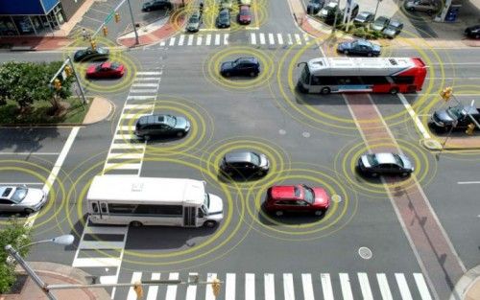
https://www.its.dot.gov/cv_basics/cv_basics_what.htm

How will driverless vehicles communicate with roads/infrastructure (e.g., traffic lights, pedestrians)?
Case examples:

Greater Cleveland Regional Transit Authority
Greater Cleveland Regional Transit Authority has six test pilot buses with connected vehicle technology. On February 10, 2015, RTA received a 2.7 million dollar grant from FTA to test two (2) programs: the Enhanced Transit Safety Retrofit Package (E-TRP) and the Transit Bus Stop Pedestrian Warning (TSPW). The E-TRP program involves using vehicle-to-infrastructure (V2I) technology to avoid collisions with pedestrians in or near intersections and crosswalks, as well as vehicle-to-vehicle (V2V) technology to warn drivers when buses are about to be cut off. The V2V technology targets vehicles that drive up along the left side of a bus, and then make a right-hand turn in front of it. As of October 4, 2016, updated information on the status of the study is not currently available.

University of Michigan in Ann Arbor tested a driverless 15-passenger shuttle service on campus in June 2017. The GPS vehicle in a geofenced setting provided transportation to students and staff from one building to another within a two mile radius while driving with regular vehicles on the road.

Navya, a French start-up that makes driverless shuttles, has demonstrated its shuttle in downtown Las Vegas during the Consumer Electronics Show in January of 2017. Their ARMA driverless and electric public transport shuttles can carry up to 15 people at a top speed of 28 miles per hour. The plan is for the shuttles to have a regular route along Fremont Street between Las Vegas Boulevard and Eighth Street.

The New York City (NYC) Connected Vehicle Pilot Deployment (CVPD) project plans to incorporate Connected Vehicle technology in taxis, buses, commercial fleet delivery trucks, city vehicles and 310 signalized intersections along major city streets. Sponsored by the U.S. Department of Transportation, this pilot project started September 1, 2016. The goal is to improve safety of travelers and pedestrians in the city.

Summary

Can driverless vehicles solve the problem of giving up the keys?

It is yet to be determined. With new independence using driverless vehicles, people with mobility-related disabilities will be able to get to work, meet up with friends, attend worship service, and keep their medical appointments and not have to depend on friends and family to get around. They can summon a driverless shuttle to take them to their destination. This is a very exciting time in transportation and the future is bright with possibilities.

Resources

U.S. Department of Transportation (DOT) Connected Vehicle Program: https://www.transportation.gov/briefing-room/us-dot-advances-deployment-connected-vehicle-technology-prevent-hundreds-thousands
National Highway and Traffic Safety Administration (NHSTA): https://www.nhtsa.gov/press-releases/us-dot-advances-deployment-connected-vehicle-technology-prevent-hundreds-thousands. https://www.nytimes.com/2014/11/09/automobiles/in-self-driving-cars-a-potential-lifeline-for-the-disabled.html?mcubz=0
Ruderman White Paper on Self-Driving Cars: http://secureenergy.org/wp-content/uploads/2017/01/Self-Driving-Cars-The-Impact-on-People-with-Disabilities_FINAL.pdf

Real-Time Transit Technology
Introduction
A common frustration of transit users, in both fixed route and demand-response systems, is the inability to determine what mobility options are available, predict when a pick-up is going to be late, what the destination arrival time might be, or if there are outages in accessibility features. For older adults and people with disabilities who may require special accommodations, the provision of real-time transit information is especially important. A consumer may spend considerable time creating a transportation plan based on options that can meet specific needs and be available at essential times yet find the selected service to be unavailable or unreliable when needed. A lack of accurate, timely information can create unequal access to transportation, particularly impacting those who do not have alternative options. It can also make consumers unhappy with services and if available, to choose another option outside of public transportation as a preferred mobility mode. Recently, there has been a renewed interest in creating systems that are responsive to passenger needs and wants. Real-time transit technology can improve the perceived and actual reliability and convenience of a service, and can better inform consumers of their travel options.

Difference between Static and Real-Time Information
Static Information
Historically, information about a transit system’s schedule and route stops was communicated via paper. It was not uncommon for system maps to be mass produced, distributed, and posted for public consumption at each stop (and this is still a standard practice in many communities).
Advances in the mid-2000s led to the development and adoption of a standardized set of data that captured transit schedules, routes, pick-up and drop-off locations, and specific times for those arrivals and departures. This became known as the General Transit Feed Specification (GTFS) (Levine, 2014).
A typical GTFS transmits static information. While it can include information like planned outages and service disruptions – examples being if there is a long term station closure, elevators that are down, or re-routed itineraries – it does not account for real-time changes, delays, or updates. Consumers may be most familiar with GTFS data in popular transit apps, like Google Maps, which provide trip planning services and transit routes, walking directions, maps, and nearby amenities (Bliss, 2017).
Real-time Information

Real-time GTFS is an extension of static GTFS that has gained popularity with consumers and transit systems alike. Real-time GTFS provides moment-by-moment updates. Many transit providers, including human service agencies, are now using real-time GTFS to improve service, track vehicles in real time and make adjustments to deliver accurate arrival and destination estimates. Most real-time transit tracking depends on something called “automatic vehicle location” (AVL). AVL is a computer based vehicle tracking system to determine geographic position of a vehicle and relay it to an information center (e.g., a website, an app, a transit dispatcher) where that data can be used. AVL uses GPS tracking to monitor time, location, motion, and speed to help determine the timing of vehicles, location in real-time, recording of arrival and departure times, monitoring of the driver’s skills, and route tracking (Automatic Vehicle Location, 2017).

How is real-time technology assisting transit systems?
Real-time technology provides significant benefits to staff, drivers, and consumers of fixed-route and specialized transportation. The provision of real-time information allows the system to be more responsive to increased rider demand and improves communication to riders and drivers regarding what their potential trips will look like (time, distance, detours, etc.). The availability of this information makes it easier for people to select the option that best meets their needs. This information may also alert riders, with advanced notice, of the need to find alternative transportation options if a planned method of travel will not work.
Rider experience might be the most important result of real-time technology. When real-time information is not available, it can lead to unhappy rider experience, confusion, and possibly reduced interest in continuing to use transit. Transit agencies need better “situational awareness” about the status of their systems in order to adjust quickly and seamlessly to service challenges (Steinfeld, Maisel, and Steinfeld, 2017). In particular, mobility managers can use real-time GTFS to assist consumers planning trips and preparing for possible delays or changes in the route. For example, when the GTFS real-time feed includes transportation accessibility data, the mobility manager and the rider better understand when paratransit might be a better mobility option over fixed-route.
It is important to note that the cost of GTFS and AVL services may inhibit some systems, especially smaller systems, from implementing such technology. But with advances in technology and reduction in the traditional cost of such software, more agencies are likely to pursue integration of such programming into their systems.
How People Consume Real-time Transportation Information
Real-time information can be made available on mobile apps, computer desktop, or by phone for riders, drivers, and system staff. Some transit providers offer automatic text and email messages, convenient for passengers who have regular or consistent routes/commutes.
For riders, real-time technology can provide:
- Status of reservation request, if applicable
- Pick-up time/delayed pick-ups (including notification of problems along intended route)
- Destination arrival time
- Fewer connections/transfers
- Realistic expectations for transit experience
- Immediate access to route maps
- Availability of route instructions, including accessibility updates about temporary or long-term closures (e.g., elevator or escalator outages, problems with the lifts)
- Up-to-date list of mobility options and eligibility requirements

For drivers, real-time data can offer:
    - Enhanced communication with dispatch
    - Immediate awareness of early/late arrival
    - Ability to make route detours
    - More realistic schedule communication
    - Improvements in rider satisfaction and improved relationship with riders

On the back end, transportation agencies can use real-time technology to analyze data and measure:
    - Rider demand
    - On-time performance
    - Over/underutilized vehicles
    - Route effectiveness and opportunities for enhancements
    - User experience feedback
(Kaufman, Smith, O’Connell and Marulli, 2017)
Real-time transit technology provides opportunities for both passengers and providers to instantly retrieve current data on transportation options and status, resulting in an increase in consumer convenience. While all users benefit from access to this information, older adults and people with disabilities especially are provided with increased opportunities for informed decision making about the transit mode that best serves their individual needs. While older adults’ adoption of technology is generally less than usage by the general public, it is noteworthy that current smart phone usage (by four in ten seniors) has more than doubled since 2013, and usage is likely to continue to rise. (Pew Research Center, Internet and Technology, May 17, 2017)
Case Example: Nelson\Nygaard Consulting Associates Report 832 & FindMyRidePA
In 2016, Nelson\Nygaard Consulting Associates conducted research on the topic of technology advancements in one-call/one-click services. This report was published by the National Cooperative Highway Research Program (NHCRP) as Report 832 “State DOTs Connecting Specialized Transportation Users and Rides Volume 1: Research Report” (available here).
A one-call/one-click service helps consumers obtain rides they need for daily activity or for occasional appointments by simplifying access for consumers and matching their varied needs with appropriate options. More advanced services integrate GTFS and AVL into their one-call/one-click programs (explored further in the FindMyRidePA example, explained in detail below).
Report 832 uses a continuum of functionality from simple to advanced, as portrayed in Figure 1, to describe the variety of systems in existence. The simplest system is a link to a central repository of limited transportation resources and static information. The more advanced systems provide information that is kept current, presented in an accessible format that can be manipulated by users, and offers amenities like direct trip booking and payment.
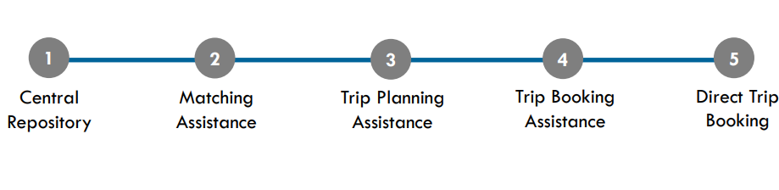
Figure 1. Continuum of one-call/one-click systems as defined in NHCRP Report 832

GTFS begins to appear in level 3, “Trip Planning Assistance”. Most level 3 systems are integrated with public transit schedules via open trip planners using the general GTFS for fixed-route transit and demand response services. These systems can also link with bicycling and walking directions, ride share services, taxi finder systems, etc.
As the continuum progresses through levels 4 and 5, real-time GTFS and AVL begin to make an appearance. Programs that fall under these levels might begin to move beyond static GTFS to integrate vehicle tracking and provide up-to-the-minute information. This is how users begin to access vehicle location and anticipated pick up and destination arrival times, along with updates on accessibility feature outages or unavailable mobility options (Rodman et al, 2016a).

FindMyRidePA
The features described in Report 832’s “level 5” are represented in the Pennsylvania Department of Transportation’s (PennDOT) “FindMyRidePA” service. In December 2011, PennDOT was awarded a Veteran’s Transportation and Community Living Initiative (VTCLI) grant from the Federal Transit Administration to develop a one-call/one-click service. The result was the FindMyRidePA program that integrated scheduling, booking, and real-time GTFS into a single one-click system. Initially, FindMyRidePA was aimed at addressing the needs of veterans, active military personnel, their families and caregivers seeking fixed-route and specialized transportation services; however, the service has evolved to benefit all transit users who are seeking to identify all available transportation options and real-time scheduling information (Rodman et al, 2016a and Rodman et al, 2016b).
The FindMyRidePA software enables users to obtain accurate and real-time information about a wide range of available transportation services across the state. The program was tested with kiosks placed in areas of high transit usage (such as Veterans Affairs Centers) and has since evolved to the online system now available via http://www.findmyridepa.com, which is optimized for smartphone access.
Once on the website, users are asked to specify needs particular to their trip to help them determine what transportation programs they may qualify for. The program lists options that match a rider’s needs and eligibility and provides schedules and cost information. One of the main benefits of FindMyRidePA is the ability to access a variety of transportation options in one centralized web location. A transit provider (e.g., fixed-route transit, ride share programs, on demand transportation, paratransit) does not need to have real-time GTFS and AVL capacity to be a part of the website. However, the benefit of the FindMyRidePA software is that it is designed in such a manner that as the various providers listed in the system convert to real-time GTFS and AVL systems, the real-time tracking will become available to riders and still remaining organized in one single platform (Rodman et al, 2016b).
Conclusion
The reliability and predictability that real-time GTFS provides to public transit systems allows all riders, but especially older adults and people with disabilities, to make more informed decisions about their mobility options. Real-time GTFS has changed the way riders consume transit information and as a result, changed the expectations consumers have in using such information. Real-time GTFS can provide information well beyond printed paper schedules or even static GTFS formats. Riders can plan routes ahead of time, mobility managers can use it to provide assistance to new riders, and riders with mobile phones can receive updates on the go, aiding in immediate transit behavior changes based on a vehicle’s departure and arrival time, a transit system’s alerts, or service delays. The availability of real-time GTFS is an important benefit to older adults and people with disabilities as they navigate transportation options in their community.

Citations and Resources
“Automatic Vehicle Location.” TransitWiki, https://www.transitwiki.org/TransitWiki/index.php/Automatic_vehicle_location#cite_note-tcrp73-1. Accessed September 7, 2017.

Bliss, Laura. “The Transit App That Can See Subway Disruptions”, CITY LAB, August 25, 2017, https://www.citylab.com/transportation/2017/08/the-transit-app-that-can-see-subway-outages/537987/. Accessed September 7, 2017.
FindMyRidePA. Pennsylvania Department of Transportation. www.findmyridepa.com. Accessed September 7, 2017.

Harmony, Xavier J. and Gayah, Vikash. (2017). Evaluation of Real-Time Transit Information Systems: An Information Demand and Supply Approach. International Journal of Transportation Science and Technology. Retrieved from: http://www.sciencedirect.com/science/article/pii/S2046043017300126. Accessed: September 5, 2017.

Kaufman, S., Smith, A., O’Connell, J., and Marulli, D. (2017). Intelligent Paratransit. NYU Wagner Rudin Institute for Transportation Policy & Management. Retrieved from: https://wagner.nyu.edu/files/rudincenter/2016/09/INTELLIGENT_PARATRANSIT.pdf. Accessed: September 5, 2017.

Levine, Kendra K. “A Brief History of GTFS.” Institute of Transportation Studies Library, Berkeley University, October 14, 2014. Retrieved from: http://library.its.berkeley.edu/node/265, Accessed September 7, 2017.

Rodman, W., Berez, D., Moser, S., and Choe, J. (2016a). State DOTs Connecting Specialized Transportation Users and Rides Volume 1: Research Report. National Academies of Sciences, Engineering, and Medicine. Washington, DC: The National Academies Press. Retrieved from: https://www.nap.edu/catalog/23506/state-dots-connecting-specialized-transportation-users-and-rides-volume-1-research-report. Accessed September 5, 2017.

Rodman, W., Berez, D., Moser, S., and Choe, J. (2016b). State DOTs Connecting Specialized Transportation Users and Rides Volume 2: Toolkit for State DOTs and Others. National Academies of Sciences, Engineering, and Medicine. Washington, DC: The National Academies Press. Retrieved from: https://www.nap.edu/catalog/23507/state-dots-connecting-specialized-transportation-users-and-rides-volume-2-toolkit-for-state-dots-and-others. Accessed September 5, 2017.

Steinfeld, A., Maisel, J., and Steinfeld, E. (Eds.). (2017). Accessible Public Transportation: Designing Service for Riders with Disabilities. New York, NY: Routledge.

Rural Travel Training

Introduction
Travel training programs across the country help teach people the critical independent travel skills they need to travel around their communities. Each day, travel trainers in cities, suburban areas, and rural towns are teaching their trainees how to safely and independently access and ride public transportation.
Travel training in rural areas brings both unique challenges and opportunities to the professionals who currently deliver those services, or to those who are seeking to begin a new type of program. Multiple levels of travel training include orientation and scheduling, familiarization on how to ride public transit, and hands-on training in a group or one-to-one setting. Rural travel training programs are growing in popularity and successful programs have been launched across the country.
Rural Travel Training Challenges
Travel training is the act of teaching independent travel, and the goal is for participants to demonstrate travel skills on their own after the conclusion of their travel instruction. Due the nature of rural transportation services, not every rural travel training program may employ a full-time travel trainer who teaches people to use transit in real-time settings. Many rural travel training programs deliver travel training under a broader definition of transportation education, and their efforts focus on teaching people how to move about their communities regardless of their travel mode.
Rural travel training often encounters unique challenges. Travel training programs report that they experience many of the following issues as they begin or enhance travel training efforts:
- Lack of money, staff time, and other critical start-up components
- Rider recruitment and addressing the stigma around reliance on public transportation
- Limited transportation options and service availability
- Sustainability challenges for ongoing funding
- Larger service areas mean longer trips and schedule flexibility
- Physical infrastructure challenges: mountains, snow and ice, watershed, isolated areas, etc.

Opportunities
With unique challenges come unique opportunities. Travel trainers in rural areas may find themselves needing to do more with less, and, while that can be a big task, rural areas have certain benefits. In smaller towns that have an “everyone knows everyone” mentality, it can be easier to make needed connections, build partnerships, and take on new tasks, such as building transportation education efforts. In areas where gaining riders through travel training can be challenging, some of the best marketing can be done by word of mouth and utilizing current riders to spread the word about your local transit services and travel training options. Doing so can increase independence for those who need it, while simultaneously increasing ridership rates for local transportation services.
Other community programs may also see a boost from the existence of a travel training program, and the resulting transportation independence that may result as people travel to health, education, workforce, and recreational places.
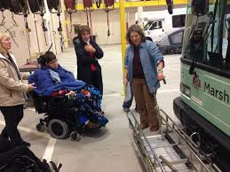
Volunteer peer-to-peer travel training remains a very popular model in many communities, as people enjoy learning from their peers in relaxed settings. Transit and human service agencies leverage their existing riders and give them training on how to be travel ambassadors.
Train-the-trainer programs also remain a popular approach to rural travel training. Existing staff may train local human and senior services agencies, who, in turn, train their own clients how to safely and independently ride local transit services.
Some communities also host annual “Transportation Days,” where the local transit service will have people come learn more about bus options available to them, practice boarding a bus and paying their fare, and more. Often times, practicing riding the bus while it is out of service can calm fears and anxieties by giving potential riders a little more time to get to know the bus and ask transit staff questions.
Levels of Rural Travel Training
There are three main levels of rural travel training:
- Transit orientation outlines the local options and services available in a given area. It may also detail topics including how to schedule a trip, preparing for a trip, and more.
- Transit familiarization demonstrates how to use a system. It typically involves a bus ride, where an overview is given on how to ride, pay your fare, and more.
- Hands-on training is training provided in a one-to-one setting repeatedly over a short time period. Training topics could include how to safely cross streets, how to board a bus using a mobility device, how to be a safe pedestrian, how to overcome anxiety and fears, and more.

Best Practices in Rural Travel Training
1. STAR Transit’s Client Advocate Program – Terrell, Texas
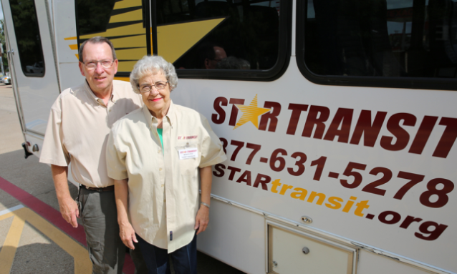
- STAR Transit is a demand response provider in rural Terrell, Texas. Their successful volunteer Client Advocate program is a peer-to-peer training model. A volunteer Client Advocate is matched with a rider in need of travel services. That volunteer is picked up first and dropped off last. He or she stays with the client who has requested a Client Advocate and helps the rider reach their destination and return home safely. In many cases, a Client Advocate will also stay with a rider during medical appointments, outpatient procedures, and other areas where care may be needed. Client Advocates support riders from the beginning to the end of their trips, teaching independent travel and safety skills along the way. This service is offered to STAR Transit riders at no additional cost, and a rider simply requests a Client Advocate when scheduling a ride.
http://www.startransit.org/star-transit/client-advocates/

2. Delmarva Community Services One Stop Travel Program – Rural Eastern Shore of Maryland
- Delmarva Community Service’s unique One-Stop Travel Program serves a large service area on Maryland’s rural Eastern Shore. Their program gives people a menu of transportation services available to them and the ability to request a Travel Trainer to assist them in learning how to utilize available services. This program looked at who was already providing educational services to people with disabilities and older adults, and those leaders came together to develop customized travel plans as needed for individuals they serve. Mobility Managers, human services staff, senior center staff, and Hispanic outreach staff all lend their expertise to the individual travel training needs.
http://www.dcsdct.org/transportation--mobility.html

3. Rogue Valley Transit District – Medford, Oregon
- RVTD’s travel training program helps people with disabilities and older adults in rural Oregon learn how to plan routes, communicate with a bus operator, navigate options, and more. RVTD also operates a transportation education program in collaboration with local school programs, including the Gus Rides the Bus interactive bus program that promotes bus and community safety.
www.rvtd.org

5. Valley Regional Transit – Meridian, Idaho
- Valley Regional Transit operates a ValleyRide travel training program. Travel Trainers teach people how to read bus schedules and maps, identify bus stops, plan trips, and more. In addition to the availability of travel trainers working one-on-one with trainees in need of travel supports, Valley Regional Transit also operates a robust Travel Information Volunteer Program. This program recruits current riders and equips them with training so that they can teach others how to ride the bus system. Volunteers may count these hours as community service as well.
www.valleyride.org

Seamless Mobility through Technology, Route Design, and Coordinated Systems

Introduction
Seamless mobility is transportation made easy for the traveler. What makes transportation seamless? Ease of movement, ease of use, availability of options, and the ability for anyone to learn how to ride a particular type of transportation with minimal explanation. Seamless mobility results in a feeling of comfort for the passenger, and when that happens, a traveler is more willing and interested to continue to use a particular mode, whether that mode is taxi, transit, bikeshare, walking, or shared ride.
Seamless mobility is made possible by infrastructure that connects without interruption. Sidewalks, biking and walking trails, stairs, elevators, ramps, and signage help the flow as travelers try to reach their destinations.
Beyond the physical infrastructure of our roads and sidewalks, technology is streamlining how people plan trips, buy tickets or pay for vehicles services, make online reservations or receive real-time information while en route.
Technology works hand in hand with coordinated and connecting systems. This includes regional coordination of transportation systems within a metropolitan area or across county lines. Examples include integrated fare collection, reservation systems, or information sharing among different transportation agencies in the same city, county or state.
Seamless mobility, or at least streamlined mobility, is achievable, and a few cities in the U.S. have made strides toward linking modes and creating fare payment structures to make it easy for both resident and visitor alike to reach their destinations, but challenges persist.

Challenges
Having more transportation options is generally considered to be a positive. If a person can choose from personal auto, transit, paratransit, bikeshare, rideshare, volunteer driver program or taxi one could say that that person’s mobility options are much better than someone who only has one or two choices. As a September 2017 Harvard Business Review article “Technology is Changing Transportation, and Cities Should Adapt” points out, however, if too many people in urban areas begin to depend on private vehicles for travel, traffic could increase and public transit systems could see dwindling fares. Whether or not this pattern occurs, these complex dynamics should be taken into consideration when a community is developing an overarching policy of what it wants its mix of mobility to look like in five to 15 years. A change in one mode ultimately affects all the other modes. As the article also points out, options are changing quickly, and the challenge is for local officials and policy makers to take a proactive role in deciding what options work best for their current and anticipated demographics. Another challenge is to think of changes that could benefit multiple modes. For example, is it possible for a community to offer an app-based service for planning and paying for trips that uses multiple modes of local transportation? Another example would be designating pick-up and drop-off zones that can be used by taxi, shared ride vehicle and transit to help maintain a flow of traffic and reduce risk to pedestrians, other drivers, cyclists, and shared ride passengers.
Several cities in the U.S. are thinking through these challenges and coming up with ways to meet customer demand for more options while also helping the customer make choices that are smart for their individual travel needs. Portland (Oregon), Houston, Denver, and Upstate New York are areas where decision-makers have moved forward technology, route changes, and redesigns to bring seamless mobility to travelers. In addition, the North American Mobility Score initiative is a means of putting power in peoples’ decision making about where they live, work and shop.
Opportunities
Technology: Electronic fare payment
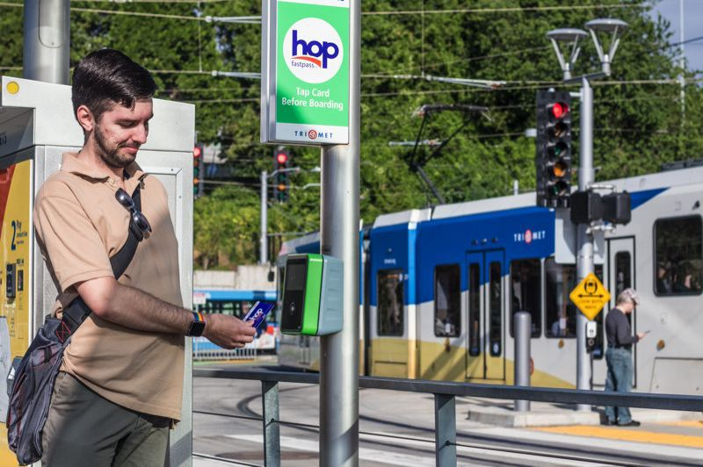
Portland, Oregon, has instituted an integrated pass system called Hop Fastpass. Transit users can load value onto their accounts and use the card for payments on TriMet, C-TRAN buses, Portland Streetcar, MAX Light Rail, and WES Commuter Rail. The fare card system is tied to the passenger’s securely stored bank information. While a number of cities in the U.S. have started integrated fare cards, Portland’s system has a rewards feature similar to credit cards or retail club memberships. With each use, a rider moves closer to earning day or monthly passes. The fare is capped once the price of a day or month pass is reached, helping riders who cannot afford the upfront costs of a full-day or monthly pass. Additional features include auto-loading, loss-prevention, and a best fare guarantee.
Initially TriMet’s efforts were focused on reducing passenger reliance on paper and coin currency and eventually incorporating smart phone technology. Another step that TriMet took in 2012 to help usher in the concept of a seamless fare system was to simplify fare collection by removing transit zones and moving to a flat rate fare system. The new Hop Fastpass electronic payment system provides the chance for passengers to move effortlessly among modes and across geographic boundaries to include C-TRAN in Clark County, Washington (Vancouver). After a successful initial pilot of 5,000 riders, Hop is being implemented throughout the Portland region, and there are plans to include the LIFT paratransit service as part of an eligible participant’s account so that they do not have to tap a card. [Photo credit: TriMet customer uses Hop Pass to pay fare. Portland Tribune file photo]

Coordinated Systems: Bus Network Redesigns
According to American Public Transportation Association statistics, bus rides made up less than half of all transit trips in the U.S. in 2014. This is the first time that bus ridership numbers have fallen to that percentage. (Bus Network Redesigns Are the ‘Hottest Trend in Transit’). The reasons for declining ridership are varied. Many cities have a broader variety of transportation options available than in recent decades; more people are taking subways, light rail, commuter rail, using bikeshare, shared ride or have left the bus system altogether. Transportation agencies are turning to route redesigns to address declining ridership. Redesigns contribute to seamless mobility for the customer by helping to reduce inefficiency in the bus network; however, redesigns do not necessarily contribute to the transit system’s farebox revenue. The movement toward denser residential development is also leading to a re-examination of how current routes are laid out.
Real-time bus departure and arrival information has made it easier to measure where there are inefficiencies in bus routes. Political will to change bus routes can be complicated and low-performing areas are typically among the first to be examined during a redesign. Network changes can make a difference, though. Cities that have recently overhauled routes include Houston, Portland, (OR), and Jacksonville, (FL). In Houston’s case, the goal was to improve frequency of service rather than to expand the coverage area but also to adjust bus service to better connect with new light rail lines. Houston was one of a number of U.S. cities that had bus routes based on early 20th century streetcar routes. Over time, these relatively straight routes have become stretched to meet the shift in employment and population centers without comprehensive redesign. In Houston’s situation, many transit users wanted to reach universities, hospital centers, and suburban office and shopping complexes, and making changes to meet these needs required a systematic review of the overall transit system. The Metro system made a decision to shift 80% of its resources toward building ridership, and 20% toward maintaining coverage. Although Houston experienced relatively flat ridership growth overall after the changes, bus ridership grew by 1.2% rather than decreasing.
In Upstate New York, bus system redesigns have led to even higher ridership growth. In Albany, changes to the network have resulted in a 25% increase in ridership since 2009. The Capital District Transportation Authority has decided to focus on frequency of service in Albany, Saratoga Springs, Schenectady, and Troy. The CEO of the authority says that when service is frequent and reliable, it “starts to feel more like a rail system.” (Vock) This predictable reliability encourages customers who want to reach their destinations quickly.
Infrastructure and Connected Systems: Denver’s A Line Rail
Spring 2017 marked the one-year anniversary of the operation of Denver’s A Line rail service between downtown Denver and Denver International Airport. The rail line—and its at-grade crossings—have had operational glitches, yet, as noted in an April 9th Denver Post article, daily ridership is close to initial projections of 18,000 riders per day with an 89% on-time record. With redevelopment of Denver’s Union Station and Amtrak’s reinstatement of snow train service to ski areas west of the city, Denver is focusing on connections to and through the central business district. As part of this effort, Denver is also in the midst of analyzing downtown’s 16th Street Mall 35 years after the pedestrian-friendly mall was created. Free bus service with frequent headways is a hallmark of the current mall, making it possible for visitors and locals alike to make short connections to hotels, restaurants, and theaters.
An October 2017 Denver Post story announced that the Regional Transportation District and the Downtown Denver Partnership are studying three different busway and pedestrian alignments with bus service continuing to remain a feature. Proposals include placing both directions of transit in the center with amenities and walkways on the side or interspersing amenities such as cafes, entertainment and seating. The mall was originally designed as a transitway, and officials expect to maintain the 16th Street path of travel used by the buses yet allow room for growth in daily ridership and emphasize gathering places along the mall. Currently, passengers who purchase an A Line airport fare receive unlimited travel on any RTD service (bus and rail) for the remainder of the service day for which the ticket was purchased. Tickets may be purchased through accessible vending machines on train platforms. By streamlining the fare payment system and connecting prime destinations, Denver is working toward creating a seamless experience that not only incorporates RTD vehicles but also national air and rail systems.
Infrastructure: MobilityScore
While the Portland, Houston, and Denver examples stress the importance of how public policy decisions shape seamless mobility, it cannot be ignored that personal choice—lifestyle choice—does play a role in how seamless one’s connections are. MobilityScore is a tool that was recently introduced in North America that can help people make decisions about their residence and connections to the transportation network. In September 2017, Fast Company posted the article “MobilityScore Tells You Exactly How Easy a Place Is to Get Around without a Car.” The article notes that around 60% of U.S. trips less than a mile are made by car. In order to provide more information for those who want to make a trip by a mode other than single occupancy vehicle, the technology firm TransitScreen developed a new MobilityScore tool similar to the now well-recognized Walkability Score.
MobilityScore provides alternative transit options available within a one-mile radius of locations within the U.S. and Canada. Data is provided for subways and buses, car sharing services (short term rental cars), bikeshare, and ride hailing services like Lyft and Uber. Scores range from 0 to 100, no mobility options to excellent mobility choices. The score takes into account changes in the availability of transportation during the day—acknowledging that some locations are served well by transit during the day but not as well on weekends or evenings.
The Mobility Score of an area is highly dependent on existing facilities, but it is a useful tool for individuals to reference as part of their residential decision-making, in particular older adults who may be giving up the car keys and looking for walking and transit options.

Summary
Seamless connectivity is both cause and effect. Cities and regions are reviewing routes and examining increased frequency as a way to attract and keep bus transit customers while keeping up with customer demand for electronic and mobile-friendly payment systems. Connectivity is the result, or effect, of demand for connected, easy-to-use services. In all the case studies, seamlessness has also been a cause, or driver, of economic growth. Residents and businesses are attracted to places that are easy to reach and communities that can be traversed on foot, by bicycle, shared ride, independent auto, and transit. Seamless connectivity is about removing barriers, adapting transportation services over time to match changes in land use, job centers, and customer patterns. Ultimately, seamless connections are about ease of use and providing passengers with a way to feel empowered by and not intimidated by the mechanics of using more than one transportation mode.
Resources
Added Flights, Expanded Train Service Offer Easy Travel Options to Colorado Ski Resorts (2017, October 4). Transworld Snowboarding.http://snowboarding.transworld.net/news/added-flights-expanded-train-service-offer-easy-travel-options-colorado-ski-resorts/
Aguilar, John. (2017, April 9). One year in: Denver’s airport train navigates interruptions, a $6 million gate glitch and surprisingly strong ridership. Denver Post. http://www.denverpost.com/2017/04/09/denver-airport-train-one-year-in/
Anzilotti, Eillie (2017, September 22). MobilityScore Tells You Exactly How Easy A Place Is To Get Around Without A Car. Fast Company. https://www.fastcompany.com/40471673/mobilityscore-tells-you-exactly-how-easy-a-place-is-to-get-around-without-a-car
Knupfer, Stefan, Eric Hanson and Shannon Bouton. (2017, September 13). Technology Is Changing Transportation, and Cities Should Adapt. Harvard Business Review. https://hbr.org/2017/09/technology-is-changing-transportation-and-cities-should-adapt
Murray, Jon. (2017, October 2). Denver’s 16th Street Mall Overhaul – First in Its 35 Years – Could Realign Bus Lanes A Lot, A Little or Not at All. Denver Post. http://www.denverpost.com/2017/10/02/denvers-16th-street-mall-overhaul-first-in-its-35-years-could-realign-bus-lanes/
Tucker, Chris. (2017, August 8). Re-Inventing Electronic Fare Payment: TriMet Hop FastPass Works to Bring Transit to the 21st Century. Mass Transit. http://www.masstransitmag.com/article/12355074/re-inventing-electronic-fare-payment-trimet-hop-fastpass-works-to-bring-transit-to-the-21st-century
Vock, Daniel (2017, September 18). Bus Network Redesigns Are the ‘Hottest Trend in Transit’. Future Structure. http://www.govtech.com/fs/Bus-Network-Redesigns-are-the-Hottest-Trend-in-Transit.html

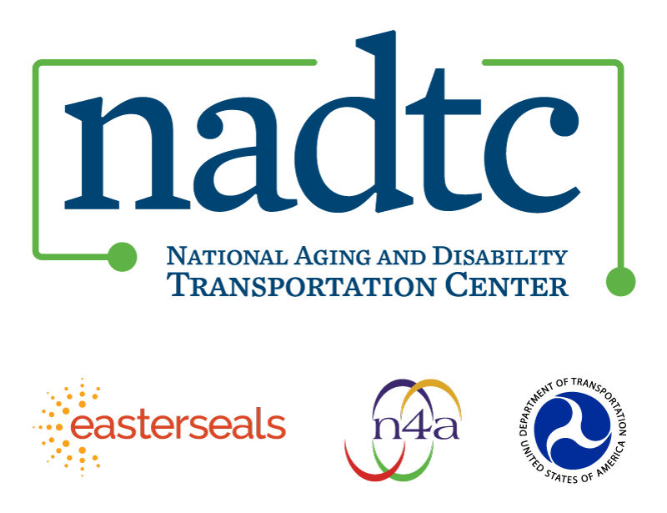

The National Aging and Disability Transportation Center is funded through a cooperative agreement of Easter Seals, the National Association of Area Agencies on Aging, and the U.S, Department of Transportation, Federal Transit Administration, with guidance from the U.S. Department of Health and Human Services, Administration for Community Living. NADTC’s mission is to increase accessible transportation options for older adults, people with disabilities and caregivers nationwide.

National Aging and Disability Transportation Center
Washington, D.C. 20005
Telephone and toll-free hotline: (866) 983-3222
TTY: (202) 347-7385
Email: contact@nadtc.org
Website: www.nadtc.org

Follow us:
Facebook
Twitter
YouTube
LinkedIn

