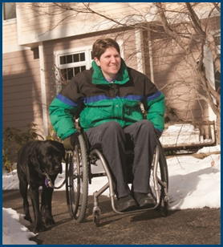
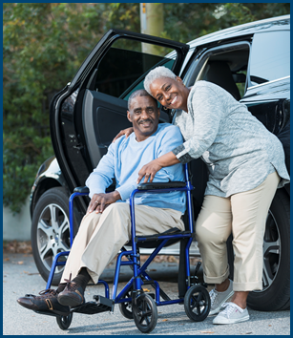
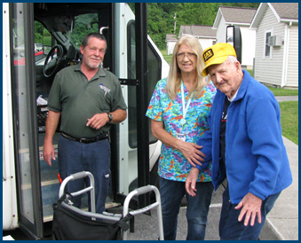

Accessible Bikeshare:
Benefits to Older Adults & People with Disabilities

Topic Spotlight from the NADTC
2016 Transportation Trends Report

Introduction

Accessible Bikeshare and its availability for older adults and people with disabilities is the focus of this Topic Spotlight, one of seven transportation issues reported on in the National Aging and Disability Transportation Center 2016 Transportation Trends Report. The complete report, available at www.nadtc.org, discusses trending topics—significant issues that affect the availability of accessible transportation in communities—identified by the National Aging and Disability Transportation Center (NADTC) in 2016.
Short information briefs were prepared in early 2017 on topics concerning developments in the field of transportation that are newsworthy and subject to change over time (e.g., shared ride services, bikeshare); others relate to longstanding problems that are not amenable to one-size-fits-all solutions and continue to present new challenges (e.g., crossing boundaries, safety). The selected topics are:
- Americans with Disabilities Act
- Accessible Bikeshare
- Crossing Jurisdictional Boundaries
- First Mile/Last Mile
- Safety
- Section 5310
- Shared Ride Services
All seven topics are covered in the full Trends Report linked above.

Accessible Bikeshare:
Benefits to Older Adults & People with Disabilities

Introduction

Bicycle sharing systems, commonly referred to as public bicycle systems or bikeshare systems, are services that provide additional mobility options for members of the community in which the bikeshare system is located. Bikeshare affords individuals the option to borrow a bike from one point and return it to another. Individuals typically use bikes from bikeshare docks for short trips in a given area, such as first and last mile connections to public transportation systems.
Costs for using a bikeshare system range from a daily fee for new users, to a subscription fee for annual members typically ranging from $65-$120. Some bikeshare programs are also free. Many systems also utilize mobile application technologies to show nearby bike station locations with available bikes and open bike docks. According to the National Bikeshare Association, as of June 2014, public bikesharing systems were available in 50 countries on five continents.

Bikesharing systems facilitate one-way rides to work, school, medical destinations, shopping destinations, and other community opportunities. These systems offer increased transportation choices as an alternative to driving while simultaneously assisting people in moving about their communities. For people with disabilities and older adults, additional transportation options can be critical to accessing needed community and regional services.

As bikesharing efforts expand across the United States, there has been an increased emphasis on ensuring these systems and programs are both accessible and inclusive to all. Fully inclusive bikesharing systems, including some mentioned as best practices in this report, recognize that they serve a diverse community needing different types of bikes for a variety of purposes. MobilityLab, a key researcher on accessible transportation options, finds that bikeshare helps people who do not own a bike or who may want to only ride a short distance in a given area with the chance to ride, but that as these programs grow, there is a heightened need to ensure all community members can benefit from the options available to them. Bikesharing enables people to access their communities in ways they might not have previously done. It also enables first and last mile connections to transportation options, thereby affording greater travel independence to community members.
There are also many programs that fall outside of the traditional city or campus-based model, including creative rural and suburban bikesharing systems that provide the same types of connections to transit that larger urban bikeshare programs do. One system in rural Montgomery County, Pennsylvania, uses libraries to facilitate short-term bike loan programs. Users can rent a bike for a day for free, and use it to connect to community destinations and transportation services. The bikes can be returned to any library within the county system, not necessarily the point of origin.

Types of Accessible Bicycles

As bikesharing grows in popularity and efforts are made to incorporate accessible bikes into the fleet of a new or existing bikeshare system, it is important to understand that there is not a “one size fits all” type of accessible bike. To utilize a bikeshare system, one user may need to use an E-bike that assists in propelling and pedaling, while another user may need a hand bike that eliminates the need for foot pedaling completely. Accessible bikes are described below.
Handcycles  Handcycles feature a hand-propelled design and easy-to-use hand steering and braking controls. They often feature an upright seat for maximum comfort and ease of use. | 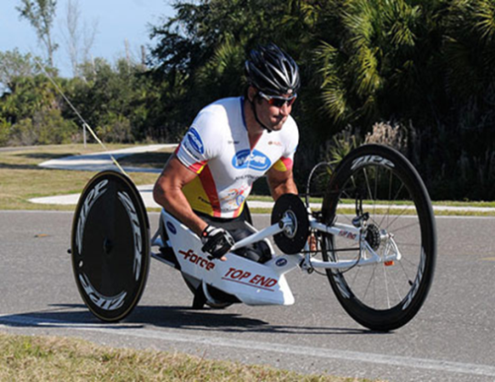
E-Bikes  Commonly referred to as E-Bikes, electric assist bicycles feature an integrated electric motor which can be used for propulsion. Electric assist motors are used to assist users in pedaling. | 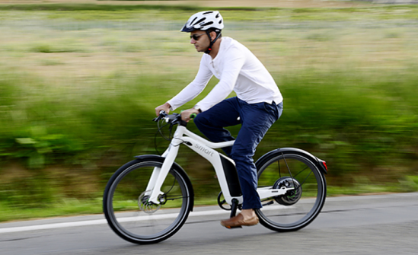
Side-by-Side Bikes  These bikes, sometimes called tandem bikes, feature side-by-side seating for pairs for riders of different sizes and abilities. They offer twin independent transmissions so each rider can pedal at his or her own pace. Side-by-side bikes typically also feature hand brakes. | 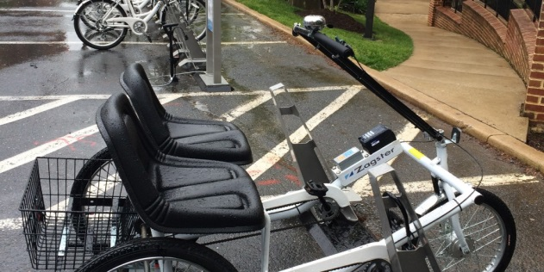
Trikes  Trikes, or tricycles, offer a different type of design than a traditional bicycle. They feature three wheels instead of two that affords users in staying seated in a more natural position. They also have hand brakes and a heavy duty frame construction. | 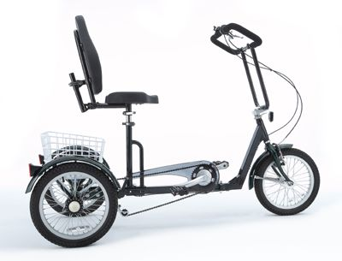
Bicycle Attachments  There are various types of attachments for bicycles, and some attachments can be cheaper additions to current bicycles. One design, for example, features a one-wheeled bike attachment that can be buckled onto a wheelchair, thus creating tricycle capabilities for the user. | 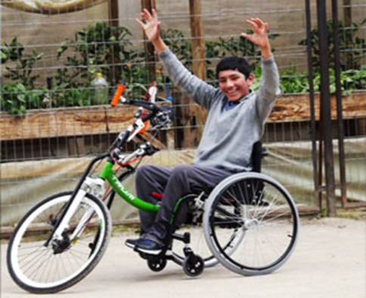

Best Practices in Accessible Bikesharing
- College Park, Maryland mBike

mBike was launched in May 2016 as a partnership between the city of College Park, Maryland, the University of Maryland, and the bikeshare operator Zagster. The mBike program has 125 bikes that serve students, faculty, staff, and residents on the university campus and in the surrounding city, and includes five accessible bikes in its fleet. Available accessible bicycles include hand cycles, tricycles, and side-by-side bikes.

- Ohio State University Bikeshare Program

Ohio State University’s system has 115 bicycles and 15 stations that deliver a safe and sustainable alternative transportation option for the large university community. In addition to commuter bicycles, the system also includes tandem, hand cycle, electric assist, heavy duty cruisers designed to carry more weight, and three-wheeled cargo bikes that have a platform or basket designed for carrying packages or boxes.

- Westminster, Colorado
The town of Westminster launched its new accessible bikeshare program in June 2016, designed to provide the entire community with equitable access to a convenient, affordable, and healthy way to experience Westminster. The system includes 32 cruiser bikes and eight accessible bikes (three hand bikes and five trikes).

- City of Detroit Bikeshare Program/Shift Transit

This innovative new program will launch in spring 2017 and features 420 bikes, including a range of accessible bikes to be selected by the City of Detroit and the manufacturer, Shift Transit.

Conclusion

The advent of bikeshare programs has brought increased choices in transportation and a greater level of independence to users of such systems. However, since accessible bikesharing is a relatively new concept, it does not come without its challenges or growing pains. One of the current challenges as bikeshare expands is the availability of accessible options that benefit people with disabilities and older adults in all bikeshare programs and systems. While some communities, such as those highlighted in this report, have been quick to develop solutions to make bikesharing accessible and inclusive, other communities have been slow to adopt similar efforts.
Planning partners should make every effort to include the disability and aging communities in all planning efforts focused on bikesharing. It is necessary to hear the ideas of potential system users and seek out opportunities to make systems inclusive and accessible to all.
As bikesharing continues to grow, special emphasis should be placed on safety for cyclists and pedestrians. Incorporating safety goals into overall bikeshare and first/last mile connection efforts is an integral part of promoting community safety.

Resources
Ohio State Bikesharing Program to Offer Accessible Bikes
https://odi.osu.edu/news/news-archive/bike-sharing-program-to-offer-accessible-bikes.html

College Park’s mBike Brings Accessible Bikeshare to the Region
http://mobilitylab.org/2016/05/12/college-parks-mbike-brings-accessible-bikeshare-region/

Zagster Company Website
http://www.zagster.com/
Zagster Press Release: Westminster and Zagster Introduce Inclusive Bike Share Program
http://www.zagster.com/press/westminster-and-zagster-introduce-inclusive-bike-share-program

Is Biketown Bike Share for All? Or Only the Able-Bodied?
http://bikeportland.org/2016/06/02/bike-share-for-all-or-only-the-able-bodied-184789

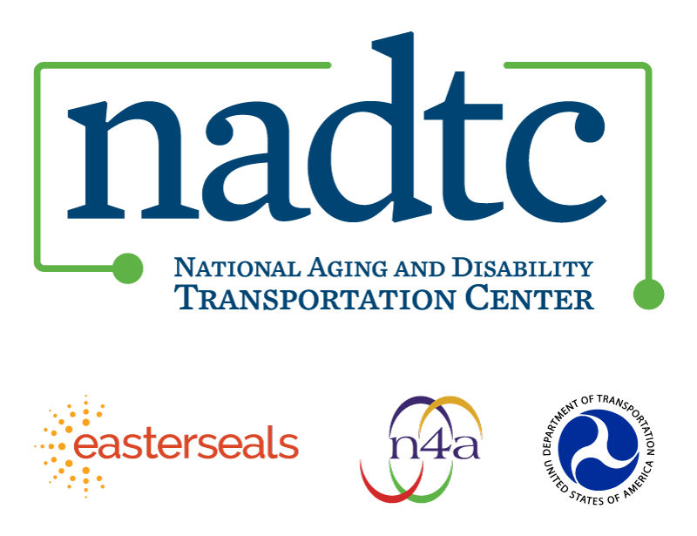

The National Aging and Disability Transportation Center is funded through a cooperative agreement of Easter Seals, the National Association of Area Agencies on Aging, and the U.S, Department of Transportation, Federal Transit Administration, with guidance from the U.S. Department of Health and Human Services, Administration for Community Living. NADTC’s mission is to increase accessible transportation options for older adults, people with disabilities and caregivers nationwide.

National Aging and Disability Transportation Center
Washington, D.C. 20005
Telephone: (866) 983-3222
TTY: (202) 347-7385
Email: contact@nadtc.org
Website: www.nadtc.org

Follow us:
Facebook
Twitter
YouTube
LinkedIn

