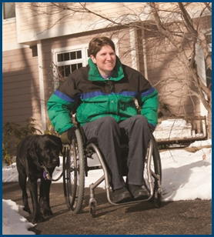
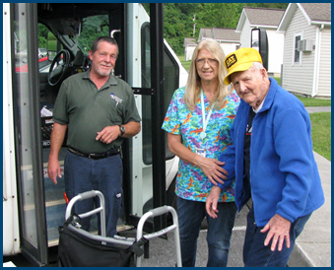

Crossing Jurisdictional Boundaries

Topic Spotlight from the NADTC
2016 Transportation Trends Report

Introduction

The ability to Cross Jurisdictional Boundaries and coordinate transportation services greatly affects mobility for older adults and people with disabilities. Crossing Jurisdictional Boundaries is the focus of this Topic Spotlight, one of seven transportation issues reported on in the National Aging and Disability Transportation Center 2016 Transportation Trends Report. The complete report, available at www.nadtc.org, discusses trending topics—significant issues that affect the availability of accessible transportation in communities—identified by the National Aging and Disability Transportation Center (NADTC) in 2016.
Short information briefs were prepared in early 2017 on topics concerning developments in the field of transportation that are newsworthy and subject to change over time (e.g., shared ride services, bikeshare); others relate to longstanding problems that are not amenable to one-size-fits-all solutions and continue to present new challenges (e.g., crossing boundaries, safety). The selected topics are:
- Americans with Disabilities Act
- Accessible Bikeshare
- Crossing Jurisdictional Boundaries
- First Mile/Last Mile
- Safety
- Section 5310
- Shared Ride Services
All seven topics are covered in the full Trends Report linked above.

Crossing Jurisdictional Boundaries

Introduction

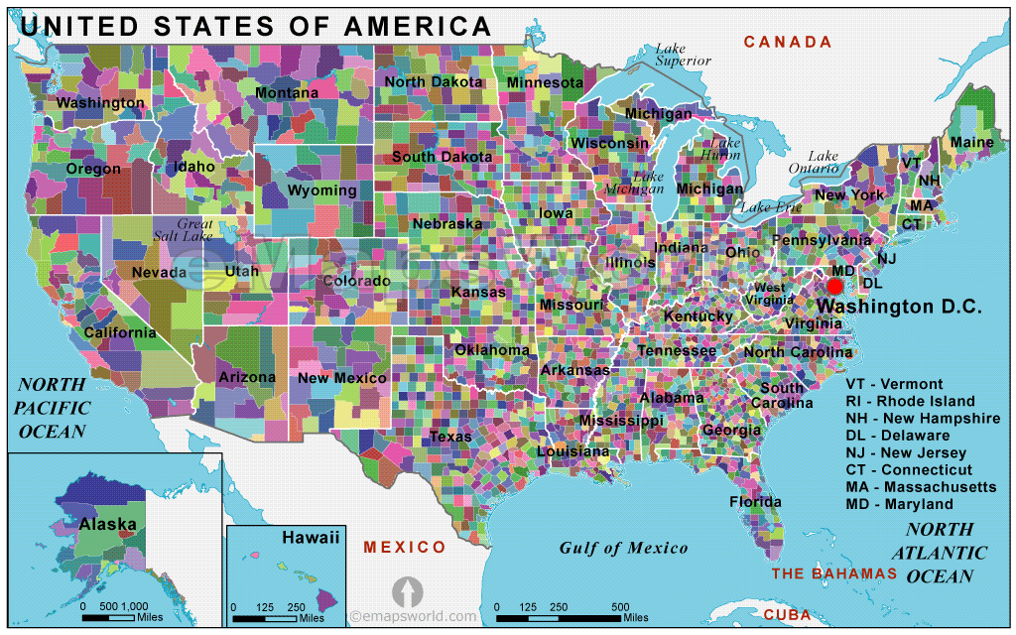
Crossing a county or state line may go unnoticed by many of us when driving, but for many people, especially older adults and people with disabilities who cannot drive, that line may represent a barrier to much-needed services. Being able to access medical care, shopping, work and social connections is vitally important to people as part of their daily lives. While many people, including older adults and people with disabilities, are able to accomplish this on their own, those who rely on public transportation services sometimes encounter obstacles based on the geographic area served. The source of transportation funds, which may come from a single county or a limited amount of funding available to cover a large geographic area, may restrict access to needed services. According to the American Public Transportation Association (APTA) Factbook, in 2013 there were more than 6,800 organizations providing transportation in the United States, with the majority of the systems being demand response and serving older adults and people with disabilities. These organizations were unequally distributed between cities and 3,143 counties and county equivalents throughout the country. While 38 states have at least one transportation agency covering more than one county, outside the major cities at least one quarter of the U.S. lacks public transportation services to travel to a neighboring county and its services. The following map of the United States divided into counties and county equivalents is an illustration of the possible patchwork of systems.

To solve the frequent problem of being able to connect people to the services they need on the other side of a border is not easy, and there is no single solution. As noted above, the primary causes of the fragmentation of transportation services are funding sources and services that are limited to one local jurisdiction. A combination of approaches is needed to expand services beyond the jurisdictional boundary, and better coordination and communication among transportation providers, support services, and representatives of many political levels is a fundamental step.

Case Examples

Following are selected examples of coordination among transportation, human services, and government agencies that illustrate the challenges, as well as efforts to diminish or eliminate barriers, to enable older adults and people with disabilities to access the services they need. These examples represent suburban, rural, and frontier environments--each with their own set of challenges.

Montgomery County, MD Call-n-Ride (Suburban)
Montgomery County created a taxi voucher program called Call-n-Ride to provide medical transportation, both within the county and to certain other jurisdictions, for low income residents who are aged 65 years or older or who have a disability. Call-n-Ride is funded by the county and utilizes county-based taxi providers. Montgomery County is on the northern border of Washington, DC, and is served by the region’s public transportation system which primarily connects it with Washington, northern Virginia, and a neighboring county in Maryland, and the county also offers a number of county-based transportation options. Call-n-Ride enables eligible residents of the county to get on-demand taxi services at a much cheaper rate, and to get to places that are not served by the public transit system, such as hospitals in Baltimore, MD. However, as much as it exemplifies good coordination between county and private transportation providers in the county, one problem is helping individuals who travel outside the county using Call-n-Ride to get back home. There is currently no relationship between Montgomery County and taxi services outside of the county, so riders cannot use the voucher for a return trip. This is a challenge that the county is still working to resolve.

Green River, KY Intra-County Transit System (Rural)
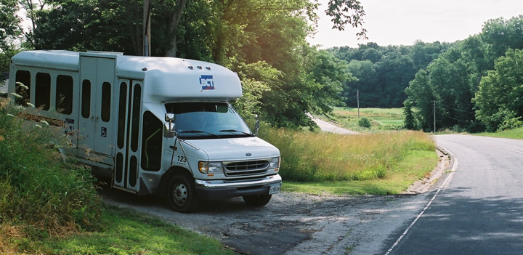
The Green River Area Development District was formed by seven counties, Daviess, Henderson, Ohio, McLean, Webster, Union, and Hancock, in the northern part of Kentucky, offering aging, health and social services. This organization created the Green River Intra-County Transit System (GRITS) to provide residents with region-wide transportation that enables them to travel and access services in the seven county area. Seven different county governments, each with their own needs and revenue sources, found common ground and came together to create a coordinated system that serves the entire region. As with Call-n-Ride, while this coordination has increased accessibility for the residents, further cooperation with other organizations and local governments could improve some people’s lives. For example, it is now easier for residents from outlying counties to travel to Henderson or Owensboro (two urban areas), but with the trip frequency limited to once a week, it is still not very practical for individuals who need frequent medical services such as dialysis.

Grand Gateway Economic Development – Pelivan (Frontier)
Another example of coordination amongst various organizations and governments is a system called Pelivan Transit. The Grand Gateway Economic Development Association established Pelivan Transit in 1985 to provide flexible, accessible transportation to a rural, seven-county area in northeastern Oklahoma. The program serves an aging and geographically dispersed population, offering demand-response, deviated fixed-route, and transportation to nutrition sites, work, medical care, and other activities. Public transportation provided by Pelivan includes integration with tribal systems through contracts with 10 tribal jurisdictions. Grand Gateway Area Agency on Aging works closely with Pelivan Transportation to improve existing service and transportation options for seniors.

Pelivan Transit has actively pursued and secured a diverse range of federal funding. Funding sources include Section 5311 (Rural & Small Urban Areas), Discretionary Section 5309 (Bus and Bus Facilities), Section 5310 (Elders/Disabled Persons), as well as Section 5311(c) Tribal Transit Funding. Some of these grants require local matching funds, which Pelivan meets through its service contracts with the State of Oklahoma, local municipalities, the Department of Human Services’ Temporary Assistance for Needy Families, Medicaid nonemergency transportation and Older Americans Act nutrition funding (Title III-C). It also supplements these funds with revenue from advertising, private for-profit businesses, nonprofit foundations and fares. Multi-county, multi-tribal, and multi-organizational cooperation and coordination created a system allowing travel for residents throughout a large territory that would otherwise have services limited to only one tribe or county.

Summary

The above examples highlight organizations that recognized the needs of their residents, formed partnerships with other organizations to explore options, and worked to address a jurisdictional or transportation boundary through better coordination of services. In the example of Montgomery County, MD, it was cooperation between county and private services that created taxi vouchers that got people to services outside of the county. In Kentucky, it was communication and cooperation between various county governments that created a larger transportation network. Finally, in Oklahoma, there was coordination among several counties, tribal governments and other organizations that opened up areas and services to groups of people who would otherwise be isolated. Coordination requires a lot of work. Resolving a boundary issue requires first of all, a willingness to seek out and communicate with other groups and/or local governments that have a vested interest in providing better services to the target populations. As these case examples show, through sharing of ideas, information, and resources (including funds), solutions may be found.

Resources

American Public Transportation Association (APTA), 2015 Public Transportation Factbook
https://www.apta.com/resources/statistics/Documents/FactBook/2015-APTA-Fact-Book.pdf

APTA; U.S. Local and State Transit Links
http://www.apta.com/resources/links/unitedstates/pages/default.aspx
- Links to thousands of transit agencies for cities, towns, and counties across the United States.

United States Census Bureau
https://censtats.census.gov/usa/usainfo.shtml

Call-n-Ride Website
https://www2.montgomerycountymd.gov/CNR/

Call-n-Ride Brochure
http://www.montgomerycountymd.gov/DOT-Transit/Resources/Files/seniors/Call-n-Ride%20Brochure.pdf

Green River Area Development District Website
http://www.gradd.com/AboutUs/
Pelivan Transit Website
http://www.pelivantransit.org/

Transit Cooperative Research Program, TCRP Report 101, Toolkit for Rural Community Coordinated Transportation Services: Provides further examples of the benefits of coordinating services between organizations, as well as guidelines on how to establish and implement coordinating efforts.
http://onlinepubs.trb.org/onlinepubs/tcrp/tcrp_rpt_101.pdf -

Federal Highway Administration, Planning for Transportation in Rural Areas: A detailed examination and explanation of rural transportation by the Federal Highway Administration.
http://www.fhwa.dot.gov/planning/publications/rural_areas_planning/page03.cfm

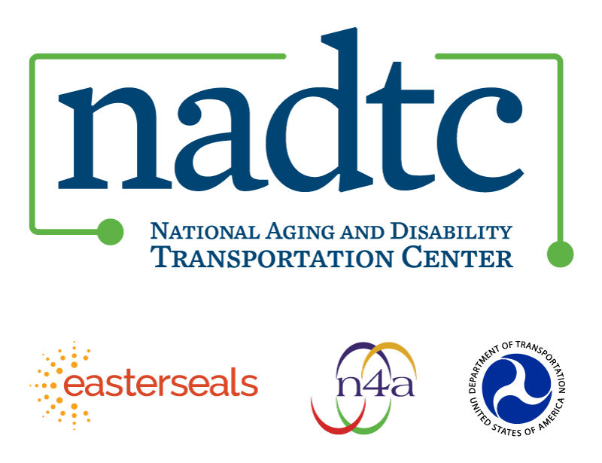

The National Aging and Disability Transportation Center is funded through a cooperative agreement of Easter Seals, the National Association of Area Agencies on Aging, and the U.S, Department of Transportation, Federal Transit Administration, with guidance from the U.S. Department of Health and Human Services, Administration for Community Living. NADTC’s mission is to increase accessible transportation options for older adults, people with disabilities and caregivers nationwide.

National Aging and Disability Transportation Center
Washington, D.C. 20005
Telephone: (866) 983-3222
TTY: (202) 347-7385
Email: contact@nadtc.org
Website: www.nadtc.org

Follow us:
Facebook
Twitter
YouTube
LinkedIn

