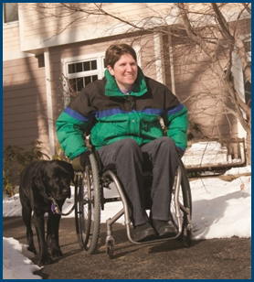
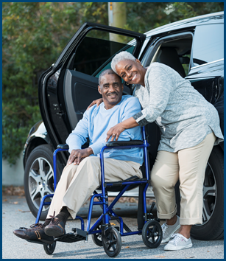
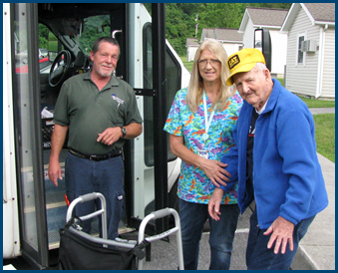

First Mile/Last Mile: Challenges and Opportunities

Topic Spotlight from the NADTC
2016 Transportation Trends Report

Introduction

Successful completion of the First Mile and Last Mile of any public transportation trip is critical for older adults and people with disabilities who want to independently move around their communities. First Mile/Last Mile is the focus of this Topic Spotlight, one of seven transportation issues reported on in the National Aging and Disability Transportation Center 2016 Transportation Trends Report. The complete report, available at www.nadtc.org, discusses trending topics—significant issues that affect the availability of accessible transportation in communities—identified by the National Aging and Disability Transportation Center (NADTC) in 2016.
Short information briefs were prepared in early 2017 on topics concerning developments in the field of transportation that are newsworthy and subject to change over time (e.g., shared ride services, bikeshare); others relate to longstanding problems that are not amenable to one-size-fits-all solutions and continue to present new challenges (e.g., crossing boundaries, safety). The selected topics are:
- Americans with Disabilities Act
- Accessible Bikeshare
- Crossing Jurisdictional Boundaries
- First Mile/Last Mile
- Safety
- Section 5310
- Shared Ride Services
All seven topics are covered in the full Trends Report linked above.

First Mile/Last Mile: Challenges and Opportunities

Introduction

Fixed-route public transportation accessibility requirements became law with the passage of the Americans with Disabilities Act of 1990. Since that time, concerted effort has been made to inform travelers of the options they have to reach destinations by public fixed-route bus or rail service and of the options available for ADA-complementary paratransit or Demand Response services. In addition, travel has become easier with updates to vehicle accessibility (e.g., kneeling buses, transition of lifts to ramps) as technology has improved. Despite these advances, a continuing challenge is connecting passengers to the public transportation system itself. Gaps include lack of service connections between transportation providers; physical breaks, such as an incomplete sidewalk system when a person is traveling to the bus stop; insufficient availability of alternate modes to reach a final destination after leaving the transit system; lack of coordination among providers; inadequate information about options; and differing levels of familiarity with and use of mobile or desktop technology applications by passengers. These gaps are referred to as “first-mile/last-mile” issues. This segment of the Trends Report examines the challenges and opportunities related to that first and last mile when a person attempts to complete a transit trip from true origin to final destination.

Challenges and Issues Related to First Mile/Last Mile

According to Transloc’s January 2016 blog post, Eliminating Public Transit’s First-Mile/Last Mile Problem, many people in the United States are ‘comfortable’ walking one-quarter mile or less to reach public transportation and then reach their destination on the other end. Many have the ability to walk farther than ¼ mile and do so to reach bus or rail service; however, people with disabilities and older adults may not be able to walk that far, especially when rest stops or completed sidewalks are not available. A lack of connection from front door or curb to the nearest transportation network or a longer than acceptable distance to transit can result in seniors driving longer. It can also result in older adults and people with disabilities traveling less, leading to decreased health and nutrition, or an inability to reach needed medical services.

Data from the National Highway Traffic Safety Administration (NHTSA) indicates that older drivers made up 18% of all licensed drivers in 2014 compared to 15% in 2005. The overall motor vehicle fatality rate declined for the 65 and older age group from 2005 to 2014; however it should be noted that the fatality rate for that age group has been increasing since the 2009. An October 2016 Toronto Star article noted that 68% of Canadians age 65 to 74 used driving as their primary means of transportation; only 31% of residents over age 85 were driving. Strategic driving cessation programs put into place in North America needs to be accompanied by adjustments to transit and alternate transportation modes that take into consideration travel needs and service frequency, as well as improvements to pathways and street intersections so that older adults would be more able and willing to walk to nearby destinations.

People with disabilities may have needs similar to or different from older adults depending on their ability to drive, use regular fixed-route transit, use bikeshare, take a taxi, or travel by rideshare services. For both older adults and people with disabilities, a person’s familiarity with transit offerings may depend on how well a person is able to access information and services through a phone or the internet, whether accessible bikeshare is available in the community, and how well local systems coordinate to support origin and destination connections. In addition, distance to the nearest public transportation routes affect awareness and comfort with using public transportation.

Four Opportunities for Improving First Mile/Last Mile

What are some of the opportunities available to close the first mile/last mile gaps? Four approaches have featured prominently in recent news and reports, and implementation depends on a community’s needs, geography, and demographics. Approaches include a) improving pedestrian access to transit; b) providing alternate modes such as bikeshare, taxi or rideshare (e.g., transportation network companies); b) technology, apps, mobile reservations; and d) coordination and partnerships between traditional public transportation agencies and private providers. The following section provides a snapshot of state or local practices that incorporate one or more of these four approaches.

Improving Pedestrian Access

The ability to use fixed-route transit hinges on the ability to reach public transportation. The number of travelers who can use fixed-route bus or rail increases when sidewalks are completed, when crosswalks have signals, when pedestrian signals offer adequate crossing times, benches or rest points are available, and when transit stops are fully accessible. The Hawaii Department of Transportation is addressing all of these factors through a statewide pedestrian master plan. A Hawaii DOT pedestrian toolbox contains sections on accessibility and pedestrian access to transit that highlight best practices. The toolbox suggests some simple measures that can make a big difference. For example, humans, by nature, tend to pick the most direct path of travel to reach a destination. With this in mind, bridges over streams, paths through parks and neighborhoods, and walkways that connect dead-end streets can be constructed so that pedestrians are not taking a circuitous route to reach transit. Section 6 of the toolkit includes a comparison of transit stop locations related to intersections and how stop placement can help or hinder pedestrians approaching a bus, rail, or bus rapid transit stop. As part of facility construction, lighting, benches, signs, and landscaping maintenance all need to be taken into consideration. Adding shade, a windbreak, a bench, and well-maintained lighting along the path of travel can make all the difference as to whether a rider chooses transit versus another mode or not traveling at all. These improvements also affect whether an older adult or person with a disability is able to use fixed-route transit versus paratransit services.
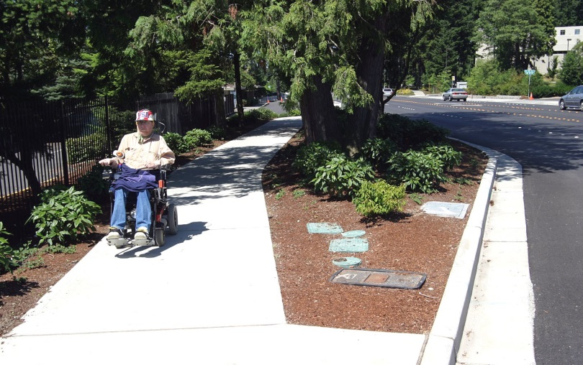
Alternate Modes

The increase in bicycle use, creation of dedicated cycling lanes, and the growth in bikeshare reflect public interest in economical, convenient, and environmentally friendly means of travel. For bikeshare to be an effective alternative for travelers of varying ages and abilities, accessible bicycles—tricycles and handcycles (powered by the rider’s hands rather than his or her legs)—must be available and identifiable on bikeshare apps. Bikeshare systems in Columbus, Ohio, Carmel, Indiana, Westminster, Colorado, and College Park, Maryland, have handcycles in their fleets. In the College Park system, riders can choose among tricycles, side-by-side bikes, and a handcycle. All of the accessible bikes can be checked out and docked at any of the 14 stations around the city, and the accessible bikes include reflectors, bells, and lights. Improvements are under way so that the bikeshare app indicates where the accessible bikes are within the system. In an article on the College Park system, a cyclist who has disabilities is quoted, saying that bikeshare systems “are meant to provide transportation for the people that are there, and in all cases, there are going to be people with disabilities. It makes a lot of business sense for bikeshare companies to be creating bikes that everyone can use.” In San Antonio, Texas, tricycles have been tested and similar to the other cities mentioned, locating a three-wheel cycle may take the assistance of a customer service representative. The easier it is to get to these accessible bicycles, the more apt they are to get used.

Technology Apps and Mobile Reservations

Valley Metro in Phoenix, Arizona, has received a Federal Transit Administration grant to develop a mobile app that integrates trip planning and ticketing. The app will incorporate the area’s light rail, bus, and paratransit systems. Transportation network companies will participate to assist with connections from transit to rider destinations. Mobile ticketing will link to apps for Lyft and Grid Bikeshare reservations. App users can pay for transit fares, reserve a bicycle, or transfer to a Lyft app if they want to make a rideshare reservation. The app project is being funded by the Federal Transit Administration, and future phases will include data alerts of bus and rail arrivals, reservation and cancellation of paratransit trips, and single payment options for multiple modes—transit, bikeshare, and rideshare. A Valley Transit survey has indicated that 65% of Valley Metro riders use smart phones, so the system sees the free app has having broad appeal.

Coordination and Partnerships

Partnerships between public agencies and private companies have been essential to the growth in shared modes, completion of pedestrian connections, and technology deployment. Mass Transit Magazine recently featured an example of how the Metropolitan Atlanta Rapid Transit Authority and Pinellas Suncoast Transit Authority have begun partnering with Uber by using an On the Go app so that rail or bus customers can reach their final destinations. In the Denver region and in Portland, Oregon, Lyft is working with transit districts on app integration. In Denver RTD’s pilot, Lyft provides subsidized rides to and from the City of Centennial’s Dry Creek light rail station. What makes the Lyft partnership so appealing? As noted in an August 2016 City Lab article, the Centennial model connects riders directly to the light-rail network, which provides regular, on-time service, and the associated trip-planning tools are simple and intuitive to use. Ease of movement and a lack of a cumbersome process are essential for first-mile/last mile models.

Summary

Innovations and increased emphasis on walking, cycling, and livable communities means opportunities for older adults and people with disabilities who would like to use public transportation but have been unable to complete that first or last mile. Mobile technology is opening doors by promoting the integration of different transportation providers’ fare payment and reservations systems into one seamless app or concierge number. When implementing first-mile/last-mile solutions, each gap-closing approach relies on the other approaches being in place, starting with the basic foundation of travelers being able to walk to public transit if they are physically able, then the secondary stage of supplementing pedestrian routes with alternate modes (e.g., accessible bikeshare and rideshare), and finally, making technology interfaces with alternate modes (e.g., apps, trip planners, and one-call centers) available to riders.

Resources

Gibson, Alex. (2016, January 26). Transloc.
http://transloc.com/eliminating-public-transits-first-milelast-mile-problem

National Highway Traffic Safety Administration. (2016, May). Traffic Safety Facts: Older Population.
https://crashstats.nhtsa.dot.gov/Api/Public/ViewPublication/812273

Spurr, Ben. (2016, October 24). Transportation Gaps Keep Seniors Driving Too Long: Study. Toronto Star.
https://www.thestar.com/news/gta/2016/10/24/transportation-gaps-keep-seniors-driving-too-long-study.html

Hawaii Department of Transportation. (2013, May). Statewide Pedestrian Master Plan and Hawaii Pedestrian Toolbox. Toolbox Section 6: Pedestrian Access to Transit. http://hidot.hawaii.gov/highways/files/2013/07/Pedest-Tbox-Toolbox_6-Pedestrian-Access-to-Transit.pdf

Kay, Alyson. (2016, September 13). College Park is Leading Other Cities with Its Disability-Friendly Bike-Share Program. The Diamondback. http://www.dbknews.com/2016/09/14/college-park-is-leading-other-cities-with-its-disability-friendly-bike-share-program/

Marketwired. (2016, October 19). Valley Metro Awarded $1M Grant to Develop Mobile App Connecting Rides and Payment. Power Engineering.
http://www.power-eng.com/marketwired/2016/10/19/valley-metro-awarded-1m-grant-to-develop-mobile-app-connecting-rides-and-payment.html

(2016, August 15). Best Practices: First Mile, Last Mile Strategies. Mass Transit Magazine. http://www.masstransitmag.com/article/12225894/best-practices-first-mile-last-mile-collaboration

Bliss, Laura. (2016, August 9). A Denver Suburb Bets Big on Free Lyft Rides to Light Rail. City Lab from the Atlantic.
http://www.citylab.com/commute/2016/08/centennial-lyft-transit-partnership/495080/

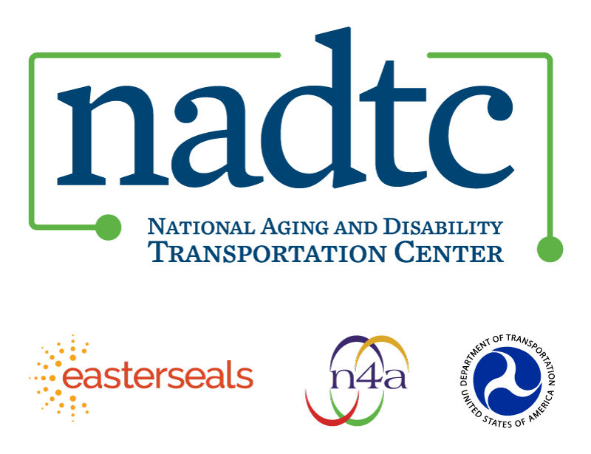

The National Aging and Disability Transportation Center is funded through a cooperative agreement of Easter Seals, the National Association of Area Agencies on Aging, and the U.S, Department of Transportation, Federal Transit Administration, with guidance from the U.S. Department of Health and Human Services, Administration for Community Living. NADTC’s mission is to increase accessible transportation options for older adults, people with disabilities and caregivers nationwide.

National Aging and Disability Transportation Center
Washington, D.C. 20005
Telephone: (866) 983-3222
TTY: (202) 347-7385
Email: contact@nadtc.org
Website: www.nadtc.org

Follow us:
Facebook
Twitter
YouTube
LinkedIn

