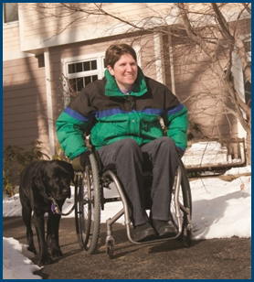
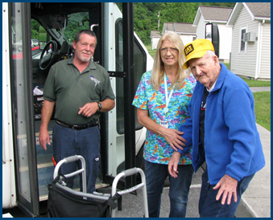

Shared Ride Services and Transportation Network Companies

Topic Spotlight from the NADTC
2016 Transportation Trends Report

Introduction

Shared Ride services and their use by older adults and people with disabilities is the focus of this Topic Spotlight, one of seven transportation issues reported on in the National Aging and Disability Transportation Center 2016 Transportation Trends Report. The complete report, available at www.nadtc.org, discusses trending topics—significant issues that affect the availability of accessible transportation in communities—identified by the National Aging and Disability Transportation Center (NADTC) in 2016.
Short information briefs were prepared in early 2017 on topics concerning developments in the field of transportation that are newsworthy and subject to change over time (e.g., shared ride services, bikeshare); others relate to longstanding problems that are not amenable to one-size-fits-all solutions and continue to present new challenges (e.g., crossing boundaries, safety). The selected topics are:
- Americans with Disabilities Act
- Accessible Bikeshare
- Crossing Jurisdictional Boundaries
- First Mile/Last Mile
- Safety
- Section 5310
- Shared Ride Services
All seven topics are covered in the full Trends Report linked above.

Shared Ride Services and Transportation Network Companies

Introduction

Older adults and people with disabilities may have limited transit options and may need to travel to destinations outside of their transit area. They also may have to travel at a time when transportation is not available. Transportation Network Companies (TNC) can be a convenient way to get around and TNCs are now putting forth an effort to increase access for people with disabilities and older adults.

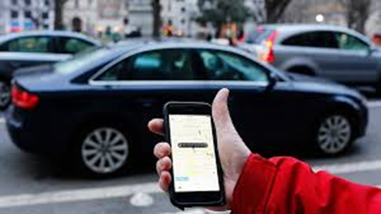
A Transportation Network Company connects paying passengers with drivers who provide transportation in their own non-commercial vehicles. With a simple download of an app on a smart phone, one can schedule a ride, at any time, at their convenience. In most cases, there is no need to have cash on hand because the ride is pre-paid on the app. TNC drivers are classified as independent contractors, and the price of the ride is based on miles and the duration of the trip.

There is some confusion as to what to call TNCs. Is it a ridesharing service or is it a ride-hailing service? The definition of ride-sharing is sharing a ride with another passenger or carpooling. Ride-hailing is defined when an individual personally summons or “hails” a vehicle, is immediately picked up and driven to their destination, usually alone. The Associated Press has also weighed in, instructing media to refer to both Uber and Lyft as “ride-hailing” or “ride-booking” services since both companies offer the option to share a ride with another passenger.

Opportunities

Transportation is a major challenge for people with disabilities and older adults who want to stay active and mobile in the community. TNCs can be an important part of the solution. If an individual does not require an accessible vehicle, one advantage of using TNCs instead of ADA paratransit is same day service instead of having to reserve a ride ahead of time.

Accessible options
uberWAV, uberASSIST and Lift Hero (now Ride Hero) are the more prominent players when it comes to accessible transportation options offered by TNCs, but these options are available in just a few locations.
- uberWAV offers on-demand wheelchair accessible vehicles equipped with ramps or hydraulic lifts and connects with paratransit drivers.
- uberASSIST provides door-to-door support for riders who may need a helping hand with wheelchairs, walkers, scooters or have a service animal.
- Lift Hero is a ridesharing service for older adults that may provide a specially trained professional driver.

Both Lyft and Uber have developed partnerships with other organizations that enable customers without Uber or Lyft accounts or access to smart phones to use their services. The services described below are currently available in parts of California, Florida, Arizona, Dallas and Texas.
- Lyft recently partnered with the San Diego firm, GreatCall. With GreatCall, customers press ‘0’ on their GreatCall Jitterbug phone and speak with an operator, who books a ride on their behalf. The operator has access to Lyft’s Concierge platform which lets them contact the assigned driver to let them know they are picking up an older passenger who may require assistance. Billing for the ride appears on the customer’s GreatCall statement.

- To book a ride with Uber, customers may call RideWith24, a toll-free number, and speak with an operator who takes the customer’s credit card details and books the ride for them.

The partnerships described above are similar to a service offered by GogoGrandparent, which began operation in San Diego and has expanded to other areas of California. Seniors call an operator to book rides with Uber or to use a variety of on-demand services such as Instacart (grocery delivery), Munchery (dinner delivery), and Postmates (shopping).

Transportation Network Companies may potentially fill in the gaps in transportation for older adults and people with disabilities. For example, MetroAccess in Washington, D.C. is now considering using TNCs to provide transportation for passengers who use the paratransit service in Prince George’s and Montgomery Counties. With the launch of the new Abilities-Ride program, the rider’s trips will be subsidized up to $15 dollars for a maximum of four one-way trips per day, compared to the $44 dollars to use the paratransit service.

Rural communities
When it comes to rural communities, Transportation Network Companies are challenged by the lack of a steady stream of customers. Other challenges include car maintenance, recruiting around-the-clock drivers, and long distances between destinations. Liberty provides transportation to rural areas in Texas and Nebraska through an Uber-like application that coordinates with existing public transportation providers. Services may include transportation at night and on weekends when public transportation is not an option. Liberty is also working with medical communities so that they can book rides on behalf of their patients as part of their caregiver platform. Currently, Liberty is awaiting approval from the Nebraska Public Service Commission to operate in the state, and the company will manage 30 to 40 drivers in the coastal city of Corpus Christi, Texas.

New developments
To address the needs of individuals with chronic conditions who require multiple and frequent medical appointments, healthcare providers and senior communities are now taking a closer look at TNCs as a potential solution. In January 2016, MedStar Health, a nonprofit health care system with hospitals in Maryland and D.C., began a partnership with Uber that allows its patients to arrange a ride via the hospital’s website and set up reminders for appointments. In some cases, Medicaid and other insurance plans cover the expense, and the rides are set up through the facility’s client advocate or a social worker. Lyft recently announced a relationship with the National Medtrans Network in New York City to provide rides to Medicaid users for non-emergency medical appointments.

Legal issues surrounding TNCs

There has been considerable discussion about the legal issues pertaining to Transportation Network Companies, especially related to serving the needs of older adults and people with disabilities. Uber and Lyft have policies barring discrimination against riders based on their geographic departure point or destination, nor may they charge additional fees to people with physical or mental disabilities. Uber has had a troubled history related to the treatment of passengers with disabilities, wheelchair issues and service animals. For example, the company settled a discrimination lawsuit with the National Federation of the Blind for $225,000.

Screening

Background check requirements for drivers vary state by state. Uber uses the driver’s social security number to conduct background checks. Overall, drivers must submit to a criminal history check initially and again every five years, and the TNC must review the driver’s driving history. Anyone who has been convicted of driving under the influence of alcohol or drugs (along with some other types of offenses) in the past seven years, or anyone who has had more than three moving violations or one major moving violation (e.g., reckless driving) in the previous three years is prohibited from being a driver. In addition, Uber monitors driver performance based on a 5-star rating from passengers who complete a questionnaire on the app.

Some states collaborate with their local police department to conduct background checks, and the TNC drivers receive a unique decal for their cars. In New York City, DMV and criminal background checks are conducted by the Taxi and Limousine Commission (TLC) according to their licensing standards, instead of through Lyft.

Conclusion

More can be done in terms of outreach to older adults and people with disabilities. Partnering with local Area Agencies on Aging and establishing an in-house TNC navigator could be a solution. In addition, outreach to medical facilities to provide transportation for discharged patients can be an introduction to the service that Transportation Network Companies provide. Finally, as part of AARP’s Life Reimagined Campaign, Uber is partnering with AARP to encourage retirees to become Uber drivers as a way to earn extra income.

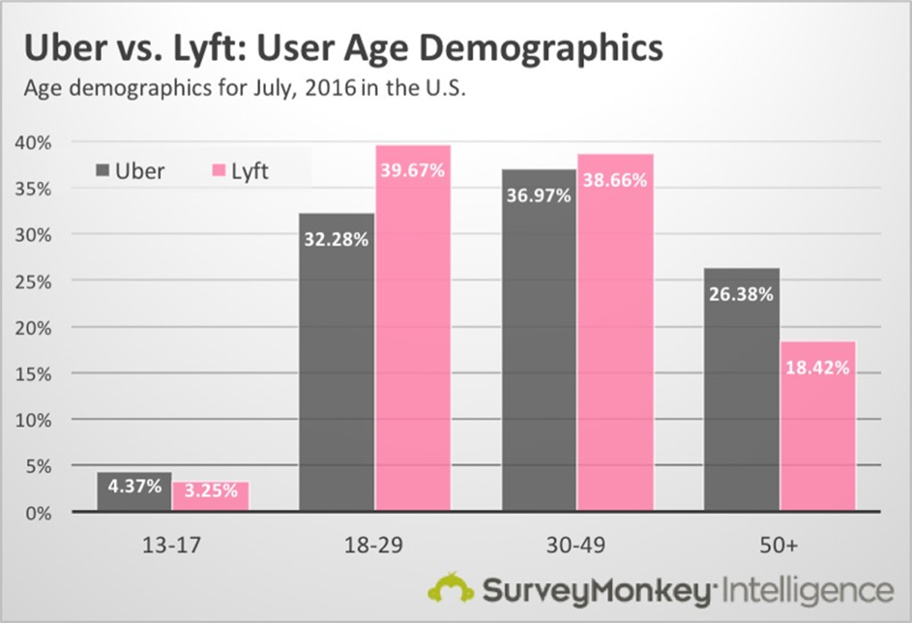

Resources

Lift Hero
http://venturebeat.com/2014/10/08/the-evolution-of-uber-leads-to-lift-hero-ridesharing-for-the-elderly/

Liberty
http://siliconprairienews.com/2016/07/meet-liberty-uber-like-service-built-for-rural-america/

Uber and Lyft fill in the gaps for senior transportation http://www.ajc.com/lifestyles/health/uber-lyft-fill-needs-gap-senior-transportation/L9TeGQJ6C4rAJxBvawjkeM/

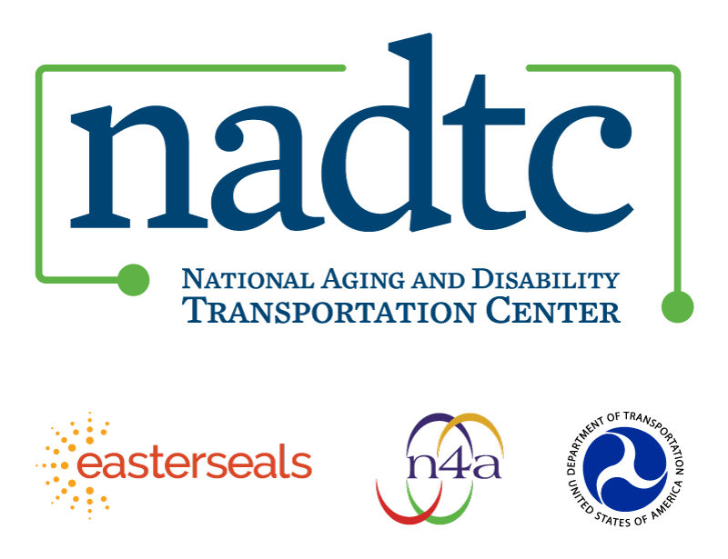

The National Aging and Disability Transportation Center is funded through a cooperative agreement of Easter Seals, the National Association of Area Agencies on Aging, and the U.S, Department of Transportation, Federal Transit Administration, with guidance from the U.S. Department of Health and Human Services, Administration for Community Living. NADTC’s mission is to increase accessible transportation options for older adults, people with disabilities and caregivers nationwide.

National Aging and Disability Transportation Center
Washington, D.C. 20005
Telephone: (866) 983-3222
TTY: (202) 347-7385
Email: contact@nadtc.org
Website: www.nadtc.org

Follow us:
Facebook
Twitter
YouTube
LinkedIn

