SMApply General Instructions

This document provides instructions on how to use the National Aging and Disability Transportation Center online application system, Survey Monkey Apply (SMApply).

Step I. Registration

- In order to access the application system, you first need to register. Visit the NADTC Application Portal to access the system.

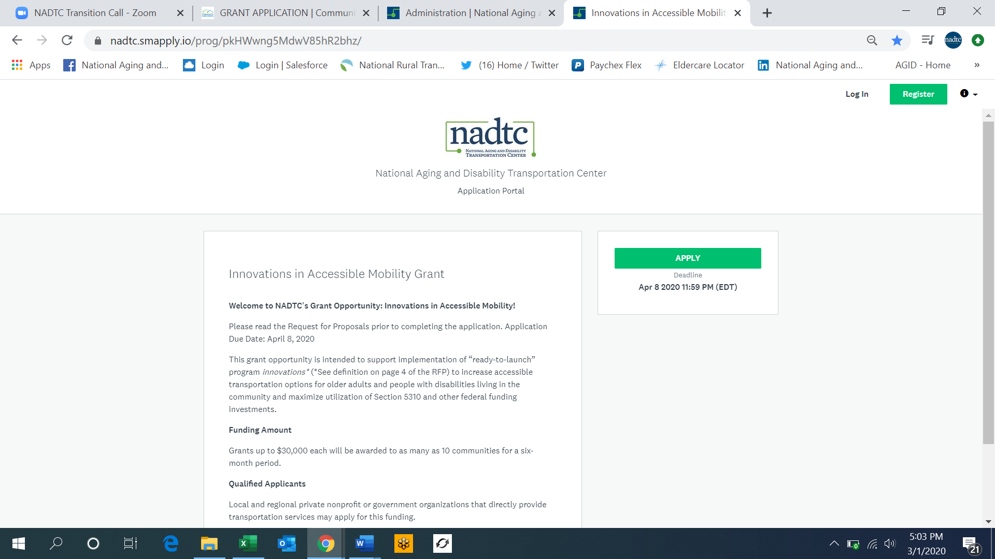

- When you select APPLY you will see the following screen which will prompt you enter the name of your organization. Once you enter the name, click Create Application.

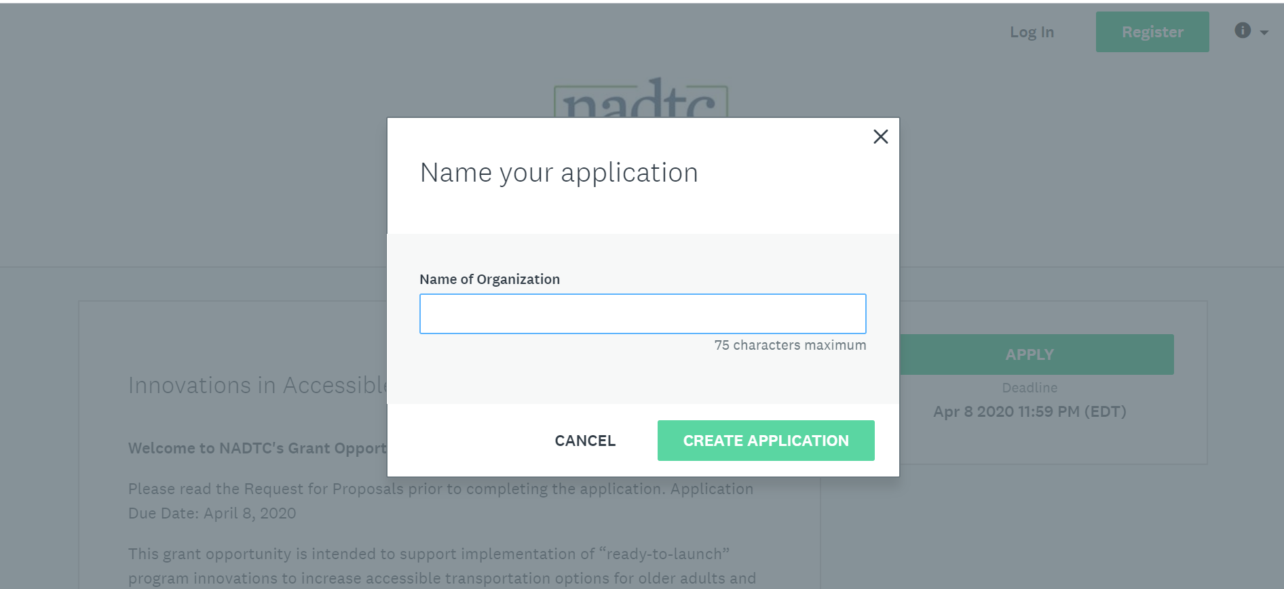

- If you do not have an SMApply log in, you must first REGISTER for an account. If you previously setup an account through the NADTC application portal, login in with your credentials.
- Click on REGISTER button at the top right of the screen to be directed to the following page.

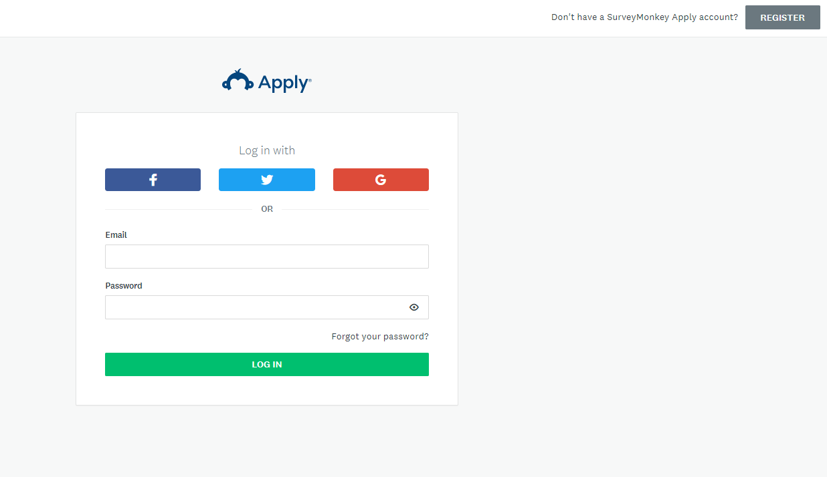

- Fill out registration page and then click on CREATE ACCOUNT button.
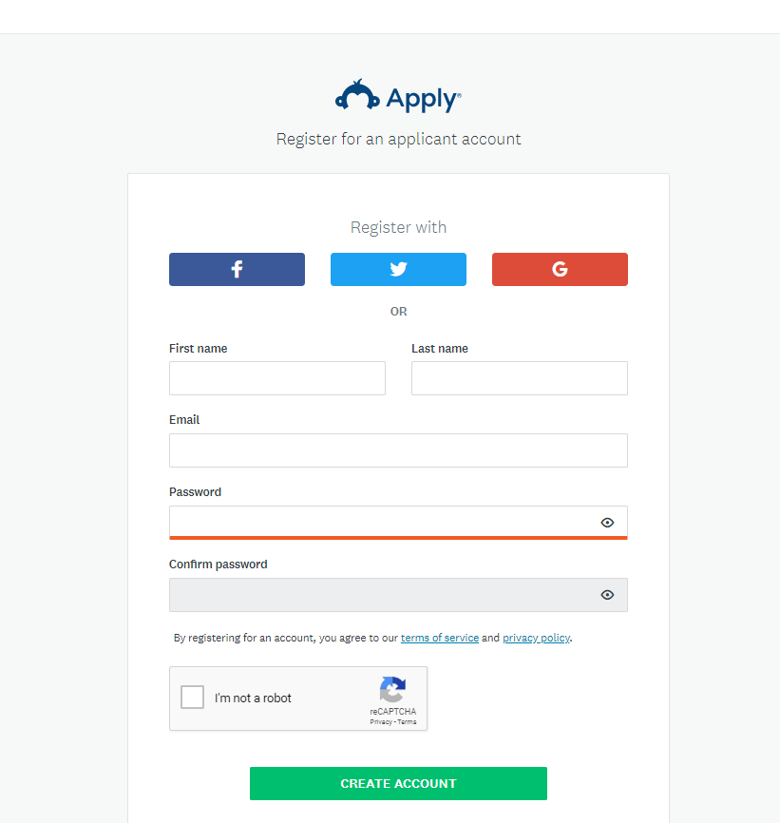

- You will receive a prompt stating “Your email address has not been verified.” Click on SEND VERIFICATION LINK.

- You will receive an email to verify your email address – NOTE: You must CONFIRM EMAIL ADDRESS in order to submit an application.
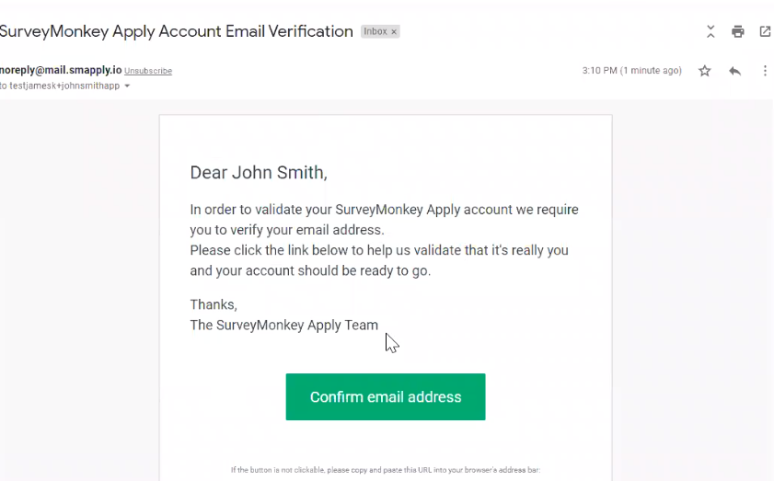

- Once your email address is confirmed, you will receive this confirmation:
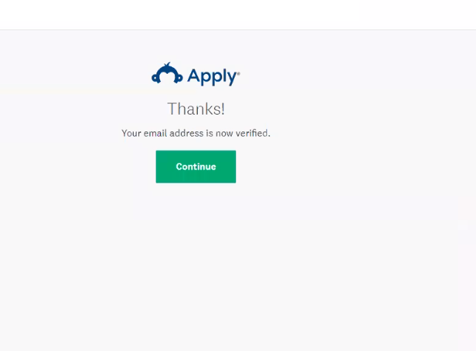

- Click CONTINUE to be brought back to the program home page.

Step II. Applying for the Innovations in Accessible Mobility Grant

- Click on the APPLY button to begin the application.

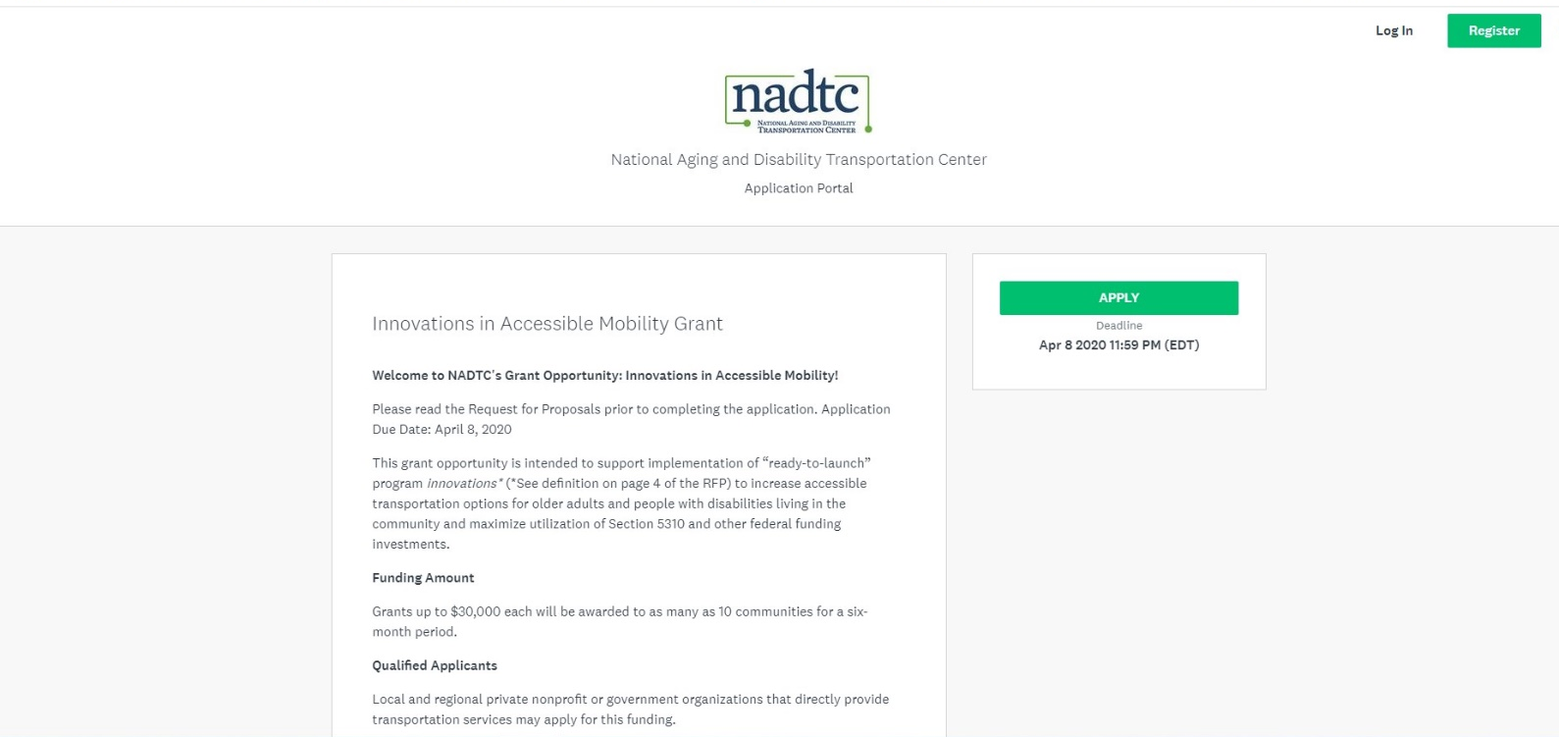

Below is a screenshot of the application page:
- Click on the hyperlinked section heading or chevron to access each section of the application. You can go through the application in any order.
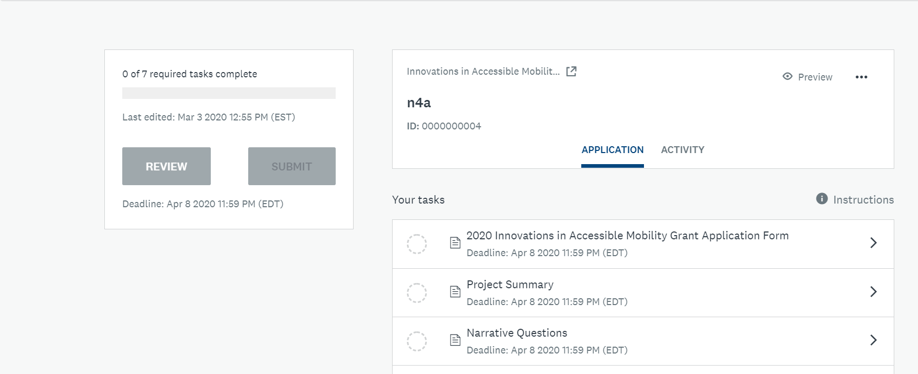
- APPLICATION FEATURES:
  - Within the application, you can SAVE AND CONTINUE EDITING OR MARK AS COMPLETE, but you cannot manually “Save” your work and exit the application. SMApply does real-time autosaving, so if at any point you need to exit the portal, when you log in again, any progress previously made will still be in the system.
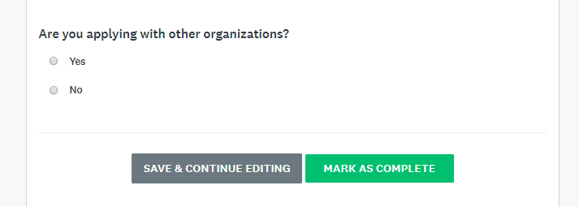

  - You will notice ellipses (…) at certain points of the application (circled below). This is an indication that there are additional functions you can access regarding that task (e.g. edit, download, preview)
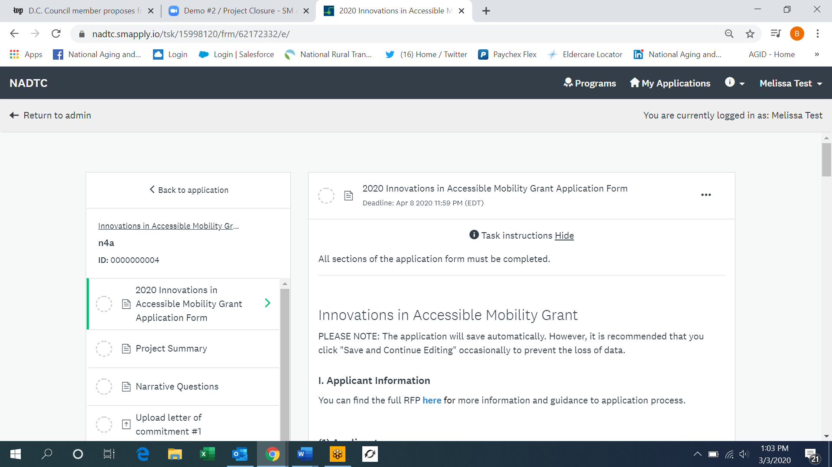

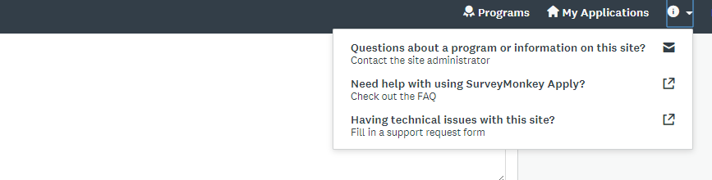
  - If at any point you have questions or need assistance with the portal, click on the “i” located on the top tool bar and you will be given the following options.

- Once you complete a section, you can see your progress on the left-hand side of the screen via the status bar (below) or a list of completed sections which will have a green check mark next to them.
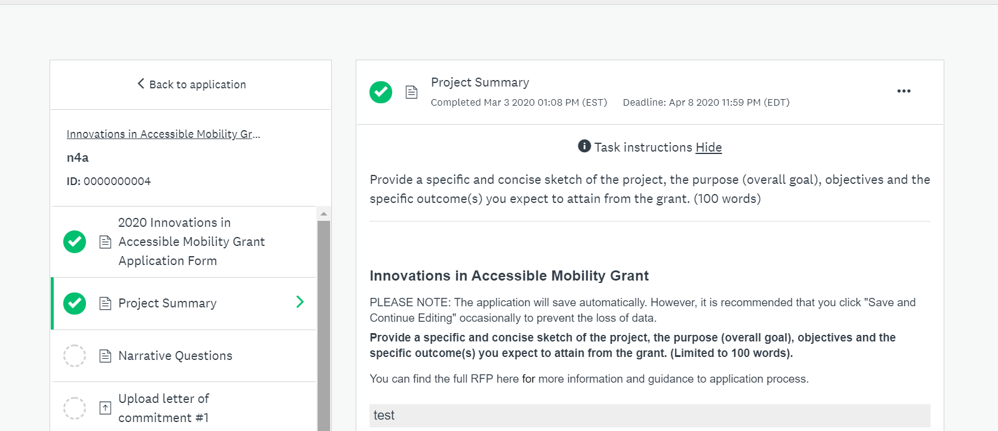

- If you attempt to MARK AS COMPLETE when a section has not been filled out completely, you will be directed to fill out missing or incomplete fields with a red error message.

- On every page of the application there will be an opportunity for you to access the RFP if needed.

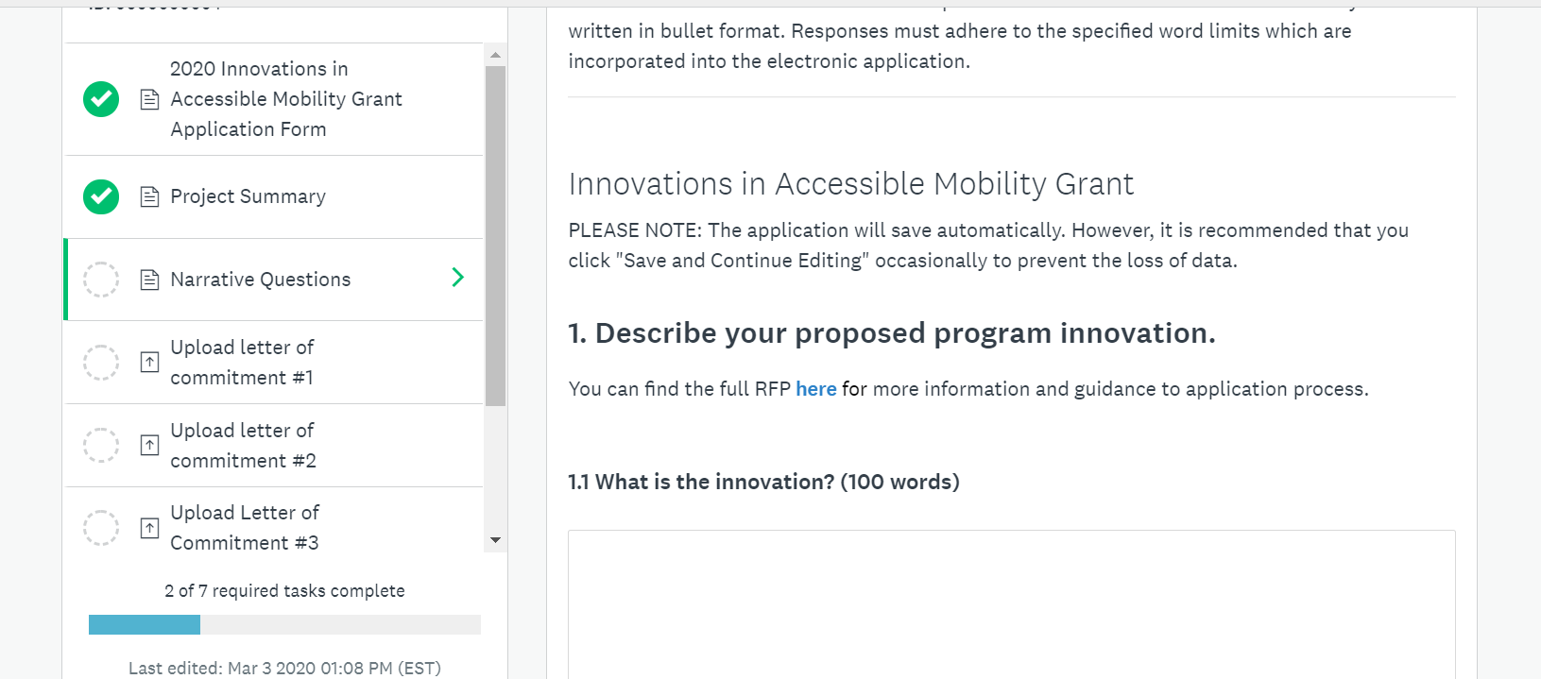

- UPLOADS: To upload documents where templates are provided (e.g. budget form), click on the provided template hyperlink to download the form. Once you have filled out the form offline, upload to the portal by clicking ATTACH FILE, select your file, upload and then MARK AS COMPLETE. Other uploads (e.g. letters of support,) where a template is not provided should be uploaded by clicking ATTACH FILE, select your file, upload and then MARK AS COMPLETE.

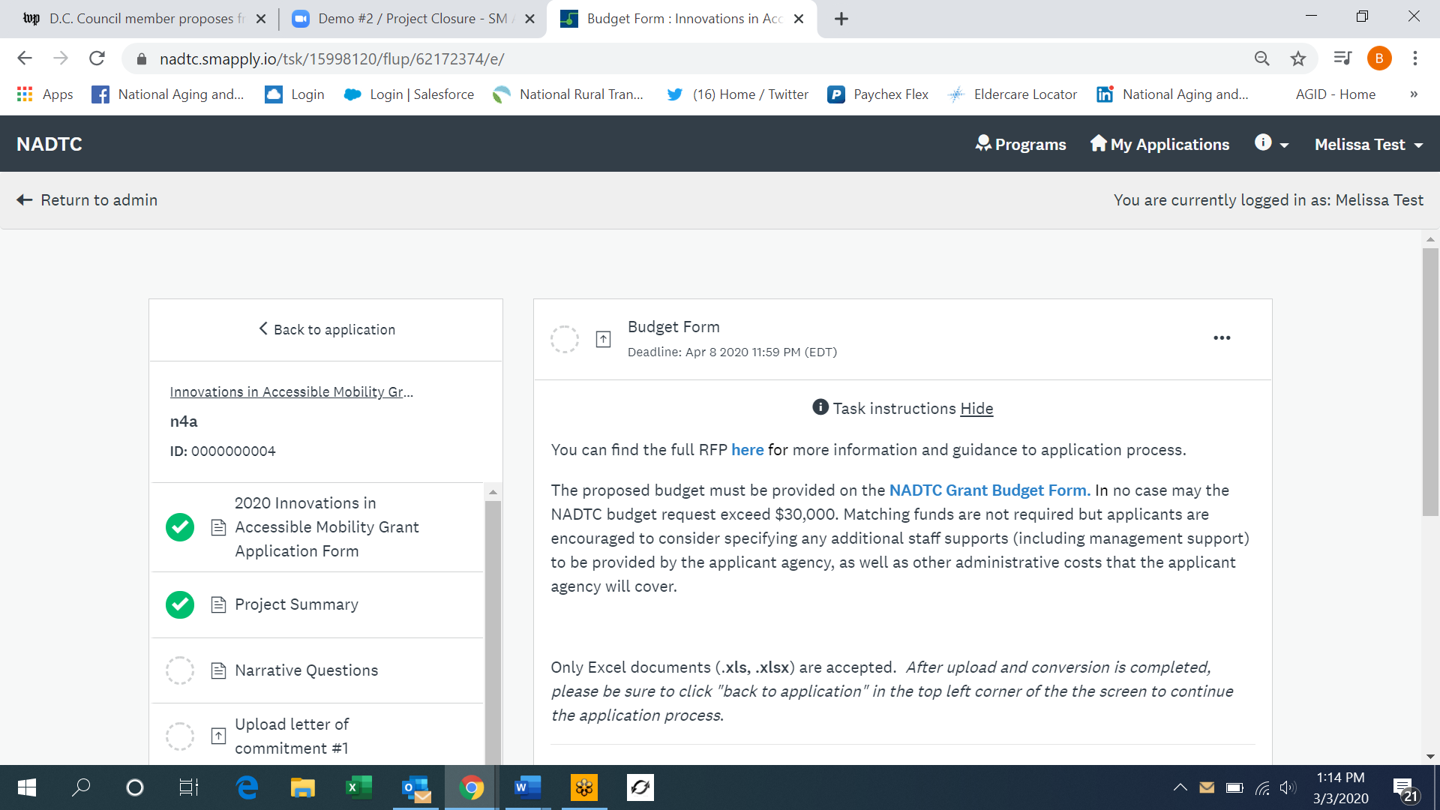

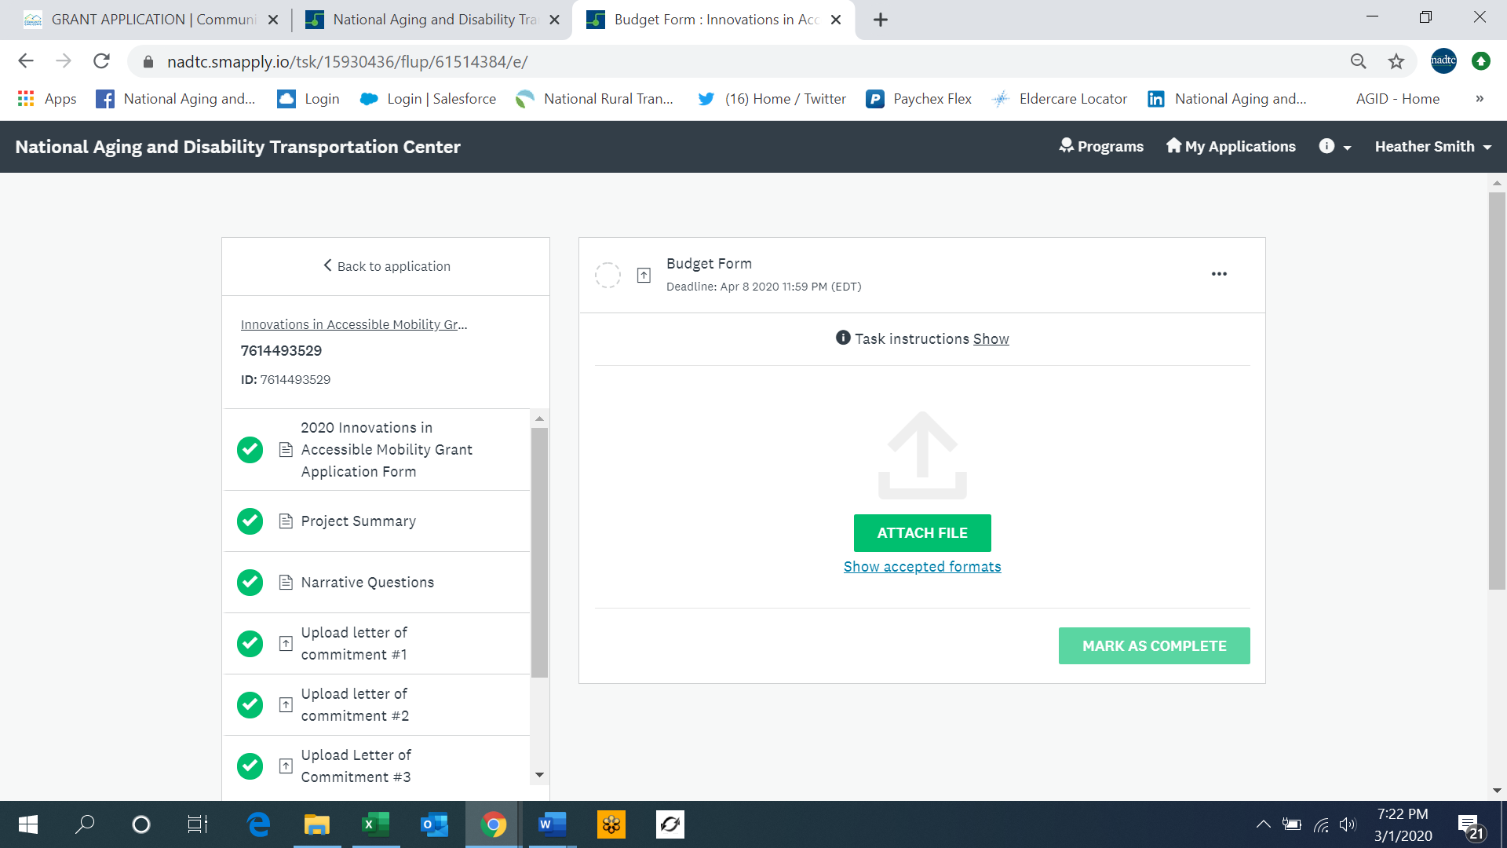

Step III. Reviewing and Submitting your Application
- Once the application is complete, you have the option to REVIEW or SUBMIT your application.

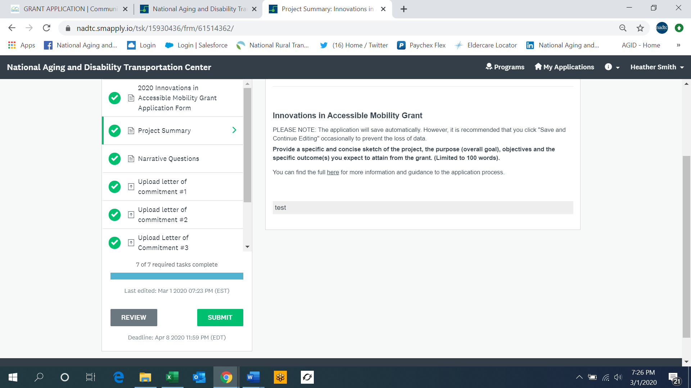

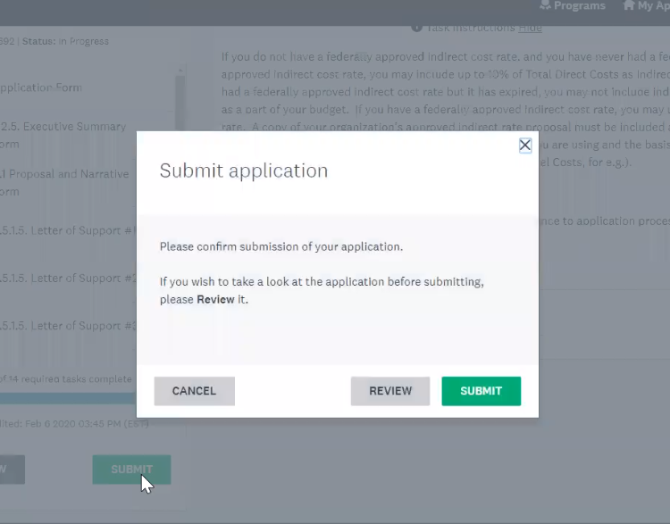
- If you click SUBMIT, you will see the following screen and will be given the option again to SUBMIT OR REVIEW.

- If you click REVIEW, it will generate a one-page summary of everything you have filled out and uploaded. You will have an option to review in the summary page, VIEW FULL SCREEN, or DOWNLOAD (circled below). When you are ready to submit, click SUBMIT YOUR APPLICATION located at the top right of the screen.

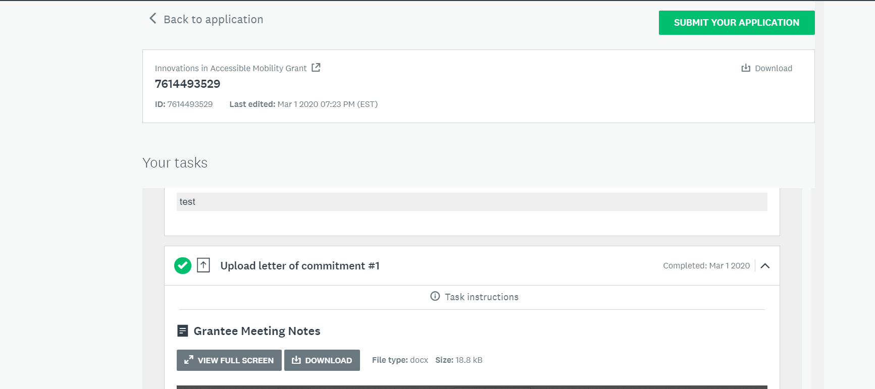

- Once you click SUBMIT YOUR APPLICATION, you will receive the following prompt to SUBMIT your application. If you need to return to the application to make any changes before submitting, click on CANCEL and then BACK TO APPLICATION (circled below) located on the left top corner of the screen. This will take you back to the application task list.

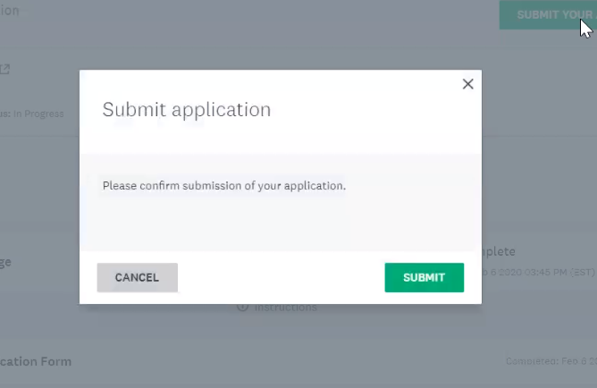

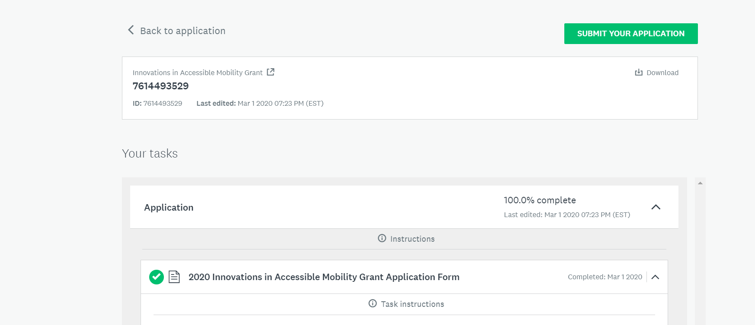

- Once you made any changes and are ready to submit the application, follow the steps noted above. Once you click SUBMIT, you will receive a confirmation that the application was submitted.

