Transportation Technology

Introduction: The Critical Role of Transportation Technology

There is no doubt that technology plays a critical role in transportation, but the process necessary to successfully implement technology is not always well understood. This is particularly true in small agencies that provide transportation services, health and human service agencies, and agencies on aging. Many of these agencies do not have the resources and expertise that is required for procuring and deploying technology systems. Further, there are challenges related to funding the deployment of technology in a public transportation environment that must be understood, including: the requirements of the funding agency(ies); a wide variety of funding cycles and timing that may not allow an entire system to be deployed in one project at one time; and scope requirements (e.g., operational funding cannot be used for capital purchases). Finally, with the rapid changes in the transportation ecosystem and technology advancement, an agency needs to be more nimble than usual. If a deployment takes a long time, the technology may already be obsolete by the time it is fully deployed.

Technology “present[s] the opportunity to seamlessly connect customers, agencies, and transportation providers by providing a single point of access for the customer and greatly enhancing the effectiveness and efficiency of the mobility services offered to the disadvantaged and to the general public.” Technology can provide other human service benefits, including the following:

- Provides choice in personal mobility:
  - Access to healthcare and jobs
  - Access to social welfare programs
  - Better transportation connectivity
- Encourages inclusiveness
- Provides equity of service delivery
The overall purpose of this Information Brief is to provide high-level guidance and resources for an agency to plan for, fund and implement technology. The Information Brief provides material that can be used by an agency to understand how to determine the need for technology, explore potential funding sources to plan for and deploy the technology, successfully plan, procure and implement technology, and work within the rapidly-changing transportation landscape.

The Brief brings together a series of six blogs, previously published separately on the NADTC website. With minor changes, Sections 1-6 contains the entire text of the blog with the same title. Section 7 provides new information, offering an example of a successful technology deployment by an agency that has followed the processes described in the Brief. Together, the seven sections are meant to provide step-by-step guidance on the deployment of transportation technologies.

Contents

Section 1: How Do I Get Started with Technology? ………………………………………...3
Section 2: What Are the Keys to Making Technology Implementation Successful?..........5
Section 3: Navigating Funding Opportunities for Technology Planning and Deployment…………..……………………………………………………………...8
Section 4: An Embarrassment of Riches: Multiple Funding Sources and Technology
Projects…………..…………………………………………………………..............12
Section 5: Leveraging Technology and Sharing Resources………………………………..14
Section 6: Transportation and Mobility: It is a Brave New World! ………………………16
Section 7: Example of Best Practice from the Field………………………………………...21
Appendix A: Resources…………………….……………………………………………...….25

Section 1: How Do I Get Started with Technology?
So what is it about technology that has become so critical to fixed-route and demand response transit? Research has concluded that technology has the potential to “make a substantial contribution to” improve human service transportation. What is this contribution?

Technology can directly address and overcome barriers that have led to unmet mobility needs facing certain population groups, including older adults and persons with disabilities.

Technology can solve problems related to service availability, service information/knowledge, system accessibility, system reliability and safety, and system flexibility. Technology generates significant efficiency and service quality benefits by:
- facilitating the coordination of demand response transit services;
- integrating disparate systems operated by various agencies in a region; and
- providing greater visibility and situational awareness of both travelers and agency vehicles.

Which technologies are the most prevalent in transportation for older adults and persons with disabilities?
- Scheduling, dispatching and routing systems;
- Customer interfaces, such as telephone, smartphones, interactive voice response (IVR), Internet, etc.;
- Traveler information and trip planning systems, particularly for customers with accessibility challenges;
- Vehicle communications such as on-board mobile data computers (e.g., tablets);
- Automatic vehicle location (AVL) and other systems that assist the operations of demand-response service;
- Integrated fare payment and management (payment, collection and processing) systems; and
- Eligibility certification and billing systems.

Determining whether or not the deployment of technology is appropriate for an agency requires a number of steps.
- Understanding the technologies is the first step. There are several resources available to learn about these technologies. Perhaps the most informative is Module 7 of the Intelligent Transportation Systems (ITS) ePrimer.
A simple way to think about the process from the 40,000-foot view is shown in the three-box graphic.
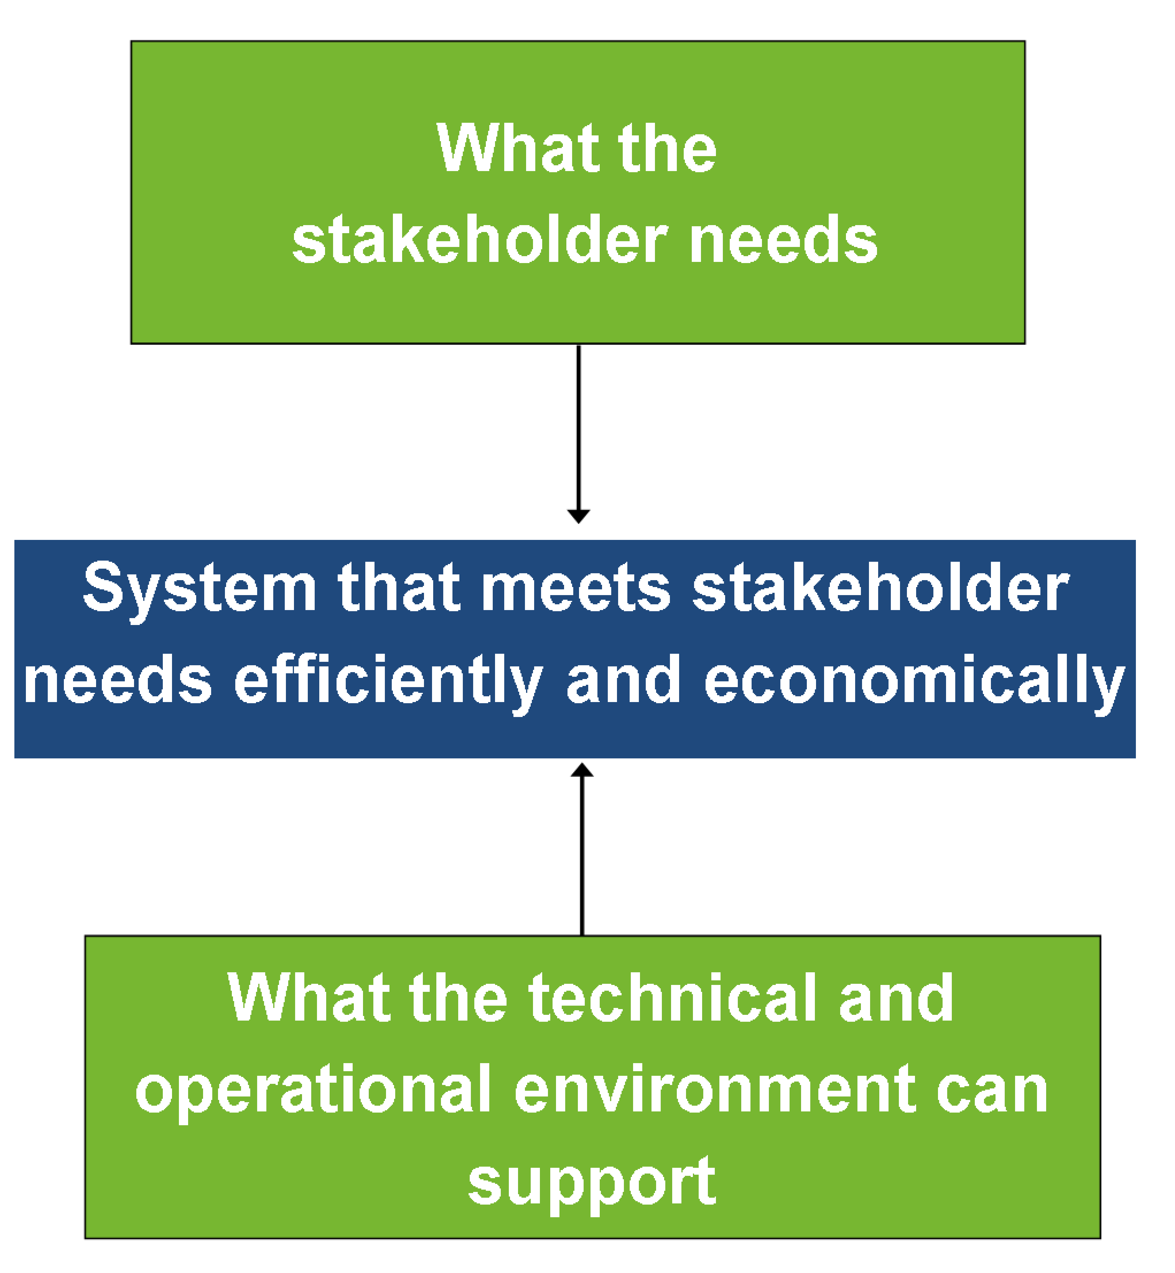
Figure 1. Technology Support

- Know what the customer wants and how the system being developed must perform. This step requires that you identify user needs and the external factors that will influence technology deployment. Here “user” means anyone who will interact with the new technology system. So, a user could be the customer traveling using an agency’s transportation services, agency staff who will be using the new technology, and other individuals who will interact with the new technology (e.g., caregivers, social service agency staff, medical office staff).

- Determine the functionality that is required to meet users’ needs. Here an agency would define “what” the technology system is required to do (versus “how” the technology will work). These functional requirements are often used in a procurement that the agency may use to purchase software and hardware that meets the requirements.

- Study various system alternatives and determine a preferred solution.

- Finally, verify the solution using a rigorous process that ensures that the solution to be implemented meets the user needs and functional requirements identified earlier. The entire planning-design-implementation process is the subject of Section 2 below.

In summary, prior research has confirmed that technology can have a significant impact on demand response transportation, particularly for older adults and persons with disabilities. A great deal of resources exist for agency staff to become familiar with the most appropriate technologies, including those listed in Appendix A. Once an agency becomes familiar with the technologies, they can proceed with a process to define, procure and implement those technologies that best meet the user needs and functional requirements.

Section 2: What Are the Keys to Making Technology Implementation Successful?
With all of the news lately about technology – technology to make it easier for older adults and people with disabilities to travel, self-driving cars and smartphone apps to tell you when the next bus is coming – you may be wondering how to approach a technology project.
To ensure success in technology planning and implementation, it is critical to use a process that identifies user needs, defines what the technology should do to satisfy user needs and follows a rigorous testing process is critical to successful technology planning implementation.
Following four basic steps will ensure a successful technology project:
Step 1. Know what the users want and need and how the system must perform. This step can be called “Requirements Analysis and Baselining.
Step 2. Determine desired functionality of the system to meet users’ needs. This step is often called “Functional Analysis and Decomposition.
Step 3. Study various system options and determine a preferred solution. This step can be called “Alternatives Analysis.”
Step 4. Verify the preferred solution. This step is often called “System Validation and Verification.”
Why do we use this structured approach? There are several reasons:
- Stakeholders or users want and need to define what the system should do (not how it should do it) and manage these “system requirements.”
- It is important to identify and minimize risk. This is very often ignored in technology projects!
- The components of the technology system have to be integrated both from a physical and organizational perspective.
- Systems can be complex, so using a process like this helps you manage the complexity.
- This type of process enhances communication and system understanding among project team members.
- It is important to verify that the system meets users’ needs.

So, who are the “users?” System users include customers of your service, internal staff and any people outside of your organization who might use the system (e.g., client managers, doctor’s office staff, caregivers).
Let’s focus on a few of the critical elements of the four steps. Do you remember the three-box diagram in Section 1 (Figure 1 on page 4)?
Here are the concepts to keep in mind as you navigate through this structured process:
- Use a combined top-down/bottom-up approach (note how the arrows point both down and up in Figure 1);
- Focus on stakeholders’/users’ needs, NOT technology; and
- Scale your process to the size and complexity of the project.

What are “needs?” Needs can be one or more of the following: problem to be solved, process to be improved, new capability. It is critical that the system users are the ones who define the needs (Step 1 above). Anyone could identify needs, but the users can best articulate what they feel is necessary for the system to function in order to best utilize the system. For example, users may describe needs that reflect how they envision interacting with the system.

Next, these needs are used to determine the system requirements – in other words, what the system must do or deliver (Step 2 above). Once system requirements are developed, the project team needs to keep track of each requirement as the system is actually developed, tested and deployed. This is called “traceability.” Traceability is necessary because we need to be able to confirm that all requirements are derived directly from user needs; and requirements may change over the life of the project, so we need a way of documenting any changes, the reasons for any change and the status of each requirement throughout the testing process.
At this stage, you will determine the technology alternatives that can be used to meet the system requirements (Step 3). Once you have identified the alternatives, you will evaluate and select the alternative that best meets the requirements. You can use a variety of factors to perform the alternatives analysis including cost, ease of use (although this can be very subjective) and maturity of the technology.
Now, the system will be built consisting of the functions identified in Step 2 (so that it meets the users’ needs) using the technology alternative defined in Step 3.
Next, Procurement…
Most likely, the system will be developed by a vendor. This means that you will need to procure a vendor’s services. The key elements of such a procurement and resulting vendor contract are:
- providing potential vendors with the system requirements;
- ensuring that vendors can meet those requirements; and
- defining a process that the vendor must use throughout the project to make sure that they are delivering a system that meets the users’ needs, that the project is on-time and that the project is within budget.

There are multiple components of such a project implementation process, including:
- maintaining a system requirements matrix that notes the status of each requirement throughout the project (for traceability, as described above);
- conducting bi-weekly conference calls or meetings with the vendor to discuss project status and action items;
- and defining and executing iterative testing to ensure that the system components work as they were intended, that all the components work together as a system and that, in the end, all requirements are met and can be accepted by your organization.

Okay… so what are the benefits of using this structured approach? It reduces the time required to move from concept to deployed systems; ensures that that system meets users’ needs; and reduces the cost of deploying systems. Further, it ensures that the number of “change orders” that result from a vendor needing to do more work than was expected is minimized. Finally, it reduces the risks associated with system development; improves system quality, reliability and performance; improve communications among team members and the vendor during design and development; and improves the ability to sustain and upgrade systems in the future.

Section 3: Navigating Funding Opportunities for Technology Planning and Deployment
As agencies think about technology deployment, one inevitable question arises: where will I get the funding to support a technology project? Navigating the funding landscape is somewhat complicated since Federal and other funding opportunities may not seem to support technology. However, with so many agencies planning and implementing technical solutions to facilitate human service transportation, more funding and grant programs, including more funding opportunities at the Federal level, are available now than in the past.
So, where do you start to look for financial support? Let’s begin with opportunities at the Federal level.
Federal Level: Specialized Grant Programs
Over the past few years, several specialized grant programs have funded technology planning and deployment projects. While the applications for the funding programs described below have closed for now, it is important to keep abreast of these Federal grant programs since new grants through these programs may become available in the future.
- Mobility Services for All Americans (MSAA): This U.S. Department of Transportation (USDOT) initiative began in Fiscal Year 2005. The overall objective of this initiative is to “improve transportation services and simplify access to employment, healthcare, education and other community activities by means of ITS technology.” Currently, there are three MSAA grantees that have been funded to plan technology systems that facilitate paratransit system coordination.

- Rides to Wellness Initiative: The purpose of this program is “to increase partnerships between health and transportation providers and show the positive financial benefit to such partnerships.” This includes financing innovative projects for the transportation disadvantaged that improve the coordination of transportation services and non-emergency medical transportation (NEMT) services such as the deployment of coordination technology; projects that create or increase access to community; and One-Call/One-Click Centers. While the 2016 funding opportunity has passed, you can receive updates on the 2017 opportunity online.
  - In addition:
    - A webinar about this program is available online.
    - A great example of a Rides to Wellness grant was the “Smart Transit” project in Worcester, MA.

- Mobility on Demand (MOD) Sandbox Demonstration Program (under grant program 5312): “MOD allows for the use of on-demand information, real-time data, and predictive analysis to provide travelers with transportation choices that best serve their needs and circumstances. MOD leverages technologies that allow for a traveler-centric approach that provides better mobility options for everyone.” $8 million has been made available through this program. Proposals were due on July 5, 2016 and project selections were made in October 2016.

- Advanced Transportation and Congestion Management Technologies Deployment Initiative: This program provides grants to develop model sites for deployment of advanced transportation technologies to improve safety, efficiency, system performance, and infrastructure return on investment. While this grant program focuses on large-scale implementation, it “also includes efforts to increase connectivity to employment, education, services and other opportunities; support workforce development; or contribute to community revitalization, particularly for disadvantaged groups: low-income residents, persons with visible and hidden disabilities, elderly individuals, and minority person and populations.” Proposals were due on June 3, 2016.

- Innovations in Accessible Mobility funded by the National Aging and Disability Transportation Center with funding from the Federal Transit Administration: “This grant opportunity is intended to support program innovations and approaches that increase accessible transportation options for older adults and people with disabilities living in the community and maximize the utilization of Section 5310 and other federal funding investments. Grants of up to $50,000 each will be awarded to as many as six communities for a twelve month period.” Applications were due on August 26, 2016.

Federal Level: On-going and Current Grant Programs
In terms of on-going and current Federal grant programs, the following are available:
- Enhanced Mobility of Seniors & Individuals with Disabilities (Section 5310): “The program aims to improve mobility for seniors and individuals with disabilities by removing barriers to transportation service and expanding transportation mobility options.” Section 5310 can fund, among other things, transit-related information technology systems, including scheduling, routing and one-call systems.

- Technology and Innovation Deployment Program: This program provides funding for five years beginning in Fiscal Year 2016 to “accelerate the implementation and delivery of new innovations and technologies that result from research and development to benefit all aspects of transportation.”

- Transportation Investment Generating Economic Recovery (TIGER) competitive grant program: “TIGER discretionary grants will fund capital investments in surface transportation infrastructure and will be awarded on a competitive basis for projects that will have a significant impact on the nation, a metropolitan area, or a region.”
  - An example of a technology related TIGER grant is the Transit Tech Ohio Project, which received $6,839,860, to develop and deploy technology improvements for fixed and demand-response transit operators in rural transit services areas in Ohio.
Beyond these grants programs, there are numerous state, local and private funding opportunities to support technology planning and deployment.

State, Local and Private Funding Opportunities
- Washington State DOT made two grant awards for technology projects in their 2015-2017 time period: (1) $293,761 for Valley Transit in Walla Walla, WA to provide ITS information technology to increase access to transportation; and (2) $296,453 for Skagit Transit in Skagit, WA to provide Americans with Disabilities Act (ADA)-compliant, next-stop-announcement system technology.

- Another state example is funding through Michigan DOT. In their Fiscal Year 2017 Public Transit Programs, there is a category for Service Development and New Technology Program (SDNT). “The SDNT Program provides funds for research, training/education, planning and coordination, and operational and technical projects that preserve or enhance public transit. Projects submitted for funding under this application must demonstrate statewide benefits and are subject to a competitive project selection process.”

- An example of a private source of funding is TransitCenter. TransitCenter provides “several grant opportunities including [their] annual open call and a rolling grant program known as Dispatch grants.” The next call for proposals for the Open Call program will be in early 2017. “Dispatch grants are available on a rolling basis to support timely opportunities and organizational capacity building.” In 2015, TransitCenter awarded nine grants totaling $838,700. One of these grants was “Intelligent Paratransit, an effort to improve the information technology, costs and service quality for transit service for the elderly and citizens living with disabilities in New York City.”

Section 4: An Embarrassment of Riches: Multiple Funding Sources and Technology Projects
Technology projects can be funded using a variety of sources (those sources were the subject of the previous section), all of which can have different requirements and time frames. This creates a challenging environment in which agencies may not have all the funding they need to fully implement technology, often causing them to make short-terms decisions. Further, this can cause agencies to “back into” the available funding and not plan for the future when they may receive additional funding. Following are some ideas for coping with this situation.
There is no doubt that technology projects in the transit and paratransit industry are subject to multiple challenges, similar to those identified below:
“Working with multiple funders allows organizations to leverage single funder interests to achieve more comprehensive programs and encourages nimble and responsive decision making. However, it also introduces challenges such as disparate expectations around program priorities, in addition to practical complexities, including unaligned grant cycles, variable timing of funding disbursements, unaligned reporting requirements, and unsynchronized regular and ad hoc financial and program audits.”

How many times have you asked or been asked, “We just got this grant for $X – what can we do for that amount of funding?” Obviously, this is the wrong approach – backing into funding in order to determine what technology can be deployed for that amount. Such short-term thinking does not usually result in a successful project. Further, if you received more than one grant to conduct a technology project, how do you determine the actual scope of the project, ensuring that (1) you meet the goals and objectives established in each grant; (2) successfully deploy something useful; and (3) implement something that can be expanded in the future?
Despite the complexity associated with using multiple funding sources, there are measures you can take to make the most of this situation. “Given the fluid nature of funding, organizations are often tempted to apply for any and all funding opportunities that are identified. However, this haphazard and opportunistic approach may ultimately derail higher organizational strategic priorities. To avoid this, organizations managing multiple funding streams and agendas must continually evaluate their projects and opportunities, not only for performance but also for fit into the broader goals and objectives of the organization.”
First, before you apply for funding, you should have a strategic planning process in place. The resources listed here, which are specific to planning and deploying transit technology, will assist you with strategic planning:
- Transit Cooperative Research Program (TCRP) Report 84, Volume 8, “Improving Public Transportation Technology Implementations and Anticipating Emerging Technologies,” available at http://www.tcrponline.org/PDFDocuments/TCRP_RPT_84v8.pdf
- TCRP Report 84, Volume 9, “Transit Enterprise Architecture and Planning Framework” available at http://www.tcrponline.org/PDFDocuments/TCRP_RPT_84v9.pdf.

Second, while the strategic planning process should include planning for the future, multiple funding streams require that you deliberately consider the “next steps” beyond the technology for which you have funding. As mentioned earlier, many agencies feel compelled to back into the funding to determine what technology they should deploy. If this is the case, often there is no thought given to how to further develop, expand or enhance that technology. While an agency typically has to apply for technology funding with a specific scope, in the planning process, the agency should always be considering how the technology will be expanded beyond that particular funding. With this “eye toward the future,” an agency will always be thinking about what happens after a specific grant ends. Further, with multiple funding sources, it will be easier to identify specifically what goals and objectives should be achieved with each grant – meaning it will be easier to manage expectations.
Finally, all grants and the work being conducted with the grants must be closely monitored and evaluated. This seems obvious, but is often not done when the focus of technology deployment may be on the deployment itself. Recognizing that each grant has its own requirements (e.g., deliverables, payment milestones, periodic status reports), it is recommended that at the outset of each grant:
- Key indicators about outcomes be developed (if they are not already required by the grant); and
- Periodic time frames when indicators will be reported internally (and to the grantor if required) be identified. This will make it easier to determine if each grant is achieving its goals and objectives, and if each activity within a grant is being achieved as it was expected.

Often, conducting this kind of monitoring and evaluation will inform future technology projects. These activities may require additional data that is not normally collected by an agency, and data analysis that takes staff expertise and time, but will be well worth it in terms of managing multiple grants and proving that the grants had the expected outcomes. Also, given the fact that the projects being conducted with multiple grants can be related (especially if they are technology projects), it is very important to understand the unique and marginal contributions of each project to the outcomes expected from each grant. An example is obtaining one grant to deploy a scheduling system and another grant to implement a computer-aided dispatch/automatic vehicle location (CAD/AVL). They are related; each will have unique outcomes (e.g., increased productivity from the scheduling system and increased on-time performance from the CAD/AVL system), and there will be a marginal reduction in deadhead miles due to both systems being used together.

Section 5: Leveraging Technology and Sharing Resources
Today, the term “Collaborative Economy” is being used as if it is a new concept within a “sharing economy.” In fact, in transportation, there has been a collaborative economy ever since agencies have been coordinating services, particularly for persons with disabilities and older adults. We can think about technology in a similar way – why should individual agencies procure their own technology if they are providing services similar to other agencies and wish to coordinate services?

Leveraging shared resources and technology is an approach that can make it possible for agencies to implement technology and facilitate coordinated operations.

Further, given that often, limited resources are available for technology deployment, leveraging shared resources and technology is an approach that can make it possible for agencies to implement technology and facilitate coordinated operations. This article addresses the benefits of leveraging technology and sharing resources to make it possible for agencies to move forward with technology.
There are several U.S. Department of Transportation programs that encourage agencies, particularly those that do not have much experience with technology, to explore the use of technology. While this encouragement is admirable, it may lead to an agency looking at technology in a vacuum. Further, funding cycles, as discussed in an earlier section, can cause agencies to look at technology procurement independent of other agencies they may work with regularly. And there is one other reason agencies consider technology in a vacuum – they may think that the way they provide service is unique. Many times I have heard agencies declare that they do not operate or provide service like any other agencies.
The fact is that human services transportation (HST) agencies have more similarities than they think. They are providing transportation whether or not they operate in the same ways. Their hours of service, eligibility criteria and other service characteristics could be different, but they still are providing transportation. Given this, technology to facilitate scheduling or coordinating service, for example, could be used by multiple agencies. This means that multiple agencies could combine their efforts to procure one scheduling software product, rather than each agency purchasing their own software. Agencies could combine their scarce resources to procure this software.
There are multiple benefits to this approach.
- First, each agency spends less to obtain the software.
- Second, the amount of time required for the procurement might be reduced as compared to each individual agency running their own procurement. This is true even though a collaborative approach will require all of the involved agencies to take the time to ensure that each agency’s needs will be met by the one system being procured.
- Third, multiple people will learn and work with the software. This means that more than one person will become knowledgeable about the software and can potentially help other agencies use the software.
- Fourth, coordinating services will be easier if the agencies are using the same software. With the same technology, agencies can easily share information that is critical to service coordination (e.g., vehicle location).
- Fifth, jointly procuring technology can create “economies of scale,” particularly with hardware. If one agency is procuring hardware, the number of units may be quite low, but the amount that agency spends on hardware could be higher than if more units are being purchased in one procurement to benefit several agencies.
- Finally, with more than one agency using the same technology, the need for information technology support may be significantly reduced. This is the case especially if the system or software is implemented using a “hosted” approach (meaning that the software is installed on the software vendor’s server and each agency accesses the software via the internet).

This joint procurement approach has been used in purchasing buses for years. Jointly procuring technology is not new either. “A more effective approach for the Eastern Contra Costa Transit Authority has been to create ‘economies of scale’ by collaborating with other agencies and by hiring subject matter experts as consultants. Our first experience with this strategy occurred several years ago when we partnered with two other small agencies in procuring the newest generation of paratransit scheduling software. This important acquisition would have been out of reach for any of us had we acted individually rather than collectively.”

The benefits of leveraging technology and sharing resources are summarized very well by the American Public Transportation Association (APTA) as follows. “Combining resources with other agencies on projects of mutual interest can result in RFPs requests for proposals that attract new bidders, increase competition, leverage better contract terms and pricing, and save time and money. The key is to forge sound, business-driven partnerships that benefit all parties.” ⁷

Section 6: Transportation and Mobility: It is a Brave New World!
There is no doubt that the transportation landscape is rapidly-changing. The term “public transportation” has a different meaning than it used to, and we no longer think about traveling on individual modes – we think about the trip as a whole. The transportation ecosystem now includes the following:
- Traditional public transit and paratransit/demand-response transit (DRT);
- Transportation network companies (TNCs), such as Uber and Lyft;
- Micro-transit, such as Bridj and Chariot;
- Shared-ride services, such as Via and Localift;
- Peer-to-peer carsharing/car rental, such as Turo and BlaBlaCar;
- Taxis;
- Carsharing, such as Zipcar and car2go;
- Bikesharing, such as Capitol Bikeshare (in Washington, DC) and Hubway (in Boston, MA);
- Car rental, such as Hertz and Avis; and
- Autonomous (self-driving) vehicles, such as Olli and nuTonomy robo-taxis.

All of these services have one thing in common: technology. Technology is used to operate and/or access these services. For the services that are accessed via a smartphone or computer application, there can be a concern about the service being accessible to persons with disabilities or lower income individuals. Another concern to persons with disabilities is the fact that some of these services are not required to comply with the Americans with Disabilities Act (ADA).
Another impact on mobility are the numerous partnerships being formed between transit agencies and TNCs or micro-transit services. Almost every week in 2016, a new partnership was being formed – primarily for the purpose of either maintaining service that is underperforming and costly for traditional public transit to provide or assisting with paratransit or demand-response service. Unfortunately, since many of these partnerships are pilot projects, we do not yet know how successful these relationships will be.
Three examples of these partnerships are as follows:
- The Massachusetts Bay Transportation Authority (MBTA) is conducting a year-long “On-Demand Paratransit Pilot Program.” In this pilot program, customers of The Ride (which is the MBTA’s paratransit service) can participate with ride-sharing companies Uber and Lyft. A comparison of The Ride and Uber/Lyft pilot is shown in Table 1. The MBTA describes the benefits of this pilot program as reduced fares; lower wait times; same-day booking; faster trips; no need to share rides; access to wheelchair accessible vehicles; and options for customers without access to smartphones.

Table 1. Comparison of The Ride and MBTA’s Pilot Uber/Lyft Program¹⁰
Service | The Ride | Pilot Program
Fare | $3.15 or $5.25 for premium trips | As low as $2.00
Booking Timeframe | Minimum on day in advance | On demand: Instant request to dispatch
Day of Wait time | 30 minutes window | As low as five minutes in core service areas
Trip reservations | By phone | Via mobile phone app or phone call-in option (Lyft only)

- The Livermore Amador Valley Transit Authority (LAVTA) (in Livermore, CA) recently introduced two innovative programs: (1) partnering with TNCs, such as Uber and Lyft, to reach commuters in neighborhoods that big buses cannot serve; and (2) exploring driverless shuttles to solve first and last mile issues to connect people to stations.

- The Kansas City Area Transit Authority (KCATA) partners with Bridj to bring workers to various locations in Kansas City, including the downtown, and to various locations from downtown and the River Market area. “’RideKC: Bridj is allowing us to provide a nimble transit service with a rich technology backbone,’ said Robbie Makinen, President and CEO of KCATA. ‘The ability to target this new transit option is a powerful tool providing vital information during this pilot phase.’”

There is one more technology-enabled innovative service to add to this rapidly changing landscape – Mobility as a Service (MaaS).

According to the MaaS Alliance, “Mobility as a Service (MaaS) puts users, both travelers and goods, at the core of transport services, offering them tailor-made mobility solutions based on their individual needs. This means that, for the first time, easy access to the most appropriate transport mode or service will be included in a bundle of flexible travel service options for end users.” Figure 2 illustrates the MaaS ecosystem including the technology components.

There are four objectives of MaaS, as follows:
- Seamless and efficient flow of information, goods and people both locally and through long distances;
- Globally scalable door-to-door mobility services without owning a car;
- A better level of service than the private car; and
- An open ecosystem for information and services in intelligent transportation.

An example of MaaS is Whim, the MaaS system currently operating in Helsinki, Finland. Whim offers four possible mobility “packages.” An example of MaaS in the US could be a personal mobility package for $200/month that includes the following:
- Transportation from A to B according to service level agreement (SLA)
- Access to all transportation services
- Access to transport related services (city logistics, home deliveries etc.)
- Roaming in other cities and counties

MaaS is the subject of an NADTC white paper, which can be found at www.nadtc.org. More details about this mobility innovation can be found in the white paper.

With the transportation and technology landscape rapidly changing due to all of these developments, there are many more mobility options available to travelers. However, this new landscape presents some challenges for older adults, persons with disabilities and low-income individuals. This brave new world requires that we ensure access to all options. Fortunately, several new service providers are beginning to meet these challenges.

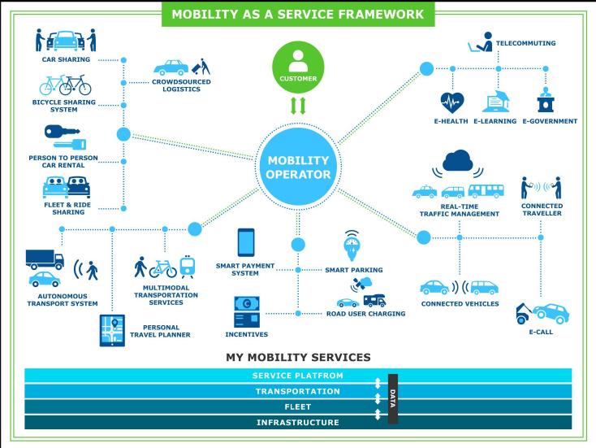
At this stage, it is not clear yet how the “new mobility” will affect travel behavior. However, we know that the millennial and centennial generations are not purchasing automobiles, and use several of the technology-enabled mobility options described in this blog. Going forward, it is important that we measure not only the use and performance of these services, but also assess the transit-TNC/micro-transit partnerships and evaluate the accessibility of these services.

Figure 2. MaaS EcoSystem

Section 7: Example of Best Practice from the Field

United Cerebral Palsy (UCP) of San Luis Obispo County/Ride-On Transportation Travel Management Coordination Center (TMCC)
San Luis Obispo County, CA

Ride-On Transportation “is a non-profit organization dedicated to improving transportation services in San Luis Obispo County, California. Started in 1993, Ride-On is comprised of the Consolidated Transportation Service Agency (CTSA) and the Transportation Management Association (TMA) for [the] county. Ride-On CTSA provides door-to-door shuttle services for seniors, veterans, people with disabilities and social service agencies. Ride-On also provides support services for social service agencies that provide their own transportation services with vehicle maintenance, driver training, emergency response plans, and other services. Ride-On TMA provides transportation services for the general public with vanpools, airport/Amtrak shuttles, Emergency Ride Home, Lunchtime Express, Visitor Shuttles, Special Event Transportation, and Medical Transport.”

In 2014, UCP/Ride-On Transportation applied for a Mobility Services for All Americans (MSAA) grant from the Federal Transit Administration (FTA). In 2015, they were awarded an MSAA grant to design an inter-operable, replicable, and scalable mobile technology system with the goal of coordinating paratransit passenger trips among partnering community transportation agencies and sharing this service information in real-time with the public.

Project partners include the following:

- United Cerebral Palsy of San Luis Obispo County/Ride-On Transportation
- San Luis Obispo Regional Transit Authority (SLO RTA)
- Community Health Centers
- San Luis Obispo Regional Rideshare
- San Luis Obispo Safe Ride
- Local Taxi Cab Operators
- The United States Department of Veterans Affairs
- Human Service Agencies
- RouteMatch Software

UCP/Ride-On is using a systems engineering process (described in Sections 1 and 2) to develop and deploy the Travel Management Coordination Center (TMCC). The stakeholders are involved in the key parts of the process, which ensures that user needs have been identified properly and will be used to drive the development of the TMCC. The stakeholders are organized into the TMCC Advisory Committee (TMCCAC), which has three committees: (1) Transportation Providers; (2) Human Service Organizations; and (3) Technology Solutions.

The expected outcomes of the project are as follows:

- Explore all local Partners’ institutional barriers to regional paratransit coordination.
- Seek a common solution to leverage Intelligent Transportation Systems (ITS) to identify opportunities to link Partner databases and services in real-time while providing immediate information to customers.
- Create a detailed set of system design documents on how to build, fund, and sustain the TMCC.
- Receive planning guidance on how to address any observed institutional coordination barriers.
- Demonstrate a “Common Fleet Information Platform” (the TMCC).
- Develop inter-agency paratransit coordination to increase customer mobility.
- Provide all deliverables to FTA as requested in a timely manner.
Currently (prior to the TMCC development):

- Ride-On and the Regional Transit Authority (RTA) utilize RouteMatch Software’s DemandTM paratransit routing and scheduling software along with mobile data tablets. Also, Ride-On uses the RouteMatch Notification Module for outbound Interactive Voice Recognition (IVR) calls. Other transportation partners utilize Microsoft Office and privately-built technology back-end or application-based systems. In the future, UCP/Ride-On plans to leverage the existing relationship with RouteMatch to design an interoperable, scalable and sustainable TMCC system that will benefit all providers in the region.

- Transportation operations include the following:

- Paratransit Services: Ride-On, SLO RTA, Community Health Centers, SLO Safe Ride, Yellow Taxi, and Smart Shuttle;
- Fixed Route Services: SLO RTA and SLO Transit; and
- SLO Council of Governments: MPO, 511, Regional Rideshare.

- Information and Referral is provided by the 211 system, which is supported by the United Way.

- Ride-On serves as the county’s state-enabled and SLO Council of Governments (SLOCOG)-designated Consolidated Transportation Service Agency (CTSA), which serves as the lead coordinated transportation agency throughout the county.

UCP/Ride-On recognizes that the challenges and opportunities associated with TMCC development include the following:

- There is a need to build trust among all transportation provider partners to further coordination opportunities;
- TMCC appeared a potential threat to existing 511 Transportation Information Service;
- Broad stakeholder input must be considered before identifying TMCC design alternatives; and
- Government agency partner concerns about the cost of the TMCC and its sustainability need to be addressed.

The future TMCC is expected to provide the administrative, operational and customer service/technology benefits such as the following:

- Administrative:
    - Inter-agency agreements
    - Joint marketing
    - Cost sharing
    - “One Call” capability
    - Information and referral
    - Establish minimum provider standards - joint training, insurance, background checks, drug testing and other procedures

- Operations:
    - Inter-agency trip coordination/sharing
    - Payment capabilities

- Customer Service / Technology:
  - In-Person, Telephone and Online/Mobile services.
  - Technology:
    - Transportation Information & Referral
    - Customer-friendly for all
    - Leverages all providers
    - Customer information/profiles and payment/fare structures
    - Provides for ride requests within 20-30 minutes
    - Available 24 hours a day

Lessons Learned

As of May 2016, UCP/Ride-On recognized the following lessons learned:

- Stakeholder involvement is key to developing a replicable, scalable TMCC and can be addressed through the following activities (note that using all three elements in conjunction with one another would produce the best results):
  - An Advisory Committee;
  - Stakeholder working committees; and
  - The involvement of human service agency networks, customers and others.
- Follow the Systems Engineering process – do not identify a solution prior to determining the problem to be solved.
- Building inter-agency and inter-personal trust is critical.
- Creating new relationships is necessary for success.
UCP/Ride-On expects to complete the planning aspect of the TMCC project (the portion of the project funded in part by FTA) by June 30, 2017.

Appendix A: Resources

In addition to the footnotes, the following resources can be used to provide more information on the topics presented in this Information Brief.

- Advanced Transportation and Congestion Management Technologies Deployment Initiative https://www.fhwa.dot.gov/fastact/nofo_atcmtd_20160325.pdf

- Burt, M.W., Cluett, C., Schweiger, C.L., Coogan, M.A., Easley, R.B. and Easley, S., Improving Public Transportation Technology Implementations and Anticipating Emerging Technologies, prepared for Transportation Research Board, Transit Cooperative Research Program (TCRP), TCRP Report 84 Volume 8, 2008, http://www.tcrponline.org/PDFDocuments/TCRP_RPT_84v8.pdf

- Enhanced Mobility of Seniors & Individuals with Disabilities (Section 5310): https://www.transit.dot.gov/funding/grants/enhanced-mobility-seniors-individuals-disabilities-section-5310

- Mobility on Demand (MOD) Sandbox Demonstration Program: https://www.transit.dot.gov/research-innovation/mobility-demand-mod-sandbox-program.html

- Mobility Services for All Americans (MSAA): http://www.its.dot.gov/research_archives/msaa/index.htm

- Rides to Wellness Initiative: https://www.transit.dot.gov/ccam/about/initiatives

- Schweiger, C., “Technology + Service Coordination = Improved Mobility,” Presentation for USDOT ITS Professional Capacity Building (PCB) Program, April 14, 2016, https://www.pcb.its.dot.gov/t3/s160414/s160414_Mobility_Options_presentation_Schweiger.pdf

- Technology and Innovation Deployment Program: http://www.fhwa.dot.gov/fastact/factsheets/technologyinnovationfs.cfm

- Transportation Investment Generating Economic Recovery (TIGER) competitive grant program: https://www.transportation.gov/tiger

- TransitCenter: http://transitcenter.org/grants/

About the Author
Carol Schweiger, President of Schweiger Consulting, has over 37 years of experience and is nationally and internationally recognized in transportation technology consulting. Her wide-ranging and in-depth expertise is in several specialty areas including systems engineering, technology strategies for public agencies, public transit technology, and traveler information strategies and systems. Ms. Schweiger has provided over 50 transportation agencies with technology technical assistance, including developing and applying structured processes to procure and implement technology systems; providing detailed procurement and implementation assistance; evaluating technology deployments; conducting research and delivering training.

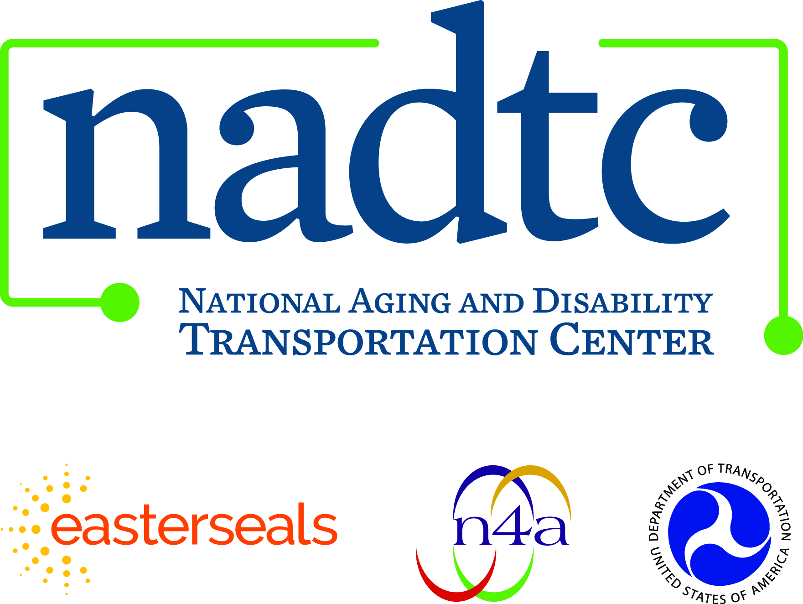

Call toll-free: 866.983.3222
Email: contact@nadtc.org
Web: www.nadtc.org

Find us on Facebook, Twitter, YouTube & LinkedIn!

Who We Are

Established in 2015, the NADTC is a federally funded technical assistance center administered by Easterseals and the National Association of Area Agencies on Aging based in Washington, D.C.

The National Aging and Disability Transportation Center is funded through a cooperative agreement of Easterseals, the National Association of Area Agencies on Aging, and the U.S Department of Transportation, Federal Transit Administration, with guidance from the U.S. Department of Health and Human Services, Administration for Community Living.

The National Association of Area Agencies on Aging (n4a) is a 501c(3) membership association representing America’s national network of 622 Area Agencies on Aging (AAAs) and providing a voice in the nation’s capital for the 256 Title VI Native American aging programs. The mission of n4a is to build the capacity of its members so they can better help older adults and people with disabilities live with dignity and choices in their homes and communities for as long as possible. www.n4a.org

Easterseals is the leading non-profit provider of services for individuals with autism, developmental disabilities, physical disabilities and other special needs. For nearly 100 years, we have been offering help, hope, and answers to children and adults living with disabilities, and to the families who love them. Through therapy, training, education and support services, Easterseals creates life-changing solutions so that people with disabilities can live, learn, work and play. www.easterseals.com

Brendon Hemily, “DRAFT Guidebook for the Planning and Design of a Travel Management Coordination Center (TMCC),” prepared for USDOT, UPDATED – November 20, 2016, page 6.
Carol Schweiger and Murat Omay, “Mobility Services for All Americans (MSAA): Enhancing Coordination of Mobility Services through Technology,” presentation to workshop entitled From Demand Responsive Transportation to Mobility on Demand: The Impact of Technology on DRT in the era of Smart Cities, Denver, CO, May 3, 2016, page 11.
Torng, G., Gross, Y., and, B. Cronin, “Mobility Services for All Americans; Unmet Mobility Needs and ITS Solutions,” 2005 ITS World Congress. https://www.its.dot.gov/msaa/docs/11MSAAWorldCongresS.htm.
Carol Schweiger. ITS ePrimer, Module 7: Public Transportation, prepared for USDOT ITS PCB Program, https://www.pcb.its.dot.gov/eprimer/module7.aspx
U.S. Department of Transportation. Success Stories: Mobility Service for All Americans. http://www.its.dot.gov/research_archives/msaa/index.htm.
U.S. Department of Transportation. Email Updates. https://public.govdelivery.com/accounts/USDOTFTA/subscriber/new.
U.S. Department of Transportation. Rides to Wellness Initiative. Webinar. https://connectdot.connectsolutions.com/p1zaef1f3kx/?launcher=false&fcsContent=true&pbMode=normal.
Clark University. “Smart Transit’ moving toward better access to healthcare”. http://www.clarku.edu/article/%E2%80%98smart-transit%E2%80%99-moving-toward-better-access-healthcare
U.S. Department of Transportation. Mobility on Demand (MOD) Sandbox Program. https://www.transit.dot.gov/research-innovation/mobility-demand-mod-sandbox-program.html
U.S. Department of Transportation. Notice of Funding Opportunity Number DTFH6116RA00012. “Advanced Transportation and Congestion Management Technologies Deployment Initiative”. Issue Date: 03/22/2016. https://www.fhwa.dot.gov/fastact/nofo_atcmtd_20160325.pdf
National Aging and Disability Transportation Center. Awarded NADTC Grants. http://www.nadtc.org/grants-funding/nadtc-grant-opportunities/nadtc-awarded-grants/.
Federal Transit Administration. Enhanced Mobility of Seniors & Individuals with Disabilities - Section 5310. https://www.transit.dot.gov/funding/grants/enhanced-mobility-seniors-individuals-disabilities-section-5310 .
Federal Highway Administration. Fixing America's Surface Transportation Act or "FAST Act". http://www.fhwa.dot.gov/fastact/factsheets/technologyinnovationfs.cfm.
U.S. Department of Transportation. TIGER Discretionary Grants. https://www.transportation.gov/tiger.
U.S. Department of Transportation. Innovation through the Tiger 2015 Discretionary Grant Program https://www.transportation.gov/sites/dot.gov/files/docs/TIGER%202015%20Innovation%20Project%20Fact%20Sheets.pdf.
TransitCenter. Grants. http://transitcenter.org/grants/.
Charles B. Holmes, MD, MPH, et al, “Managing Multiple Funding Streams and Agendas to Achieve Local and Global Health and Research Objectives: Lessons From the Field,” J Acquir Immune Defic Syndr, Volume 65, Supplement 1, January 1, 2014, Copyright © 2013 by Lippincott Williams & Wilkins, page S32
Ibid, page S33
American Public Transportation Association, Procurement Handbook: A Guide for Transit Industry Executives, October 2014, page 13, https://www.apta.com/resources/bookstore/Documents/APTA_Procurement.pdf.
Massachusetts Bay Transportation Authority. On-Demand Paratransit Pilot Program. http://www.mbta.com/riding_the_t/accessible_services/default.asp?id=6442456760.
Luz Lazo. “Arlington Studying A Plan That Would Pay For Your Uber To Metro”. The Washington Post. August 16, 2016 http://www.hcaog.net/sites/default/files/5c_encl_mod_articles.pdf.
Kansas City Area Transportation Authority. “RideKC: Bridj Expands Service to the River Market” April 29, 2016. http://www.kcata.org/news/ridekc_bridj_expands_service_to_the_river_market.
The MaaS Alliance. http://maas-alliance.eu/
Spyros Evangelatos. Inlecom Systems. Mobility as a Service (MaaS) Concept and Landscape. Presentation October 6, 2016. http://eutravel.eu/Conference/wp-content/uploads/2016/10/INLECOM_EUTRAVEL.pdf
“How To Order Uber Online: Use Uber Without A Smartphone?” http://lyftubernewsletter.com/can-you-use-uber-without-a-smart-phone/
Ride-on Transportation. http://www.ride-on.org/ride-on-about-us.php
Information in the rest of this section is derived from the following documents: - United Cerebral Palsy of San Luis Obispo County/Ride-On Transportation, Revised Draft Project Management Plan (PMP): The San Luis Obispo County Travel Management Coordination Center (TMCC) Project, prepared for Federal Transit Administration (FTA), January 8, 2016. - Mark Shaffer, Ride-On Transportation, San Luis Obispo County, CA Travel Management Coordination Center (TMCC), prepared for FTA Mobility Services for All Americans (MSAA) Initiative, prepared for ITS America/USDOT Workshop “From Demand Responsive Transportation to Mobility on Demand: The Impact of Technology on DRT in the era of Smart Cities,” Denver, Colorado, May 3-4, 2016.

