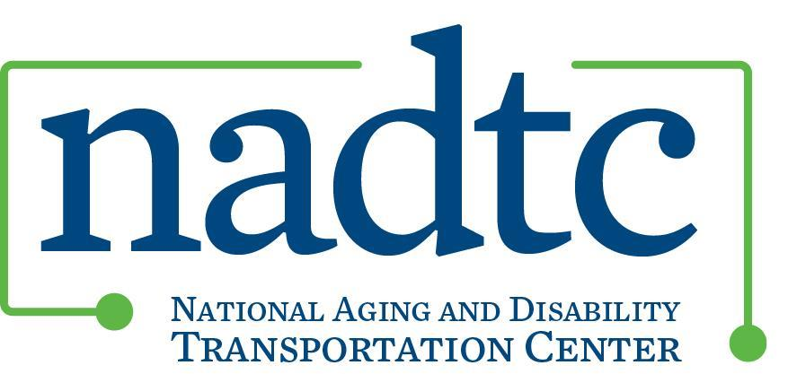

NADTC Human Services Transportation Course: Session 2

*\*This document is a continuation of information provided in Session 1 on the Sound Generations Program.*

**A conversation with Cindy Zwart, Sound Generations, King County, WA**

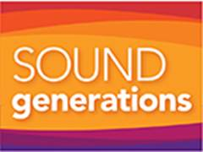

1. The array of transportations services that Sound Generations provides, con’t.

To maximize funding and ensure effective delivery of transportation services, we coordinate the efforts of community volunteers through contractual agreements with three community partners: Group Health Volunteer Transportation; Senior Companion Program; the Mt. Si Senior Center. These community partners schedule their own volunteer drivers to transport their agency clients. We reimburse their volunteers for mileage and parking, provide supplemental insurance and they in turn report client demographic data to us; we then prepare all monthly and quarterly reports for funding sources.

The Hyde Shuttles are a community-based paratransit operation that use paid and volunteer drivers to transport seniors 55 years of age and older and people with disabilities of all ages to medical appointments, nutrition programs, shopping, food banks and other local errands. Currently we have 38 vehicles in our fleet on 45 different routes.

The Hyde Shuttles fall into two categories: Nutrition Vans and Community Vans. Community Vans provide transportation within specific geographic neighborhood throughout King County. The Nutrition Vans transport refugee and immigrant elders to lunch programs supported by our local area agency on aging. Currently we serve Somali, Bhutanese, Ethiopian, Eritrean, Ukrainian, Laotian, Hmong, Filipino, Polynesian, Korean and Hispanic/Latino elders. We also contract with the County’s Housing Authority to transport older adults and people with disabilities to food banks and shopping.

Sound Generations works with many community partners and stakeholders to support and sustain the Hyde Shuttles and ensure an affordable and accessible transportation alternative for seniors and people with disabilities in King County. We successfully bring together many diverse agencies under one coordinated system instead of a myriad of small providers throughout King County with different scheduling, dispatching, call-taking, reporting software and eligibility requirements.

1. How does your agency get a full picture of King County’s transportation services? What organizations are included in the “conversation” in your community about these issues, and why are they at the table?

Our agency staff gets a full picture primarily be taking the time to participate in our local mobility coalition; collaborating, networking and partnering with numerous community partners and stakeholders; and also ensuring that we keep our transportation resource information current and up to date.

Sound Generations is an active member of the King County Mobility Coalition, whose members include transportation service providers, riders and funders from governmental, non-profit and for-profit sectors from rural, suburban and urban areas. The Coalition plays an active role in improving community transportation accessibility for special needs populations. The Coalition’s vision is: A coordinated transportation network that allows all people to move freely around King County and the Puget Sound region. Its purpose is to inform the planning of special needs transportation services in King County and develop strategies, tools, and projects to improve mobility for people with limited transportation options due to age, income, disability, limited English proficiency or other limiting factors. Coalition members share information; assess the needs of the local community and current transportation network; provide recommendations to improve the system; and educate decision-makers, community groups, and the general public.

Specific goals of the Coalition include the following:

* Broad based community representation and participation on the Coalition
* Transparency and open communication between system providers, funders and users
* Enhanced mobility for the entire community
* Coordination, efficiency and availability of transportation services that meet the specific needs of people who are transportation disadvantaged

Members create and maintain a Coalition work plan and form subcommittees and workgroups to implement the work plan.

Several years back I took the lead in the Coalition’s successful Immigrant and Refugee Elders Transportation Project, whose goal was to increase the availability of culturally and ethnically appropriate information about transportation resources available in King County for immigrant and refugee populations. The project was implemented through a grant from the National Center on Senior Transportation. We developed a three part transportation instruction video series narrated in thirteen languages that teach people How to Ride the Bus, Pay for the Bus and about Other Community Travel Options, including Volunteer Transportation and the Hyde Shuttles.

1. How do you create connections with other transportation providers?

The Transportation Program has been responsible for bringing together many different agencies and stakeholders to improve transportation for King County seniors and people with disabilities.

Sound Generations’ Hyde Shuttle project in particular is a model of efficiency through coordination in service delivery. Our service prevents service duplication and redundancy in many jurisdictions throughout King County while offering a successful alternative to public transportation. We increase mobility options, create service efficiencies, maximize resources and improve service quality for the special needs population.

We established our first Hyde Shuttle in July of 1997 through a collaboration of Sound Generations, the county’s transit agency and the Des Moines Senior Activity Center. In 1998 the Area Aging on Aging consolidated its ethnic nutrition transportation services through the project rather than supporting van programs at individual sites. We partnered with agencies serving refugees, immigrants and people with limited proficiency in English to ensure culturally sensitive and appropriate transportation for our shared clients.

Further collaborations and partnerships with the King County Hhousing Authority, rural, suburban and urban cities, senior centers, community centers and other human services agencies facilitated the expansion of the Hyde Shuttle project. We implemented several of our routes at the request of senior center directors and city planners to meet identified needs in their communities.

The county’s transit agency provides both financial and in-kind support to the Hyde Shuttle project. We operate county vans through a Vehicle Use Agreement, they purchase and provide routine maintenance for our vans and replace aging vehicles in our fleet. They also provide fuel, Trapeze scheduling software, radios and airtime.

Numerous other community partners also provide vehicle parking, staff support, facilitate referrals and/or share responsibility for outreach and marketing.

Contact Information

If anyone has any questions or would like more information, please feel free to contact me at:

Cindy Zwart, Sound Generations’ Transportation Program Director

(206)727-6255

cindyz@soundgenerations.org