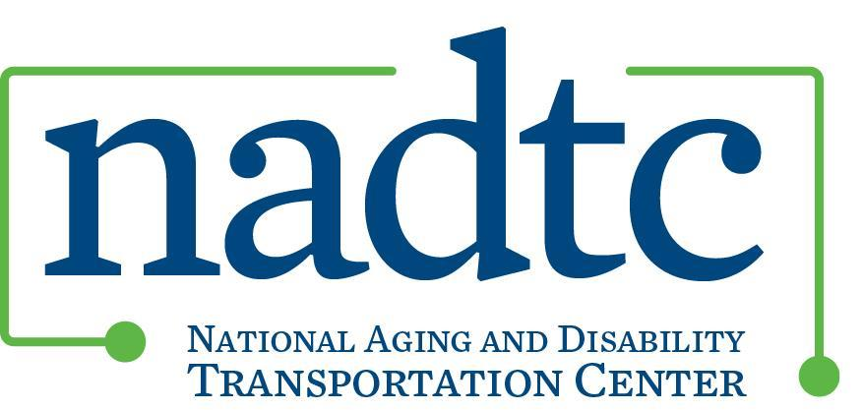

NADTC Human Services Transportation Course: Session 3

*\*This document is a continuation of information provided in Session 1 and Session 2 on the Sound Generations Program.*

**A conversation with Cindy Zwart, Sound Generations, King County, WA**

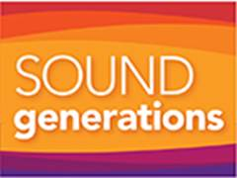

1. How do you (as a human services agency) asses the need for transportation in a community? How are transportation gaps identified? Do you engage older adults and people with disabilities in these conversations? How so?

Sound Generations assesses needs, identifies transportation gaps and engages older adults and people with disabilities in the following ways:

* We participate in community planning groups, including the King County Mobility Coalition and the Puget Sound Regional Council’s Special Needs Transportation Committee, to share information, assess the needs of the local community and current transportation network, share recommendations to improve the system and better serve the community.
* We conduct rider surveys on an annual basis to elicit feedback, comments and suggestions for service improvement, planning and implementation.
* Following Washington State’s Agency Council on Coordinated Transportation guidelines, we developed Customer Comment Cards which we place in all our vehicles to assure riders an easy and accessible way to comment and provide feedback on Hyde Shuttle service.
* We work closely with nutrition site managers to ensure culturally appropriate service to our shared clients and make revisions to service based on their feedback.
* Before implementing community shuttle routes in suburban and rural locations, we meet with senior center directors, city planners and other stakeholders in the community to customize service to meet the needs of their city.
* Recently we conducted a program evaluation and solicited feedback from stakeholders in the community which will be used to enhance service efficiency and effectiveness and develop potential modifications to our service model.

1. Sound Generations is just one piece of King County’s transportation puzzle. Talk a bit about how the transportation system in King County has become the network of services that it is today. How was it developed and what was your agency’s role in that development?

King County is fortunate to have a wide range of transportation options provided by government, public, private, for-profit and non-profit agencies, each with a discrete service area, target population and operating authority. These included fixed route bus and rail service, ferry service, deviated fixed route, demand response (paratransit), shared ride, brokered transportation, program transportation, school transportation, volunteer driver programs and other human services transportation, taxis, limos, airport shuttles as well as mobility management.

Even when I started twenty-six years ago with Sound Generations there was quite a variety of transportation options throughout the county. However, back then, there was little coordination or collaboration happening in the region.

I would say King County’s transportation system became the successful network of services it is today because we had the vision to start discussing coordination, collaboration and proactive partnership building before the FTA required that projects seeking SAFETEA-LU and now MAP-21 funding be derived from a locally developed, coordinated public transit-human services transportation plan. Some of us started meeting years ago, at times only a handful from various organizations, including transit, government and non-profit agencies, to identify community transportation needs, specifically for special needs populations, and how our region could best address those needs.

Our group eventually evolved into the King County Mobility Coalition, our county’s local coordinating committee, and now has over 50 active members. The Coalition responds both to MAP-21 and the State of Washington requirements for receiving federal and state funds. However, even now there are never enough transportation providers to meet service demand and King County still has people who are underserved, as documented in the Puget Sound Regional Council’s (our local MPO) Coordinated Transit-Human Services Transportation plan.

1. We receive many inquiries from professionals who don’t know about the transportation services available in their community. How do people in King County learn about the services?  Is there a comprehensive list of services available for older adults and people with disabilities? What places in the community do King County residents need to contact to find out information on transportation?

King County residents learn about services in a variety of ways and from a variety of agencies. For example, all of our transportation program staff provide information and referral for other transportation resources if we are unable to provide service ourselves. Senior centers and community centers hold resource fairs on a regular basis. The county has very active mobility management and travel training programs whose staff conduct extensive outreach, participate in resource fairs and provide training to professionals, social workers, human service agency staff as well as end users. Harborview Medical Center conducts in-person eligibility screening for our County’s paratransit service and also serves as a transportation resource center as well. Many agencies, including Sound Generations, the King County Mobility Coalition and the local transit agency, offer on-line transportation databases with links to all the major transportation providers in the region as well as other transportation databases including findaride.org, vets-go.com and crisisclinic.org. The county also offers the 2-1-1 community resource information line.

However, learning how to access and utilize transportation options can still be a daunting task for individuals and social service agencies are not always familiar with or not fully informed of all the transportation programs and services available in the region. We hear from riders and other community members that there is too much information available and the lack of one single number to call for information and to request a ride can be very challenging.

While King County is proud of all the work we have done to improve transportation for the special needs population, there is still much work to be done to inform not only professionals but the general public and end-users about services availability in our community. The Puget Sound Regional Council’s Coordinated Plan identifies the need for clear information on available transportation options as well as language and cultural barriers to accessing transportation options.

Contact Information  
If anyone has any questions or would like more information, please feel free to contact me at:

Cindy Zwart, Sound Generations’ Transportation Program Director   
(206)727-6255

cindyz@soundgenerations.org