
SMApply Instructions

This document provides instructions on how to use the National Aging and Disability Transportation Center online grant system to complete tasks and monthly reports for the 2024 Rural Community Innovations: Transportation Planning Grant. Contact mbratton@usaging.org for all issues related to access of the online system. To access the system and complete your assigned tasks and reports, please follow these steps:

- Login to NADTC/SM Apply: https://nadtc.smapply.io/acc/l/. “Login” using the same credentials (email address and password) that were used when submitting the grant application. If you are the same person who submitted the application, but have forgotten your password, please click “Forgot your password?” and follow the instructions.
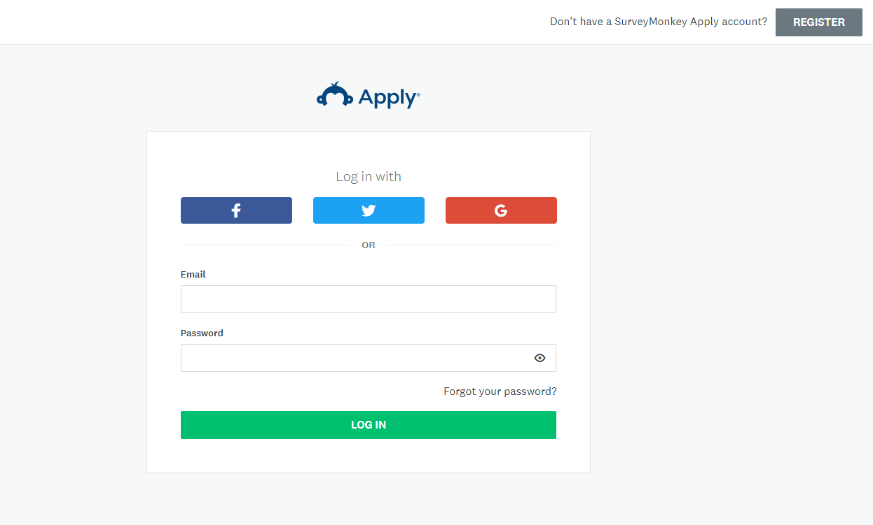

- Click “Start” to access assigned tasks and reports.
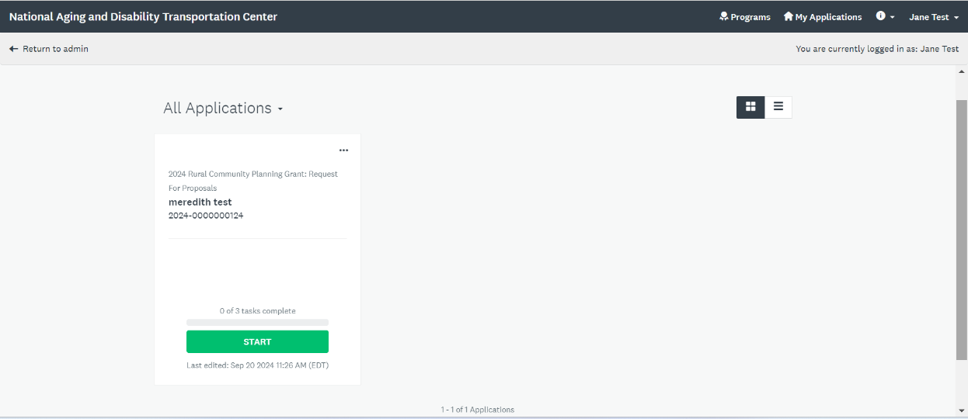
- TASKS: All tasks that that are currently available to work on will be displayed at the top under Your Tasks. Click on each task box to access and complete it. Tasks that were previously completed (e.g. your application) will be listed below under Previous Tasks.
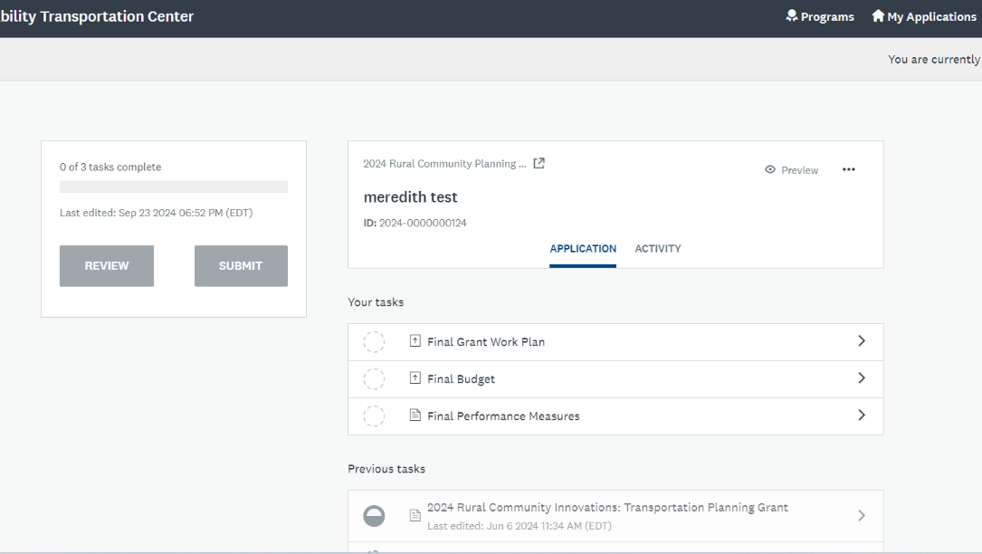
NOTE: SM Apply does real-time autosaving, so if at any point you need to exit the portal, when you log in again, any progress previously made will still be in the system.
- UPLOADS: To upload documents where templates are provided (e.g., Final Grant Work Plan, Final Budget and Monthly Financial Report) click on the hyperlink to download the form. Once you have filled out the form offline, save it on your computer, then upload by clicking Attach File, select your file, and click Open to upload it. Click Mark as Complete which will bring up your other open tasks on the left.
NOTE: Budget and financial forms will only be accepted though the system as .xls or .xlsx. All other documents will only be accepted as .doc, .docx or .pdf.
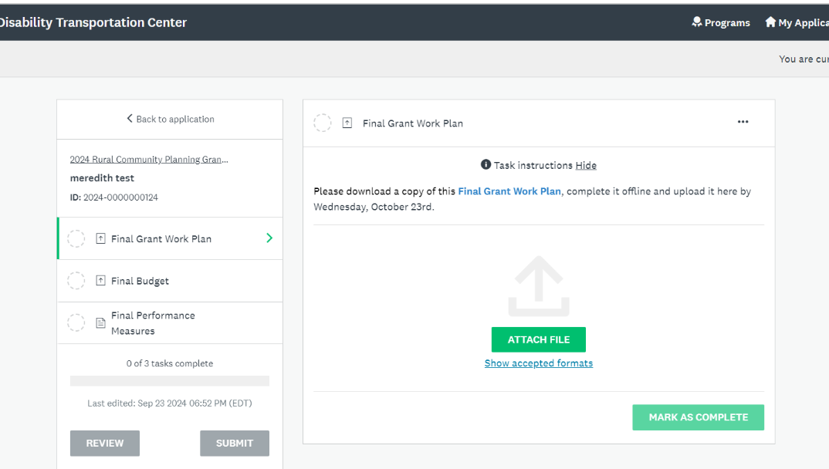

Note: If you would like to make changes to or remove the document you have just uploaded, click the ellipses to the right of the document name for a menu of options.
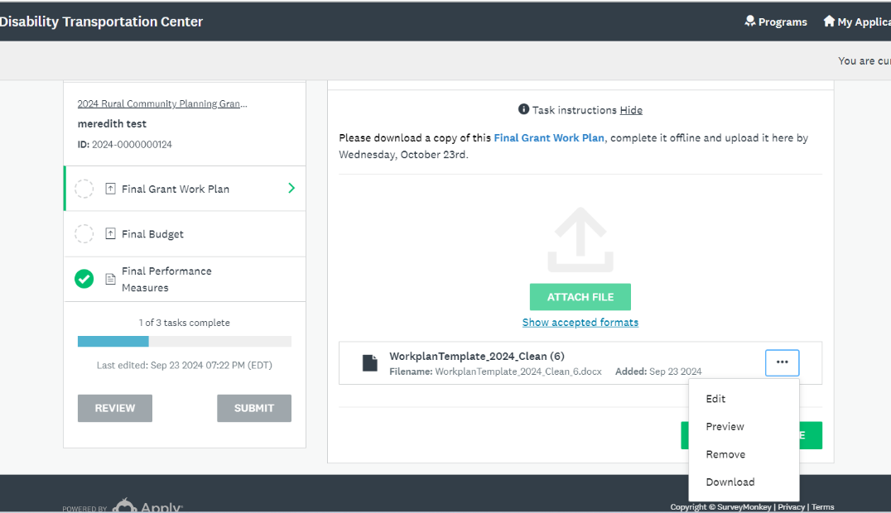
- FINAL PERFORMANCE MEASURES FORM: Information for this form is entered directly on the form in SM Apply. If you have completed the Performance Measures Template, you can use Ctrl C to copy and Ctrl V to paste the information from the template to the online form. Click Mark as Complete at the bottom of the page once you have entered all the required information.
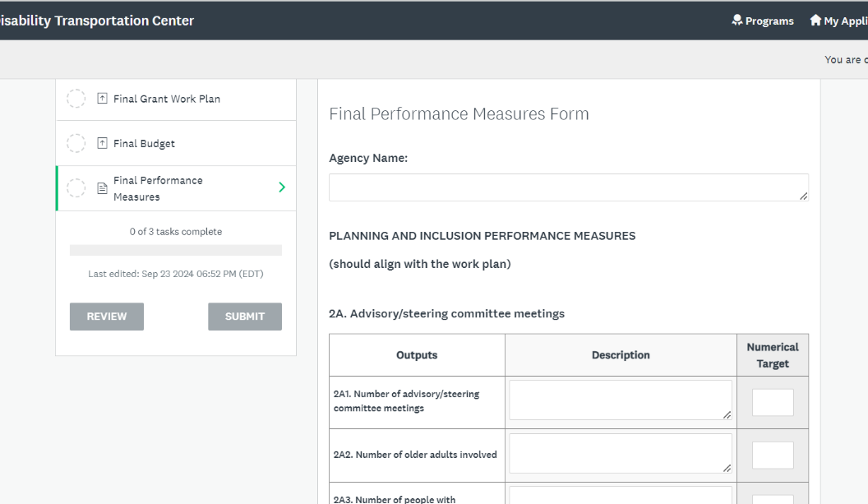
NOTE: If you would like to download the form, change any of the information entered, or upload a different document for a task after you have clicked Mark as Complete, click the ellipse in the top right corner for a dropdown menu. Edit will reopen the form for changes and Reset will erase all of the information that you previously entered.
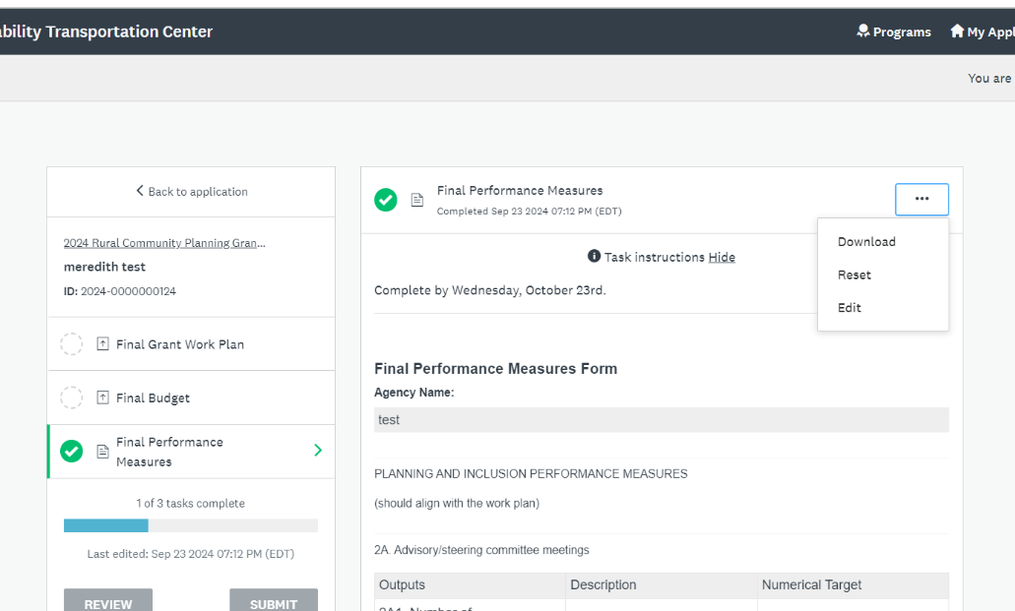
- MONTHLY REPORTS: Each month, a Monthly Progress Report and Monthly Financial Report will be added to Your Task list. To complete the Monthly Progress Report, you will enter your information directly on the form. Click Save & Continue Editing at the bottom of the page to allow editing of the report. Once you are certain all of the information is exactly as you want it, click Mark as Complete.
- The Monthly Financial Report will be completed off-line, saved and uploaded each month along with the required back up. See #4 above for instructions for uploading documents.
NOTE: Some form questions are required. If you attempt to click Mark as Complete before filling out all required fields, you will receive a red error message at the top of the page, as well as above each required answer. Once you answer all required questions, then you can click Mark as Complete at the bottom of the page.
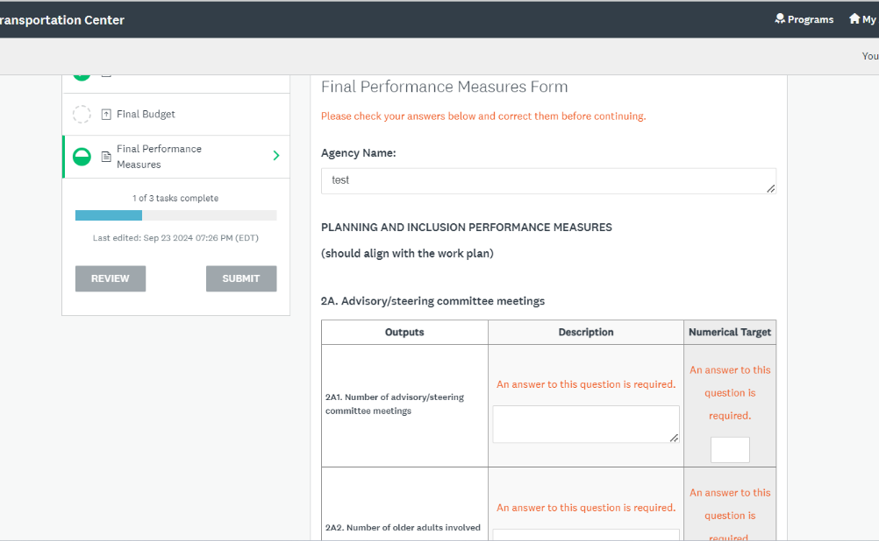
9.) Task Progress: Once you start a task, you can see your progress on the left-hand side of the screen via the status bar. The half green circle indicates that you’ve started the task but have not completed it. Once you click Mark as Complete, the task will be marked with a green check mark.
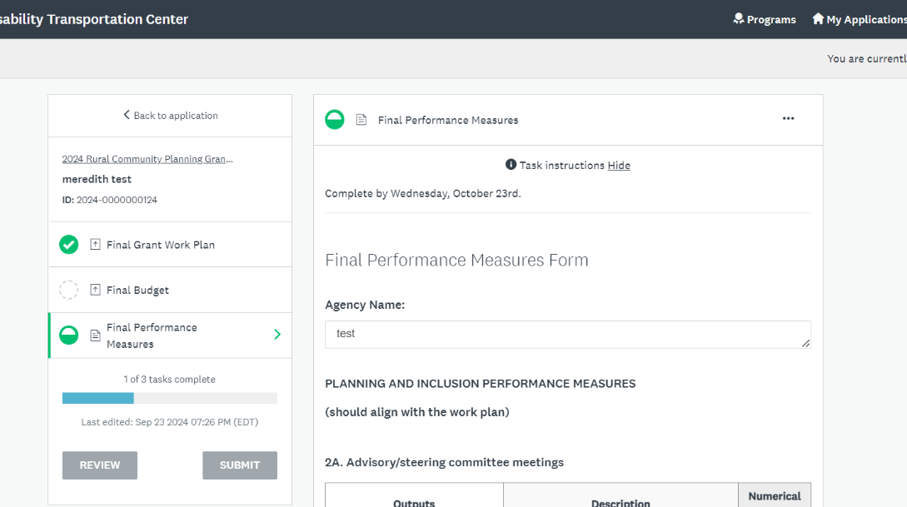
After all of the tasks for the month are completed and all task circles are green checked, you are done for the month! There is no need to click Submit.

