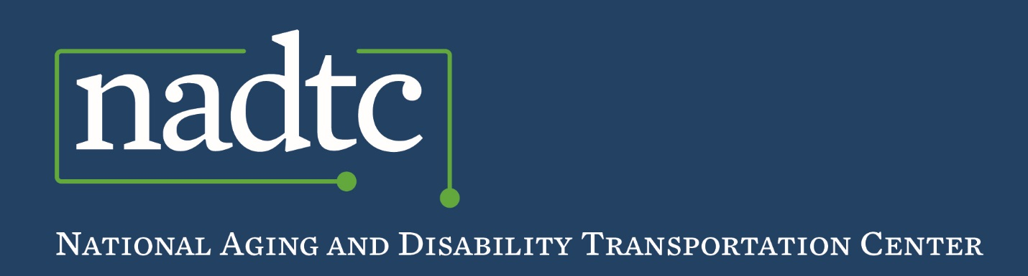

*Events Report*

**Summary of National Aging and Disability Transportation Center Activities at the 2017 National Association of Area Agencies on Aging Conference**

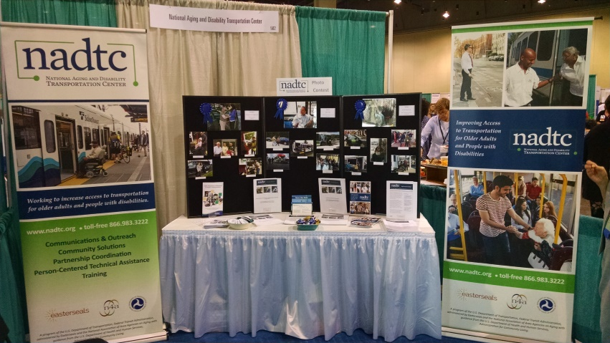

The topic of transportation for older adults and people with disabilities has had a longstanding presence at the National Association of Area Agencies on Aging (n4a) Conference, held this year July 30 - August 2, 2017 in Savannah, GA.  This setting is host to over 1,000 leaders in aging for idea sharing, interactivity, networking and practical information exchange. The 2017 conference was again an opportunity for the National Aging and Disability Transportation Center to highlight transportation as a key topic area in the conference agenda with an NADTC hosted booth, a ‘Mobility Fair’, a pre-intensive training on rural transportation, and four transportation workshop sessions hosted by local programs. Expert panels offered information, interaction and discussion to provide attendees with a unique opportunity to engage in stimulating activities and professional peer-to-peer discussions. What follows is a review of the discussions that took place during the transportation-focused sessions.

**Section I. Pre-Conference Intensive Training Session on Rural Transportation**

NADTC staff led a half-day training session with 31 conference attendees to review the unique challenges rural communities face in providing comprehensive transportation services. Transportation remains a significant barrier for older adults and people with disabilities nationwide, but nowhere is this barrier felt more keenly than in rural America. This intensive training session featured remarks from two Area Agency on Aging (AAA) programs that have been successful in developing creative programs that address the transportation needs of rural residents and a small group activity for reflection and brainstorming on solutions to implement in their own communities.

The agenda featured the following presentations:

* [Virginia Dize, NADTC Co-Director, National Association of Area Agencies on Aging, Washington, DC](http://www.nadtc.org/wp-content/uploads/Rural-Transportation-Intensive-vd-Intro.pdf)
* [Joy Shirley, Director, and Belinda Hayes, a Program Manager, both with the Area Agency on Aging, Three Rivers Regional Commission in Griffin, GA](http://www.nadtc.org/wp-content/uploads/Shirley_Transportation.pdf)
* [Mitch Elliott, Transit Director, Mountain Empire Older Citizens in Big Stone Gap, VA](http://www.nadtc.org/wp-content/uploads/MEOC-Transit-July-2017.pdf)

**[Section II. 5](http://www.nadtc.org/wp-content/uploads/MEOC-Transit-July-2017.pdf)[th](http://www.nadtc.org/wp-content/uploads/MEOC-Transit-July-2017.pdf) [Annual Mobility Fair](http://www.nadtc.org/wp-content/uploads/MEOC-Transit-July-2017.pdf)**

The ‘Mobility Fair’ is the longest-running, formally recognized transportation presence at the n4a Conference. Since 2013, the Mobility Fair has provided a platform for dialogue with Area Agencies on Aging around transportation challenges, potential solutions and best practices in the transportation field.  The 2017 Mobility Fair was successful in building a supportive learning environment with opportunities for connection and engagement. The event offered four roundtable topics:

* **Information and Referral**
* **Rural Transportation**
* **Transportation Funding**
* **Travel Training**

Roundtables each had 7-10 participants, who were given the opportunity to rotate between tables, listen to table hosts frame the issue, and then engage in conversation as a small group. Each roundtable session highlighted the different ways transportation is making a difference in communities around the country and generated valuable ideas to improve community transportation services that meet the needs of older adults and people with disabilities. Suggested resources for each subject are linked within the topic summaries below.

* 1. **Information & Referral.** Highlights from the roundtable on transportation information and referral are below, with key topics of the conversation centering on public outreach methods, one-call one-click centers, and partnerships. **Discussion leader**: Roberta Habowski, Mobility Project Manager, Area Agency on Aging 1-B, Southfield, MI.
  + **Public Outreach**
* Public outreach is important for ensuring the community is aware of the information and referral resources available.
* The database your agency uses to house information must be kept up to date. Scheduling regular follow-up with providers can ensure that the most accurate information is being distributed, including hours of operation, cost, and eligibility requirements.
* Social media can be a powerful tool to reach the community with mobility information. In the Los Angeles area, [Riders Clubs](https://www.metro.net/riding/senior-tips/move-riders-club/) are a peer-to-peer travel training program for older adults. These Clubs rely heavily on social media to get the word out about the various chapters of the group, upcoming events, and travel options within the region. Facebook, Twitter, and YouTube are some of the commonly used social media tools by the clubs.
* Other activities that Riders Clubs participate in to reach the public are “Pop-Up Expos”. These Expos happen in select locations to reach a large group of potential riders, such as main transit hubs, community centers, and senior centers. They often include presentations on how to apply for a senior discount card, or how to get involved with a particular chapter of the Riders Club. The events are free and heavily publicized throughout the community using social media.
* **One-Call One-Click Transportation Centers**
* One-call one-click centers enable customers to make one phone call or search one website to receive information about all transportation in their region. This [page](http://nationalcenterformobilitymanagement.org/by-topic-one-call-one-click/) on the National Center for Mobility Management website is a good resource on one-call one-click promising practices, resources and training.
* A frequent best practice of one-call one-click centers is using the “No Wrong Door” (NWD) approach. This means that when a consumer reaches out to an agency for information, the agency will ensure the consumer is directed promptly to someone who has the answer. When an older adult or person with a disability contacts your agency, implementing a NWD approach means that there are protocols in place to support the caller in finding the information they are seeking, removing the need to navigate multiple agencies and systems to secure the transportation. A NWD approach might also include one-on-one counseling.
* The [One-Call One-Click Toolkit](http://bit.ly/OCOCmain) is a valuable resource for communities interested in developing a one-call or one-click service for transportation. This document contains information related to organization, maintenance, staffing, interacting with members of the public, and operational guidance.
* **Partnerships**
* Partnerships of Area Agencies on Aging, community centers, independent living centers, and the general public can help foster more robust information and referral networks and even leverage funding.
* At the core of mobility management is creating partnerships with transportation providers to enhance travel options, and then developing approaches to effectively communicate those options to the public. With networking and partnership development, mobility management services can receive support from the business community, citizens, and local government.
* Partnerships allow for the sharing of data on unmet transportation needs. By sharing this information with partnering organizations, creative solutions may be found to meet these needs and address barriers.

1. **Rural Transportation.** Highlights from the roundtable on rural transportation are below, with key topics of the conversation centering on volunteers, technology, and funding. **Discussion leader**: Mitch Elliott, Transit Director, Mountain Empire Older Citizens in Big Stone Gap, VA.

* **Volunteers**
  + Participants discussed the success of on-board volunteer escorts to assist in door-through-door transportation and on-board rider assistance. A major concern is volunteer recruitment, retention and the struggle to maximize the skills of volunteers, expand services, and enhance effectiveness. Mountain Empire Older Citizens in Big Stone Gap, VA has had great success in recruiting student volunteers from local college nursing and medical training programs to provide transportation assistance to dialysis and chemotherapy patients. After treatment, these riders experience fatigue, nausea, and difficulty carrying personal belongings. Local students find these real life volunteer experiences valuable as a supplement to their classroom instruction.
  + The [“Got an Hour?”](http://www.giveitbacktoseniors.org/about-the-campaign.html) Campaign can be used to address volunteer commitment concerns. Agencies who have adopted this campaign find success with volunteers who commit time they have available in 1-hour increments instead of committing to a specific schedule that can become overwhelming or difficult to maintain. The campaign provides downloadable materials, webinars, and a search tool (powered by VolunteerMatch.org) to help connect prospective volunteers with opportunities and programs in their neighborhood. More information and resources on volunteers can be found through the [Volunteer Resource Center](https://www.n4a.org/volunteercenter).
  + Volunteer job descriptions and background checks are important, especially when volunteers are entering homes or using their own vehicle for providing transportation.
  + Funding for volunteers: Volunteer programs are not free to organizations and the time and cost of volunteer coordinator salaries, background checks, training programs, etc. need to be considered when creating volunteer programs.
  + Senior intern programsarea creative way to find volunteer staff and utilize the talents of older adult community members. For example, one participant offered an example of an agency in New Jersey where volunteers donate 10 hours of time per week for 10 weeks. If there is synergybetween the organization and the volunteer they are brought on as per-diem staff.
* **Technology**
  + While popular in urban and suburban communities, ride-sharing technologies like Uber and Lyft are not available in many rural areas, potentially because of a perceived lack of consistent demand. In addition, rural areas still have neighborhoods and communities without internet and cell service so technology solutions that might work elsewhere may not even be a possibility in rural communities.
  + [Liberty Mobility Now](http://libertymobilitynow.com/), a rural and small urban Mobility as a Service (MaaS), is an example of a ride sharing concept that has found traction in some rural communities. Liberty Mobility Now offers part-time work to drivers and operators of the Liberty call center. In rural areas, unemployment is often high and this opportunity provides both transportation to those in need and jobs to those seeking employment. (More information on Mobility as a Service can be found in the NADTC white paper: [Bringing Mobility as a Service to the United States: Accessibility Opportunities and Challenges](http://www.nadtc.org/resources-publications/bringing-mobility-as-a-service-to-the-united-states-accessibility-opportunities-and-challenges/). This white paper describes the unique opportunities and challenges associated with MaaS in the U.S., along with describing a few of the systems that are under currently development.)
  + Even when ride-sharing services are available, some older adults are apprehensive about using a cell-phone to request and pay for rides. To overcome this, some agencies have implemented an intergenerational approach where college students act as “technology mentors”. These mentors provide one-on-one guidance to those unfamiliar with using cell phones for the service. Other creative solutions that reduce the need for smartphone apps include the [GoGoGrandparent](https://gogograndparent.com/) program that turns on-demand transportation companies (that typically operate via smartphone) into services that allow individuals to connect to an operator 24/7 to schedule rides.
* **Funding** 
  + Participants highlighted the particular challenge of finding and maintaining funding for rural transportation services. Many felt it was difficult to provide data to prove meaningful impact of funds and also expressed frustration that rural areas tend to receive smaller amounts of funding than their urban and suburban neighbors because of a perceived “smaller impact”. Participants also noted the power of stories that illustrate the impact of transportation successes and noted the importance of capturing stories to provide additional meaning beyond data and numbers.
  + A lack of funding leads to limited service. For many areas, public transit is only offered on the weekdays on a limited schedule. For those contracting services out, there is also limited choice in provider options.

1. **Transportation Funding.** Highlights from the roundtable on transportation funding are below, with key topics of the conversation centering on the Federal Transit Administration’s Section 5310 program, diversification of funds, and partnerships. **Discussion leader**: Virginia Dize, NADTC Co-Director, National Association of Area Agencies on Aging, Washington, DC.

* **Federal Transportation Administration Funding Programs**
  + - * Many participants were familiar with FTA’s Section 5310 program, “Enhanced Mobility of Seniors and Individuals with Disabilities”. This program provides funds to serve the special needs of transit-dependent populations beyond traditional public transportation services and Americans with Disabilities Act (ADA) complementary paratransit services. Details of the program are specified FTA’s [Section 5310 Fact Sheet](https://www.transit.dot.gov/funding/grants/enhanced-mobility-seniors-people-disabilities-fact-sheet-section-5310). Under the 5310 program, each state and “designated recipient” has created its own process and dates in place for distributing funds. For rural and small urban areas, the state Department of Transportation administers the funds. In large urban areas, the governor may choose a “designated recipient”. Eligible sub-recipients of funds include private nonprofit organizations, states or local government authorities, or operators of public transportation (AAAs and other human services agencies can receive 5310 dollars).
      * NADTC has developed a number of resources for those interested in learning more about the 5310 program. An [online course](http://www.nadtc.org/event/section5310-gapsinmobility/) is archived on the NADTC website and provides information about eligibility and funding requirements, coordination planning, and ideas for innovative approaches for using Section 5310 funds. NADTC also developed an application [checklist](http://www.nadtc.org/resources-publications/section-5310-funding-an-application-checklist/) to assist agencies in managing the requirements, tasks, and deadlines of the 5310 application process.
      * Participants were also familiar with FTA’s Section 5311 program, Formula Grants for Rural. This program provides capital, planning, and operating assistance to states and federally recognized Indian tribes to support public transportation in rural areas with populations less than 50,000. Details of the program are specified in FTA’s [Section 5311](https://www.transit.dot.gov/funding/grants/formula-grants-rural-areas-fact-sheet-section-5311) Fact Sheet.
      * NADTC can provide information and technical assistance to organizations who are seeking additional information about FTA funding programs. You can contact NADTC Technical Assistance Staff at 1-866-983-3222 or [contact@nadtc.org](mailto:contact@nadtc.org).
  + **Diversification of Funds:**
    - It is important to find diversified funding streams to maintain program sustainability. For example, if a transportation service is supported by a grant program or government funding that is reduced or eliminated, it is essential that organizations have a base of funding that’s varied so they have a reliable and flexible source to support continued existence of the transportation service.
    - Diversified partnerships are as important as diversified funding sources. Partners who may be interested in serving the transportation needs of older adults and people with disabilities might be found in the health field, community development, economic development, or veterans services.
    - To continue to receive funding, it is necessary to track data to showcase the outcomes, outputs, and impacts of your program to current and future funders.
    - Match funding: The Administration on Community Living (ACL), a Health and Human Services agency, provides [Older Americans Act](https://www.acl.gov/about-acl/authorizing-statutes/older-americans-act) (OAA) funds that many Area Agencies on Aging use as eligible match for Sections 5310. ACL has [prepared guidance](https://www.acl.gov/about-acl/authorizing-statutes/older-americans-act) on how to use OAA funds to match FTA funding programs. NADTC also created a blog post, “[Section 5307, 5310, and 5311: Using Non-DOT Funds for Local Match](http://www.nadtc.org/news/blog/section-5307-5310-and-5311-using-non-dot-funds-for-local-match/)”, that explores match opportunities.
* **Partnerships:**
* While funding is very important, so are non-monetary resources. Consider the best way to involve your partners and make the most of the resources they have to offer. Not everyone who becomes a partner needs to have the same type or degree of involvement, and support doesn’t always need to be financial. In-kind donations like event space, staff time, trainings, etc. can be valuable contributions.
* When seeking new partnerships and managing existing partnerships, it is important to make them aware of the benefits they may receive from working with your organization.
  + - Identify and develop champions who can assist your organization in gaining the recognition and resources needed to achieve short- and long-term goals.

1. **Travel Training:** The roundtable on travel training is highlighted below, with key topics of the conversation centering on volunteer travel training programs, the definition of travel training, and transportation education. **Discussion Leader:** Julie Dupree, Training & Technical Assistance Specialist, National Aging and Disability Transportation Center, Washington, DC.
   * **The Definition of Travel Training/Transportation Education** 
     + Participants discussed the various forms and approaches travel training takes. The group agreed that a broader definition of transportation education is important to consider when conducting travel training.
     + Transportation education can include community transportation education days, bus or train familiarization training, etc. Due to budget and time limitations, this transportation education can be difficult for many transportation, human services, or aging or disability organizations.

* **Volunteer Travel Training Programs:**
  + Participants discussed the volunteer travel training program approach, specifically those at senior centers in urban, suburban, and rural areas. The unique approach to volunteer travel training through peer-to-peer “bus buddy” programs can help promote and achieve travel independence. Individuals at the roundtable shared their appreciation for peer-to-peer volunteers with antecedes of programs that used peer models. Older adults in these programs who were shown how to ride the bus, plan a trip, prepare for a trip, etc. by their peers, had an overall high success rate of independent travel. Peer-to-peer training is often more encouraging, lively, and fun than other travel training models that may focus on classroom instruction.
  + Identifying programs, activities or strategies that have worked within one organization and show promise and success should be shared with other programs for potential replication. Programs identified as “best practices” included older adult volunteer travel training programs at [Ride Wise/Ride Connection in Portland, OR](https://rideconnection.org/), [We Get Around in San Diego, CA](https://www.wegetaround.org/), and [Via in Boulder, CO.](https://viacolorado.org/service/travel-training/)
  + The Riders Clubs out of Los Angeles County (*Riders Clubs are defined in greater detail in the Information and Referral discussion section above*) have an innovative approach to recruiting and retaining older adult volunteer travel trainers. More information on this unique solution can be found on the program website: [www.metro.net/riding/senior-tips/move-riders-club/](http://www.metro.net/riding/senior-tips/move-riders-club/).

**Section III. Additional Transportation Sessions at the Conference**

Four additional transportation sessions occurred throughout the conference featuring NADTC staff, Area Agencies on Aging Directors and staff, and representatives from the Administration on Community Living (ACL) and the Federal Transit Administration (FTA).

1. **Expanding Senior Transportation Alternatives: It Takes a Community!**

Lack of transportation presents a significant barrier to aging in place, limiting access to the cornerstones of basic needs: medical appointments, social events, and shopping. It takes a community to work together to provide the help that is needed. This session highlighted how Sonoma County, CA formed countywide partnerships to expand transportation alternatives and coordinate services to the most vulnerable seniors and people living with disabilities in the county. With the AAA coordinating the efforts and bringing partners together, successes include the expansion of volunteer driver programs from one to six regions over the past two years; the implementation of travel voucher programs utilizing both traditional taxi services and the Transportation Network Company (TNC) Lyft; and collectively advocating for change to increase options and reduce gaps in transportation services.

* **PowerPoint Presentation:** [Tracy Repp, Area Agency on Aging Program Manager, Sonoma County Human Services Department, Santa Rosa, CA and Diane Kaljian, Assistant Director, Sonoma County Area Agency on Aging, Santa Rosa, CA](http://www.nadtc.org/wp-content/uploads/Sonoma-n4a.pdf)

1. **Inclusive Community Transportation**

Older adults and people with disabilities use transportation to engage in life, but as with all systems, consumer feedback is an important component of improvement. This session reviewed how an inclusive planning process that fully engages older adults and people with disabilities can lead to transit system improvements. The session reviewed the Inclusive Coordinated Transportation Partnerships project, an initiative of ACL. Participants also learned about the FTA [Section 5310](https://www.transit.dot.gov/funding/grants/enhanced-mobility-seniors-people-disabilities-fact-sheet-section-5310) program and how the federal funding program is supporting improved mobility for seniors and individuals with disabilities by removing barriers to transportation services and expanding the transportation mobility options available. Finally successful strategies used by Area Agency on Aging 1-B, an ACL grantee, were presented, including the development of the myride2 project, a one-call one-click center.

* **PowerPoint Presentations:** 
  + - Virginia Dize, NADTC Co-Director, National Association of Area Agencies on Aging, Washington, DC
    - [Roberta Habowski, Mobility Project Manager, Area Agency on Aging 1-B, Southfield, MI](http://www.nadtc.org/wp-content/uploads/Roberta_n4a.pdf)
    - [Kelly Tyler, Program Manager, Enhanced Mobility for Seniors and Individuals with Disabilities Program, Federal Transit Administration, U.S. Department of Transportation, Washington, DC](http://www.nadtc.org/wp-content/uploads/N-4-A-Presentation-Final_Kelly-Tyler.pdf)
    - [Lori Gerhard, Director, Office of Consumer Access and Self-Determination, U.S. Administration for Community Living, Washington, DC](http://www.nadtc.org/wp-content/uploads/Lori-Gerhard-ppt..pdf)

1. **Getting There Together: Mobility Management Strategies**

Transportation is a lifeline for older adults and people with disabilities, and yet it remains one of the greatest unmet needs in the community. This workshop explored Mobility Management strategies such as a one-call, one-click center, Volunteer Transportation program, Aging and Disability Sensitivity and ADA training for transit providers, and accessibility audits and improvement plans to increase and enhance transportation options in your community.

* **PowerPoint Presentation**: [Katie Kutcher, Aging Programs Coordinator, and Angel Stoy, Community Health and Wellness Aging Specialist, Centralina Area Agency on Aging, Charlotte, NC](http://www.nadtc.org/wp-content/uploads/GettingThereTogether.Kutcher.n4a.2017.pdf)

1. **Improving Health through Better Access to Transportation: Atlanta’s Model Approach**

Access to transportation is a crucial component of good health. Many with limited transportation options are forced to skip preventive care, forgo care when ill and seek care only in emergency situations, resulting in higher costs for both the individual and health care system at large. Both disability and low income can contribute to one's inability to drive and maintain a car. The Atlanta Regional Commission (ARC) is employing a multi-pronged approach to increase vulnerable residents' access to health care and related daily needs so that people can remain healthy and independent as long as possible. This session explored ARC's comprehensive transportation strategies and services to improve transportation in the region. Participants learned how ARC is evaluating the “return on investment” of reliable transportation for individuals and healthcare providers in order to attract additional investments for transportation services.

* + - **PowerPoint Presentation**: [Mary Blumberg, Program Manager, Strategic Planning and Development and  Cyndi Burke, Mobility Manager, Atlanta Regional Commission Area Agency on Aging, Atlanta, GA](http://www.nadtc.org/wp-content/uploads/2017.8.1-N4A-ARC-Improving-Health-Through-Better-Access-to-Transportation.pdf)

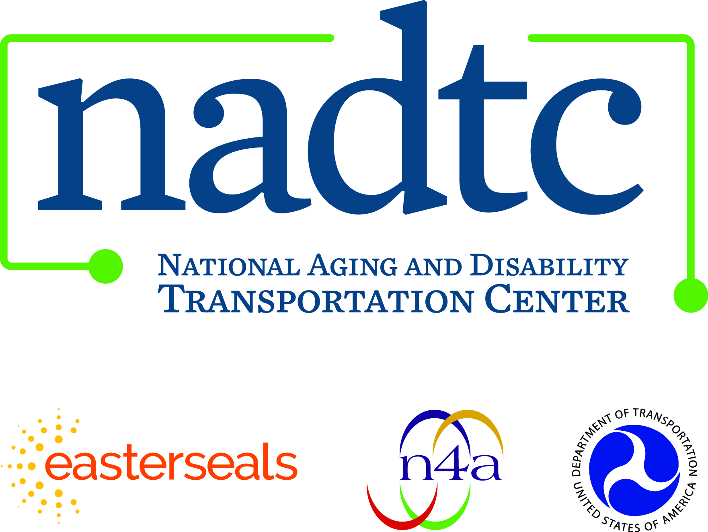

**Call toll-free:** 866.983.3222

**Email:** contact@nadtc.org

**Web:** [www.nadtc.org](http://www.nadtc.org)

**Find us** on Facebook, Twitter, YouTube & LinkedIn!



