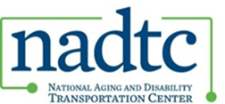

**All Projects Meeting**

**May 28, 2025 at 2:00PM Eastern Time**

The meeting will be held via [Zoom](https://usaging-org.zoom.us/j/86376279422?pwd=9RdJSLVzXlshIoBb6vMd1twPBQM1Wb.1). Meeting ID: 863 7627 9422. Passcode: 503965

**2:00PM Welcome**

**2:05PM Guest Speaker and Discussion: Laura Loe**

* Laura Loe, Program Manager with Hopelink, will join us to share highlights on how their agency has approached community engagement and sustainability.

**2:35PM NADTC Updates**

**2:55PM Wrap-Up**

* Additional questions?
* Survey

**3:00PM Adjourn**