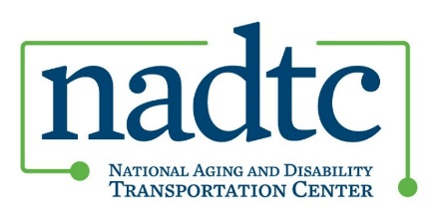

# All Projects Meeting

## July 16, 2025 at 2:00pm Eastern Time

The meeting will be held via [Zoom](https://usaging-org.zoom.us/s/89497033135?pwd=Epaxss0LtMTKab6iAjazawgdTMIOeU.1#success) ; Meeting ID: 894 9703 3135, Passcode: 194023

### **2:00PM** **Welcome and NADTC Updates**

* Co-Director's Update.

### **2:05PM** **Chicago In-Person Meeting Update**

* Final Presentations and Final Reports.
* Logistics overview – hotel block, meals, etc.
* Speaker/Trainer – Compass Transit Consulting, Michael Koch
* More details will be provided closer to August.

### **2:15PM** **Grantee Discussion**

* Site Visits – Grantees share their experience hosting grant managers.
* Sustainability Efforts—grantees share updates on next steps for identifying funding for implementation.
* Open Discussion

### **3:00PM** **Adjourn**