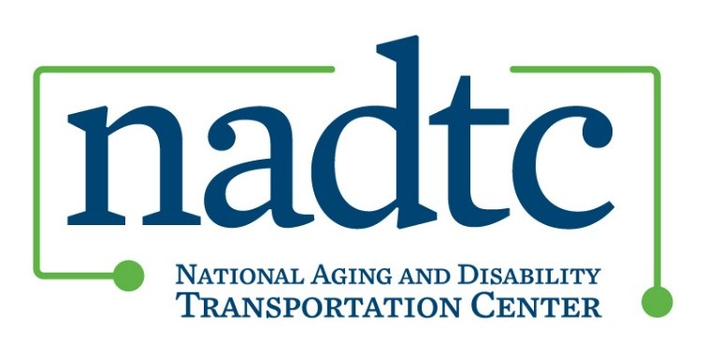

# All Projects Meeting

## June 18, 2025 at 2:00pm Eastern Time

The meeting will be held via [Zoom](https://usaging-org.zoom.us/j/89497033135?pwd=Epaxss0LtMTKab6iAjazawgdTMIOeU.1) ; Meeting ID: 894 9703 3135, Passcode: 194023

### **2:00PM** **Welcome and Grantee Updates**

Grantees should be prepared to share with their peers at least one of the following items:

* What is your agency and/or community experience with 5310?
* What would you like to know more about regarding 5310?

### **2:15PM** **Focus Topic-5310 Funding**

NADTC Staff Members Jeremy Johnson-Miller and Dave Somers will lead a brief presentation and grantee discussion.

* Overview of 5310
* Flexibilities and Best Practices
* NADTC Resources and Technical Assistance
* Questions?

### **2:45PM** **Wrap Up and NADTC Updates**

* Co-Director's Update
* Final Presentations and Final Reports
* In-Person Meeting Plan

### **3:00PM** **Adjourn**

The next All Projects Meeting will be held Wednesday, July 16th.