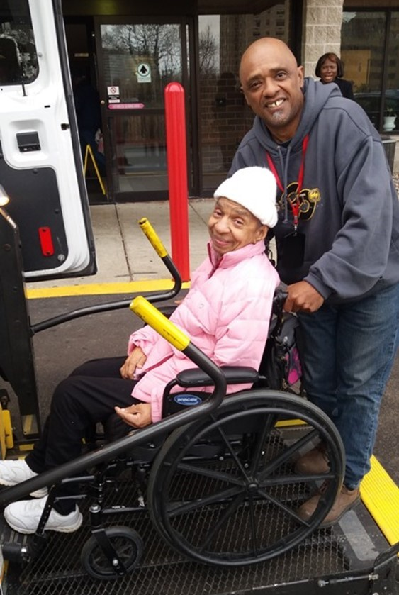
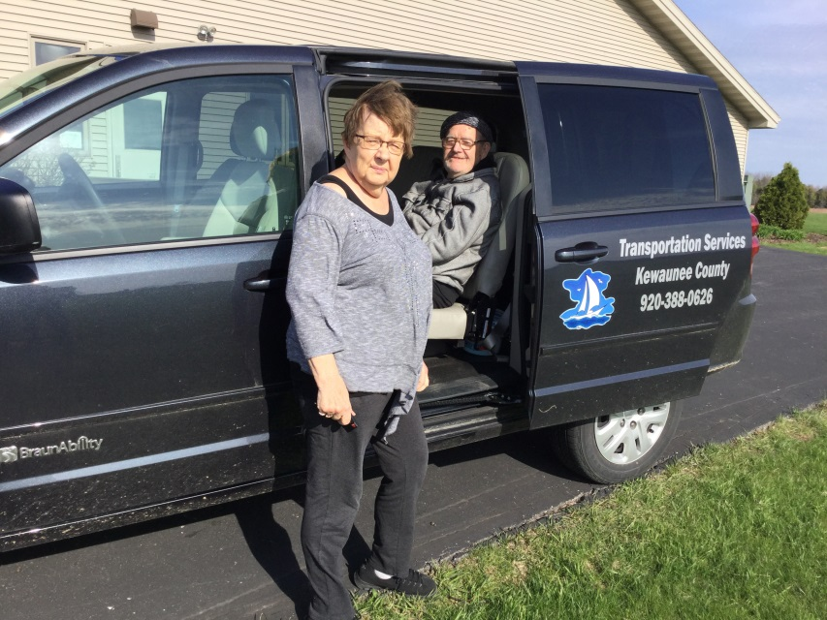

Introduction

The National Aging and Disability Transportation Center (NADTC) is pleased to present this Trends Report Topic Spotlight on the ADA Complaint Process. For transit agencies, a solid Americans with Disabilities Act (ADA) complaint process and policy will ensure that customer complaints and concerns are resolved quickly and fairly.
The 2017 Trends Report is divided into stand-alone information briefs that explore significant issues that affect the availability of accessible transportation in communities. Each brief includes case studies on how changes in transportation are being implemented in communities in the U.S., from large cities like Denver, to small towns on the Eastern Shore of Maryland.
2017’s information briefs address:
- Americans with Disabilities Act No-Shows and Cancellations
- Americans with Disabilities Act Complaint Process
- Connected Vehicle Technology
- Real-Time Transit Technology
- Rural Travel Training
- Seamless Mobility
While the ADA can hardly be considered a “trending topic”, NADTC regularly receives questions about how to implement ADA requirements. No-shows, cancellations, and the complaint process are topics frequently addressed by our technical assistance specialists. The technology and mobility briefs take a look at how the rapidly evolving world of technology is affecting safety, service efficiency, and customer information. Finally, the rural travel training brief gets back to basics with information on how small transportation systems with limited resources can make a difference through passenger instruction and peer-mentoring.
If you have questions about any Topic Spotlight or have a story to share from your community, reach out to us at (866) 983-3222 or email contact@nadtc.org.

Cover Photo Credits
Top left: 8330 On the River/Poah Communities, Detroit, Michigan
Top right: Kewaunee County Services, Kewaunee, Wisconsin
Bottom left: The Center for Volunteer Caregiving, Cary, North Carolina
Bottom right: Wallingford Committee on Aging, Inc., Wallingford, Connecticut
Bottom right:

ADA Trending Questions Requiring Clarification: Complaint Process
Introduction

For transit agencies, a solid Americans with Disabilities Act (ADA) complaint process and policy will ensure that customer complaints and concerns are resolved quickly and fairly. ADA regulations at 49 CFR Part 37.17 and 27.13 require agencies to have specific procedures in place to address complaints alleging ADA violations. The regulations also require a designated responsible employee to manage the overall process.

Key Points
- Adopt complaint procedures that provide for prompt and equitable resolution
- Maintain a copy of all complaints of ADA noncompliance for 1 year
- Maintain a record (summary) of all complaints for 5 years

Keep in mind that the complaint process is the responsibility of the transit agency. Complaint procedures must apply to all transit service provided by the agency including contracted service.

FTA Compliance Review Findings
- A record of complaints on a spreadsheet without details of follow-up communication and resolution is not adequate.
- Agency did not advertise to the public what process to follow for filing an ADA complaint.
- Accessible formats of the complaint process were not available on request.

Complaint Procedures Requirement

Transit agencies must have a process in place for the prompt and equitable resolution of complaints.

49 CFR Part 37.17 - Designation of responsible employee and adoption of complaint procedures.
(a) Designation of responsible employee. Each public or private entity subject to this part shall designate at least one person to coordinate its efforts to comply with this part. (b) Adoption of complaint procedures. An entity shall adopt procedures that incorporate appropriate due process standards and provide for the prompt and equitable resolution of complaints alleging any action prohibited by this part and 49 CFR parts 27, 38 and 39. The procedures shall meet the following requirements:

(1) The process for filing a complaint, including the name, address, telephone number, and email address of the employee designated under paragraph (a) of this section, must be sufficiently advertised to the public, such as on the entity's Web site;

(2) The procedures must be accessible to and usable by individuals with disabilities;

(3) The entity must promptly communicate its response to the complaint allegations, including its reasons for the response, to the complainant and must ensure that it has documented its response. Transit agencies must advertise the process for filing a complaint through means such as agency websites and include the contact information (name, address, telephone number, and email address) for the employee designated to coordinate compliance. A defined advertising process will be informative to riders on how to file a complaint.

FTA has found it acceptable to designate a staff person with a title of “ADA Coordinator” or “Customer Complaint Representative” so that communications are directed to the designated employee with that job title can then promptly respond to the complainant. Complaints should be filed through a defined collection process or person rather than in an informal manner with various transit personnel; this enables a complaint and resolution to be easily tracked. At the same time, the procedures help ensure that the agency provides appropriate due process for any actual ADA complaints received. This can be accomplished by forwarding telephone calls, retrieving recorded messages, forwarding emails, or other communications to appropriate staff.

It is crucial that the complaint process and procedures be accessible and usable by individuals with disabilities. Alternative formats can include large print, braille, audio recordings, and documents stored electronically on CDs in a format preferred by the requestor. The complaint process must allow for qualified interpreters, video relay such as 711, or another auxiliary aid or service so that a complainant can communicate effectively with the transit agency.

Submission and communication of complaints can be in writing on paper, electronic (online), in-person, or by telephone. Transit agencies must promptly communicate its response to the complainant, including the reasons for the response, and document this response for purposes of recordkeeping, see part 37.17(b)(3). The transit agency must also track communications on an internal records system.

Collecting Information

Transit agencies typically request the following information to assist with investigating a complaint:
- Contact information (name, rider ID (if applicable), address, telephone, email, etc.)
- Mobility aid used or other equipment including (type or model)
- Date, time, and location of the incident
- Transit mode and rail line or route number including vehicle ID number
- Name(s) or ID numbers of agency employee(s) or others
- Clear description of the incident
- Other documentation including photographs or video

Because of the unique service requirements of complementary paratransit, many agencies also establish specific information requirements related to such topics as:
- Telephone reservations or cancellations
- Lateness and missed trips
- On-board ride times

Part 37.17(b) requires agencies to resolve complaints in a manner that is both “prompt” and “equitable” so as not to discriminate against individuals with disabilities. Transit agencies are free to establish their own timelines for resolving complaints. Include a process that captures:
- Date of receipt of complaint
- Date of assignment for investigation
- Date of resolution
- Date of communication to complainant

Retain this information as part of the complaint file. FTA recommends that complaint investigations include communications with complainant and applicable staff. Other information can come from:
- Telephone call recordings
- Written communications (paper and electronic)
- Bus tracking
- Dispatch input
- Driver manifests
- Video recordings and on-board cameras
- Interviews with transit agency employees, contractors, or witnesses to the incident

A vital component of a complaint process is to determine if a submitted complaint is describing a potential occurrence of ADA non-compliance or is a general service related complaint or comment. A general service complaint may be situations such as the ride is not smooth enough for a rider, the speaker volume is not loud enough, the bus stop is not conveniently located, or the bus is too crowded.

Some examples of common ADA complaints include:
- Service animal refusal
- Inoperable lifts or ramps without backup vehicle or next bus
- Bus passes the stop with waiting wheelchair customer
- Regularly occurring pattern or practice of late pick-ups for ADA paratransit
- Excessively long trips on ADA paratransit
- No stop announcements or route identification

FTA’s Title VI Circular 4702.1B states that ADA complaints must be categorized distinctly from Title VI complaints in record keeping and communications:
- Keep all complaints of ADA noncompliance on file for one year.
- Keep a record of all ADA complaints (may be in summary form) for five years.
- Electronic database of complaints is a suggested practice.

Part 37.17(b)(1) requires transit agencies to publicize their process for filing complaints with highlighting the information an agency needs to investigate a complaint, timelines for resolution, and details on how the resolution will be communicated to the complainant.

Use complaint findings for case studies and examples in training drivers and transit staff. Part 37.173 requires transit staff are to be trained to proficiency as appropriate to their duties. Training may include staff responsible for accessibility equipment, operating procedures or maintenance procedures. This requirement applies to contracted service personnel, as well.

Summary
A public or private transportation provider that operates fixed-route or demand response service, or any combination, is required to provide accessible services for everyone meeting the ADA requirements and without discrimination. ADA regulations require agencies to have specific procedures in place to address complaints alleging ADA violations and to resolve them quickly and equitably. The regulations also require a designated responsible employee to manage the overall process. Finally, transit agencies must clearly advertise the complaint process on websites, at in-person events, with print materials and in accessible formats. It is required that agencies maintain original copies of all ADA complaints for one year and keep a summary record of complaints for 5 years.
Resources
Americans with Disabilities Act: Guidance, FTA Circular 4710.1
https://www.transit.dot.gov/sites/fta.dot.gov/files/docs/Final_FTA_ADA_Circular_C_4710.1.pdf

Topic Guides on ADA Transportation
https://dredf.org/ADAtg/index.shtml

Transit Manager’s Toolkit: ADA
http://nationalrtap.org/transitmanager/Administration-Compliance/ADA

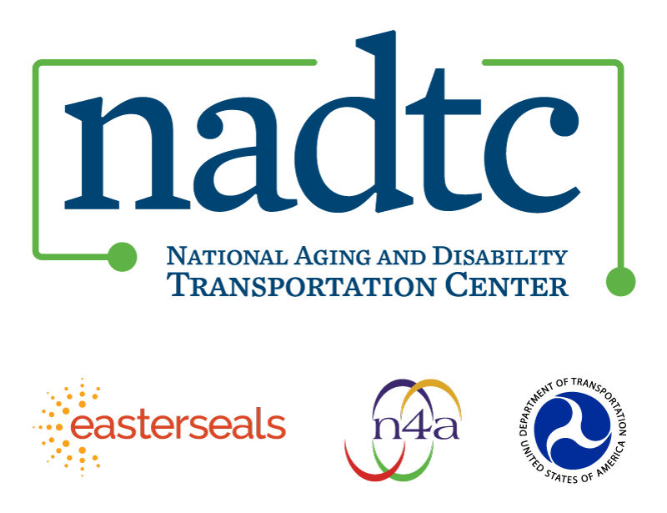

The National Aging and Disability Transportation Center is funded through a cooperative agreement of Easter Seals, the National Association of Area Agencies on Aging, and the U.S, Department of Transportation, Federal Transit Administration, with guidance from the U.S. Department of Health and Human Services, Administration for Community Living. NADTC’s mission is to increase accessible transportation options for older adults, people with disabilities and caregivers nationwide.

National Aging and Disability Transportation Center
Washington, D.C. 20005
Telephone and toll-free hotline: (866) 983-3222
TTY: (202) 347-7385
Email: contact@nadtc.org
Website: www.nadtc.org

Follow us:
Facebook
Twitter
YouTube
LinkedIn

