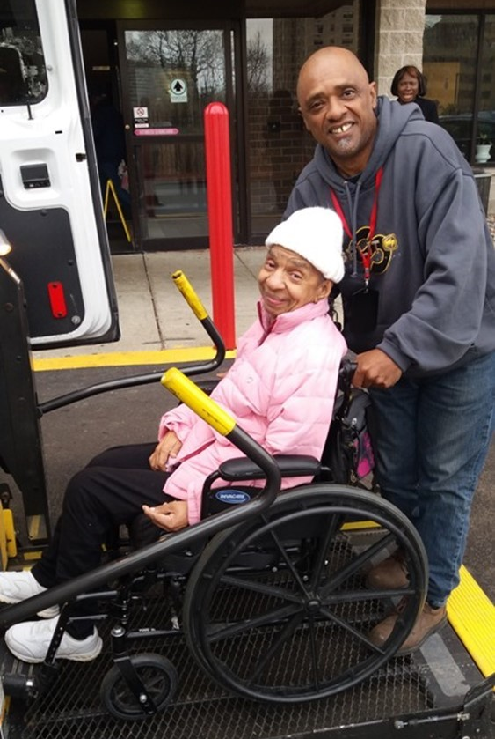
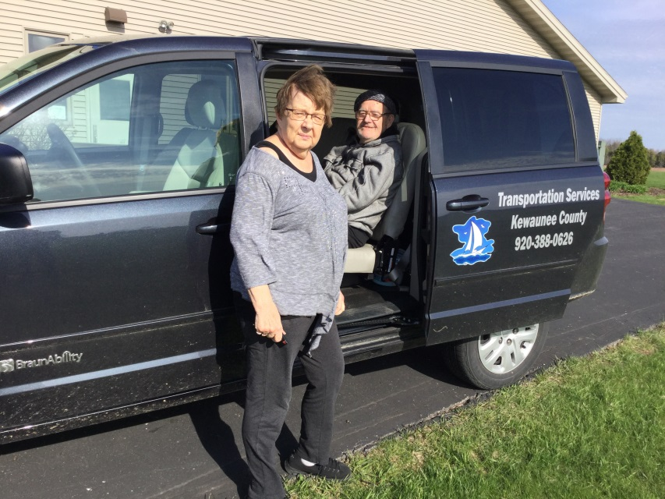

Introduction

The National Aging and Disability Transportation Center (NADTC) is pleased to present this Trends Report Topic Spotlight on ADA No-Shows and Cancellation policies. While the ADA addresses a number of issues that promote transportation accessibility, issues around no-shows and penalties for ADA paratransit frequently evoke questions or requests for technical assistance. This brief intends to clarify many of these recurring issues and provide information that is helpful to transit providers.
As in 2016, the Trends Report is divided into stand-alone information briefs that explore significant issues that affect the availability of accessible transportation in communities. Each brief includes case studies on how changes in transportation are being implemented in communities in the U.S., from large cities like Denver, to small towns on the Eastern Shore of Maryland.
2017’s information briefs address:
- Americans with Disabilities Act No-Shows and Cancellations
- Americans with Disabilities Act Complaint Process
- Connected Vehicle Technology
- Real-Time Transit Technology
- Rural Travel Training
- Seamless Mobility
While the ADA can hardly be considered a “trending topic”, NADTC regularly receives questions about how to implement ADA requirements. No-shows, cancellations, and the complaint process are topics frequently addressed by our technical assistance specialists. The technology and mobility briefs take a look at how the rapidly evolving world of technology is affecting safety, service efficiency, and customer information. Finally, the rural travel training brief gets back to basics with information on how small transportation systems with limited resources can make a difference through passenger instruction and peer-mentoring.
If you have questions about any Topic Spotlight or have a story to share from your community, reach out to us at (866) 983-3222 or email contact@nadtc.org.

Cover Photo Credits
Top left: 8330 On the River/Poah Communities, Detroit, Michigan
Top right: Kewaunee County Services, Kewaunee, Wisconsin
Bottom left: The Center for Volunteer Caregiving, Cary, North Carolina
Bottom right: Wallingford Committee on Aging, Inc., Wallingford, Connecticut
Bottom right:

ADA Trending Questions Requiring Clarification: No-Shows and Penalties for Paratransit

Introduction
The Americans with Disabilities Act (ADA) is a civil rights law prohibiting discrimination against persons with disabilities. Under Title II of the ADA, public transportation must be usable by people with disabilities. The U.S. Department of Transportation regulations pertaining to transportation (49 CFR Part 37 and 38) are written to create an equal travel environment so that people with disabilities will not be excluded or denied from participation in using transportation systems or facilities.

While the ADA addresses a number of issues that promote transportation accessibility, issues around no-shows and penalties for ADA paratransit frequently evoke questions or requests for technical assistance. This brief intends to clarify many of these recurring issues and provide information that is helpful to transit providers.

Key Points
- Define when a “no-show” occurs and include the “pick-up window” in the definition.
- Penalties can be established that are reasonable.
- Any penalty can be appealed.
- Protect return trips on the schedule if rider is a “no-show” on the outbound trip.

For transit agencies, a comprehensible ADA paratransit no-show policy and penalty process will provide assurance that customer complaints and concerns are resolved in a timely manner and with fairness. ADA regulations at Part 37.125(h) and Part 37, App. D, Part 37.125 require agencies to have specific procedures in place to address no-shows and equitable penalties.

It is important to define when a “no-show” occurs. Typically, a no-show is when a transit vehicle or contracted provider arrives at a location at a negotiated scheduled time or within a “pick-up window” but the customer and the driver do not connect for the ride. Keep in mind that regulations in Part 37.121 require complementary paratransit service to be comparable to the fixed-route service. Transit agencies can establish a reasonable pick-up window—typically within 20 to 30 minutes of the negotiated pick-up time. The pick-up window allows for an arrival time dependent on traffic or other delays. This pick-up window would make the scheduled pick-up time comparable to the fixed-route. Additionally, a common practice is for paratransit drivers to wait at least five minutes for a rider to board the van. If the van arrives early, it is recommended that the countdown for the five minute period does not start until the beginning of the pick-up window. (See FTA ADA Circular Section 8.5.3.)

Penalties

An ADA eligible rider may be suspended for a reasonable period of time if they have established a pattern or practice of no-showing for scheduled trips.

The ADA regulations at Part 37.125 state:
(h) The entity may establish an administrative process to suspend, for a reasonable period of time, the provision of complementary paratransit service to ADA eligible individuals who establish a pattern or practice of missing scheduled trips.
(1) Trips missed by the individual for reasons beyond his or her control (including, but not limited to, trips which are missed due to operator error) shall not be a basis for determining that such a pattern or practice exists.
(2) Before suspending service, the entity shall take the following steps:
(i) Notify the individual in writing that the entity proposes to suspend service, citing with specificity the basis of the proposed suspension and setting forth the proposed sanction.
(ii) Provide the individual an opportunity to be heard and to present information and arguments;
(iii) Provide the individual with written notification of the decision and the reasons for it.
(3) The appeals process of paragraph (g) of this section is available to an individual on whom sanctions have been imposed under this paragraph. The sanction is stayed pending the outcome of the appeal.

Remember, “establishing a pattern” is not the rider with one or two no-shows in a six-month period, but several no-shows over a reasonable period of time. When considering penalties for no-shows, a transit agency should look at the proportion of no-shows in relationship to the number of trips scheduled. A rider who requests sixty trips in one month and who has five no-shows has a proportional no-show rate of 8%. This should be compared to the amount with the agency’s system wide average of no-shows. Amounts higher than the system wide average could be considered for penalty.

The transit agency must not count no-shows outside of a rider’s control and only count legitimate occurrences. Missed trips, where a driver does not arrive within a pick-up window or does not wait for at least five minutes, must not be counted as a no-show. Agencies often include late cancellations in this calculation. Such occurrences should only be included if they are so close in time as to have the operational equivalent of a no-show. An example would be a trip cancellation with a one hour or less notification to the transit agency.

Determine a reasonable time period for suspension by working with your local disability and aging community. Suspensions of months may cause an economic or medical hardship for people while a one or two week penalty may be difficult though reasonable enough to remind customers that no-shows must be taken seriously. Every no-show, because it may involve a penalty that could deny service, must have a clear process for remediation. The appeals process must be based on factual information and be fair to both parties. No-show penalties should not be given casually.

DOT ADA regulation Part 37, Appendix D provides some guidance:

It is very important to note that sanctions could be imposed only for a ``pattern or practice'' of missed trips. A pattern or practice involves intentional, repeated or regular actions, not isolated, accidental, or singular incidents. Moreover, only actions within the control of the individual count as part of a pattern or practice. Missed trips due to operator error are not attributable to the individual passenger for this purpose.

If the vehicle arrives substantially after the scheduled pickup time, and the passenger has given up on the vehicle and taken a taxi or gone down the street to talk to a neighbor, that is not a missed trip attributable to the passenger. If the vehicle does not arrive at all, or is sent to the wrong address, or to the wrong entrance to a building, that is not a missed trip attributable to the passenger. There may be other circumstances beyond the individual's control (e.g., a sudden turn for the worse in someone with a variable condition, a sudden family emergency) that make it impracticable for the individual to travel at the scheduled time and also for the individual to notify the entity in time to cancel the trip before the vehicle comes. Such circumstances also would not form part of a sanctionable pattern or practice.

FTA Compliance Review Findings
- To count all cancellations after 5:00 p.m. in the evening is not the operational equivalent of a no-show (transit operates until 10:00 p.m.).
- Three no-shows in a 90-day period would not be a pattern or practice for a daily rider (2% of trips).
- A suspension for one year of a rider who no-shows 12 times in a year would not be a reasonable sanction.

Keep Return Trips on the Schedule
When a rider misses a scheduled outbound trip, transit agencies should not automatically cancel his or her return trip. For instance, a rider might get to an appointment by riding with a family member but will use paratransit for the trip back home. Without an indication from the rider that the return trip is not needed, it should remain on the schedule and be protected from cancellation. If a return trip is not protected and cancelled by the transit agency, it must be counted as a missed trip.

Section 7 of Topic Guides on ADA Transportation is a useful resource on no-shows. These guides provide ADA related technical assistance on transportation for transit agencies, riders, and advocates and bring together the requirements of the ADA and the DOT ADA regulations, FTA compliance determinations, and operational practices for ADA compliance. The guides can be found at https://dredf.org/ADAtg/index.shtml.

Summary

A public or private transportation provider that operates fixed-route or demand response service, or any combination, is required to provide accessible services for everyone meeting the ADA requirements and without discrimination. A comprehensible ADA paratransit no-show policy and penalty process will provide assurance that customer complaints and concerns are resolved in a timely manner and with fairness. It is important that public transit agencies develop a policy that defines when a “no-show” occurs and put in place an unbiased administrative process for penalty. The counted no-shows must establish a “pattern or practice” to be considered for penalty. Every no-show must have a clear process for remediation any penalties or to challenge no-shows. There must be a fair appeal process that gives the rider an opportunity to present factual information and any circumstances beyond the rider’s control should not count towards a no-show penalty. For the transit agency, it is important that accurate trip information is available for the appeal from trip logs and other communications.

Resources
Americans with Disabilities Act: Guidance, FTA Circular 4710.1
https://www.transit.dot.gov/sites/fta.dot.gov/files/docs/Final_FTA_ADA_Circular_C_4710.1.pdf
TCRP Synthesis 60: Practices in No-Show and Late Cancellation Policies for ADA Paratransit
http://www.trb.org/Publications/Blurbs/156210.aspx

Topic Guides on ADA Transportation (No-Shows as section 7)
https://dredf.org/ADAtg/index.shtml

Transit Manager’s Toolkit: ADA
http://nationalrtap.org/transitmanager/Administration-Compliance/ADA

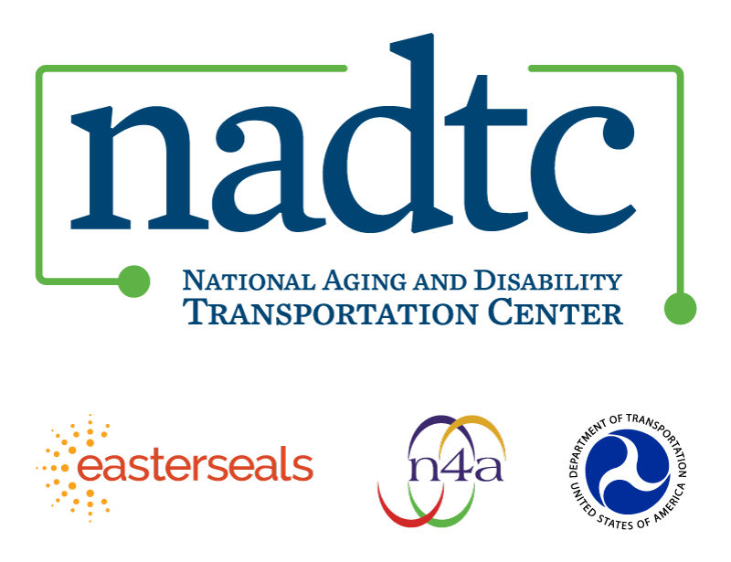

The National Aging and Disability Transportation Center is funded through a cooperative agreement of Easter Seals, the National Association of Area Agencies on Aging, and the U.S, Department of Transportation, Federal Transit Administration, with guidance from the U.S. Department of Health and Human Services, Administration for Community Living. NADTC’s mission is to increase accessible transportation options for older adults, people with disabilities and caregivers nationwide.

National Aging and Disability Transportation Center
Washington, D.C. 20005
Telephone and toll-free hotline: (866) 983-3222
TTY: (202) 347-7385
Email: contact@nadtc.org
Website: www.nadtc.org

Follow us:
Facebook
Twitter
YouTube
LinkedIn

