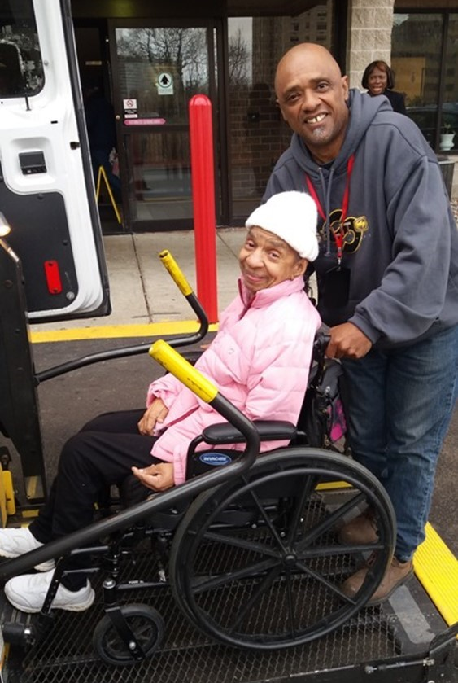
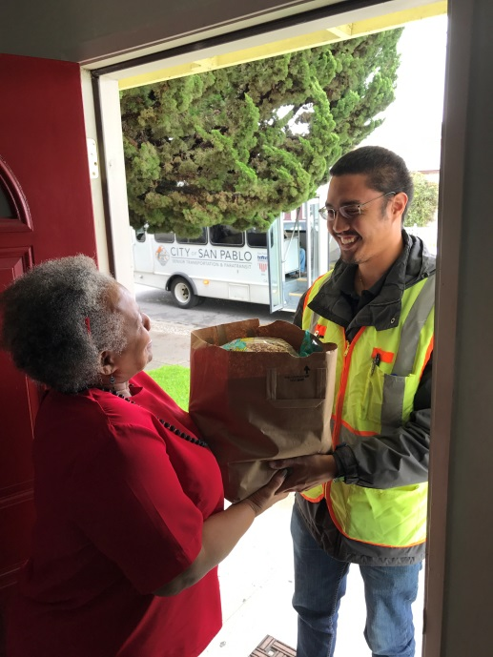

Introduction
The National Aging and Disability Transportation Center (NADTC) is pleased to present this Trends Report Topic Spotlight on Real-Time Transit Technology. For older adults and people with disabilities who may require special accommodations, the provision of real-time transit information is especially important. Real-time transit technology can improve the perceived and actual reliability and convenience of a service, and can better inform consumers of their travel options.
The Trends Report is divided into stand-alone information briefs that explore significant issues that affect the availability of accessible transportation in communities. Each brief includes case studies on how changes in transportation are being implemented in communities in the U.S., from large cities like Denver, to small towns on the Eastern Shore of Maryland.
2017’s information briefs address:
- Americans with Disabilities Act No-Shows and Cancellations
- Americans with Disabilities Act Complaint Process
- Connected Vehicle Technology
- Real-Time Transit Technology
- Rural Travel Training
- Seamless Mobility
While the ADA can hardly be considered a “trending topic”, NADTC regularly receives questions about how to implement ADA requirements. No-shows, cancellations, and the complaint process are topics frequently addressed by our technical assistance specialists. The technology and mobility briefs take a look at how the rapidly evolving world of technology is affecting safety, service efficiency, and customer information. Finally, the rural travel training brief gets back to basics with information on how small transportation systems with limited resources can make a difference through passenger instruction and peer-mentoring.
If you have questions about any Topic Spotlight or have a story to share from your community, reach out to us at (866) 983-3222 or email contact@nadtc.org.
Cover Photo Credits
Top left: 8330 On the River/Poah Communities, Detroit, Michigan
Top right: Kewaunee County Services, Kewaunee, Wisconsin
Bottom left: The Center for Volunteer Caregiving, Cary, North Carolina
Bottom right: Wallingford Committee on Aging, Inc., Wallingford, Connecticut
Bottom right:

Real-Time Transit Technology
Introduction
A common frustration of transit users, in both fixed route and demand-response systems, is the inability to determine what mobility options are available, predict when a pick-up is going to be late, what the destination arrival time might be, or if there are outages in accessibility features. For older adults and people with disabilities who may require special accommodations, the provision of real-time transit information is especially important. A consumer may spend considerable time creating a transportation plan based on options that can meet specific needs and be available at essential times yet find the selected service to be unavailable or unreliable when needed. A lack of accurate, timely information can create unequal access to transportation, particularly impacting those who do not have alternative options. It can also make consumers unhappy with services and if available, to choose another option outside of public transportation as a preferred mobility mode. Recently, there has been a renewed interest in creating systems that are responsive to passenger needs and wants. Real-time transit technology can improve the perceived and actual reliability and convenience of a service, and can better inform consumers of their travel options.

Difference between Static and Real-Time Information
Static Information
Historically, information about a transit system’s schedule and route stops was communicated via paper. It was not uncommon for system maps to be mass produced, distributed, and posted for public consumption at each stop (and this is still a standard practice in many communities).
Advances in the mid-2000s led to the development and adoption of a standardized set of data that captured transit schedules, routes, pick-up and drop-off locations, and specific times for those arrivals and departures. This became known as the General Transit Feed Specification (GTFS) (Levine, 2014).
A typical GTFS transmits static information. While it can include information like planned outages and service disruptions – examples being if there is a long term station closure, elevators that are down, or re-routed itineraries – it does not account for real-time changes, delays, or updates. Consumers may be most familiar with GTFS data in popular transit apps, like Google Maps, which provide trip planning services and transit routes, walking directions, maps, and nearby amenities (Bliss, 2017).
Real-time Information

Real-time GTFS is an extension of static GTFS that has gained popularity with consumers and transit systems alike. Real-time GTFS provides moment-by-moment updates. Many transit providers, including human service agencies, are now using real-time GTFS to improve service, track vehicles in real time and make adjustments to deliver accurate arrival and destination estimates. Most real-time transit tracking depends on something called “automatic vehicle location” (AVL). AVL is a computer based vehicle tracking system to determine geographic position of a vehicle and relay it to an information center (e.g., a website, an app, a transit dispatcher) where that data can be used. AVL uses GPS tracking to monitor time, location, motion, and speed to help determine the timing of vehicles, location in real-time, recording of arrival and departure times, monitoring of the driver’s skills, and route tracking (Automatic Vehicle Location, 2017).

How is real-time technology assisting transit systems?
Real-time technology provides significant benefits to staff, drivers, and consumers of fixed-route and specialized transportation. The provision of real-time information allows the system to be more responsive to increased rider demand and improves communication to riders and drivers regarding what their potential trips will look like (time, distance, detours, etc.). The availability of this information makes it easier for people to select the option that best meets their needs. This information may also alert riders, with advanced notice, of the need to find alternative transportation options if a planned method of travel will not work.
Rider experience might be the most important result of real-time technology. When real-time information is not available, it can lead to unhappy rider experience, confusion, and possibly reduced interest in continuing to use transit. Transit agencies need better “situational awareness” about the status of their systems in order to adjust quickly and seamlessly to service challenges (Steinfeld, Maisel, and Steinfeld, 2017). In particular, mobility managers can use real-time GTFS to assist consumers planning trips and preparing for possible delays or changes in the route. For example, when the GTFS real-time feed includes transportation accessibility data, the mobility manager and the rider better understand when paratransit might be a better mobility option over fixed-route.
It is important to note that the cost of GTFS and AVL services may inhibit some systems, especially smaller systems, from implementing such technology. But with advances in technology and reduction in the traditional cost of such software, more agencies are likely to pursue integration of such programming into their systems.
How People Consume Real-time Transportation Information
Real-time information can be made available on mobile apps, computer desktop, or by phone for riders, drivers, and system staff. Some transit providers offer automatic text and email messages, convenient for passengers who have regular or consistent routes/commutes.
For riders, real-time technology can provide:
- Status of reservation request, if applicable
- Pick-up time/delayed pick-ups (including notification of problems along intended route)
- Destination arrival time
- Fewer connections/transfers
- Realistic expectations for transit experience
- Immediate access to route maps
- Availability of route instructions, including accessibility updates about temporary or long-term closures (e.g., elevator or escalator outages, problems with the lifts)
- Up-to-date list of mobility options and eligibility requirements

For drivers, real-time data can offer:
    - Enhanced communication with dispatch
    - Immediate awareness of early/late arrival
    - Ability to make route detours
    - More realistic schedule communication
    - Improvements in rider satisfaction and improved relationship with riders

On the back end, transportation agencies can use real-time technology to analyze data and measure:
    - Rider demand
    - On-time performance
    - Over/underutilized vehicles
    - Route effectiveness and opportunities for enhancements
    - User experience feedback
(Kaufman, Smith, O’Connell and Marulli, 2017)
Real-time transit technology provides opportunities for both passengers and providers to instantly retrieve current data on transportation options and status, resulting in an increase in consumer convenience. While all users benefit from access to this information, older adults and people with disabilities especially are provided with increased opportunities for informed decision making about the transit mode that best serves their individual needs. While older adults’ adoption of technology is generally less than usage by the general public, it is noteworthy that current smart phone usage (by four in ten seniors) has more than doubled since 2013, and usage is likely to continue to rise. (Pew Research Center, Internet and Technology, May 17, 2017)
Case Example: Nelson\Nygaard Consulting Associates Report 832 & FindMyRidePA
In 2016, Nelson\Nygaard Consulting Associates conducted research on the topic of technology advancements in one-call/one-click services. This report was published by the National Cooperative Highway Research Program (NHCRP) as Report 832 “State DOTs Connecting Specialized Transportation Users and Rides Volume 1: Research Report” (available here).
A one-call/one-click service helps consumers obtain rides they need for daily activity or for occasional appointments by simplifying access for consumers and matching their varied needs with appropriate options. More advanced services integrate GTFS and AVL into their one-call/one-click programs (explored further in the FindMyRidePA example, explained in detail below).
Report 832 uses a continuum of functionality from simple to advanced, as portrayed in Figure 1, to describe the variety of systems in existence. The simplest system is a link to a central repository of limited transportation resources and static information. The more advanced systems provide information that is kept current, presented in an accessible format that can be manipulated by users, and offers amenities like direct trip booking and payment.
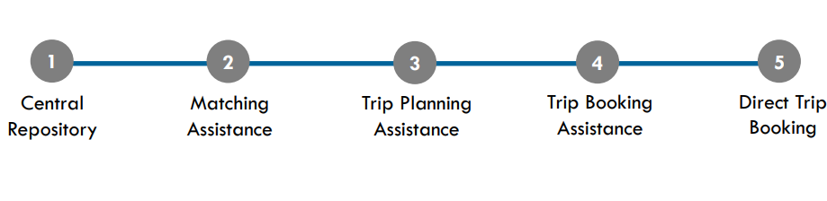
Figure 1. Continuum of one-call/one-click systems as defined in NHCRP Report 832
GTFS begins to appear in level 3, “Trip Planning Assistance”. Most level 3 systems are integrated with public transit schedules via open trip planners using the general GTFS for fixed-route transit and demand response services. These systems can also link with bicycling and walking directions, ride share services, taxi finder systems, etc.
As the continuum progresses through levels 4 and 5, real-time GTFS and AVL begin to make an appearance. Programs that fall under these levels might begin to move beyond static GTFS to integrate vehicle tracking and provide up-to-the-minute information. This is how users begin to access vehicle location and anticipated pick up and destination arrival times, along with updates on accessibility feature outages or unavailable mobility options (Rodman et al, 2016a).

FindMyRidePA
The features described in Report 832’s “level 5” are represented in the Pennsylvania Department of Transportation’s (PennDOT) “FindMyRidePA” service. In December 2011, PennDOT was awarded a Veteran’s Transportation and Community Living Initiative (VTCLI) grant from the Federal Transit Administration to develop a one-call/one-click service. The result was the FindMyRidePA program that integrated scheduling, booking, and real-time GTFS into a single one-click system. Initially, FindMyRidePA was aimed at addressing the needs of veterans, active military personnel, their families and caregivers seeking fixed-route and specialized transportation services; however, the service has evolved to benefit all transit users who are seeking to identify all available transportation options and real-time scheduling information (Rodman et al, 2016a and Rodman et al, 2016b).
The FindMyRidePA software enables users to obtain accurate and real-time information about a wide range of available transportation services across the state. The program was tested with kiosks placed in areas of high transit usage (such as Veterans Affairs Centers) and has since evolved to the online system now available via http://www.findmyridepa.com, which is optimized for smartphone access.
Once on the website, users are asked to specify needs particular to their trip to help them determine what transportation programs they may qualify for. The program lists options that match a rider’s needs and eligibility and provides schedules and cost information. One of the main benefits of FindMyRidePA is the ability to access a variety of transportation options in one centralized web location. A transit provider (e.g., fixed-route transit, ride share programs, on demand transportation, paratransit) does not need to have real-time GTFS and AVL capacity to be a part of the website. However, the benefit of the FindMyRidePA software is that it is designed in such a manner that as the various providers listed in the system convert to real-time GTFS and AVL systems, the real-time tracking will become available to riders and still remaining organized in one single platform (Rodman et al, 2016b).

Summary
The reliability and predictability that real-time GTFS provides to public transit systems allows all riders, but especially older adults and people with disabilities, to make more informed decisions about their mobility options. Real-time GTFS has changed the way riders consume transit information and as a result, changed the expectations consumers have in using such information. Real-time GTFS can provide information well beyond printed paper schedules or even static GTFS formats. Riders can plan routes ahead of time, mobility managers can use it to provide assistance to new riders, and riders with mobile phones can receive updates on the go, aiding in immediate transit behavior changes based on a vehicle’s departure and arrival time, a transit system’s alerts, or service delays. The availability of real-time GTFS is an important benefit to older adults and people with disabilities as they navigate transportation options in their community.
Citations and Resources
“Automatic Vehicle Location.” TransitWiki, https://www.transitwiki.org/TransitWiki/index.php/Automatic_vehicle_location#cite_note-tcrp73-1. Accessed September 7, 2017.

Bliss, Laura. “The Transit App That Can See Subway Disruptions”, CITY LAB, August 25, 2017, https://www.citylab.com/transportation/2017/08/the-transit-app-that-can-see-subway-outages/537987/. Accessed September 7, 2017.
FindMyRidePA. Pennsylvania Department of Transportation. www.findmyridepa.com. Accessed September 7, 2017.

Harmony, Xavier J. and Gayah, Vikash. (2017). Evaluation of Real-Time Transit Information Systems: An Information Demand and Supply Approach. International Journal of Transportation Science and Technology. Retrieved from: http://www.sciencedirect.com/science/article/pii/S2046043017300126. Accessed: September 5, 2017.

Kaufman, S., Smith, A., O’Connell, J., and Marulli, D. (2017). Intelligent Paratransit. NYU Wagner Rudin Institute for Transportation Policy & Management. Retrieved from: https://wagner.nyu.edu/files/rudincenter/2016/09/INTELLIGENT_PARATRANSIT.pdf. Accessed: September 5, 2017.

Levine, Kendra K. “A Brief History of GTFS.” Institute of Transportation Studies Library, Berkeley University, October 14, 2014. Retrieved from: http://library.its.berkeley.edu/node/265, Accessed September 7, 2017.

Rodman, W., Berez, D., Moser, S., and Choe, J. (2016a). State DOTs Connecting Specialized Transportation Users and Rides Volume 1: Research Report. National Academies of Sciences, Engineering, and Medicine. Washington, DC: The National Academies Press. Retrieved from: https://www.nap.edu/catalog/23506/state-dots-connecting-specialized-transportation-users-and-rides-volume-1-research-report. Accessed September 5, 2017.

Rodman, W., Berez, D., Moser, S., and Choe, J. (2016b). State DOTs Connecting Specialized Transportation Users and Rides Volume 2: Toolkit for State DOTs and Others. National Academies of Sciences, Engineering, and Medicine. Washington, DC: The National Academies Press. Retrieved from: https://www.nap.edu/catalog/23507/state-dots-connecting-specialized-transportation-users-and-rides-volume-2-toolkit-for-state-dots-and-others. Accessed September 5, 2017.

Steinfeld, A., Maisel, J., and Steinfeld, E. (Eds.). (2017). Accessible Public Transportation: Designing Service for Riders with Disabilities. New York, NY: Routledge.

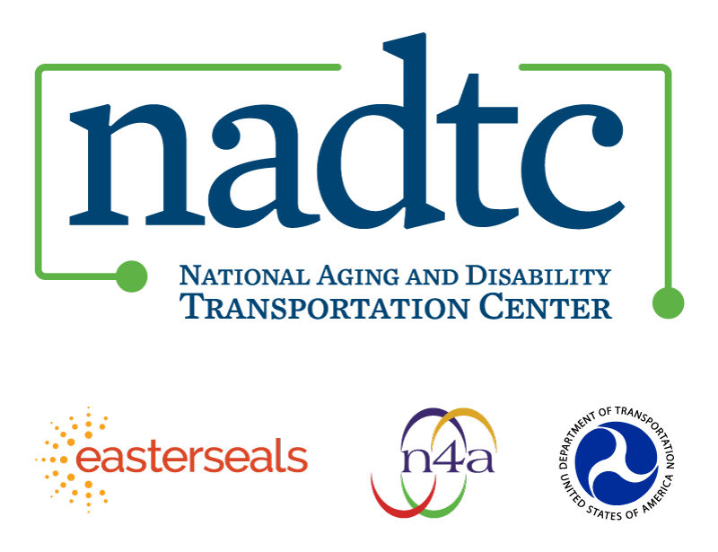

The National Aging and Disability Transportation Center is funded through a cooperative agreement of Easter Seals, the National Association of Area Agencies on Aging, and the U.S, Department of Transportation, Federal Transit Administration, with guidance from the U.S. Department of Health and Human Services, Administration for Community Living. NADTC’s mission is to increase accessible transportation options for older adults, people with disabilities and caregivers nationwide.

National Aging and Disability Transportation Center
Washington, D.C. 20005
Telephone and toll-free hotline: (866) 983-3222
TTY: (202) 347-7385
Email: contact@nadtc.org
Website: www.nadtc.org

Follow us:
Facebook
Twitter
YouTube
LinkedIn

