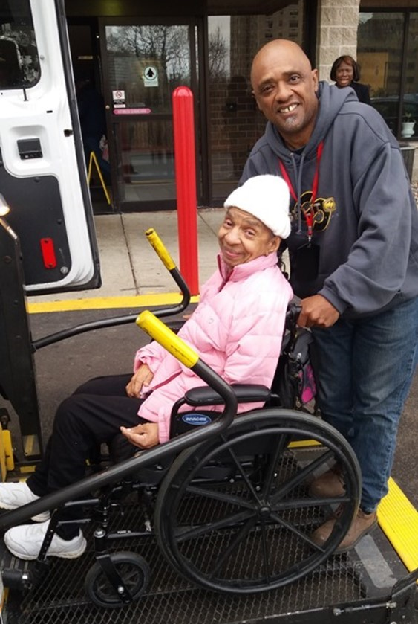
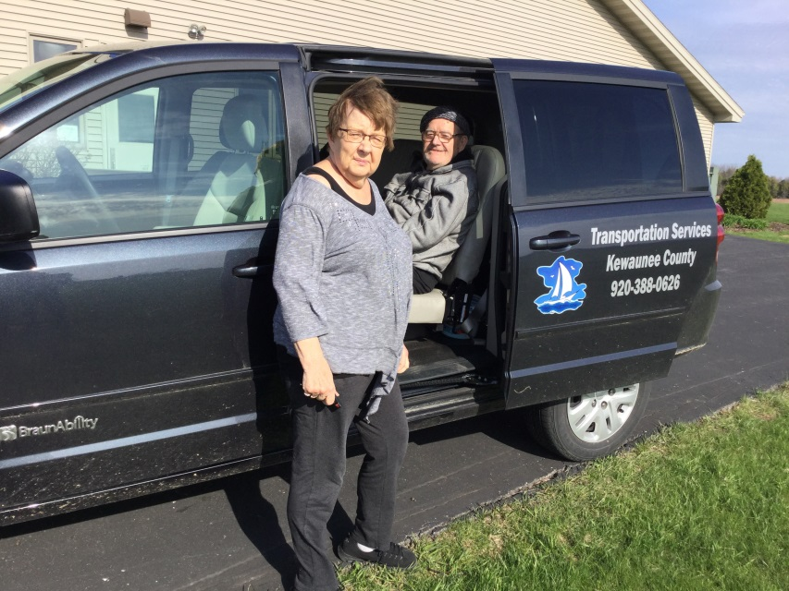
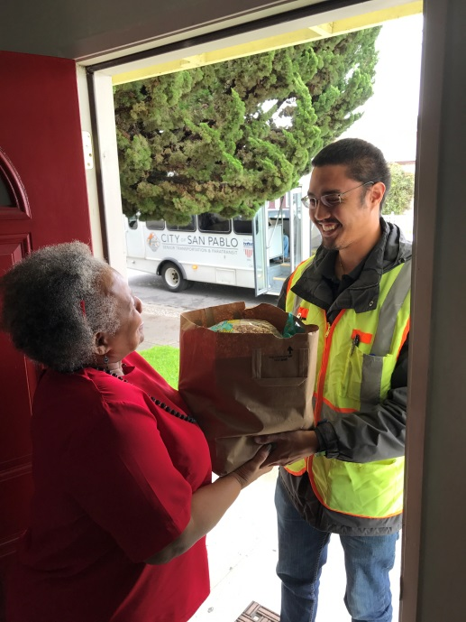
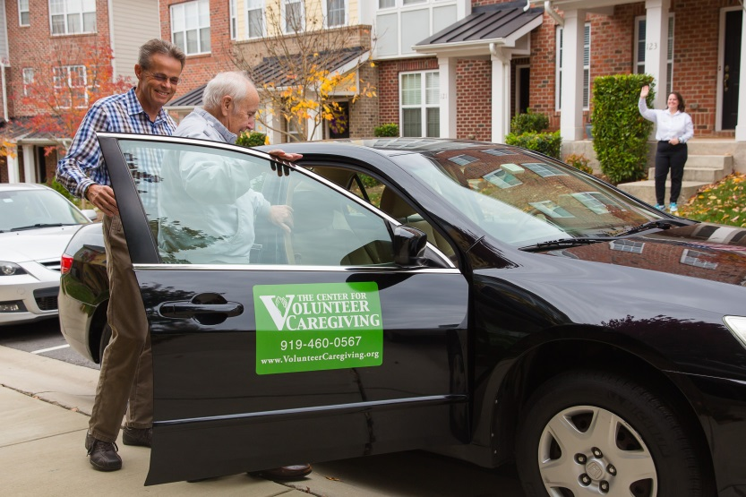

Introduction

The National Aging and Disability Transportation Center (NADTC) is pleased to present this Trends Report Topic Spotlight on Seamless Mobility. Seamless mobility is made possible by infrastructure, technology, and connected, coordinated transportation systems.
The Trends Report is divided into stand-alone information briefs that explore significant issues that affect the availability of accessible transportation in communities. Each brief includes case studies on how changes in transportation are being implemented in communities in the U.S., from large cities like Denver, to small towns on the Eastern Shore of Maryland.
2017’s information briefs address:
- Americans with Disabilities Act No-Shows and Cancellations
- Americans with Disabilities Act Complaint Process
- Connected Vehicle Technology
- Real-Time Transit Technology
- Rural Travel Training
- Seamless Mobility
While the ADA can hardly be considered a “trending topic”, NADTC regularly receives questions about how to implement ADA requirements. No-shows, cancellations, and the complaint process are topics frequently addressed by our technical assistance specialists. The technology and mobility briefs take a look at how the rapidly evolving world of technology is affecting safety, service efficiency, and customer information. Finally, the rural travel training brief gets back to basics with information on how small transportation systems with limited resources can make a difference through passenger instruction and peer-mentoring.
If you have questions about any Topic Spotlight or have a story to share from your community, reach out to us at (866) 983-3222 or email contact@nadtc.org.

Cover Photo Credits
Top left: 8330 On the River/Poah Communities, Detroit, Michigan
Top right: Kewaunee County Services, Kewaunee, Wisconsin
Bottom left: The Center for Volunteer Caregiving, Cary, North Carolina
Bottom right: Wallingford Committee on Aging, Inc., Wallingford, Connecticut
Bottom right:

Seamless Mobility through Technology, Route Design, and Coordinated Systems

Introduction
Seamless mobility is transportation made easy for the traveler. What makes transportation seamless? Ease of movement, ease of use, availability of options, and the ability for anyone to learn how to ride a particular type of transportation with minimal explanation. Seamless mobility results in a feeling of comfort for the passenger, and when that happens, a traveler is more willing and interested to continue to use a particular mode, whether that mode is taxi, transit, bikeshare, walking, or shared ride.
Seamless mobility is made possible by infrastructure that connects without interruption. Sidewalks, biking and walking trails, stairs, elevators, ramps, and signage help the flow as travelers try to reach their destinations.
Beyond the physical infrastructure of our roads and sidewalks, technology is streamlining how people plan trips, buy tickets or pay for vehicles services, make online reservations or receive real-time information while en route.
Technology works hand in hand with coordinated and connecting systems. This includes regional coordination of transportation systems within a metropolitan area or across county lines. Examples include integrated fare collection, reservation systems, or information sharing among different transportation agencies in the same city, county or state.
Seamless mobility, or at least streamlined mobility, is achievable, and a few cities in the U.S. have made strides toward linking modes and creating fare payment structures to make it easy for both resident and visitor alike to reach their destinations, but challenges persist.

Challenges
Having more transportation options is generally considered to be a positive. If a person can choose from personal auto, transit, paratransit, bikeshare, rideshare, volunteer driver program or taxi one could say that that person’s mobility options are much better than someone who only has one or two choices. As a September 2017 Harvard Business Review article “Technology is Changing Transportation, and Cities Should Adapt” points out, however, if too many people in urban areas begin to depend on private vehicles for travel, traffic could increase and public transit systems could see dwindling fares. Whether or not this pattern occurs, these complex dynamics should be taken into consideration when a community is developing an overarching policy of what it wants its mix of mobility to look like in five to 15 years. A change in one mode ultimately affects all the other modes. As the article also points out, options are changing quickly, and the challenge is for local officials and policy makers to take a proactive role in deciding what options work best for their current and anticipated demographics. Another challenge is to think of changes that could benefit multiple modes. For example, is it possible for a community to offer an app-based service for planning and paying for trips that uses multiple modes of local transportation? Another example would be designating pick-up and drop-off zones that can be used by taxi, shared ride vehicle and transit to help maintain a flow of traffic and reduce risk to pedestrians, other drivers, cyclists, and shared ride passengers.
Several cities in the U.S. are thinking through these challenges and coming up with ways to meet customer demand for more options while also helping the customer make choices that are smart for their individual travel needs. Portland (Oregon), Houston, Denver, and Upstate New York are areas where decision-makers have moved forward technology, route changes, and redesigns to bring seamless mobility to travelers. In addition, the North American Mobility Score initiative is a means of putting power in peoples’ decision making about where they live, work and shop.
Opportunities
Technology: Electronic fare payment
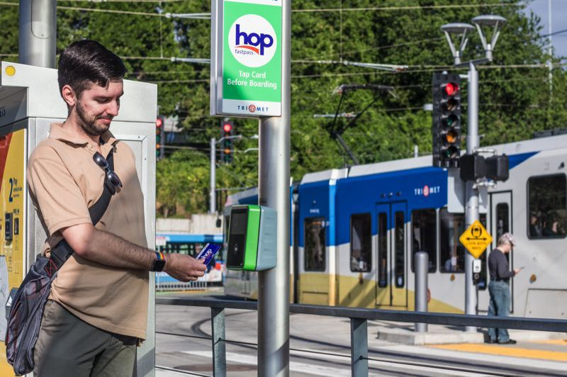
Portland, Oregon, has instituted an integrated pass system called Hop Fastpass. Transit users can load value onto their accounts and use the card for payments on TriMet, C-TRAN buses, Portland Streetcar, MAX Light Rail, and WES Commuter Rail. The fare card system is tied to the passenger’s securely stored bank information. While a number of cities in the U.S. have started integrated fare cards, Portland’s system has a rewards feature similar to credit cards or retail club memberships. With each use, a rider moves closer to earning day or monthly passes. The fare is capped once the price of a day or month pass is reached, helping riders who cannot afford the upfront costs of a full-day or monthly pass. Additional features include auto-loading, loss-prevention, and a best fare guarantee.
Initially TriMet’s efforts were focused on reducing passenger reliance on paper and coin currency and eventually incorporating smart phone technology. Another step that TriMet took in 2012 to help usher in the concept of a seamless fare system was to simplify fare collection by removing transit zones and moving to a flat rate fare system. The new Hop Fastpass electronic payment system provides the chance for passengers to move effortlessly among modes and across geographic boundaries to include C-TRAN in Clark County, Washington (Vancouver). After a successful initial pilot of 5,000 riders, Hop is being implemented throughout the Portland region, and there are plans to include the LIFT paratransit service as part of an eligible participant’s account so that they do not have to tap a card. [Photo credit: TriMet customer uses Hop Pass to pay fare. Portland Tribune file photo]

Coordinated Systems: Bus Network Redesigns
According to American Public Transportation Association statistics, bus rides made up less than half of all transit trips in the U.S. in 2014. This is the first time that bus ridership numbers have fallen to that percentage. (Bus Network Redesigns Are the ‘Hottest Trend in Transit’). The reasons for declining ridership are varied. Many cities have a broader variety of transportation options available than in recent decades; more people are taking subways, light rail, commuter rail, using bikeshare, shared ride or have left the bus system altogether. Transportation agencies are turning to route redesigns to address declining ridership. Redesigns contribute to seamless mobility for the customer by helping to reduce inefficiency in the bus network; however, redesigns do not necessarily contribute to the transit system’s farebox revenue. The movement toward denser residential development is also leading to a re-examination of how current routes are laid out.
Real-time bus departure and arrival information has made it easier to measure where there are inefficiencies in bus routes. Political will to change bus routes can be complicated and low-performing areas are typically among the first to be examined during a redesign. Network changes can make a difference, though. Cities that have recently overhauled routes include Houston, Portland, (OR), and Jacksonville, (FL). In Houston’s case, the goal was to improve frequency of service rather than to expand the coverage area but also to adjust bus service to better connect with new light rail lines. Houston was one of a number of U.S. cities that had bus routes based on early 20th century streetcar routes. Over time, these relatively straight routes have become stretched to meet the shift in employment and population centers without comprehensive redesign. In Houston’s situation, many transit users wanted to reach universities, hospital centers, and suburban office and shopping complexes, and making changes to meet these needs required a systematic review of the overall transit system. The Metro system made a decision to shift 80% of its resources toward building ridership, and 20% toward maintaining coverage. Although Houston experienced relatively flat ridership growth overall after the changes, bus ridership grew by 1.2% rather than decreasing.
In Upstate New York, bus system redesigns have led to even higher ridership growth. In Albany, changes to the network have resulted in a 25% increase in ridership since 2009. The Capital District Transportation Authority has decided to focus on frequency of service in Albany, Saratoga Springs, Schenectady, and Troy. The CEO of the authority says that when service is frequent and reliable, it “starts to feel more like a rail system.” (Vock) This predictable reliability encourages customers who want to reach their destinations quickly.
Infrastructure and Connected Systems: Denver’s A Line Rail
Spring 2017 marked the one-year anniversary of the operation of Denver’s A Line rail service between downtown Denver and Denver International Airport. The rail line—and its at-grade crossings—have had operational glitches, yet, as noted in an April 9th Denver Post article, daily ridership is close to initial projections of 18,000 riders per day with an 89% on-time record. With redevelopment of Denver’s Union Station and Amtrak’s reinstatement of snow train service to ski areas west of the city, Denver is focusing on connections to and through the central business district. As part of this effort, Denver is also in the midst of analyzing downtown’s 16th Street Mall 35 years after the pedestrian-friendly mall was created. Free bus service with frequent headways is a hallmark of the current mall, making it possible for visitors and locals alike to make short connections to hotels, restaurants, and theaters.
An October 2017 Denver Post story announced that the Regional Transportation District and the Downtown Denver Partnership are studying three different busway and pedestrian alignments with bus service continuing to remain a feature. Proposals include placing both directions of transit in the center with amenities and walkways on the side or interspersing amenities such as cafes, entertainment and seating. The mall was originally designed as a transitway, and officials expect to maintain the 16th Street path of travel used by the buses yet allow room for growth in daily ridership and emphasize gathering places along the mall. Currently, passengers who purchase an A Line airport fare receive unlimited travel on any RTD service (bus and rail) for the remainder of the service day for which the ticket was purchased. Tickets may be purchased through accessible vending machines on train platforms. By streamlining the fare payment system and connecting prime destinations, Denver is working toward creating a seamless experience that not only incorporates RTD vehicles but also national air and rail systems.
Infrastructure: MobilityScore
While the Portland, Houston, and Denver examples stress the importance of how public policy decisions shape seamless mobility, it cannot be ignored that personal choice—lifestyle choice—does play a role in how seamless one’s connections are. MobilityScore is a tool that was recently introduced in North America that can help people make decisions about their residence and connections to the transportation network. In September 2017, Fast Company posted the article “MobilityScore Tells You Exactly How Easy a Place Is to Get Around without a Car.” The article notes that around 60% of U.S. trips less than a mile are made by car. In order to provide more information for those who want to make a trip by a mode other than single occupancy vehicle, the technology firm TransitScreen developed a new MobilityScore tool similar to the now well-recognized Walkability Score.
MobilityScore provides alternative transit options available within a one-mile radius of locations within the U.S. and Canada. Data is provided for subways and buses, car sharing services (short term rental cars), bikeshare, and ride hailing services like Lyft and Uber. Scores range from 0 to 100, no mobility options to excellent mobility choices. The score takes into account changes in the availability of transportation during the day—acknowledging that some locations are served well by transit during the day but not as well on weekends or evenings.
The Mobility Score of an area is highly dependent on existing facilities, but it is a useful tool for individuals to reference as part of their residential decision-making, in particular older adults who may be giving up the car keys and looking for walking and transit options.

Summary
Seamless connectivity is both cause and effect. Cities and regions are reviewing routes and examining increased frequency as a way to attract and keep bus transit customers while keeping up with customer demand for electronic and mobile-friendly payment systems. Connectivity is the result, or effect, of demand for connected, easy-to-use services. In all the case studies, seamlessness has also been a cause, or driver, of economic growth. Residents and businesses are attracted to places that are easy to reach and communities that can be traversed on foot, by bicycle, shared ride, independent auto, and transit. Seamless connectivity is about removing barriers, adapting transportation services over time to match changes in land use, job centers, and customer patterns. Ultimately, seamless connections are about ease of use and providing passengers with a way to feel empowered by and not intimidated by the mechanics of using more than one transportation mode.

Resources
Added Flights, Expanded Train Service Offer Easy Travel Options to Colorado Ski Resorts (2017, October 4). Transworld Snowboarding.http://snowboarding.transworld.net/news/added-flights-expanded-train-service-offer-easy-travel-options-colorado-ski-resorts/
Aguilar, John. (2017, April 9). One year in: Denver’s airport train navigates interruptions, a $6 million gate glitch and surprisingly strong ridership. Denver Post. http://www.denverpost.com/2017/04/09/denver-airport-train-one-year-in/
Anzilotti, Eillie (2017, September 22). MobilityScore Tells You Exactly How Easy A Place Is To Get Around Without A Car. Fast Company. https://www.fastcompany.com/40471673/mobilityscore-tells-you-exactly-how-easy-a-place-is-to-get-around-without-a-car
Knupfer, Stefan, Eric Hanson and Shannon Bouton. (2017, September 13). Technology Is Changing Transportation, and Cities Should Adapt. Harvard Business Review. https://hbr.org/2017/09/technology-is-changing-transportation-and-cities-should-adapt
Murray, Jon. (2017, October 2). Denver’s 16th Street Mall Overhaul – First in Its 35 Years – Could Realign Bus Lanes A Lot, A Little or Not at All. Denver Post. http://www.denverpost.com/2017/10/02/denvers-16th-street-mall-overhaul-first-in-its-35-years-could-realign-bus-lanes/
Tucker, Chris. (2017, August 8). Re-Inventing Electronic Fare Payment: TriMet Hop FastPass Works to Bring Transit to the 21st Century. Mass Transit. http://www.masstransitmag.com/article/12355074/re-inventing-electronic-fare-payment-trimet-hop-fastpass-works-to-bring-transit-to-the-21st-century
Vock, Daniel (2017, September 18). Bus Network Redesigns Are the ‘Hottest Trend in Transit’. Future Structure. http://www.govtech.com/fs/Bus-Network-Redesigns-are-the-Hottest-Trend-in-Transit.html

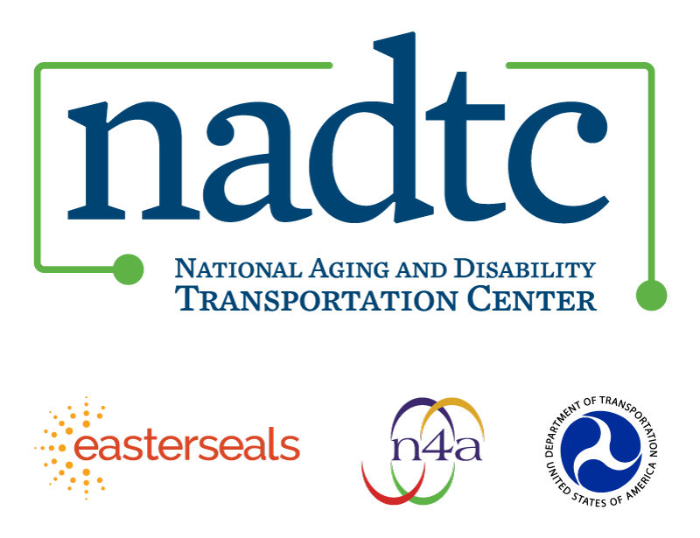

The National Aging and Disability Transportation Center is funded through a cooperative agreement of Easter Seals, the National Association of Area Agencies on Aging, and the U.S, Department of Transportation, Federal Transit Administration, with guidance from the U.S. Department of Health and Human Services, Administration for Community Living. NADTC’s mission is to increase accessible transportation options for older adults, people with disabilities and caregivers nationwide.

National Aging and Disability Transportation Center
Washington, D.C. 20005
Telephone and toll-free hotline: (866) 983-3222
TTY: (202) 347-7385
Email: contact@nadtc.org
Website: www.nadtc.org

Follow us:
Facebook
Twitter
YouTube
LinkedIn

