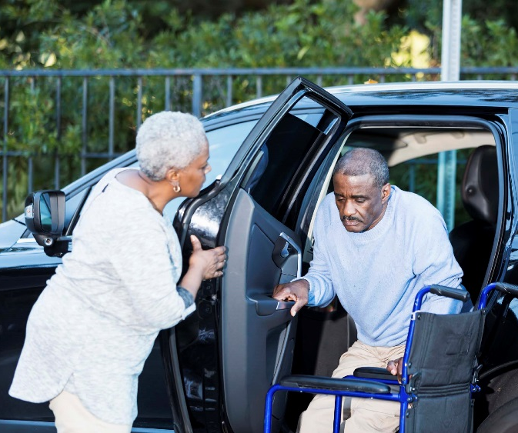
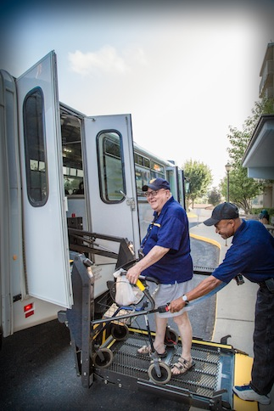

Introduction
Initiated in 2016, NADTC’s annual Trends Report explores trending topics in transportation from the last one to two years with a focus on accessible transportation services used by older adults and people with disabilities. The complete Trends Report is supplemented by Topic Spotlights for those who would like to download just one section of the report.
With its mission to increase the availability and accessibility of transportation for older adults and people with disabilities, NADTC recognizes that our work must be grounded in, and respond to, the needs and preferences of the communities and organizations that the center was created to serve. Critical to the center’s success is access to information about local communities’ efforts to develop, fund, and operate accessible transportation, how those developments are received by people with disabilities and older adults, and the reactions of leaders in accessible transportation to developments in the transportation field.
2018’s information reports address:
- Cancer Care and Dialysis Transportation
- Innovative Approaches to Section 5310 Match
- Non-Emergency Medical Brokerages and Coordination
- Opioid Use and Transportation
- Volunteer Transportation Programs
In this Cancer Care and Dialysis Transportation Topic Spotlight, NADTC looks at creative strategies being implemented in some communities to increase patient access to continuous care or follow-up appointments. Programs featured include Mountain Empire Older Citizens in Virginia, ChemoCars in North Carolina and Texas, Ride Health in Pennsylvania, Ride Connection in Oregon, and the Cancer Justice Network in Ohio.
Explore transportation’s trending news with us through this report! If you have questions or have a story to share from your community, reach out to us at (866) 983-3222 or email contact@nadtc.org.
Cover Photo Credits:
Top: National RTAP
Bottom left: National RTAP
Bottom right: NADTC

Bottom right:

Cancer Care and Dialysis Transportation

Introduction
Approximately 3.6 million Americans miss or delay non-emergency medical care each year because of transportation barriers, according to the National Academy of Sciences. Transportation is a critical issue for individuals living with chronic conditions, such as cancer and kidney disease, who need frequent or ongoing medical treatment. Chan, et al. (2014) reported that patients with private transportation have significantly better adherence to medical treatment than patients who rely on public transportation or reside in rural areas that have limited transportation options. Dialysis patients are usually responsible for their own transportation, whereas cancer patients usually have more options.
Challenges and Opportunities
When people with chronic conditions miss medical appointments due to lack of transportation, the result can be an increase in healthcare costs. Transportation challenges can also mean limited pharmacy access with a corresponding decrease in medication compliance. The results of a study show patients who experience barriers to transportation often seek treatment in emergency rooms or delay treatment altogether (MacLeod, Ragland, Prohaska, Smith, Irmiter & Satariano, 2014). According to a report from the National Institutes of Health, an estimated 13-14% of cancer patients experience transportation problems related to obtaining care. Increasingly, hospitals and health care facilities are beginning to understand that accessibility to transportation is vital to patients receiving appropriate care.
There are several factors that increase the barrier to transportation for patients:
- Transportation availability at the time of scheduled appointments
- Travel distance to appointment
- Transportation options for multiple appointments
- Retaining qualified volunteer drivers
- Financing to pay for transportation
- Difficulty navigating the transit system

Creative strategies are being implemented in some communities to increase patient access to care. Healthcare organizations may partner with ride-share programs to assist patients with transportation to their medical appointments. Communities may also develop volunteer transportation programs to provide medical transportation.

Local Programs

The cancer car and dialysis transportation programs of Mountain Empire Older Citizens in Virginia, ChemoCars in North Carolina and Texas, Ride Health in Pennsylvania, Ride Connection in Oregon, and Cancer Justice Network in Ohio are featured below.

Mountain Empire Older Citizens (MEOC) Transit in Big Stone Gap, Virginia, provides Dial-a-Ride public transportation service to people of all ages with 24-hour notice. To arrange a ride, older adults and people with disabilities call a central phone number. In 2017, MEOC expanded their service to focus specifically on the needs of persons with chronic care needs, including individuals receiving dialysis or cancer treatment. Riders with chronic care needs are connected to a Care Coordinator who helps them arrange transportation and discusses any other needs they may have. If the patient needs someone to ride with them and does not have a family member or friend who can help, a paid or volunteer Transportation Aid can provide assistance getting on and off the vehicle and any additional help that may be needed during the ride. MEOC is funded through federal and state grants. Additional funding is received from corporate and individual donations and through fundraising efforts.
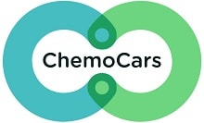
ChemoCars 501(c)3 was launched in March 2017 in Charlotte, North Carolina, and Amarillo, Texas, by Zach Bolster. ChemoCars was born out of Zach’s personal experience when his mom was diagnosed with cancer. During her treatments, he started to realize how many patients were driving themselves to treatment or were unable to get treatment because of the lack of transportation options. ChemoCars provides free round-trip rides to patients receiving chemotherapy, radiation and non-surgical treatments at verified treatment centers. ChemoCars will arrange a ride with Lyft or Uber and the ride sharing company is paid directly by ChemoCars. First time riders register over the phone and after registration, rides can be booked via phone or online. In 2017, ChemoCars provided 2,240 successful rides.

Penn Medicine's Abramson Cancer Center launched Ride Health in 2017, a pilot program that works with Uber and Lyft in Philadelphia, Pennsylvania, to offer round-trip transportation to patients who lack other means of getting to appointments for treatments like chemotherapy. The rides are free for patients. Penn Medicine pays for the rides with funds that would typically go to taxi vouchers. A Care Coordinator at the cancer center can arrange a ride for same-day appointments or months in advance on a web-based platform. Based on the patient profile in the system, Ride Health uses SMS text messages and automated landline calls to share updates with patients, caregivers and/or clinical contacts before, during and after each ride. Healthcare providers and health plans across the United States can arrange transportation through Ride Health for low-income, elderly and disabled patients who face transportation barriers to care.
Ride Connection is a door-to-door non-profit organization based in Portland, Oregon, that has been linking people to transportation in their community for over 25 years. Individuals request a ride either by phone or through an online application, and transportation is provided at no charge. Ride Connection and its partner agencies provide rides for any purpose including medical, meals, shopping, recreation, and volunteering or work. Currently Ride Connection provides door-to-door services for older adults (60+) and people with disabilities. Among Ride Connection’s special services are a Medical Shuttle Pilot Program that provides rides to individuals traveling to and from Providence Medical Center in Northeast Portland, and Dialysis Transportation, which uses a combination of volunteer and paid drivers to provide rides for individuals who need frequent dialysis treatments.
Cancer Justice Network - Navigators
Based in Cincinnati, Ohio, the Cancer Justice Network (CJN) helps low income individuals and minorities gain access to early screenings for cancer and treatment. This program uses “Navigators” who are trained guides working to help individuals overcome barriers to care. In New York, Philadelphia, Memphis, Denver, and many other cities, Navigators were able to improve life for cancer patients. The Navigators work with individuals in churches, community centers, schools, and neighborhood associations to assist with transportation and accompany patients to medical appointments. CJN is currently developing a transportation system for transporting cancer patients to and from medical appointments.
Funding

Programs providing non-emergency medical transportation services are funded in a variety of ways, including federal, state or local government funds, fundraising, donations, foundation and corporate support. The five programs discussed above are funded as follows.

- Started in 1974, Mountain Empire Older Citizens transportation services was funded through the Older Americans Act (OAA). Over the years, MEOC has received funding assistance through federal, state and local government funds. In 2017, MEOC was awarded the Innovations in Accessible Mobility grant from the National Aging and Disability Transportation Center (NADTC). Other funding for MEOC comes from fundraising and donations.
- ChemoCars receives support through charitable donations from private donors.
- Through donations (corporate and individual) and fundraising, Penn Medicine's Abramson Cancer Center can provide free rides to patients.
- To support their transportation program, Ride Connection has received funding from Federal Transit Administration (FTA) section 5310 and state grants. Additional funding is received from private foundation grants and both corporate and individual donations.
- The Cancer Justice Network (CJN) provides services to their community through donations and support from local hospitals, faith-based and corporate organizations. In fiscal year 2017, CJN received funding through the National Aging and Disability Transportation Center (NADTC) Innovations in Accessible Mobility grant.

Conclusion
Having a chronic condition is a difficult lifestyle change, but with proper care and available and accessible transportation options, patients can stabilize their health. Coordination with the community, patients, and their families is necessary for improving access to transportation for frequent medical appointments.

Resources
Chan, K., Thadhani, R., & Maddux, F. (2014). Adherence Barriers to Chronic Dialysis in the United States. Journal of American Society of Nephrology. Retrieved from: https://www.ncbi.nlm.nih.gov/pmc/articles/PMC4214530/
When Do I Need Dialysis?
https://www.webmd.com/a-to-z-guides/kidney-dialysis#1

Sunderland, S. Why is Cancer Mortality So High in Cincinnati Minorities and People of Low Income: Part 10: Imagining a Welcoming Health Care Story for All. 2018.

Hughes-Cromwich P., Wallace R. (2006). Cost benefit analysis of providing non-emergency medical transportation. http://www.trb.org/main/blurbs/156625.aspx

Zullig, L., Jackson, G., Provenzale, D., Griffin, J., Phelan, S., & van Ryn, M. (2011). Transportation – A Vehicle or Roadblock to Cancer Care for VA Colorectal Cancer Patients?
Retrieved from: https://www.ncbi.nlm.nih.gov/pmc/articles/PMC3274660/

MacLeod, K., Ragland, D., Prohaska, T., Smith, M., Irmiter, C., & Satariano, W. (2014). Missed or Delayed Medical Care Appointments by Older Users of Nonemergency Medical Transportation. The Gerontologist.
Retrieved from: https://www.ncbi.nlm.nih.gov/pmc/articles/PMC4668763/#CIT0014

Guidry, JJ., Aday, LA., Zhang, D., & Winn, RJ. (1997). Transportation as a barrier to cancer treatment. Cancer Practice. Retrieved from: https://www.ncbi.nlm.nih.gov/pubmed/9397704

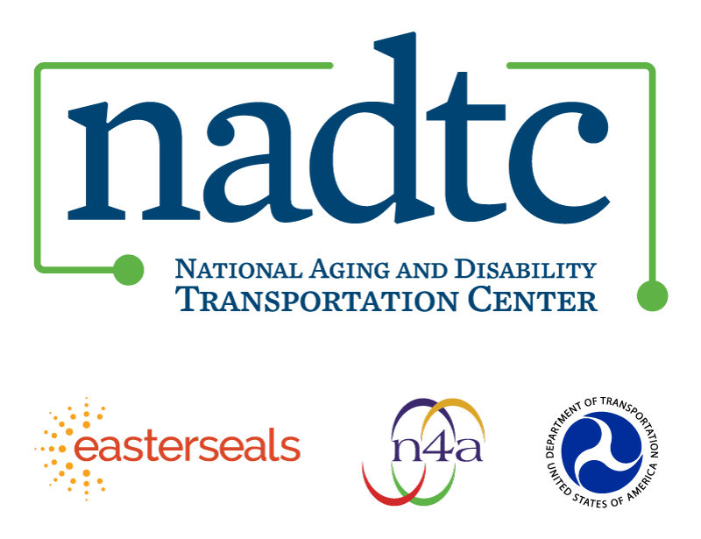

The National Aging and Disability Transportation Center (NADTC) is a program funded by the Federal Transit Administration and administered by Easterseals and the National Association of Area Agencies on Aging (n4a) with guidance from the U.S. Department of Health and Human Services, Administration for Community Living.

NADTC’s mission is to increase accessible transportation options for older adults, people with disabilities, and caregivers nationwide.

National Aging and Disability Transportation Center
Washington, D.C. 20005
Telephone and toll-free hotline: (866) 983-3222
TTY: (202) 347-7385
Email: contact@nadtc.org
Website: www.nadtc.org

Follow us:
Facebook
Twitter
YouTube
LinkedIn

