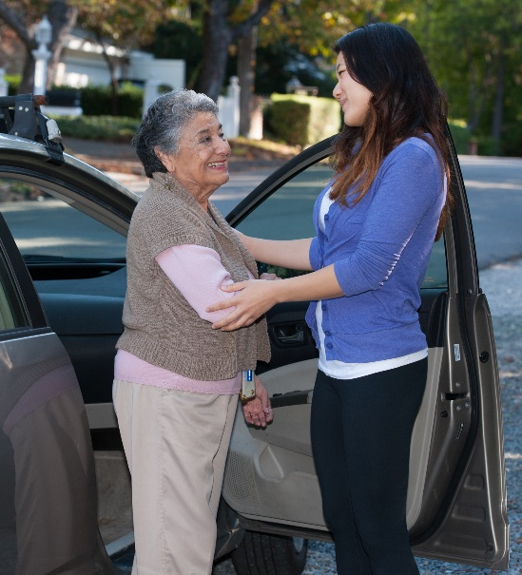
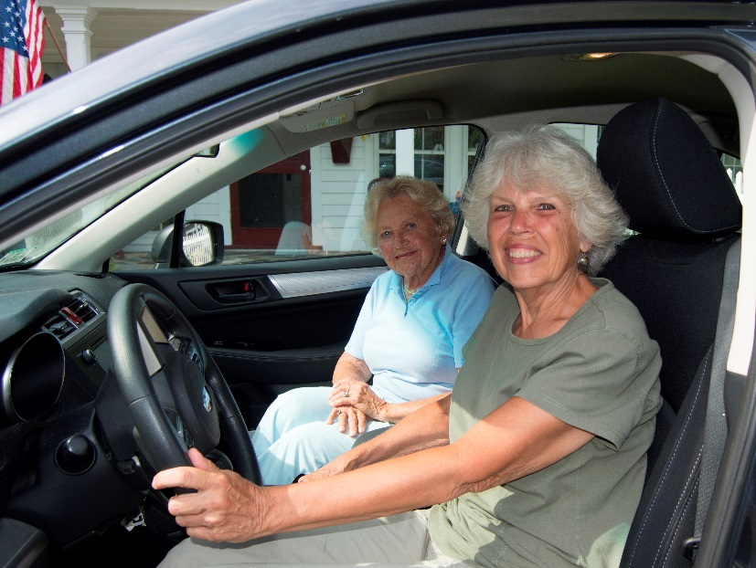

Introduction
Initiated in 2016, NADTC’s annual Trends Report explores trending topics in transportation from the last one to two years with a focus on accessible transportation services used by older adults and people with disabilities. The complete Trends Report is supplemented by Topic Spotlights for those who would like to download just one section of the report.
With its mission to increase the availability and accessibility of transportation for older adults and people with disabilities, NADTC recognizes that our work must be grounded in, and respond to, the needs and preferences of the communities and organizations that the center was created to serve. Critical to the center’s success is access to information about local communities’ efforts to develop, fund, and operate accessible transportation, how those developments are received by people with disabilities and older adults, and the reactions of leaders in accessible transportation to developments in the transportation field.
2018’s information reports address:
- Cancer Care and Dialysis Transportation
- Innovative Approaches to Section 5310 Match
- Non-Emergency Medical Brokerages and Coordination
- Opioid Use and Transportation
- Volunteer Transportation Programs
In this Volunteer Transportation Programs Topic Spotlight, NADTC looks at volunteer transportation as a viable alternative for older adults and people with disabilities, examines funding, community support and collaboration, and the measurement structures of programs in Colorado, California, Virginia, and Tennessee.
Explore transportation’s trending news with us through this report! If you have questions or have a story to share from your community, reach out to us at (866) 983-3222 or email contact@nadtc.org.
Cover Photo Credits:
Top: LifePath Rides for Health, Greenfield, Massachusetts
Bottom left: The Center for Volunteer Caregiving, Cary, North Carolina
Bottom right: Whistlestop Carepool, San Rafael, California

Bottom right:

Volunteer Transportation Programs

Introduction

The availability of accessible and affordable transportation options is a top concern for older adults, people with disabilities, and caregivers. Access to transportation is a key determinant of whether an individual can live independently, at home, and in the community. According to a 2012 AARP survey, more than 90% of older adults reported that they want to remain in their homes for as long as possible, yet this can only be possible if their transportation needs are met. Volunteer transportation programs are one solution to fill transportation gaps in communities.

What are Volunteer Transportation Programs?
Volunteer transportation programs are not a new approach to alternative transportation, but these community-based programs have recently received more recognition because of the role they play in supporting the health and well-being of older adults and people with disabilities. Volunteer transportation programs vary based on their size, scope of services offered, target population, funding and unique community needs. For many people, volunteer transportation programs are their only means of accessing medical care or grocery shopping. One of the chief attractions of this transportation option for many older adults and people with disabilities is the one-on-one service these programs provide. The key to a volunteer transportation program’s success is to customize service and delivery methods to the circumstances and needs of the community.

Volunteer Transportation: A National Perspective
The top transportation methods used by those surveyed in NADTC’s 2018 national poll were driving a vehicle (82% of older adults and 66% of younger adults with disabilities) and riding with friends or family (58% of older adults, 74% of younger adults with disabilities). While 15% of older adults and nearly one-third of younger adults with disabilities report using public transportation, riding with a volunteer, and/or using special transportation services for people with disabilities, when asked specifically about the use of volunteer transportation, only 8% of older adults and 27% of people with disabilities reported that they did. This is surprising, considering that volunteer transportation programs are often created to meet the transportation needs of these populations. Despite the relatively low utilization of volunteer transportation programs, both older adults and younger adults with disabilities expressed high interest in using these programs if they were available in their communities: 43% of older adults and 44% of younger adults with disabilities.

Volunteer Transportation: A Tale of Four Programs
NADTC’s online course on volunteer transportation, offered in the fall of 2018, provided an in-depth look at volunteer transportation programs. The course brought into focus the “5 Keys of Successful Volunteer Driver Programs,” identified in a NADTC blog of the same title and explored critical aspects of volunteer transportation programs. This report provides a brief overview of the four programs featured in the course and highlights how these programs address: 1) funding, 2) community support and collaboration, and 3) measuring and sharing impact. Additional information about these programs can be found on the NADTC website and YouTube page.

In early 2019, NADTC will release individual profiles of each of the four programs and promote further work on volunteer transportation with a focus on risk, liability and insurance in the coming year.
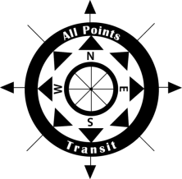
All Points Transit
All Points Transit (APT), based in Montrose, Colorado, is a non-profit transit organization that has provided transportation services for seniors, people with disabilities and others in need for more than 35 years. APT covers four counties—a nearly 4,500 square mile area of very small and rural towns. The volunteer transportation program uses volunteer drivers to provide safe and reliable door-to-door, driver-assisted transportation to medical appointments and other critical services. The mobility manager works as the volunteer transportation program coordinator and sends out requests to the volunteer pool.

APT provides a company vehicle, a Toyota Prius, which volunteers share. To become certified, volunteer drivers undergo an extensive three-day training program, similar to the training used for APT’s paid drivers. One of the ways APT maximizes the program is through time banking: volunteer drivers have the option to join a time bank and accumulate time credits that they can use for future goods and services. For more information visit www.allpointstransit.com or call (970) 249-6204.

Sonoma County Area Agency on Aging (AAA)
Sonoma County is one of nine counties that make up the San Francisco Bay area and is located about 50 miles north of San Francisco. Sonoma County is a geographically diverse county that includes a mix of rural and suburban areas. Sonoma County AAA contracts with six non-profit agencies (e.g., faith-based organizations, senior centers) that provide volunteer transportation throughout the county. This consortium of providers operates under a common set of policies and procedures that were developed by Sonoma County Area Agency on Aging. Volunteer transportation services are typically curb to curb; however, volunteers may use their discretion to provide door-to-door service as needed. Volunteer drivers use their own vehicles and gas and are reimbursed for mileage. Sonoma County AAA’s vision is to have volunteer transportation programs throughout the whole county. For more information visit http://sonomacounty.ca.gov/Human-Services/Adult-and-Aging/Area-Agency-on-Aging/ or call (707) 565-7186.

NV Rides
Located just 30 minutes west of Washington, D.C., NV Rides sits in the central part of northern Virginia and the D.C. suburbs. NV Rides supports local community-based organizations that either have a volunteer transportation program or are looking to start a new program. Partner agencies offer free or low-cost rides to individuals who are 55+ and ambulatory. NV Rides supports partner agencies at no cost in the following ways: ride scheduling software (RideScheduler.com); marketing support; volunteer coordinator support; and volunteer background checks. NV Rides is a neighborhood-based program that enables volunteers to sign up and accept rides based on their location and availability. Volunteers use their own vehicles and gas and may be reimbursed for mileage. Volunteers may also track their mileage and hours through a cloud-based scheduling software for tax purposes. For more information visit www.nvrides.org or call (703) 537-3071.

Blount County Office on Aging SMILES (Senior Miles) Program
SMiles is a rural volunteer transportation service provided by the Blount County, TN, Community Action Agency, which covers the Blount County region made up of nearly 125,000 residents. SMiles is a membership program that costs $25 per year. In addition to the cost of membership, the advance purchase of four $6 round trip rides is required. All fees are paid in advance by check or credit card to Blount County Community Action Agency. SMiles is designed for seniors 60+ who live independently, can walk with assistance of a walker or cane and can communicate with the volunteer driver. Wheelchair transportation is not included. SMiles drivers are 21+ with an average age of 66. Volunteers go through an initial screening followed by a four-hour training. Background checks are conducted for those who successfully complete the training. For more information visit https://www.blountcaa.org/programs/ or call (865) 724-1331.

Funding

Volunteer transportation programs can be funded in a variety of ways, including federal, state or local government funds, fundraising, passenger donations, in-kind contributions, foundation and corporate support. The four programs discussed above are funded as follows.
- As an overall operational model, All Points Transit (APT) relies heavily on donations and fundraising and receives support for all of their programs from partners, local government and foundations. The volunteer transportation program is operated with general support funds from local governments, hospitals, foundations, and donations. The administration of the program is funded through their Section 5310 mobility manager funding.
- To support their volunteer transportation programs, Sonoma County AAA began leveraging Older Americans Act dollars for transportation services beginning in 2008. As the success of the program grew, the AAA has since applied for additional transportation grants from the Federal Transit Administration (FTA), receiving New Freedom funds for fiscal year 2014 to 2017 and Enhanced Mobility of Seniors and Individuals with Disabilities Program Section 5310 funds for fiscal years 2016 through 2018 and most recently for fiscal years 2018 to 2020. In addition, they include a local match and in-kind services where needed.
- NV Rides receives local government and foundation funding through Fairfax County. Additional funding comes from FTA Section 5310.
- SMiles received their startup funding and additional funding (three-year grant beginning in August 2013) from the regional transportation planning group, the administrator for all the federal and state transportation dollars in their region. Additionally, Smiles’ membership fee model generates income for the program. In fiscal year 2017, SMiles received $20,000 from participant fees, making up nearly 20% of the budget.

Community Support and Collaboration

Volunteer transportation programs should fit into the broader community’s transportation efforts by prioritizing coordination and collaboration with other agencies.
- In launching the volunteer transportation program, All Points Transit (APT) partnered with a number of organizations like the regional Area Agency on Aging, Coalition for the Homeless, Montrose Community Foundation and Volunteers of America (Senior Services). Other partners were identified during the launch process to help with program implementation. The program was designed to fill transportation gaps in existing regional services provided by APT and other agencies that cover the region through partnership efforts and collaboration.
- Sonoma County AAA brings together advocates, community partners, and service providers to advocate, engage, coordinate and educate the community and partners to increase transportation access and services. They have organized the AAA Advisory Council Transportation and Mobility (T&M) Committee and the Sonoma Access Coordinated Transportation Services (SACTS) Consortium to coordinate services among service providers, share best practices, discuss challenges, and identify areas of focus for local and regional areas.
- NV Rides is a partnership between Jewish Community Center of Northern Virginia, where the program is housed, the Jewish Council for the Aging, and receives financial support from Fairfax County and Community Foundation of Northern Virginia. NV Rides’ service model of bringing together human services agencies, community centers, local government, faith communities, villages and non-profits as partner agencies represents how they garner support and collaborate with the community to solve transportation issues for non-driving seniors.
- SMiles receives a lot of community input through surveys, small and large community meetings, and events like their previously held Aging Summit. Through these efforts, staff is simply looking for people to “buy in” to SMiles. SMiles program staff believes that “buy in” leads to ownership of the program and ownership leads to a greater understanding of the need and the desire to sell the concept to friends and family, which ultimately leads to program growth and impact.

Measuring and Sharing Impact

As volunteer transportation programs collect data on the rides they provide and the riders they impact, it is important to share, with drivers, staff, management, media and other stakeholders, relevant and meaningful information on a regular ongoing basis. All four of the programs recognize the art of storytelling and make sure that stories and quotes from riders and drivers are being captured and shared. Program outcomes are shared in a variety of ways.
- All Points Transit features testimonials on their website to promote program successes.
- Sonoma County AAA hosted a widely publicized celebration event in January 2019 to highlight the 10-year anniversary of the start of their volunteer driver programs. Additionally, Sonoma County shares impact through various marketing and social media campaigns and making community presentations on a regular basis.
- NV Rides sends out surveys to drivers, program coordinators and riders on a biennial basis to measure partner satisfaction of NV Rides services, ease of use for volunteers, volunteer satisfaction, and rider satisfaction. Data and impact are shared through marketing initiatives.
2018 Annual Program Stats (as of Nov/Dec 2018)
Program | Trips provided | # of riders | # of drivers | Most frequent trip
APT | 142 | 37 | 5 | Medical
Sonoma | 10,839 | 546 | 128 | Medical
NV Rides | 12,244 | 753 | 477 | Medical
SMiles | 6,082 | 203 | 134 | Medical

- SMiles staff write stories for local newspapers, put out a monthly newsletter and share program impact through a case for support document that is used in annual campaigns and an annual report. According to staff, riders and drivers are the ambassadors for Smiles, and one of the more effective ways impact is shared.

Summary
Improving access to transportation is critical to ensure that older adults and people with disabilities stay connected to essential services and other activities. Volunteer transportation programs are filling gaps where other transportation and informal networks stop and contribute greatly to the mobility needs of older adults and people with disabilities across the country. With the increasing demand for transportation services to link people to employment, healthcare and community services, local agencies and community organizations are encouraged to explore volunteer transportation programs as a viable option for improving transportation access for older adults and people with disabilities in their communities.

NADTC Resources

Volunteer Transportation: Keys of a Successful Program Toolkit
https://www.nadtc.org/wp-content/uploads/Volunteer-Transp-Toolkit_Final.pdf
Volunteer Transportation: Risk, Liability and Insurance Webinar https://www.nadtc.org/resources-publications/keys-to-a-successful-volunteer-transportation-program-risk-liability-and-insurance-webinar/
Blog: 5 Keys to Successful Volunteer Driver Programs
https://www.nadtc.org/news/blog/5-keys-to-successful-volunteer-driver-programs/
National Aging and Disability Transportation Volunteer Information Brief https://www.nadtc.org/wp-content/uploads/Volunteer-Transportation-Info-Brief-Cover.pdf

References

AARP. (2012). The United States of Aging. Retrieved from https://www.aarp.org/content/dam/aarp/livable-communities/old-learn/research/the-united-states-of-aging-survey-2012-aarp.pdf

Federal Transit Administration (n.d.). Enhanced Mobility of Seniors and Individuals with Disabilities – Section 5310. Retrieved from https://www.transit.dot.gov/funding/grants/enhanced-mobility-seniors-individuals-disabilities-section-5310

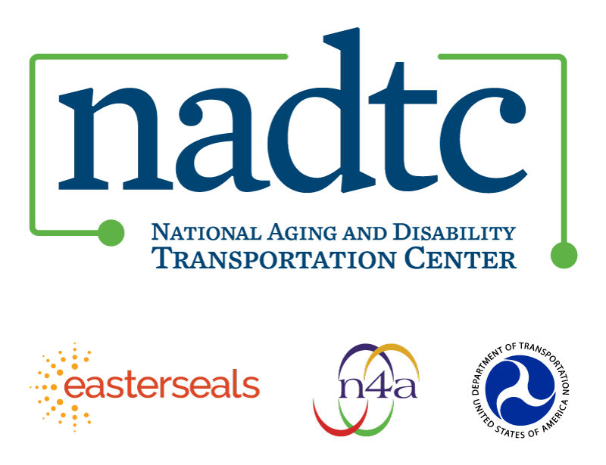

The National Aging and Disability Transportation Center (NADTC) is a program funded by the Federal Transit Administration and administered by Easterseals and the National Association of Area Agencies on Aging (n4a) with guidance from the U.S. Department of Health and Human Services, Administration for Community Living.

NADTC’s mission is to increase accessible transportation options for older adults, people with disabilities, and caregivers nationwide.

National Aging and Disability Transportation Center
Washington, D.C. 20005
Telephone and toll-free hotline: (866) 983-3222
TTY: (202) 347-7385
Email: contact@nadtc.org
Website: www.nadtc.org

Follow us:
Facebook
Twitter
YouTube
LinkedIn

