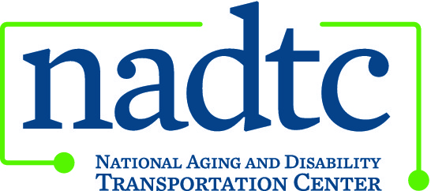

This publication was downloaded from the National Aging and Disability Transportation Center’s website (www.nadtc.org). It was developed by Easter Seals Project ACTION, a technical assistance center operated by Easter Seals, Inc. through a cooperative agreement with the U.S. Department of Transportation, Federal Transit Administration.

Front:

Facts About Service Animals and Transportation

This document is an accessible version provided for those using screen readers.

Service animals perform tasks to help a person with a disability live independently. U.S. Department of Transportation Americans with Disabilities Act regulations define a service animal as “any guide dog, signal dog, or other animal individually trained to work or perform tasks for an individual with a disability, including, but not limited to:
- guiding individuals with impaired vision,
- alerting individuals with impaired hearing to intruders or sounds,
- providing minimal protection or rescue work,
- pulling a wheelchair, or
- fetching dropped items” (49 CFR 37.3).

When riding transit, customers are responsible for maintaining control over their animals and caring for them at all times. Riders are also responsible for knowing the best way to board and position the animal on the vehicle, particularly if the animal might be required to provide assistance during the transit trip. Service animals may not block aisles or exits.

www.nadtc.org

Logos: Easterseals, National Association of Area Agencies on Aging (n4a), U.S. Department of Transportation.

A program of the U.S. Department of Transportation, Federal Transit Administration, administered by Easterseals, the National Association of Area Agencies on Aging (n4a), with guidance from the U.S. Department of Health and Human Services, Administration for Community Living.

Back:

Photo: A woman using a wheelchair with a guide dog on a sidewalk surrounded by snow.

ADA regulations state that every transportation employee or operator who serves people with disabilities must be trained so that he knows how to provide non-discriminatory service in an appropriate and respectful way.

When serving passengers who are blind, operators should identify themselves; speak directly to the customer instead of through a companion; and use specifics such as “there are three boarding steps and a 12-inch drop to the curb” when giving directions. Excellent customer service makes good business sense!

Transit agencies should be aware of the following rules under ADA:
- Operators must allow all service animals on board.
- Operators may not:
  - Ask for proof of service animal certification or of the customer’s disability.
  - Require a person traveling with a service animal to sit in a particular seat on the vehicle.
  - Charge a cleaning fee for customers who bring service animals onto the vehicle, unless the animal causes damage.

www.nadtc.org

To learn more about accessible public transportation, contact:
National Aging and Disability Transportation Center
Washington, DC
Toll-free 866.983-3222
contact@nadtc.org

December 2017

