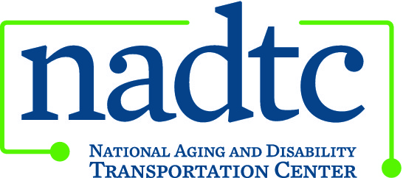

This publication was downloaded from the National Aging and Disability Transportation Center’s website (www.nadtc.org). It was developed by Easter Seals Project ACTION, a technical assistance center operated by Easter Seals, Inc. through a cooperative agreement with the U.S. Department of Transportation, Federal Transit Administration.

Facts about Service Animals and Transportation Poster
This document is an accessible version provided for those using screen readers.

Service animals have a job to do. And so do you.
Every day, service animals perform tasks to help people with disabilities live independently. Customers with service animals have rights and responsibilities under the Americans with Disabilities Act. Transit operators have responsibilities, too.
Service animals and public transportation
U.S. Department of Transportation ADA regulations define a service animal as “any guide dog, signal dog, or other animal individually trained to work or perform tasks for an individual with a disability, including, but not limited to:
- guiding individuals with impaired vision,
- alerting individuals with impaired hearing to intruders or sounds,
- providing minimal protection or rescue work,
- pulling a wheelchair, or
- fetching dropped items” (49 CFR 37.3).
Customer responsibilities
- Customers are responsible for maintaining control over their animals and caring for them at all times when riding transit.
- Customers are responsible for knowing the best way to board and position their animal on the transit vehicle.
- Service animals may not block aisles or exits.
Operator responsibilities
- Every operator or employee who serves people with disabilities must be trained to provide non-discriminatory service in an appropriate and respectful way.
- Operators must allow all service animals on board.
Operators may not:
- Ask for proof of service animal certification or of the customer’s disability.
- Require a customer traveling with a service animal to sit in a particular seat on a vehicle.
- Charge a cleaning fee for customers who bring their service animals onto a vehicle, unless the animal causes damage.
Easter Seals Project ACTION logo
Easter Seals logo
U.S. Department of Transportation logo
Easter Seals Project ACTION
www.projecaction.org
800-659-6428 ∙ 202-347-7385 (TTY)
projecaction@easterseals.com

Easter Seals Project ACTION (ESPA) is funded through a cooperative agreement with the U.S. Department of Transportation, Federal Transit Administration, and is administered by Easter Seals, Inc. This information is distributed by ESPA in the interest of information exchange. Neither Easter Seals nor the U.S. DOT, FTA assumes liability for its content or use.
March 2014

