Questions and Information to Share with Providers When Considering Transportation Options

When preparing to choose a public or private transportation option for yourself, a family member, or a client, you’ll want to select an option that is reliable and best-suited for the trip.

Be prepared to ask and answer the following questions.

- Service Area and Trip Type: Many transportation options have a defined service area and set hours of operation and days of the week that should be considered when planning your trip. A transportation service may limit services by type of trip. For example, some services may only provide rides to doctor appointments.
- Information you will need to provide:
  - How far and when you need to travel.

- Ask the provider:
  - What is the service area? Is there a limitation on distance?
  - Is there a limitation to the kind of service provided? Are rides provided to social as well as medical or shopping appointments?

- Scheduling: Some services do not require reservations, some may take same-day reservations, and others will require reservations to be made days in advance of your trip. It is important to ask if there is a waiting list for services and what the typical wait time is for ride requests to be accommodated. If there is a waiting list, some ride requests may not be accommodated, or they may be prioritized by urgency or type of trip.
- Information you will need to provide:
  - When you will need to travel.
  - Do you need one round trip ride, or rides to multiple appointments?

- Ask the provider:
  - How much advanced notice is required before using the service? Is there a waiting list?
  - Are rides provided in the evenings, on weekends or on holidays?
  - Will there be a wait when picked up from home? If so, how long?
  - How do I let the driver know that I am ready to be picked up for my ride home?
  - Will there be a wait when picked up for my return trip? If so, how long?
  - What is your cancellation policy?

- Eligibility: A person may have to qualify for services by age, disability or income level that prevents them from using an alternative transportation option.
- Information you will need to provide:
  - Age.
  - Household income.
  - Disability or mobility limitations.

- Ask the provider:
  - Are there requirements to qualify for the service? If so, what are they?
  - Is there an evaluation that must take place prior to the first ride?

- Cost: The fees for the transportation services in your community will vary. One service may operate on a fixed-fare system or may have a reduced rate available for older adults and people with disabilities. Services may calculate costs by distance traveled, others may provide vouchers or coupons, and some transportation services are provided at no cost.
- Information you will need to provide:
  - Your income and the amount you can afford to pay for the trip.

- Ask the provider:
  - What is the cost for the service?
  - Will insurance pay for rides provided by the service?
  - Is there a membership fee that must be paid before scheduling rides with the service?

- Special Accommodations: Consider any needs you may have that will need to be accommodated when traveling.
- Information you will need to provide:
  - Do you need a vehicle that can accommodate a wheelchair, scooter or other mobility device?
  - Do you need assistance getting in and out of the vehicle or walking between your door and the vehicle?

- Ask the provider:
  - Can the service accommodate special assistance?
  - Is there an escort or attendant in the vehicle with the driver?
  - Does someone stay with me/my family member during appointments?
  - Can a family member serve as a personal care attendant?

Notes

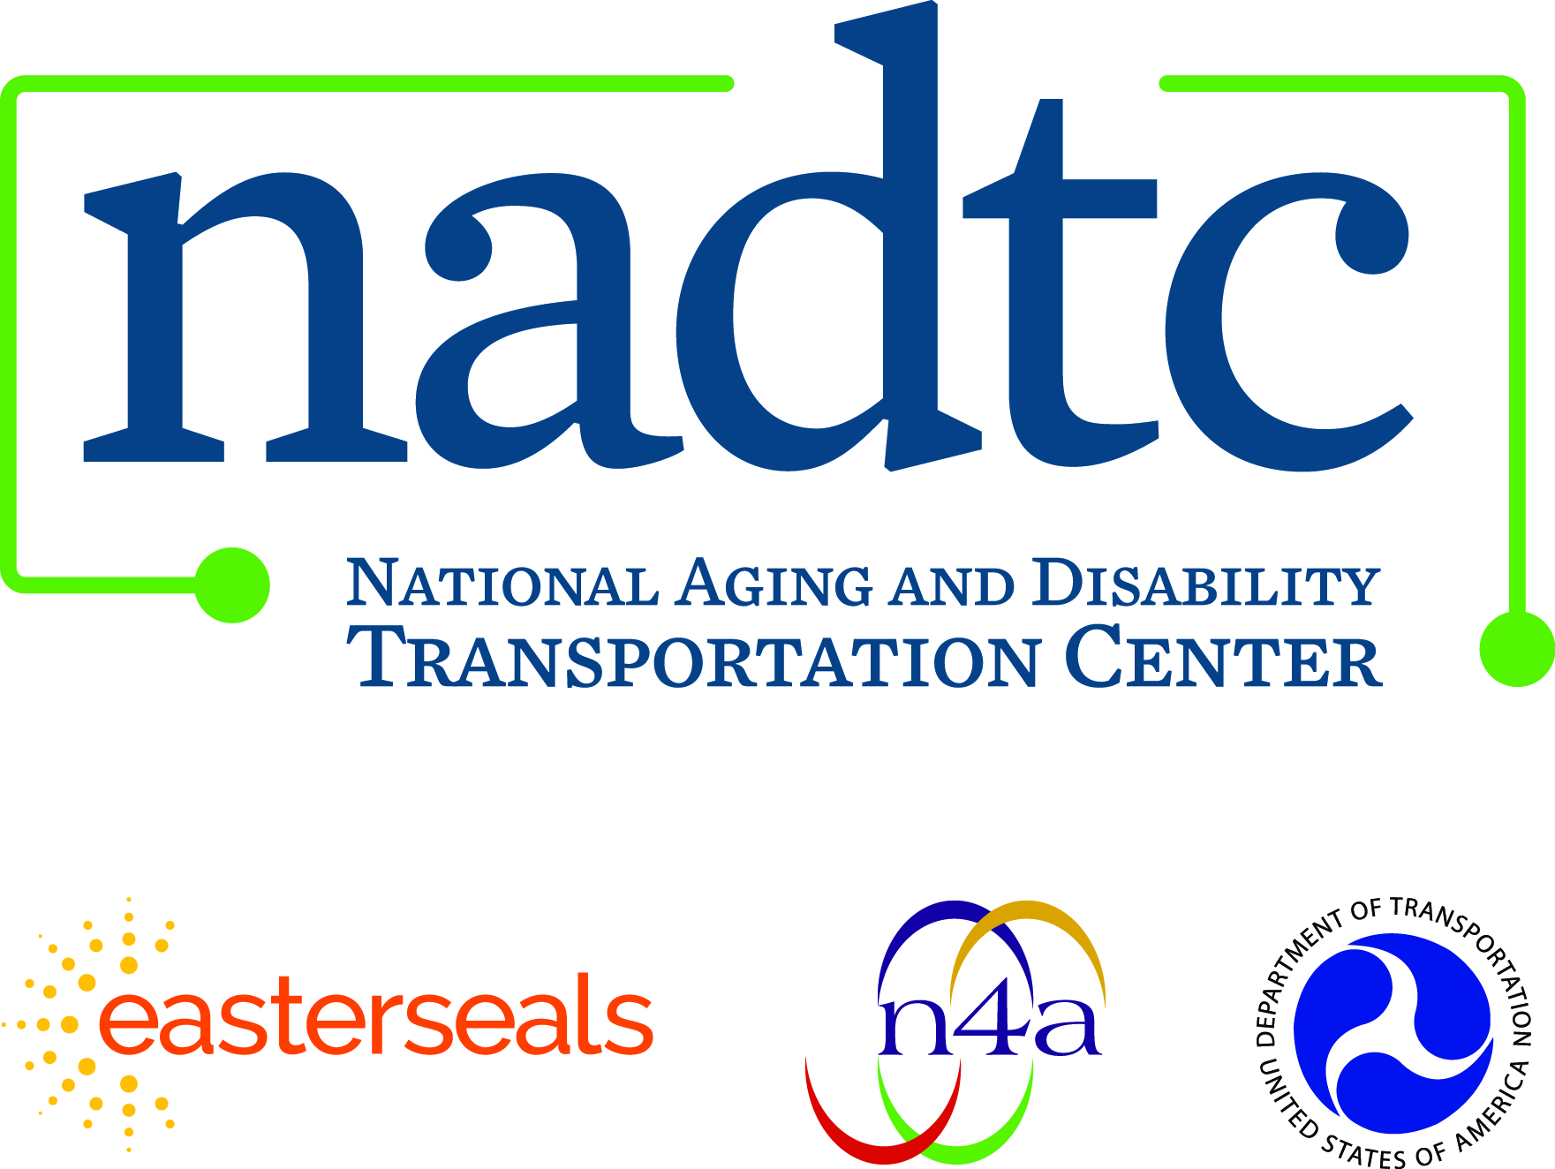

Call toll-free: 866.983.3222
Email: contact@nadtc.org
Web: www.nadtc.org

Find us on Facebook, Twitter, YouTube & LinkedIn!

Who We Are

Established in 2015, the NADTC is a federally funded technical assistance center administered by Easterseals and the National Association of Area Agencies on Aging based in Washington, D.C.

The National Aging and Disability Transportation Center is funded through a cooperative agreement of Easterseals, the National Association of Area Agencies on Aging, and the U.S Department of Transportation, Federal Transit Administration, with guidance from the U.S. Department of Health and Human Services, Administration for Community Living.

The National Association of Area Agencies on Aging (n4a) is a 501c(3) membership association representing America’s national network of 622 Area Agencies on Aging (AAAs) and providing a voice in the nation’s capital for the 256 Title VI Native American aging programs. The mission of n4a is to build the capacity of its members so they can better help older adults and people with disabilities live with dignity and choices in their homes and communities for as long as possible. www.n4a.org

Easterseals is the leading non-profit provider of services for individuals with autism, developmental disabilities, physical disabilities and other special needs. For nearly 100 years, we have been offering help, hope, and answers to children and adults living with disabilities, and to the families who love them. Through therapy, training, education and support services, Easterseals creates life-changing solutions so that people with disabilities can live, learn, work and play. www.easterseals.com

