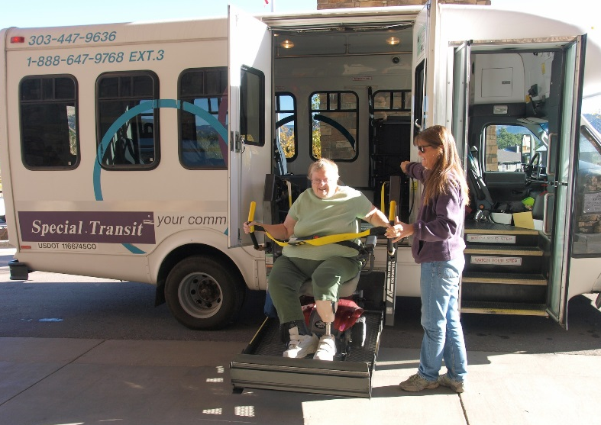
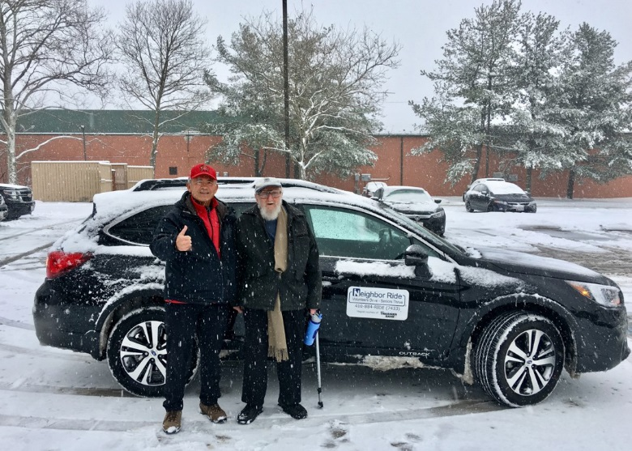

Introduction

Initiated in 2016, NADTC’s annual Trends Report explores trending topics in transportation from the last one to two years with a focus on accessible transportation services used by older adults and people with disabilities. The full report is supplemented by Topic Spotlights for those who would like to download just one section of the report. Each section of the report includes case studies on how changes in transportation are being implemented in states and communities in the U.S.
With its mission to increase the availability and accessibility of transportation for older adults and people with disabilities, the National Aging and Disability Transportation Center (NADTC) recognizes that our work must be grounded in, and respond to, the needs and preferences of the communities and organizations that the center was created to serve. Critical to the center’s success is access to information about local communities’ efforts to develop, fund, and operate accessible transportation, how those developments are received by people with disabilities and older adults, and the reactions of leaders in accessible transportation to developments in the transportation field.
2018’s information briefs address:
- Cancer Care and Dialysis Transportation
- Innovative Approaches to Section 5310 Match
- Non-Emergency Medical Brokerages and Coordination
- Opioid Use and Transportation
- Volunteer Transportation Programs
As a Medicaid benefit, non-emergency medical transportation provision varies state-to-state depending on each state’s model coordination practices. This NEMT brief looks at examples from Massachusetts, North Carolina, Oregon, and Texas.
Explore transportation’s trending news with us through this report! If you have questions about any topic here or have a story to share from your community, reach out to us at (866) 983-3222 or email contact@nadtc.org.
Cover Photo Credits: Metrolina Association for the Blind; Neighbor Ride; National RTAP
Interior Photo Credits: Transportation Connection; Kewaunee County Services

Non-Emergency Medical Transportation Brokerages and Benefits of Coordination

Introduction
This trends report is based on information from a review of Transit Cooperative Research Program (TCRP) Research Report 202: Handbook for Examining the Effects of Non-Emergency Medical Transportation Brokerages on Transportation Coordination and companion document, State-by-State Profiles for Examining the Effects of Non-Emergency Medical Transportation Brokerages on Transportation Coordination.
Medicaid is a state and federal program that delivers health care coverage for people of low income or people with disabilities. Each state sets its own guidelines regarding eligibility and the level of services provided. Non-emergency medical transportation (NEMT) is a vital Medicaid benefit providing rides so that people can receive medical care. Medicaid pays for transportation services to a Medicaid-approved appointment for an eligible rider and determines what type of transportation is appropriate for their appointment. The type of transportation can range from door-to-door taxicab services, public transportation, human service agency trips, and wheelchair accessible vans. NEMT is the largest single program activity that provides federal money for human service transportation. NEMT may have limitations due to brokerage contracts that limit service area or the amount of service that can be provided. In many state Medicaid transportation plans, transportation outside of a county is considered non-local transportation and requires additional approval from that state’s Medicaid agency. Often, there is an additional administrative requirement for NEMT long distance trips to specialists at regional medical centers or when no local provider is available.
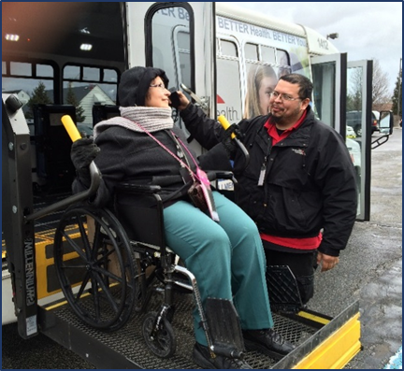
NEMT Models
Some states use an in-house management model where the state Medicaid agency oversees the booking of NEMT trips with local transportation providers. Often, these states define local service boundaries by counties or regions, and book trips with local transit providers, for-profit companies, and human service organizations.
Many states are creating a statewide or regional brokerage to provide NEMT service. Federal requirements provide an incentive to states to create brokerages since a higher federal match rate is available when brokerages are used. The brokerage models provide cost savings and reduce administrative burdens to the states. It is important to note that NEMT reimbursement varies by state. For example, in Alaska, the majority of NEMT spending is for air transportation due to travel needs of people living in remote villages or on islands.
Managed care organizations may hold Medicaid contracts to provide health care delivery that is designed to offer cost savings, efficiency in use of services, and quality control. NEMT transportation is often integrated into these managed care contracts.
Finally, transportation network companies (TNC) modes are a prospective option for NEMT, as ride hailing is available in urban areas throughout much of the country. In some states, NEMT brokers are working with TNCs to provide trips for riders for whom it is appropriate.
Coordination Requirements
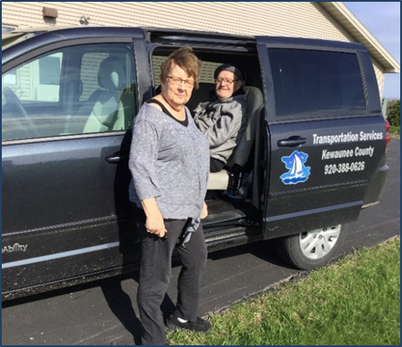
There are existing requirements for coordination of human service transportation. The Coordinating Council on Access and Mobility (CCAM), as established by Executive Order 13330, promotes activities to coordinate the efforts of 80 federal agencies that fund transportation services for older adults, people with disabilities, and individuals of low income. The goal is to improve efficiency and reduce duplication so that more transportation trips are available to these targeted populations. NEMT is a large and important transportation program to ensure that Medicaid beneficiaries get care they need, and because of this, must be part of the local transportation coordination process. Additionally, as part of the Fixing America’s Surface Transportation Act (FAST Act), transportation projects selected for funding under the Section 5310 Enhanced Mobility of Seniors & Individuals with Disabilities program must be included in a local coordinated transportation plan that is approved through a process that includes participation by older adults, individuals with disabilities, as well as representatives of public, private, and nonprofit transportation agencies and human services providers.
Human service transportation consists of options that meet the needs of older adults, people with disabilities or other disadvantaged groups such as people with lower incomes and includes door-to-door service or dial-a-ride service that is provided by an agency or contractor. Additionally, options that support transportation include funds to purchase bus passes, vouchers to pay for rides, or reimbursement to volunteer drivers or family members.
Human service providers face challenges when coordinating with NEMT such as not having the resources to purchase on-vehicle technology or software designed for ride scheduling and booking trips with other programs. State funding for human service agencies may be limited to vehicle purchases and may not include adequate amounts for technology improvements such as scheduling software. In some states with a broker model, the broker has limited incentive to coordinate with public transportation, and efforts are concentrated on booking NEMT trips with their contracted providers. Scheduling trips that meet the needs for Medicaid beneficiaries can be challenging to transportation operators when working with multiple human service providers and entities who customarily provide rides to their own program participants rather than anyone who is Medicaid-eligible.
For NEMT providers, coordinating with public transportation providers and human service agencies provides benefits and opportunities. One primary benefit is that NEMT providers meet Federal Transit Administration and state requirements for coordination that include being a part of the public transportation mix. Other benefits include reducing duplicative and redundant transportation services when trips are not coordinated. Scheduling rides with various providers that offer multiple trip types results in increased efficiency in the use of transportation resources and cost savings.
A coordination strategy for local planners and transportation entities is to collaborate with NEMT stakeholders when updating a locally developed human service transportation plan. The goal is to develop a process and plan to better coordinate NEMT trips between various human service providers and public transportation agencies. This effort can offer opportunities to work out a process to better meet the transportation needs of Medicaid beneficiaries for NEMT trips and non-medical trips alike. Using public transportation via fixed-route and demand-response modes can be suitable f or some NEMT trips and reduce the cost by using established systems. Brokers can work with public transportation ADA providers to establish a cost-effective rate to provide NEMT trips based on Medicaid payment guidelines.
Highlight: Rides to Wellness Demonstration Grants
Transportation is a key service to link people to the healthcare they need. The Federal Transit Administration (FTA) Rides to Wellness Demonstration Grants (FY 2016) funded projects that aim to help people with access to healthcare destinations. With better access to services through transportation, people will get preventive healthcare that result in improved health outcomes.

For example, the New Hampshire Department of Transportation innovation is the Bridge to Integration Project that focuses on technology improvement between Medicaid brokers and coordination software system. Innovation includes integrating Medicaid trips with non-Medicaid trips that increases coordination of transportation resources.

Likewise, the Michigan Department of Transportation project will expand a brokerage-based non-emergency medical transportation program to a statewide model for older adults, people with low incomes, and people with disabilities. Using integrated trip coordination software, health providers can refer people for transportation scheduling that better meets the needs of the rider.

Additional information on this FTA (FY 2016) grant program can be found at https://www.transit.dot.gov/funding/grants/fy-2016-rides-wellness-demonstration-and-innovative-coordinated-access-and-mobility.

For information on current FTA grant investments and grant opportunity, go to https://www.transit.dot.gov/funding/grants/grant-programs/access-and-mobility-partnership-grants

Massachusetts
This handbook contains detailed examples of how states coordinate with human service providers for their NEMT program. For example, in Massachusetts, the state Department of Health and Human Services created the Human Service Transportation (HST) Office to coordinate transportation for human service agencies, and their Medicaid program, MassHealth. Contracts are given to Regional Transit Authorities (RTAs) to provide brokerage services in nine regions of the state. This coordinated system has resulted in cost savings through shared rides among client groups, and there are incentives for brokers to keep trip expenses and overhead low.
North Carolina
For North Carolina, Medicaid transportation is provided by county departments of social services where the local departments purchase NEMT on a fee-for-service basis. Community transportation providers deliver service to all counties, although there are private operators in six counties. The program also offers reimbursements to families or friends that provide trips. Coordination occurs between public transportation and human service providers. Most trips are coordinated at the county level, but when needed for cross county rides, a regional operator sets up the trip. Additionally, North Carolina requires local and regional public transportation providers to have a Transportation Advisory Board (TAB). The TAB is established to ensure that the transportation-related needs are identified for local governments within a service area.
Oregon
The state of Oregon has a managed care model using Coordinated Care Organizations (CCOs) that contract with eleven brokers to provide NEMT. The organizations include public transit agencies, councils of governments, and private companies. Coordination occurs when brokers work with their CCOs, and trips may be provided by public transportation. In some areas, the NEMT broker no long works with the CCOs, and coordination may be a problem.
Texas
Texas has a mixed model, using for profit and non-profit brokers. NEMT is provided as a contracted fee-for-service, and Transportation Service Area Providers (TSAPs) are the lead entities. The TSAPs include rural or urban public transit districts, for-profit companies, and nonprofit human service agencies. Coordination of transportation by regional brokers is minimal, and only three percent of NEMT trips were provided by public transportation. In 2014, a managed transportation organization model was implemented in eleven regions of the state. Results of this change are not included in the handbook (TCRP Report 202).
Summary
TCRP Report 202 provides a wealth of information on NEMT programs in each state and why strategies to coordinate transportation can result in increased efficiencies in providing more trips and cost savings to the program. Strategies for coordination such as involving NEMT providers, brokers, and human service agencies in coordination plans and planning can be vitally important to reduce duplicative trips and increase service coverage. Coordination can also improve availability of long-distance and cross-jurisdiction trips with improved availability of rides. Human service transportation, public transportation, and NEMT stakeholders can work together to achieve common desired outcomes which include improved health, better quality of service, and maximized service delivery with available resources. Focus on these desired outcomes as the impetus to coordination can lead to efficiency in providing trips to NEMT beneficiaries and opportunities for more rides for a community.
References
TCRP Report 202. (Linda Cherrington, 2018). Handbook for Examining the Effects of NEMT Brokerages on Transportation Coordination. Retrieved from https://mtap.transportation.org/wp-content/uploads/sites/42/2018/11/TCRP-202-for-AASHTO-Nov-8-Final.pdf
State-by-State Profiles for Examining the Effects of Non-Emergency Medical Transportation Brokerages on Transportation Coordination, companion document to TCRP Report 202. (TCRP Project B-44, 2018).
Retrieved from http://onlinepubs.trb.org/onlinepubs/tcrp/tcrp_rpt_202_companion.pdf
TCRP Report 173. (Gail Murray, 2014). Improving Transit Integration Among Multiple Providers, Volume I: Transit Integration Manual.
Retrieved from http://www.trb.org/Publications/Blurbs/171934.aspx
National Center for Mobility Management. 2014. Promising Practices in Transportation Coordination: Enabled by Technology and Innovative Design.
Retrieved from https://nationalcenterformobilitymanagement.org/wp-content/uploads/2013/11/Promising-Practices_Transportation-Coordination-Enabled-by-Technology.pdf
National Conference of State Legislatures. 2012. Regional Human Service Transportation Coordinating Councils: Synthesis, Case Studies, and Directory. Retrieved from http://www.ncsl.org/research/transportation/regional-coordinating-councils-report.aspx

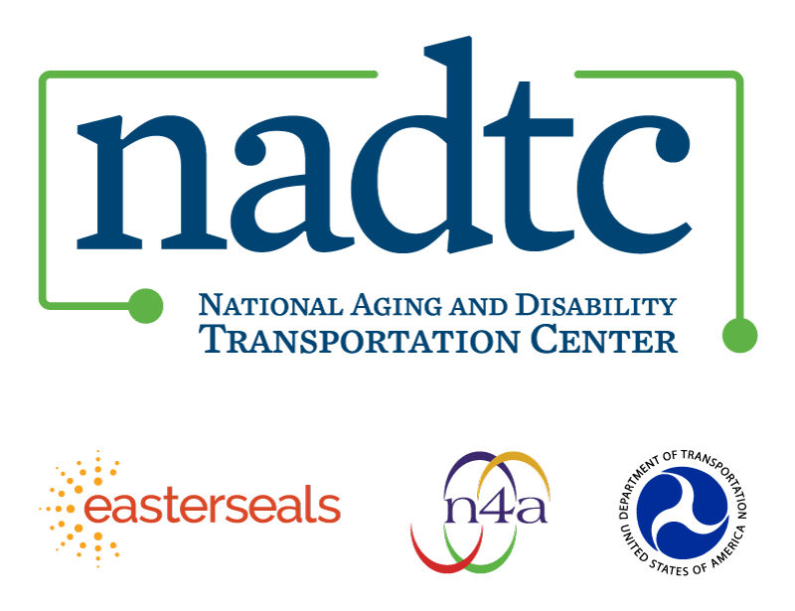

The National Aging and Disability Transportation Center (NADTC) is a program funded by the Federal Transit Administration and administered by Easterseals and the National Association of Area Agencies on Aging (n4a) with guidance from the U.S. Department of Health and Human Services, Administration for Community Living.

NADTC’s mission is to increase accessible transportation options for older adults, people with disabilities, and caregivers nationwide.

National Aging and Disability Transportation Center
Washington, D.C. 20005
Telephone and toll-free hotline: (866) 983-3222
TTY: (202) 347-7385
Email: contact@nadtc.org
Website: www.nadtc.org

Follow us:
Facebook
Twitter
YouTube
LinkedIn

