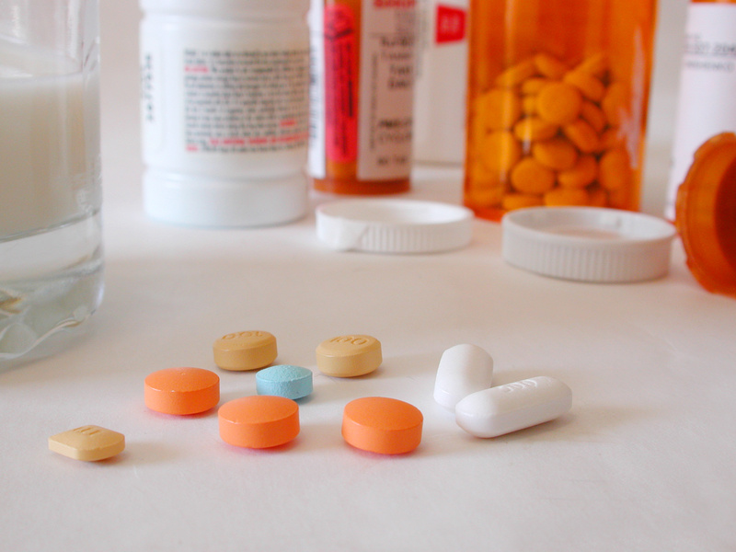

Introduction
Initiated in 2016, NADTC’s annual Trends Report explores trending topics in transportation from the last one to two years with a focus on accessible transportation services used by older adults and people with disabilities. The complete Trends Report is supplemented by Topic Spotlights for those who would like to download just one section of the report.
With its mission to increase the availability and accessibility of transportation for older adults and people with disabilities, NADTC recognizes that our work must be grounded in, and respond to, the needs and preferences of the communities and organizations that the center was created to serve. Critical to the center’s success is access to information about local communities’ efforts to develop, fund, and operate accessible transportation, how those developments are received by people with disabilities and older adults, and the reactions of leaders in accessible transportation to developments in the transportation field.
2018’s information reports address:
- Cancer Care and Dialysis Transportation
- Innovative Approaches to Section 5310 Match
- Non-Emergency Medical Brokerages and Coordination
- Opioid Use and Transportation
- Volunteer Transportation Programs
In this Opioid Use and Transportation Topic Spotlight, NADTC explores how transportation to opioid treatment is an eligible activity under federal funding programs and communities across the country are making a concerted effort to involve transportation providers in recognizing opioid abuse and providing support to those addressing addiction. Programs in Idaho, Illinois, Massachusetts, Michigan, Minnesota, New York, and Washington State are featured.
Explore transportation’s trending news with us through this report! If you have questions or have a story to share from your community, reach out to us at (866) 983-3222 or email contact@nadtc.org.
Cover Photo Credits
Top left and right: Creative Commons
Bottom: National Rural Transit Assistance Program

Bottom right:

Opioid Use and Transportation
Introduction
The opioid crisis has reached emergency response-level proportions in many parts of the United States. More than 115 people in the U.S. overdose on opioids daily, costing approximately $78.5 billion a year when considering healthcare, effects to productivity, treatment and the criminal justice proceedings involved (National Institute on Drug Abuse, 2019). As the crisis worsens, transportation agencies and programs are beginning to be brought to the table as a part of a holistic response. This report provides a current snapshot of both the state of the opioid crisis and the transportation industry’s response.
Defining Terms
Opioid misuse is defined as when a patient is not following instructions of a medical provider of the drug (NIH, MedlinePlus).
Opioid addiction occurs when a person seeks opioids even if/when taken they will cause the person harm (NIH, Medline Plus).
Opioid overdose occurs when high doses of opioids are taken causing the slowing or stopping of breathing and sometimes death (NIH, Medline Plus).

State of the Opioid Crisis

What are Opioids?

Opiates are drugs created from opium. Opioid is a term inclusive of drugs derived naturally, as well as those synthetically and semi-synthetically created. Opioids are a class of narcotic that, when taken, attach to opioid receptors in the body. Once attached to the receptor, signals to the brain are sent that block pain sensation, slow breathing, reduce anxiety, and create a calming, euphoric sensation (National Alliance of Advocates for Buprenorphine Treatment, 2008). Opioids in common use include heroin, fentanyl, oxycodone, codeine, and morphine.

How the Opioid Crisis Began

In the late 1990s, the American Pain Society began advocating that pain be seen as a measure of a person’s essential bodily function or a vital sign (Lyapustina & Caleb Alexander, 2015). Professionals in the pharmaceutical community began advocating and provided safety assurances for the increase of prescriptions of opioids for pain management. As a result, the medical community began prescribing opioids at a much higher rate (U.S. Department of Health and Human Services, 2019). From 1991 to 2009, the number of opioid prescriptions written increased by 300% (Lyapustina & Caleb Alexander, 2015).

Opioids and Addiction
Opioid Addiction Statistics
Drug overdose deaths rose from 8,048 in 1999 to 47,600 in 2017. (NIH National Institute on Drug Abuse).

Roughly 21% to 29% of patients prescribed opioids for chronic pain misuse them.

Between 8% and 12% develop an opioid use disorder.

An estimated 4% to 6% who misuse prescription opioids transition to heroin.

About 80% of people who use heroin first misused prescription opioids.

Opioid overdoses increased 30% from July 2016 through September 2017 in 52 areas in 45 states.

The Midwestern region saw opioid overdoses increase 70% from July 2016 through September 2017.

Opioid overdoses in large cities increase by 54% in 16 states (NIH, National Institute on Drug Abuse).

Source: www.drugabuse.gov

The increase in prescribing opioids for pain management occurred prior to the full understanding by the medical community of their highly addictive nature. “Our brains are wired to ensure that we will repeat life-sustaining activities by associating those activities with pleasure or reward” (National Alliance of Advocates for Buprenorphine Treatment, December 2008). Dopamine is a substance the body releases facilitating the transfer of an impulse from one nerve to another. Dopamine regulates movement, emotion, cognition, and feelings of pleasure causing a euphoric effect when released in high amounts. Opioids target this system of pleasure and reward by releasing large quantities of dopamine. This overwhelming sense of pleasure and euphoria is often sought by people that misuse drugs causing a repeat in the behavior and can then cause addiction (National Alliance for Advocates for Buprenorphine Treatment, December 2008).

Opioid Treatment Options and Availability

Treatments for opioid addiction include medications, counseling, behavioral therapy, medication-assisted therapy (MAT), and/or residential and hospital-based treatment (NIH, Medline Plus, November 2018).

There are three medications currently used to treat opioid abuse: methadone, buprenorphine, and naltrexone. Methadone and buprenorphine target the same receptors in the brain as opioids but do not create the same euphoric feeling as opioids. These drugs are used to treat withdrawal and craving symptoms, and therefore, to treat the addiction itself. Naltrexone prevents the euphoric feeling of taking opioids. Rather than treating addiction, Naltrexone is used to prevent a relapse of opioid use (NIH, Medline Plus, November 2018).

Individual counseling, including cognitive-behavioral therapy, motivational enhancement therapy, and/or contingency management, group counseling, and family counseling may be used to treat opioid abuse and addiction. Therapy attempts to change the user’s attitudes and behaviors related to taking opioids. Therapy may also assist in building and increasing healthy life skills and can assist the person in maintaining alternative treatments such as medications. Counselors also often refer patients to additional assistance including peer support groups, case management, educational supports, and organizations assisting with life needs such as housing and transportation (NIH, Medline Plus, November 2018).

Residential and hospital-based treatment options allow persons to live with, provide support to, and receive support from their peers. Intensive outpatient services may also be available. These options are generally very structured and include counseling, behavioral therapy, and medication treatments as well (NIH, Medline Plus, November 2018).

Addressing the Opioid Crisis via Public Transportation

Barriers to Receiving Opioid Treatment

In November 2017, the U.S. Commission on Combating Drug Addiction and the Opioid Crisis submitted a report to President Donald Trump detailing the state of and providing suggestions for addressing the opioid crisis. This report aligned with recommendations for addressing the crisis provided by the American College of Physicians. Both suggest the following (list taken from the American College of Physicians’ November 2017 letter):

- Taking action to end the stigma surrounding substance use disorders
- Supporting the integration of behavioral health care into primary care
- Strongly supporting parity of mental health and substance use disorders and the coverage of comprehensive evidence-based treatment of substance use disorders
- Supporting broad, unrestricted access to effective nonpharmalogic pain management services
- Recommending that public and private health insurance payers, policymakers, and primary care and behavioral health care professionals work toward removing payment barriers that impede behavioral health and primary care integration
- Lifting barriers that impede access to medications to treat opioid use disorder (methadone, buprenorphine, and naltrexone) and to medications for overdose prevention (naloxone)
- Directing states to make prescription drug monitoring programs easier to use and interoperable with electronic health records
- Supporting alternatives to incarceration, including drug courts, for those with substance use disorders particularly if they serve as a gateway to receiving medication-assisted treatment (American College of Physicians, 2017) (The White House, 2017).

Arguments can be made that increased access to public transportation services would support each of the recommendations above. The report to the president explains that, when and where treatment facilities were available, access to medical services, especially in rural areas, was made difficult because of a reliance on friends and family for transportation to/from treatment. The report further states that “connecting treatment to social supports, such as stable housing, employment/job training, educational/vocational training, medical care, transportation, child care, etc., is also needed on an ongoing basis to help the individual be successful in their recovery and rebuild a lifestyle that is healthy and productive” (The White House, 2017). American Addiction Centers further explains that lack of transportation greatly affects those in outpatient programs needing to get to/from rehab centers on a regular basis, and that transportation in rural areas may be nonexistent or cost prohibitive for patients (American Addiction Centers, 2019).

Drug Addiction and the Americans with Disabilities Act

The Americans with Disabilities Act (ADA) is “a civil rights law which prohibits discrimination against individuals with disabilities in all areas of public life, including jobs, schools, transportation, and all public and private places that are open to the general public” (ADA National Network, 2019). “The ADA defines a person with a disability as a person who has a physical or mental impairment that substantially limits one or more major life activity. This includes people who have a record of such an impairment, even if they do not currently have a disability. It also includes individuals who do not have a disability but are regarded as having a disability (ADA National Network, 2019).”

Drug addiction is covered as a disability under the ADA as a physical impairment (U.S. Department of Justice). This allows a person whose addiction to drugs substantially limits one or more of his or her major life activities access to transportation to drug treatment centers from agencies operating Section 5310 (and other) federally funded programs. While persons experiencing drug addiction are protected by the ADA, transportation agencies and other public entities may withhold services or benefits if a patron or passenger is currently engaged in the illegal use of drugs (U.S. Department of Justice). For more information on ADA requirements for public and private transportation, please see the U.S. Department of Transportation, Federal Transit Administration Americans with Disabilities Act Guidance Circular, FTA C 4710.1 (U.S. Department of Transportation, Federal Transit Administration, 2015).
As a result of the Federal Transit Administration’s adoption of the definition of disability from the Americans with Disabilities Act, utilizing 5310 funded vehicles for the transportation of persons to rehabilitation treatment center is allowed. This is explained in more detail on the FTA frequently asked questions in the eligible activities section.

Question: May vehicles and equipment funded through the Section 5310 program be used to provide service to a drug rehabilitation treatment center?
Answer: Yes, when the passengers are individuals with disabilities and the service is part of the coordinated plan. For purposes of the section 5310 program, FTA has adopted the definition of “disability” as that found in section 3(1) of the Americans with Disabilities Act (42 U.S.C. 12102). Section 510 of the ADA (42 U.S.C. 12210) provides that the term “individual with a disability" does not include an individual who is currently engaging in the illegal use of drugs, when the covered entity acts on the basis of such use. However, a person may be considered an individual with a disability if the person has successfully completed a supervised drug rehabilitation program and is no longer engaging in the illegal use of drugs; has otherwise been rehabilitated successfully and is no longer engaging in such use; is participating in a supervised rehabilitation program and is no longer engaging in such use; or is erroneously regarded as engaging in such use, but is not engaging in such use.
In other words, an individual who is not currently using illegal drugs but who is addicted to drugs, has a history of addiction, or who is regarded as being addicted has an impairment under the ADA. In order for an individual's drug addiction to be considered a disability under the ADA, it would have to pose a substantial limitation on one or more major life activities.
A person whose addiction to drugs poses a substantial limitation on one or more major life activities is a person with a disability and is eligible to receive transportation through the Section 5310 program, including to a drug treatment center. Recipients are reminded that all Section 5310 activities must be part of a locally developed, coordinated plan (U.S. Department of Transportation, FTA FAQs #30).

Public Transportation Response to Opioid Treatment for Passengers

The current state of responding to the opioid crisis by public transportation varies greatly by community and is influenced largely by the extent of the severity of the crisis for each locality. Transportation’s role in the response is to increase and improve access to transportation to medication and other opioid treatment and to reduce reliability for transportation on friends and family of those seeking treatment.

Current Transit Programs Addressing the Epidemic

The following is a short list of programs and communities engaging transportation services specifically to address the opioid crisis. This list is by no means exhaustive as there are communities across the U.S. that have transportation services available for individuals undergoing treatment.

Flint Mass Transportation, Michigan

The Flint Mass Transportation Authority mobility management program includes coordinated non-emergency medical transportation, trip planning, and training. The program provides rides to wellness appointments for behavioral health patients, dialysis patients, and primary/urgent care for families, and elderly and elderly disabled patients in Flint and nearby Genesee County, both of which are impacted by Flint's municipal water crisis. Building on a 2015 FTA-funded Healthcare Access Mobility Design Challenge Grant, the project will improve local coordination and access in the community (U.S. Department of Transportation, FTA, FY 2016 Rides to Wellness Demonstration and Innovative Coordinated Access and Mobility Grants).

Snohomish County, Washington

Snohomish County, in western Washington State, is treating the opioid epidemic as a natural disaster. They have mobilized in much the same way as a community would for a hurricane. Snohomish has created an emergency operations center, the Multi-Agency Coordination group (MAC), where emergency management personnel meet every two weeks. Personnel include members from all parts of the local community government, including transportation. Making ease of access to transportation to drug treatment centers was addressed as a small step in the large plan, and community officials have explained to persons needing treatment that they should consider local transit services basically as their “Uber” to get to/from treatment appointments. Ease of access to transportation has helped hundreds of people to acquire drug treatment (Boiko-Weyrauch, 2018).

Rochester Regional Transit, New York

In 2017, Rochester-Genesee Regional Transportation Authority (RGRTA) began training its employees in the administration of naloxone, or Narcan, which is a drug administered in an attempt to reverse an opioid overdose. RGRTA recognizes the opioid epidemic as a community crisis. Considering the sheer numbers of people in the community traveling through the transit center, they felt it important to have their operators ready to act as first responders (Dahlberg, 2018).

Minneapolis, Minnesota

For Super Bowl weekend, several nonprofit agencies and other community organizations, including The Stefe Rummler HOPE Network and Valhalla Place, trained volunteers to ride Metro Transit prepared to administer naloxone wearing black hats reading “Got Narcan” (Prather, 2018).

Beacon Health Options, Boston, Massachusetts

Beacon Health Options has instituted several pilot and permanent programs to combat the opioid crisis. Programs include but are not limited to: reducing early discharges from treatment by using facility-led interventions; increasing patients’ adherence to treatment by ensuring care continuity through Community Support Programs (CSPs); changing the pathway to care from withdrawal management directly to Medication-Assisted Therapy (MAT) by promoting timely connections between withdrawal management and MAT; and providing outpatient withdrawal management with links to primary care for MAT treatment. Beacon Health has also “contracted with a transportation company to help members get to opioid MAT as transportation is often a barrier to engagement” (Beacon Health Options, 2019).

Idaho Department of Health and Welfare

The Idaho Department of Health and Welfare program, Idaho’s Response to the Opioid Crisis (IROC), utilizes a multi-faceted approach to fighting the opioid epidemic. Services include MAT, outpatient treatment, housing, drug testing, transportation for treatment and recover services, life skills, and recovery coaching (Idaho Department of Health and Welfare, 2019).

Rides Mass Transit District, Southern Illinois

Unlike the previous examples from other states, the Rides Mass Transit District project has a transportation focus. The project is intended to enhance access to medical and mental health services in two Southern Illinois areas through a collaboration of medical providers, education and transportation providers. RMTD will develop a Rides Plus Call Center (formerly MedTrans) in Robinson, Illinois which will be staffed with mobility professionals. They will assist healthcare facilities and patients to set up effective, customer centered transportation solutions. They will also be available to link riders to transportation for any other need.
RMTD, Southern Illinois University Center for Rural Health and Social Service Development (CRHSSD) and its collaborating partners will conduct organizational sessions throughout the project area to explain the program and possible benefits to transportation and healthcare providers. Relationships will be developed with key players from each organization to insure successful implementation and communication. This should develop a grass roots referral network that will be key to the success of the project.
Surveys of medical facilities, transportation providers and patients will be conducted at mid-project and at the end of the grant period. These surveys will provide an evaluation of the success of the program and valuable data such as increased ridership, rider options, rider perceptions, improved healthcare outcomes and reductions in cost related to both completion of treatment and re-hospitalizations. Additionally, the effort should identify all transportation resources and provide travel pattern data that should improve existing transit services.
This application DOES NOT include research and development activities.
RMTD will be utilizing $518,844 in FY 2016 5310-3 /49 USC 5310 - (FAST) Pilot Program Enhanced Mobility 16. Local Matching share of $129,960 will be provided from RMTD’s allocation of Illinois State assistance generated from tax revenue. Should any additional funding be required to complete the grant it would be provided by RMTD from local tax equivalent sources (U.S. Department of Transportation, FTA, FY 2016 Rides to Wellness Demonstration and Innovative Coordinated Access and Mobility Grants).

Bus Operators and Opioid Use

Current Drug Testing Laws

Employees that perform safety-sensitive functions for organizations receiving funding from the U.S. Department of Transportation, Federal Transit Administration (FTA) and by contractors of those organizations are subject to drug testing laws as covered in the Code of Federal Regulations 49 CFR Part 655 (U.S. Department of Transportation, Federal Transit Administration, 2014). Safety-sensitive personnel include vehicle operators, controllers, mechanics, and armed security personnel. The DOT requires urine specimen testing for marijuana metabolites/THC, cocaine metabolites, amphetamines, opiates (including codeine, heroine, and morphine), and phencyclidine. Testing should be completed at the following times: pre-employment, reasonable suspicion/cause, random, return-to-duty, follow-up, and post-accident (U.S. Department of Transportation, 2012). A minimum of 25% of safety-sensitive personnel should be randomly tested annually (U.S. Department of Transportation, 2019).
Legislation

Support for Patients and Communities Act

In October 2018, President Donald Trump signed the Support for Patients and Communities Act into law. Touted by the president as the “single largest bill to combat the drug crisis in the history of this country,” the act covers screening of transportation employees for opioid misuse, including the following (Bergeron, 2018):

- Mechanical rail employees and yardmasters must be included in the FRA’s random drug and alcohol testing program.
- The DOT must establish a public database of drug and alcohol testing results by March 31, 2019.
- Fentanyl may be included on the DOT drug testing panel.
- Hair testing & oral fluid guidelines will be an option.
- A Commercial Driver’s License drug and alcohol clearinghouse will be implemented by 2020 (Bergeron, 2018).

Summary
Communities across the country are beginning to see the need for a significant response to the opioid epidemic. Just as access to transportation affects all aspects of life, access to treatment for opioid misuse and addiction is limited for many because of the lack of availability and access to transportation options. As such, transportation agencies are becoming directly involved in comprehensive community response plans by increasing and improving access to transportation services to treatment and medical facilities and by increasing and improving transportation for all.

Recommended Resources

Centers for Disease Control and Prevention. CDC Stacks. (2018). Evidence-based strategies for preventing opioid overdose: what’s working in the United States: An introduction for public heath, law enforcement, local organizations, and others striving to serve their community. https://stacks.cdc.gov/view/cdc/59393

Pew. (2019). Opioid Use Disorder: Challenges and Opportunities in Rural Communities Fact Sheet https://www.pewtrusts.org/en/research-and-analysis/fact-sheets/2019/02/opioid-use-disorder-challenges-and-opportunities-in-rural-communities

U.S. Department of Transportation, Federal Transit Administration. Fact Sheet: Enhanced Mobility of Seniors and Individuals with Disabilities, Chapter 53 Section 5310. Retrieved from https://www.transit.dot.gov/sites/fta.dot.gov/files/docs/funding/grants/37971/5310-enhanced-mobility-seniors-and-individuals-disabilities-fact-sheet_1.pdf

Note: The Other section of the Section 5310 Fact Sheet specifies that a person whose addiction to drugs poses a substantial limitation on one or more major life activities is a person with a disability and is eligible to receive transportation through the Section 5310 program, including to a drug treatment center.

U.S. Department of Transportation, Federal Transit Administration. (2018, September 20). 2018 CCAM Meetings & Listening Session. Opioids Misuse: Increasing Access to Transportation in Rural Communities. Retrieved from https://www.transit.dot.gov/regulations-and-guidance/ccam/about/2018-ccam-meetings-listening-sessions

FTA, in collaboration with USDA Rural Development, the Substance Abuse Mental Health Services Administration (SAMHSA), and the National Rural Transit Assistance Program (RTAP) conducted a workshop at the West Virginia School of Osteopathic Medicine with stakeholders from across West Virginia to discuss increasing transportation in rural areas to improve access to treatment and services. View the livestream. | Download the handouts. |
Related USDA/DOJ videos: https://youtu.be/cg1eoG5h7nM and https://youtu.be/RlN_z3PdBpA

References

National Institute on Drug Abuse. (January 2019). Opioid Crisis. Retrieved from https://www.drugabuse.gov/drugs-abuse/opioids/opioid-overdose-crisis

National Alliance of Advocates for Buprenorphine Treatment.
(December 2008). How do opioids work in the brain? Retrieved from https://www.naabt.org/faq_answers.cfm?ID=6

Lyapustina, T. and Caleb Alexander, G. (2015). The prescription opioid addiction and abuse epidemic: how it happened and what we can do about it. The Pharmaceutical Journal, 13 June 2015, Vol 294, No 7866, online | DOI: 10.1211/PJ.2015.20068579 Retrieved from https://www.pharmaceutical-journal.com/opinion/comment/the-prescription-opioid-addiction-and-abuse-epidemic-how-it-happened-and-what-we-can-do-about-it/20068579.article?firstPass=false

U.S. Department of Health and Human Services. (January 2019). What is the U.S. Opioid Epidemic? Retrieved from https://www.hhs.gov/opioids/about-the-epidemic/index.html

National Institutes of Health. U.S. National Library of Medicine. Medline Plus. (November 2018). Opioid Abuse and Addiction Treatment. Retrieved from https://medlineplus.gov/opioidabuseandaddictiontreatment.html
National Institutes of Health. U.S. National Library of Medicine. Medline Plus. (December 2018). Opioid Overdose. Retrieved from https://medlineplus.gov/opioidoverdose.html

National Institutes of Health, National Institute on Drug Abuse. (January 2019). https://www.drugabuse.gov/related-topics/trends-statistics/overdose-death-rates

National Institutes of Health, National Institute on Drug Abuse. (November 2016). Effective Treatments for Opioid Addiction. Retrieved from https://www.drugabuse.gov/publications/effective-treatments-opioid-addiction/effective-treatments-opioid-addiction

American College of Physicians. (2017, November 22). Retrieved from https://www.acponline.org/acp_policy/letters/letter_to_president_trump_re_final_report_of_presidents_commission_on_combatting_drug_addiction_and_the_opioid_crisis_2017.pdf

The White House. (November 2017). The President’s Commission on Combating Drug Addiction and the Opioid Crisis. Retrieved from https://www.whitehouse.gov/sites/whitehouse.gov/files/images/Final_Report_Draft_11-1-2017.pdf

American Addiction Centers. (2019). Retrieved from https://americanaddictioncenters.org/rehab-guide/treatment-barriers

ADA National Network. (2019). What is the Americans with Disabilities Act (ADA)? Retrieved from https://adata.org/learn-about-ada

U.S. Department of Justice, Civil Rights Division. Americans with Disabilities Act. Title II Technical Assistance Manual Covering State and Local Government Programs and Services. Retrieved from https://www.ada.gov/taman2.html#II-2.3000

U.S. Department of Transportation, Federal Transit Administration. (November 2015). FTA C 4710.1 Americans with Disabilities Act Guidance. Retrieved from https://www.transit.dot.gov/regulations-and-guidance/fta-circulars/americans-disabilities-act-guidance-pdf

U.S. Department of Transportation, Federal Transit Administration. (n.d.) Frequently Asked Questions #30. Retrieved from https://www.transit.dot.gov/30-may-vehicles-and-equipment-funded-through-section-5310-program-be-used-provide-service-drug

U.S. Department of Transportation, Federal Transit Administration. (n.d.) FY 2016 Rides to Wellness Demonstration and Innovative Coordinated Access and Mobility Grants. Retrieved from https://www.transit.dot.gov/funding/grants/fy-2016-rides-wellness-demonstration-and-innovative-coordinated-access-and-mobility

Boyko-Weyrauch, A. (2018, October 28). Washington’s Snohomish County is treating opioid addiction like a natural disaster. Northwest Public Broadcasting. Retrieved from https://www.nwpb.org/2018/10/28/washingtons-snohomish-county-is-treating-opioid-addiction-like-a-natural-disaster/

Dahlberg, B. (2018, October 30). RTS training employees in lifesaving overdose treatment. WXXI News. Retrieved from https://www.wxxinews.org/post/rts-training-employees-lifesaving-overdose-treatment

Prather, S. (2018 February 1). Nonprofit volunteers riding Metro Transit with opioid antidote on Super Bowl weekend. Star Tribune. Retrieved from http://www.startribune.com/nonprofit-volunteers-riding-metro-transit-with-opioid-antidote-on-super-bowl-weekend/472229243/

Beacon Health Options. (2019). How Beacon is combating the opioid addiction crisis. Retrieved from https://www.beaconhealthoptions.com/combating-the-crisis-of-opioid-addiction/

Idaho Department of Health and Welfare. IROC – Idaho’s Response to the Opioid Crisis. (2019). Retrieved from https://healthandwelfare.idaho.gov/Medical/SubstanceUseDisorders/AccessIROCServices/tabid/3307/Default.aspx

Rides Mass Transit District. (2017) FY 18 5310 Program of Projects Rides to Wellness. Retrieved from http://www.ridesmtd.com/wp-content/uploads/2018/07/FY-17-5310-POP.pdf

U.S. Department of Transportation, Federal Transit Administration. Code of Federal Regulations Title 49 Subtitle B Chapter VI (49 CFR Part 655). Retrieved from https://transit-safety.fta.dot.gov/drugandalcohol/regulations/regulations/49cfr655/49cfr655.pdf

U.S. Department of Transportation, Office of the Secretary of Transportation. Office of Drug & Alcohol Policy & Compliance. (January 2012). What Employees Need to Know about DOT Drug & Alcohol Testing. Retrieved from https://www.transportation.gov/sites/dot.dev/files/docs/ODAPC%20EmployeeHandbook%20En.pdf

U.S. Department of Transportation. (2019). Current Random Testing Rates. 2019 DOT Random Testing Rates. Retrieved from https://www.transportation.gov/odapc/random-testing-rates

Bergeron, L. (2018, November 15). Opioid abuse in transportation act signed into law. Foley Services. Retrieved from https://www.foleyservices.com/news/opioid-abuse-transportation-act-signed-law/

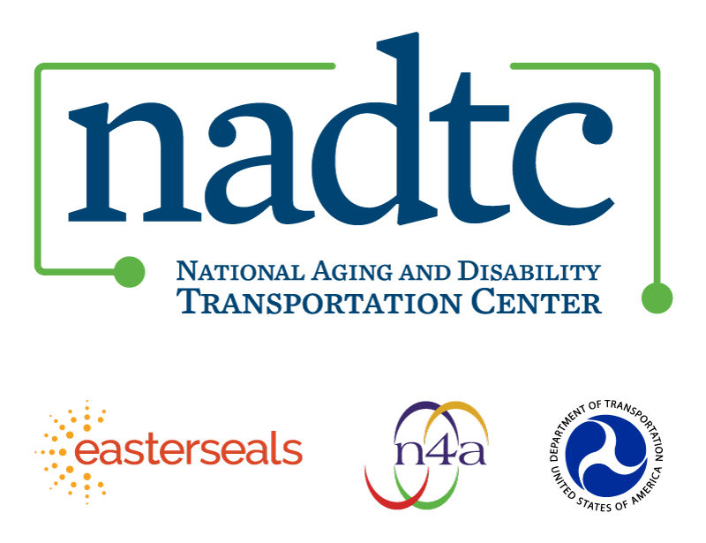

The National Aging and Disability Transportation Center (NADTC) is a program funded by the Federal Transit Administration and administered by Easterseals and the National Association of Area Agencies on Aging (n4a) with guidance from the U.S. Department of Health and Human Services, Administration for Community Living.

NADTC’s mission is to increase accessible transportation options for older adults, people with disabilities, and caregivers nationwide.

National Aging and Disability Transportation Center
Washington, D.C. 20005
Telephone and toll-free hotline: (866) 983-3222
TTY: (202) 347-7385
Email: contact@nadtc.org
Website: www.nadtc.org

Follow us:
Facebook
Twitter
YouTube
LinkedIn

