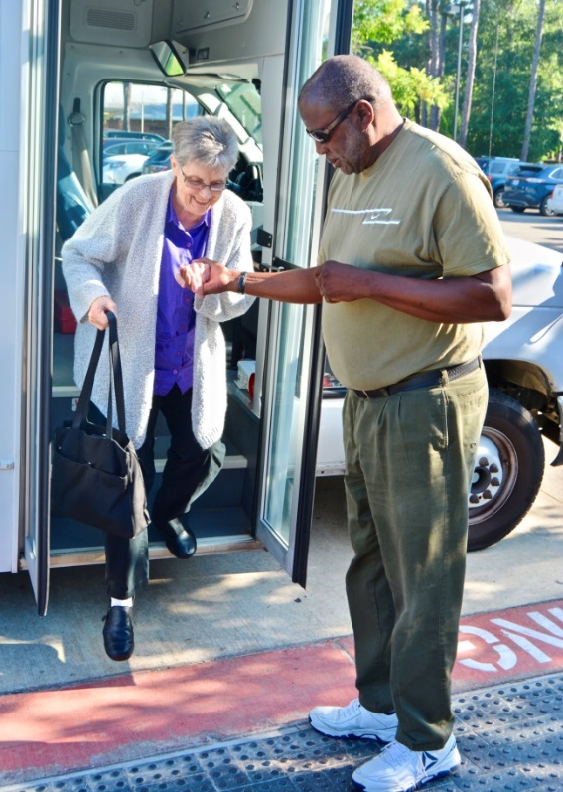
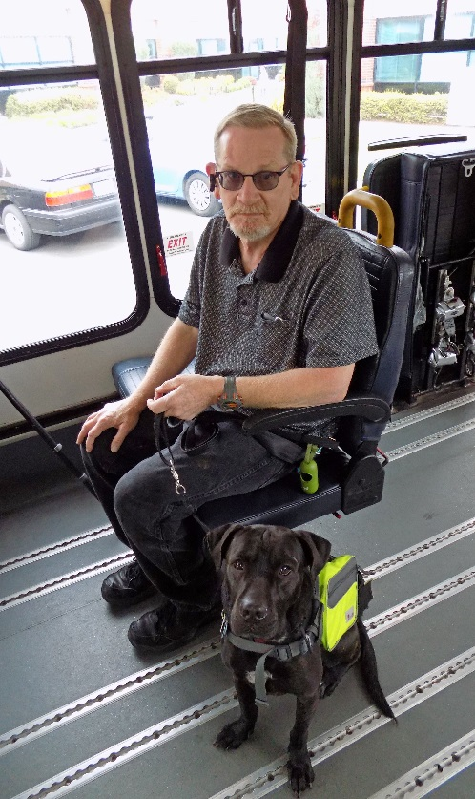
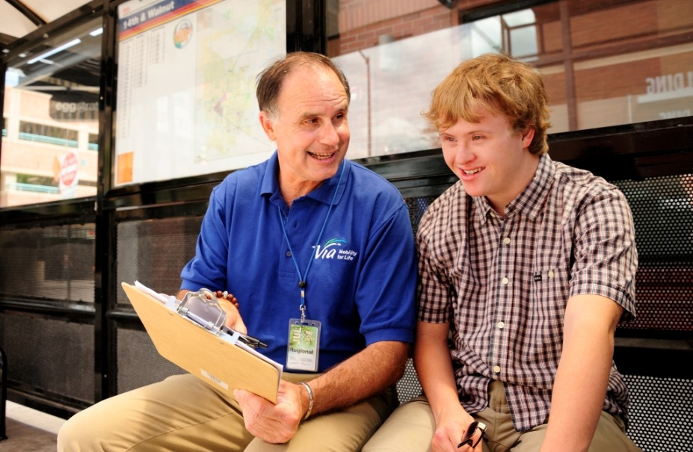
Table of Contents

1 Introduction 1-3
2 Cancer Care and Dialysis Transportation 2-5
3 Innovative Approaches to Section 5310 Funding Match 3-10
4 Non-Emergency Medical Transportation Brokerages and Benefits of Coordination 4-19
5 Opioid Use and Transportation 5-25
6 Volunteer Transportation Programs 6-37

Cover Photo Credits:
Top: Via Mobility Services, Boulder, Colorado
Bottom left: Meals on Wheels Montgomery County, Conroe, Texas
Bottom right: Human Services Council, Southwest Washington, Vancouver, Washington
Section 3 Photo Credits:
Paris Metro, Texas
All Points Transit, Colorado
Section 4 Photo Credits:
Senior Transportation Connection, Cleveland, Ohio
Kewaunee County Services, Kewaunee, Wisconsin

Bottom right:

Introduction

Initiated in 2016, NADTC’s annual Trends Report explores trending topics in transportation from the last one to two years with a focus on accessible transportation services used by older adults and people with disabilities. The full report is supplemented by Topic Spotlights for those who would like to download just one section of the report. Each section of the report includes case studies on how changes in transportation are being implemented in states and communities in the U.S.
With its mission to increase the availability and accessibility of transportation for older adults and people with disabilities, the National Aging and Disability Transportation Center (NADTC) recognizes that our work must be grounded in, and respond to, the needs and preferences of the communities and organizations that the center was created to serve. Critical to the center’s success is access to information about local communities’ efforts to develop, fund, and operate accessible transportation, how those developments are received by people with disabilities and older adults, and the reactions of leaders in accessible transportation to developments in the transportation field.
2018’s information briefs address:
- Cancer Care and Dialysis Transportation
- Innovative Approaches to Section 5310 Match
- Non-Emergency Medical Brokerages and Coordination
- Opioid Use and Transportation
- Volunteer Transportation Programs
There is a continually growing awareness of the transportation needs of older adults and people with disabilities who are receiving medical care for chronic conditions. This topic, and local approaches to address the issue, are covered in the section on Cancer Care and Dialysis. Local funding match is necessary to implement federally funded transit, and the report on Section 5310 match looks at practices that communities in Colorado and Texas are using to support transportation funding.
As a Medicaid benefit, non-emergency medical transportation provision varies state-to-state depending on each state’s model coordination practices. The NEMT brief looks at examples from Massachusetts, North Carolina, Oregon, and Texas. Opioid use and addiction have reached crisis proportions in the U.S. in recent years. Transportation to treatment is an eligible activity under federal funding programs, and communities across the country are making a concerted effort to involve transportation providers in recognizing opioid abuse and providing support to those addressing addiction. Volunteer transportation, a viable alternative for older adults and people with disabilities, is explored as NADTC looks at the funding, community support and collaboration, and measurement structures of programs in Colorado, California, Virginia, and Tennessee.
Explore transportation’s trending news with us through this report! If you have questions about any topic here or have a story to share from your community, reach out to us at (866) 983-3222 or email contact@nadtc.org.

Cancer Care and Dialysis Transportation

Introduction
Approximately 3.6 million Americans miss or delay non-emergency medical care each year because of transportation barriers, according to the National Academy of Sciences. Transportation is a critical issue for individuals living with chronic conditions, such as cancer and kidney disease, who need frequent or ongoing medical treatment. Chan, et al. (2014) reported that patients with private transportation have significantly better adherence to medical treatment than patients who rely on public transportation or reside in rural areas that have limited transportation options. Dialysis patients are usually responsible for their own transportation, whereas cancer patients usually have more options.
Challenges and Opportunities
When people with chronic conditions miss medical appointments due to lack of transportation, the result can be an increase in healthcare costs. Transportation challenges can also mean limited pharmacy access with a corresponding decrease in medication compliance. The results of a study show patients who experience barriers to transportation often seek treatment in emergency rooms or delay treatment altogether (MacLeod, Ragland, Prohaska, Smith, Irmiter & Satariano, 2014). According to a report from the National Institutes of Health, an estimated 13-14% of cancer patients experience transportation problems related to obtaining care. Increasingly, hospitals and health care facilities are beginning to understand that accessibility to transportation is vital to patients receiving appropriate care.
There are several factors that increase the barrier to transportation for patients:
- Difficulty navigating the transit system
- Financing to pay for transportation
- Retaining qualified volunteer drivers
- Transportation availability at the time of scheduled appointments
- Travel distance to appointment
- Transportation options for multiple appointments

Creative strategies are being implemented in some communities to increase patient access to care. Healthcare organizations may partner with ride-share programs to assist patients with transportation to their medical appointments. Communities may also develop volunteer transportation programs to provide medical transportation.

Local Programs

The cancer care and dialysis transportation programs of Mountain Empire Older Citizens in Virginia, ChemoCars in North Carolina and Texas, Ride Health in Pennsylvania, Ride Connection in Oregon, and Cancer Justice Network in Ohio are featured below.

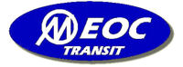
Mountain Empire Older Citizens (MEOC) Transit in Big Stone Gap, Virginia, provides Dial-a-Ride public transportation service to people of all ages with 24-hour notice. To arrange a ride, older adults and people with disabilities call a central phone number. In 2017, MEOC expanded their service to focus specifically on the needs of persons with chronic care needs, including individuals receiving dialysis or cancer treatment. Riders with chronic care needs are connected to a Care Coordinator who helps them arrange transportation and discusses any other needs they may have. If the patient needs someone to ride with them and does not have a family member or friend who can help, a paid or volunteer Transportation Aid can provide assistance getting on and off the vehicle and any additional help that may be needed during the ride. MEOC is funded through federal and state grants. Additional funding is received from corporate and individual donations and through fundraising efforts.
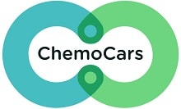
ChemoCars 501(c)3 was launched in March 2017 in Charlotte, North Carolina, and Amarillo, Texas, by Zach Bolster. ChemoCars was born out of Zach’s personal experience when his mom was diagnosed with cancer. During her treatments, he started to realize how many patients were driving themselves to treatment or were unable to get treatment because of the lack of transportation options. ChemoCars provides free round-trip rides to patients receiving chemotherapy, radiation, and non-surgical treatments at verified treatment centers. ChemoCars will arrange a ride with Lyft or Uber and the ride sharing company is paid directly by ChemoCars. First time riders register over the phone and after registration, rides can be booked via phone or online. In 2017, ChemoCars provided 2,240 successful rides.

Penn Medicine's Abramson Cancer Center launched Ride Health in 2017, a pilot program that works with Uber and Lyft in Philadelphia, Pennsylvania, to offer round-trip transportation to patients who lack other means of getting to appointments for treatments like chemotherapy. The rides are free for patients. Penn Medicine pays for the rides with funds that would typically go to taxi vouchers. A Care Coordinator at the cancer center can arrange a ride for same-day appointments or months in advance on a web-based platform. Based on the patient profile in the system, Ride Health uses SMS text messages and automated landline calls to share updates with patients, caregivers and/or clinical contacts before, during and after each ride. Healthcare providers and health plans across the United States can arrange transportation through Ride Health for low-income, elderly, and disabled patients who face transportation barriers to care.
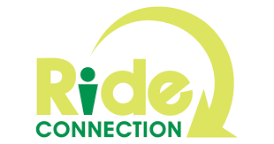
Ride Connection is a door-to-door non-profit organization based in Portland, Oregon, that has been linking people to transportation in their community for over 25 years. Individuals request a ride either by phone or through an online application, and transportation is provided at no charge. Ride Connection and its partner agencies provide rides for any purpose including medical, meals, shopping, recreation, and volunteering or work. Currently, Ride Connection provides door-to-door services for older adults (60+) and people with disabilities. Among Ride Connection’s special services are a Medical Shuttle Pilot Program that provides rides to individuals traveling to and from Providence Medical Center in Northeast Portland, and Dialysis Transportation, which uses a combination of volunteer and paid drivers to provide rides for individuals who need frequent dialysis treatments.
Cancer Justice Network - Navigators
Based in Cincinnati, Ohio, the Cancer Justice Network (CJN) helps low income individuals and minorities gain access to early screenings for cancer and treatment. This program uses “Navigators” who are trained guides working to help individuals overcome barriers to care. In New York, Philadelphia, Memphis, Denver, and many other cities, Navigators were able to improve life for cancer patients. The Navigators work with individuals in churches, community centers, schools, and neighborhood associations to assist with transportation and accompany patients to medical appointments. CJN is currently developing a transportation system for transporting cancer patients to and from medical appointments.
Funding

Programs providing non-emergency medical transportation services are funded in a variety of ways, including federal, state or local government funds, fundraising, donations, foundation and corporate support. The five programs discussed above are funded as follows.

- Started in 1974, Mountain Empire Older Citizens transportation services was funded through the Older Americans Act (OAA). Over the years, MEOC has received funding assistance through federal, state, and local government funds. In 2017, MEOC was awarded the Innovations in Accessible Mobility grant from the National Aging and Disability Transportation Center (NADTC). Other funding for MEOC comes from fundraising and donations.
- ChemoCars receives support through charitable donations from private donors.
- Through donations (corporate and individual) and fundraising, Penn Medicine's Abramson Cancer Center can provide free rides to patients.
- To support their transportation program, Ride Connection has received funding from Federal Transit Administration (FTA) Section 5310 and state grants. Additional funding is received from private foundation grants and both corporate and individual donations.
- The Cancer Justice Network (CJN) provides services to their community through donations and support from local hospitals, faith-based and corporate organizations. In fiscal year 2017, CJN received funding through the National Aging and Disability Transportation Center (NADTC) Innovations in Accessible Mobility grant.

Conclusion
Having a chronic condition is a difficult lifestyle change, but with proper care and available and accessible transportation options, patients can stabilize their health. Coordination with the community, patients, and their families is necessary for improving access to transportation for frequent medical appointments.

Resources
Chan, K., Thadhani, R., & Maddux, F. (2014). Adherence Barriers to Chronic Dialysis in the United States. Journal of American Society of Nephrology. Retrieved from: https://www.ncbi.nlm.nih.gov/pmc/articles/PMC4214530/
When Do I Need Dialysis?
https://www.webmd.com/a-to-z-guides/kidney-dialysis#1

Sunderland, S. (2018). Why is Cancer Mortality So High in Cincinnati Minorities and People of Low Income: Part 10: Imagining a Welcoming Health Care Story for All. 2018.

Hughes-Cromwich P., Wallace R. (2006). Cost benefit analysis of providing non-emergency medical transportation. http://www.trb.org/main/blurbs/156625.aspx

Zullig, L., Jackson, G., Provenzale, D., Griffin, J., Phelan, S., & van Ryn, M. (2011). Transportation – A Vehicle or Roadblock to Cancer Care for VA Colorectal Cancer Patients?
Retrieved from: https://www.ncbi.nlm.nih.gov/pmc/articles/PMC3274660/

MacLeod, K., Ragland, D., Prohaska, T., Smith, M., Irmiter, C., & Satariano, W. (2014). Missed or Delayed Medical Care Appointments by Older Users of Nonemergency Medical Transportation. The Gerontologist.
Retrieved from: https://www.ncbi.nlm.nih.gov/pmc/articles/PMC4668763/#CIT0014

Guidry, JJ., Aday, LA., Zhang, D., & Winn, RJ. (1997). Transportation as a barrier to cancer treatment. Cancer Practice. Retrieved from: https://www.ncbi.nlm.nih.gov/pubmed/9397704

Innovative Approaches to Section 5310 Funding Match

Introduction
Local match requirements for U.S. Department of Transportation grant programs vary by program and the level of state funding available for transit services for older adults and people with disabilities. With pressures to meet demand for rides among a growing senior population along with services for people with disabilities both in urban and rural areas, many cities, counties, and regional agencies are taking a coordinated approach to providing the match needed to successfully fund transit services under the Federal Transit Administration (FTA) Section 5310 program.
Overview of Section 5310 Funding Requirement
FTA’s Enhanced Mobility of Seniors and Individuals with Disabilities Program (Section 5310) is designated to “improve mobility for seniors and individuals by removing barriers to transportation service and expanding transportation mobility options” (FTA, 2018). Section 5310 funding is provided to large urban, small urban, and rural areas, with urban areas receiving 60% of the Section 5310 funding apportioned to a state. Small urban areas receive 20% of the funding, and rural areas receive 20% of the funding. States are allowed to transfer small urban and rural allocations to large urbanized areas but not the other way around.
Additional details about Section 5310 funding from the FTA Circular C 9070.1G:
Direct recipients of funding include:
- States for rural and small urban areas.
- Designated recipients chosen by the governor or a state for large urban areas.
- State or local government entities that operate a public transportation service.
Funding eligibility requirements:
- At least 55% of funds must be used on:
  - Capital projects such as buses and vans; wheelchair lifts; securement devices; transit-related information; technology systems; and mobility management programs.
  - Acquisition of transportation services under a contract, lease or other arrangement. Per the FTA Section 5310 Circular, “both capital and operating costs associated with contracted service are eligible capital expenses.”
- The remaining 45% of funds is for “nontraditional projects.” Beginning with the Moving Ahead for Progress in the 21st Century Act (MAP-21) in 2012, the Section 5310 program was changed to include projects that had been eligible under the former Section 5317 New Freedom program that funded transportation services and alternatives beyond those required by the Americans with Disabilities Act.
The types of projects eligible under this expansion include, but are not limited to, travel training; volunteer driver programs; accessible infrastructure projects (curb ramps, sidewalks, signals, and bus stop features); and mobility management. Additional project ideas are included in the Section 5310 Circular.
Other key information about the Section 5310 program that recipients should know:
- Other federal funds (non-DOT) can be used as match. This means that a program can implement a project with 100% federal funding. An example would be Older Americans Act Title IIIB funding.
- Section 5310 programs may partner with meal delivery programs such as OAA--funded meal programs and the USDA Summer Food Service program. Eldercare Locator is a resource for finding local meal programs. As stated in Chapter 53 of Title 49 of the U.S. Code, transit providers funded by Section 5310 or Section 5311 (c) grants can assist with these programs if they do not conflict with regularly provided transit service. [Some state DOTs may place a percentage cap on the total incidental use of the vehicle. Refer to your state DOT’s Section 5310 instructions for additional information.]
- Transportation to drug treatment centers is eligible transportation under Section 5310.
Local Match
Local share of capital projects “shall not be less than 20% of the net cost of the activity” and local share for eligible operating costs “shall not be less than 50% of the net operating costs” (FTA Circular 9070.1G, p. III-16). Exceptions to these percentages exist for ADA-compliant vehicle purchases, clean-fuel or alternative-fuel vehicles, and in some cases where Federal Highway Administration funds are transferred to the FTA program. In terms of how the FTA stipulates how match can be provided, local share can be undistributed cash, a replacement or depreciation cash fund or reserve, a service agreement with a state or local agency or private social service organization, or new capital.
Specific examples of these types of allowable monetary match include:
- State or local appropriations
- Dedicated tax revenues
- Private donations
- Revenue from service contracts
- Transportation development credits
- Net income from advertising and concessions
Income from contracts to provide human services transportation may be used to provide local match and, if used, must be counted in the total project cost.
No FTA program funds can be used as local match for other FTA programs; however, as noted earlier, Federal Lands Highway program funds or other non-U.S. DOT federal funds can be used as local match. Other federal agency programs commonly tapped for match funding are employment, training, aging, medical, community services, and rehabilitation services.
Non-Cash Project Contributions
Specific examples of non-cash share include:
- Donations (e.g. vehicles, property)
- Volunteer services
- In-kind contributions
In the case of non-cash contributions, each must be documented and supported. States may be more restrictive than the FTA. In-kind match requests must be approved in advance.
State Administration and Guidelines for Section 5310 Project Match
The state DOTs, as direct recipients of Section 5310 funds, develop guidelines and processes for potential applicants. Within those guidelines, the states explain the requirements for match and the documentation that needs to take place for categories of funds to be used for local match. The language contained in state Section 5310 application guidance naturally follows the requirements set forth by the FTA.
Example of State Guidelines for Local Match
The use of non-U.S. DOT federal funds for match is relatively new, and with limited federal funds available for competing projects, the majority of match applied to Section 5310 projects continues to be drawn from local sources. The ability to use non-U.S. DOT federal funds as local match was initiated under SAFETEA-LU in 2005 when non-DOT match funds were approved for Section 5310, Section 5311, and for former Section 5316 (JARC), and former Section 5317 (New Freedom) programs. Under MAP-21, some Section 5316 and 5317 eligible activities were melded into the expanded Section 5310 program, and the non-DOT match allowance expanded to include the Section 5307 program (Blog, www.nadtc.org). Local match is typically resourced from state or city/county/town-level funding sources.
Match guidelines may differ state to state. To share an example, NADTC reviewed the Wisconsin Department of Transportation’s application process. For capital projects, the Wisconsin DOT requires a cash match from one of the following sources: state or local funds, private donations, grantee agency funding, and non-U.S. DOT federal funds.
Examples of non-traditional project matching funds that can be used in Wisconsin include cash match of state or local funding, private donations, grantee agency funding, and non-U.S. DOT federal funds, and in-kind funding. Examples of in-kind match for Section 5310 can include donated facility space or supplies, labor contributed to the project, and miscellaneous expenses such as website hosting, marketing costs, or travel and mileage.
Expansion of Local Match Sources
The guidelines that Wisconsin provides may differ slightly from other states, but across the country, state DOTs provide similar guidance to Section 5310 applicants. Within the type of match allowed, transportation agencies have expanded the variety of sources from which they draw local match funds. For example, Texas and other states have used or are currently using toll credits or Transportation Development Credits. According to a Texas A&M Transportation Institute memorandum (Geiselbrecht & Baker, 2013), the credits reduce the amount of funding a state or local agency must provide for projects, allowing many programs to be funded with 100% federal funds. In Texas’ case, 75% of credits are allocated to the metropolitan planning organization of the region where the funds are generated, and 25% is allocated on a competitive statewide basis. Credits may be used for public transit funding although use of the credits for transit is less common than for highway project match.
In Texas, toll or transportation development credits are a form of “soft” match, rather than “hard” match of actual money, and toll credits are used in state projects to meet non-federal match requirements tied to capital purchases such as vehicle purchases and transit facilities. While Transportation Development Credits can be used for operating costs, in Texas they are most often applied to capital costs (Geiselbrecht & Baker, 2013).
Other states that have piloted or used toll credits or Transportation Development Credits include California, Florida, Illinois, Michigan, New Jersey, and Virginia. To take a closer look at how states are providing local match for Section 5310 transit programs, NADTC sent an email questionnaire to the state department of transportation public transportation offices. Based on responses to that survey and a review of recent transportation funding initiatives, NADTC will focus on a few local match initiatives in Texas and Colorado.

Building Partnerships to Establish Local Match in Texas
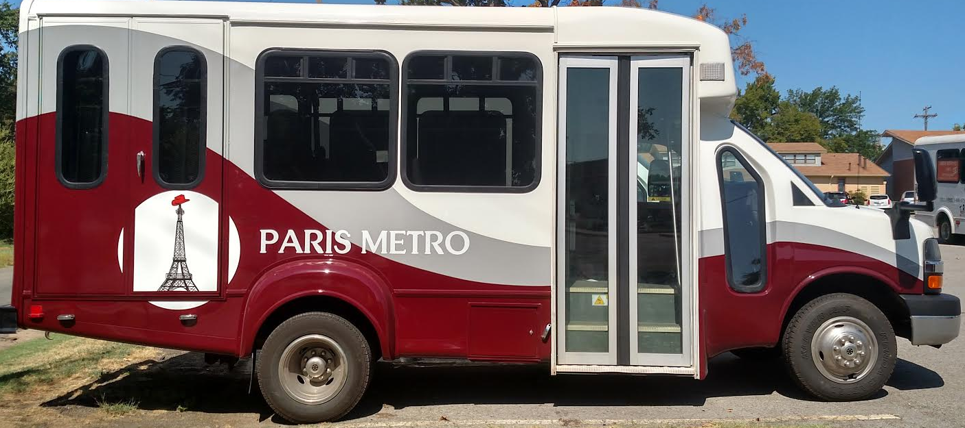
As noted, Texas uses Transportation Development credits as a form of soft match for capital investments. In the case of Paris, Texas’ Metro system, operation match has been funded through a cooperative effort. The Ark-Tex Council of Governments offered rural service in its region but wanted to improve service in Paris, Texas, to meet demand for local transit needs. Working in partnership with private agencies identified in the coordinated human services transportation plan, Paris Metro met with key stakeholders and in working with the City of Paris, was able to secure engineering, sign construction, sign installation, benches, and shelters through in-kind services.
Due to the level of operations expenses needed, Paris Metro established a sponsorship/partnership program. As a result, Paris received in-kind office space from the Paris Regional Medical Center, the City of Paris, the United Way, Paris Junior College, Texas Oncology, the Results Company, the RAM Foundation, and St. Joseph’s Foundation. Community service workers took responsibility for cleaning the new Paris Metro office.
Innovative Match Resources in Colorado
Douglas County
Douglas County, Colorado, is geographically located between Denver and Colorado Springs. In 2001, Douglas and Arapahoe counties approved a tax to fund programs serving people with disabilities. The Disabilities Mill Levy assesses a 1 mill tax on all homes in the two counties. According to a Denver Post article, approximately 95% of the funds support Developmental Pathways, a multi-jurisdictional, community-centered group, and 5% of the funds are retained for the Douglas County Developmental Disabilities Grant Program. Approximately half of the funding for third party trips in Douglas County has been provided by Developmental Pathways, and $50,000 has been provided by the mill levy funds (Mitchell, 2017). As a note, Developmental Pathways funding is also used as cash match by the Denver Regional Mobility & Access Council.
City of Durango
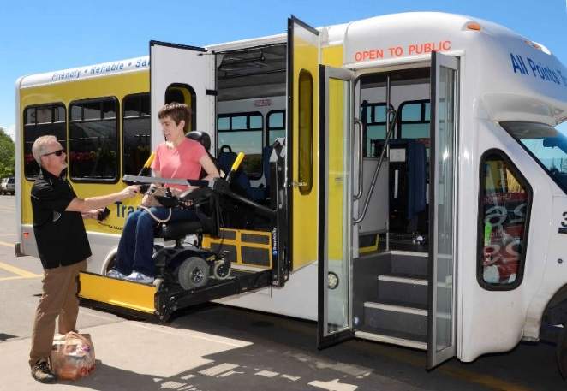
The City of Durango’s Transportation Services Enterprise Fund uses parking meter revenue and fines and a portion of the lodgers’ 2% tax to support public transit. In 2016, the City of Durango increased its parking and meter fines to help fund the city’s transit system. Expired meter fines increased by $13 per penalty (Shinn, 2016). A variety of tax increases were considered by the City Council in 2017, and state funding decreases in 2018 resulted in the decision to eliminate two transit routes. If the city were to raise fares to maintain its routes, fares would likely need to increase from $1 to $5 per ride according to a recent Durango Herald article (Shinn, 2018). Municipalities considering using fines or ticket fees for transportation revenue or match similar to the Durango model should take into consideration that increasing fines may result in fewer violations, which is a positive; however, it may ultimately result in lower revenue for transportation.
All Points Transit
Serving the region between Grand Junction and Montrose, All Points Transit receives match through foundation support, non-profit organizations, and local governments including two cities, three counties, and six towns. All Points has experienced an increase in demand, specifically for medical-related trips. In 2015, Delta County and its municipalities were funding 40% of the cost of rides (Sunderland, 2015). Donations and fundraising also cover a portion of local match, including funds raised through an annual Montrose Oktoberfest.
Mesa County
Grand Valley Transit in Mesa County uses an intergovernmental agreement to fund transit service. According to a September 2018 Daily Sentinel article on bus system funding, local governments support Grand Valley Transit through a percentage formula (Hamilton, 2018). In 2019, it is budgeted that Mesa County pays 65% of the costs, City of Grand Junction pays 30%, the City of Fruita pays 3%, and Town of Palisade pitches in 2%. The language of the intergovernmental agreement notes that the Grand Valley Regional Transportation Committee acknowledges that local match funding and the percentages agreed to for 2019 are not permanent funding, and the funding formula and match commitments are subject to future changes.
Summary
Local match initiatives in Texas and Colorado are just a few examples of the types of agreements, partnerships, and policies being implemented in states across the nation. Coordination and agreement that the services funded are beneficial to all participating constituencies is critical when multiple jurisdictions are involved. In the Texas example, the ability to communicate a shared vision was important for bringing new partners on board, and in the case of agencies offering in-kind services, identifying how transportation ties to the non-transportation entity (e.g., healthcare facility) will help solidify the role that accessible transit plays in a community’s health and well-being.
The examples from Colorado indicate that local match models vary and are often based on opportunities unique to a region or state such as foundation support, taxes, or fundraising. Before implementing a match model, a community needs to consider the short-term and long-term budgetary impacts. No matter how a transportation system decides to fund local match for federal grants, the partnerships created through coordination can lead to long-term benefits for not only transportation but other community services as well.
References and Resources
Federal
U.S. Department of Transportation, Federal Transit Administration. Enhanced Mobility of Seniors & Individuals with Disabilities - Section 5310. (2018). Retrieved from https://www.transit.dot.gov/funding/grants/enhanced-mobility-seniors-individuals-disabilities-section-5310
U.S. Department of Transportation, Federal Transit Administration. FTA Section 5310 Circular 9070.1G Enhanced Mobility of Seniors and Individuals with Disabilities Program Guidance and Application Instructions. (2014). Retrieved from https://www.transit.dot.gov/sites/fta.dot.gov/files/docs/C9070_1G_FINAL_circular_4-20-15%281%29.pdf
U.S. Department of Transportation, Federal Highway Administration. (2015, November 20). Special Federal Aid Funding. Retrieved from https://www.fhwa.dot.gov/specialfunding/151120.cfm
U.S. Department of Transportation. (2015, December 1). Chapter 53 of title 49, United States Code, as amended by Fixing America’s Surface Transportation Act Related FAST and MAP-21 provisions. Retrieved from https://www.transit.dot.gov/sites/fta.dot.gov/files/docs/Chapter%2053%20as%20amended%20by%20the%20FAST%20Act_1.pdf
National Aging and Disability Transportation Center. (2017, March 31). Section 5307, 5310, and 5311: Using Non-DOT Federal Funds for Local Match [Web log post]. Retrieved https://www.nadtc.org/news/blog/section-5307-5310-and-5311-using-non-dot-funds-for-local-match/

Wisconsin
Wisconsin Department of Transportation. (2018). Section 5310 Application Guidelines for Vehicle Capital. Retrieved from https://wisconsindot.gov/Documents/doing-bus/local-gov/astnce-pgms/transit/5310-app-trad.pdf
Wisconsin Department of Transportation. (2018). Section 5310 Application Guidelines for Non-Traditional Projects. Retrieved from https://wisconsindot.gov/Documents/doing-bus/local-gov/astnce-pgms/transit/5310-app-non.pdf
Texas
Geiselbrecht, T. & Baker, R.T. (2013, October 30). The Use of Federal Toll Credits and Transportation Development Credits by States and Regional Planning Entities [Memorandum]. College Station, TX: Texas A&M Transportation Institute. Retrieved from http://ftp.dot.state.tx.us/pub/txdot-info/lgp/tech-memo-transportation-development-credits.pdf
Rall, C. Transportation for America. (2018). The Paris Metro in small-town Texas [Web log post.] Retrieved from http://t4america.org/2018/08/16/the-paris-metro-in-small-town-texas/
Colorado
Mitchell, M. (2017, September 19). These services for developmentally disabled residents have grown because Douglas and Arapahoe voters approved a tax in 2001. The Denver Post. Retrieved from https://www.denverpost.com/2017/09/19/developmental-disabilities-mill-levy-tax-douglas-arapahoe/
Shinn, M. (2016, December 18). Increase in parking fines will help pay for transit. The Durango Herald. Retrieved from https://durangoherald.com/articles/122479
Shinn, M. (2017, March 14). City of Durango facing 5 years of transit budget shortfalls. The Durango Herald. Retrieved from https://durangoherald.com/articles/143003
Shinn, M. (2018, May 18). Durango Transit leaves some neighborhoods unserved. The Durango Herald. Retrieved from https://durangoherald.com/articles/224355
Shinn, M. (2018, April 11). Durango Transit tightens its belt. The Durango Herald. Retrieved from https://durangoherald.com/articles/217993
Sunderland, P. (2015, October 28). All Points Transit expands services. Delta County Independent. Retrieved from https://www.deltacountyindependent.com/all-points-transit-expands-services-cms-1164
Hamilton, A. (2018, September 17). Bus system seeks boost in funding. The Daily Sentinel. Retrieved from https://www.gjsentinel.com/news/western_colorado/bus-system-seeks-boost-in-funding/article_6de5ebc2-ba3b-11e8-a901-10604b9f6eda.html
Photo credits:
Paris Metro, Texas
All Points Transit, Colorado
State DOT Survey on Section 5310 Funding Practices
(The following email survey was sent to all state DOT public transit offices on November 2, 2018.)
Dear State Public Transportation Directors and Program Managers,
The National Aging and Disability Transportation Center (NADTC), the Federal Transit Administration’s technical assistance center that focuses on transportation mobility for older adults and people with disabilities, is preparing an information brief that will highlight innovations in Section 5310 match funding. If you have an example in your state that you’re open to having featured in the brief, we’d like to hear from you!
Do you have:
- Recipient(s) in your state that has approached Section 5310 match through an innovative solution (or solution that is being newly tried), combination of funds, or is using non-DOT federal funds for match?

- Or do you have a tribal transportation provider in your state who’s applied for Section 5310 funding?
If yes to either or both, we’re looking for a very short description of the type of match (e.g., pooled funds, non-DOT federal, tax revenue, in-kind) and type of agencies or partners involved in funding the match.

Non-Emergency Medical Transportation Brokerages and Benefits of Coordination

Introduction
This trends report is based on information from a review of Transit Cooperative Research Program (TCRP) Research Report 202: Handbook for Examining the Effects of Non-Emergency Medical Transportation Brokerages on Transportation Coordination and companion document, State-by-State Profiles for Examining the Effects of Non-Emergency Medical Transportation Brokerages on Transportation Coordination.
Medicaid is a state and federal program that delivers health care coverage for people of low income or people with disabilities. Each state sets its own guidelines regarding eligibility and the level of services provided. Non-emergency medical transportation (NEMT) is a vital Medicaid benefit providing rides so that people can receive medical care. Medicaid pays for transportation services to a Medicaid-approved appointment for an eligible rider and determines what type of transportation is appropriate for their appointment. The type of transportation can range from door-to-door taxicab services, public transportation, human service agency trips, and wheelchair accessible vans. NEMT is the largest single program activity that provides federal money for human service transportation. NEMT may have limitations due to brokerage contracts that limit service area or the amount of service that can be provided. In many state Medicaid transportation plans, transportation outside of a county is considered non-local transportation and requires additional approval from that state’s Medicaid agency. Often, there is an additional administrative requirement for NEMT long distance trips to specialists at regional medical centers or when no local provider is available.
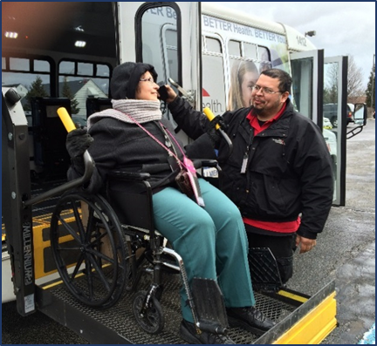
NEMT Models
Some states use an in-house management model where the state Medicaid agency oversees the booking of NEMT trips with local transportation providers. Often, these states define local service boundaries by counties or regions, and book trips with local transit providers, for-profit companies, and human service organizations.
Many states are creating a statewide or regional brokerage to provide NEMT service. Federal requirements provide an incentive to states to create brokerages since a higher federal match rate is available when brokerages are used. The brokerage models provide cost savings and reduce administrative burdens to the states. It is important to note that NEMT reimbursement varies by state. For example, in Alaska, the majority of NEMT spending is for air transportation due to travel needs of people living in remote villages or on islands.
Managed care organizations may hold Medicaid contracts to provide health care delivery that is designed to offer cost savings, efficiency in use of services, and quality control. NEMT transportation is often integrated into these managed care contracts.
Finally, transportation network companies (TNC) modes are a prospective option for NEMT, as ride hailing is available in urban areas throughout much of the country. In some states, NEMT brokers are working with TNCs to provide trips for riders for whom it is appropriate.
Coordination Requirements
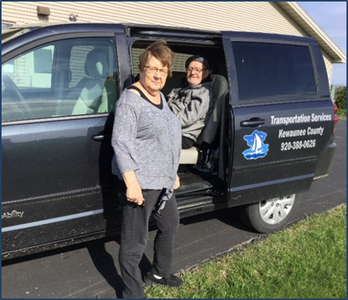
There are existing requirements for coordination of human service transportation. The Coordinating Council on Access and Mobility (CCAM), as established by Executive Order 13330, promotes activities to coordinate the efforts of 80 federal agencies that fund transportation services for older adults, people with disabilities, and individuals of low income. The goal is to improve efficiency and reduce duplication so that more transportation trips are available to these targeted populations. NEMT is a large and important transportation program to ensure that Medicaid beneficiaries get care they need, and because of this, must be part of the local transportation coordination process. Additionally, as part of the Fixing America’s Surface Transportation Act (FAST Act), transportation projects selected for funding under the Section 5310 Enhanced Mobility of Seniors & Individuals with Disabilities program must be included in a local coordinated transportation plan that is approved through a process that includes participation by older adults, individuals with disabilities, as well as representatives of public, private, and nonprofit transportation agencies and human services providers.
Human service transportation consists of options that meet the needs of older adults, people with disabilities or other disadvantaged groups such as people with lower incomes and includes door-to-door service or dial-a-ride service that is provided by an agency or contractor. Additionally, options that support transportation include funds to purchase bus passes, vouchers to pay for rides, or reimbursement to volunteer drivers or family members.
Human service providers face challenges when coordinating with NEMT such as not having the resources to purchase on-vehicle technology or software designed for ride scheduling and booking trips with other programs. State funding for human service agencies may be limited to vehicle purchases and may not include adequate amounts for technology improvements such as scheduling software. In some states with a broker model, the broker has limited incentive to coordinate with public transportation, and efforts are concentrated on booking NEMT trips with their contracted providers. Scheduling trips that meet the needs for Medicaid beneficiaries can be challenging to transportation operators when working with multiple human service providers and entities who customarily provide rides to their own program participants rather than anyone who is Medicaid-eligible.
For NEMT providers, coordinating with public transportation providers and human service agencies provides benefits and opportunities. One primary benefit is that NEMT providers meet Federal Transit Administration and state requirements for coordination that include being a part of the public transportation mix. Other benefits include reducing duplicative and redundant transportation services when trips are not coordinated. Scheduling rides with various providers that offer multiple trip types results in increased efficiency in the use of transportation resources and cost savings.
A coordination strategy for local planners and transportation entities is to collaborate with NEMT stakeholders when updating a locally developed human service transportation plan. The goal is to develop a process and plan to better coordinate NEMT trips between various human service providers and public transportation agencies. This effort can offer opportunities to work out a process to better meet the transportation needs of Medicaid beneficiaries for NEMT trips and non-medical trips alike. Using public transportation via fixed-route and demand-response modes can be suitable f or some NEMT trips and reduce the cost by using established systems. Brokers can work with public transportation ADA providers to establish a cost-effective rate to provide NEMT trips based on Medicaid payment guidelines.
Highlight: Rides to Wellness Demonstration Grants
Transportation is a key service to link people to the healthcare they need. The Federal Transit Administration (FTA) Rides to Wellness Demonstration Grants (FY 2016) funded projects that aim to help people with access to healthcare destinations. With better access to services through transportation, people will get preventive healthcare that result in improved health outcomes.

For example, the New Hampshire Department of Transportation innovation is the Bridge to Integration Project that focuses on technology improvement between Medicaid brokers and coordination software system. Innovation includes integrating Medicaid trips with non-Medicaid trips that increases coordination of transportation resources.

Likewise, the Michigan Department of Transportation project will expand a brokerage-based non-emergency medical transportation program to a statewide model for older adults, people with low incomes, and people with disabilities. Using integrated trip coordination software, health providers can refer people for transportation scheduling that better meets the needs of the rider.

Additional information on this FTA (FY 2016) grant program can be found at https://www.transit.dot.gov/funding/grants/fy-2016-rides-wellness-demonstration-and-innovative-coordinated-access-and-mobility.

For information on current FTA grant investments and grant opportunity, go to https://www.transit.dot.gov/funding/grants/grant-programs/access-and-mobility-partnership-grants

Massachusetts
This handbook contains detailed examples of how states coordinate with human service providers for their NEMT program. For example, in Massachusetts, the state Department of Health and Human Services created the Human Service Transportation (HST) Office to coordinate transportation for human service agencies, and their Medicaid program, MassHealth. Contracts are given to Regional Transit Authorities (RTAs) to provide brokerage services in nine regions of the state. This coordinated system has resulted in cost savings through shared rides among client groups, and there are incentives for brokers to keep trip expenses and overhead low.
North Carolina
For North Carolina, Medicaid transportation is provided by county departments of social services where the local departments purchase NEMT on a fee-for-service basis. Community transportation providers deliver service to all counties, although there are private operators in six counties. The program also offers reimbursements to families or friends that provide trips. Coordination occurs between public transportation and human service providers. Most trips are coordinated at the county level, but when needed for cross county rides, a regional operator sets up the trip. Additionally, North Carolina requires local and regional public transportation providers to have a Transportation Advisory Board (TAB). The TAB is established to ensure that the transportation-related needs are identified for local governments within a service area.
Oregon
The state of Oregon has a managed care model using Coordinated Care Organizations (CCOs) that contract with eleven brokers to provide NEMT. The organizations include public transit agencies, councils of governments, and private companies. Coordination occurs when brokers work with their CCOs, and trips may be provided by public transportation. In some areas, the NEMT broker no long works with the CCOs, and coordination may be a problem.
Texas
Texas has a mixed model, using for profit and non-profit brokers. NEMT is provided as a contracted fee-for-service, and Transportation Service Area Providers (TSAPs) are the lead entities. The TSAPs include rural or urban public transit districts, for-profit companies, and nonprofit human service agencies. Coordination of transportation by regional brokers is minimal, and only three percent of NEMT trips were provided by public transportation. In 2014, a managed transportation organization model was implemented in eleven regions of the state. Results of this change are not included in the handbook (TCRP Report 202).
Summary
TCRP Report 202 provides a wealth of information on NEMT programs in each state and why strategies to coordinate transportation can result in increased efficiencies in providing more trips and cost savings to the program. Strategies for coordination such as involving NEMT providers, brokers, and human service agencies in coordination plans and planning can be vitally important to reduce duplicative trips and increase service coverage. Coordination can also improve availability of long-distance and cross-jurisdiction trips with improved availability of rides. Human service transportation, public transportation, and NEMT stakeholders can work together to achieve common desired outcomes which include improved health, better quality of service, and maximized service delivery with available resources. Focus on these desired outcomes as the impetus to coordination can lead to efficiency in providing trips to NEMT beneficiaries and opportunities for more rides for a community.
References
TCRP Report 202. (Linda Cherrington, 2018). Handbook for Examining the Effects of NEMT Brokerages on Transportation Coordination. Retrieved from https://mtap.transportation.org/wp-content/uploads/sites/42/2018/11/TCRP-202-for-AASHTO-Nov-8-Final.pdf
State-by-State Profiles for Examining the Effects of Non-Emergency Medical Transportation Brokerages on Transportation Coordination, companion document to TCRP Report 202. (TCRP Project B-44, 2018).
Retrieved from http://onlinepubs.trb.org/onlinepubs/tcrp/tcrp_rpt_202_companion.pdf
TCRP Report 173. (Gail Murray, 2014). Improving Transit Integration Among Multiple Providers, Volume I: Transit Integration Manual.
Retrieved from http://www.trb.org/Publications/Blurbs/171934.aspx
National Center for Mobility Management. 2014. Promising Practices in Transportation Coordination: Enabled by Technology and Innovative Design.
Retrieved from https://nationalcenterformobilitymanagement.org/wp-content/uploads/2013/11/Promising-Practices_Transportation-Coordination-Enabled-by-Technology.pdf
National Conference of State Legislatures. 2012. Regional Human Service Transportation Coordinating Councils: Synthesis, Case Studies, and Directory. Retrieved from http://www.ncsl.org/research/transportation/regional-coordinating-councils-report.aspx

Photo credits:
Senior Transportation Connection, Cleveland, Ohio
Kewaunee County Services, Kewaunee, Wisconsin

Opioid Use and Transportation
Introduction
The opioid crisis has reached emergency response-level proportions in many parts of the United States. More than 115 people in the U.S. overdose on opioids daily, costing approximately $78.5 billion a year when considering healthcare, effects to productivity, treatment and the criminal justice proceedings involved (National Institute on Drug Abuse, 2019). As the crisis worsens, transportation agencies and programs are beginning to be brought to the table as a part of a holistic response. This report provides a current snapshot of both the state of the opioid crisis and the transportation industry’s response.
Defining Terms
Opioid misuse is defined as when a patient is not following instructions of a medical provider of the drug (NIH, MedlinePlus).
Opioid addiction occurs when a person seeks opioids even if/when taken they will cause the person harm (NIH, Medline Plus).
Opioid overdose occurs when high doses of opioids are taken causing the slowing or stopping of breathing and sometimes death (NIH, Medline Plus).

State of the Opioid Crisis

What are Opioids?

Opiates are drugs created from opium. Opioid is a term inclusive of drugs derived naturally, as well as those synthetically and semi-synthetically created. Opioids are a class of narcotic that, when taken, attach to opioid receptors in the body. Once attached to the receptor, signals to the brain are sent that block pain sensation, slow breathing, reduce anxiety, and create a calming, euphoric sensation (National Alliance of Advocates for Buprenorphine Treatment, 2008). Opioids in common use include heroin, fentanyl, oxycodone, codeine, and morphine.

How the Opioid Crisis Began

In the late 1990s, the American Pain Society began advocating that pain be seen as a measure of a person’s essential bodily function or a vital sign (Lyapustina & Caleb Alexander, 2015). Professionals in the pharmaceutical community began advocating and provided safety assurances for the increase of prescriptions of opioids for pain management. As a result, the medical community began prescribing opioids at a much higher rate (U.S. Department of Health and Human Services, 2019). From 1991 to 2009, the number of opioid prescriptions written increased by 300% (Lyapustina & Caleb Alexander, 2015).
Opioids and Addiction
Opioid Addiction Statistics
Drug overdose deaths rose from 8,048 in 1999 to 47,600 in 2017. (NIH National Institute on Drug Abuse).

Roughly 21% to 29% of patients prescribed opioids for chronic pain misuse them.

Between 8% and 12% develop an opioid use disorder.

An estimated 4% to 6% who misuse prescription opioids transition to heroin.

About 80% of people who use heroin first misused prescription opioids.

Opioid overdoses increased 30% from July 2016 through September 2017 in 52 areas in 45 states.

The Midwestern region saw opioid overdoses increase 70% from July 2016 through September 2017.

Opioid overdoses in large cities increase by 54% in 16 states (NIH, National Institute on Drug Abuse).

Source: www.drugabuse.gov

The increase in prescribing opioids for pain management occurred prior to the full understanding by the medical community of their highly addictive nature. “Our brains are wired to ensure that we will repeat life-sustaining activities by associating those activities with pleasure or reward” (National Alliance of Advocates for Buprenorphine Treatment, December 2008). Dopamine is a substance the body releases facilitating the transfer of an impulse from one nerve to another. Dopamine regulates movement, emotion, cognition, and feelings of pleasure causing a euphoric effect when released in high amounts. Opioids target this system of pleasure and reward by releasing large quantities of dopamine. This overwhelming sense of pleasure and euphoria is often sought by people that misuse drugs causing a repeat in the behavior and can then cause addiction (National Alliance for Advocates for Buprenorphine Treatment, December 2008).

Opioid Treatment Options and Availability

Treatments for opioid addiction include medications, counseling, behavioral therapy, medication-assisted therapy (MAT), and/or residential and hospital-based treatment (NIH, Medline Plus, November 2018).

There are three medications currently used to treat opioid abuse: methadone, buprenorphine, and naltrexone. Methadone and buprenorphine target the same receptors in the brain as opioids but do not create the same euphoric feeling as opioids. These drugs are used to treat withdrawal and craving symptoms, and therefore, to treat the addiction itself. Naltrexone prevents the euphoric feeling of taking opioids. Rather than treating addiction, Naltrexone is used to prevent a relapse of opioid use (NIH, Medline Plus, November 2018).

Individual counseling, including cognitive-behavioral therapy, motivational enhancement therapy, and/or contingency management, group counseling, and family counseling may be used to treat opioid abuse and addiction. Therapy attempts to change the user’s attitudes and behaviors related to taking opioids. Therapy may also assist in building and increasing healthy life skills and can assist the person in maintaining alternative treatments such as medications. Counselors also often refer patients to additional assistance including peer support groups, case management, educational supports, and organizations assisting with life needs such as housing and transportation (NIH, Medline Plus, November 2018).

Residential and hospital-based treatment options allow persons to live with, provide support to, and receive support from their peers. Intensive outpatient services may also be available. These options are generally very structured and include counseling, behavioral therapy, and medication treatments as well (NIH, Medline Plus, November 2018).

Addressing the Opioid Crisis via Public Transportation

Barriers to Receiving Opioid Treatment

In November 2017, the U.S. Commission on Combating Drug Addiction and the Opioid Crisis submitted a report to President Donald Trump detailing the state of and providing suggestions for addressing the opioid crisis. This report aligned with recommendations for addressing the crisis provided by the American College of Physicians. Both suggest the following (list taken from the American College of Physicians’ November 2017 letter):

- Taking action to end the stigma surrounding substance use disorders
- Supporting the integration of behavioral health care into primary care
- Strongly supporting parity of mental health and substance use disorders and the coverage of comprehensive evidence-based treatment of substance use disorders
- Supporting broad, unrestricted access to effective nonpharmalogic pain management services
- Recommending that public and private health insurance payers, policymakers, and primary care and behavioral health care professionals work toward removing payment barriers that impede behavioral health and primary care integration
- Lifting barriers that impede access to medications to treat opioid use disorder (methadone, buprenorphine, and naltrexone) and to medications for overdose prevention (naloxone)
- Directing states to make prescription drug monitoring programs easier to use and interoperable with electronic health records
- Supporting alternatives to incarceration, including drug courts, for those with substance use disorders particularly if they serve as a gateway to receiving medication-assisted treatment (American College of Physicians, 2017) (The White House, 2017).

Arguments can be made that increased access to public transportation services would support each of the recommendations above. The report to the president explains that, when and where treatment facilities were available, access to medical services, especially in rural areas, was made difficult because of a reliance on friends and family for transportation to/from treatment. The report further states that “connecting treatment to social supports, such as stable housing, employment/job training, educational/vocational training, medical care, transportation, child care, etc., is also needed on an ongoing basis to help the individual be successful in their recovery and rebuild a lifestyle that is healthy and productive” (The White House, 2017). American Addiction Centers further explains that lack of transportation greatly affects those in outpatient programs needing to get to/from rehab centers on a regular basis, and that transportation in rural areas may be nonexistent or cost prohibitive for patients (American Addiction Centers, 2019).

Drug Addiction and the Americans with Disabilities Act

The Americans with Disabilities Act (ADA) is “a civil rights law which prohibits discrimination against individuals with disabilities in all areas of public life, including jobs, schools, transportation, and all public and private places that are open to the general public” (ADA National Network, 2019). “The ADA defines a person with a disability as a person who has a physical or mental impairment that substantially limits one or more major life activity. This includes people who have a record of such an impairment, even if they do not currently have a disability. It also includes individuals who do not have a disability but are regarded as having a disability (ADA National Network, 2019).”

Drug addiction is covered as a disability under the ADA as a physical impairment (U.S. Department of Justice). This allows a person whose addiction to drugs substantially limits one or more of his or her major life activities access to transportation to drug treatment centers from agencies operating Section 5310 (and other) federally funded programs. While persons experiencing drug addiction are protected by the ADA, transportation agencies and other public entities may withhold services or benefits if a patron or passenger is currently engaged in the illegal use of drugs (U.S. Department of Justice). For more information on ADA requirements for public and private transportation, please see the U.S. Department of Transportation, Federal Transit Administration Americans with Disabilities Act Guidance Circular, FTA C 4710.1 (U.S. Department of Transportation, Federal Transit Administration, 2015).
As a result of the Federal Transit Administration’s adoption of the definition of disability from the Americans with Disabilities Act, utilizing 5310 funded vehicles for the transportation of persons to rehabilitation treatment center is allowed. This is explained in more detail on the FTA frequently asked questions in the eligible activities section.

Question: May vehicles and equipment funded through the Section 5310 program be used to provide service to a drug rehabilitation treatment center?
Answer: Yes, when the passengers are individuals with disabilities and the service is part of the coordinated plan. For purposes of the section 5310 program, FTA has adopted the definition of “disability” as that found in section 3(1) of the Americans with Disabilities Act (42 U.S.C. 12102). Section 510 of the ADA (42 U.S.C. 12210) provides that the term “individual with a disability" does not include an individual who is currently engaging in the illegal use of drugs, when the covered entity acts on the basis of such use. However, a person may be considered an individual with a disability if the person has successfully completed a supervised drug rehabilitation program and is no longer engaging in the illegal use of drugs; has otherwise been rehabilitated successfully and is no longer engaging in such use; is participating in a supervised rehabilitation program and is no longer engaging in such use; or is erroneously regarded as engaging in such use, but is not engaging in such use.
In other words, an individual who is not currently using illegal drugs but who is addicted to drugs, has a history of addiction, or who is regarded as being addicted has an impairment under the ADA. In order for an individual's drug addiction to be considered a disability under the ADA, it would have to pose a substantial limitation on one or more major life activities.
A person whose addiction to drugs poses a substantial limitation on one or more major life activities is a person with a disability and is eligible to receive transportation through the Section 5310 program, including to a drug treatment center. Recipients are reminded that all Section 5310 activities must be part of a locally developed, coordinated plan (U.S. Department of Transportation, FTA FAQs #30).

Public Transportation Response to Opioid Treatment for Passengers

The current state of responding to the opioid crisis by public transportation varies greatly by community and is influenced largely by the extent of the severity of the crisis for each locality. Transportation’s role in the response is to increase and improve access to transportation to medication and other opioid treatment and to reduce reliability for transportation on friends and family of those seeking treatment.

Current Transit Programs Addressing the Epidemic

The following is a short list of programs and communities engaging transportation services specifically to address the opioid crisis. This list is by no means exhaustive as there are communities across the U.S. that have transportation services available for individuals undergoing treatment.

Flint Mass Transportation, Michigan

The Flint Mass Transportation Authority mobility management program includes coordinated non-emergency medical transportation, trip planning, and training. The program provides rides to wellness appointments for behavioral health patients, dialysis patients, and primary/urgent care for families, and elderly and elderly disabled patients in Flint and nearby Genesee County, both of which are impacted by Flint's municipal water crisis. Building on a 2015 FTA-funded Healthcare Access Mobility Design Challenge Grant, the project will improve local coordination and access in the community (U.S. Department of Transportation, FTA, FY 2016 Rides to Wellness Demonstration and Innovative Coordinated Access and Mobility Grants).

Snohomish County, Washington

Snohomish County, in western Washington State, is treating the opioid epidemic as a natural disaster. They have mobilized in much the same way as a community would for a hurricane. Snohomish has created an emergency operations center, the Multi-Agency Coordination group (MAC), where emergency management personnel meet every two weeks. Personnel include members from all parts of the local community government, including transportation. Making ease of access to transportation to drug treatment centers was addressed as a small step in the large plan, and community officials have explained to persons needing treatment that they should consider local transit services basically as their “Uber” to get to/from treatment appointments. Ease of access to transportation has helped hundreds of people to acquire drug treatment (Boiko-Weyrauch, 2018).

Rochester Regional Transit, New York

In 2017, Rochester-Genesee Regional Transportation Authority (RGRTA) began training its employees in the administration of naloxone, or Narcan, which is a drug administered in an attempt to reverse an opioid overdose. RGRTA recognizes the opioid epidemic as a community crisis. Considering the sheer numbers of people in the community traveling through the transit center, they felt it important to have their operators ready to act as first responders (Dahlberg, 2018).

Minneapolis, Minnesota

For Super Bowl weekend, several nonprofit agencies and other community organizations, including The Stefe Rummler HOPE Network and Valhalla Place, trained volunteers to ride Metro Transit prepared to administer naloxone wearing black hats reading “Got Narcan” (Prather, 2018).

Beacon Health Options, Boston, Massachusetts

Beacon Health Options has instituted several pilot and permanent programs to combat the opioid crisis. Programs include but are not limited to: reducing early discharges from treatment by using facility-led interventions; increasing patients’ adherence to treatment by ensuring care continuity through Community Support Programs (CSPs); changing the pathway to care from withdrawal management directly to Medication-Assisted Therapy (MAT) by promoting timely connections between withdrawal management and MAT; and providing outpatient withdrawal management with links to primary care for MAT treatment. Beacon Health has also “contracted with a transportation company to help members get to opioid MAT as transportation is often a barrier to engagement” (Beacon Health Options, 2019).

Idaho Department of Health and Welfare

The Idaho Department of Health and Welfare program, Idaho’s Response to the Opioid Crisis (IROC), utilizes a multi-faceted approach to fighting the opioid epidemic. Services include MAT, outpatient treatment, housing, drug testing, transportation for treatment and recover services, life skills, and recovery coaching (Idaho Department of Health and Welfare, 2019).

Rides Mass Transit District, Southern Illinois

Unlike the previous examples from other states, the Rides Mass Transit District project has a transportation focus. The project is intended to enhance access to medical and mental health services in two Southern Illinois areas through a collaboration of medical providers, education and transportation providers. RMTD will develop a Rides Plus Call Center (formerly MedTrans) in Robinson, Illinois which will be staffed with mobility professionals. They will assist healthcare facilities and patients to set up effective, customer centered transportation solutions. They will also be available to link riders to transportation for any other need.
RMTD, Southern Illinois University Center for Rural Health and Social Service Development (CRHSSD) and its collaborating partners will conduct organizational sessions throughout the project area to explain the program and possible benefits to transportation and healthcare providers. Relationships will be developed with key players from each organization to insure successful implementation and communication. This should develop a grass roots referral network that will be key to the success of the project.
Surveys of medical facilities, transportation providers and patients will be conducted at mid-project and at the end of the grant period. These surveys will provide an evaluation of the success of the program and valuable data such as increased ridership, rider options, rider perceptions, improved healthcare outcomes and reductions in cost related to both completion of treatment and re-hospitalizations. Additionally, the effort should identify all transportation resources and provide travel pattern data that should improve existing transit services.
This application DOES NOT include research and development activities.
RMTD will be utilizing $518,844 in FY 2016 5310-3 /49 USC 5310 - (FAST) Pilot Program Enhanced Mobility 16. Local Matching share of $129,960 will be provided from RMTD’s allocation of Illinois State assistance generated from tax revenue. Should any additional funding be required to complete the grant it would be provided by RMTD from local tax equivalent sources (U.S. Department of Transportation, FTA, FY 2016 Rides to Wellness Demonstration and Innovative Coordinated Access and Mobility Grants).

Bus Operators and Opioid Use

Current Drug Testing Laws

Employees that perform safety-sensitive functions for organizations receiving funding from the U.S. Department of Transportation, Federal Transit Administration (FTA) and by contractors of those organizations are subject to drug testing laws as covered in the Code of Federal Regulations 49 CFR Part 655 (U.S. Department of Transportation, Federal Transit Administration, 2014). Safety-sensitive personnel include vehicle operators, controllers, mechanics, and armed security personnel. The DOT requires urine specimen testing for marijuana metabolites/THC, cocaine metabolites, amphetamines, opiates (including codeine, heroine, and morphine), and phencyclidine. Testing should be completed at the following times: pre-employment, reasonable suspicion/cause, random, return-to-duty, follow-up, and post-accident (U.S. Department of Transportation, 2012). A minimum of 25% of safety-sensitive personnel should be randomly tested annually (U.S. Department of Transportation, 2019).
Legislation

Support for Patients and Communities Act

In October 2018, President Donald Trump signed the Support for Patients and Communities Act into law. Touted by the president as the “single largest bill to combat the drug crisis in the history of this country,” the act covers screening of transportation employees for opioid misuse, including the following (Bergeron, 2018):

- Mechanical rail employees and yardmasters must be included in the FRA’s random drug and alcohol testing program.
- The DOT must establish a public database of drug and alcohol testing results by March 31, 2019.
- Fentanyl may be included on the DOT drug testing panel.
- Hair testing & oral fluid guidelines will be an option.
- A Commercial Driver’s License drug and alcohol clearinghouse will be implemented by 2020 (Bergeron, 2018).

Summary
Communities across the country are beginning to see the need for a significant response to the opioid epidemic. Just as access to transportation affects all aspects of life, access to treatment for opioid misuse and addiction is limited for many because of the lack of availability and access to transportation options. As such, transportation agencies are becoming directly involved in comprehensive community response plans by increasing and improving access to transportation services to treatment and medical facilities and by increasing and improving transportation for all.

Recommended Resources

Centers for Disease Control and Prevention. CDC Stacks. (2018). Evidence-based strategies for preventing opioid overdose: what’s working in the United States: An introduction for public heath, law enforcement, local organizations, and others striving to serve their community. https://stacks.cdc.gov/view/cdc/59393

Pew. (2019). Opioid Use Disorder: Challenges and Opportunities in Rural Communities Fact Sheet https://www.pewtrusts.org/en/research-and-analysis/fact-sheets/2019/02/opioid-use-disorder-challenges-and-opportunities-in-rural-communities

U.S. Department of Transportation, Federal Transit Administration. Fact Sheet: Enhanced Mobility of Seniors and Individuals with Disabilities, Chapter 53 Section 5310. Retrieved from https://www.transit.dot.gov/sites/fta.dot.gov/files/docs/funding/grants/37971/5310-enhanced-mobility-seniors-and-individuals-disabilities-fact-sheet_1.pdf

Note: The Other section of the Section 5310 Fact Sheet specifies that a person whose addiction to drugs poses a substantial limitation on one or more major life activities is a person with a disability and is eligible to receive transportation through the Section 5310 program, including to a drug treatment center.

U.S. Department of Transportation, Federal Transit Administration. (2018, September 20). 2018 CCAM Meetings & Listening Session. Opioids Misuse: Increasing Access to Transportation in Rural Communities. Retrieved from https://www.transit.dot.gov/regulations-and-guidance/ccam/about/2018-ccam-meetings-listening-sessions

FTA, in collaboration with USDA Rural Development, the Substance Abuse Mental Health Services Administration (SAMHSA), and the National Rural Transit Assistance Program (RTAP) conducted a workshop at the West Virginia School of Osteopathic Medicine with stakeholders from across West Virginia to discuss increasing transportation in rural areas to improve access to treatment and services. View the livestream. | Download the handouts. |
Related USDA/DOJ videos: https://youtu.be/cg1eoG5h7nM and https://youtu.be/RlN_z3PdBpA

References

National Institute on Drug Abuse. (January 2019). Opioid Crisis. Retrieved from https://www.drugabuse.gov/drugs-abuse/opioids/opioid-overdose-crisis

National Alliance of Advocates for Buprenorphine Treatment.
(December 2008). How do opioids work in the brain? Retrieved from https://www.naabt.org/faq_answers.cfm?ID=6

Lyapustina, T. and Caleb Alexander, G. (2015). The prescription opioid addiction and abuse epidemic: how it happened and what we can do about it. The Pharmaceutical Journal, 13 June 2015, Vol 294, No 7866, online | DOI: 10.1211/PJ.2015.20068579 Retrieved from https://www.pharmaceutical-journal.com/opinion/comment/the-prescription-opioid-addiction-and-abuse-epidemic-how-it-happened-and-what-we-can-do-about-it/20068579.article?firstPass=false

U.S. Department of Health and Human Services. (January 2019). What is the U.S. Opioid Epidemic? Retrieved from https://www.hhs.gov/opioids/about-the-epidemic/index.html

National Institutes of Health. U.S. National Library of Medicine. Medline Plus. (November 2018). Opioid Abuse and Addiction Treatment. Retrieved from https://medlineplus.gov/opioidabuseandaddictiontreatment.html
National Institutes of Health. U.S. National Library of Medicine. Medline Plus. (December 2018). Opioid Overdose. Retrieved from https://medlineplus.gov/opioidoverdose.html

National Institutes of Health, National Institute on Drug Abuse. (January 2019). https://www.drugabuse.gov/related-topics/trends-statistics/overdose-death-rates

National Institutes of Health, National Institute on Drug Abuse. (November 2016). Effective Treatments for Opioid Addiction. Retrieved from https://www.drugabuse.gov/publications/effective-treatments-opioid-addiction/effective-treatments-opioid-addiction

American College of Physicians. (2017, November 22). Retrieved from https://www.acponline.org/acp_policy/letters/letter_to_president_trump_re_final_report_of_presidents_commission_on_combatting_drug_addiction_and_the_opioid_crisis_2017.pdf

The White House. (November 2017). The President’s Commission on Combating Drug Addiction and the Opioid Crisis. Retrieved from https://www.whitehouse.gov/sites/whitehouse.gov/files/images/Final_Report_Draft_11-1-2017.pdf

American Addiction Centers. (2019). Retrieved from https://americanaddictioncenters.org/rehab-guide/treatment-barriers

ADA National Network. (2019). What is the Americans with Disabilities Act (ADA)? Retrieved from https://adata.org/learn-about-ada

U.S. Department of Justice, Civil Rights Division. Americans with Disabilities Act. Title II Technical Assistance Manual Covering State and Local Government Programs and Services. Retrieved from https://www.ada.gov/taman2.html#II-2.3000

U.S. Department of Transportation, Federal Transit Administration. (November 2015). FTA C 4710.1 Americans with Disabilities Act Guidance. Retrieved from https://www.transit.dot.gov/regulations-and-guidance/fta-circulars/americans-disabilities-act-guidance-pdf

U.S. Department of Transportation, Federal Transit Administration. (n.d.) Frequently Asked Questions #30. Retrieved from https://www.transit.dot.gov/30-may-vehicles-and-equipment-funded-through-section-5310-program-be-used-provide-service-drug

U.S. Department of Transportation, Federal Transit Administration. (n.d.) FY 2016 Rides to Wellness Demonstration and Innovative Coordinated Access and Mobility Grants. Retrieved from https://www.transit.dot.gov/funding/grants/fy-2016-rides-wellness-demonstration-and-innovative-coordinated-access-and-mobility

Boyko-Weyrauch, A. (2018, October 28). Washington’s Snohomish County is treating opioid addiction like a natural disaster. Northwest Public Broadcasting. Retrieved from https://www.nwpb.org/2018/10/28/washingtons-snohomish-county-is-treating-opioid-addiction-like-a-natural-disaster/

Dahlberg, B. (2018, October 30). RTS training employees in lifesaving overdose treatment. WXXI News. Retrieved from https://www.wxxinews.org/post/rts-training-employees-lifesaving-overdose-treatment

Prather, S. (2018 February 1). Nonprofit volunteers riding Metro Transit with opioid antidote on Super Bowl weekend. Star Tribune. Retrieved from http://www.startribune.com/nonprofit-volunteers-riding-metro-transit-with-opioid-antidote-on-super-bowl-weekend/472229243/

Beacon Health Options. (2019). How Beacon is combating the opioid addiction crisis. Retrieved from https://www.beaconhealthoptions.com/combating-the-crisis-of-opioid-addiction/

Idaho Department of Health and Welfare. IROC – Idaho’s Response to the Opioid Crisis. (2019). Retrieved from https://healthandwelfare.idaho.gov/Medical/SubstanceUseDisorders/AccessIROCServices/tabid/3307/Default.aspx

Rides Mass Transit District. (2017) FY 18 5310 Program of Projects Rides to Wellness. Retrieved from http://www.ridesmtd.com/wp-content/uploads/2018/07/FY-17-5310-POP.pdf

U.S. Department of Transportation, Federal Transit Administration. Code of Federal Regulations Title 49 Subtitle B Chapter VI (49 CFR Part 655). Retrieved from https://transit-safety.fta.dot.gov/drugandalcohol/regulations/regulations/49cfr655/49cfr655.pdf

U.S. Department of Transportation, Office of the Secretary of Transportation. Office of Drug & Alcohol Policy & Compliance. (January 2012). What Employees Need to Know about DOT Drug & Alcohol Testing. Retrieved from https://www.transportation.gov/sites/dot.dev/files/docs/ODAPC%20EmployeeHandbook%20En.pdf

U.S. Department of Transportation. (2019). Current Random Testing Rates. 2019 DOT Random Testing Rates. Retrieved from https://www.transportation.gov/odapc/random-testing-rates

Bergeron, L. (2018, November 15). Opioid abuse in transportation act signed into law. Foley Services. Retrieved from https://www.foleyservices.com/news/opioid-abuse-transportation-act-signed-law/

Volunteer Transportation Programs

Introduction

The availability of accessible and affordable transportation options is a top concern for older adults, people with disabilities, and caregivers. Access to transportation is a key determinant of whether an individual can live independently, at home, and in the community. According to a 2012 AARP survey, more than 90% of older adults reported that they want to remain in their homes for as long as possible, yet this can only be possible if their transportation needs are met. Volunteer transportation programs are one solution to fill transportation gaps in communities.

What are Volunteer Transportation Programs?
Volunteer transportation programs are not a new approach to alternative transportation, but these community-based programs have recently received more recognition because of the role they play in supporting the health and well-being of older adults and people with disabilities. Volunteer transportation programs vary based on their size, scope of services offered, target population, funding and unique community needs. For many people, volunteer transportation programs are their only means of accessing medical care or grocery shopping. One of the chief attractions of this transportation option for many older adults and people with disabilities is the one-on-one service these programs provide. The key to a volunteer transportation program’s success is to customize service and delivery methods to the circumstances and needs of the community.

Volunteer Transportation: A National Perspective
The top transportation methods used by those surveyed in NADTC’s 2018 national poll were driving a vehicle (82% of older adults and 66% of younger adults with disabilities) and riding with friends or family (58% of older adults, 74% of younger adults with disabilities). While 15% of older adults and nearly one-third of younger adults with disabilities report using public transportation, riding with a volunteer, and/or using special transportation services for people with disabilities, when asked specifically about the use of volunteer transportation, only 8% of older adults and 27% of people with disabilities reported that they did. This is surprising, considering that volunteer transportation programs are often created to meet the transportation needs of these populations. Despite the relatively low utilization of volunteer transportation programs, both older adults and younger adults with disabilities expressed high interest in using these programs if they were available in their communities: 43% of older adults and 44% of younger adults with disabilities.

Volunteer Transportation: A Tale of Four Programs
NADTC’s online course on volunteer transportation, offered in the fall of 2018, provided an in-depth look at volunteer transportation programs. The course brought into focus the “5 Keys of Successful Volunteer Driver Programs,” identified in a NADTC blog of the same title and explored critical aspects of volunteer transportation programs. This report provides a brief overview of the four programs featured in the course and highlights how these programs address: 1) funding, 2) community support and collaboration, and 3) measuring and sharing impact. Additional information about these programs can be found on the NADTC website and YouTube page.

In early 2019, NADTC will release individual profiles of each of the four programs and promote further work on volunteer transportation with a focus on risk, liability and insurance in the coming year.
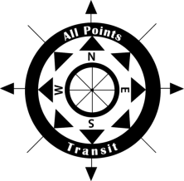
All Points Transit
All Points Transit (APT), based in Montrose, Colorado, is a non-profit transit organization that has provided transportation services for seniors, people with disabilities and others in need for more than 35 years. APT covers four counties—a nearly 4,500 square mile area of very small and rural towns. The volunteer transportation program uses volunteer drivers to provide safe and reliable door-to-door, driver-assisted transportation to medical appointments and other critical services. The mobility manager works as the volunteer transportation program coordinator and sends out requests to the volunteer pool.

APT provides a company vehicle, a Toyota Prius, which volunteers share. To become certified, volunteer drivers undergo an extensive three-day training program, similar to the training used for APT’s paid drivers. One of the ways APT maximizes the program is through time banking: volunteer drivers have the option to join a time bank and accumulate time credits that they can use for future goods and services. For more information visit www.allpointstransit.com or call (970) 249-6204.

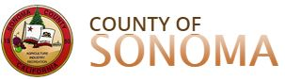
Sonoma County Area Agency on Aging (AAA)
Sonoma County is one of nine counties that make up the San Francisco Bay area and is located about 50 miles north of San Francisco. Sonoma County is a geographically diverse county that includes a mix of rural and suburban areas. Sonoma County AAA contracts with six non-profit agencies (e.g., faith-based organizations, senior centers) that provide volunteer transportation throughout the county. This consortium of providers operates under a common set of policies and procedures that were developed by Sonoma County Area Agency on Aging. Volunteer transportation services are typically curb to curb; however, volunteers may use their discretion to provide door-to-door service as needed. Volunteer drivers use their own vehicles and gas and are reimbursed for mileage. Sonoma County AAA’s vision is to have volunteer transportation programs throughout the whole county. For more information visit http://sonomacounty.ca.gov/Human-Services/Adult-and-Aging/Area-Agency-on-Aging/ or call (707) 565-7186.

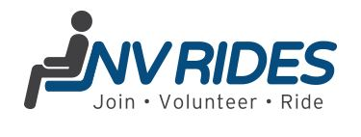
NV Rides
Located just 30 minutes west of Washington, D.C., NV Rides sits in the central part of northern Virginia and the D.C. suburbs. NV Rides supports local community-based organizations that either have a volunteer transportation program or are looking to start a new program. Partner agencies offer free or low-cost rides to individuals who are 55+ and ambulatory. NV Rides supports partner agencies at no cost in the following ways: ride scheduling software (RideScheduler.com); marketing support; volunteer coordinator support; and volunteer background checks. NV Rides is a neighborhood-based program that enables volunteers to sign up and accept rides based on their location and availability. Volunteers use their own vehicles and gas and may be reimbursed for mileage. Volunteers may also track their mileage and hours through a cloud-based scheduling software for tax purposes. For more information visit www.nvrides.org or call (703) 537-3071.

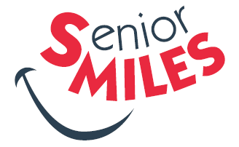
Blount County Office on Aging SMILES (Senior Miles) Program
SMiles is a rural volunteer transportation service provided by the Blount County, TN, Community Action Agency, which covers the Blount County region made up of nearly 125,000 residents. SMiles is a membership program that costs $25 per year. In addition to the cost of membership, the advance purchase of four $6 round trip rides is required. All fees are paid in advance by check or credit card to Blount County Community Action Agency. SMiles is designed for seniors 60+ who live independently, can walk with assistance of a walker or cane and can communicate with the volunteer driver. Wheelchair transportation is not included. SMiles drivers are 21+ with an average age of 66. Volunteers go through an initial screening followed by a four-hour training. Background checks are conducted for those who successfully complete the training. For more information visit https://www.blountcaa.org/programs/ or call (865) 724-1331.

Funding

Volunteer transportation programs can be funded in a variety of ways, including federal, state or local government funds, fundraising, passenger donations, in-kind contributions, foundation and corporate support. The four programs discussed above are funded as follows.
- As an overall operational model, All Points Transit (APT) relies heavily on donations and fundraising and receives support for all of their programs from partners, local government and foundations. The volunteer transportation program is operated with general support funds from local governments, hospitals, foundations, and donations. The administration of the program is funded through their Section 5310 mobility manager funding.
- To support their volunteer transportation programs, Sonoma County AAA began leveraging Older Americans Act dollars for transportation services beginning in 2008. As the success of the program grew, the AAA has since applied for additional transportation grants from the Federal Transit Administration (FTA), receiving New Freedom funds for fiscal year 2014 to 2017 and Enhanced Mobility of Seniors and Individuals with Disabilities Program Section 5310 funds for fiscal years 2016 through 2018 and most recently for fiscal years 2018 to 2020. In addition, they include a local match and in-kind services where needed.
- NV Rides receives local government and foundation funding through Fairfax County. Additional funding comes from FTA Section 5310.
- SMiles received their startup funding and additional funding (three-year grant beginning in August 2013) from the regional transportation planning group, the administrator for all the federal and state transportation dollars in their region. Additionally, Smiles’ membership fee model generates income for the program. In fiscal year 2017, SMiles received $20,000 from participant fees, making up nearly 20% of the budget.

Community Support and Collaboration

Volunteer transportation programs should fit into the broader community’s transportation efforts by prioritizing coordination and collaboration with other agencies.
- In launching the volunteer transportation program, All Points Transit (APT) partnered with a number of organizations like the regional Area Agency on Aging, Coalition for the Homeless, Montrose Community Foundation and Volunteers of America (Senior Services). Other partners were identified during the launch process to help with program implementation. The program was designed to fill transportation gaps in existing regional services provided by APT and other agencies that cover the region through partnership efforts and collaboration.
- Sonoma County AAA brings together advocates, community partners, and service providers to advocate, engage, coordinate and educate the community and partners to increase transportation access and services. They have organized the AAA Advisory Council Transportation and Mobility (T&M) Committee and the Sonoma Access Coordinated Transportation Services (SACTS) Consortium to coordinate services among service providers, share best practices, discuss challenges, and identify areas of focus for local and regional areas.
- NV Rides is a partnership between Jewish Community Center of Northern Virginia, where the program is housed, the Jewish Council for the Aging, and receives financial support from Fairfax County and Community Foundation of Northern Virginia. NV Rides’ service model of bringing together human services agencies, community centers, local government, faith communities, villages and non-profits as partner agencies represents how they garner support and collaborate with the community to solve transportation issues for non-driving seniors.
- SMiles receives a lot of community input through surveys, small and large community meetings, and events like their previously held Aging Summit. Through these efforts, staff is simply looking for people to “buy in” to SMiles. SMiles program staff believes that “buy in” leads to ownership of the program and ownership leads to a greater understanding of the need and the desire to sell the concept to friends and family, which ultimately leads to program growth and impact.

Measuring and Sharing Impact

As volunteer transportation programs collect data on the rides they provide and the riders they impact, it is important to share, with drivers, staff, management, media and other stakeholders, relevant and meaningful information on a regular ongoing basis. All four of the programs recognize the art of storytelling and make sure that stories and quotes from riders and drivers are being captured and shared. Program outcomes are shared in a variety of ways.
- All Points Transit features testimonials on their website to promote program successes.
- Sonoma County AAA hosted a widely publicized celebration event in January 2019 to highlight the 10-year anniversary of the start of their volunteer driver programs. Additionally, Sonoma County shares impact through various marketing and social media campaigns and making community presentations on a regular basis.
- NV Rides sends out surveys to drivers, program coordinators and riders on a biennial basis to measure partner satisfaction of NV Rides services, ease of use for volunteers, volunteer satisfaction, and rider satisfaction. Data and impact are shared through marketing initiatives.
2018 Annual Program Stats (as of Nov/Dec 2018)
Program | Trips provided | # of riders | # of drivers | Most frequent trip
APT | 142 | 37 | 5 | Medical
Sonoma | 10,839 | 546 | 128 | Medical
NV Rides | 12,244 | 753 | 477 | Medical
SMiles | 6,082 | 203 | 134 | Medical

- SMiles staff write stories for local newspapers, put out a monthly newsletter and share program impact through a case for support document that is used in annual campaigns and an annual report. According to staff, riders and drivers are the ambassadors for Smiles, and one of the more effective ways impact is shared.

Summary
Improving access to transportation is critical to ensure that older adults and people with disabilities stay connected to essential services and other activities. Volunteer transportation programs are filling gaps where other transportation and informal networks stop and contribute greatly to the mobility needs of older adults and people with disabilities across the country. With the increasing demand for transportation services to link people to employment, healthcare and community services, local agencies and community organizations are encouraged to explore volunteer transportation programs as a viable option for improving transportation access for older adults and people with disabilities in their communities.

NADTC Resources

Volunteer Transportation: Keys of a Successful Program Toolkit
https://www.nadtc.org/wp-content/uploads/Volunteer-Transp-Toolkit_Final.pdf
Volunteer Transportation: Risk, Liability and Insurance Webinar https://www.nadtc.org/resources-publications/keys-to-a-successful-volunteer-transportation-program-risk-liability-and-insurance-webinar/
Blog: 5 Keys to Successful Volunteer Driver Programs
https://www.nadtc.org/news/blog/5-keys-to-successful-volunteer-driver-programs/
National Aging and Disability Transportation Volunteer Information Brief https://www.nadtc.org/wp-content/uploads/Volunteer-Transportation-Info-Brief-Cover.pdf

References

AARP. (2012). The United States of Aging. Retrieved from https://www.aarp.org/content/dam/aarp/livable-communities/old-learn/research/the-united-states-of-aging-survey-2012-aarp.pdf

Federal Transit Administration (n.d.). Enhanced Mobility of Seniors and Individuals with Disabilities – Section 5310. Retrieved from https://www.transit.dot.gov/funding/grants/enhanced-mobility-seniors-individuals-disabilities-section-5310

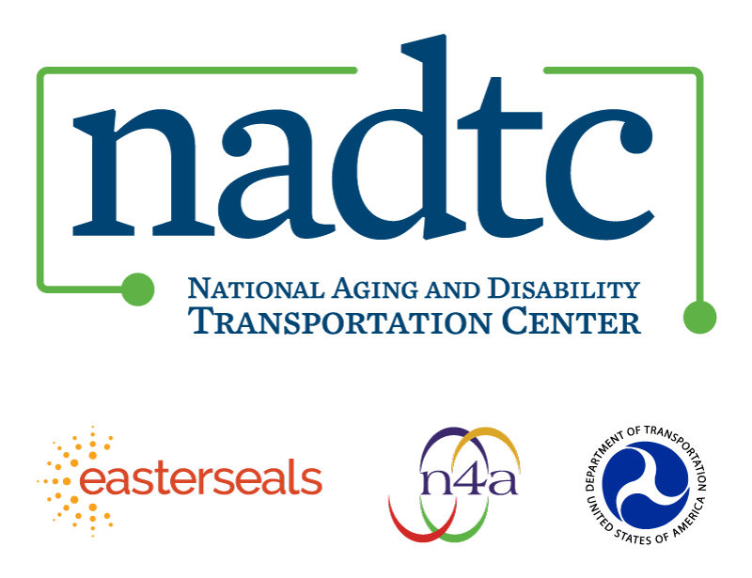

The National Aging and Disability Transportation Center (NADTC) is a program funded by the Federal Transit Administration and administered by Easterseals and the National Association of Area Agencies on Aging (n4a) with guidance from the U.S. Department of Health and Human Services, Administration for Community Living.

NADTC’s mission is to increase accessible transportation options for older adults, people with disabilities, and caregivers nationwide.

National Aging and Disability Transportation Center
Washington, D.C. 20005
Telephone and toll-free hotline: (866) 983-3222
TTY: (202) 347-7385
Email: contact@nadtc.org
Website: www.nadtc.org

Follow us:
Facebook
Twitter
YouTube
LinkedIn

