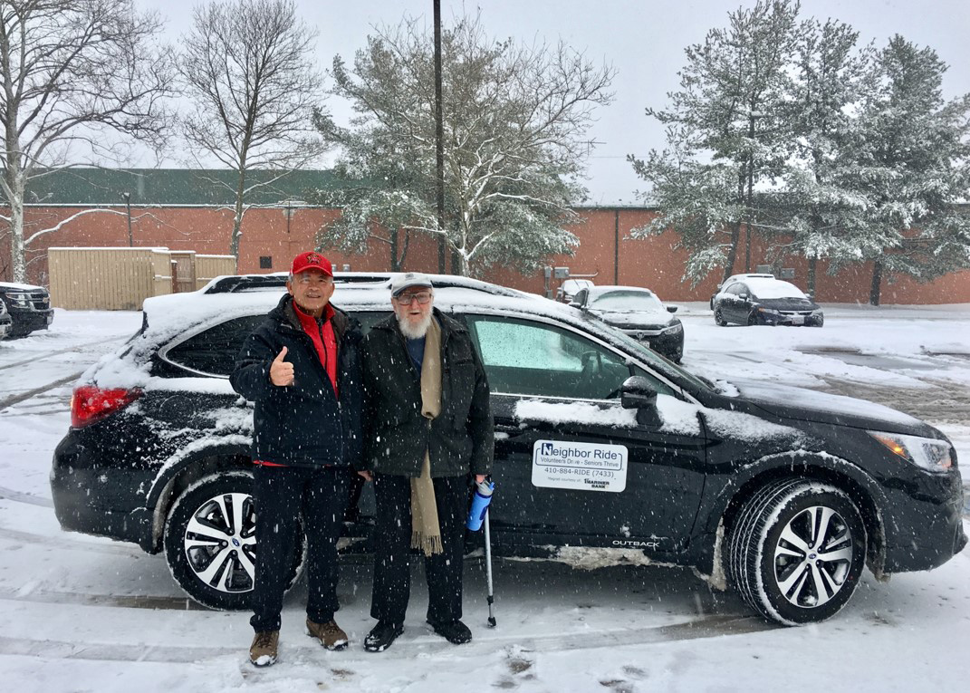
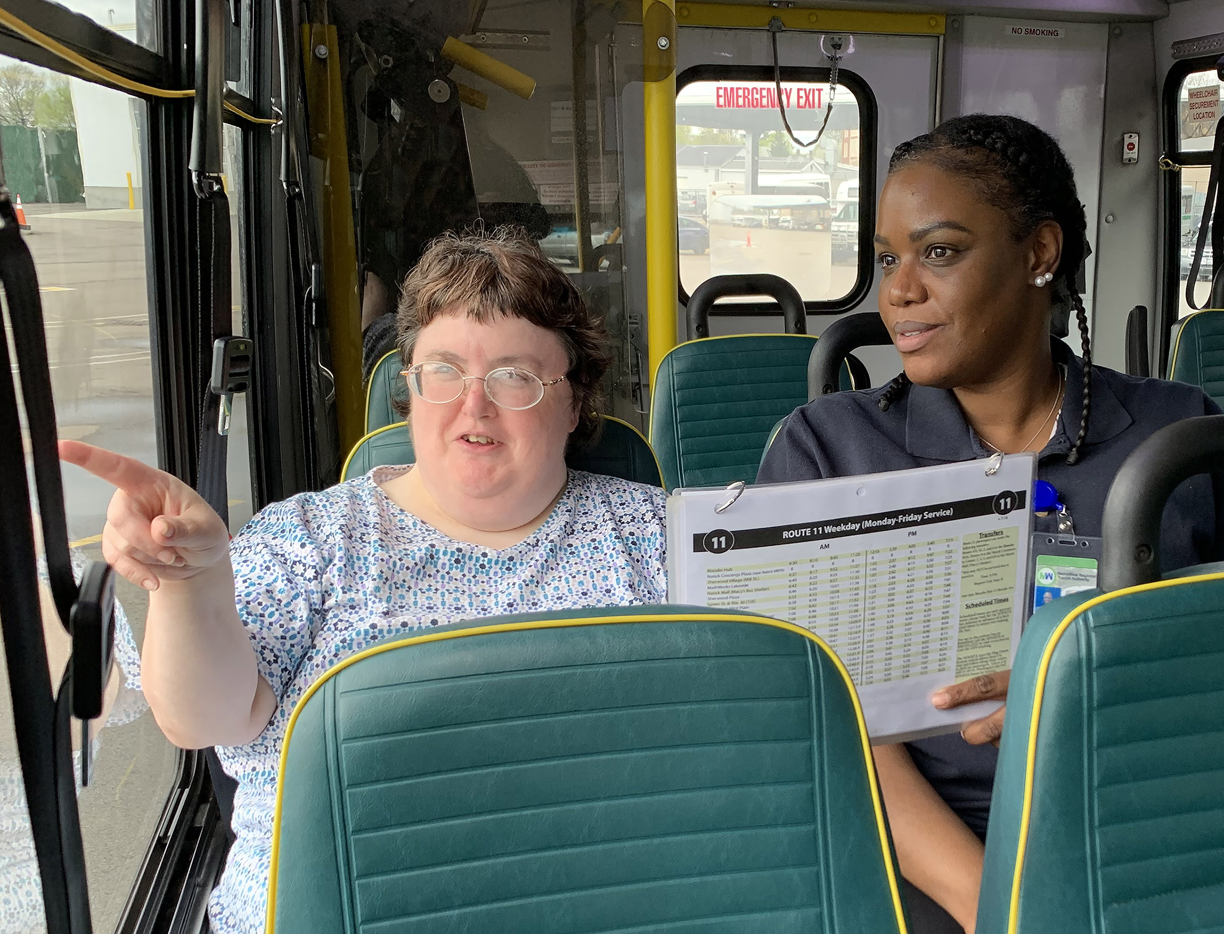
Table of Contents
1 Introduction 1-3
2 Filling a Need: Hiring People with Disabilities in Transit 2-5
3 Travel Training for Older Adults 3-14
4 Procuring Demand Response Transit Technology 4-21
5 Scooter Policies and Accessibility within Shared Pedestrian Space 5-28
6 Mental Health and Transportation 6-34
7 Workforce Development in Transportation Occupations 7-40

Cover Photo Credits
Top: Neighbor Ride, Columbia, MD
Bottom left: Metrolina Association for the Blind, Charlotte, NC
Bottom right: MetroWest Regional Transit Authority (MWRTA), Framingham, MA

Bottom right:

Introduction

Each year, the National Aging and Disability Transportation Center (NADTC) publishes a trends report to review significant topics in transportation. Published annually since 2016, the report includes overviews of popular transportation matters, challenges and opportunities of each topic, and examples of how the transportation trend is being implemented in communities across the United States. As in previous years, the Trends Report is divided into stand-alone ‘Topic Spotlights’ for individual download.

With its mission to increase the availability and accessibility of transportation for older adults and people with disabilities, NADTC recognizes that our work must be grounded in, and respond to, the needs and preferences of the communities and organizations that the center was created to serve. Critical to the center’s success is access to information about local communities’ efforts to develop accessible transportation, how those developments are received by people with disabilities and older adults, and the reactions of leaders in accessible transportation to developments in the transportation field.
The 2019 trends report reviews:
- Filling a Need: Hiring Veterans and People with Disabilities in Transit
- Travel Training for Older Adults
- Procuring Demand Response Transit Technology
- Scooter Policies and Accessibility within Shared Pedestrian Space
- Mental Health and Transportation
- Workforce Development in Transportation Occupations

These six topics represent a collection of what the NADTC has identified as important issues in 2019 based on requests for information, the provision of technical assistance, conversations and online communication with transit providers and human service agencies, and activity on our website.

Topic 1 reviews the hiring of veterans and people with disabilities in transit. There are many transit agencies that could benefit from the capabilities of and value added by qualified applicants with disabilities. This section guides agencies in understanding the values, skills, and ideas people with disabilities and veterans with disabilities can bring to any organization.

Topic 2 focuses on travel training for older adults. Travel Training can empower individuals with the skills and confidence to successfully navigate community transportation systems. This section of the report provides a review and explanation of travel training terminology, strategies to assist older adults in independent travel, and examples from local programs in Colorado, Illinois, and New Jersey.

Topic 3 outlines the best methods to procure technology for your agency. Following proper procurement processes will ensure a fair and open competition for those services and net your agency with the product that will best meet its identified needs.

Topic 4 examines scooter policies and accessibility within shared pedestrian space. Dockless e-scooters have changed the way people move through city spaces and as a result, changed the expectations and behaviors of consumers when using such options. This section reviews the challenges and opportunities these devices pose to maintaining accessibility in public spaces.

Topic 5 reviews mental health and transportation. Providing access to mental health services for disadvantaged populations requires coordination of a number of different elements, including transportation providers. This section provides examples of how some transportation agencies are using federal, local and/or state funding to coordinate or provide transportation to mental health services.

Topic 6 addresses workforce development in transportation occupations. The struggle to recruit, train and retain skilled workers, the lack of planning to address workforce exits and the need to stay competitive in a changing work economy are just a few of the challenges transportation managers are currently facing. This section reviews challenges of workforce development and provides resources and examples of organizations involved in improving the transportation workforce.

Explore transportation’s trending topics with us through this report! If you have questions about any topic here or have a story to share from your community, reach out to us at (866) 983-3222 or email contact@nadtc.org.

Filling a Need: Hiring People with Disabilities in Transit

Introduction

Transit agencies and human service providers are in the business of transporting people and are effective in providing accessible services. Buses have accessibility equipment and drivers receive training to interact with and assist passengers, working closely with riders to ensure that they make their trips. Advisory committees and collaboration with disability organizations are necessary for gaining information about service quality and needed improvements. These experiences should make our workplaces attractive to a diverse workforce. Nonetheless, transit providers are struggling to fill vacant positions as people retire and technical staff move into other positions or to private sector jobs. When driver shortages occur, routes may be realigned or, in truly difficult circumstances, canceled. However, there is a pool of qualified and motivated employees that can fill shortages and add benefits to the transit workplace: that pool is people with disabilities and veterans with disabilities who can bring needed values, skills, and ideas to the organization.

Challenges and Opportunities

Hiring People with Disabilities

Pat Hansen, Executive Director of South Central Transit Network headquartered in Valley City, ND explained her reaction when a former truck driver applied at her agency for a bus driving job. “His resume was perfect for the job. It isn’t always easy to find drivers with a Commercial Driver’s License in rural areas, so I was excited when Richard’s application came across my desk.” She tried to hide her surprise when he showed up for the interview with an arm amputated at the elbow and a prosthesis. The interview progressed well. His driving record was impeccable with no accidents or tickets. She decided to “take a chance.” Pat said, “It was one of the best hiring decisions I have ever made. Our passengers loved him! He was kind and compassionate with a personality that meshed well with other staff and the people we serve.”

Richard never had an accident while working at South Central. He passed away several years later from an unexpected illness unrelated to his disability. When asked if she would hesitate to hire another individual with a disability, Pat responded, “I wouldn’t hesitate at all. I would definitely not worry about the impact on our agency. In regard to Richard, I wish I could have had 10 more just like him!”

Within any community, there may be many personal stories about employment of people with disabilities. In the process of hiring, the transit agency could be creating a life changing opportunity for an applicant, but more importantly, bringing value to the organization and its passengers.

Excuses

There are excuses we hear all the time – people don’t know where to find qualified people with disabilities; it will cost too much to make accommodations; people with disabilities will be less productive than other employees; or they will miss too much work because of their disability. The Virginia Commonwealth University, Rehabilitation Research and Training Center on Workplace Supports and Job Retention put together a Fact Sheet on the Realities of Hiring People with Disabilities that addresses those misconceptions and allows you to have information about the realities of hiring someone with a disability. It can be found at https://vcurrtc.org/resources/viewContent.cfm/589.

Getting Started

A key to attracting motivated and skilled employees with disabilities is to begin reviewing your organization’s workplace inclusive culture. The leadership and management must promote a policy and practice that people with disabilities are welcome and valued at all levels of the transit organization, meeting and going beyond basic affirmative action requirements of the Rehabilitation Act of 1973 (https://www.dol.gov/agencies/oasam/civil-rights-center/statutes/section-504-rehabilitation-act-of-1973) and the Americans with Disabilities Act (ADA) (www.ADA.gov).
October 2019 Disability Employment Statistics Ages 16 years and over

Labor Force Participation
People with disabilities: 20.6%
People without disabilities: 68.9%

Unemployment Rate
People with disabilities: 6.9%
People without disabilities: 3.2%

Source: U.S. Department of Labor, Office of Disability Employment Policy (ODEP)

A great starting point is to review your transit organization’s statement of commitment to the principles of affirmative action and equal employment opportunity for individuals with disabilities. The statement may proclaim that the agency will not discriminate on the basis of disability and make efforts to employ and advance qualified individuals with disabilities at all levels within the company. The organization’s efforts will include a promise that all employment actions, including recruitment, hiring, selection for training, promotion, transfer, demotion, layoff, recall, termination, rates of pay or other forms of compensation, will be administered without regard to disability.

Local Examples: Sample Transit Diversity Policy Statements

Each of the following example policy statements contains language that expresses the value that a diverse workforce brings to the organization. What does your statement say about your organization for hiring of veterans and people with disabilities?

- Green Mountain Transit, Burlington, Vermont: It is the policy of Green Mountain Transit (GMT) to provide equal employment opportunity to all qualified applicants. GMT is an equal opportunity employer and all qualified applicants will receive consideration for employment without regard to race, sex, color, national origin, religion, ancestry, place of birth, sexual orientation, gender identity, HIV status, veteran, marital, citizen, genetic information, or physical mental, or emotional condition.

GMT is committed to providing a workplace that includes people of diverse backgrounds and fully utilizes their talents to achieve its mission. GMT believes that an inclusive and diverse workplace culture enhances the performance of our organization and our ability to fulfill the agency’s mission. Retrieved from https://ridegmt.com/wp-content/uploads/Applicant-Affirmative-Action-Information-1-1-2019.pdf.

- Lane Transit, Eugene, Oregon: Lane Transit District is one of the most successful and highly regarded public transit systems in the nation; has received numerous national, state, and local awards for service to the community; and, for transit districts its size, is consistently ranked among the nation's leaders in the successful implementation of Bus Rapid Transit, bus ridership, and service efficiency. LTD is committed to the values of working together, taking initiative, being professional, and practicing safety.

If you are interested in joining us as we endeavor to provide and improve services to all our diverse communities in ways that are sensitive and responsive to cultural differences, including accessibility for persons with disabilities, we urge you to apply for this position. Refer to https://www.ltd.org/employment/.

- Dallas Area Rapid Transit (DART): The Dart website employment page (https://www.dart.org/hr/humanresources.asp) features a distinct statement for hiring veterans: DART values the service Veterans and their family members have given to our country, and DART supports the hiring of returning Service Members and military spouses. If you are a Veteran or wounded warrior or the spouse of a veteran and would like assistance with the employment process at DART, please contact our EEO Office at 214-749-3366.

Review your diversity statement and determine if your agency is actually practicing the principles in it by looking at your workforce, its diversity and inclusiveness for people with disabilities. Look not only numbers of employees that have revealed they have a disability but also at the numbers in administration, management, technical and mechanical positions and drivers. Consider these questions:

- Do you have drivers with disabilities?
- Do you have technicians with disabilities?
- Are employees with disabilities primarily in one department such as customer service or reservations?
- Are there people with disabilities in management?
- Are there veterans with disabilities in a variety of departments?

The answers to questions such as these may reveal if you have placed or considered people with disabilities at all level of your organization. If not, begin to develop a process for expanding inclusive hiring and promotion.

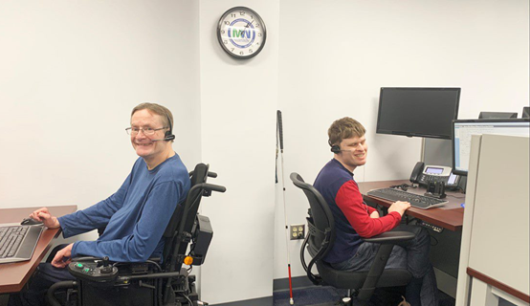
Take a moment to review the language and pictures on the agency website and read staff profiles. Do they reflect diversity and are they welcoming for people and veterans with disabilities? If not, work with your management and communications staff to make changes. Consider adding language on the agency hiring page that specifically invites people with disabilities and veterans to apply, such as this sample language:

People with disabilities are welcome to apply. If assistance or accommodation is needed during the application process or if you have questions, contact the transit human resources office at (phone number) or (email address).

In seeking employees with disabilities, staff cannot ask questions about a disability before a job offer is made. Instead, focus on the skills and tasks that need to be performed for the job. The applicant can be asked to demonstrate how they would perform job tasks specific to the position, but cannot be questioned about disabilities, limitations, or previous medical history.

When you have a candidate with a known disability, ask the person if he or she requires any specific accommodation and discuss any accommodations in a private space. The employee with a disability is the expert on their specific needs and accommodations. Make no assumptions prior to asking – each person relates to the world and other people in a very personal way. For example, one person may use an electronic device to assist with communication, while another prefers conversing in a quiet location to help with concentration. Allow adequate time for the discussion and do not artificially set time limits that would rush the conversation.

Reasonable Accommodations

All employees need the right tools and work environment to effectively perform their jobs. Similarly, individuals with disabilities may need workplace adjustments – or accommodations – to maximize the value they can add to their employer. The Americans with Disabilities Act requires employers to provide job applicants and employees with disabilities reasonable accommodations so that they can perform jobs and benefit from equal employment opportunities. Employees with disabilities have the right to reasonable accommodations through modifications to the workplace, job tasks, or policies that allow them to do the job. An employer must provide an accommodation unless it would create undue hardship or burden on the organization.

An accommodation can be simple, such as putting blocks under a desk’s legs so a person who uses a wheelchair can roll up to it. It might involve advanced technology, such as installing a screen reader on a computer so that a person who is blind can manage documents. It may be procedural, such as altering a work schedule or job assignments. When thinking about accommodations, the focus should not be on the person’s disability but rather on essential job tasks and the functions necessary to complete them.

Employers are to discuss any accommodation requested by the employee through an interactive process. The employee may suggest an accommodation, and after discussion, an employer may suggest an alternative modification or accommodation the employee must consider. The alternative may or may not be acceptable to the employee. Accommodations vary based on the needs of the individual, so a truly interactive process is important. To ensure that accommodations are readily available, create a budget for accommodation requests that is reasonable and readily available for current and future staff. Additionally, it is valuable for employers to have a process to regularly review and update their reasonable accommodation policy along with procedures for implementation.
When an accommodation request is submitted:

- Review accommodation request form and documentation;
- Meet with the employee to explain the process and discuss the employee's request and using an interactive process, identify which accommodations could be effective and reasonable;
- If accommodations are warranted and approved, sign an accommodations agreement;
- Work with the supervisor to provide the agreed upon accommodations; and
- Follow up periodically with employee regarding effectiveness of the requested accommodation.

The Job Accommodation Network (JAN) is a resource and service that provides individualized work related accommodation assistance based on needs of an employee. Information can be found at www.askjan.org or (800) 526-7234 voice and (877) 781-9403 TTY.

Disability Etiquette

People are all different with varying ways of interacting with others and the world around us. Some of the differences may be related to disability, may be cultural, or may be based on a habit or mannerism. Regardless, each person wants to be treated with respect and as an equal to everyone else. Proper disability etiquette can make the employee with a disability feel welcomed and valued. Here are some tips:

- Emphasize the person, not the disability. Use person-first language, such as “a man with a disability” instead of “a disabled man” or “a woman who uses a wheelchair” instead of “a wheelchair-bound woman.” Avoid outdated terms such as “handicapped,” “crippled” or “elderly.”
- Communicate with people with courtesy and respect. Identify yourself and provide your title, if appropriate. Shake hands when appropriate. Never make assumptions about a person’s physical or mental abilities.
- If you are interviewing person in a wheelchair, sit in a chair to be at eye level and facing the person. If applicant has an assistant, speak directly to the job applicant rather than the assistant, referring to the assistant only if prompted by the applicant.
- When speaking with someone who is deaf or hard of hearing, face the person to whom you are speaking and do not let objects obstruct his view. Use a normal tone of voice and speak naturally.

- When speaking with someone who is blind or has a visual impairment: Identify yourself and others who may be with you. Do not leave without letting the person know of your departure. When offering to assist, allow the person to take your arm. This will help you to guide rather than propel or lead her.
- When giving directions, use specifics such as “walk until the carpet ends and turn left” or “turn to your right, and the door is 10 feet ahead on the right.” Instructions can include identifying architectural elements that would provide orientation such as the number of doorways to pass or noticeable changes in the surface underfoot to reach the place that is being sought.
- Ensure that the workplace is accessible and disability inclusive by reviewing physical accessibility such as ramps, doors and accessible restrooms. Likewise, ensure that information and communication technology is accessible or can be used with assistive technology equipment. It is important that attitudinal barriers be removed within the organization so applicants and employees are welcomed as qualified individuals with disabilities and are valued contributors to the workplace.
Tips for an Accessible Workplace

- Organization Policy: The transit agency must have a policy that clearly recognizes the value of hiring and keeping employees with disabilities, including providing accommodation and supports. The policy must also be clear that verbal harassment around disability and other protected traits is not tolerated and expedient action on complaints will occur. Verbal harassment includes off handed comments, jokes, and insensitive remarks focused on the disability or other protected traits.

- Accessible Website: All employee pay systems, and internal communication should be accessible to workers. If not currently usable by the employee, work with your IT department, vendors, or state assistive technology organization to improve website accessibility or develop a work around until accessibility can be improved. To assess your website accessibility, go to https://www.w3.org.

- Assistive Technology: Assistive technology is one of the most important accommodations for employees with various disabilities to use computers and other electronic systems or for communication. An assistive technology device is defined as “any item, piece of equipment, or product system, whether acquired commercially off the shelf, modified, or customized, that is used to increase, maintain or improve functional capabilities of a person with a disability. Assistive technology also includes items such as tools for manual gripping or holding or for modification of shop tools. The Assistive Technology Industry Association (ATiA) has published an Assistive Technology Resources Funding Guide, which can be found at https://www.atia.org/at-resources/what-is-at/reources.

- Modified Training: If new devices or technology is being displayed in an all-staff training, ensure that individualized instruction is available to assist people needing it, including people with disabilities. If technology is being used at a meeting, make sure it is accessible to all, including closed captioning, if appropriate.

- Employment Test Modification: When applying for jobs, a potential applicant with a disability could request to have the process modified to meet a specific need. For example, an applicant with a cognitive or reading disability could ask for a qualified reader to orally read the test questions. Additionally, an applicant may request that more time be allowed for testing due to concentration or focus issues related to a disability. For a person who is blind or visually impaired, modifications could be made through large print applications or online formats.

- Accessible Formats: An employee or applicant with a visual or learning disability can request that work-related written materials be made available in their preferred accessible format such as accessible pdf, large print, braille or audio.

- Work from Home: Employees may request a work from home arrangements if their disability makes it difficult for them to travel to the workplace due to inclement weather or major travel delays. The request must be evaluated on its effect on workplace productivity or coverage. For some transit jobs, such as driving, maintenance or dispatch, working from home would not be possible.

Summary

In your transit workplace, there are many positions that could benefit from the capabilities of and value added by qualified applicants with disabilities. Look around the organization and envision where a more diverse workforce is beneficial to everyone. Work proactively with department managers to determine how vacant job positions could be filled with a veteran or person with a disability. Think about ways to modify a job requirement or workplace to make it more welcoming for an applicant with disabilities through accommodations. Be proactive in seeking valued employees with disabilities and confirm that the workplace is welcoming through the practice of disability etiquette. With an organizational commitment to hiring people with disabilities and veterans, positions can be filled with highly-motivated, capable, and skilled employees.

Resources and References

ADA National Network. Retrieved from: https://adata.org/
Department of Labor. Veteran and Military Transition Center. Retrieved from: https://www.careeronestop.org/Veterans/default.aspx
Employer Assistance and Resource Network on Disability Inclusion (EARN). Retrieved from: https://askearn.org/
Federal Transit Administration. Equal Employment Opportunities (EEO) Circular 4704.1A. (2016). Retrieved from: https://www.transit.dot.gov/sites/fta.dot.gov/files/docs/regulations-and-guidance/civil-rights-ada/56501/eeo-circular-c-47041a.pdf
National Aging and Disability Transportation Center (NADTC). Including People with Disabilities: Communication & Meeting Etiquette Guide. Retrieved from: https://www.nadtc.org/resources-publications/including-people-with-disabilities-communication-meeting-etiquette-guide/
U.S Department of Labor. Office of Disability Employment Policy (ODEP). The Partnership on Employment and Accessible Technology. Accessible Technology Action Steps: A Guide for Employers. Retrieved from: https://www.peatworks.org/action-steps
U.S Department of Labor. Veterans' Employment & Training Service. Retrieved from: https://www.dol.gov/agencies/vets/hire

Travel Training for Older Adults

Introduction

Travel training, or travel instruction, is a professional method of teaching individuals skills for independent travel, often focusing on fixed route public transit, but can include instruction on other modes such as shared ride options, volunteer transportation, and even pedestrian safety. Travel training can be beneficial to most everyone in the community looking to familiarize themselves with available transportation options, but can be particularly beneficial to older adults, especially when nearing or experiencing retirement from driving. For many, losing the ability to drive means a loss of reliable transportation, leading to barriers in access to employment, health care, social services, recreational activities and a general loss of independence.
Many different types of organizations provide travel training services including, but not limited to: transit agencies, schools, human service organizations, aging and disability resource centers, and area agencies on aging. These organizations may be for-profit or non-profit, and they may provide services for free or for a fee. Any organization with the mission, vision, and/or values supported by travel training may develop and implement a travel training program.
Family of Travel Training Services
The family of travel training services refers to the array of methods and strategies used by professionals to increase the independent travel skills of the people they serve. The family of services can include:

- Origin to Destination Training: Instruction on how to travel from a specific origin to a specific destination (receiving highly individualized path of travel and route instructions that are delivered on the street and on transit vehicles)
- Orientation/Familiarization: A general overview and orientation to a transportation system (reading a schedule, identifying a stop location, purchasing fare, and using vehicle features)
- Mobility Device Orientation: Instruction on how to use personal mobility devices on transit vehicles (safely boarding, riding, and alighting vehicles)
Origin to Destination Training
Origin-to-destination travel training consists of a travel trainer and the trainee(s) selecting a specific start point (origin) and a specific end point (destination) that the trainee wishes to travel. Travel trainers and trainees work together to determine the best way to travel this specific route. This includes but is not limited to:
- Assessments to determine the gap between the trainee’s current skills and skills needed for independent travel
- Assessments of the built (sidewalks, curb cuts, bus stop amenities) and natural (hills, trees, etc.) environment
- Planning the trip and selecting the best route (selecting the time, stop location, vehicle, path of travel, etc.)
- Identifying information and supplies needed by the trainee (schedule, fare, landmarks, how to signal the operator, etc.)
- Developing a travel instruction plan with a task analysis (what to teach) and training strategy (how to teach) related to:
  - Street crossing
  - Boarding, riding, and alighting vehicles
  - Preparing for unforeseen incidents and emergencies

Origin to destination training is appropriate for older adults that have significant gaps between current skill level and the skills needed for independent travel. Depending on the skill level of the trainee(s) and travel trainer, the route, the number of travel trainers, and the learning environment, this service may be delivered one-on-one or in small groups.
Orientation/Familiarization
Orientation to a transportation system includes but is not limited to:
- Planning a trip (selecting the time, stop location, and vehicle) and using the transportation system’s trip-planning tools (website, customer service telephone number, printed schedule, etc.)
- Learning where and how to purchase fare
- Using vehicle features (paying fare, signaling the operator, etc.)

Orientation to a transportation system is appropriate for older adults who have some experience using the transit mode being taught, need minimal support in order to use the transportation system independently, and have good judgment and safety skills.

Older adults enrolled in orientation to a transportation system may not require one-on-one attention from a travel trainer. If older adults do not require individualized attention, small group training is an efficient and effective teaching strategy. Small group training, especially for people who know each other, may lead to future independent travel by group members, who support each other as they travel together.
Mobility Device Orientation
In mobility device orientation sessions, travel trainers teach older adults who use personal mobility devices (wheelchairs, walkers, etc.) how to board, ride and alight vehicles. Travel trainers, trainees, and transportation personnel work together to determine the best way to:

- Approach and board the ramp or lift
- Ride the ramp or lift
- Use the fare box
- Approach the securement area
- Use securements
- Approach and board the ramp or lift during deboarding
- Alight the vehicle

Personal mobility device training is appropriate for older adults who use mobility devices and are uncomfortable boarding, riding, and alighting vehicles without additional training and practice. Since personal mobility devices vary, as do the skills of trainees, this is a highly individualized service. Travel trainers should not attempt to teach trainees how to operate their mobility devices.

Challenges and Opportunities

While the family of travel training creates many opportunities for effective and personalized teaching and learning based on the needs of the individual seeking services, there are a few strategies that have been found to be particularly effective in managing thriving travel training programs. Successful travel training programs for older adults tailor their services to the needs of the individual and community. A thorough inventory of programs, services, and modes of transportation within the community is key to ensuring the appropriate type of travel training program is developed.

Programs should have a keen awareness of their target audience to create specific communication and marketing campaigns to effectively reach these individuals. For older adults with little experience in alternate modes of transportation outside of driving and caregiver-provided transportation, personal success stories and word of mouth have been found to be successful recruitment tools. Highlighting the cost savings, flexibility, and independence of using fixed-route transportation also resonates with older adults interested in enrolling in travel training programs (TCRP Report 168, 2014).
The development, expansion, longevity of travel training programs is often determined by reliable funding. Consistent data tracking and evaluation can help organizations strengthen the quality of their programs to improve outcomes for older adults, but also help also share their successes with the community to attract potential community partnerships and potential clients. Increased recruitment numbers can help programs demonstrate the value of their program to potential funders and the importance of sustaining such a program long term.
Successful travel training programs provide older adults with the skills to independently utilize fixed-route transit and as a result, reduce use of ADA paratransit. The cost of operating fixed-route transit is significantly less than providing ADA paratransit. If travel training helps individuals shift from using paratransit to using public transit, it can significantly reduce demand for paratransit services and agency spending.

Local Examples

The following travel training program case studies were drawn from community programs featured in Transit Cooperative Research Program (TCRP) Report 168 Parts I and II. For more detail, please refer to that report or contact each organization.

Via Mobility Services, Boulder, Colorado
Via Mobility Services, a community non-profit, runs the Via Mobility Services Travel Training Program. Via Mobility Services promotes self-sufficiency and independence for individuals with limited mobility, and their travel training program offers individual and group training to older adults, people with disabilities, and low-income individuals. When the program first started in 2003, it was sustained via federal funding. As time has passed, program funding has diversified, and funders have included the Rose Foundation, Denver Regional Mobility and Access Council, United Way, the City of Boulder and Boulder County. In 2014, the program received FTA Section 5310 funding to create an area-wide program.
Via Mobility Services’ travel training program largely relies on volunteers who devote their time and assist older adults with travel training; however, the program employs two full-time travel trainers providing more intensive services. Travel trainers complete an assessment form in the participant’s home. Based on the assessment, instructors derive a progress checklist to assure that client’s requirements and needs are being met through their training. In order for trainers to feel comfortable instructing the client, trainers plan trips and scout routes, which will overall assist in the client’s understanding of the routes.
Via Mobility Services offers multiple programs to familiarize seniors with the transportation system; they include:

- One-on-one travel training
- Group training
- Volunteer bus buddy program
- Train-the-trainer program

RTA Travel Training Program, Chicago, Illinois
The Regional Transportation Authority is a travel training program established by the state of Illinois division of Chicago Transit Authority, Metra, and Pace transit agencies. The program was initially created to serve clients who are blind or who have visual impairments; however, today, the RTA’s services have expanded to include non-ADA complementary paratransit applicants.

The programs RTA offers include:
- One-on-one training programs
- Group training program

The one-on-one programs involve a trip training program, which teaches participants how to navigate specific trips that they often need to make, as well as an orientation to the transportation system. Multiple trips are conducted to facilitate the client’s familiarization with the route. To conduct these programs, travel trainers most often will first practice using the system until they are comfortable teaching the route to the participant. RTA evaluates the benefits of the programs by using follow-up surveys every six to twelve months, to assess the participants’ continued involvement with the transit system.
NJTIP @ Rutgers, New Brunswick, New Jersey
New Jersey’s Rutgers State University provides travel training programs in order to teach individuals how to use the available transit programs and encourage independence of participants. The travel training program was first initiated through a pilot program overseen by New Jersey Transit. Through the pilot, NJ TRANSIT assessed the demand for travel training programs and tested the effectiveness of the program. Upon completion of the pilot program, New Jersey Travel Independence Program (NJTIP), a non-profit organization, officially established the travel training program.

The services NJTIP offers include:
- One-on-one training
- Small group travel
- Transit seminars
- In-school travel training classes
The goal of one-on-one training is to teach participants how to travel using the public bus and rail system. This allows for greater mobility, as well as improved rates of employment, increased community involvement, and educational opportunities on a broader spectrum. Furthermore, NJTIP provides a specialized small group training to supplement the one-on-one travel training program. In order to conduct this service, NJTIP outreaches to other agencies, such as senior centers, to provide an orientation on utilization of the public transportation with hands-on experience taking trips. NJTIP also has services to support professionals and volunteers with their understanding of the local transportation system. Through the Connect to Transit Training Program, NJTIP extends services to those assisting seniors and providing social services by providing a seminar that reviews the public transit system.

Summary

Travel training can empower individuals with the skills and confidence to successfully navigate community transportation systems. Benefits to the traveler include increased social activity, improved health through access to medical services, and increased independence. Caregivers can also benefit from travel training services, as it eases their support services burden and increases self-care. This can lead to improved health and economic standing, increasing their own and their family’s quality of life. The benefits to transit agencies include reduced spending on ADA paratransit and creating a positive rapport with the community. Finally, travel training benefits the community as a whole by assisting older adults to remain active and contributing members of society for as long as possible.

Resources and References

The Association for Travel Instruction (ATI) has as its mission to advance the right of all persons with disabilities and older adults to equal access to public transportation and community participation by providing: support, information, training and education to promote quality Travel Instruction. ATI has many resources for individuals who are travel trainers. It would be a good place to start for people wanting to start a travel training program. https://www.travelinstruction.org

Burkhardt, J., et al. (2014). Transit Cooperative Research Program Report 168. Travel Training for Older Adult Part I: A Handbook. Retrieved from: https://doi.org/10.17226/22299

Burkhardt, J., et al. (2014). Transit Cooperative Research Program Report 168. Travel Training for Older Adults Part II: Research Report and Case Studies. Retrieved from: https://doi.org/10.17226/22298
The Consortium for the Educational Advancement of Travel Instruction (CEATI) is another association that supports and promotes the continuing development of the discipline and profession of Travel Instruction to enable individuals with disabilities and seniors to travel in the safest and most autonomous manner possible. To access their resources go to: http://ceati-travelinstruction.org/

Easterseals Project Action Consulting (ESPAC) offers certification for professional travel trainers. This innovative certification program, ctti, is co-sponsored by Easterseals and the Center for Urban Transportation Research (CUTR) at the University of South Florida. Certified through CUTR, the program provides new and veteran travel trainers with the Certified Travel Trainer credential. For more information visit: https://www.projectaction.com/certification-programs

Kansas RTAP Fact Sheet. (2015). Developing and Marketing a Travel Training Program for Older Adults. http://www2.ku.edu/~kutc/pdffiles/KTRFS15-TravTraining.pdf

Metro Magazine. (2017, reprinted in 2019). 10 Steps for Transit Agencies Starting Travel Training Programs. https://www.metro-magazine.com/accessibility/article/714837/10-steps-for-transit-agencies-starting-travel-training-programs

Procuring Demand Response Transit Technology

Introduction

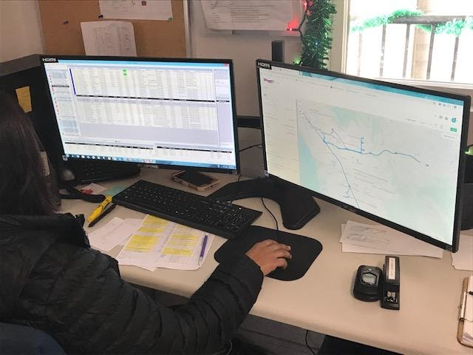
Procuring technology for demand response transportation – whether a scheduling and dispatch system, communications capabilities (internet or FM radio), real-time vehicle tracking apps, or a maintenance management system – requires preparation and care. There are different procurement methods that can be used. This brief will outline the best use of Requests for Proposals, Requests for Qualifications, Requests for Information, and Requests for Expressions of Interest when preparing to procure technology for your agency. It is critical that you be prepared ahead of time by understanding your agency’s needs before going through the process of obtaining technology. Following proper procurement processes will ensure a fair and open competition for those services and net your agency with the product that will best meet its identified needs. Seeking advice from other similar agencies who have recently procured technology or from coaches and consultants who specialize in technology for demand response transit can help you get the best results.

Procurement Method

A Request for Proposals (RFP) is the preferred procurement method for transit technology – especially for technology used for ride booking, scheduling, and dispatch. An Invitation to Bid is not appropriate to obtain transit technology, as transit technology is in a constant state of innovation. Equipment and operating systems are regularly being improved and constantly becoming out-of-date. The RFP process enables the purchase of functionality, rather than equipment or software that may soon become obsolete. Scheduling and dispatch technology (both hardware and software) must be integrated to maintain functionality. The RFP process allows the purchaser to question offerors on the capabilities of each component, and their ability to integrate those functionalities.

The RFP process also offers the option of procuring on the Software as a Service (SaaS) model, where the capabilities are bought through a subscription. The vendor is responsible for installing, maintaining, and updating the software and hardware and training the users. SaaS can also include training the user to update and replace software and hardware, as a cost reduction measure. Two necessary caveats to a SaaS agreement are: 1) the transportation provider must own the data; and 2) the data must be transferrable, should a new SaaS vendor be procured in the future.
Bids are a good procurement vehicle when purchasing equipment or services for which the concept, design and functionality can be thoroughly described and will be satisfactory through the expected life of the product being obtained. Examples of items to be obtained through a bidding process include vehicles and furniture as well as cleaning or catering services. Offers can’t be questioned during a bid process. Bids that meet the procurement specifications are evaluated by price, not functionality.

Preparation

Before developing the scope of services for a procurement, you must decide on the functionalities to be obtained. In which areas is current performance deficient, based on input from drivers, dispatchers, customers, and funding agencies? In what areas is the current functionality adequate? Assessing the strengths and weaknesses of the current technology is a critical prerequisite to developing the functionalities needed for new technology.

Next, do your own due diligence to gather intelligence on which vendors offer – or which agencies have procured – technology that seems to be successful. Attending trade shows associated with state and national transit conferences will provide a perspective on the products offered. You can network with users of those products attending the convention for their perspective. Vendors usually will share contact information for their customers on their websites or upon request. Vendors will also provide an on-line demonstration. The follow-up is to travel to those sites that are as close to equivalent as yours to see the product being used. Seeing the dispatch and booking screens and talking with the users can be very enlightening. Asking for the local definition of on-time performance and seeing their success in that measure provides a good indicator of functional performance. If the product has been in use for a few years, you can also consult the National Transit Database for sites using the product to check the productivity of services using software, specifically the boardings per vehicle service (revenue) hour or mile.

If a difficult functionality is needed, one can issue a Request for Qualifications (RFQ) as a prerequisite for responding to the subsequent RFP. The RFQ can be used to weed out vendors who have no experience or no success in providing that difficult functionality. The RFQ can require contact information for properties in which the technology has been successfully implemented.

Once one finds a transit technology application that appears to meet one’s needs, ask for the Scope of Services as well as RFP Price Sheet used to obtain the technology. Public sector procurement documents are generally public information. Use other’s procurements to develop an Independent Cost Estimate (ICE) for the desired functionalities. Developing an Independent Cost Estimate of the functionality to be procured is a best practice – and required if using Federal Transit Administration (FTA) funds. An ICE can’t be supplied by a vendor – independent research is necessary. Reviewing price sheets from successful technology procurements that include the desired functionalities in conjunction with their first-year costs and current year costs will form the basis of a very solid ICE. Comparing first year and current year costs gives a good base for estimating cost hikes in future years.

If a new functionality is needed and doesn’t seem to be offered, one can issue a Request for Information (RFI) or Request for Expressions of Interest (REOI). An RFI is useful if the requested is not cutting-edge. An REOI is a tool to test the vendor market with preliminary ideas for a functionality and solicit responses that help shape those ideas into a clearly-defined vision. Responding vendors won’t be obligated to respond to a subsequent RFP. They may offer a product that offers similar functionality – and references useful for developing an ICE.

Scope of Services

The Scope of Services should begin with a description of service area characteristics, which may affect the functionalities sought in the RFP. These include the jurisdictions served, land area, and population of the service area; the peak vehicle requirement; annual ridership, costs, revenues, service miles and hours; discussion of clientele groups and their service needs; and annual or monthly reports.

Technology vendors need to know the environment of the service area including a general description of the topography. Does the service area have cellular coverage throughout; mostly but with holes; only in sections; or little-to-none? Does the service area have FM-band coverage throughout; mostly but with holes; only in sections; or little-to-none? Dispatch technology can be adapted either to cellular tracking or FM tracking – whichever makes more sense locally.

Describe the service structure, which may include a call center, multiple ride providers, and several agencies that fund rides. The fare structure and client intake process should be included as well as average weekday/Saturday/Sunday trip and call volumes.

A statement is needed regarding the purposes of the functionalities to be procured. What deficiencies need to be remedied? This section should also specify that the client retains ownership and all rights thereof to all data and reports produced and be granted unencumbered access to all client data. The Contractor shall provide a “data dictionary” showing each database and defining each field in those databases. The software, hardware and licenses associated with producing and transmitting that data shall be the property of the Contractor.

Functionalities

If the Scope is focused on functionality rather than equipment, the service being procured is unlikely to become obsolete during the contract term.

The table below lists functionality categories, adapted from a combined call center/demand response technology procurement. The full detailed version of the functionality requirements are shown in this blog post: https://www.nadtc.org/news/blog/procuring-technology-for-computer-aided-scheduling-dispatch/.

SECTION | DESCRIPTION
1 | Dashboard and On-Going Monitoring
2 | Ride Vendor Management
3 | Client File, Booking and Scheduling
4 | Dispatch
5 | Web-Based Tools
6 | Telephonics
7 | Reporting

Evaluation Criteria

The RFP must list each evaluation criteria with a description of the criteria and the associated points. Depending on state and local procurement guidelines, price may only count for 20% of the evaluation points. Other criterion may include corporate and staff experience; references from successful installations; responsiveness to the functionalities in the Scope; and transition plan; as well as duration.

Deliverables

As a contract resulting from an RFP is subject to negotiation, vendor responses to the RFP should be divided into two documents: a technical proposal and a business proposal. The technical proposal would respond to both the Contract Terms and Provisions and the Scope. A Selection Advisory Committee (SAC) would review the technical proposals and reject those that don’t meet procurement functionality requirements.

The business proposal responds to the RFP Price Sheet. Business proposals from qualified vendors (those technical proposals deemed acceptable) would be reviewed by the SAC.

The Price Sheet is a key document within the RFP, vital to both cost projections and cost control. A well-structured price sheet – which can also be provided in an attached electronic spreadsheet – will enable the agency to project costs over the contract term. The price sheet should split out the cost of each overall functionality, including: telephonics; booking and scheduling; dispatch; website; etc., recognizing that these are interdependent. As option years are generally subject to negotiation, analysis should focus on the fixed-term of the contract. The length of the contract term including option years may depend on state procurement regulations.

Technology procurements are best prepared as a partnership with a purchasing officer, who can serve two purposes: to ensure that the document is in compliance with procurement best practices as well as state requirements and your agency’s policies; and being from a non-transportation perspective, to ask for clarifications to ensure that the language is clear. The purchasing officer will coach you on whether an RFI, REOI, or RFQ is needed based on the field work you have done in developing your draft scope of services. The purchasing officer will also assist you in structuring the price sheet, the evaluation criteria, and choosing members of the SAC. Your agency may have rules prohibiting selection of outside customer organization representatives to serve on the SAC and also may limit the number of SAC members from any single department.
Coaches and Consultants

While technology is constantly improving, the process to procure technology seldom changes. People who have been through this process and overseen successful procurements of demand response transportation technology are available to advise. Reach out to agencies that have recently procured technology to see who they have used as experts as coaches and consultants to guide them through the process. Ask them how satisfied they were with the services that were provided to them, and whether or not they would recommend them for your project. It is also good to find advisors who have experience in assisting agencies in developing specifications.

Summary

Following best practice procedures when procuring technology for demand response transportation programs is critical for ending up with a product that will provide the agency with the functionality that will serve you best for as long as possible. If you have never done a technology procurement, it may be advisable to speak to an expert or contract with a consultant. It is always important to do your homework first and make sure you understand what it is your agency needs before attempting to make a significant purchase. Taking the time to do it right will pay off in the long run and provide you with the best results for your efforts.

Resources and References

Chambers, Kevin. (2019). A Jewel in the Rough: Articulating Your Vision for Technology in RFP Form. National Center for Mobility Management. Retrieved from: https://nationalcenterformobilitymanagement.org/wp-content/uploads/2019/07/2019-07-16-A-Jewel-in-the-Rough-Articulating-Your-Vision-for-Technology-in-RFP-Form.pdf

Schweiger, Carol. (2017). Transportation Technology Information Brief. National Aging and Disability Transportation Center. Retrieved from: https://www.nadtc.org/resources-publications/transportation-technology-information-brief/

What is a Request for Expressions of Interest (REOI) and How Do I Use One? Artscape. Retrieved from: http://www.artscapediy.org/Creative-Placemaking-Toolbox/How-Can-a-REOI-Advance-My-Project/What-is-a-Request-for-Expressions-of-Interest.aspx

There are a number of resources for public sector contract terms and conditions. The following website provide information on this topic:

- https://www.bakertilly.com/insights/developing-effective-contracts-for-the-public-sector
- https://www.cbord.com/standard-terms-and-conditions-of-purchase-united-states/
- http://www.sapdc.org/business/government-contracting-terms-definitions
- https://www.usa.gov/understand-contracting-terms

Scooter Policies and Accessibility within Shared Pedestrian Space

Introduction

Over the last decade, cities across the United States have experienced an increased presence of ‘micromobility’: transportation systems of shared on-demand bikes, electric bikes (e-bikes), and electric scooters (e-scooters) that allow individuals to make short distance trips at a low cost. Micromobility companies charge a fixed rate to unlock a device (sometimes as little as $1) and then a per-minute charge as the device is ridden. Rates can fluctuate based on the time of day and the city, but are considerably less than operating a vehicle. And while comparable to the cost of public transit, micromobility options provide a level of efficiency and flexibility for short distance trips unmatched by available transit.

Manual bike sharing systems paved the way for the eventual expansion of the micromobility market to include e-bikes, and most recently, e-scooters. In fact, e-scooters are rising so fast in popularity that over one-half of the 75-million micromobility trips documented in 2018 took place using an e-scooter (NACTO, 2018).

In addition to playing host to these new modes, cities have also witnessed a transformation in how micromobility modes are stored and accessed by users. Dockless e-scooters were first introduced in small numbers in 2017 (USDOT, 2019). Today, it is customary that e-scooters operate via dockless systems, where the rider uses a smartphone app to locate drop-off and pick-up locations, track time and distance for payment, and gain access to the device (locking and unlocking of an e-scooter typically occurs by using the company app to scan a QR code located on the e-scooter). As the “dockless” name implies, there is no specific e-scooter docking station to which a return must be made. According to the U.S. Department of Transportation’s Bureau of Transportation Statistics, as of July 2019, e-scooter systems can be found in 108 cities across the United States (USDOT, 2019). Such systems provide a tremendous amount of flexibility and convenience for users (for example, a user can simply leave the scooter at their destination for a future user to find, its location tracked by the company via GPS), but have also created new issues surrounding the accessibility of shared pedestrian public spaces.

Challenges and Opportunities

While some communities certainly welcome the availability and flexibility these micromobility modes provide, others find themselves wholly unprepared for the realities of such a rapid increase in the presence of e-scooters throughout city spaces. Even the most thoughtful policies and regulations crafted for an umbrella of micromobility modes don’t seem to reflect the specific nature of dockless e-scooter systems or user behavior surrounding treatment of e-scooters.

Without a defined and fixed feature on city streets to accept returned scooters, sidewalks, curb ramps, bike lanes, parking areas, roadways and even crosswalks become a default “parking lot” of sorts for discarded e-scooters. As a result, these micromobility travel solutions have become a significant barrier in maintaining accessible spaces for individuals with visual or mobility impairments and adhering to ADA regulations.

As dockless e-scooters expand their presence in communities across the U.S., both the challenges and the opportunities of the devices must be acknowledged. Below are a few common issues encountered in the management of dockless e-scooters:

- Maintaining accessible pedestrian walkways: When users are improperly riding and parking e-scooters, it is nearly impossible to maintain orderly and accessible public space. The two issues that are most commonly referenced in relation to sidewalk accessibility are scooter parking and the lack of dedicated bike/scooter lanes for riding. The nature of dockless systems allows users to “park” their e-scooter anywhere and when done incorrectly, the abandoned items create obstructions on sidewalks, in doorways, ramps, etc. While the appropriate position for a parked e-scooter is upright, sometimes the device falls over or is intentionally left laying down, creating a significantly more cumbersome barrier to maneuver around. Additionally, if infrastructure for dedicated bike/scooter lanes doesn’t exist, users often ride on the sidewalks, challenging pedestrians for safe walking space.

- The absence of consistent regulations around e-scooter use: What is the role of the local government to develop, and then enforce, policies around improper user behavior and dedicated parking space? The National Association of City Transportation Officials (NACTO) has issued comprehensive guidance to help cities regulate and manage micromobility companies, balancing micromobility innovation with the provision of safe, accessible sidewalks and streets. NACTO’s Guidelines for Regulating Shared Micromobility provides cities with best practices and recommendations on minimum standards that cities should introduce for operation of dockless e-scooters including permitting frameworks, public communication and education, privacy of consumer data, and safety standards (NACTO, 2019).

- Consumer education and involvement: To better respond to the needs of users, inclusive planning efforts are encouraged since “shared micromobility system work best when they are planned with rather than for communities” (NACTO, 2019). Specifically, a dedicated effort to include people with disabilities in the development of city regulations would encourage responsiveness to concerns around accessibility. Regardless of the e-scooter policies put forth by a city, the information must be clearly communicated to the community at large. NACTO’s guidelines suggests cities require e-scooter companies to share their communication plans, which should include general information on the product, operational guidelines, information on rates and fees, and safety issues. Additionally, it suggests e-scooter companies have dedicated staff to coordinate public engagement campaigns and demonstrations and all public marketing efforts be produced in multiple languages.

Local Examples

City of Atlanta, GA
In January 2019, the city council in Atlanta, GA voted to adopt an ordinance regulating the operations of what they refer to as “Shareable Dockless Mobility Devices” (SDMD), which includes both dockless bicycles and e-scooters. The ordinance lays out requirements for businesses to obtain permits to operate SDMDs within the city and regulations regarding device riding and parking.

Dockless e-scooters first appeared in Atlanta in the spring of 2018 and the city ordinance was a reaction to concerns relating to SDMDs impeding public safety and accessibility of the public-right-of-way where piles of upright or knocked over devices sometimes blocked pedestrian pathways (City of Atlanta, GA, 2019). Under the ordinance guidelines, SDMD companies in Atlanta must pay $12,000 annually for a permit allowing them to operate up to 500 scooters. Each additional e-scooter within a fleet costs $50. Since February 2019, Atlanta has permitted 9 companies to operate with a total of 12,700 devices.

Atlanta’s regulations for the devices include the following:
- The SDMD can’t exceed 15 miles per hour.
- A “no ride” time between 9:00 PM – 4:00 AM daily when devices are not allowed to be rented.
- SDMDs must be parked upright on sidewalks in a manner that allows pedestrians five feet of space. To encourage responsible user behavior, the city installed parking decals as a way to provide clear examples of legal parking areas and encourage better parking behavior.
- SDMD riders must yield to pedestrians in all cases, cannot ride with more than one person per SDMD, and cannot use wireless devices while on a SDMD.

To educate and promote safe riding behavior, Atlanta created a #ScootSmart Campaign via social media and print to provide information on the new rules along with tips on how to ride and park safely. Decals posted around the city remind users of the prohibited sidewalk riding. “Park Here” stickers mark examples of dockless parking locations that leave space (at least 5 feet) for people walking and using wheelchairs. Riders must also park devices upright and not block walkways, doorways and ramps (City of Atlanta, GA, 2019).

Examples of the e-scooter decals used in Atlanta (City of Atlanta, GA, 2019)

City of San Antonio, TX
Beginning in October 2018, the city of San Antonio, TX launched several iterations of an e-scooter pilot program that ultimately tested a balance between flexible riding regulations and safe, accessible sidewalks and streets. The pilot program kicked off with permitting regulations, requiring companies to pay $500 for an operational permit and $10 per scooter. The city required each company to have a San Antonio-based fleet manager to address issues like the parking of scooters. Eventually, seven e-scooter companies were granted permits to operate a total of 16,100 vehicles.

Initial regulations in the pilot program required riders to be 16 years old, prohibited riding on roads with speed limits above 35 mph, and recommend using bike lanes when available. Yet e-scooters were allowed to use sidewalks, as long as they stayed 2 feet from pedestrians. As the pilot program progressed, the city observed a number of challenges, including an oversupply of e-scooters in downtown San Antonio leading to cluttered sidewalks and irresponsible parking; tandem riding; use of e-scooters in prohibited areas; and obstruction of the City’s ADA infrastructure with parked or fallen scooters (City of San Antonio, 2019).

City staff monitored the program for six months before returning to City Council with recommended program changes in late spring 2019. The approved changes included no riding between the hours of 11pm and 6 am, but most significantly, made an adjustment to eliminate previously allowable sidewalk riding and stricter enforcement in parking. Currently, parked e-scooters must not obstruct the right-of-way or risk being impounded by the city.
Throughout the course of the pilot program, the City engaged a variety of stakeholders, riders, and the general community for feedback on e-scooter presence. During the summer of 2018 and the spring of 2019, 9,000 people provided feedback through two surveys conducted. Over 16% of the respondents in 2018 were age 55 and older and 25% of the respondents in 2019 were age 55 and older. In addition, the city sought input from more than 800 riders on specific behavior including how often they utilize dockless vehicles, for what purposes, and what mode of transportation they would have taken if not for the dockless vehicle trips. A telephone town hall was held as an opportunity for residents to ask questions of City staff and provide input on current regulations.

The next steps in San Antonio e-scooter presence are expected to take place in December 2019. As a reaction to lessons learned in the pilot program, the city anticipates reducing permits for dockless e-scooters to just three companies with a total of 5,000 devices (City of San Antonio, 2019).

Summary

Dockless e-scooters have changed the way users navigate their cities and as a result, changed the expectations and behaviors of consumers when using such options. The benefits of dockless e-scooters (flexibility, ease of use, low cost, etc.) must be weighed against the challenges created for pedestrians, especially individuals with disabilities, to safely navigate their community’s public spaces. While many cities lack dedicated infrastructure for e-scooter use, pilot programs like those described above create opportunities for cities to determine and adjust regulations for riders, and share their lessons learned in an attempt to guide other local attempts in creating a standard in micromobility transportation.

Resources and References

City of Atlanta, GA. (2019). Shareable Dockless Mobility Devices. Retrieved from:
https://www.atlantaga.gov/government/departments/shareable-dockless-mobility-devices

City of San Antonio. (2019). Dockless Vehicle Regulations. Retrieved from: https://www.sanantonio.gov/ccdo/DocklessVehicles#270093527-next-steps

National Association of City Transportation Officials (NACTO). (2018). Shared Micromobility in the U.S.: 2018. Retrieved from: https://nacto.org/shared-micromobility-2018/

National Association of City Transportation Officials (NACTO). (2019). Guidelines for Regulating Shared Micromobility Version 2. Retrieved from: https://nacto.org/wp-content/uploads/2019/09/NACTO_Shared_Micromobility_Guidelines_Web.pdf

U.S. Department of Transportation (USDOT). Bikeshare and e-scooters in the U.S. (2019). Retrieved from: https://data.transportation.gov/stories/s/fwcs-jprj

Mental Health and Transportation

Introduction
Millions of people are affected by mental health disorders, also called mental illness, (defined as a mental, behavioral, or emotional disorder) in the United States each year. In the U.S. 1 in 5 adults experience mental illness each year (SAMHSA, 2018). It is important for people with mental illness to have consistent access to effective treatment. For many individuals, there are challenges when it comes to accessing mental health services. While transportation may not be the top barrier to accessing treatment, it does present a challenge for many individuals, especially in rural areas. This report looks at mental health, the issue surrounding access to mental health services and how transportation agencies and programs are responding.

What is Mental Health and Mental Illness?

Mental health is our emotional, psychological and social well-being. It affects how we think, feel and act. We all have mental health. However, a person that is experiencing poor mental health does not necessarily mean that individual has a mental illness. Mental illnesses are serious disorders that can affect a person’s thinking, mood and/or behavior. There are several factors that contribute to mental illness, including:
- Family History
- Life experiences (e.g. trauma or abuse)
- Biological factors, (e.g. genes or brain chemistry)
A mental illness that interferes with a person’s life and ability to function is called a serious mental illness (SMI). More than 11 million adults have SMI (SAMHSA, 2018). Serious mental illnesses include:
- Bipolar Disorder is a brain disorder, also known as a manic-depressive illness that causes intense shifts in mood, energy, and activity levels.
- Major Depressive Disorder (MDD) is one of the most common mental disorders. Symptoms vary from person to person, but may include sadness, hopelessness, anxiety, pessimism, irritability, worthlessness, and fatigue.
- Schizophrenia is a chronic and severe mental disorder that interferes with a person’s ability to think clearly, manage emotions and make decisions. People may experience hallucinations, delusions, extremely disordered thinking and a reduced ability to function in their daily life.
Having access to mental health services can improve lives and reduce the challenges that come with managing mental illness. There are many treatment options for mental health disorders and these treatments will vary from person to person.

Treatment Options

The treatment of mental health disorders can include Psychotherapy, medication, hospitalization and support groups (Mental Health America, 2019).
Psychotherapy, also known as “talk therapy,” is a therapeutic treatment that explores emotions, thoughts, and behavior with a licensed mental health care professional. With Psychotherapy, you can learn coping, stress management skills and improve a patient’s overall well-being. This type of therapy can include Cognitive Behavioral Therapy, Exposure Therapy or Dialectical Behavior Therapy. Peer support groups are a way to connect with others facing similar challenges to help an individual to cope. Therapy can also involve family members. The care of a person with mental illness often continues with family members or caregivers. Caregivers and/or family members of adults with mental or emotional health issues spend an average of 32 hours per week providing unpaid care (National Alliance for Caregiving, 2016).
Treatment often involves prescribing psychiatric medications in tandem with therapy. Medications do not cure mental illness, but they can improve symptoms and increase the effectiveness of other treatments such as psychotherapy. In some cases, hospital and residential treatment programs are a necessary option for treatment if an individual’s mental illness becomes severe.

Barriers to Receiving Mental Health Treatment

Treatment of mental health disorders can be effective if you have access to the different types of care as described above. For many individuals, there are barriers to receiving mental health treatment, including transportation. Not having transportation to the pharmacy for medications or the doctor’s office for therapy can impede progress in the treatment of mental illness. Those who are unable to receive regular mental health treatment may eventually seek emergency treatment. Mental illness and substance use disorders are involved in 1 out of every 8 emergency department visits by a U.S. adults (estimated 12 million visits).
Individuals may have challenges with riding public transportation due to symptoms (anxiety, Increased sensitivity, confused thinking) associated with mental illness and need to find alternative transportation options that may not be available in their area. Transportation to mental health treatment can be especially challenging for rural residents. In rural areas, mental health care needs are often not met because there is a shortage of providers. A study in the American Journal of Preventive Medicine that 65% of non-metropolitan counties do not have psychiatrists and 47% do not have psychologists. For this reason, treatment for rural residents may be long distance and without access to transportation, care may be inaccessible.
Other barriers to mental health treatment include:
- Scarce financial resources allocated to mental health care
- Stigma associated with receiving mental health care
- Limited number of trained mental health providers who are trained to address the needs of the community (e.g. older adults)

Local Examples: Addressing Mental Health via Transportation

Throughout the United States, organizations are realizing the critical need to provide transportation to health care services, including treatment for mental health disorders through the provision of behavioral health services. Behavioral health is an umbrella term for care that addresses any behavioral problems impacting health, mental health and substance abuse disorders. The following are examples of programs that provide transportation to enable to access to behavioral health.

Access & Mobility Partnership Grants Initiative
Under the Access & Mobility Partnership Grants Initiative, the Federal Transit Administration (FTA) awarded grants in 2019 to 37 states. Among the grantees are Southern Highlands Community Mental Health Center and Mass Transit Authority Flint (MTA Flint). Although these projects are in the early stages of development, these programs will focus their efforts on providing or coordinating transportation for behavioral health services.

- Southern Highlands Community Mental Health Center, Illinois
Transportation for Rural Appalachian Communities (TRAC) seeks to safely transport a vulnerable, underserved population in rural southern West Virginia. TRAC provides coordinated door-to-service transportation for community members seeking Southern Highlands (SH) services via five SUVs, one 12-passenger van, and one ADA accessible van. Through the grant, the TRAC fleet will work to reduce access barriers, increase clients served, and reduce the missed appointment rate, leading to improved mental and physical health outcomes. Clients will be asked if they need transportation services during appointment scheduling. The TRAC Coordinator will coordinate transit and clients will be given an appointment and transported by a trained driver on appointment day. Southern Highlands also receives Section 5310 funding.

- Mass Transportation Authority, Flint, Michigan
Mass Transportation Authority (MTA) Flint provides non-emergency medical transportation that includes mobility management, door-to-door service and same day service. The program provides rides to wellness appointments for behavioral health patients, to dialysis treatment, and to primary/urgent care for families, and elderly and elderly disabled patients in Flint and nearby Genesee County. In FY 2016, MTA Flint received funding through the FTA’s Rides to Wellness pilot project to provide those initial rides to health services. Since the project was a success, the Michigan Department of Health and Human Services has been providing funding to MTA Flint since FY 2016. MTA Flint has also received funding through the local Department of Veterans Services, Section 5311 funding and a Michigan Mobility Challenge grant. Through the ICAM program, MTA Flint will improve their current services (Rides to Wellness) by bridging the gaps of unmet needs of their aging population and people with disabilities.
Additional information on the FTA FY18/19 Access & Mobility Grant program can be found at
https://www.transit.dot.gov/funding/grants/grant-programs/access-and-mobility-partnership-grants.

Additional Transit Programs that Provide access to Mental Health Treatment

- Rides Mass Transit District, Southern Illinois
The Rides Mass Transit District (RMTD) project is intended to enhance access to medical and mental health services in two Southern Illinois areas through a collaboration among medical providers, education and transportation providers. Rides Mass Transit is a public transportation provider and recipient of Section 5311 and Section 5307 funds, serving southern and southeastern Illinois. RMTD received a grant under the Federal Transit Administration’s Rides to Wellness Demonstration and Innovative Coordinated Access and Mobility Initiative and Section 5310 funding in FY 2016. The project is ongoing. RMTD has established a Rides Plus Call Center staffed with mobility professionals to expand services for patients seeking behavioral health services.

- Northwest Alabama Mental Health Center
The Northwest Alabama Mental Health Center has its own transportation system, using vans obtained with assistance from the Alabama Department of Transportation, to provide transportation to all their residential and day-treatment patients in all five counties in their service area (including Winston and Marion Counties). Patients can access this system any day of the week, and it can also be used to provide transportation for other outpatient needs unrelated to mental health treatment, going as far as Birmingham. Northwest Alabama Mental Health Center has been a recipient of Section 5310 funds for its residential treatment programs for people with disabilities.

Summary

Living with a mental illness can present challenges in life, but with access to proper treatment and available and accessible transportation options, individuals can be on the road to recovery and wellness. Providing access to mental health services for disadvantaged populations requires the coordination of health providers, community, patient, family, and transportation providers. A growing number of transportation agencies are recognizing the need for access to mental health services and are using federal, local and/or state funding to coordinate or provide transportation to these services, especially for disadvantaged populations in rural areas.

Resources and References

Andrilla, C. et al. (2018). Geographic Variation in the Supply of Selected Behavioral Health Providers. American Journal of Preventive Medicine, Volume 54, Issue 6, S199 - S207.
Retrieved from: https://www.ajpmonline.org/article/S0749-3797(18)30005-9/fulltext

Bose, J. et al. (2018). Substance Abuse and Mental Health Services Administration. Key substance use and mental health indicators in the United States: Results from the 2017 National Survey on Drug Use and Health. Rockville, MD: Center for Behavioral Health Statistics and Quality, Substance Abuse and Mental Health Services Administration. Retrieved from: https://www.samhsa.gov/data/sites/default/files/cbhsq-reports/NSDUHFFR2017/NSDUHFFR2017.pdf

Federal Transit Administration. (2019). Access & Mobility Partnership Grants. Retrieved from https://www.transit.dot.gov/funding/grants/grant-programs/access-and-mobility-partnership-grants

Mental Health America. (2019). Mental Health Treatments. Retrieved from: https://www.mhanational.org/mental-health-treatments

National Alliance for Caregiving. (2016). On Pins and Needles: Caregivers of Adults with Mental Illness. Retrieved from:
https://www.caregiving.org/wp-content/uploads/2016/02/NAC_Mental_Illness_Study_2016_FINAL_WEB.pdf

National Alliance on Mental Illness. (2019). Mental Health by The Numbers. Retrieved from: https://www.nami.org/learn-more/mental-health-by-the-numbers
Owens, P., Mutter, R., & Stocks, C. (2007). Mental Health and Substance Abuse-Related Emergency Department Visits among Adults. Agency for Healthcare Research and Quality. Retrieved from: https://www.hcup-us.ahrq.gov/reports/statbriefs/sb92.pdf

Rural Health Information Hub. (2018). Rural Mental Health. Retrieved from: https://www.ruralhealthinfo.org/topics/mental-health

Rural Health Information Hub. (2019). Barriers to Mental Health Treatment in Rural Areas. Retrieved from: https://www.ruralhealthinfo.org/toolkits/mental-health/1/barriers

Substance Abuse and Mental Health Services Administration. (2019). Older Adults Living with Serious Mental Illness: The State of the Behavioral Health Workforce. Retrieved from:
https://store.samhsa.gov/system/files/new_older_adults_living_with_serious_mental_illness_final.pdf

Workforce Development in Transportation Occupations

Introduction

The American Public Transportation Association reported that 2.5 billion Americans used public transportation in the second quarter of 2019, a jump of 11 million riders over the same period of 2018, as many U.S. cities have reported an increase in public transit ridership for the first time in years. In order to meet the demand in ridership, transportation systems must learn to effectively address and overcome many of the challenges they face related to workforce recruitment, training and retention. According to the Bureau of Labor Statistics, there is projected growth of 4 percent from 2018 to 2028 in employment of transportation and material moving occupations which would add 483,100 new jobs, yet there is growing concern among transportation managers and administrators that they will be unable to fill these jobs. This paper will discuss some of the challenges, solutions and opportunities related to workforce development and the current and future transportation industry.

Challenges and Potential Solutions

Work in transportation will require a broader range of experience and skills than ever before as emerging technologies and agency missions change to address the changing needs of the transportation sector. Workforce issues include:

- Maintaining a Competitive Workforce
- Succession Planning
- Workforce Diversity

Maintaining a Competitive Workforce
Competition with the private sector and other fields that offer higher wages and more attractive working environments to new employees entering the workforce present challenges in recruiting and retaining employees for publicly funded transportation providers. Strategies to attract newer and younger workers to the field may vary from traditional recruitment campaigns that were once effective with older workers. To stay competitive in a changing work economy, transportation agencies must focus on the expectations and needs of those entering the job market. Younger workers are expecting greater levels of support from employers when it comes to flexibility and work-life balance. Transportation agencies may have to adopt different management approaches to better understand and address these differences in order to attract and retain younger employees in the workforce.

Succession Planning
As more and more older workers approach and exit the workforce, transportation agencies face losing knowledge, experience and talent. Employers often wait too late to start developing a talent pipeline and instead wait until older workers reach retirement age before seeking out new workers to fill vacancies. Having an effective talent pipeline in place can better ensure that transportation agencies are positioned to continue to provide services without interruption or termination of services altogether. Promoting and training existing workers is a good way to enhance the talent pool, but agencies should look to develop external pipelines that would include workers who are not currently working in transportation.

Workforce Diversity
The majority of the transportation workforce is comprised of white, able-bodied, and English-speaking men, and like most other industries, the aging workforce plays a significant role on the age profile of employees. However, for the first time in U.S. history, minorities and women are driving the trend with the most new hires aged 25 to 54. Employers can broaden their potential pool of applicants by building a more diverse workforce through the hiring of traditionally under-represented groups like women, minorities, people with disabilities and non-English speakers. Transportation employers, workforce development boards and trade organizations must all take a role in developing special strategies for attracting and retaining under-represented segments of the workforce. Strategies may include educating current workers on diversity and acceptance, promoting more positive images of diverse populations in the transportation workforce and working closely with diverse groups of current employees to develop innovative approaches specifically designed to reach diverse audiences.

Opportunities

The transportation industry will continue to face new and shifting challenges, yet if addressed correctly, these challenges can present opportunities for industry growth and revitalization and ensure success now and in the future. A few of these opportunities include:

- Continuing Education and Training
- Raising Career Awareness among Students
- Developments in Technology

Continuing Education and Training
Raising interest and awareness among entry and mid-level transportation industry employees by providing ongoing education and training can provide great opportunities to build the size and skill of the current transportation workforce. On-the-job training and continuing education opportunities as well as internships, apprenticeship and leadership opportunities could increase the interest and skills of entry and mid-level workers who are currently in the field. Such efforts can also attract professionals who possess a range of experiences in other fields to consider a second career in transportation.

Raising Career Awareness among Students
Many students are unaware of the potential career pathway transportation provides. Employers can address this lack of awareness of transportation career opportunities and raise interest with potential future transportation workers by educating parents and school officials, like teachers and counselors about the industry. Employers can also work with school systems to introduce programs in the classrooms, beginning at the primary level and implement other ways to raise awareness outside of the classroom through career focused activities. These types of efforts can increase interest in a career in transportation and improve a student’s readiness to join the transportation workforce.

Developments in Technology
Attracting and retaining more technically diverse and skilled workers will help transportation agencies prepare for a transportation future of rapidly advancing technology development and innovation to accomplish their missions and to stay competitive. Transportation agencies have the opportunity to support emerging technologies such as connected and automated vehicles, big-data analytics and other support systems that impact overall transportation systems management and operations (TSMO). Retraining and developing the expertise and skill of current workers to address the constant change in technology may present challenges. Adapting to continual technology advancements in the transportation industry will require transportation industry members to be strategic in determining which emerging technology to adopt and prioritize for on-the-job training for their workers. Identifying technology advances on the horizon can enable transportation agencies to share this knowledge and training across transportation modes which would allow for more collaboration, partnering and ultimately better preparedness for emerging tools.

Summary

The struggle to recruit, train and retain skilled workers, the lack of planning to address workforce exits and the need to stay competitive in a changing work economy are just a few of the challenges transportation managers are currently facing. Efforts to increase career awareness and training, address the increasing diversity of the workforce and anticipate technology advancements can position agencies to effectively grow their workforce. Examples of organizations involved in improving the transportation workforce through training, developing best practices and resource exchange are provided below.

Local Examples

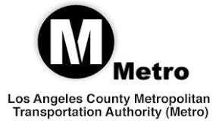
Los Angeles County Metropolitan Transportation Authority (Metro)
The Los Angeles County Metropolitan Transportation Authority (Metro) developed Workforce Initiative Now-LA (WIN-LA), a workforce development program focused on creating career pathways in the transportation industry. WIN-LA provides support for participants in areas such as life skills development, skill set enhancement and educational attainment services through a collaboration of program partners. It also increases the resources needed for training and placement of hard-to-fill positions within Metro and the transportation industry. WIN-LA is a collaborative partnership between Metro and institutions and organizations interested in helping job seekers, companies and local communities through demand-driven workforce services. The goal is to create career pathway opportunities in the transportation and construction industries. For more information visit, https://www.metro.net/about/win-la/

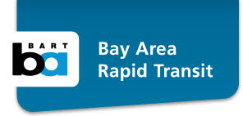
Bay Area Rapid Transit
The Bay Area Rapid Transit District (BART) received funding to establish the Transit Career Ladders Training (TCLT) Program. This program creates direct and accessible pathways to employment in the transit industry by partnering with Workforce Investment Boards and community colleges in the Bay Area. As encouraged by USDOT's Ladders of Opportunity Initiative, the TCLT program promotes transportation careers in low-income areas, in unemployed and underemployed communities, and among minorities, veterans, and women. TCLT also supports and enhances existing technical programs at local colleges through real-world interaction with the transit system. For more information, visit https://www.bart.gov/sites/default/files/docs/BART%20Career%20Ladder%20Bro%20%204_6_16%20.pdf

Workforce Resources

According to the Eno Center for Transportation, “more than 13 million jobs—about 9 percent of the civilian workforce in the United States—are transportation-related.” Because of this growth, the transportation industry is positioned to be a major source of jobs in the U.S. Yet, this will require the hiring of millions of workers to fill vacancies created by those leaving the field for other industries, those retiring and those exiting for other reasons. The following workforce resources support initiatives to develop and expand the nation's transportation workforce.

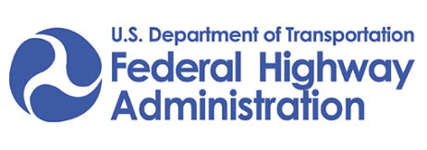
U.S. Department of Transportation/Federal Highway Administration
Center for Transportation Workforce Development
The Center for Transportation Workforce Development provides national leadership, coordination, and assistance that supports initiatives to develop and expand the nation's transportation workforce. From early education through ongoing professional development, the center provides program support, technical assistance, and workforce development activities in partnership with federal, state, and local agencies, industry organizations, schools, colleges and universities, and other education providers. For more information, visit https://www.fhwa.dot.gov/innovativeprograms/centers/workforce_dev/

APTU
APTAU is the American Public Transportation Association’s (APTA) one-stop educational, professional, career, and workforce development center where members can access professional development and career learning opportunities. APTAU is strengthening and expanding APTA’s existing legacy training programs, including “Leadership APTA” and “Emerging Leaders”, education, and workforce development offerings. This virtual portal provides real-time information and allows members to access resources for employees and post their best practices. It helps APTA members plan for, attract, and retain a diverse, skilled, and knowledgeable workforce to meet tomorrow’s needs. For more information visit https://www.apta.com/research-technical-resources/aptau/

Eno Center for Transportation
Through its professional development programs, Eno cultivates creative and visionary leadership by giving public and private transportation leaders the tools and training they need to succeed together. Since its inception, Eno has instructed over 3,500 transportation professionals. For more information, visit https://www.enotrans.org/issues-and-modes/workforce/page/2/

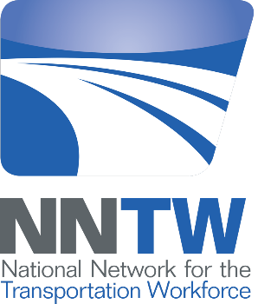
National Network for the Transportation Workforce
The National Network for the Transportation Workforce (NNTW) comprises five regional transportation workforce centers funded by Federal Highway Administration. The five centers are as follows:
- West Region Transportation Workforce Center (WRTWC) based at Montana State University;
- Midwest Transportation Workforce Center (MTWC) based at the University of Wisconsin;
- Northeast Transportation Workforce Center (NETWC) based at the University of Vermont;
- Southeast Transportation Workforce Center (SETWC) based at University of Memphis; and the
- Southwest Transportation Workforce Center (SWTWC) based at California State University, Long Beach
Each of the five centers is dedicated to the development of the transportation workforce as well as certain disciplines unique to each center. For more information, visit http://nntw.org/

Resources and References

American Public Transportation Association University (APTAU). Delivering the Future-Ready Workforce. Retrieved from:
https://www.apta.com/research-technical-resources/aptau/

Bureau of Labor Statistics. (2019). Transportation and Material Moving Occupations. Retrieved from: https://www.bls.gov/ooh/transportation-and-material-moving/home.htm

Department of Transportation, Federal Highway Administration. Center for Transportation Workforce Development. Retrieved from:
https://www.fhwa.dot.gov/innovativeprograms/centers/workforce_dev/default.aspx

Eno Center for Transportation. Workforce. Retrieved from:
https://www.enotrans.org/issues-and-modes/workforce/

George, Justin. (2019, October 5). A glimmer of hope as ridership rebounds for Metro and other transit systems. The Washington Post. Retrieved from:
https://www.washingtonpost.com/local/trafficandcommuting/a-glimmer-of-hope-as-ridership-rebounds-for-metro-and-other-transit-systems/2019/10/05/f4e92aae-e5f4-11e9-a331-2df12d56a80b_story.html

The National Network for the Transportation Workforce (NNTW). (2012). National Transportation Workforce Summit Summary of Results: Framework for Action. Retrieved from:
http://netwc.net/wp-content/uploads/2018/02/NTWS_Summary_of_Results1.pdf

The National Network for the Transportation Workforce (NNTW). (2019). Retrieved from:
http://nntw.org

Rapier, Graham. (2019, October 7). The transportation sector was a breakout star in the latest jobs report thanks to historic shortages and the upcoming holiday season. Business Insider. Retrieved from:
https://www.businessinsider.com/september-jobs-report-transportation-came-out-on-top-2019-10

Sweet, S., et al. (2010). Talent Pressures and the Aging Workforce: Responsive Action Steps for the Transportation and Warehousing Sector. The Sloan Center on Aging & Work at Boston College. Retrieved from:
https://www.bc.edu/content/dam/files/research_sites/agingandwork/pdf/publications/TMISR09_Transportation.pdf

TR News September-October 2019: Transportation Workforce of the Future. Retrieved from:
http://www.trb.org/Publications/Blurbs/179950.aspx

Transit Career Ladders Training (TCLT). Bay Area Rapid Transit. 2016. Retrieved from:
https://www.bart.gov/sites/default/files/docs/BART%20Career%20Ladder%20Bro%20%204_6_16%20.pdf

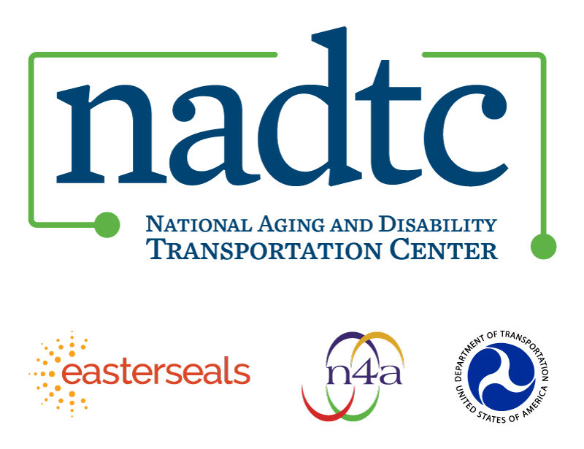

The National Aging and Disability Transportation Center (NADTC) is a program funded by the Federal Transit Administration and administered by Easterseals and the National Association of Area Agencies on Aging (n4a) with guidance from the U.S. Department of Health and Human Services, Administration for Community Living.
NADTC’s mission is to increase accessible transportation options for older adults, people with disabilities, and caregivers nationwide.
National Aging and Disability Transportation Center
Washington, D.C. 20003
Telephone and toll-free hotline: (866) 983-3222
TTY: (202) 347-7385
Email: contact@nadtc.org
Website: www.nadtc.org

Follow us:
Facebook
Twitter
YouTube
LinkedIn

