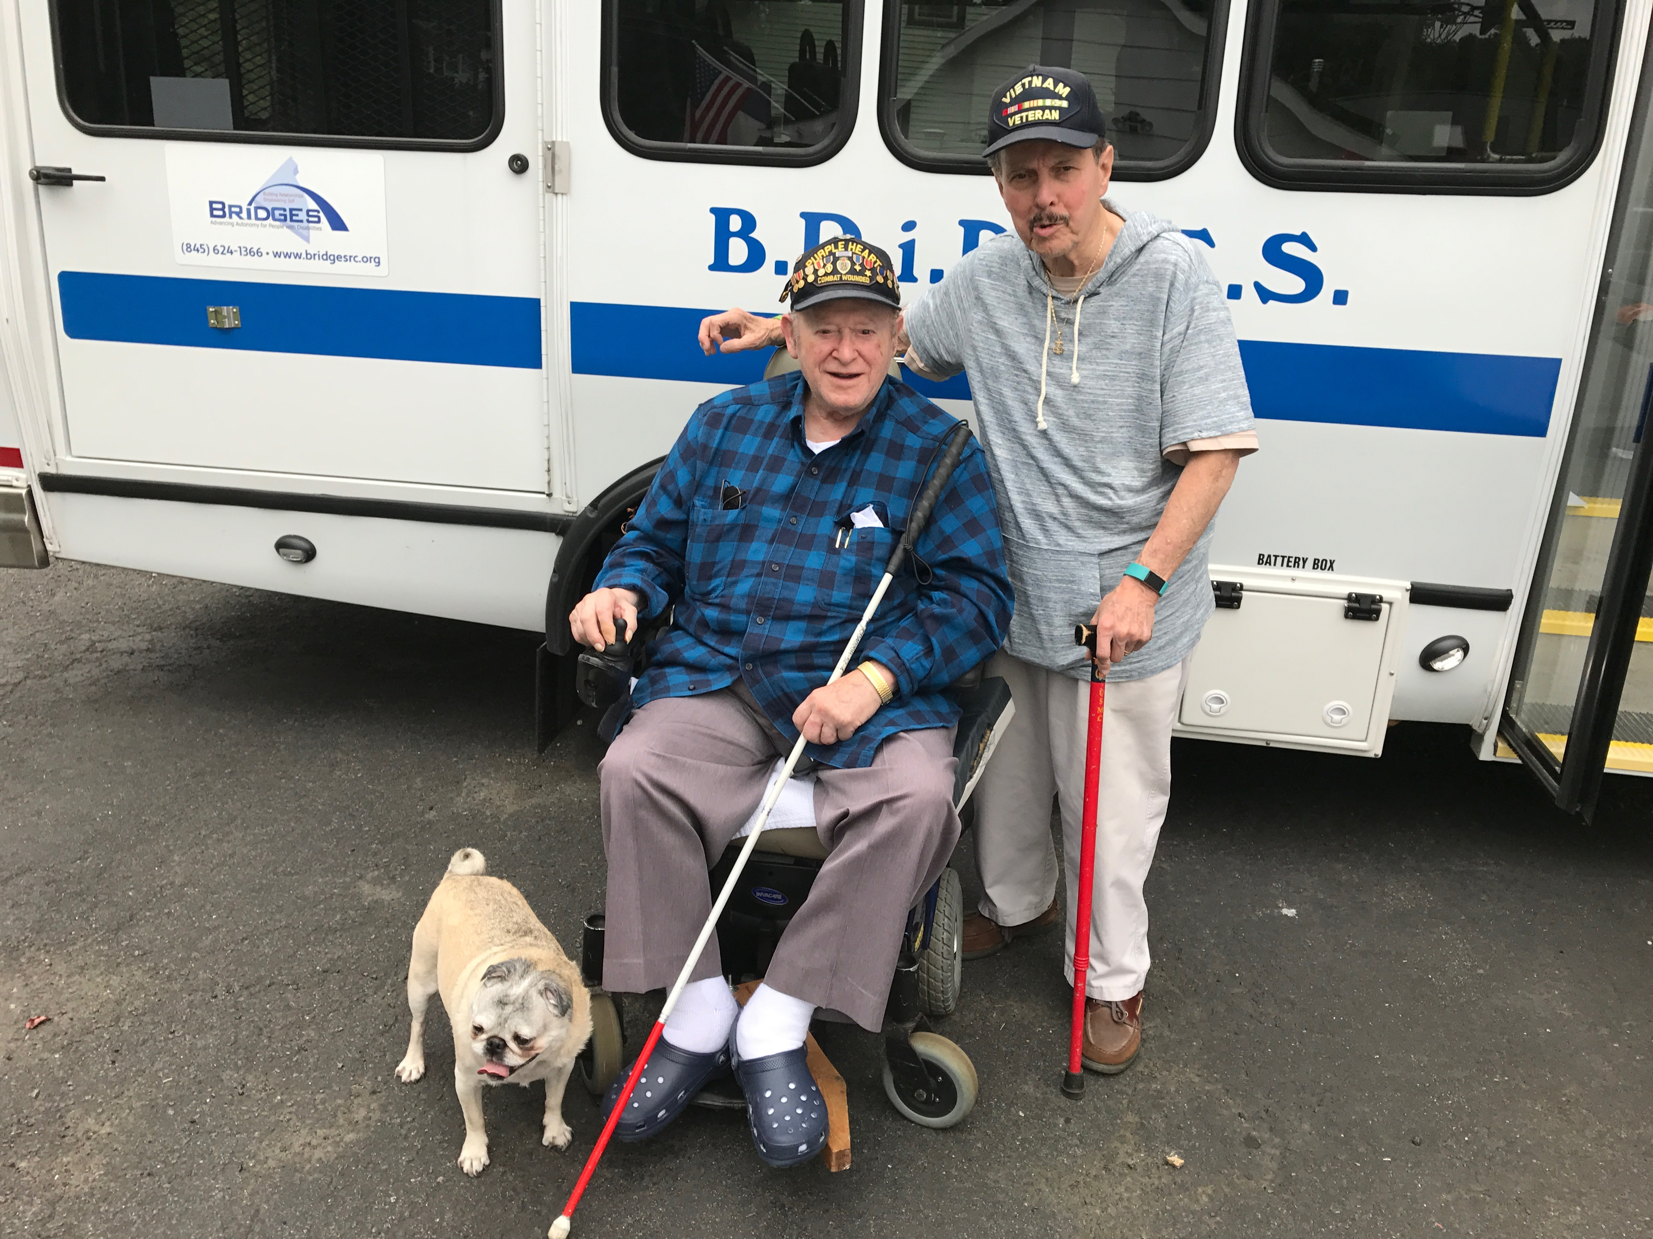
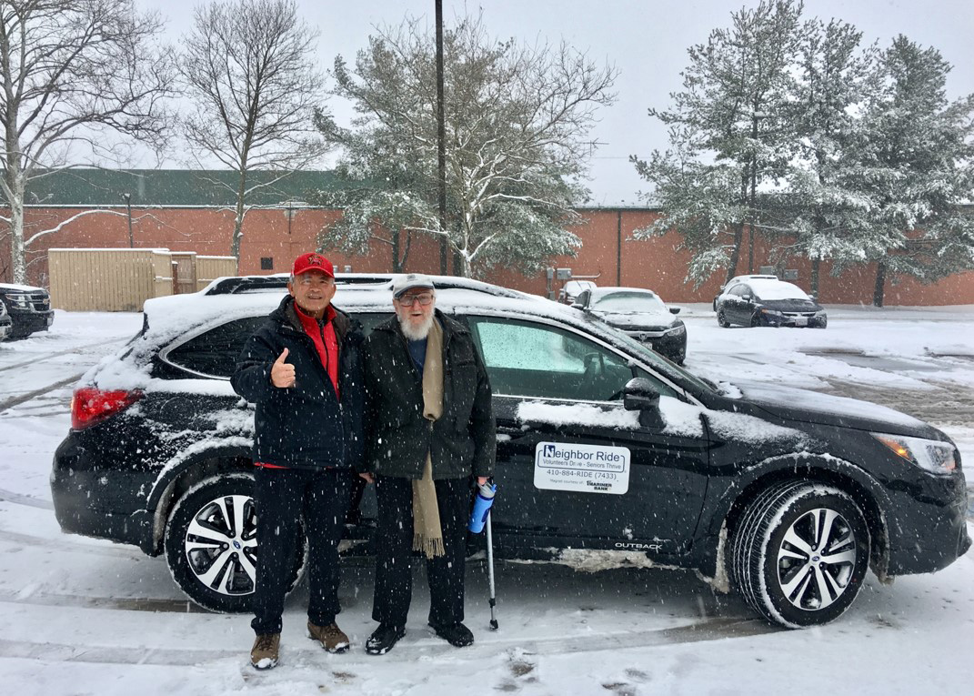
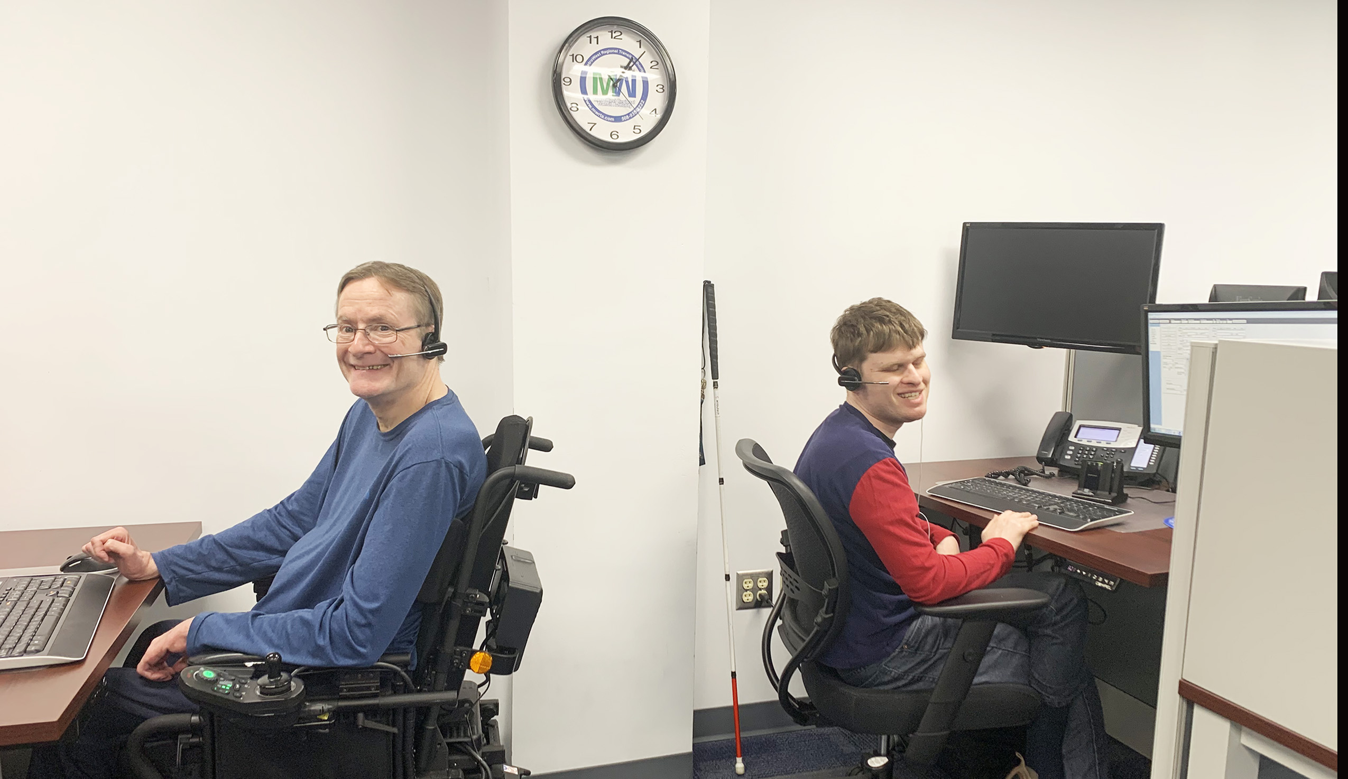

Introduction

Each year, the National Aging and Disability Transportation Center (NADTC) publishes a trends report to review significant topics in transportation. Published annually since 2016, the report includes overviews of popular transportation matters, challenges and opportunities of each topic, and examples of how the transportation trend is being implemented in communities across the United States. As in previous years, the Trends Report is divided into stand-alone ‘Topic Spotlights’ for individual download.

With its mission to increase the availability and accessibility of transportation for older adults and people with disabilities, NADTC recognizes that our work must be grounded in, and respond to, the needs and preferences of the communities and organizations that the center was created to serve. Critical to the center’s success is access to information about local communities’ efforts to develop accessible transportation, how those developments are received by people with disabilities and older adults, and the reactions of leaders in accessible transportation to developments in the transportation field.
The 2019 trends report reviews:
- Filling a Need: Hiring Veterans and People with Disabilities in Transit
- Travel Training for Older Adults
- Procuring Demand Response Transit Technology
- Scooter Policies and Accessibility within Shared Pedestrian Space
- Mental Health and Transportation
- Workforce Development in Transportation Occupations

In this Hiring Veterans and People with Disabilities in Transit Topic Spotlight, NADTC reviews the hiring of veterans and people with disabilities in transit. There are many transit agencies that could benefit from the capabilities of and value added by qualified applicants with disabilities. This report guides agencies in understanding the values, skills, and ideas people with disabilities and veterans with disabilities can bring to any organization.
Explore transportation’s trending news with us through this report! If you have questions or have a story to share from your community, reach out to us at (866) 983-3222 or email contact@nadtc.org.
Cover Photo Credits:
Top: Neighbor Ride, Columbia MD
Bottom left: MetroWest Regional Transit Authority (MWRTA)
Bottom right: BRIDGES Independent Living Center

Filling a Need: Hiring Veterans and People with Disabilities in Transit

Introduction

Transit agencies and human service providers are in the business of transporting people and are effective in providing accessible services. Buses have accessibility equipment and drivers receive training to interact with and assist passengers, working closely with riders to ensure that they make their trips. Advisory committees and collaboration with disability organizations are necessary for gaining information about service quality and needed improvements. These experiences should make our workplaces attractive to a diverse workforce. Nonetheless, transit providers are struggling to fill vacant positions as people retire and technical staff move into other positions or to private sector jobs. When driver shortages occur, routes may be realigned or, in truly difficult circumstances, canceled. However, there is a pool of qualified and motivated employees that can fill shortages and add benefits to the transit workplace: that pool is people with disabilities and veterans with disabilities who can bring needed values, skills, and ideas to the organization.

Challenges and Opportunities

Hiring People with Disabilities

Pat Hansen, Executive Director of South Central Transit Network headquartered in Valley City, ND explained her reaction when a former truck driver applied at her agency for a bus driving job. “His resume was perfect for the job. It isn’t always easy to find drivers with a Commercial Driver’s License in rural areas, so I was excited when Richard’s application came across my desk.” She tried to hide her surprise when he showed up for the interview with an arm amputated at the elbow and a prosthesis. The interview progressed well. His driving record was impeccable with no accidents or tickets. She decided to “take a chance.” Pat said, “It was one of the best hiring decisions I have ever made. Our passengers loved him! He was kind and compassionate with a personality that meshed well with other staff and the people we serve.”

Richard never had an accident while working at South Central. He passed away several years later from an unexpected illness unrelated to his disability. When asked if she would hesitate to hire another individual with a disability, Pat responded, “I wouldn’t hesitate at all. I would definitely not worry about the impact on our agency. In regard to Richard, I wish I could have had 10 more just like him!”
Within any community, there may be many personal stories about employment of people with disabilities. In the process of hiring, the transit agency could be creating a life changing opportunity for an applicant, but more importantly, bringing value to the organization and its passengers.

Excuses

There are excuses we hear all the time – people don’t know where to find qualified people with disabilities; it will cost too much to make accommodations; people with disabilities will be less productive than other employees; or they will miss too much work because of their disability. The Virginia Commonwealth University, Rehabilitation Research and Training Center on Workplace Supports and Job Retention put together a Fact Sheet on the Realities of Hiring People with Disabilities that addresses those misconceptions and allows you to have information about the realities of hiring someone with a disability. It can be found at https://vcurrtc.org/resources/viewContent.cfm/589.

Getting Started

A key to attracting motivated and skilled employees with disabilities is to begin reviewing your organization’s workplace inclusive culture. The leadership and management must promote a policy and practice that people with disabilities are welcome and valued at all levels of the transit organization, meeting and going beyond basic affirmative action requirements of the Rehabilitation Act of 1973 (https://www.dol.gov/agencies/oasam/civil-rights-center/statutes/section-504-rehabilitation-act-of-1973) and the Americans with Disabilities Act (ADA) (www.ADA.gov).
October 2019 Disability Employment Statistics Ages 16 years and over

Labor Force Participation
People with disabilities: 20.6%
People without disabilities: 68.9%

Unemployment Rate
People with disabilities: 6.9%
People without disabilities: 3.2%

Source: U.S. Department of Labor, Office of Disability Employment Policy (ODEP)

A great starting point is to review your transit organization’s statement of commitment to the principles of affirmative action and equal employment opportunity for individuals with disabilities. The statement may proclaim that the agency will not discriminate on the basis of disability and make efforts to employ and advance qualified individuals with disabilities at all levels within the company. The organization’s efforts will include a promise that all employment actions, including recruitment, hiring, selection for training, promotion, transfer, demotion, layoff, recall, termination, rates of pay or other forms of compensation, will be administered without regard to disability.

Local Examples: Sample Transit Diversity Policy Statements

Each of the following example policy statements contains language that expresses the value that a diverse workforce brings to the organization. What does your statement say about your organization for hiring of veterans and people with disabilities?

- Green Mountain Transit, Burlington, Vermont: It is the policy of Green Mountain Transit (GMT) to provide equal employment opportunity to all qualified applicants. GMT is an equal opportunity employer and all qualified applicants will receive consideration for employment without regard to race, sex, color, national origin, religion, ancestry, place of birth, sexual orientation, gender identity, HIV status, veteran, marital, citizen, genetic information, or physical mental, or emotional condition.

GMT is committed to providing a workplace that includes people of diverse backgrounds and fully utilizes their talents to achieve its mission. GMT believes that an inclusive and diverse workplace culture enhances the performance of our organization and our ability to fulfill the agency’s mission. Retrieved from https://ridegmt.com/wp-content/uploads/Applicant-Affirmative-Action-Information-1-1-2019.pdf.

- Lane Transit, Eugene, Oregon: Lane Transit District is one of the most successful and highly regarded public transit systems in the nation; has received numerous national, state, and local awards for service to the community; and, for transit districts its size, is consistently ranked among the nation's leaders in the successful implementation of Bus Rapid Transit, bus ridership, and service efficiency. LTD is committed to the values of working together, taking initiative, being professional, and practicing safety.

If you are interested in joining us as we endeavor to provide and improve services to all our diverse communities in ways that are sensitive and responsive to cultural differences, including accessibility for persons with disabilities, we urge you to apply for this position. Refer to https://www.ltd.org/employment/.

- Dallas Area Rapid Transit (DART): The Dart website employment page (https://www.dart.org/hr/humanresources.asp) features a distinct statement for hiring veterans: DART values the service Veterans and their family members have given to our country, and DART supports the hiring of returning Service Members and military spouses. If you are a Veteran or wounded warrior or the spouse of a veteran and would like assistance with the employment process at DART, please contact our EEO Office at 214-749-3366.
Review your diversity statement and determine if your agency is actually practicing the principles in it by looking at your workforce, its diversity and inclusiveness for people with disabilities. Look not only numbers of employees that have revealed they have a disability but also at the numbers in administration, management, technical and mechanical positions and drivers. Consider these questions:

- Do you have drivers with disabilities?
- Do you have technicians with disabilities?
- Are employees with disabilities primarily in one department such as customer service or reservations?
- Are there people with disabilities in management?
- Are there veterans with disabilities in a variety of departments?

The answers to questions such as these may reveal if you have placed or considered people with disabilities at all level of your organization. If not, begin to develop a process for expanding inclusive hiring and promotion.

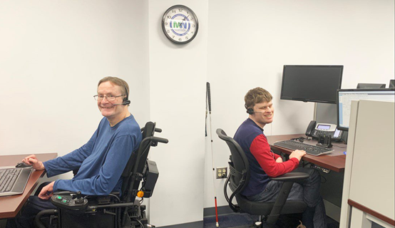
Take a moment to review the language and pictures on the agency website and read staff profiles. Do they reflect diversity and are they welcoming for people and veterans with disabilities? If not, work with your management and communications staff to make changes. Consider adding language on the agency hiring page that specifically invites people with disabilities and veterans to apply, such as this sample language:

People with disabilities are welcome to apply. If assistance or accommodation is needed during the application process or if you have questions, contact the transit human resources office at (phone number) or (email address).

In seeking employees with disabilities, staff cannot ask questions about a disability before a job offer is made. Instead, focus on the skills and tasks that need to be performed for the job. The
applicant can be asked to demonstrate how they would perform job tasks specific to the position, but cannot be questioned about disabilities, limitations, or previous medical history.

When you have a candidate with a known disability, ask the person if he or she requires any specific accommodation and discuss any accommodations in a private space. The employee with a disability is the expert on their specific needs and accommodations. Make no assumptions prior to asking – each person relates to the world and other people in a very personal way. For example, one person may use an electronic device to assist with communication, while another prefers conversing in a quiet location to help with concentration. Allow adequate time for the discussion and do not artificially set time limits that would rush the conversation.

Reasonable Accommodations

All employees need the right tools and work environment to effectively perform their jobs. Similarly, individuals with disabilities may need workplace adjustments – or accommodations – to maximize the value they can add to their employer. The Americans with Disabilities Act requires employers to provide job applicants and employees with disabilities reasonable accommodations so that they can perform jobs and benefit from equal employment opportunities. Employees with disabilities have the right to reasonable accommodations through modifications to the workplace, job tasks, or policies that allow them to do the job. An employer must provide an accommodation unless it would create undue hardship or burden on the organization.

An accommodation can be simple, such as putting blocks under a desk’s legs so a person who uses a wheelchair can roll up to it. It might involve advanced technology, such as installing a screen reader on a computer so that a person who is blind can manage documents. It may be procedural, such as altering a work schedule or job assignments. When thinking about accommodations, the focus should not be on the person’s disability but rather on essential job tasks and the functions necessary to complete them.

Employers are to discuss any accommodation requested by the employee through an interactive process. The employee may suggest an accommodation, and after discussion, an employer may suggest an alternative modification or accommodation the employee must consider. The alternative may or may not be acceptable to the employee. Accommodations vary based on the needs of the individual, so a truly interactive process is important. To ensure that accommodations are readily available, create a budget for accommodation requests that is reasonable and readily available for current and future staff. Additionally, it is valuable for
employers to have a process to regularly review and update their reasonable accommodation policy along with procedures for implementation.
When an accommodation request is submitted:
- Review accommodation request form and documentation;
- Meet with the employee to explain the process and discuss the employee's request and using an interactive process, identify which accommodations could be effective and reasonable;
- If accommodations are warranted and approved, sign an accommodations agreement;
- Work with the supervisor to provide the agreed upon accommodations; and
- Follow up periodically with employee regarding effectiveness of the requested accommodation.

The Job Accommodation Network (JAN) is a resource and service that provides individualized work related accommodation assistance based on needs of an employee. Information can be found at www.askjan.org or (800) 526-7234 voice and (877) 781-9403 TTY.

Disability Etiquette

People are all different with varying ways of interacting with others and the world around us. Some of the differences may be related to disability, may be cultural, or may be based on a habit or mannerism. Regardless, each person wants to be treated with respect and as an equal to everyone else. Proper disability etiquette can make the employee with a disability feel welcomed and valued. Here are some tips:

- Emphasize the person, not the disability. Use person-first language, such as “a man with a disability” instead of “a disabled man” or “a woman who uses a wheelchair” instead of “a wheelchair-bound woman.” Avoid outdated terms such as “handicapped,” “crippled” or “elderly.”
- Communicate with people with courtesy and respect. Identify yourself and provide your title, if appropriate. Shake hands when appropriate. Never make assumptions about a person’s physical or mental abilities.
- If you are interviewing person in a wheelchair, sit in a chair to be at eye level and facing the person. If applicant has an assistant, speak directly to the job applicant rather than the assistant, referring to the assistant only if prompted by the applicant.
- When speaking with someone who is deaf or hard of hearing, face the person to whom you are speaking and do not let objects obstruct his view. Use a normal tone of voice and speak naturally.
- When speaking with someone who is blind or has a visual impairment: Identify yourself and others who may be with you. Do not leave without letting the person know of your departure. When offering to assist, allow the person to take your arm. This will help you to guide rather than propel or lead her.
- When giving directions, use specifics such as “walk until the carpet ends and turn left” or “turn to your right, and the door is 10 feet ahead on the right.” Instructions can include identifying architectural elements that would provide orientation such as the number of doorways to pass or noticeable changes in the surface underfoot to reach the place that is being sought.
- Ensure that the workplace is accessible and disability inclusive by reviewing physical accessibility such as ramps, doors and accessible restrooms. Likewise, ensure that information and communication technology is accessible or can be used with assistive technology equipment. It is important that attitudinal barriers be removed within the organization so applicants and employees are welcomed as qualified individuals with disabilities and are valued contributors to the workplace.

Tips for an Accessible Workplace

- Organization Policy: The transit agency must have a policy that clearly recognizes the value of hiring and keeping employees with disabilities, including providing accommodation and supports. The policy must also be clear that verbal harassment around disability and other protected traits is not tolerated and expedient action on complaints will occur. Verbal harassment includes off handed comments, jokes, and insensitive remarks focused on the disability or other protected traits.

- Accessible Website: All employee pay systems, and internal communication should be accessible to workers. If not currently usable by the employee, work with your IT department, vendors, or state assistive technology organization to improve website accessibility or develop a work around until accessibility can be improved. To assess your website accessibility, go to https://www.w3.org.

- Assistive Technology: Assistive technology is one of the most important accommodations for employees with various disabilities to use computers and other electronic systems or for communication. An assistive technology device is defined as “any item, piece of equipment, or product system, whether acquired commercially off the shelf, modified, or customized, that is used to increase, maintain or improve functional capabilities of a person with a disability. Assistive technology also includes items such as tools for manual gripping or holding or for modification of shop tools. The Assistive Technology Industry Association (ATiA) has published an Assistive Technology Resources Funding Guide, which can be found at https://www.atia.org/at-resources/what-is-at/reources.

- Modified Training: If new devices or technology is being displayed in an all-staff training, ensure that individualized instruction is available to assist people needing it, including people with disabilities. If technology is being used at a meeting, make sure it is accessible to all, including closed captioning, if appropriate.

- Employment Test Modification: When applying for jobs, a potential applicant with a disability could request to have the process modified to meet a specific need. For example, an applicant with a cognitive or reading disability could ask for a qualified reader to orally read the test questions. Additionally, an applicant may request that more time be allowed for testing due to concentration or focus issues related to a disability. For a person who is blind or visually impaired, modifications could be made through large print applications or online formats.

- Accessible Formats: An employee or applicant with a visual or learning disability can request that work-related written materials be made available in their preferred accessible format such as accessible pdf, large print, braille or audio.

- Work from Home: Employees may request a work from home arrangements if their disability makes it difficult for them to travel to the workplace due to inclement weather or major travel delays. The request must be evaluated on its effect on workplace productivity or coverage. For some transit jobs, such as driving, maintenance or dispatch, working from home would not be possible.

Summary

In your transit workplace, there are many positions that could benefit from the capabilities of and value added by qualified applicants with disabilities. Look around the organization and envision where a more diverse workforce is beneficial to everyone. Work proactively with department managers to determine how vacant job positions could be filled with a veteran or person with a disability. Think about ways to modify a job requirement or workplace to make it more welcoming for an applicant with disabilities through accommodations. Be proactive in seeking valued employees with disabilities and confirm that the workplace is welcoming through the practice of disability etiquette. With an organizational commitment to hiring people with disabilities and veterans, positions can be filled with highly-motivated, capable, and skilled employees.

Resources and References

ADA National Network. Retrieved from: https://adata.org/
Department of Labor. Veteran and Military Transition Center. Retrieved from: https://www.careeronestop.org/Veterans/default.aspx
Employer Assistance and Resource Network on Disability Inclusion (EARN). Retrieved from: https://askearn.org/
Federal Transit Administration. Equal Employment Opportunities (EEO) Circular 4704.1A. (2016). Retrieved from: https://www.transit.dot.gov/sites/fta.dot.gov/files/docs/regulations-and-guidance/civil-rights-ada/56501/eeo-circular-c-47041a.pdf
National Aging and Disability Transportation Center (NADTC). Including People with Disabilities: Communication & Meeting Etiquette Guide. Retrieved from: https://www.nadtc.org/resources-publications/including-people-with-disabilities-communication-meeting-etiquette-guide/
U.S Department of Labor. Office of Disability Employment Policy (ODEP). The Partnership on Employment and Accessible Technology. Accessible Technology Action Steps: A Guide for Employers. Retrieved from: https://www.peatworks.org/action-steps
U.S Department of Labor. Veterans' Employment & Training Service. Retrieved from: https://www.dol.gov/agencies/vets/hire
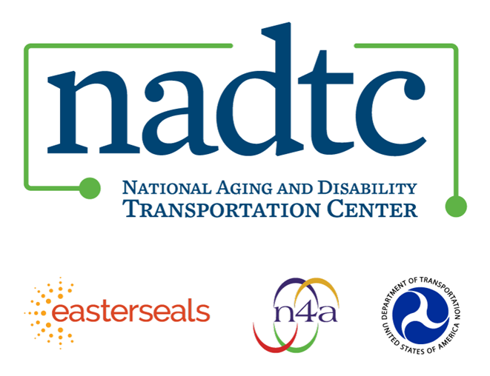
The National Aging and Disability Transportation Center (NADTC) is a program funded by the Federal Transit Administration and administered by Easterseals and the National Association of Area Agencies on Aging (n4a) with guidance from the U.S. Department of Health and Human Services, Administration for Community Living.

NADTC’s mission is to increase accessible transportation options for older adults, people with disabilities, and caregivers nationwide.

National Aging and Disability Transportation Center
Washington, D.C. 20003
Telephone and toll-free hotline: (866) 983-3222
TTY: (202) 347-7385
Email: contact@nadtc.org
Website: www.nadtc.org

Follow us:
Facebook
Twitter
YouTube
LinkedIn

