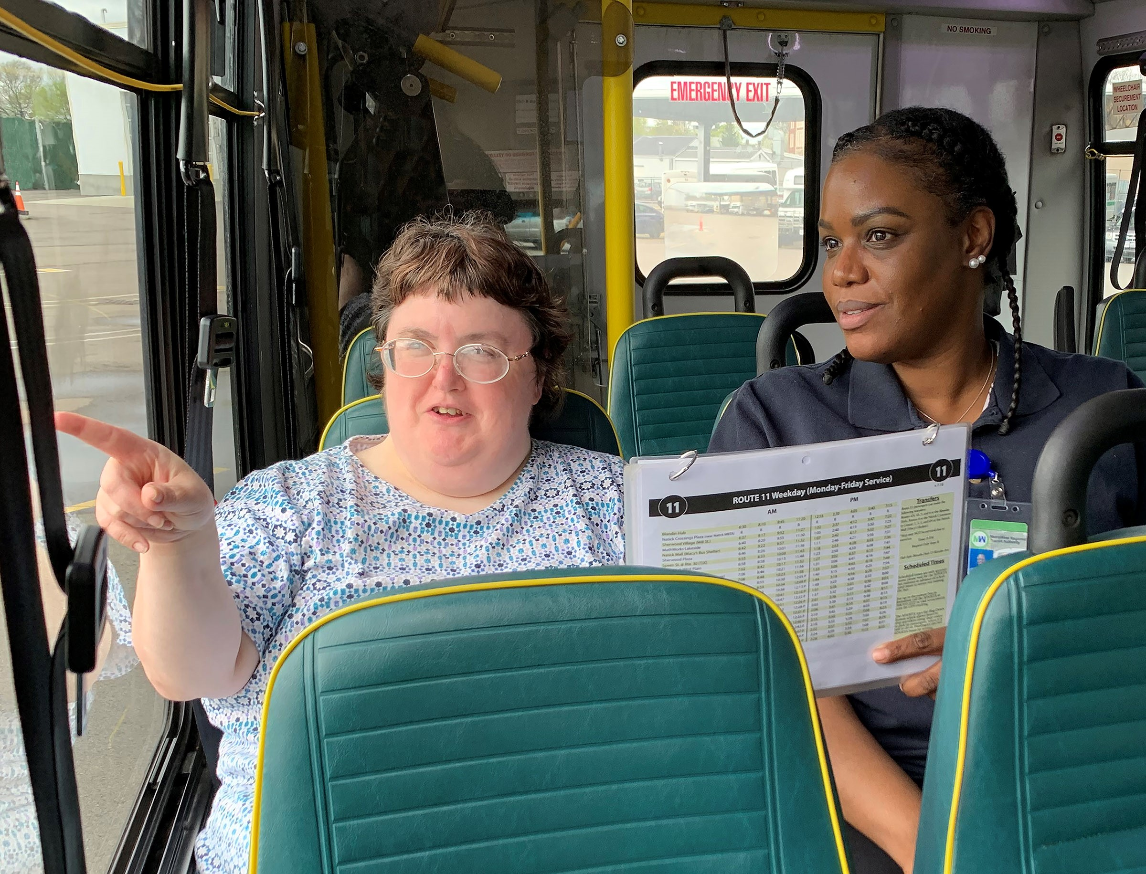
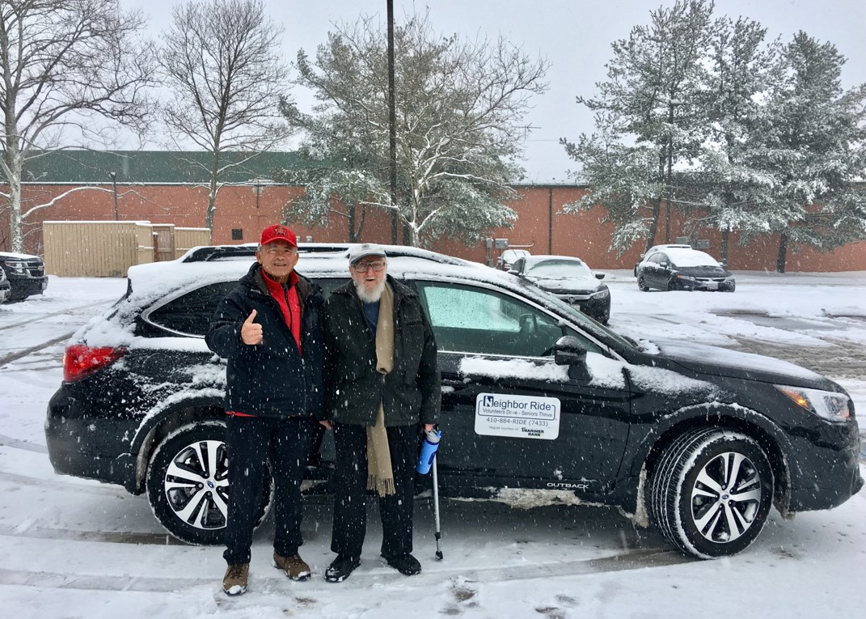

Introduction

Each year, the National Aging and Disability Transportation Center (NADTC) publishes a trends report to review significant topics in transportation. Published annually since 2016, the report includes overviews of popular transportation matters, challenges and opportunities of each topic, and examples of how the transportation trend is being implemented in communities across the United States. As in previous years, the Trends Report is divided into stand-alone ‘Topic Spotlights’ for individual download.

With its mission to increase the availability and accessibility of transportation for older adults and people with disabilities, NADTC recognizes that our work must be grounded in, and respond to, the needs and preferences of the communities and organizations that the center was created to serve. Critical to the center’s success is access to information about local communities’ efforts to develop accessible transportation, how those developments are received by people with disabilities and older adults, and the reactions of leaders in accessible transportation to developments in the transportation field.
The 2019 trends report reviews:
- Filling a Need: Hiring Veterans and People with Disabilities in Transit
- Travel Training for Older Adults
- Procuring Demand Response Transit Technology
- Scooter Policies and Accessibility within Shared Pedestrian Space
- Mental Health and Transportation
- Workforce Development in Transportation Occupations

In this Mental Health and Transportation Topic Spotlight, NADTC reviews mental health and transportation. Providing access to mental health services for disadvantaged populations requires coordination of a number of different elements, including transportation providers. This section provides examples of how some transportation agencies are using federal, local and/or state funding to coordinate or provide transportation to mental health services.

Explore transportation’s trending news with us through this report! If you have questions or have a story to share from your community, reach out to us at (866) 983-3222 or email contact@nadtc.org.
Cover Photo Credits
Top: Metrolina Association for the Blind, Charlotte, NC
Bottom left: Neighbor Ride, Columbia, MD
Bottom right: MetroWest Regional Transit Authority (MWRTA), Framingham, MA

Mental Health and Transportation

Introduction
Millions of people are affected by mental health disorders, also called mental illness, (defined as a mental, behavioral, or emotional disorder) in the United States each year. In the U.S. 1 in 5 adults experience mental illness each year (SAMHSA, 2018). It is important for people with mental illness to have consistent access to effective treatment. For many individuals, there are challenges when it comes to accessing mental health services. While transportation may not be the top barrier to accessing treatment, it does present a challenge for many individuals, especially in rural areas. This report looks at mental health, the issue surrounding access to mental health services and how transportation agencies and programs are responding.

What is Mental Health and Mental Illness?

Mental health is our emotional, psychological and social well-being. It affects how we think, feel and act. We all have mental health. However, a person that is experiencing poor mental health does not necessarily mean that individual has a mental illness. Mental illnesses are serious disorders that can affect a person’s thinking, mood and/or behavior. There are several factors that contribute to mental illness, including:
- Family History
- Life experiences (e.g. trauma or abuse)
- Biological factors, (e.g. genes or brain chemistry)
A mental illness that interferes with a person’s life and ability to function is called a serious mental illness (SMI). More than 11 million adults have SMI (SAMHSA, 2018). Serious mental illnesses include:
- Bipolar Disorder is a brain disorder, also known as a manic-depressive illness that causes intense shifts in mood, energy, and activity levels.
- Major Depressive Disorder (MDD) is one of the most common mental disorders. Symptoms vary from person to person, but may include sadness, hopelessness, anxiety, pessimism, irritability, worthlessness, and fatigue.
- Schizophrenia is a chronic and severe mental disorder that interferes with a person’s ability to think clearly, manage emotions and make decisions. People may experience hallucinations, delusions, extremely disordered thinking and a reduced ability to function in their daily life.

Having access to mental health services can improve lives and reduce the challenges that come with managing mental illness. There are many treatment options for mental health disorders and these treatments will vary from person to person.

Treatment Options

The treatment of mental health disorders can include Psychotherapy, medication, hospitalization and support groups (Mental Health America, 2019).
Psychotherapy, also known as “talk therapy,” is a therapeutic treatment that explores emotions, thoughts, and behavior with a licensed mental health care professional. With Psychotherapy, you can learn coping, stress management skills and improve a patient’s overall well-being. This type of therapy can include Cognitive Behavioral Therapy, Exposure Therapy or Dialectical Behavior Therapy. Peer support groups are a way to connect with others facing similar challenges to help an individual to cope. Therapy can also involve family members. The care of a person with mental illness often continues with family members or caregivers. Caregivers and/or family members of adults with mental or emotional health issues spend an average of 32 hours per week providing unpaid care (National Alliance for Caregiving, 2016).
Treatment often involves prescribing psychiatric medications in tandem with therapy. Medications do not cure mental illness, but they can improve symptoms and increase the effectiveness of other treatments such as psychotherapy. In some cases, hospital and residential treatment programs are a necessary option for treatment if an individual’s mental illness becomes severe.

Barriers to Receiving Mental Health Treatment

Treatment of mental health disorders can be effective if you have access to the different types of care as described above. For many individuals, there are barriers to receiving mental health treatment, including transportation. Not having transportation to the pharmacy for medications or the doctor’s office for therapy can impede progress in the treatment of mental illness. Those who are unable to receive regular mental health treatment may eventually seek emergency treatment. Mental illness and substance use disorders are involved in 1 out of every 8 emergency department visits by a U.S. adult (estimated 12 million visits).
Individuals may have challenges with riding public transportation due to symptoms (anxiety, Increased sensitivity, confused thinking) associated with mental illness and need to find alternative transportation options that may not be available in their area. Transportation to mental health treatment can be especially challenging for rural residents. In rural areas, mental health care needs are often not met because there is a shortage of providers. A study in the American Journal of Preventive Medicine that 65% of non-metropolitan counties do not
have psychiatrists and 47% do not have psychologists. For this reason, treatment for rural residents may be long distance and without access to transportation, care may be inaccessible.
Other barriers to mental health treatment include:
- Scarce financial resources allocated to mental health care
- Stigma associated with receiving mental health care
- Limited number of trained mental health providers who are trained to address the needs of the community (e.g. older adults)

Local Examples: Addressing Mental Health via Transportation

Throughout the United States, organizations are realizing the critical need to provide transportation to health care services, including treatment for mental health disorders through the provision of behavioral health services. Behavioral health is an umbrella term for care that addresses any behavioral problems impacting health, mental health and substance abuse disorders. The following are examples of programs that provide transportation to enable to access to behavioral health.

Access & Mobility Partnership Grants Initiative
Under the Access & Mobility Partnership Grants Initiative, the Federal Transit Administration (FTA) awarded grants in 2019 to 37 states. Among the grantees are Southern Highlands Community Mental Health Center and Mass Transit Authority Flint (MTA Flint). Although these projects are in the early stages of development, these programs will focus their efforts on providing or coordinating transportation for behavioral health services.

- Southern Highlands Community Mental Health Center, Illinois
Transportation for Rural Appalachian Communities (TRAC) seeks to safely transport a vulnerable, underserved population in rural southern West Virginia. TRAC provides coordinated door-to-service transportation for community members seeking Southern Highlands (SH) services via five SUVs, one 12-passenger van, and one ADA accessible van. Through the grant, the TRAC fleet will work to reduce access barriers, increase clients served, and reduce the missed appointment rate, leading to improved mental and physical health outcomes. Clients will be asked if they need transportation services during appointment scheduling. The TRAC Coordinator will coordinate transit and clients will be given an appointment and transported by a trained driver on appointment day. Southern Highlands also receives Section 5310 funding.

- Mass Transportation Authority, Flint, Michigan
Mass Transportation Authority (MTA) Flint provides non-emergency medical transportation that includes mobility management, door-to-door service and same day service. The program provides rides to wellness appointments for behavioral health patients, to dialysis treatment, and to primary/urgent care for families, and elderly and elderly disabled patients in Flint and nearby Genesee County. In FY 2016, MTA Flint received funding through the FTA’s Rides to Wellness pilot project to provide those initial rides to health services. Since the project was a success, the Michigan Department of Health and Human Services has been providing funding to MTA Flint since FY 2016. MTA Flint has also received funding through the local Department of Veterans Services, Section 5311 funding and a Michigan Mobility Challenge grant. Through the ICAM program, MTA Flint will improve their current services (Rides to Wellness) by bridging the gaps of unmet needs of their aging population and people with disabilities.
Additional information on the FTA FY18/19 Access & Mobility Grant program can be found at
https://www.transit.dot.gov/funding/grants/grant-programs/access-and-mobility-partnership-grants.

Additional Transit Programs that Provide access to Mental Health Treatment

- Rides Mass Transit District, Southern Illinois
The Rides Mass Transit District (RMTD) project is intended to enhance access to medical and mental health services in two Southern Illinois areas through a collaboration among medical providers, education and transportation providers. Rides Mass Transit is a public transportation provider and recipient of Section 5311 and Section 5307 funds, serving southern and southeastern Illinois. RMTD received a grant under the Federal Transit Administration’s Rides to Wellness Demonstration and Innovative Coordinated Access and Mobility Initiative and Section 5310 funding in FY 2016. The project is ongoing. RMTD has established a Rides Plus Call Center staffed with mobility professionals to expand services for patients seeking behavioral health services.

- Northwest Alabama Mental Health Center
The Northwest Alabama Mental Health Center has its own transportation system, using vans obtained with assistance from the Alabama Department of Transportation, to provide transportation to all their residential and day-treatment patients in all five counties in their service area (including Winston and Marion Counties). Patients can access this system any day of the week, and it can also be used to provide transportation for other outpatient needs unrelated to mental health treatment, going
as far as Birmingham. Northwest Alabama Mental Health Center has been a recipient of Section 5310 funds for its residential treatment programs for people with disabilities.

Summary

Living with a mental illness can present challenges in life, but with access to proper treatment and available and accessible transportation options, individuals can be on the road to recovery and wellness. Providing access to mental health services for disadvantaged populations requires the coordination of health providers, community, patient, family, and transportation providers. A growing number of transportation agencies are recognizing the need for access to mental health services and are using federal, local and/or state funding to coordinate or provide transportation to these services, especially for disadvantaged populations in rural areas.

Resources and References

Andrilla, C. et al. (2018). Geographic Variation in the Supply of Selected Behavioral Health Providers. American Journal of Preventive Medicine, Volume 54, Issue 6, S199 - S207.
Retrieved from: https://www.ajpmonline.org/article/S0749-3797(18)30005-9/fulltext

Bose, J. et al. (2018). Substance Abuse and Mental Health Services Administration. Key substance use and mental health indicators in the United States: Results from the 2017 National Survey on Drug Use and Health. Rockville, MD: Center for Behavioral Health Statistics and Quality, Substance Abuse and Mental Health Services Administration. Retrieved from: https://www.samhsa.gov/data/sites/default/files/cbhsq-reports/NSDUHFFR2017/NSDUHFFR2017.pdf

Federal Transit Administration. (2019). Access & Mobility Partnership Grants. Retrieved from https://www.transit.dot.gov/funding/grants/grant-programs/access-and-mobility-partnership-grants

Mental Health America. (2019). Mental Health Treatments. Retrieved from: https://www.mhanational.org/mental-health-treatments

National Alliance for Caregiving. (2016). On Pins and Needles: Caregivers of Adults with Mental Illness. Retrieved from:
https://www.caregiving.org/wp-content/uploads/2016/02/NAC_Mental_Illness_Study_2016_FINAL_WEB.pdf

National Alliance on Mental Illness. (2019). Mental Health by The Numbers. Retrieved from: https://www.nami.org/learn-more/mental-health-by-the-numbers
Owens, P., Mutter, R., & Stocks, C. (2007). Mental Health and Substance Abuse-Related Emergency Department Visits among Adults. Agency for Healthcare Research and Quality. Retrieved from: https://www.hcup-us.ahrq.gov/reports/statbriefs/sb92.pdf

Rural Health Information Hub. (2018). Rural Mental Health. Retrieved from: https://www.ruralhealthinfo.org/topics/mental-health

Rural Health Information Hub. (2019). Barriers to Mental Health Treatment in Rural Areas. Retrieved from: https://www.ruralhealthinfo.org/toolkits/mental-health/1/barriers

Substance Abuse and Mental Health Services Administration. (2019). Older Adults Living with Serious Mental Illness: The State of the Behavioral Health Workforce. Retrieved from:
https://store.samhsa.gov/system/files/new_older_adults_living_with_serious_mental_illness_final.pdf

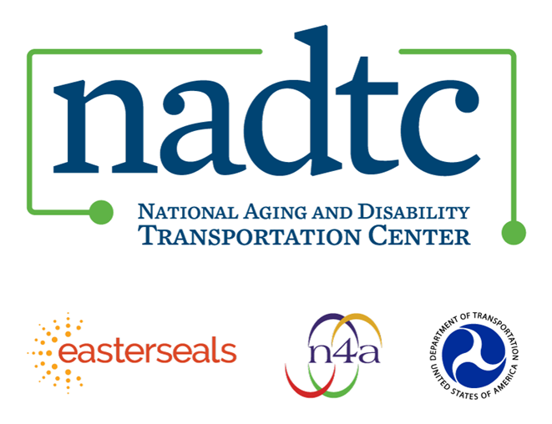
The National Aging and Disability Transportation Center (NADTC) is a program funded by the Federal Transit Administration and administered by Easterseals and the National Association of Area Agencies on Aging (n4a) with guidance from the U.S. Department of Health and Human Services, Administration for Community Living.

NADTC’s mission is to increase accessible transportation options for older adults, people with disabilities, and caregivers nationwide.

National Aging and Disability Transportation Center
Washington, D.C. 20003
Telephone and toll-free hotline: (866) 983-3222
TTY: (202) 347-7385
Email: contact@nadtc.org
Website: www.nadtc.org

Follow us:
Facebook
Twitter
YouTube
LinkedIn

