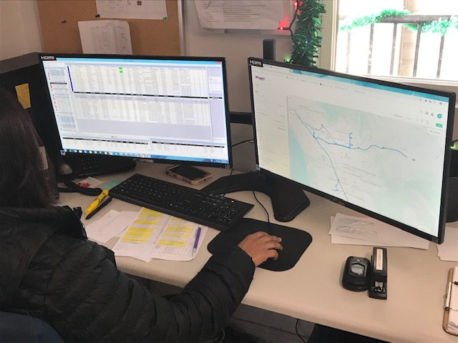
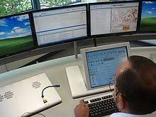

Introduction

Each year, the National Aging and Disability Transportation Center (NADTC) publishes a trends report to review significant topics in transportation. Published annually since 2016, the report includes overviews of popular transportation matters, challenges and opportunities of each topic, and examples of how the transportation trend is being implemented in communities across the United States. As in previous years, the Trends Report is divided into stand-alone ‘Topic Spotlights’ for individual download.

With its mission to increase the availability and accessibility of transportation for older adults and people with disabilities, NADTC recognizes that our work must be grounded in, and respond to, the needs and preferences of the communities and organizations that the center was created to serve. Critical to the center’s success is access to information about local communities’ efforts to develop accessible transportation, how those developments are received by people with disabilities and older adults, and the reactions of leaders in accessible transportation to developments in the transportation field.
The 2019 trends report reviews:
- Filling a Need: Hiring Veterans and People with Disabilities in Transit
- Travel Training for Older Adults
- Procuring Demand Response Transit Technology
- Scooter Policies and Accessibility within Shared Pedestrian Space
- Mental Health and Transportation
- Workforce Development in Transportation Occupations

In this Procuring Demand Response Transit Technology Topic Spotlight, NADTC outlines the best methods to procure technology for your agency. Following proper procurement processes will ensure a fair and open competition for those services and net your agency with the product that will best meet its identified needs.

Explore transportation’s trending news with us through this report! If you have questions or have a story to share from your community, reach out to us at (866) 983-3222 or email contact@nadtc.org.

Procuring Demand Response Transit Technology

Introduction

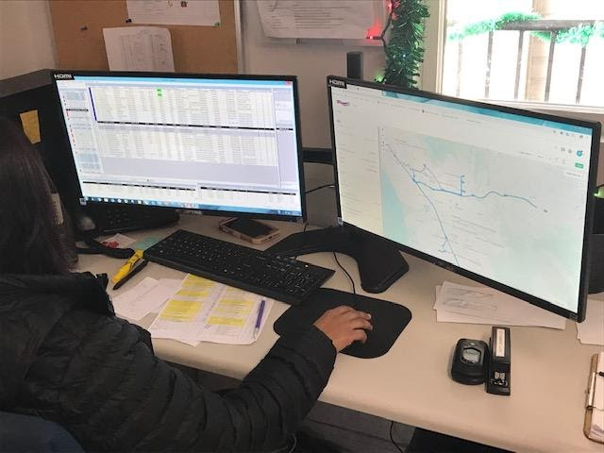
Procuring technology for demand response transportation – whether a scheduling and dispatch system, communications capabilities (internet or FM radio), real-time vehicle tracking apps, or a maintenance management system – requires preparation and care. There are different procurement methods that can be used. This brief will outline the best use of Requests for Proposals, Requests for Qualifications, Requests for Information, and Requests for Expressions of Interest when preparing to procure technology for your agency. It is critical that you be prepared ahead of time by understanding your agency’s needs before going through the process of obtaining technology. Following proper procurement processes will ensure a fair and open competition for those services and net your agency with the product that will best meet its identified needs. Seeking advice from other similar agencies who have recently procured technology or from coaches and consultants who specialize in technology for demand response transit can help you get the best results.

Procurement Method

A Request for Proposals (RFP) is the preferred procurement method for transit technology – especially for technology used for ride booking, scheduling, and dispatch. An Invitation to Bid is not appropriate to obtain transit technology, as transit technology is in a constant state of innovation. Equipment and operating systems are regularly being improved and constantly becoming out-of-date. The RFP process enables the purchase of functionality, rather than equipment or software that may soon become obsolete. Scheduling and dispatch technology (both hardware and software) must be integrated to maintain functionality. The RFP process allows the purchaser to question offerors on the capabilities of each component, and their ability to integrate those functionalities.
The RFP process also offers the option of procuring on the Software as a Service (SaaS) model, where the capabilities are bought through a subscription. The vendor is responsible for installing, maintaining, and updating the software and hardware and training the users. SaaS can also include training the user to update and replace software and hardware, as a cost reduction measure. Two necessary caveats to a SaaS agreement are: 1) the transportation provider must own the data; and 2) the data must be transferrable, should a new SaaS vendor be procured in the future.
Bids are a good procurement vehicle when purchasing equipment or services for which the concept, design and functionality can be thoroughly described and will be satisfactory through the expected life of the product being obtained. Examples of items to be obtained through a bidding process include vehicles and furniture as well as cleaning or catering services. Offers can’t be questioned during a bid process. Bids that meet the procurement specifications are evaluated by price, not functionality.

Preparation

Before developing the scope of services for a procurement, you must decide on the functionalities to be obtained. In which areas is current performance deficient, based on input from drivers, dispatchers, customers, and funding agencies? In what areas is the current functionality adequate? Assessing the strengths and weaknesses of the current technology is a critical prerequisite to developing the functionalities needed for new technology.

Next, do your own due diligence to gather intelligence on which vendors offer – or which agencies have procured – technology that seems to be successful. Attending trade shows associated with state and national transit conferences will provide a perspective on the products offered. You can network with users of those products attending the convention for their perspective. Vendors usually will share contact information for their customers on their websites or upon request. Vendors will also provide an on-line demonstration. The follow-up is to travel to those sites that are as close to equivalent as yours to see the product being used. Seeing the dispatch and booking screens and talking with the users can be very enlightening. Asking for the local definition of on-time performance and seeing their success in that measure provides a good indicator of functional performance. If the product has been in use for a few years, you can also consult the National Transit Database for sites using the product to check the productivity of services using software, specifically the boardings per vehicle service (revenue) hour or mile.
If a difficult functionality is needed, one can issue a Request for Qualifications (RFQ) as a prerequisite for responding to the subsequent RFP. The RFQ can be used to weed out vendors
who have no experience or no success in providing that difficult functionality. The RFQ can require contact information for properties in which the technology has been successfully implemented.
Once one finds a transit technology application that appears to meet one’s needs, ask for the Scope of Services as well as RFP Price Sheet used to obtain the technology. Public sector procurement documents are generally public information. Use other’s procurements to develop an Independent Cost Estimate (ICE) for the desired functionalities. Developing an Independent Cost Estimate of the functionality to be procured is a best practice – and required if using Federal Transit Administration (FTA) funds. An ICE can’t be supplied by a vendor – independent research is necessary. Reviewing price sheets from successful technology procurements that include the desired functionalities in conjunction with their first-year costs and current year costs will form the basis of a very solid ICE. Comparing first year and current year costs gives a good base for estimating cost hikes in future years.

If a new functionality is needed and doesn’t seem to be offered, one can issue a Request for Information (RFI) or Request for Expressions of Interest (REOI). An RFI is useful if the requested is not cutting-edge. An REOI is a tool to test the vendor market with preliminary ideas for a functionality and solicit responses that help shape those ideas into a clearly-defined vision. Responding vendors won’t be obligated to respond to a subsequent RFP. They may offer a product that offers similar functionality – and references useful for developing an ICE.

Scope of Services

The Scope of Services should begin with a description of service area characteristics, which may affect the functionalities sought in the RFP. These include the jurisdictions served, land area, and population of the service area; the peak vehicle requirement; annual ridership, costs, revenues, service miles and hours; discussion of clientele groups and their service needs; and annual or monthly reports.

Technology vendors need to know the environment of the service area including a general description of the topography. Does the service area have cellular coverage throughout; mostly but with holes; only in sections; or little-to-none? Does the service area have FM-band coverage throughout; mostly but with holes; only in sections; or little-to-none? Dispatch technology can be adapted either to cellular tracking or FM tracking – whichever makes more sense locally.

Describe the service structure, which may include a call center, multiple ride providers, and several agencies that fund rides. The fare structure and client intake process should be included as well as average weekday/Saturday/Sunday trip and call volumes.

A statement is needed regarding the purposes of the functionalities to be procured. What deficiencies need to be remedied? This section should also specify that the client retains ownership and all rights thereof to all data and reports produced and be granted unencumbered access to all client data. The Contractor shall provide a “data dictionary” showing each database and defining each field in those databases. The software, hardware and licenses associated with producing and transmitting that data shall be the property of the Contractor.

Functionalities

If the Scope is focused on functionality rather than equipment, the service being procured is unlikely to become obsolete during the contract term.

The table below lists functionality categories, adapted from a combined call center/demand response technology procurement. The full detailed version of the functionality requirements are shown in this blog post: https://www.nadtc.org/news/blog/procuring-technology-for-computer-aided-scheduling-dispatch/.

SECTION | DESCRIPTION
1 | Dashboard and On-Going Monitoring
2 | Ride Vendor Management
3 | Client File, Booking and Scheduling
4 | Dispatch
5 | Web-Based Tools
6 | Telephonics
7 | Reporting

Evaluation Criteria

The RFP must list each evaluation criteria with a description of the criteria and the associated points. Depending on state and local procurement guidelines, price may only count for 20% of the evaluation points. Other criterion may include corporate and staff experience; references from successful installations; responsiveness to the functionalities in the Scope; and transition plan; as well as duration.

Deliverables

As a contract resulting from an RFP is subject to negotiation, vendor responses to the RFP should be divided into two documents: a technical proposal and a business proposal. The technical proposal would respond to both the Contract Terms and Provisions and the Scope. A Selection Advisory Committee (SAC) would review the technical proposals and reject those that don’t meet procurement functionality requirements.

The business proposal responds to the RFP Price Sheet. Business proposals from qualified vendors (those technical proposals deemed acceptable) would be reviewed by the SAC.

The Price Sheet is a key document within the RFP, vital to both cost projections and cost control. A well-structured price sheet – which can also be provided in an attached electronic spreadsheet – will enable the agency to project costs over the contract term. The price sheet should split out the cost of each overall functionality, including: telephonics; booking and scheduling; dispatch; website; etc., recognizing that these are interdependent. As option years are generally subject to negotiation, analysis should focus on the fixed-term of the contract. The length of the contract term including option years may depend on state procurement regulations.

Technology procurements are best prepared as a partnership with a purchasing officer, who can serve two purposes: to ensure that the document is in compliance with procurement best practices as well as state requirements and your agency’s policies; and being from a non-transportation perspective, to ask for clarifications to ensure that the language is clear. The purchasing officer will coach you on whether an RFI, REOI, or RFQ is needed based on the field work you have done in developing your draft scope of services. The purchasing officer will also assist you in structuring the price sheet, the evaluation criteria, and choosing members of the SAC. Your agency may have rules prohibiting selection of outside customer organization representatives to serve on the SAC and also may limit the number of SAC members from any single department.
Coaches and Consultants

While technology is constantly improving, the process to procure technology seldom changes. People who have been through this process and overseen successful procurements of demand response transportation technology are available to advise. Reach out to agencies that have recently procured technology to see who they have used as experts as coaches and consultants to guide them through the process. Ask them how satisfied they were with the services that were provided to them, and whether or not they would recommend them for your project. It is also good to find advisors who have experience in assisting agencies in developing specifications.

Summary

Following best practice procedures when procuring technology for demand response transportation programs is critical for ending up with a product that will provide the agency with the functionality that will serve you best for as long as possible. If you have never done a technology procurement, it may be advisable to speak to an expert or contract with a consultant. It is always important to do your homework first and make sure you understand what it is your agency needs before attempting to make a significant purchase. Taking the time to do it right will pay off in the long run and provide you with the best results for your efforts.

Resources and References

Chambers, Kevin. (2019). A Jewel in the Rough: Articulating Your Vision for Technology in RFP Form. National Center for Mobility Management. Retrieved from: https://nationalcenterformobilitymanagement.org/wp-content/uploads/2019/07/2019-07-16-A-Jewel-in-the-Rough-Articulating-Your-Vision-for-Technology-in-RFP-Form.pdf

Schweiger, Carol. (2017). Transportation Technology Information Brief. National Aging and Disability Transportation Center. Retrieved from: https://www.nadtc.org/resources-publications/transportation-technology-information-brief/

What is a Request for Expressions of Interest (REOI) and How Do I Use One? Artscape. Retrieved from: http://www.artscapediy.org/Creative-Placemaking-Toolbox/How-Can-a-REOI-Advance-My-Project/What-is-a-Request-for-Expressions-of-Interest.aspx

There are a number of resources for public sector contract terms and conditions. The following website provide information on this topic:
- https://www.bakertilly.com/insights/developing-effective-contracts-for-the-public-sector
- https://www.cbord.com/standard-terms-and-conditions-of-purchase-united-states/
- http://www.sapdc.org/business/government-contracting-terms-definitions
- https://www.usa.gov/understand-contracting-terms

The National Aging and Disability Transportation Center (NADTC) is a program funded by the Federal Transit Administration and administered by Easterseals and the National Association of Area Agencies on Aging (n4a) with guidance from the U.S. Department of Health and Human Services, Administration for Community Living.

NADTC’s mission is to increase accessible transportation options for older adults, people with disabilities, and caregivers nationwide.

National Aging and Disability Transportation Center
Washington, D.C. 20003
Telephone and toll-free hotline: (866) 983-3222
TTY: (202) 347-7385
Email: contact@nadtc.org
Website: www.nadtc.org

Follow us:
Facebook
Twitter
YouTube
LinkedIn

