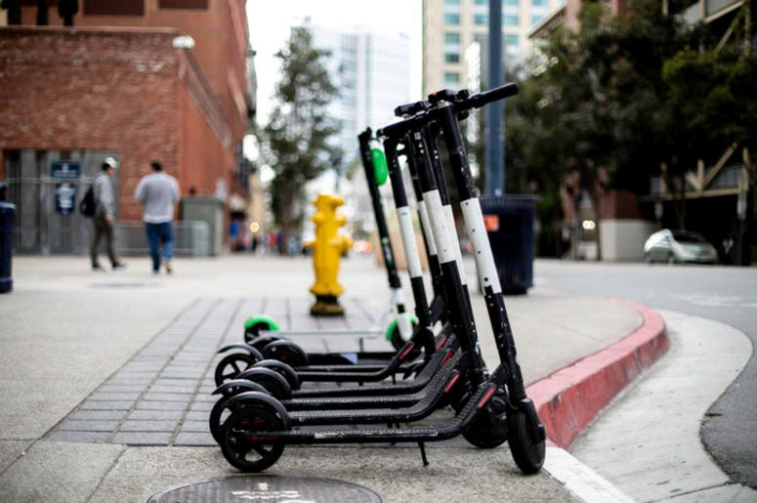
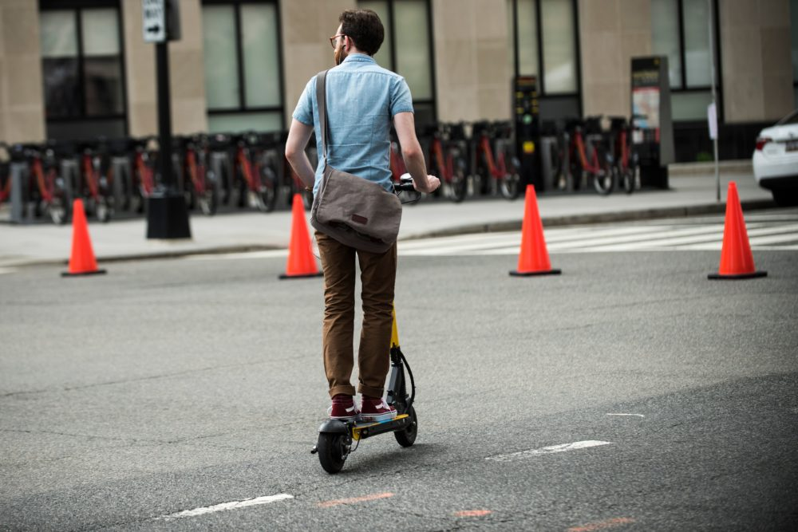
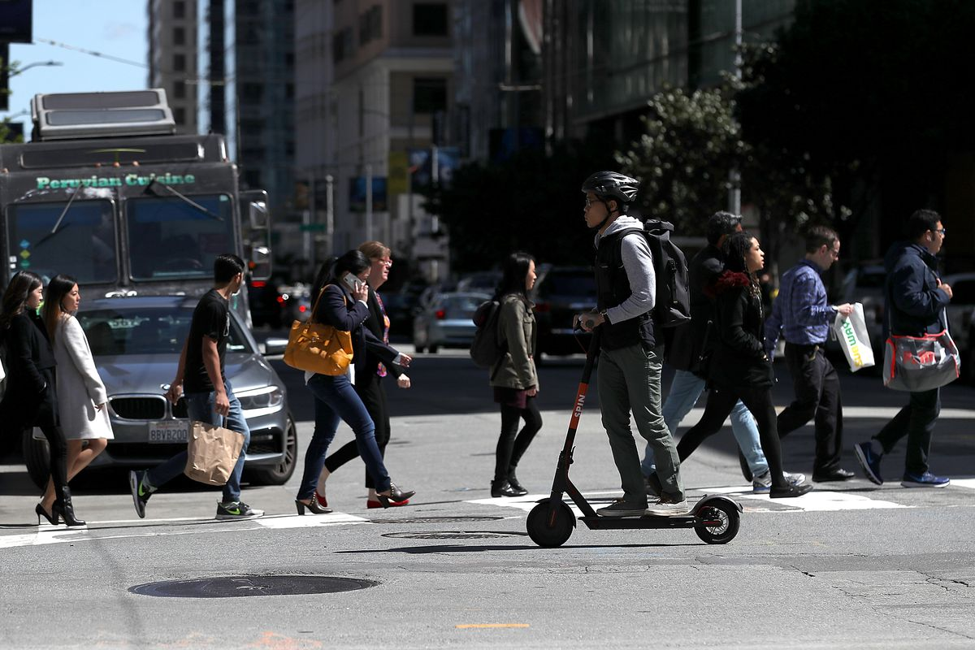

Introduction

Each year, the National Aging and Disability Transportation Center (NADTC) publishes a trends report to review significant topics in transportation. Published annually since 2016, the report includes overviews of popular transportation matters, challenges and opportunities of each topic, and examples of how the transportation trend is being implemented in communities across the United States. As in previous years, the Trends Report is divided into stand-alone ‘Topic Spotlights’ for individual download.

With its mission to increase the availability and accessibility of transportation for older adults and people with disabilities, NADTC recognizes that our work must be grounded in, and respond to, the needs and preferences of the communities and organizations that the center was created to serve. Critical to the center’s success is access to information about local communities’ efforts to develop accessible transportation, how those developments are received by people with disabilities and older adults, and the reactions of leaders in accessible transportation to developments in the transportation field.
The 2019 trends report reviews:
- Filling a Need: Hiring Veterans and People with Disabilities in Transit
- Travel Training for Older Adults
- Procuring Demand Response Transit Technology
- Scooter Policies and Accessibility within Shared Pedestrian Space
- Mental Health and Transportation
- Workforce Development in Transportation Occupations

In this Scooter Policies and Accessibility Topic Spotlight, NADTC explores scooter policies and accessibility within shared pedestrian space. Dockless e-scooters have changed the way people move through city spaces and as a result, changed the expectations and behaviors of consumers when using such options. This report reviews the challenges and opportunities these devices pose to maintaining accessibility in public spaces.
Explore transportation’s trending news with us through this report! If you have questions or have a story to share from your community, reach out to us at (866) 983-3222 or email contact@nadtc.org.

Scooter Policies and Accessibility within Shared Pedestrian Space

Introduction

Over the last decade, cities across the United States have experienced an increased presence of ‘micromobility’: transportation systems of shared on-demand bikes, electric bikes (e-bikes), and electric scooters (e-scooters) that allow individuals to make short distance trips at a low cost. Micromobility companies charge a fixed rate to unlock a device (sometimes as little as $1) and then a per-minute charge as the device is ridden. Rates can fluctuate based on the time of day and the city, but are considerably less than operating a vehicle. And while comparable to the cost of public transit, micromobility options provide a level of efficiency and flexibility for short distance trips unmatched by available transit.

Manual bike sharing systems paved the way for the eventual expansion of the micromobility market to include e-bikes, and most recently, e-scooters. In fact, e-scooters are rising so fast in popularity that over one-half of the 75-million micromobility trips documented in 2018 took place using an e-scooter (NACTO, 2018).

In addition to playing host to these new modes, cities have also witnessed a transformation in how micromobility modes are stored and accessed by users. Dockless e-scooters were first introduced in small numbers in 2017 (USDOT, 2019). Today, it is customary that e-scooters operate via dockless systems, where the rider uses a smartphone app to locate drop-off and pick-up locations, track time and distance for payment, and gain access to the device (locking and unlocking of an e-scooter typically occurs by using the company app to scan a QR code located on the e-scooter). As the “dockless” name implies, there is no specific e-scooter docking station to which a return must be made. According to the U.S. Department of Transportation’s Bureau of Transportation Statistics, as of July 2019, e-scooter systems can be found in 108 cities across the United States (USDOT, 2019). Such systems provide a tremendous amount of flexibility and convenience for users (for example, a user can simply leave the scooter at their destination for a future user to find, its location tracked by the company via GPS), but have also created new issues surrounding the accessibility of shared pedestrian public spaces.

Challenges and Opportunities

While some communities certainly welcome the availability and flexibility these micromobility modes provide, others find themselves wholly unprepared for the realities of such a rapid increase in the presence of e-scooters throughout city spaces. Even the most thoughtful policies and regulations crafted for an umbrella of micromobility modes don’t seem to reflect the specific nature of dockless e-scooter systems or user behavior surrounding treatment of e-scooters.

Without a defined and fixed feature on city streets to accept returned scooters, sidewalks, curb ramps, bike lanes, parking areas, roadways and even crosswalks become a default “parking lot” of sorts for discarded e-scooters. As a result, these micromobility travel solutions have become a significant barrier in maintaining accessible spaces for individuals with visual or mobility impairments and adhering to ADA regulations.

As dockless e-scooters expand their presence in communities across the U.S., both the challenges and the opportunities of the devices must be acknowledged. Below are a few common issues encountered in the management of dockless e-scooters:

- Maintaining accessible pedestrian walkways: When users are improperly riding and parking e-scooters, it is nearly impossible to maintain orderly and accessible public space. The two issues that are most commonly referenced in relation to sidewalk accessibility are scooter parking and the lack of dedicated bike/scooter lanes for riding. The nature of dockless systems allows users to “park” their e-scooter anywhere and when done incorrectly, the abandoned items create obstructions on sidewalks, in doorways, ramps, etc. While the appropriate position for a parked e-scooter is upright, sometimes the device falls over or is intentionally left laying down, creating a significantly more cumbersome barrier to maneuver around. Additionally, if infrastructure for dedicated bike/scooter lanes doesn’t exist, users often ride on the sidewalks, challenging pedestrians for safe walking space.

- The absence of consistent regulations around e-scooter use: What is the role of the local government to develop, and then enforce, policies around improper user behavior and dedicated parking space? The National Association of City Transportation Officials (NACTO) has issued comprehensive guidance to help cities regulate and manage micromobility companies, balancing micromobility innovation with the provision of safe, accessible sidewalks and streets. NACTO’s Guidelines for Regulating Shared Micromobility provides cities with best practices and recommendations on minimum standards that cities should introduce for operation of dockless e-scooters including permitting frameworks, public communication and education, privacy of consumer data, and safety standards (NACTO, 2019).

- Consumer education and involvement: To better respond to the needs of users, inclusive planning efforts are encouraged since “shared micromobility system work best when they are planned with rather than for communities” (NACTO, 2019). Specifically, a dedicated effort to include people with disabilities in the development of city regulations would encourage responsiveness to concerns around accessibility. Regardless of the e-scooter policies put forth by a city, the information must be clearly communicated to the community at large. NACTO’s guidelines suggests cities require e-scooter companies to share their communication plans, which should include general information on the product, operational guidelines, information on rates and fees, and safety issues. Additionally, it suggests e-scooter companies have dedicated staff to coordinate public engagement campaigns and demonstrations and all public marketing efforts be produced in multiple languages.

Local Examples

City of Atlanta, GA
In January 2019, the city council in Atlanta, GA voted to adopt an ordinance regulating the operations of what they refer to as “Shareable Dockless Mobility Devices” (SDMD), which includes both dockless bicycles and e-scooters. The ordinance lays out requirements for businesses to obtain permits to operate SDMDs within the city and regulations regarding device riding and parking.

Dockless e-scooters first appeared in Atlanta in the spring of 2018 and the city ordinance was a reaction to concerns relating to SDMDs impeding public safety and accessibility of the public-right-of-way where piles of upright or knocked over devices sometimes blocked pedestrian pathways (City of Atlanta, GA, 2019). Under the ordinance guidelines, SDMD companies in Atlanta must pay $12,000 annually for a permit allowing them to operate up to 500 scooters. Each additional e-scooter within a fleet costs $50. Since February 2019, Atlanta has permitted 9 companies to operate with a total of 12,700 devices.

Atlanta’s regulations for the devices include the following:
- The SDMD can’t exceed 15 miles per hour.
- A “no ride” time between 9:00 PM – 4:00 AM daily when devices are not allowed to be rented.
- SDMDs must be parked upright on sidewalks in a manner that allows pedestrians five feet of space. To encourage responsible user behavior, the city installed parking decals as a way to provide clear examples of legal parking areas and encourage better parking behavior.
- SDMD riders must yield to pedestrians in all cases, cannot ride with more than one person per SDMD, and cannot use wireless devices while on a SDMD.

To educate and promote safe riding behavior, Atlanta created a #ScootSmart Campaign via social media and print to provide information on the new rules along with tips on how to ride and park safely. Decals posted around the city remind users of the prohibited sidewalk riding. “Park Here” stickers mark examples of dockless parking locations that leave space (at least 5 feet) for people walking and using wheelchairs. Riders must also park devices upright and not block walkways, doorways and ramps (City of Atlanta, GA, 2019).

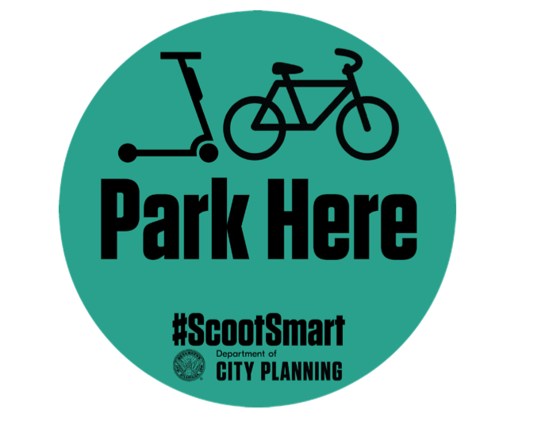
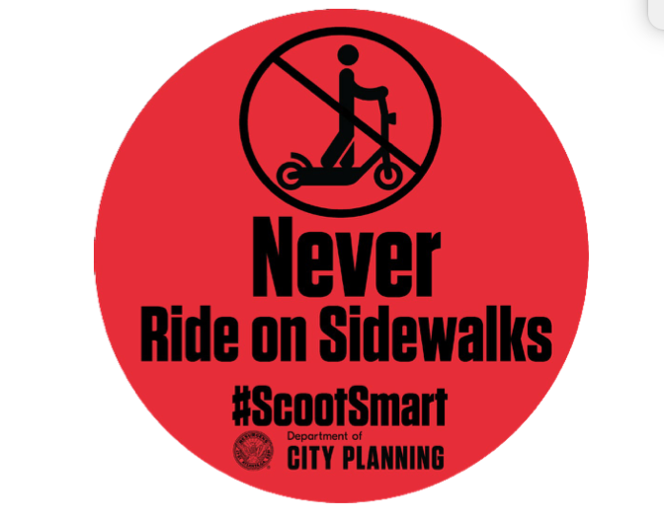
Examples of the e-scooter decals used in Atlanta (City of Atlanta, GA, 2019)

City of San Antonio, TX
Beginning in October 2018, the city of San Antonio, TX launched several iterations of an e-scooter pilot program that ultimately tested a balance between flexible riding regulations and safe, accessible sidewalks and streets. The pilot program kicked off with permitting regulations, requiring companies to pay $500 for an operational permit and $10 per scooter. The city required each company to have a San Antonio-based fleet manager to address issues like the parking of scooters. Eventually, seven e-scooter companies were granted permits to operate a total of 16,100 vehicles.

Initial regulations in the pilot program required riders to be 16 years old, prohibited riding on roads with speed limits above 35 mph, and recommend using bike lanes when available. Yet e-scooters were allowed to use sidewalks, as long as they stayed 2 feet from pedestrians. As the pilot program progressed, the city observed a number of challenges, including an oversupply of e-scooters in downtown San Antonio leading to cluttered sidewalks and irresponsible parking; tandem riding; use of e-scooters in prohibited areas; and obstruction of the City’s ADA infrastructure with parked or fallen scooters (City of San Antonio, 2019).

City staff monitored the program for six months before returning to City Council with recommended program changes in late spring 2019. The approved changes included no riding between the hours of 11pm and 6 am, but most significantly, made an adjustment to eliminate previously allowable sidewalk riding and stricter enforcement in parking. Currently, parked e-scooters must not obstruct the right-of-way or risk being impounded by the city.
Throughout the course of the pilot program, the City engaged a variety of stakeholders, riders, and the general community for feedback on e-scooter presence. During the summer of 2018 and the spring of 2019, 9,000 people provided feedback through two surveys conducted. Over 16% of the respondents in 2018 were age 55 and older and 25% of the respondents in 2019 were age 55 and older. In addition, the city sought input from more than 800 riders on specific behavior including how often they utilize dockless vehicles, for what purposes, and what mode of transportation they would have taken if not for the dockless vehicle trips. A telephone town hall was held as an opportunity for residents to ask questions of City staff and provide input on current regulations.

The next steps in San Antonio e-scooter presence are expected to take place in December 2019. As a reaction to lessons learned in the pilot program, the city anticipates reducing permits for dockless e-scooters to just three companies with a total of 5,000 devices (City of San Antonio, 2019).

Summary

Dockless e-scooters have changed the way users navigate their cities and as a result, changed the expectations and behaviors of consumers when using such options. The benefits of dockless e-scooters (flexibility, ease of use, low cost, etc.) must be weighed against the challenges created for pedestrians, especially individuals with disabilities, to safely navigate their community’s public spaces. While many cities lack dedicated infrastructure for e-scooter use, pilot programs like those described above create opportunities for cities to determine and adjust regulations for riders, and share their lessons learned in an attempt to guide other local attempts in creating a standard in micromobility transportation.

Resources and References

City of Atlanta, GA. (2019). Shareable Dockless Mobility Devices. Retrieved from:
https://www.atlantaga.gov/government/departments/shareable-dockless-mobility-devices

City of San Antonio. (2019). Dockless Vehicle Regulations. Retrieved from: https://www.sanantonio.gov/ccdo/DocklessVehicles#270093527-next-steps

National Association of City Transportation Officials (NACTO). (2018). Shared Micromobility in the U.S.: 2018. Retrieved from: https://nacto.org/shared-micromobility-2018/

National Association of City Transportation Officials (NACTO). (2019). Guidelines for Regulating Shared Micromobility Version 2. Retrieved from: https://nacto.org/wp-content/uploads/2019/09/NACTO_Shared_Micromobility_Guidelines_Web.pdf

U.S. Department of Transportation (USDOT). Bikeshare and e-scooters in the U.S. (2019). Retrieved from: https://data.transportation.gov/stories/s/fwcs-jprj

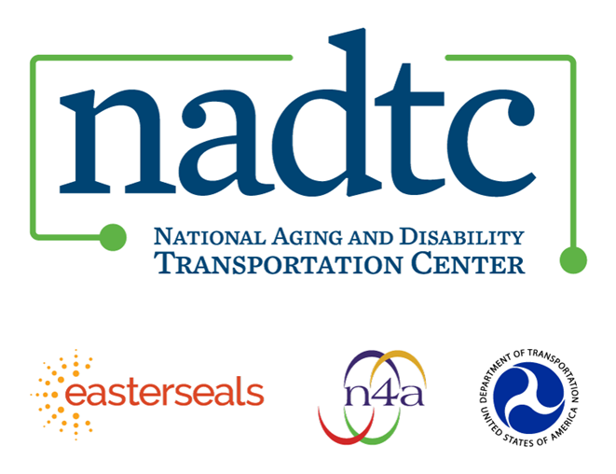
The National Aging and Disability Transportation Center (NADTC) is a program funded by the Federal Transit Administration and administered by Easterseals and the National Association of Area Agencies on Aging (n4a) with guidance from the U.S. Department of Health and Human Services, Administration for Community Living.

NADTC’s mission is to increase accessible transportation options for older adults, people with disabilities, and caregivers nationwide.

National Aging and Disability Transportation Center
Washington, D.C. 20003
Telephone and toll-free hotline: (866) 983-3222
TTY: (202) 347-7385
Email: contact@nadtc.org
Website: www.nadtc.org

Follow us:
Facebook
Twitter
YouTube
LinkedIn

