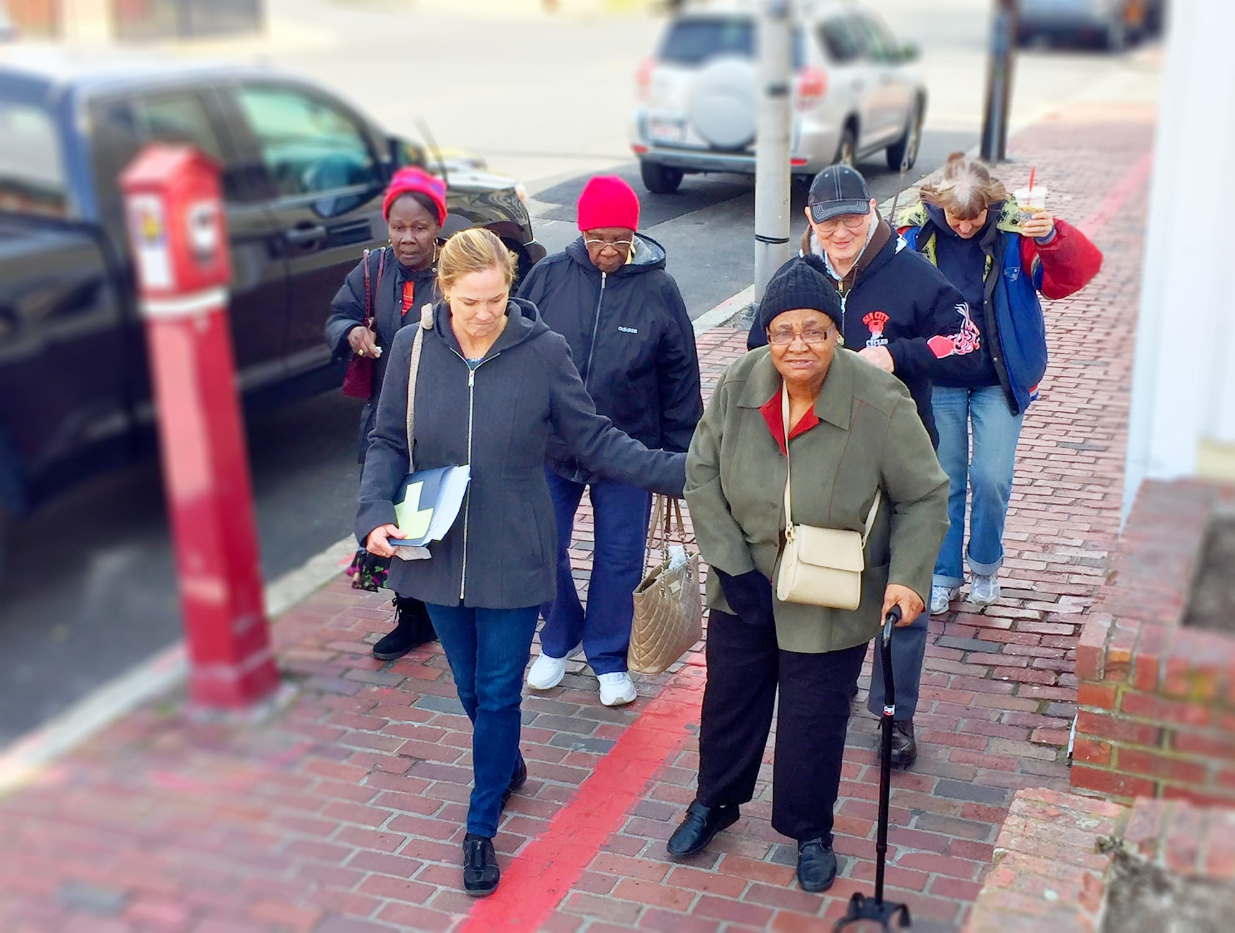
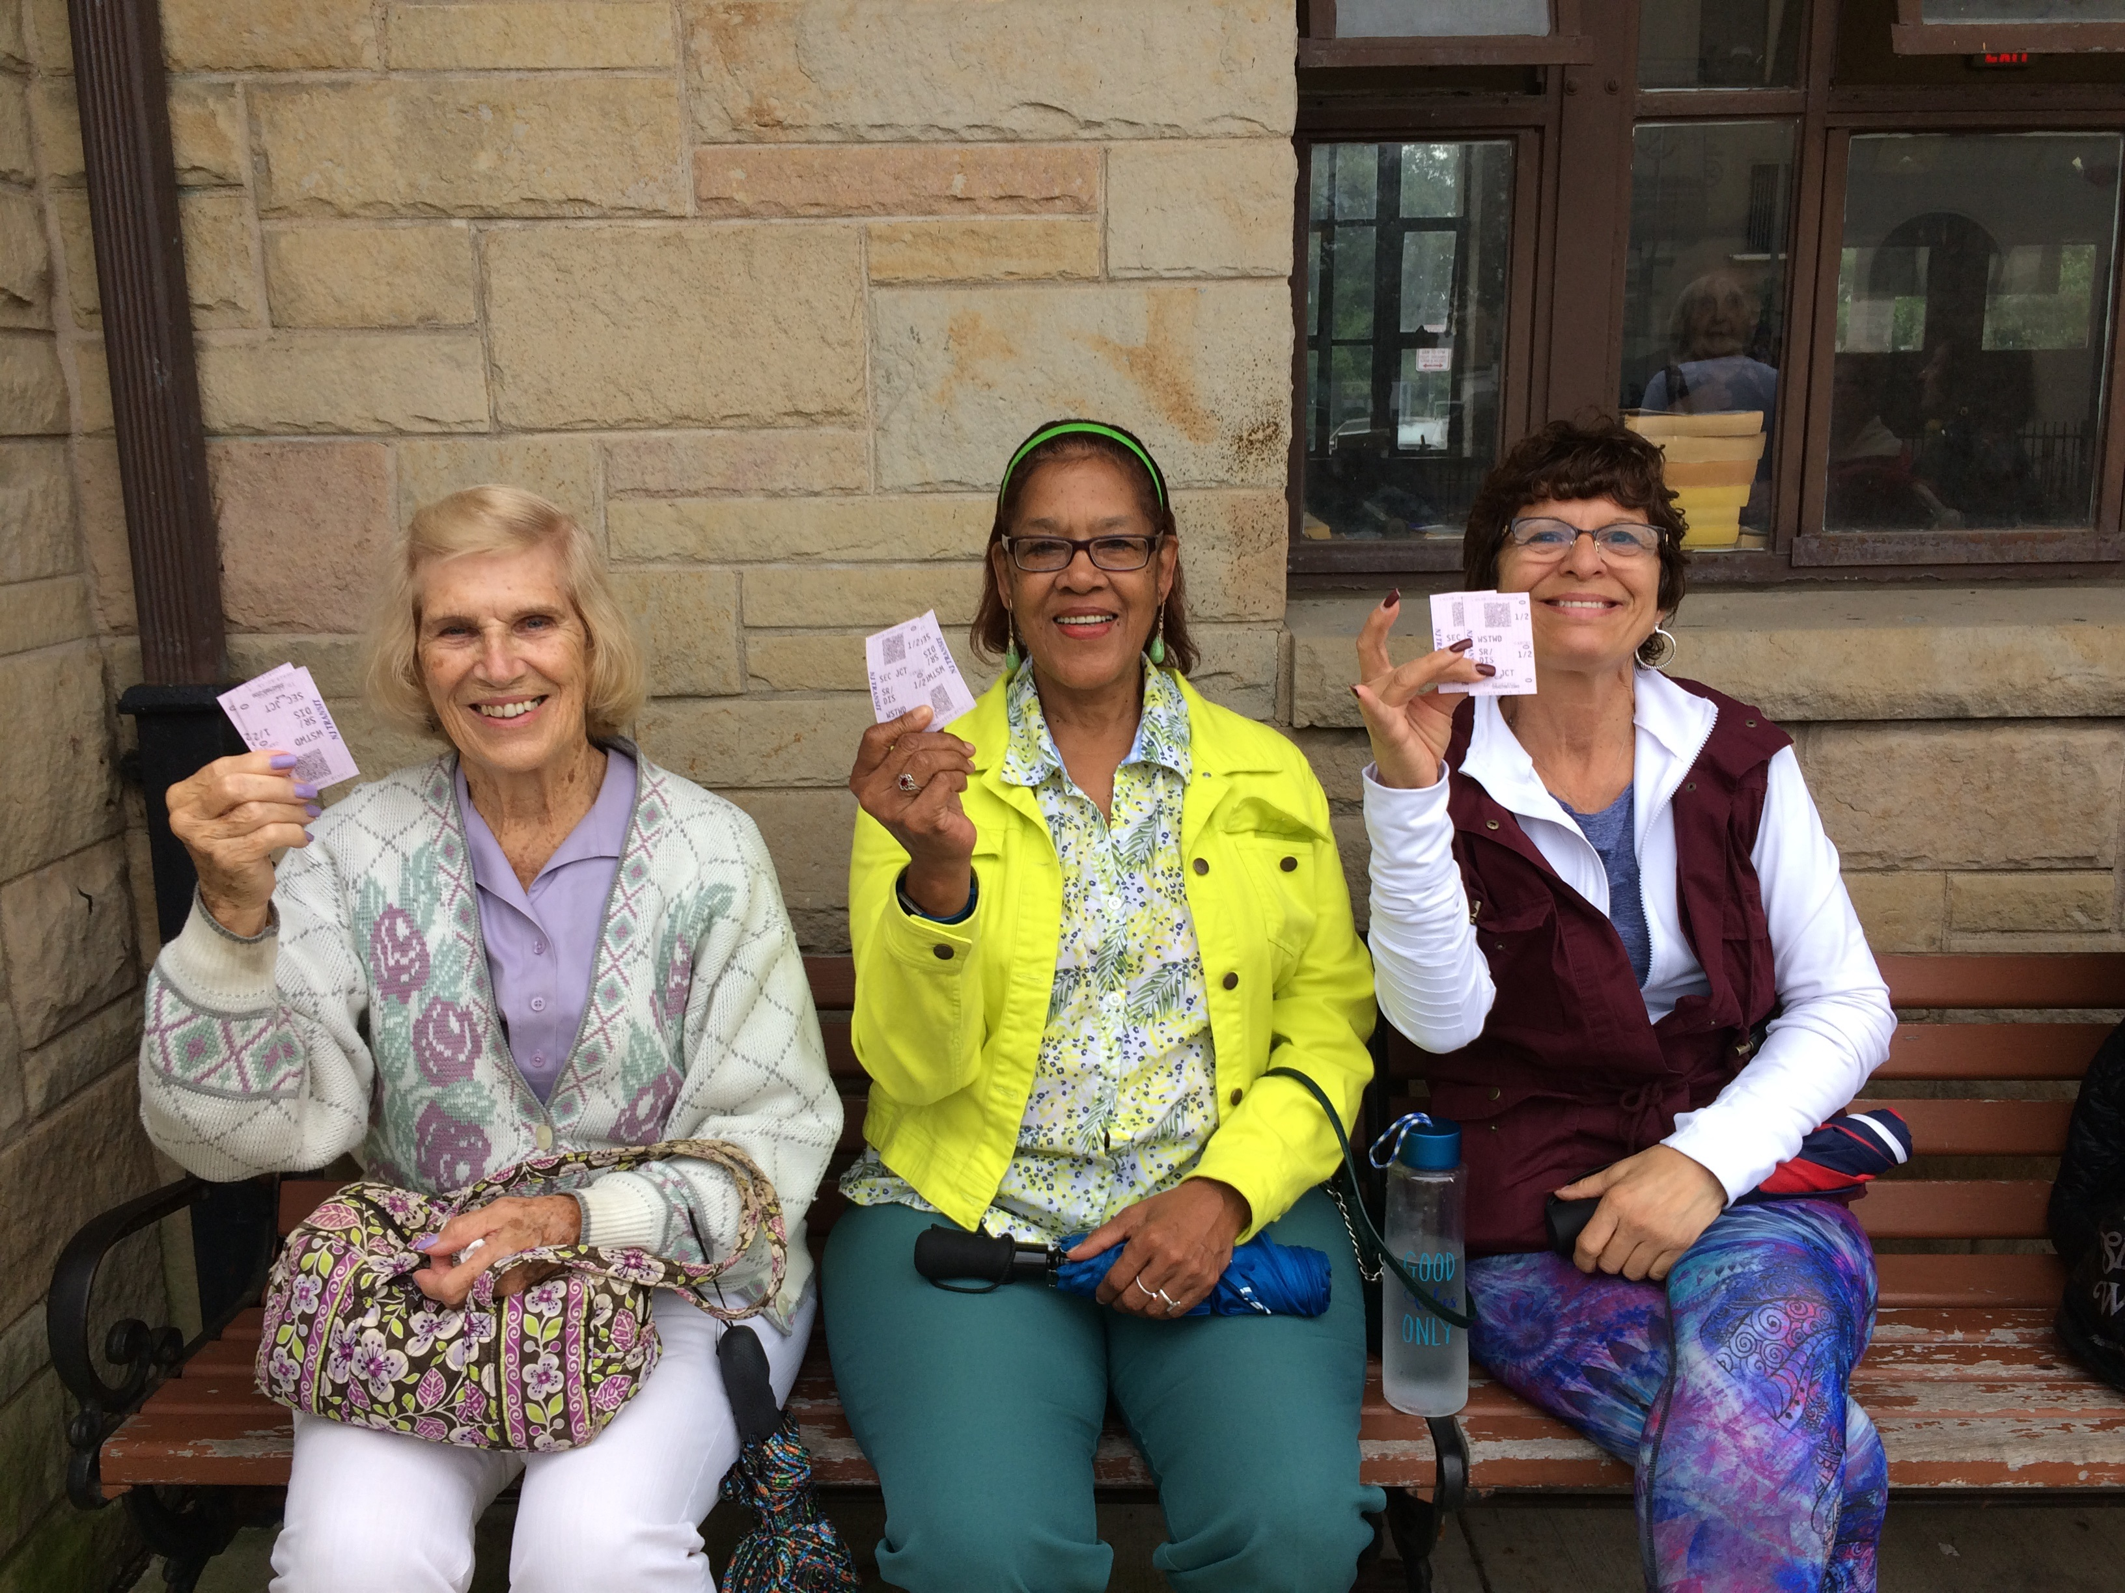
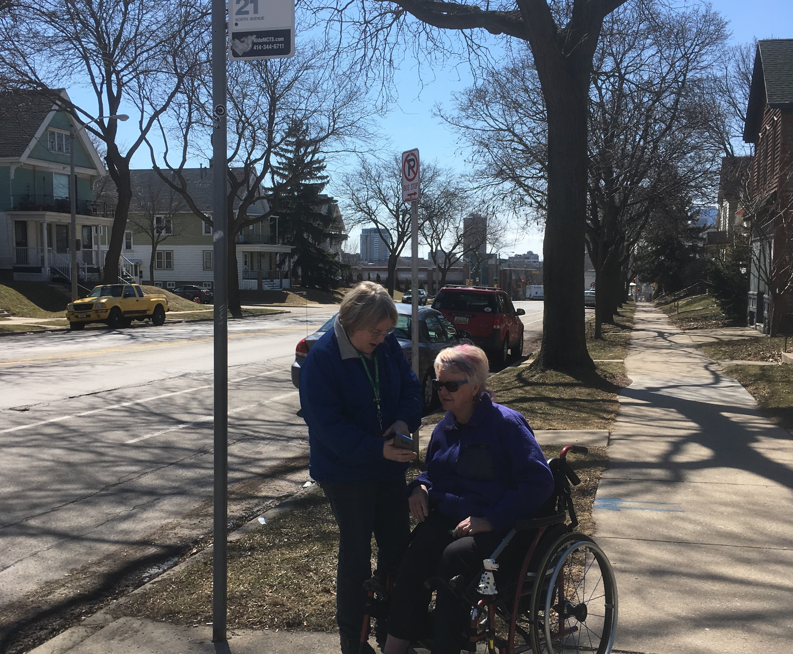

Introduction

Each year, the National Aging and Disability Transportation Center (NADTC) publishes a trends report to review significant topics in transportation. Published annually since 2016, the report includes overviews of popular transportation matters, challenges and opportunities of each topic, and examples of how the transportation trend is being implemented in communities across the United States. As in previous years, the Trends Report is divided into stand-alone ‘Topic Spotlights’ for individual download.

With its mission to increase the availability and accessibility of transportation for older adults and people with disabilities, NADTC recognizes that our work must be grounded in, and respond to, the needs and preferences of the communities and organizations that the center was created to serve. Critical to the center’s success is access to information about local communities’ efforts to develop accessible transportation, how those developments are received by people with disabilities and older adults, and the reactions of leaders in accessible transportation to developments in the transportation field.
The 2019 trends report reviews:
- Filling a Need: Hiring Veterans and People with Disabilities in Transit
- Travel Training for Older Adults
- Procuring Demand Response Transit Technology
- Scooter Policies and Accessibility within Shared Pedestrian Space
- Mental Health and Transportation
- Workforce Development in Transportation Occupations

In this Travel Training for Older Adults Topic Spotlight, NADTC focuses on how travel training can empower individuals with the skills and confidence to successfully navigate community transportation systems. This section of the report provides a review and explanation of travel training terminology, strategies to assist older adults in independent travel, and examples from local programs in Colorado, Illinois, and New Jersey.
Explore transportation’s trending news with us through this report! If you have questions or have a story to share from your community, reach out to us at (866) 983-3222 or email contact@nadtc.org.
Cover Photo Credits:
Top: NJTIP, Rutgers, NJ
Bottom left: Ride MCTS, Milwaukee County Transit System, Milwaukee, WI
Bottom right: Greater Lynn Senior Services, Lynn, MA

Travel Training for Older Adults

Introduction

Travel training, or travel instruction, is a professional method of teaching individuals skills for independent travel, often focusing on fixed route public transit, but can include instruction on other modes such as shared ride options, volunteer transportation, and even pedestrian safety. Travel training can be beneficial to most everyone in the community looking to familiarize themselves with available transportation options, but can be particularly beneficial to older adults, especially when nearing or experiencing retirement from driving. For many, losing the ability to drive means a loss of reliable transportation, leading to barriers in access to employment, health care, social services, recreational activities and a general loss of independence.
Many different types of organizations provide travel training services including, but not limited to: transit agencies, schools, human service organizations, aging and disability resource centers, and area agencies on aging. These organizations may be for-profit or non-profit, and they may provide services for free or for a fee. Any organization with the mission, vision, and/or values supported by travel training may develop and implement a travel training program.
Family of Travel Training Services
The family of travel training services refers to the array of methods and strategies used by professionals to increase the independent travel skills of the people they serve. The family of services can include:

- Origin to Destination Training: Instruction on how to travel from a specific origin to a specific destination (receiving highly individualized path of travel and route instructions that are delivered on the street and on transit vehicles)
- Orientation/Familiarization: A general overview and orientation to a transportation system (reading a schedule, identifying a stop location, purchasing fare, and using vehicle features)
- Mobility Device Orientation: Instruction on how to use personal mobility devices on transit vehicles (safely boarding, riding, and alighting vehicles)
Origin to Destination Training
Origin-to-destination travel training consists of a travel trainer and the trainee(s) selecting a specific start point (origin) and a specific end point (destination) that the trainee wishes to travel. Travel trainers and trainees work together to determine the best way to travel this specific route. This includes but is not limited to:
- Assessments to determine the gap between the trainee’s current skills and skills needed for independent travel
- Assessments of the built (sidewalks, curb cuts, bus stop amenities) and natural (hills, trees, etc.) environment
- Planning the trip and selecting the best route (selecting the time, stop location, vehicle, path of travel, etc.)
- Identifying information and supplies needed by the trainee (schedule, fare, landmarks, how to signal the operator, etc.)
- Developing a travel instruction plan with a task analysis (what to teach) and training strategy (how to teach) related to:
  - Street crossing
  - Boarding, riding, and alighting vehicles
  - Preparing for unforeseen incidents and emergencies

Origin to destination training is appropriate for older adults that have significant gaps between current skill level and the skills needed for independent travel. Depending on the skill level of the trainee(s) and travel trainer, the route, the number of travel trainers, and the learning environment, this service may be delivered one-on-one or in small groups.
Orientation/Familiarization
Orientation to a transportation system includes but is not limited to:
- Planning a trip (selecting the time, stop location, and vehicle) and using the transportation system’s trip-planning tools (website, customer service telephone number, printed schedule, etc.)
- Learning where and how to purchase fare
- Using vehicle features (paying fare, signaling the operator, etc.)

Orientation to a transportation system is appropriate for older adults who have some experience using the transit mode being taught, need minimal support in order to use the transportation system independently, and have good judgment and safety skills.

Older adults enrolled in orientation to a transportation system may not require one-on-one attention from a travel trainer. If older adults do not require individualized attention, small group training is an efficient and effective teaching strategy. Small group training, especially for people who know each other, may lead to future independent travel by group members, who support each other as they travel together.
Mobility Device Orientation
In mobility device orientation sessions, travel trainers teach older adults who use personal mobility devices (wheelchairs, walkers, etc.) how to board, ride and alight vehicles. Travel trainers, trainees, and transportation personnel work together to determine the best way to:

- Approach and board the ramp or lift
- Ride the ramp or lift
- Use the fare box
- Approach the securement area
- Use securements
- Approach and board the ramp or lift during deboarding
- Alight the vehicle

Personal mobility device training is appropriate for older adults who use mobility devices and are uncomfortable boarding, riding, and alighting vehicles without additional training and practice. Since personal mobility devices vary, as do the skills of trainees, this is a highly individualized service. Travel trainers should not attempt to teach trainees how to operate their mobility devices.

Challenges and Opportunities

While the family of travel training creates many opportunities for effective and personalized teaching and learning based on the needs of the individual seeking services, there are a few strategies that have been found to be particularly effective in managing thriving travel training programs. Successful travel training programs for older adults tailor their services to the needs of the individual and community. A thorough inventory of programs, services, and modes of transportation within the community is key to ensuring the appropriate type of travel training program is developed.

Programs should have a keen awareness of their target audience to create specific communication and marketing campaigns to effectively reach these individuals. For older adults with little experience in alternate modes of transportation outside of driving and caregiver-provided transportation, personal success stories and word of mouth have been found to be successful recruitment tools. Highlighting the cost savings, flexibility, and independence of using fixed-route transportation also resonates with older adults interested in enrolling in travel training programs (TCRP Report 168, 2014).

The development, expansion, longevity of travel training programs is often determined by reliable funding. Consistent data tracking and evaluation can help organizations strengthen the quality of their programs to improve outcomes for older adults, but also help also share their successes with the community to attract potential community partnerships and potential clients. Increased recruitment numbers can help programs demonstrate the value of their program to potential funders and the importance of sustaining such a program long term.
Successful travel training programs provide older adults with the skills to independently utilize fixed-route transit and as a result, reduce use of ADA paratransit. The cost of operating fixed-route transit is significantly less than providing ADA paratransit. If travel training helps individuals shift from using paratransit to using public transit, it can significantly reduce demand for paratransit services and agency spending.

Local Examples

The following travel training program case studies were drawn from community programs featured in Transit Cooperative Research Program (TCRP) Report 168 Parts I and II. For more detail, please refer to that report or contact each organization.

Via Mobility Services, Boulder, Colorado
Via Mobility Services, a community non-profit, runs the Via Mobility Services Travel Training Program. Via Mobility Services promotes self-sufficiency and independence for individuals with limited mobility, and their travel training program offers individual and group training to older adults, people with disabilities, and low-income individuals. When the program first started in 2003, it was sustained via federal funding. As time has passed, program funding has diversified, and funders have included the Rose Foundation, Denver Regional Mobility and Access Council, United Way, the City of Boulder and Boulder County. In 2014, the program received FTA Section 5310 funding to create an area-wide program.
Via Mobility Services’ travel training program largely relies on volunteers who devote their time and assist older adults with travel training; however, the program employs two full-time travel trainers providing more intensive services. Travel trainers complete an assessment form in the participant’s home. Based on the assessment, instructors derive a progress checklist to assure that client’s requirements and needs are being met through their training. In order for trainers to feel comfortable instructing the client, trainers plan trips and scout routes, which will overall assist in the client’s understanding of the routes.
Via Mobility Services offers multiple programs to familiarize seniors with the transportation system; they include:

- One-on-one travel training
- Group training
- Volunteer bus buddy program
- Train-the-trainer program

RTA Travel Training Program, Chicago, Illinois
The Regional Transportation Authority is a travel training program established by the state of Illinois division of Chicago Transit Authority, Metra, and Pace transit agencies. The program was initially created to serve clients who are blind or who have visual impairments; however, today, the RTA’s services have expanded to include non-ADA complementary paratransit applicants.

The programs RTA offers include:
- One-on-one training programs
- Group training program

The one-on-one programs involve a trip training program, which teaches participants how to navigate specific trips that they often need to make, as well as an orientation to the transportation system. Multiple trips are conducted to facilitate the client’s familiarization with the route. To conduct these programs, travel trainers most often will first practice using the system until they are comfortable teaching the route to the participant. RTA evaluates the benefits of the programs by using follow-up surveys every six to twelve months, to assess the participants’ continued involvement with the transit system.
NJTIP @ Rutgers, New Brunswick, New Jersey
New Jersey’s Rutgers State University provides travel training programs in order to teach individuals how to use the available transit programs and encourage independence of participants. The travel training program was first initiated through a pilot program overseen by New Jersey Transit. Through the pilot, NJ TRANSIT assessed the demand for travel training programs and tested the effectiveness of the program. Upon completion of the pilot program, New Jersey Travel Independence Program (NJTIP), a non-profit organization, officially established the travel training program.

The services NJTIP offers include:
- One-on-one training
- Small group travel
- Transit seminars
- In-school travel training classes

The goal of one-on-one training is to teach participants how to travel using the public bus and rail system. This allows for greater mobility, as well as improved rates of employment, increased community involvement, and educational opportunities on a broader spectrum. Furthermore, NJTIP provides a specialized small group training to supplement the one-on-one travel training program. In order to conduct this service, NJTIP outreaches to other agencies, such as senior centers, to provide an orientation on utilization of the public transportation with hands-on experience taking trips. NJTIP also has services to support professionals and volunteers with their understanding of the local transportation system. Through the Connect to Transit Training Program, NJTIP extends services to those assisting seniors and providing social services by providing a seminar that reviews the public transit system.

Summary

Travel training can empower individuals with the skills and confidence to successfully navigate community transportation systems. Benefits to the traveler include increased social activity, improved health through access to medical services, and increased independence. Caregivers can also benefit from travel training services, as it eases their support services burden and increases self-care. This can lead to improved health and economic standing, increasing their own and their family’s quality of life. The benefits to transit agencies include reduced spending on ADA paratransit and creating a positive rapport with the community. Finally, travel training benefits the community as a whole by assisting older adults to remain active and contributing members of society for as long as possible.

Resources and References

The Association for Travel Instruction (ATI) has as its mission to advance the right of all persons with disabilities and older adults to equal access to public transportation and community participation by providing: support, information, training and education to promote quality Travel Instruction. ATI has many resources for individuals who are travel trainers. It would be a good place to start for people wanting to start a travel training program. https://www.travelinstruction.org

Burkhardt, J., et al. (2014). Transit Cooperative Research Program Report 168. Travel Training for Older Adult Part I: A Handbook. Retrieved from: https://doi.org/10.17226/22299

Burkhardt, J., et al. (2014). Transit Cooperative Research Program Report 168. Travel Training for Older Adults Part II: Research Report and Case Studies. Retrieved from: https://doi.org/10.17226/22298
The Consortium for the Educational Advancement of Travel Instruction (CEATI) is another association that supports and promotes the continuing development of the discipline and profession of Travel Instruction to enable individuals with disabilities and seniors to travel in the safest and most autonomous manner possible. To access their resources go to: http://ceati-travelinstruction.org/

Easterseals Project Action Consulting (ESPAC) offers certification for professional travel trainers. This innovative certification program, ctti, is co-sponsored by Easterseals and the Center for Urban Transportation Research (CUTR) at the University of South Florida. Certified through CUTR, the program provides new and veteran travel trainers with the Certified Travel Trainer credential. For more information visit: https://www.projectaction.com/certification-programs

Kansas RTAP Fact Sheet. (2015). Developing and Marketing a Travel Training Program for Older Adults. http://www2.ku.edu/~kutc/pdffiles/KTRFS15-TravTraining.pdf

Metro Magazine. (2017, reprinted in 2019). 10 Steps for Transit Agencies Starting Travel Training Programs. https://www.metro-magazine.com/accessibility/article/714837/10-steps-for-transit-agencies-starting-travel-training-programs

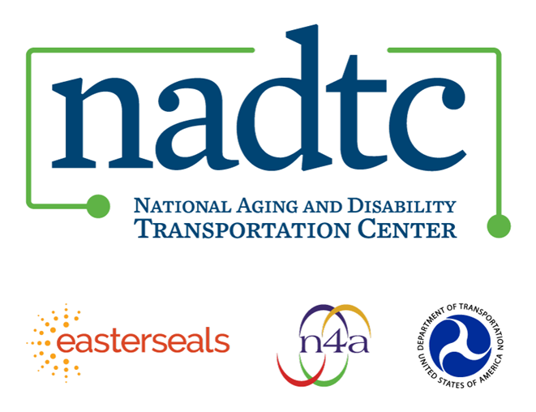
The National Aging and Disability Transportation Center (NADTC) is a program funded by the Federal Transit Administration and administered by Easterseals and the National Association of Area Agencies on Aging (n4a) with guidance from the U.S. Department of Health and Human Services, Administration for Community Living.

NADTC’s mission is to increase accessible transportation options for older adults, people with disabilities, and caregivers nationwide.

National Aging and Disability Transportation Center
Washington, D.C. 20003
Telephone and toll-free hotline: (866) 983-3222
TTY: (202) 347-7385
Email: contact@nadtc.org
Website: www.nadtc.org

Follow us:
Facebook
Twitter
YouTube
LinkedIn

