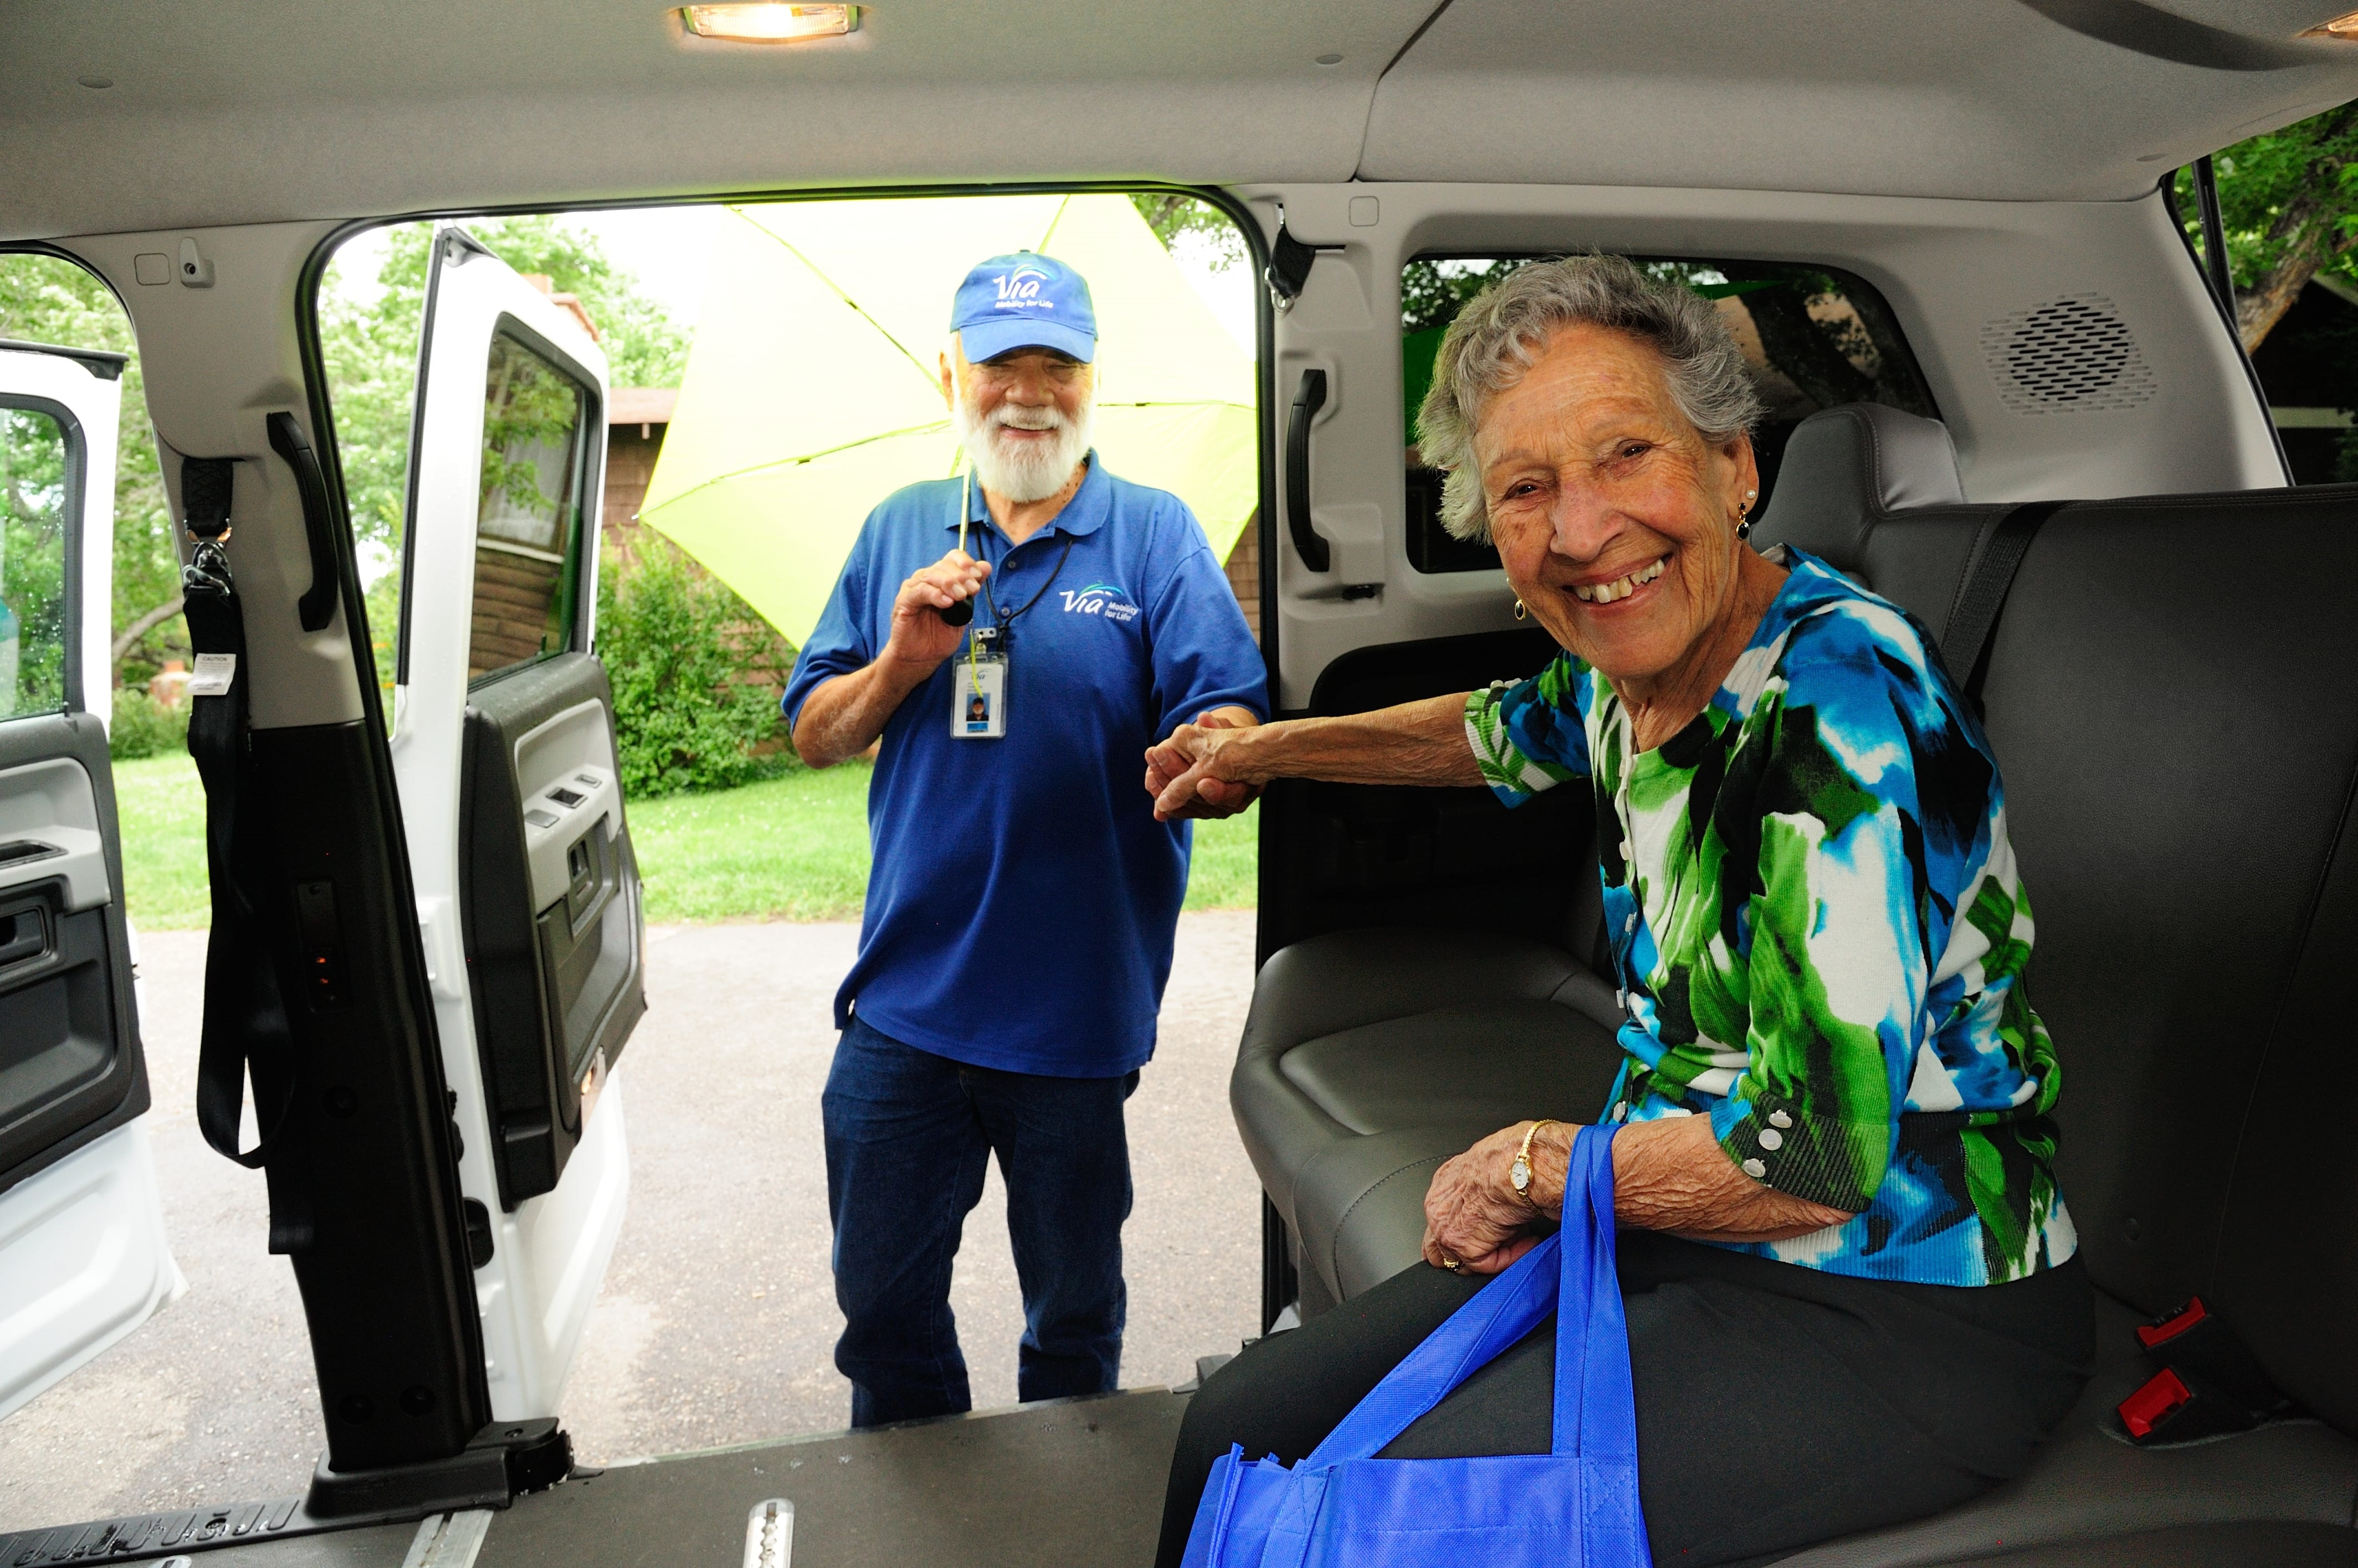

# Introduction

Each year, the National Aging and Disability Transportation Center (NADTC) publishes a trends report to review significant topics in transportation. Published annually since 2016, the report includes overviews of popular transportation matters, challenges and opportunities of each topic, and examples of how the transportation trend is being implemented in communities across the United States. As in previous years, the Trends Report is divided into stand-alone ‘**Topic Spotlights’** for individual download.

With its mission to increase the availability and accessibility of transportation for older adults and people with disabilities, NADTC recognizes that our work must be grounded in, and respond to, the needs and preferences of the communities and organizations that the center was created to serve. Critical to the center’s success is access to information about local communities’ efforts to develop accessible transportation, how those developments are received by people with disabilities and older adults, and the reactions of leaders in accessible transportation to developments in the transportation field.

The 2019 trends report reviews:

* Filling a Need: Hiring Veterans and People with Disabilities in Transit
* Travel Training for Older Adults
* Procuring Demand Response Transit Technology
* Scooter Policies and Accessibility within Shared Pedestrian Space
* Mental Health and Transportation
* **Workforce Development in Transportation Occupations**

In this **Workforce Development in Transportation Occupations Topic Spotlight,** NADTC addresses the struggle to recruit, train and retain skilled workers, the lack of planning to address workforce exits and the need to stay competitive in a changing work economy are just a few of the challenges transportation managers are currently facing. This spotlight reviews challenges of workforce development and provides resources and examples of organizations involved in improving the transportation workforce.

Explore transportation’s trending news with us through this report! If you have questions or have a story to share from your community, reach out to us at (866) 983-3222 or email [contact@nadtc.org](mailto:contact@nadtc.org).

Photo Credits:

Top and Bottom left: NADTC

Bottom Right: Via Mobility Services, Boulder, CO

# Workforce Development in Transportation Occupations

**Introduction**

The American Public Transportation Association reported that 2.5 billion Americans used public transportation in the second quarter of 2019, a jump of 11 million riders over the same period of 2018, as many U.S. cities have reported an increase in public transit ridership for the first time in years. In order to meet the demand in ridership, transportation systems must learn to effectively address and overcome many of the challenges they face related to workforce recruitment, training and retention. According to the Bureau of Labor Statistics, there is projected growth of 4 percent from 2018 to 2028 in employment of transportation and material moving occupations which would add 483,100 new jobs, yet there is growing concern among transportation managers and administrators that they will be unable to fill these jobs. This paper will discuss some of the challenges, solutions and opportunities related to workforce development and the current and future transportation industry.



*Maintaining a Competitive Workforce*

Competition with the private sector and other fields that offer higher wages and more attractive working environments to new employees entering the workforce present challenges in recruiting and retaining employees for publicly funded transportation providers. Strategies to attract newer and younger workers to the field may vary from traditional recruitment campaigns that were once effective with older workers. To stay competitive in a changing work economy, transportation agencies must focus on the expectations and needs of those entering the job market. Younger workers are expecting greater levels of support from employers when it comes to flexibility and work-life balance. Transportation agencies may have to adopt different management approaches to better understand and address these differences in order to attract and retain younger employees in the workforce.

*Succession Planning*

As more and more older workers approach and exit the workforce, transportation agencies face losing knowledge, experience and talent. Employers often wait too late to start developing a talent pipeline and instead wait until older workers reach retirement age before seeking out new workers to fill vacancies. Having an effective talent pipeline in place can better ensure that transportation agencies are positioned to continue to provide services without interruption or termination of services altogether. Promoting and training existing workers is a good way to enhance the talent pool, but agencies should look to develop external pipelines that would include workers who are not currently working in transportation.

*Workforce Diversity*

The majority of the transportation workforce is comprised of white, able-bodied, and English-speaking men, and like most other industries, the aging workforce plays a significant role on the age profile of employees. However, for the first time in U.S. history, minorities and women are driving the trend with the most new hires aged 25 to 54. Employers can broaden their potential pool of applicants by building a more diverse workforce through the hiring of traditionally under-represented groups like women, minorities, people with disabilities and non-English speakers. Transportation employers, workforce development boards and trade organizations must all take a role in developing special strategies for attracting and retaining under-represented segments of the workforce. Strategies may include educating current workers on diversity and acceptance, promoting more positive images of diverse populations in the transportation workforce and working closely with diverse groups of current employees to develop innovative approaches specifically designed to reach diverse audiences.

**Opportunities**

The transportation industry will continue to face new and shifting challenges, yet if addressed correctly, these challenges can present opportunities for industry growth and revitalization and ensure success now and in the future. A few of these opportunities include:

* Continuing Education and Training
* Raising Career Awareness among Students
* Developments in Technology

*Continuing Education and Training*

Raising interest and awareness among entry and mid-level transportation industry employees by providing ongoing education and training can provide great opportunities to build the size and skill of the current transportation workforce. On-the-job training and continuing education

opportunities as well as internships, apprenticeship and leadership opportunities could increase the interest and skills of entry and mid-level workers who are currently in the field. Such efforts can also attract professionals who possess a range of experiences in other fields to consider a second career in transportation.

*Raising Career Awareness among Students*

Many students are unaware of the potential career pathway transportation provides. Employers can address this lack of awareness of transportation career opportunities and raise interest with potential future transportation workers by educating parents and school officials, like teachers and counselors about the industry. Employers can also work with school systems to introduce programs in the classrooms, beginning at the primary level and implement other ways to raise awareness outside of the classroom through career focused activities. These types of efforts can increase interest in a career in transportation and improve a student’s readiness to join the transportation workforce.

*Developments in Technology*

Attracting and retaining more technically diverse and skilled workers will help transportation agencies prepare for a transportation future of rapidly advancing technology development and innovation to accomplish their missions and to stay competitive. Transportation agencies have the opportunity to support emerging technologies such as connected and automated vehicles, big-data analytics and other support systems that impact overall transportation systems management and operations (TSMO). Retraining and developing the expertise and skill of current workers to address the constant change in technology may present challenges. Adapting to continual technology advancements in the transportation industry will require transportation industry members to be strategic in determining which emerging technology to adopt and prioritize for on-the-job training for their workers. Identifying technology advances on the horizon can enable transportation agencies to share this knowledge and training across transportation modes which would allow for more collaboration, partnering and ultimately better preparedness for emerging tools.

**Summary**

The struggle to recruit, train and retain skilled workers, the lack of planning to address workforce exits and the need to stay competitive in a changing work economy are just a few of the challenges transportation managers are currently facing. Efforts to increase career awareness and training, address the increasing diversity of the workforce and anticipate technology advancements can position agencies to effectively grow their workforce. Examples

of organizations involved in improving the transportation workforce through training, developing best practices and resource exchange are provided below.

**Local Examples**

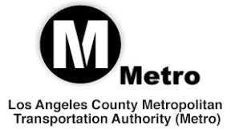**Los Angeles County Metropolitan Transportation Authority (Metro)**

The Los Angeles County Metropolitan Transportation Authority (Metro) developed *Workforce Initiative Now-LA (WIN-LA)*, a workforce development program focused on creating career pathways in the transportation industry. WIN-LA provides support for participants in areas such as life skills development, skill set enhancement and educational attainment services through a collaboration of program partners. It also increases the resources needed for training and placement of hard-to-fill positions within Metro and the transportation industry. WIN-LA is a collaborative partnership between Metro and institutions and organizations interested in helping job seekers, companies and local communities through demand-driven workforce services. The goal is to create career pathway opportunities in the transportation and construction industries. For more information visit, [**https://www.metro.net/about/win-la/**](https://www.metro.net/about/win-la/)

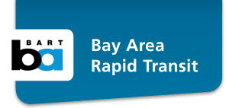**Bay Area Rapid Transit**

The Bay Area Rapid Transit District (BART) received funding to establish the Transit Career Ladders Training (TCLT) Program. This program creates direct and accessible pathways to employment in the transit industry by partnering with Workforce Investment Boards and community colleges in the Bay Area. As encouraged by USDOT's Ladders of Opportunity Initiative, the TCLT program promotes transportation careers in low-income areas, in unemployed and underemployed communities, and among minorities, veterans, and women. TCLT also supports and enhances existing technical programs at local colleges through real-world interaction with the transit system. For more information, visit [**https://www.bart.gov/sites/default/files/docs/BART%20Career%20Ladder%20Bro%20%204_6_16%20.pdf**](https://www.bart.gov/sites/default/files/docs/BART%20Career%20Ladder%20Bro%20%204_6_16%20.pdf)

**Workforce Resources**

According to the Eno Center for Transportation, “more than 13 million jobs—about 9 percent of the civilian workforce in the United States—are transportation-related.” Because of this growth, the transportation industry is positioned to be a major source of jobs in the U.S. Yet, this will require the hiring of millions of workers to fill vacancies created by those leaving the

field for other industries, those retiring and those exiting for other reasons. The following workforce resources support initiatives to develop and expand the nation's transportation workforce.

**U.S. Department of Transportation/Federal Highway Administration**

**Center for Transportation Workforce Development**

The Center for Transportation Workforce Development provides national leadership, coordination, and assistance that supports initiatives to develop and expand the nation's transportation workforce. From early education through ongoing professional development, the center provides program support, technical assistance, and workforce development activities in partnership with federal, state, and local agencies, industry organizations, schools, colleges and universities, and other education providers. For more information, visit [**https://www.fhwa.dot.gov/innovativeprograms/centers/workforce_dev/**](https://www.fhwa.dot.gov/innovativeprograms/centers/workforce_dev/)

**APTU**

APTAU is the American Public Transportation Association’s (APTA) one-stop educational, professional, career, and workforce development center where members can access professional development and career learning opportunities. APTAUis strengthening and expanding APTA’s existing legacy training programs, including “Leadership APTA” and “Emerging Leaders”, education, and workforce development offerings. This virtual portal provides real-time information and allows members to access resources for employees and post their best practices. It helps APTA members plan for, attract, and retain a diverse, skilled, and knowledgeable workforce to meet tomorrow’s needs. For more information visit[**https://www.apta.com/research-technical-resources/aptau/**](https://www.apta.com/research-technical-resources/aptau/)

**Eno Center for Transportation**

Through its professional development programs, Eno cultivates creative and visionary leadership by giving public and private transportation leaders the tools and training they need to succeed together. Since its inception, Eno has instructed over 3,500 transportation professionals. For more information, visit [**https://www.enotrans.org/issues-and-modes/workforce/page/2/**](https://www.enotrans.org/issues-and-modes/workforce/page/2/)

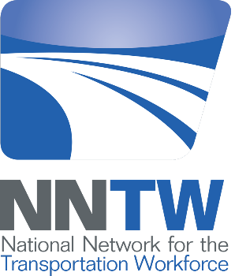**National Network for the Transportation Workforce**

The National Network for the Transportation Workforce (NNTW) comprises five regional transportation workforce centers funded by Federal Highway Administration. The five centers are as follows:

* West Region Transportation Workforce Center (WRTWC) based at Montana State University;
* Midwest Transportation Workforce Center (MTWC) based at the University of Wisconsin;
* Northeast Transportation Workforce Center (NETWC) based at the University of Vermont;
* Southeast Transportation Workforce Center (SETWC) based at University of Memphis; and the
* Southwest Transportation Workforce Center (SWTWC) based at California State University, Long Beach

Each of the five centers is dedicated to the development of the transportation workforce as well as certain disciplines unique to each center. For more information, visit [**http://nntw.org/**](http://nntw.org/)

**Resources and References**

American Public Transportation Association University (APTAU). Delivering the Future-Ready Workforce. Retrieved from:

<https://www.apta.com/research-technical-resources/aptau/>

Bureau of Labor Statistics. (2019). Transportation and Material Moving Occupations. Retrieved from: <https://www.bls.gov/ooh/transportation-and-material-moving/home.htm>

Department of Transportation, Federal Highway Administration. Center for Transportation Workforce Development. Retrieved from:

<https://www.fhwa.dot.gov/innovativeprograms/centers/workforce_dev/default.aspx>

Eno Center for Transportation. Workforce. Retrieved from:

<https://www.enotrans.org/issues-and-modes/workforce/>

George, Justin. (2019, October 5). A glimmer of hope as ridership rebounds for Metro and other transit systems. *The Washington Post.* Retrieved from:

<https://www.washingtonpost.com/local/trafficandcommuting/a-glimmer-of-hope-as-ridership-rebounds-for-metro-and-other-transit-systems/2019/10/05/f4e92aae-e5f4-11e9-a331-2df12d56a80b_story.html>

The National Network for the Transportation Workforce (NNTW). (2012). National Transportation Workforce Summit Summary of Results: Framework for Action. Retrieved from:

<http://netwc.net/wp-content/uploads/2018/02/NTWS_Summary_of_Results1.pdf>

The National Network for the Transportation Workforce (NNTW). (2019). Retrieved from:

<http://nntw.org>

Rapier, Graham. (2019, October 7). The transportation sector was a breakout star in the latest jobs report thanks to historic shortages and the upcoming holiday season. *Business Insider.* Retrieved from:

<https://www.businessinsider.com/september-jobs-report-transportation-came-out-on-top-2019-10>

Sweet, S., et al. (2010). Talent Pressures and the Aging Workforce: Responsive Action Steps for the Transportation and Warehousing Sector. The Sloan Center on Aging & Work at Boston College. Retrieved from:

<https://www.bc.edu/content/dam/files/research_sites/agingandwork/pdf/publications/TMISR09_Transportation.pdf>

TR News September-October 2019: Transportation Workforce of the Future. Retrieved from:

<http://www.trb.org/Publications/Blurbs/179950.aspx>

Transit Career Ladders Training (TCLT). Bay Area Rapid Transit. 2016. Retrieved from:

<https://www.bart.gov/sites/default/files/docs/BART%20Career%20Ladder%20Bro%20%204_6_16%20.pdf>

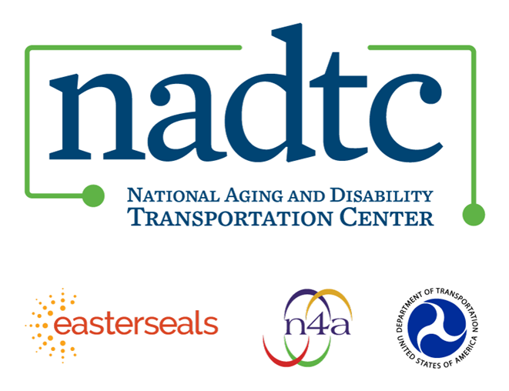

The National Aging and Disability Transportation Center (NADTC) is a program funded by the Federal Transit Administration and administered by Easterseals and the National Association of Area Agencies on Aging (n4a) with guidance from the U.S. Department of Health and Human Services, Administration for Community Living.

NADTC’s mission is to increase accessible transportation options for older adults, people with disabilities, and caregivers nationwide.

National Aging and Disability Transportation Center

Washington, D.C. 20003

Telephone and toll-free hotline: (866) 983-3222

TTY: (202) 347-7385

Email: contact@nadtc.org

Website: [www.nadtc.org](http://www.nadtc.org)

Follow us:

[Facebook](https://twitter.com/nadtcmobility)

[Twitter](https://twitter.com/nadtcmobility)

[YouTube](https://www.youtube.com/channel/UCAZ2yI_CbI-N8kMEXApeNxA)

[LinkedIn](https://www.linkedin.com/in/nadtc-staff-94a816116/)