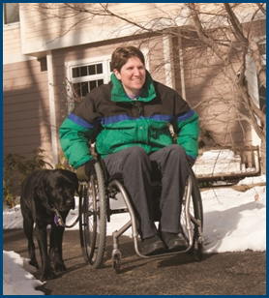
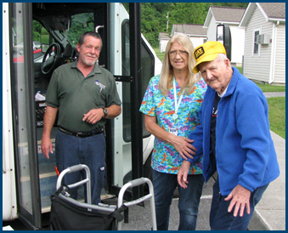

Americans with Disabilities Act (ADA):
Trending Questions Requiring Clarification

Topic Spotlight from the NADTC
2016 Transportation Trends Report

Introduction

The Americans with Disabilities Act (ADA) and its application to transportation services for older adults and people with disabilities is the focus of this Topic Spotlight, one of seven transportation issues reported on in the National Aging and Disability Transportation Center 2016 Transportation Trends Report. The complete report, available at www.nadtc.org, discusses trending topics—significant issues that affect the availability of accessible transportation in communities—identified by the National Aging and Disability Transportation Center (NADTC) in 2016.
Short information briefs were prepared in early 2017 on topics concerning developments in the field of transportation that are newsworthy and subject to change over time (e.g., shared ride services, bikeshare); others relate to longstanding problems that are not amenable to one-size-fits-all solutions and continue to present new challenges (e.g., crossing boundaries, safety). The selected topics are:
- Americans with Disabilities Act
- Accessible Bikeshare
- Crossing Jurisdictional Boundaries
- First Mile/Last Mile
- Safety
- Section 5310
- Shared Ride Services
All seven topics are covered in the full Trends Report linked above.

Americans with Disabilities Act (ADA):
Trending Questions Requiring Clarification

Introduction

The Americans with Disabilities Act (ADA) is a civil rights law prohibiting discrimination against persons with disabilities. Under Title II of the ADA, public transportation must be usable by people with disabilities. The U.S. Department of Transportation regulations pertaining to transportation at 49 CFR Part 37 and 38 are written to create an equal travel environment so that people with disabilities will not be excluded or denied from participation in using transportation systems or facilities.
While the ADA addresses a number of issues that promote transportation accessibility, there are three topics that currently create the most requests for technical assistance or are brought up as questions: reasonable modification, service animals, and customer service/passenger assistance. Even though the ADA was enacted in 1990, this brief intends to clarify these recurring issues.

Reasonable Modification

The U.S. Department of Transportation (DOT) published a final rule in 2015 that clarifies the obligation of "transportation entities" to make "reasonable modifications/accommodations to policies, practices, and procedures to avoid discrimination and ensure that their programs are accessible to individuals with disabilities." Transit systems must modify their policies to accommodate the needs of people with disabilities unless the modified policies result in an undue burden or a fundamental alteration of the program.
The final rule requires transit agencies to designate at least one person to coordinate its efforts to comply with their reasonable modification policy and process.
Providers are expected to develop procedures that meet the following requirements:
- The process for filing a complaint, including the name, address, telephone number, and email address of the employee designated under (a) of this part, must be sufficiently advertised to the public, such as on the public transit agency’s website.
- The procedures must be accessible to and usable by individuals with disabilities.
- The public transit agency must promptly communicate its response to the complaint allegations, including reasons for the response, to the complainant by a means that will result in documentation of the response.

The process shall provide a means, accessible to and usable by individuals with disabilities, to request a modification in the entity’s policies and practices applicable to its transportation services.
- Individuals requesting modifications shall describe what they need in order to use the service.
- Individuals requesting modifications are not required to use the term ‘reasonable modification’ when making a request.
- Whenever feasible, requests for modifications shall be made and determined in advance, before the transportation provider is expected to provide the modified service, for example, during the paratransit eligibility process, through customer service inquiries, or through the entity’s complaint process.
- Where a request for modification cannot practicably be made and determined in advance, operating personnel of the entity shall make a determination of whether the modification should be provided at the time of the request.
Reasons for Denial of a Request for Reasonable Modification

Requests for modification of a public entity’s policies and practices may be denied only on one or more of the following grounds:
- Granting the request would fundamentally alter the nature of the entity’s services, programs, or activities.
- Granting the request would create a direct threat to the health or safety of others.
- Without the requested modification, the individual with a disability is able to fully use the entity’s services, programs, or activities for their intended purpose.

A request for rides on a specific type or style of vehicle could be denied, for example, if the normal operation of the provider is to use a mixed fleet with no guarantee that specific vehicles can be assigned to specific routes or trips. In contrast, some providers make an effort to provide a specific type vehicle for most trips but advise the customer that it is not guaranteed for a specific type of vehicle to be available for all trip requests.

Reasonable Modification Examples
Reasonable modification to policy examples can be found in U.S. DOT ADA Regulations at Appendix E to Part 37—Reasonable Modification Requests. The examples provided there are not exhaustive and providers should look at each individual request and make determinations. Flexibility in perspective is helpful.
U.S. DOT identifies additional examples of reasonable modification:
- Allowing food or drink on a vehicle for a customer who is diabetic.
- Allowing operators to handle fare for a customer who has a disability that makes fare payment difficult or impossible.
- A driver will stop a bus away from the bus stop so a person in a wheelchair can avoid obstructions at a boarding location due to construction or snow and ice.
- Demand response drivers may need to adjust their policy of curb to curb service to door to door service for the customer that needs assistance to the door to complete their trip.
Service Animals
For transit providers and customers, there is often confusion because of differences in the definitions of Service Animals of the U.S. Department of Transportation and the U.S. Department of Justice (DOJ). For vehicle operations, DOT rules apply for both public and private providers. The DOT definition states, “Any guide dog, signal dog, or other animal individually trained to work or perform tasks for an individual with a disability.” Tasks include but are not limited to:
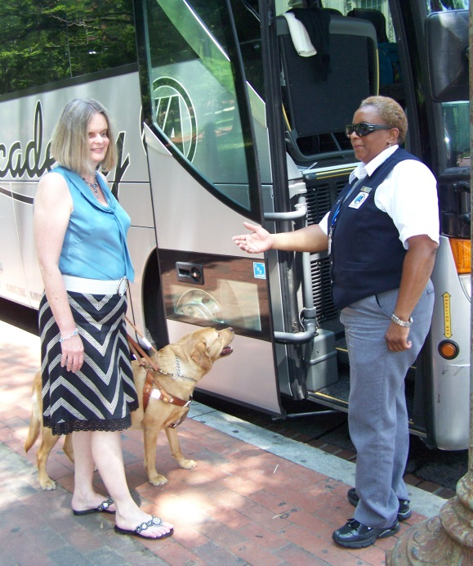
  - Guiding individuals with impaired vision
  - Alerting individuals with impaired hearing to intruders or sounds
  - Providing minimal protection or rescue work
  - Pulling a wheelchair or fetching dropped items

DOJ defines service animals as dogs that are individually trained to do work or perform tasks for people with disabilities. Tasks include,
  - Guiding people who are blind
  - Alerting people who are deaf
  - Pulling a wheelchair
  - Alerting and protecting a person having a seizure
  - Reminding a person to take prescribed medications
  - Calming a person with Posttraumatic Stress Disorder (PTSD)
  - Other duties needed by the person with disabilities

The DOJ regulations apply to any areas where the public is permitted go and apply to Title II (State and Local Governments) and Title III (Places of Public Accommodation) entities.
There are no national certification processes for identifying service animals. Transportation providers cannot require:
- A certificate
- Identification card
- Note from a physician
- The animal to wear a vest or other identifying gear
- Any limitation on the type of animal
Service Animal Policy Examples
- Transit providers may have a policy that service animals must not occupy a seat.
In general, service animals are trained to stay at a rider’s feet or under a seat.

- There is no limit to the number of service animals that a customer could bring on to a bus. If the animal meets the definition of a service animal and is under control of the owner, a provider should allow more than one service animal to board. Some service animals provide assistance at locations away from the bus.

- Service animals can ride on lifts but must be under control of the customer to protect
the animal and harness from moving parts of the lift.

Passenger Assistance

For riders using public transit, assistance from the driver is often vital to ensure that the trip can be made successfully by passengers with disabilities and seniors. Drivers should be trained to assist passengers and be sensitive to disability etiquette when interacting with people. Good customer service begins with drivers who make it part of their routine to assist passengers.
Additionally, Section 37.163(f) of the Department of Transportation’s Americans with Disabilities Act regulations states: “Where necessary or upon request, the entity’s personnel shall assist individuals with disabilities with the use of securement systems, ramps and lifts. If it is necessary for the personnel to leave their seats to provide this assistance, they shall do so.” Regulation 37.173 adds that transit operators are required to ensure that personnel are trained to proficiency, as appropriate to their duties, so that they operate vehicles and equipment safely and properly to assist individuals with disabilities in a respectful and courteous way.
The appendix to this section clarifies: “On a vehicle which uses a ramp for entry, the driver may have to assist in pushing a manual wheelchair up the ramp (particularly where the ramp slope is relatively steep). [This may] involve a driver leaving his seat.”
Summary

A public or private transportation provider that operates fixed-route or demand response service, or any combination, is required to provide accessible services for everyone meeting the ADA requirements and without discrimination. The reasonable modification rule of U.S. DOT helps clarify and guide providers to ensure that people with disabilities have opportunities to use accessible transportation and be connected to their communities. Likewise, understanding service animal requirements and passenger assistance requirements under the ADA benefits both customers and providers to make trips without hassle.
A crucial element for providing quality accessible transportation is to have a solid operator training program for ADA requirements and passenger assistance. The training is strongest when guided by clearly written agency policy that promotes practices which help customers make trips from origin to destination.

Resources

Americans with Disabilities Act: Guidance, FTA Circular 4710.1
https://www.transit.dot.gov/sites/fta.dot.gov/files/docs/Final_FTA_ADA_Circular_C_4710.1.pdf

Topic Guides on ADA Transportation
https://dredf.org/ADAtg/index.shtml

Transit Manager’s Toolkit: ADA
http://nationalrtap.org/transitmanager/Administration-Compliance/ADA

DOT Final Rule, reasonable modifications to policies, practices and procedures for public transportation providers.
https://www.federalregister.gov/documents/2015/03/13/2015-05646/transportation-for-individuals-with-disabilities-reasonable-modification-of-policies-and-practices

Kansas RTAP, How to Respond to Requests for Reasonable Modification to Your Policies? Use Common Sense. http://www2.ku.edu/~kutc/pdffiles/KTRFS16-ModifyPolices.pdf

Department of Justice Definition of Service Animal, National ADA Network Fact Sheet. http://adata.org/factsheet/service-animals

Frequently Asked Questions about Service Animals.
http://www.nadtc.org/wp-content/uploads/NADTC-Frequently-Asked-Questions-about-Service-Animals.pdf
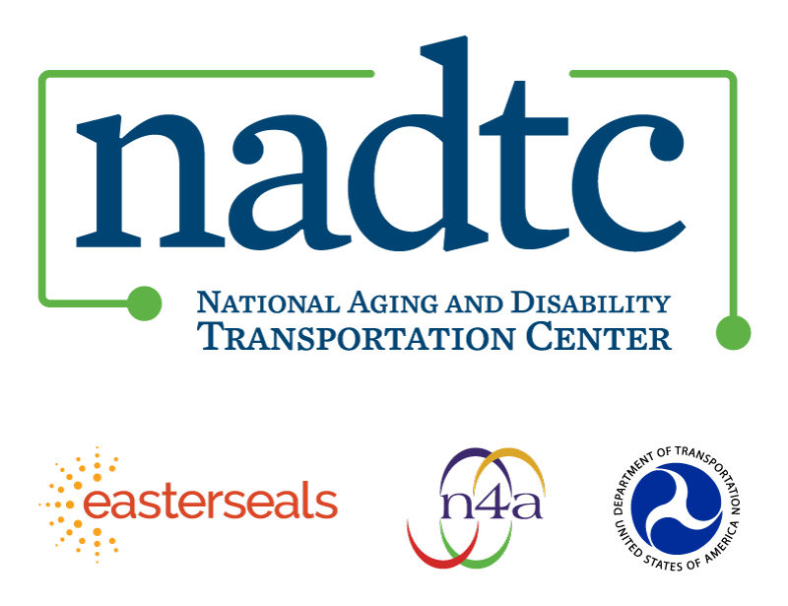

The National Aging and Disability Transportation Center is funded through a cooperative agreement of Easter Seals, the National Association of Area Agencies on Aging, and the U.S, Department of Transportation, Federal Transit Administration, with guidance from the U.S. Department of Health and Human Services, Administration for Community Living. NADTC’s mission is to increase accessible transportation options for older adults, people with disabilities and caregivers nationwide.

National Aging and Disability Transportation Center
Washington, D.C. 20005
Telephone: (866) 983-3222
TTY: (202) 347-7385
Email: contact@nadtc.org
Website: www.nadtc.org

Follow us:
Facebook
Twitter
YouTube
LinkedIn

