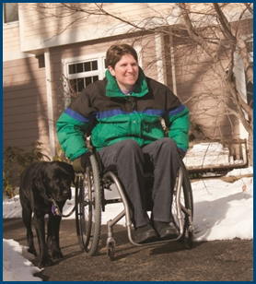
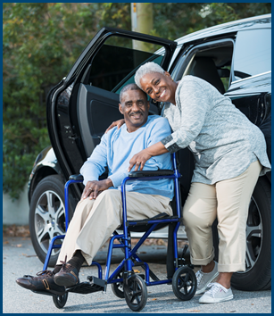
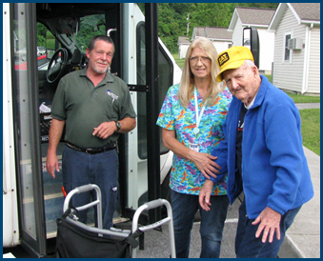

Addressing Transportation Safety Concerns of Older Adults
& People with Disabilities

Topic Spotlight from the NADTC
2016 Transportation Trends Report

Introduction

Potential Safety Concerns of older adults and people with disabilities planning to use public transportation is the focus of this Topic Spotlight, one of seven transportation issues reported on in the National Aging and Disability Transportation Center 2016 Transportation Trends Report. The complete report, available at www.nadtc.org, discusses trending topics—significant issues that affect the availability of accessible transportation in communities—identified by the National Aging and Disability Transportation Center (NADTC) in 2016.
Short information briefs were prepared in early 2017 on topics concerning developments in the field of transportation that are newsworthy and subject to change over time (e.g., shared ride services, bikeshare); others relate to longstanding problems that are not amenable to one-size-fits-all solutions and continue to present new challenges (e.g., crossing boundaries, safety). The selected topics are:
- Americans with Disabilities Act
- Accessible Bikeshare
- Crossing Jurisdictional Boundaries
- First Mile/Last Mile
- Safety
- Section 5310
- Shared Ride Services
All seven topics are covered in the full Trends Report linked above.

Addressing Transportation Safety Concerns of Older Adults & People with Disabilities

Introduction

Public transportation helps everyone—commuters, families, students, older adults, persons with disabilities—in their efforts to reach their personal and career goals, meet their daily needs, and maintain a high level of transportation independence. Public transportation helps foster an active lifestyle, encouraging people to walk and/or bike to transit stops. In 2014, an estimated 14.5% of the population was 65 or older and in 2015, nearly 20% of Americans were living with some type of disability. Accessible, safe mobility options are especially vital in supporting the independence of these two populations and of those who care for them.

For many older adults and people with disabilities, lack of experience using public transportation limits their interest in the possibilities available to them. The lack of experience with and knowledge about the various modes of transportation available in today’s market often results in fears about the potential risks associated with using public transit and deters people from exploring the options. Such fears can pose a major obstacle to efforts that encourage transit travel and improve transit services. Although rational arguments alone may not change everyone’s attitudes and feelings about public transit, carefully crafted, positive, and inviting safety and security messages disseminated through familiar and trusted sources can help dispel some of the negative attitudes and feelings of insecurity. www.vtpi.org/safer.pdf

Positive safety messages should also highlight that the availability of public transportation during emergencies—both natural and man-made—is critical in maintaining basic access, mobility, and safety for all individuals, especially older adults and people with disabilities. In an emergency, the availability of public transportation can literally become a matter of life or death.

Issues Related to Safety

- One of the primary reasons older people are often reluctant to give up driving and use public transportation is that they have never learned how to use public transportation. In addition, when asked about their hesitance to use public transportation, many older adults say they are concerned about their safety and vulnerability while waiting for and riding on local public transportation vehicles.

- Older adults with memory issues or dementia will need help to navigate the public transportation system safely.

- Older people with mobility limitations may experience physical instability when getting in or out of various transportation vehicles.

- Many parents/caregivers of children and young adults with disabilities—particularly those with intellectual and developmental disabilities—have never allowed those children/young adults to learn how to use public transportation because they feared for their safety.

- Although most public transportation vehicles in urban/suburban settings are now accessible (e.g., kneeling buses with low floors and small ramps to curbs, automated annunciator systems that call out names of stops) to people with physical disabilities, the areas where passengers must wait to get onto the vehicles are often not accessible (e.g., no seat available on which to sit and wait, broken or no sidewalks leading to the stop, poorly or unlit area). Such missing elements cause legitimate safety concerns.

- Public transportation can be the key to achieving independence for adults with intellectual and developmental disabilities; however, using transit on one’s own can create anxiety and fears.

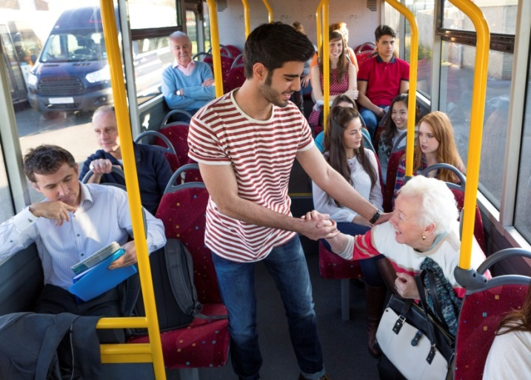
Opportunities Related to Safety

Each of these challenges present a variety of opportunities for transportation and health care service providers, local governments, commercial businesses, and other supporters of public transportation to engage with older adults and people with disabilities and their caregivers in efforts to increase passengers’ ability to use and be comfortable with using public transportation.

- Identify and/or develop ways to help older adults learn to use public transportation and feel safe doing so.
  - Organizations that provide services to older adults (e.g., Area Agencies on Aging, adult day programs, community senior services programs) can partner/collaborate with public transportation agencies to develop and disseminate information specifically describing the ways in which older adults can receive the assistance they need in order to use public transportation safely. System familiarization programs and travel training specifically designed for this population have proven very effective.

- Identify and/or develop ways to help people with memory problems or dementia and their caregivers safely use public transportation.
  - For people with memory issues, including dementia, offer programs that provide operators with information and training on the challenges that individuals with dementia and their caregivers face so they are better able to recognize dementia symptoms and ensure a safe and enjoyable trip for all riders. It is important to know the difference between normal age-related changes and the symptoms that may indicate a developing problem. As the first line of contact for many riders, the operator’s observations are important and may help detect changes in riders’ behavior that are indicative of a need for extra assistance.

- Identify and/or develop ways to help parents feel comfortable allowing their young and adult children with disabilities to learn how to use public transportation.
  - Organizations that provide services to children can partner/collaborate with public transportation agencies to develop and disseminate through as many channels as possible information specifically for parents describing the ways in which all parties can provide the necessary assistance to teach both young and adult children how to use public transportation safely.

- Identify and/or develop ways to help children and adults with disabilities learn how to use public transportation and feel safe doing so.
  - Schools and organizations that provide services to children and adults with disabilities can partner/collaborate with public transportation agencies to develop and disseminate information specifically describing the ways in which individuals can receive the assistance they need in order to use public transportation safely. System familiarization programs and travel training specifically designed for people with disabilities have proven very effective.

Case Studies/Addressing the Issues

Two examples of local transportation systems’ efforts, from the State of Maryland and the City of Chicago, illustrate how programs might allay the fears of, and provide hands-on support/training to, potential passengers on their public transportation vehicles. Click on the links provided below to access additional information on the MTA and Chicago RTA websites.

- Ten Ways to be Safe and Feel Safe on Public Transportation
The following is an abbreviated section from the Maryland Department of Transportation website. Click on the title “Ten Ways to be Safe” below to view the entire page.
The National Safety Council estimates that taking the bus is 170 times safer than traveling by automobile. That number shouldn’t surprise us when one adds up the number of fatalities on the road due to driving intoxicated (30%) or distracted (26%) or speeding (30%). Those bad options just aren’t available to us as passengers on a bus or rail vehicle. That’s why it makes the news when a mishap involves public transportation. The suggestions below are offered to help you travel more safely and feel safer too.
While waiting for a bus or streetcar, try to avoid unlit or deserted areas. Stand near others who are waiting, an occupied building, or in a lighted area until transportation arrives.
- Plan your route. If you’re new to public transportation, the bus or train schedule may be confusing at first. You should plan ahead of time where you are going and how you will get there.
- Consider tracking the real-time arrival of your MTA Local Bus or Light Rail if you own a smart phone, or via text messages on any mobile phone. (MyMTATracker.com is a good place to start.)
- Do not run to the train. Watch your step when boarding or exiting a subway train, as there is a gap between the edge of the subway platform and the train door.
- Listen for public announcements and follow the directions provided.
- Never attempt to board a subway train once the doors begin to close.
- Stand to one side to allow people to exit the subway car before you board.
- Stay alert and hold on to railings when a bus or train is slowing down or turning.
- When you arrive at your stop, be aware of others around you. If you feel you are being followed, go to the nearest occupied building and ask for assistance.
- Limit your display of money, electronics or valuables in public. Carry your wallet in an inside pocket or a pocket that can be buttoned. Keep your purse, shopping bag or other belongings in your lap, on your arm or between your feet. Do not leave them on an empty seat.
We invite you to check out more tips about traveling safely on MTA.

- The RTA Travel Training Program teaches individuals with disabilities and older adults how to use Chicago Transit Authority, Metra, and Pace buses and trains.

The RTA Travel Training Program offers three types of training tailored to meet each participant’s need: (1) Trip Training, (2) Individual Transit Orientation, and (3) Group Transit Orientation. The RTA Travel Training Coordinator will help participants decide which type of training will work best for them. Travel training sessions are provided by professionals who have experience working with people with disabilities and older adults, and are knowledgeable about transportation accessibility. Travel Training is free except for the cost of transit fares during training sessions.

Travel Training Brochure - English Travel Training Brochure - Spanish
Trip Training: Participants in this type of training work one-on-one with a travel trainer to practice using buses and trains to travel to locations they visit on a regular basis.
Individual Transit Orientation: Participants in this type of training will work one-on-one with a Travel Trainer to receive a general introduction to bus and train accessibility.
Group Transit Orientation: This type of training provides group presentations at agencies that serve people with disabilities and older adults throughout the six-county region. To sign up for Travel Training, contact the RTA Travel Training Program at (312) 913-3120 or by email at: traveltraining@rtachicago.org

Conclusion

It is imperative that transportation systems find and promote ways to meet the needs of citizens who are unable to drive or who want other mobility options so that they are better able to participate in their communities. Wide distribution of clear and welcoming information and programs that promote safety and security for older adults and people with disabilities can help position public transit as an efficient, enjoyable, and respected form of travel. In addition to such program information, transportation networks should be sure to highlight the essential role they play in providing emergency services for all community residents when natural and/or man-made disasters strike.

Resources
AAPD: Facts about Equity in Transportation for People with Disabilities
http://www.civilrights.org/transportation/disability/facts.html

Current Practices Used by Travel Trainers for Seniors
http://www.nadtc.org/wp-content/uploads/Current-Practices-Used-by-Travel-Trainers-for-Seniors-Cover.pdf

10 Safety Tips for Seniors Using Public Transportation
http://seniorliving.about.com/od/travelsmart/a/publictransport.htm

Transportation Education Curriculum
http://www.nadtc.org/resources-publications/transportation-education-curriculum/

Manual for the Development of Bus Transit System Safety Program Plans
Prepared by APTA, this document serves as a primer and guideline for both new start and established bus systems in defining the elements recommended for inclusion in a system safety program plan. http://bussafety.fta.dot.gov/show_resource.php?id=2951

Dementia Awareness in Public Transportation
http://www.nadtc.org/wp-content/uploads/Dementia-Awareness-Transportation-Final-Cover.pdf

Recommended Practice for the Development and Implementation of a Security and Emergency Preparedness Plan [SEPP
This APTA-recommended practice for the development and implementation of a security and emergency preparedness plan represents a common viewpoint of those parties concerned with its provisions, namely transit operating/planning agencies (transit systems), manufacturers, consultants, engineers, and general interest groups.) http://bussafety.fta.dot.gov/show_resource.php?id=3916

Clearinghouse for Older Road User Safety
https://www.roadsafeseniors.org/forum/general-discussion/public-transportation-fear

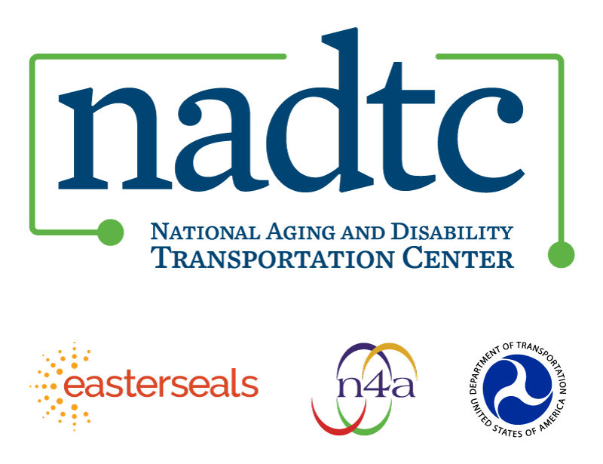

The National Aging and Disability Transportation Center is funded through a cooperative agreement of Easter Seals, the National Association of Area Agencies on Aging, and the U.S, Department of Transportation, Federal Transit Administration, with guidance from the U.S. Department of Health and Human Services, Administration for Community Living. NADTC’s mission is to increase accessible transportation options for older adults, people with disabilities and caregivers nationwide.

National Aging and Disability Transportation Center
Washington, D.C. 20005
Telephone: (866) 983-3222
TTY: (202) 347-7385
Email: contact@nadtc.org
Website: www.nadtc.org

Follow us:
Facebook
Twitter
YouTube
LinkedIn

