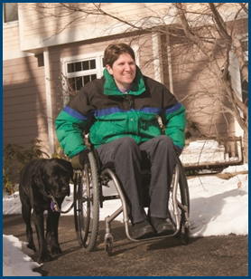
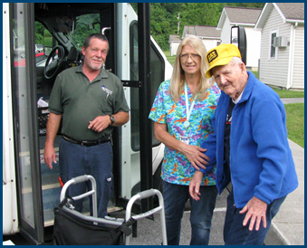

Section 5310: Opportunities, Requirements,
and New Developments

Topic Spotlight from the NADTC
2016 Transportation Trends Report

Introduction
The Federal Transit Administration’s Section 5310 funding program supports transportation services for older adults and individuals with disabilities. Section 5310 funding is the focus of this Topic Spotlight, one of seven transportation issues reported on in the National Aging and Disability Transportation Center 2016 Transportation Trends Report. The complete report, available at www.nadtc.org, discusses trending topics—significant issues that affect the availability of accessible transportation in communities—identified by the National Aging and Disability Transportation Center (NADTC) in 2016.
Short information briefs were prepared in early 2017 on topics concerning developments in the field of transportation that are newsworthy and subject to change over time (e.g., shared ride services, bikeshare); others relate to longstanding problems that are not amenable to one-size-fits-all solutions and continue to present new challenges (e.g., crossing boundaries, safety). The selected topics are:
- Americans with Disabilities Act
- Accessible Bikeshare
- Crossing Jurisdictional Boundaries
- First Mile/Last Mile
- Safety
- Section 5310
- Shared Ride Services
All seven topics are covered in the full Trends Report linked above.

Section 5310: Opportunities, Requirements, and New Developments

Introduction

The “Section 5310 Program: Enhanced Mobility for Seniors & Individuals with Disabilities” (Section 5310) is a program of the Federal Transit Administration (FTA) that supports investments to remove transportation barriers for older adults and individuals with disabilities. While there is no single solution to address the mobility needs of a community, Section 5310 provides the necessary flexibility of funding, whether capital or operational, to create investments specific to the needs of a select community’s population.

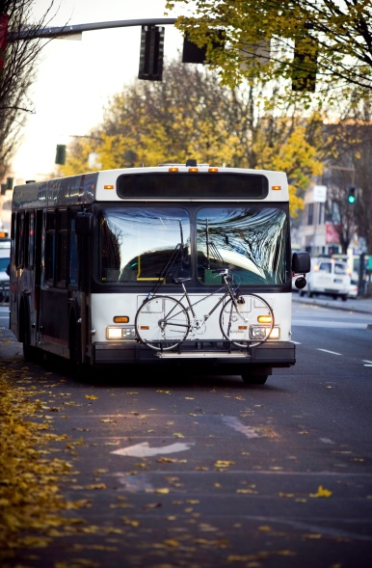
The Section 5310 program was initially established in 1975 as a discretionary capital assistance program directed mainly to human service agencies and non–profit organizations for the purchase of vehicles. As federal transportation legislation evolved over the next four decades, changes were made to Section 5310 to benefit older adults and people with disabilities, including allowing funds to be used for operating expenses, encouraging coordination among human service providers, and mandating development of a Coordinated Public Transit – Human Service Transportation Plan. Recent funding increases to the Section 5310 program represent an opportunity to continue and expand projects that serve the needs of older adults and people with disabilities.

Under the previous federal legislation, Moving Ahead for Progress in the 21st Century or MAP-21, the “New Freedom Program” (Section 5317) was merged into the Section 5310 program. Under the New Freedom Program, funds were made available for both capital and operating investments for services beyond traditional public transportation services and ADA complementary paratransit services. As a result of this merger of programs, activities eligible under the New Freedom program became eligible under Section 5310.

The combination of New Freedom-type activities (also called “nontraditional” activities) and “traditional” Section 5310 capital expenses was critical in creating a new 5310 program that not only aids in the purchase of much needed vehicles, but the development and support of creative programs to address the wide range of travel options, services, and modes of travel that a community has available.

Section 5310 dollars are apportioned to states based on the population of older adults and people with disabilities, and then divided into urban, small urban, and rural areas. Finally, funds are distributed through a flexible state-managed process (this could be a competitive application process, formula-based distribution, or discretionary).
Currently the Section 5310 program provides funding for:
- “Traditional” investments, which are capital transportation projects planned, designed, and carried out to meet the special needs of older adults and people with disabilities when public transportation is insufficient, inappropriate, or unavailable (at least 55% of funding must be used on these projects);
- “Nontraditional” investments, meaning capital or operating projects that exceed the requirements of the Americans with Disabilities Act (ADA) complementary paratransit (up to 45% of funding can be spent on these projects); and
- Program administration including planning and technical assistance (up to 10% of funding can be used on program administration).

Section 5310 also outlines the following match requirements:
- The match ratio for capital expenses is 80% federal and 20% local;
- For operating expenses, the federal share cannot exceed 50%;
- For program administration, 100% of federal funds can be used (meaning no match is required).

It is important to also keep in mind that the match can be derived from other federal funds (e.g., funds from the Administration for Community Living can be used as match), but funds from other FTA or US Department of Transportation (DOT) projects cannot be used as match.

Changes to Section 5310 under the Fixing America's Surface Transportation Act

The Fixing America's Surface Transportation (FAST) Act is the most recent federal surface transportation legislation which was signed into law on December 4, 2015. The FAST Act replaces previous MAP-21, and while it continues many of the Section 5310 provisions that MAP-21 established, it also includes some critical changes. Namely, the FAST Act:

- Increases Section 5310 funding to $262.9 million in FY 2016, $274 million in FY 2018, and $285.6 million in FY 2020;
- Requires FTA to develop a best practices guide for Section 5310 service providers;
- Establishes a pilot program to provide grants to entities eligible for Section 5310 funding for innovative projects that improve the coordination of transportation services and non-emergency medical transportation (NEMT) services;
- Allows states or localities that provide transit service and are eligible as direct recipients under Sections 5307 and 5311 to be direct recipients under Section 5310;
- Requires the Interagency Transportation Coordinating Council on Access and Mobility (CCAM) to publish a new strategic plan by December 2016.

Section 5310 Opportunities
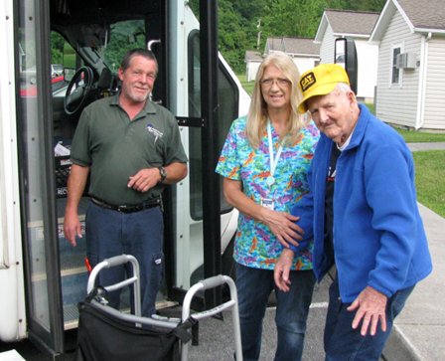
With the availability of Section 5310 funds, communities across the country have been provided with the opportunity to develop unique, local solutions to increase mobility for older adults and people with disabilities. A community’s family of transportation options may include a range of modes and services, such as fixed-route public transit, dial-a-ride services, taxis, driving, private vehicles, and biking, as well as options such as volunteer transportation programs, mobility management services, one call/one click platforms and travel training programs.

Examples of program innovations that may be funded under Section 5310 include a variety of projects defined under the traditional and nontraditional categories.

Traditional projects can include:
- buses and vans
- wheelchair lifts
- ramps, and securement devices
- transit-related information technology systems
- mobility management programs.

Nontraditional projects can include:
- travel training
- volunteer driver programs
- building an accessible path to a bus stop
- mobility management programs

You’ll notice that mobility management programs can be funded as either a traditional or nontraditional project. Mobility management activities help users choose the best transportation option(s) to meet their individual needs, while also optimizing existing community resources. While both aspects are important for the success of mobility management, some programs put greater emphasis on one or the other. An individual approach focuses on information and assistance to help older adults and people with disabilities make confident and educated transportation choices based on their own needs and preferences, while a systems approach is concerned with improves efficiency and reduces service duplication so providers can work together to better meet demand and unmet needs.

A one-call/one-click platform may be considered a component of mobility management activities. There are a number of ways a one-call/one-click service may operate, but typically users call a single telephone number and receive assistance from a trained specialist and/or independently use a website to compare different travel options and costs, including specialized services targeted to older adults, people with disabilities and veterans. Often one-click websites will complement and operate in conjunction with one-call Information & Referral programs. Some one-click websites even allow users to make trip transactions including booking and scheduling rides, and arranging payment. Not only are individuals provided assistance with obtaining a ride where and when they need to go, but the information collected from the platform can help identify service gaps.

Section 5310 Requirements

In addition to the flexibility Section 5310 offers in supporting a wide range of activities, there are also mandates in the program that require communities to participate in certain activities for funding eligibility. MAP-21 specified that projects selected for funding must be included in a region’s Coordinated Public Transit – Human Service Transportation Plan (also called a coordinated plan), and this requirement is continued in the FAST Act. A coordinated plan lays out a regional strategy to provide transportation and is meant to ensure that Section 5310 funding is being used in the most appropriate manner to reduce duplication in services. A coordinated plan also helps the region identify needs and gaps, and strategies for addressing those.
The coordinated planning requirement also includes a mandate for the coordinated plan to be developed and approved through a process that includes participation by older adults, individuals with disabilities, representatives of public, private and nonprofit transportation and human services providers, and other members of the public. This engagement can be in the form of public meetings, workshops, or surveys. By mandating public participation, Section 5310 is supporting and empowering older adults and people with disabilities to be actively involved in designing community transportation systems that are responsive to their needs as users. To find information on your region’s coordinated plan, contact your local Metropolitan Planning Organization: https://www.planning.dot.gov/mpo.asp.
Case Example: Innovative Use of Section 5310 Funds in North Carolina

In 2016, North Carolina’s Centralina Area Agency on Aging (AAA) and the Centralina Council of Governments Planning Department developed the “Centralina Transportation Barriers Study” under a Section 5310 grant from the North Carolina Department of Transportation (NCDOT). The purpose of the project was to identify challenges faced by older adults and people with disabilities in the nine-county Centralina region served by the AAA: Anson, Cabarrus, Gaston, Iredell, Lincoln, Mecklenburg, Rowan, Stanly, and Union. The study also created recommendations to overcome the barriers and synthesized and presented information to inform policy decisions and strategies. Section 5310 funding allowed this project to tackle a depth and breadth of research that the region would otherwise have been unable to capture.

The study gathered input from older adults and people with disabilities through a combination of online and paper surveys and focus groups, as well as input from 25 mobility providers and regional planning professionals. With this input, the study identified the most prominent challenges faced by older adults and people with disabilities in the Centralina region, which include: financial constraints, isolation, physical access issues, and lack of eligibility for transit programs. To develop recommendations, the study conducted a literature review and analysis of nationwide best practices on transportation and mobility. Combined with the surveys, focus groups, and input from mobility providers, the study resulted in a recommendation list that addressed five categories of barriers: Physical and Accessibility Factors; Rider Perceptions and Education; Policy and Service Coordination; Funding Structure; and Land Use and Environmental Conditions. The development of these recommendations, along with all of the information the study gathered in the process, will guide future development of transportation for the area.

Resources

National Aging and Disability Transportation Center Resources
http://www.nadtc.org

Section 5310 Course: Filling Gaps in Mobility for Older Adults & People with Disabilities
http://www.nadtc.org/event/section5310-gapsinmobility/

Section 5310 Funding Application Checklist
http://www.nadtc.org/resources-publications/section-5310-funding-an-application-checklist/

FTA Resources (http://www.transit.dot.gov)
  - FAST Act Webpage https://www.transit.dot.gov/FAST
  - Section 5310 Webpage https://www.transit.dot.gov/funding/grants/enhanced- mobility-seniors-individuals-disabilities-section-5310
  - Section 5310 Fact Sheet https://www.transit.dot.gov/funding/grants/enhanced-mobility-seniors-disabled-fact-sheet-section-5310

Centralina Transportation Barriers Study
http://www.nadtc.org/wp-content/uploads/Transportation-Barriers-Study-FINAL-Dec2016.pdf.

Centralina Region Transportation Services Information
http://centralinamobility.org/.

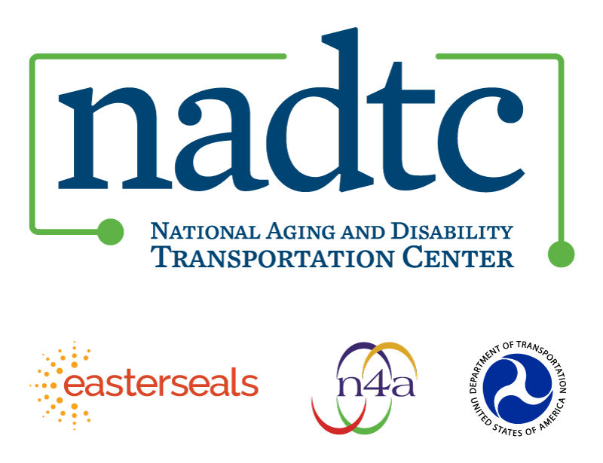

The National Aging and Disability Transportation Center is funded through a cooperative agreement of Easter Seals, the National Association of Area Agencies on Aging, and the U.S, Department of Transportation, Federal Transit Administration, with guidance from the U.S. Department of Health and Human Services, Administration for Community Living. NADTC’s mission is to increase accessible transportation options for older adults, people with disabilities and caregivers nationwide.

National Aging and Disability Transportation Center
Washington, D.C. 20005
Telephone: (866) 983-3222
TTY: (202) 347-7385
Email: contact@nadtc.org
Website: www.nadtc.org

Follow us:
Facebook
Twitter
YouTube
LinkedIn

