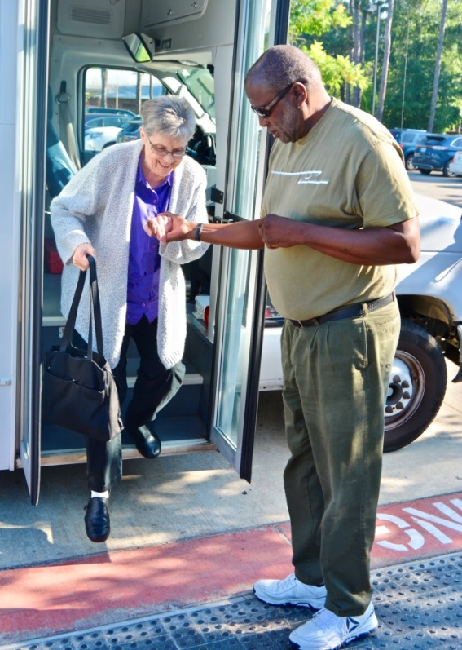
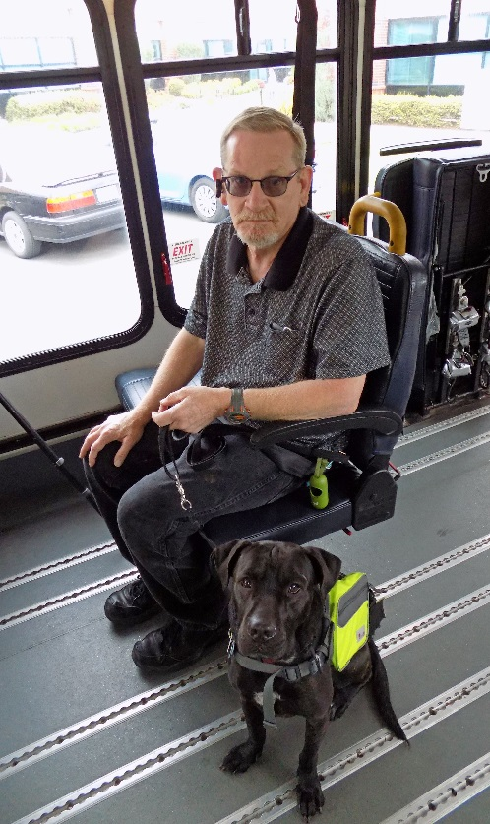
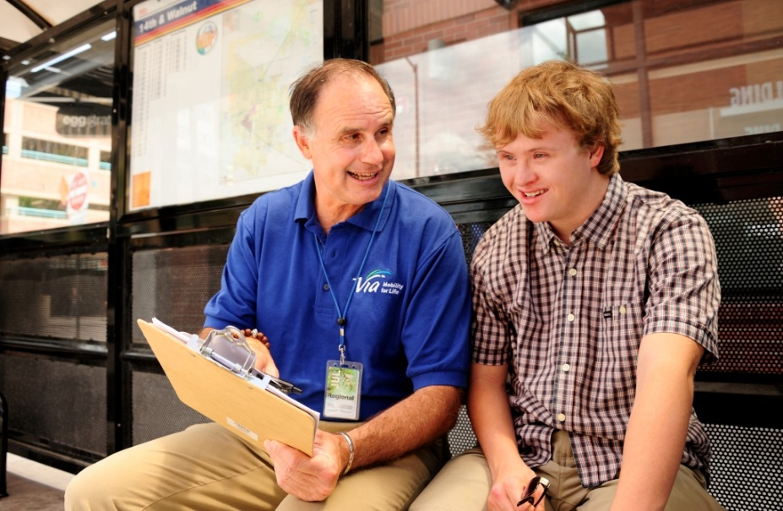

Introduction
Initiated in 2016, NADTC’s annual Trends Report explores trending topics in transportation from the last one to two years with a focus on accessible transportation services used by older adults and people with disabilities. The complete Trends Report is supplemented by Topic Spotlights for those who would like to download just one section of the report.
With its mission to increase the availability and accessibility of transportation for older adults and people with disabilities, NADTC recognizes that our work must be grounded in, and respond to, the needs and preferences of the communities and organizations that the center was created to serve. Critical to the center’s success is access to information about local communities’ efforts to develop, fund, and operate accessible transportation, how those developments are received by people with disabilities and older adults, and the reactions of leaders in accessible transportation to developments in the transportation field.
2018’s information reports address:
- Cancer Care and Dialysis Transportation
- Innovative Approaches to Section 5310 Match
- Non-Emergency Medical Brokerages and Coordination
- Opioid Use and Transportation
- Volunteer Transportation Programs
In this Innovative Section 5310 Funding Match Topic Spotlight, NADTC explores how local funding match is integral to implementing federally funded transit service and looks at Section 5310 funding practices that communities in Colorado and Texas are using to support transportation programs.
Explore transportation’s trending news with us through this report! If you have questions or have a story to share from your community, reach out to us at (866) 983-3222 or email contact@nadtc.org.
Cover Photo Credits:
Top: Via Mobility Services, Boulder, Colorado
Bottom left: Meals on Wheels Montgomery County, Conroe, Texas
Bottom right: Human Services Council, Southwest Washington, Vancouver, Washington
Section 3 Photo Credits:
Paris Metro, Texas
All Points Transit, Colorado
Section 4 Photo Credits:
Senior Transportation Connection, Cleveland, Ohio
Kewaunee County Services, Kewaunee, Wisconsin

Bottom right:

Innovative Approaches to Section 5310 Funding Match

Introduction
Local match requirements for U.S. Department of Transportation grant programs vary by program and the level of state funding available for transit services for older adults and people with disabilities. With pressures to meet demand for rides among a growing senior population along with services for people with disabilities both in urban and rural areas, many cities, counties, and regional agencies are taking a coordinated approach to providing the match needed to successfully fund transit services under the Federal Transit Administration (FTA) Section 5310 program.
Overview of Section 5310 Funding Requirement
FTA’s Enhanced Mobility of Seniors and Individuals with Disabilities Program (Section 5310) is designated to “improve mobility for seniors and individuals by removing barriers to transportation service and expanding transportation mobility options” (FTA, 2018). Section 5310 funding is provided to large urban, small urban, and rural areas, with urban areas receiving 60% of the Section 5310 funding apportioned to a state. Small urban areas receive 20% of the funding, and rural areas receive 20% of the funding. States are allowed to transfer small urban and rural allocations to large urbanized areas but not the other way around.
Additional details about Section 5310 funding from the FTA Circular C 9070.1G:
Direct recipients of funding include:
- States for rural and small urban areas.
- Designated recipients chosen by the governor or a state for large urban areas.
- State or local government entities that operate a public transportation service.
Funding eligibility requirements:
- At least 55% of funds must be used on:
  - Capital projects such as buses and vans; wheelchair lifts; securement devices; transit-related information; technology systems; and mobility management programs.
  - Acquisition of transportation services under a contract, lease or other arrangement. Per the FTA Section 5310 Circular, “both capital and operating costs associated with contracted service are eligible capital expenses.”
- The remaining 45% of funds is for “nontraditional projects.” Beginning with the Moving Ahead for Progress in the 21st Century Act (MAP-21) in 2012, the Section 5310 program was changed to include projects that had been eligible under the former Section 5317 New Freedom program that funded transportation services and alternatives beyond those required by the Americans with Disabilities Act.
The types of projects eligible under this expansion include, but are not limited to, travel training; volunteer driver programs; accessible infrastructure projects (curb ramps, sidewalks, signals, and bus stop features); and mobility management. Additional project ideas are included in the Section 5310 Circular.
Other key information about the Section 5310 program that recipients should know:
- Other federal funds (non-DOT) can be used as match. This means that a program can implement a project with 100% federal funding. An example would be Older Americans Act Title IIIB funding.
- Section 5310 programs may partner with meal delivery programs such as OAA--funded meal programs and the USDA Summer Food Service program. Eldercare Locator is a resource for finding local meal programs. As stated in Chapter 53 of Title 49 of the U.S. Code, transit providers funded by Section 5310 or Section 5311 (c) grants can assist with these programs if they do not conflict with regularly provided transit service. [Some state DOTs may place a percentage cap on the total incidental use of the vehicle. Refer to your state DOT’s Section 5310 instructions for additional information.]
- Transportation to drug treatment centers is eligible transportation under Section 5310.
Local Match
Local share of capital projects “shall not be less than 20% of the net cost of the activity” and local share for eligible operating costs “shall not be less than 50% of the net operating costs” (FTA Circular 9070.1G, p. III-16). Exceptions to these percentages exist for ADA-compliant vehicle purchases, clean-fuel or alternative-fuel vehicles, and in some cases where Federal Highway Administration funds are transferred to the FTA program. In terms of how the FTA stipulates how match can be provided, local share can be undistributed cash, a replacement or depreciation cash fund or reserve, a service agreement with a state or local agency or private social service organization, or new capital.
Specific examples of these types of allowable monetary match include:
- State or local appropriations
- Dedicated tax revenues
- Private donations
- Revenue from service contracts
- Transportation development credits
- Net income from advertising and concessions
Income from contracts to provide human services transportation may be used to provide local match and, if used, must be counted in the total project cost.
No FTA program funds can be used as local match for other FTA programs; however, as noted earlier, Federal Lands Highway program funds or other non-U.S. DOT federal funds can be used as local match. Other federal agency programs commonly tapped for match funding are employment, training, aging, medical, community services, and rehabilitation services.
Non-Cash Project Contributions
Specific examples of non-cash share include:
- Donations (e.g. vehicles, property)
- Volunteer services
- In-kind contributions
In the case of non-cash contributions, each must be documented and supported. States may be more restrictive than the FTA. In-kind match requests must be approved in advance.
State Administration and Guidelines for Section 5310 Project Match
The state DOTs, as direct recipients of Section 5310 funds, develop guidelines and processes for potential applicants. Within those guidelines, the states explain the requirements for match and the documentation that needs to take place for categories of funds to be used for local match. The language contained in state Section 5310 application guidance naturally follows the requirements set forth by the FTA.
Example of State Guidelines for Local Match
The use of non-U.S. DOT federal funds for match is relatively new, and with limited federal funds available for competing projects, the majority of match applied to Section 5310 projects continues to be drawn from local sources. The ability to use non-U.S. DOT federal funds as local match was initiated under SAFETEA-LU in 2005 when non-DOT match funds were approved for Section 5310, Section 5311, and for former Section 5316 (JARC), and former Section 5317 (New Freedom) programs. Under MAP-21, some Section 5316 and 5317 eligible activities were melded into the expanded Section 5310 program, and the non-DOT match allowance expanded to include the Section 5307 program (Blog, www.nadtc.org). Local match is typically resourced from state or city/county/town-level funding sources.
Match guidelines may differ state to state. To share an example, NADTC reviewed the Wisconsin Department of Transportation’s application process. For capital projects, the Wisconsin DOT requires a cash match from one of the following sources: state or local funds, private donations, grantee agency funding, and non-U.S. DOT federal funds.
Examples of non-traditional project matching funds that can be used in Wisconsin include cash match of state or local funding, private donations, grantee agency funding, and non-U.S. DOT federal funds, and in-kind funding. Examples of in-kind match for Section 5310 can include donated facility space or supplies, labor contributed to the project, and miscellaneous expenses such as website hosting, marketing costs, or travel and mileage.
Expansion of Local Match Sources
The guidelines that Wisconsin provides may differ slightly from other states, but across the country, state DOTs provide similar guidance to Section 5310 applicants. Within the type of match allowed, transportation agencies have expanded the variety of sources from which they draw local match funds. For example, Texas and other states have used or are currently using toll credits or Transportation Development Credits. According to a Texas A&M Transportation Institute memorandum (Geiselbrecht & Baker, 2013), the credits reduce the amount of funding a state or local agency must provide for projects, allowing many programs to be funded with 100% federal funds. In Texas’ case, 75% of credits are allocated to the metropolitan planning organization of the region where the funds are generated, and 25% is allocated on a competitive statewide basis. Credits may be used for public transit funding although use of the credits for transit is less common than for highway project match.
In Texas, toll or transportation development credits are a form of “soft” match, rather than “hard” match of actual money, and toll credits are used in state projects to meet non-federal match requirements tied to capital purchases such as vehicle purchases and transit facilities. While Transportation Development Credits can be used for operating costs, in Texas they are most often applied to capital costs (Geiselbrecht & Baker, 2013).
Other states that have piloted or used toll credits or Transportation Development Credits include California, Florida, Illinois, Michigan, New Jersey, and Virginia. To take a closer look at how states are providing local match for Section 5310 transit programs, NADTC sent an email questionnaire to the state department of transportation public transportation offices. Based on responses to that survey and a review of recent transportation funding initiatives, NADTC will focus on a few local match initiatives in Texas and Colorado.

Building Partnerships to Establish Local Match in Texas
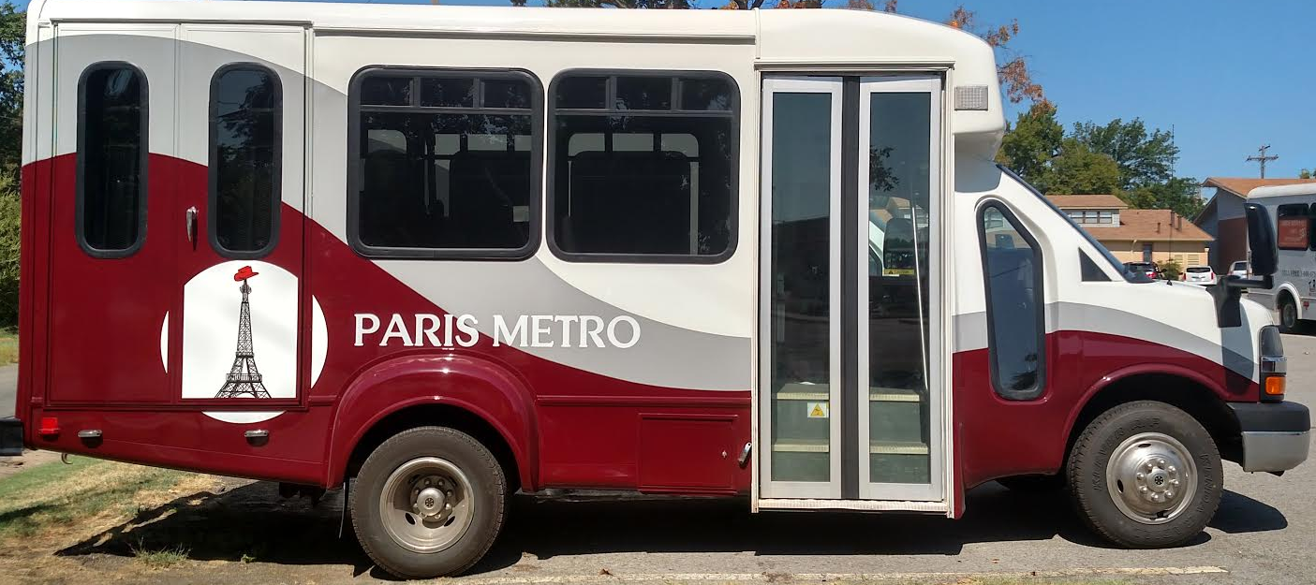
As noted, Texas uses Transportation Development credits as a form of soft match for capital investments. In the case of Paris, Texas’ Metro system, operation match has been funded through a cooperative effort. The Ark-Tex Council of Governments offered rural service in its region but wanted to improve service in Paris, Texas, to meet demand for local transit needs. Working in partnership with private agencies identified in the coordinated human services transportation plan, Paris Metro met with key stakeholders and in working with the City of Paris, was able to secure engineering, sign construction, sign installation, benches, and shelters through in-kind services.
Due to the level of operations expenses needed, Paris Metro established a sponsorship/partnership program. As a result, Paris received in-kind office space from the Paris Regional Medical Center, the City of Paris, the United Way, Paris Junior College, Texas Oncology, the Results Company, the RAM Foundation, and St. Joseph’s Foundation. Community service workers took responsibility for cleaning the new Paris Metro office.
Innovative Match Resources in Colorado
Douglas County
Douglas County, Colorado, is geographically located between Denver and Colorado Springs. In 2001, Douglas and Arapahoe counties approved a tax to fund programs serving people with disabilities. The Disabilities Mill Levy assesses a 1 mill tax on all homes in the two counties. According to a Denver Post article, approximately 95% of the funds support Developmental Pathways, a multi-jurisdictional, community-centered group, and 5% of the funds are retained for the Douglas County Developmental Disabilities Grant Program. Approximately half of the funding for third party trips in Douglas County has been provided by Developmental Pathways, and $50,000 has been provided by the mill levy funds (Mitchell, 2017). As a note, Developmental Pathways funding is also used as cash match by the Denver Regional Mobility & Access Council.
City of Durango
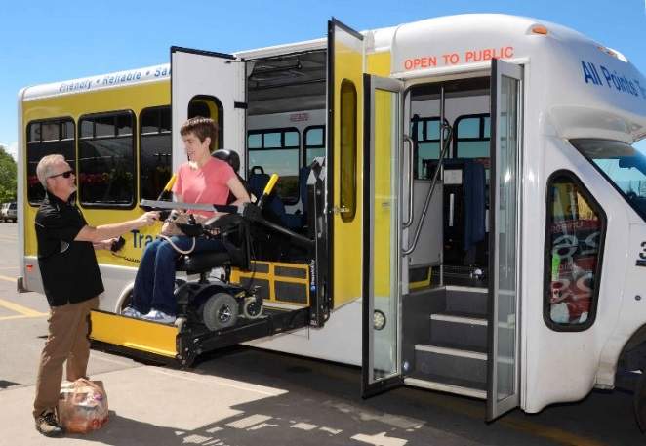
The City of Durango’s Transportation Services Enterprise Fund uses parking meter revenue and fines and a portion of the lodgers’ 2% tax to support public transit. In 2016, the City of Durango increased its parking and meter fines to help fund the city’s transit system. Expired meter fines increased by $13 per penalty (Shinn, 2016). A variety of tax increases were considered by the City Council in 2017, and state funding decreases in 2018 resulted in the decision to eliminate two transit routes. If the city were to raise fares to maintain its routes, fares would likely need to increase from $1 to $5 per ride according to a recent Durango Herald article (Shinn, 2018). Municipalities considering using fines or ticket fees for transportation revenue or match similar to the Durango model should take into consideration that increasing fines may result in fewer violations, which is a positive; however, it may ultimately result in lower revenue for transportation.
All Points Transit
Serving the region between Grand Junction and Montrose, All Points Transit receives match through foundation support, non-profit organizations, and local governments including two cities, three counties, and six towns. All Points has experienced an increase in demand, specifically for medical-related trips. In 2015, Delta County and its municipalities were funding 40% of the cost of rides (Sunderland, 2015). Donations and fundraising also cover a portion of local match, including funds raised through an annual Montrose Oktoberfest.
Mesa County
Grand Valley Transit in Mesa County uses an intergovernmental agreement to fund transit service. According to a September 2018 Daily Sentinel article on bus system funding, local governments support Grand Valley Transit through a percentage formula (Hamilton, 2018). In 2019, it is budgeted that Mesa County pays 65% of the costs, City of Grand Junction pays 30%, the City of Fruita pays 3%, and Town of Palisade pitches in 2%. The language of the intergovernmental agreement notes that the Grand Valley Regional Transportation Committee acknowledges that local match funding and the percentages agreed to for 2019 are not permanent funding, and the funding formula and match commitments are subject to future changes.
Summary
Local match initiatives in Texas and Colorado are just a few examples of the types of agreements, partnerships, and policies being implemented in states across the nation. Coordination and agreement that the services funded are beneficial to all participating constituencies is critical when multiple jurisdictions are involved. In the Texas example, the ability to communicate a shared vision was important for bringing new partners on board, and in the case of agencies offering in-kind services, identifying how transportation ties to the non-transportation entity (e.g., healthcare facility) will help solidify the role that accessible transit plays in a community’s health and well-being.
The examples from Colorado indicate that local match models vary and are often based on opportunities unique to a region or state such as foundation support, taxes, or fundraising. Before implementing a match model, a community needs to consider the short-term and long-term budgetary impacts. No matter how a transportation system decides to fund local match for federal grants, the partnerships created through coordination can lead to long-term benefits for not only transportation but other community services as well.
References and Resources
Federal
U.S. Department of Transportation, Federal Transit Administration. Enhanced Mobility of Seniors & Individuals with Disabilities - Section 5310. (2018). Retrieved from https://www.transit.dot.gov/funding/grants/enhanced-mobility-seniors-individuals-disabilities-section-5310
U.S. Department of Transportation, Federal Transit Administration. FTA Section 5310 Circular 9070.1G Enhanced Mobility of Seniors and Individuals with Disabilities Program Guidance and Application Instructions. (2014). Retrieved from https://www.transit.dot.gov/sites/fta.dot.gov/files/docs/C9070_1G_FINAL_circular_4-20-15%281%29.pdf
U.S. Department of Transportation, Federal Highway Administration. (2015, November 20). Special Federal Aid Funding. Retrieved from https://www.fhwa.dot.gov/specialfunding/151120.cfm
U.S. Department of Transportation. (2015, December 1). Chapter 53 of title 49, United States Code, as amended by Fixing America’s Surface Transportation Act Related FAST and MAP-21 provisions. Retrieved from https://www.transit.dot.gov/sites/fta.dot.gov/files/docs/Chapter%2053%20as%20amended%20by%20the%20FAST%20Act_1.pdf
National Aging and Disability Transportation Center. (2017, March 31). Section 5307, 5310, and 5311: Using Non-DOT Federal Funds for Local Match [Web log post]. Retrieved https://www.nadtc.org/news/blog/section-5307-5310-and-5311-using-non-dot-funds-for-local-match/

Wisconsin
Wisconsin Department of Transportation. (2018). Section 5310 Application Guidelines for Vehicle Capital. Retrieved from https://wisconsindot.gov/Documents/doing-bus/local-gov/astnce-pgms/transit/5310-app-trad.pdf
Wisconsin Department of Transportation. (2018). Section 5310 Application Guidelines for Non-Traditional Projects. Retrieved from https://wisconsindot.gov/Documents/doing-bus/local-gov/astnce-pgms/transit/5310-app-non.pdf
Texas
Geiselbrecht, T. & Baker, R.T. (2013, October 30). The Use of Federal Toll Credits and Transportation Development Credits by States and Regional Planning Entities [Memorandum]. College Station, TX: Texas A&M Transportation Institute. Retrieved from http://ftp.dot.state.tx.us/pub/txdot-info/lgp/tech-memo-transportation-development-credits.pdf
Rall, C. Transportation for America. (2018). The Paris Metro in small-town Texas [Web log post.] Retrieved from http://t4america.org/2018/08/16/the-paris-metro-in-small-town-texas/
Colorado
Mitchell, M. (2017, September 19). These services for developmentally disabled residents have grown because Douglas and Arapahoe voters approved a tax in 2001. The Denver Post. Retrieved from https://www.denverpost.com/2017/09/19/developmental-disabilities-mill-levy-tax-douglas-arapahoe/
Shinn, M. (2016, December 18). Increase in parking fines will help pay for transit. The Durango Herald. Retrieved from https://durangoherald.com/articles/122479
Shinn, M. (2017, March 14). City of Durango facing 5 years of transit budget shortfalls. The Durango Herald. Retrieved from https://durangoherald.com/articles/143003
Shinn, M. (2018, May 18). Durango Transit leaves some neighborhoods unserved. The Durango Herald. Retrieved from https://durangoherald.com/articles/224355
Shinn, M. (2018, April 11). Durango Transit tightens its belt. The Durango Herald. Retrieved from https://durangoherald.com/articles/217993
Sunderland, P. (2015, October 28). All Points Transit expands services. Delta County Independent. Retrieved from https://www.deltacountyindependent.com/all-points-transit-expands-services-cms-1164
Hamilton, A. (2018, September 17). Bus system seeks boost in funding. The Daily Sentinel. Retrieved from https://www.gjsentinel.com/news/western_colorado/bus-system-seeks-boost-in-funding/article_6de5ebc2-ba3b-11e8-a901-10604b9f6eda.html
Photo credits:
Paris Metro, Texas
All Points Transit, Colorado
State DOT Survey on Section 5310 Funding Practices
(The following email survey was sent to all state DOT public transit offices on November 2, 2018.)
Dear State Public Transportation Directors and Program Managers,
The National Aging and Disability Transportation Center (NADTC), the Federal Transit Administration’s technical assistance center that focuses on transportation mobility for older adults and people with disabilities, is preparing an information brief that will highlight innovations in Section 5310 match funding. If you have an example in your state that you’re open to having featured in the brief, we’d like to hear from you!
Do you have:
- Recipient(s) in your state that has approached Section 5310 match through an innovative solution (or solution that is being newly tried), combination of funds, or is using non-DOT federal funds for match?

- Or do you have a tribal transportation provider in your state who’s applied for Section 5310 funding?
If yes to either or both, we’re looking for a very short description of the type of match (e.g., pooled funds, non-DOT federal, tax revenue, in-kind) and type of agencies or partners involved in funding the match.

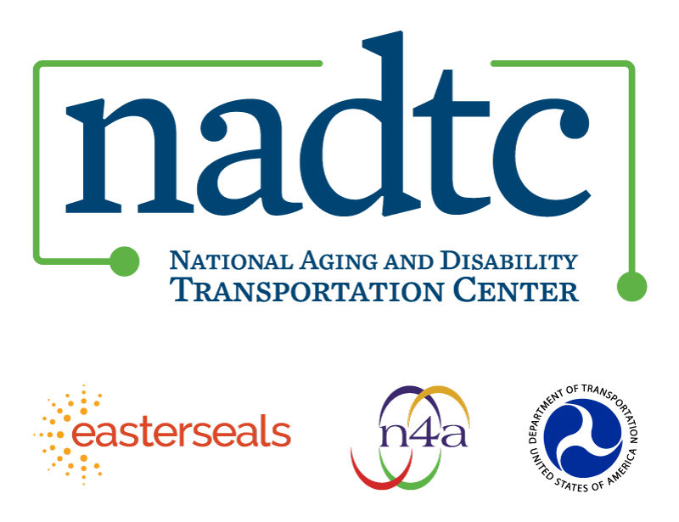

The National Aging and Disability Transportation Center (NADTC) is a program funded by the Federal Transit Administration and administered by Easterseals and the National Association of Area Agencies on Aging (n4a) with guidance from the U.S. Department of Health and Human Services, Administration for Community Living.

NADTC’s mission is to increase accessible transportation options for older adults, people with disabilities, and caregivers nationwide.

National Aging and Disability Transportation Center
Washington, D.C. 20005
Telephone and toll-free hotline: (866) 983-3222
TTY: (202) 347-7385
Email: contact@nadtc.org
Website: www.nadtc.org

Follow us:
Facebook
Twitter
YouTube
LinkedIn

