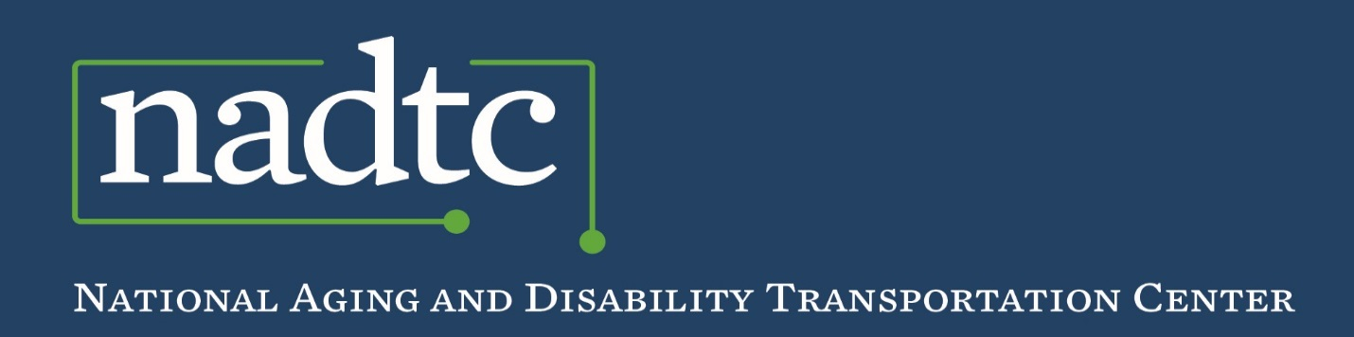

*Best Practice*

**Volunteer Best Practice:**

***Door-through-Door Transportation Program***

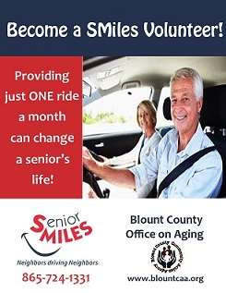Launched in 2013,[**Senior Miles**](https://www.blountcaa.org/programs/) (SMiles) transportation program was developed by the Blount County Office on Aging, with the help of community leaders committed to solving senior transporation issues in Blount County, Tennessee. The program is designed to be senior-friendly, sustainable and affordable. SMiles provides door-through-door transportation for individuals 60 years or older.

**Service Area:** SMiles serves the area of Blount County.

**Population:** Approximately 129,929 people live in Blount County, TN. Nineteen percent (19%) of the county’s population is over 60 years of age.

***Challenge:*** *Blount County is a rural community with limited low-cost transportation options for older adults.*

**How the Program Works:**

SMiles is a membership-based program for adults 60 or older who are unable to drive and ambulatory with assistance of a cane or walker; wheelchairs cannot be accommodated. An initial payment of $49.00 covers annual membership plus four round trip rides: the annual membership fee is $25.00; rides cost $6.00 per round trip. All fees are paid in advance by check or credit card to Blount County Community Action Agency. Volunteers do not accept any money from riders. Caregivers, family, friends or faith-based organizations can submit membership and rider fees on behalf of the member.

To sign up for the SMiles transportation program, an individual calls the office. Staff conducts a pre-screening which addresses the requirements for eligibility (unable to drive, ambulatory and able to communicate by phone). After the pre-screening, a packet of information consisting of membership, informed consent and code of conduct forms must be completed and returned to the SMiles office. Individuals that cannot be accommodated (e.g. require a wheelchair) through SMiles transportation program are referred to the East Tennessee Human Resource Agency (ETHRA), which provides services for persons over the age of 60, family caregivers, or adults with disabilities.

Once the membership forms are returned along with payment, the rider is entered into the *Assisted Rides* software system, a web-based program that tracks all rides, client accounts, client payments, volunteer records, trips, and destinations. After a rider’s account is set up, they can immediately start calling for rides. Members also have the option to log in to the *Assisted Rides* system and schedule rides. A lead time of three days is typically required to book a ride. The rider’s request is posted online in the Assisted Rides system and selected by an available volunteer. SMiles drivers log into the system to check pending rides and then self-assign rides online using Assisted Rides Software, logging back in to complete the trip afterwards.

**Volunteer Eligibility and Training:**

Drivers must be at least 21 years of age, pass a criminal background check, hold a valid driver’s license and have a safe driving record. Volunteers are expected to provide at least one ride per month (three-hour commitment), but they have the flexibility to sign up for additional rides that fit into their schedule. SMiles drivers use their personal automobiles and their auto insurance is primary. The SMiles program purchases excess medical and liability insurance through CIMA for the volunteers. This insurance is secondary to a volunteer’s own medical insurance and automobile liability insurance policies. Drivers are not paid for their time; however, reimbursement for gas is offered.

Volunteers receive four hours of training, which includes information on program policies and procedures as well as senior sensitivity training. Each volunteer receives a copy of the SMiles Volunteer Driver Handbook. Assisted Rides software training is also provided to each driver.

**Volunteer Recruitment:**

The SMiles program is staffed with a full-time manager and a director who assists with marketing through events, presentations and media. Word of mouth is the key to the program’s success and area partners such as the Chamber of Commerce, retirement communities and physicians’ offices help spread the word. However, seniors themselves are the program’s biggest advocates. Seniors spread the word about SMiles at doctor’s offices and other places they frequent. Volunteers are also great ambassadors of the SMiles program.

**Funding:** SMiles received their startup support through New Freedom funds, administered by their local regional transportation planning organization. In 2015, SMiles received three years of funding from the Federal Transit Administration and the Tennessee Department of Transportation. Additional funding comes from the local United Way, memberships, rider fees, annual fundraisers, and donations.

**Results:**

SMiles has provided over 27,000 trips to medical appointments, supermarkets, and social events since 2013. Over 50% were for medical services and the remainder were trips to hair salons, grocery stores, banks, social gatherings and volunteer work. Currently, the SMiles program has 135 volunteer drivers (average age of 67) and 213 riders (average age of 81).

**For additional information, contact:** Joani Shaver, Director, Blount County Community Action Agency. Email: [jshaver@blountcaa.org](mailto:jshaver@blountcaa.org). Agency website: [www.blountcaa.org](http://www.blountcaa.org)

*Photo courtesy of Blount County Community Action Agency’s Office on Aging, Blount County, TN*



**Who We Are**

The **National Aging and Disability Transportation Center** is funded through a cooperative agreement of Easterseals, the National Association of Area Agencies on Aging, and the U.S Department of Transportation, Federal Transit Administration, with guidance from the U.S. Department of Health and Human Services, Administration for Community Living.

The **National Association of Area Agencies on Aging (n4a)** is a 501c(3) membership association representing America’s national network of 622 Area Agencies on Aging (AAAs) and providing a voice in the nation’s capital for the 256 Title VI Native American aging programs. The mission of n4a is to build the capacity of its members so they can better help older adults and people with disabilities live with dignity and choices in their homes and communities for as long as possible. [**www.n4a.org**](http://www.n4a.org)

**Easterseals** is the leading non-profit provider of services for individuals with autism, developmental disabilities, physical disabilities and other special needs. For nearly 100 years, we have been offering help, hope, and answers to children and adults living with disabilities, and to the families who love them. Through therapy, training, education and support services, Easterseals creates life-changing solutions so that people with disabilities can live, learn, work and play. **[www.easterseals.com](http://www.easterseals.com/)**

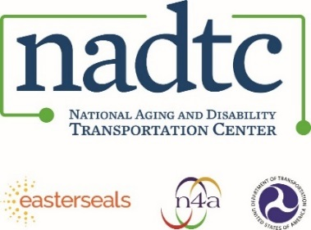

**Call toll-free:** 866.983.3222

**Email:** contact@nadtc.org

**Web:** [www.nadtc.org](http://www.nadtc.org)

**Find us** on Facebook, Twitter, YouTube & LinkedIn!

